Write a Stored Procedure that takes table name as input parameter and finds out the name of all the columns in table.

**Constraint:** You cannot use sp_columns statement

**Answer:**

CREATE PROCEDURE colname @tablename varchar(90)

AS

BEGIN

SELECT name

FROM sys.columns

WHERE object_id = OBJECT_ID(@TableName)

END;

exec colname StudentDetails;

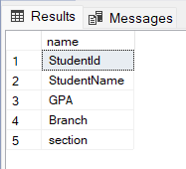

**output:**

**Original Table:**

