**Write a Stored Procedure that inserts all the data using list of columns from Table A to Table B and truncates the data in Table A post insertion to Table B.**

**Constraint**: The column list will be passed in a single parameter and the column values would be comma separated

**Answers:**

select * from Studentdetails;

output:

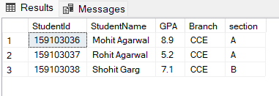

CREATE PROCEDURE CopyData @ColumnList VARCHAR(MAX)

AS

BEGIN

DECLARE @sql NVARCHAR(MAX);

SET @sql = N'SELECT ' + @ColumnList + ' FROM Studentdetails;';

EXEC sp_executesql @sql;

TRUNCATE TABLE StudentDetails;

END

exec copydata StudentId;

output:

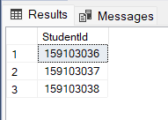

select * from StudentDetails;

output:

