Quick Attend

**A HACKATHON PROJECT REPORT**

***Submitted by***

**ARYAN LANGHANOJA (92200133030)**

**RISHIT RATHOD (92200133027)**

***In partial fulfillment for CPMAD (01CT1517) Project***

# Sem – 5th Degree ENGINEERING

***in***

# Information and Communication Technology Engineering



**Faculty of Technology Marwadi University, Rajkot**

**Abstract:**

**Quick Attend: Revolutionizing Classroom Attendance Management**

Quick Attend is a cutting-edge mobile application designed to streamline and optimize the process of student attendance in educational institutions. By leveraging modern technology, it empowers faculty members and students alike to enhance classroom efficiency and ensure accurate record-keeping. Below are the key features and their detailed descriptions:

**Key Features and Elaborations**

**1. Efficient Attendance Management**

Faculty members can seamlessly take attendance within the app, completely eliminating the need for manual methods such as roll calls or physical attendance sheets.

* **User-Friendly Interface**: Designed with a clean and intuitive UI, the app ensures that educators can quickly navigate and manage attendance without technical hurdles.
* **Real-Time Tracking**: Faculty can view and edit attendance records in real-time, ensuring immediate updates.
* **Customized Attendance Sessions**: Teachers can create specific sessions for different classes, courses, or even events.

**2. Student Self-Attendance**

Students are empowered to mark their own attendance during active attendance sessions.

* **QR Code-Based Verification**: Students can scan a unique QR code displayed in the classroom to mark their attendance.
* **Transparency**: Students can view their attendance history and receive notifications for attendance-related updates.

**3. Time and Location Bound Attendance**

The app ensures that attendance sessions are both time-restricted and location-specific to maintain accuracy and integrity.

* **Geofencing Technology**: Attendance can only be marked within a defined radius of the classroom or institution.
* **Session Timers**: Faculty can set specific start and end times for attendance sessions, after which no entries are allowed.
* **Enhanced Accountability**: This feature discourages proxy attendance and ensures that only those physically present within the classroom can mark their presence.

**4. Offline Support**

Quick Attend is designed to function even in environments with limited or no internet connectivity.

* **Data Queueing**: Attendance records are stored locally on the device during offline sessions.
* **Auto-Syncing**: Once the device reconnects to the internet, all queued data is automatically synchronized with the central database, maintaining up-to-date records.
* **Seamless User Experience**: Educators and students can continue using the app uninterrupted, regardless of connectivity issues.

**Additional Features**

* **Reports and Analytics**: Generate detailed attendance reports for classes, individuals, or time periods.
* **Integration**: Compatible with Learning Management Systems (LMS) and institutional databases for seamless data integration.
* **Notifications and Alerts**: Automated reminders for students and faculty regarding attendance deadlines or updates.
* **Role-Based Access**: Role-specific permissions for faculty, students, and administrators ensure secure and appropriate access.

**Benefits**

* **Time-Saving**: Automates attendance processes, saving valuable class time for teaching and discussions.
* **Accuracy**: Reduces errors and discrepancies in attendance records.
* **Convenience**: Enables remote access and management for faculty and administrators.
* **Environmentally Friendly**: Minimizes the use of paper for attendance sheets.

**Project Demo:**

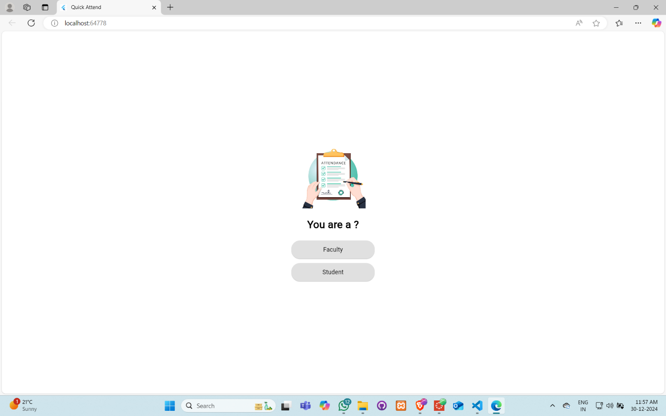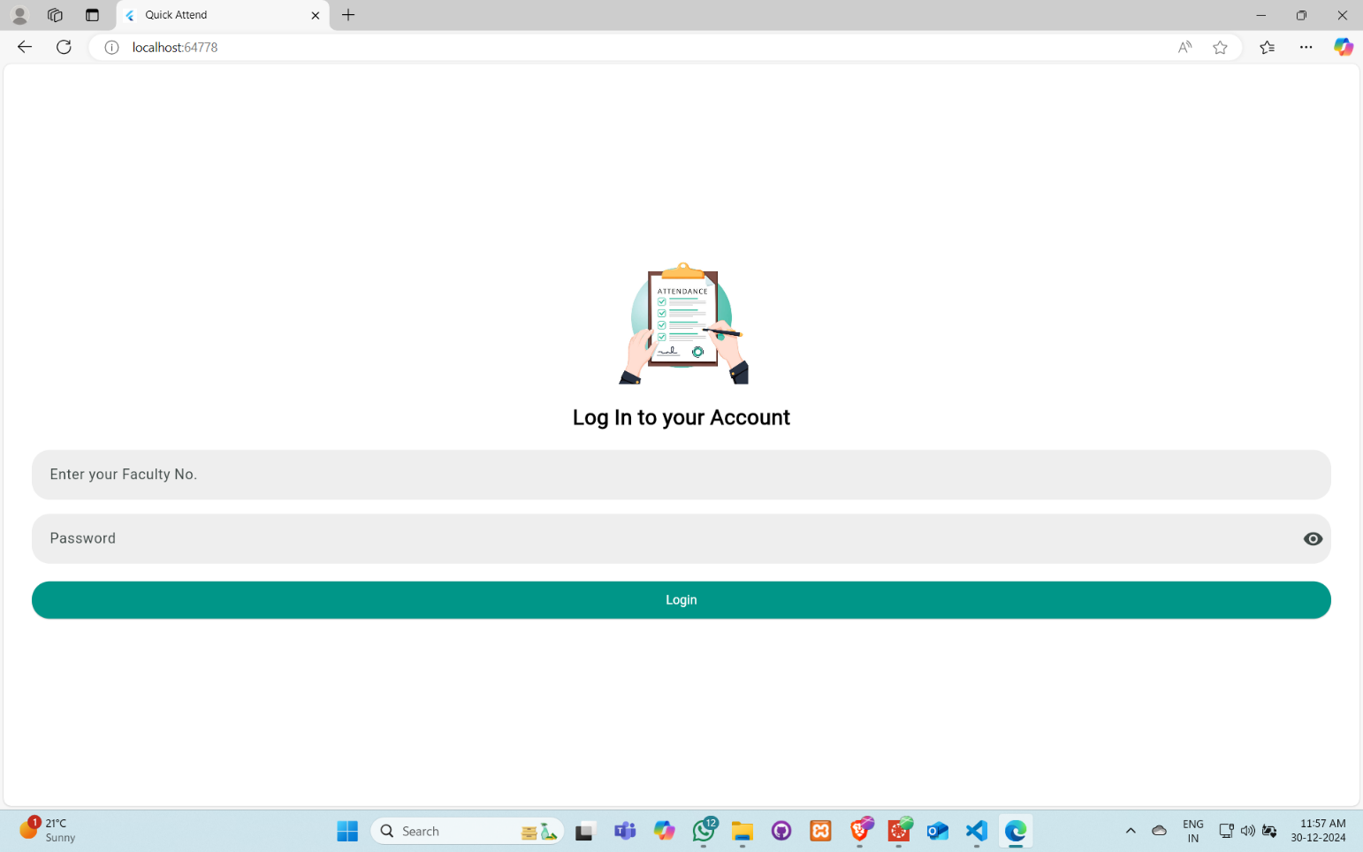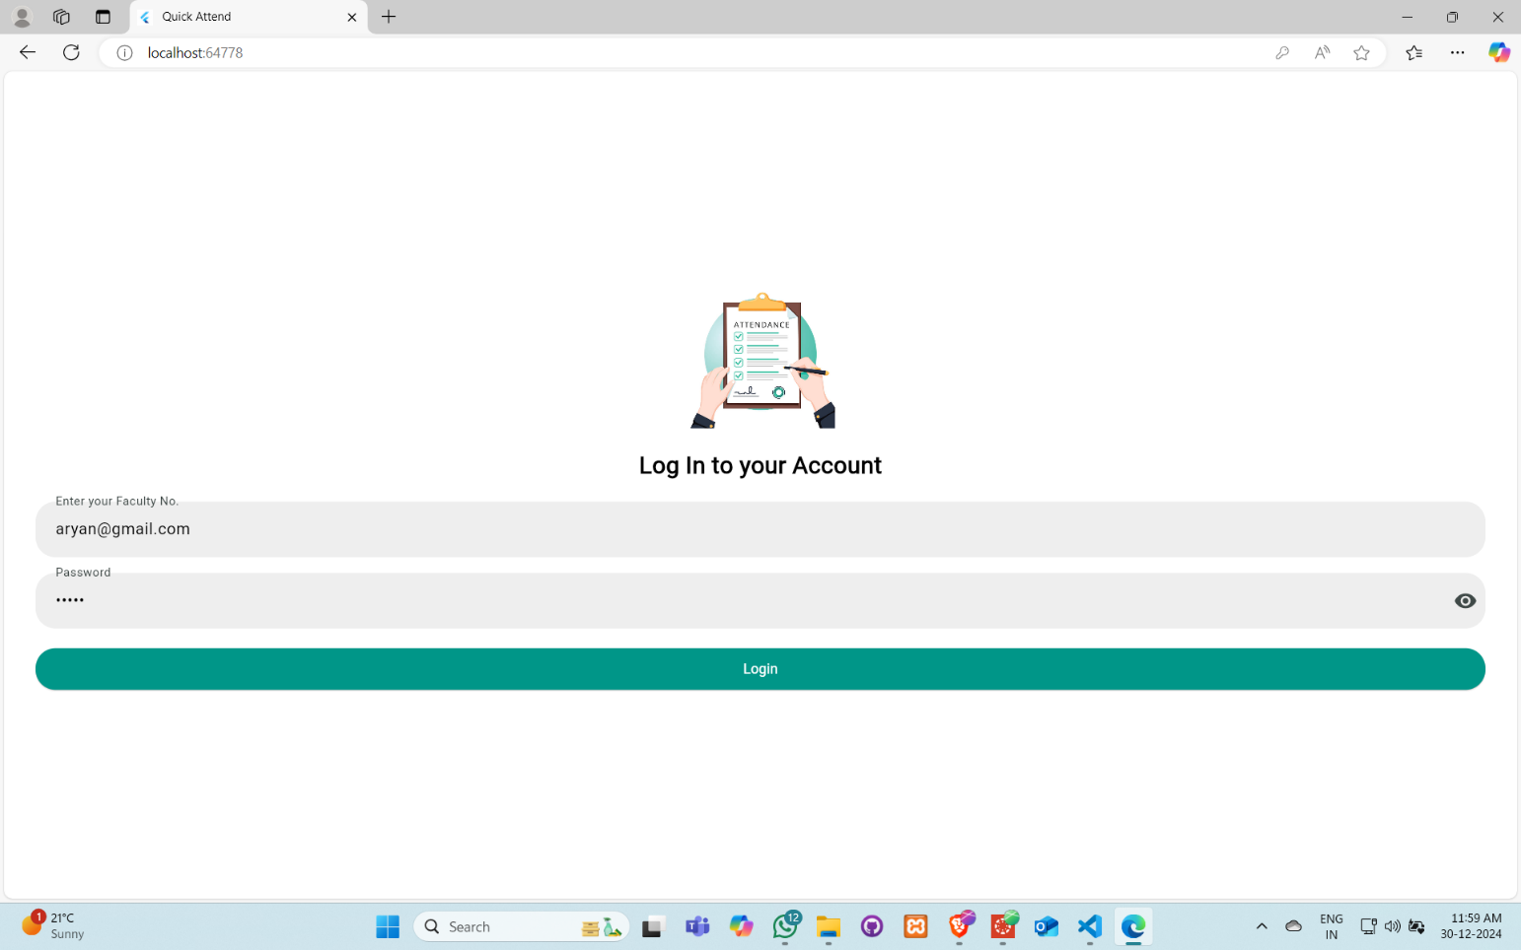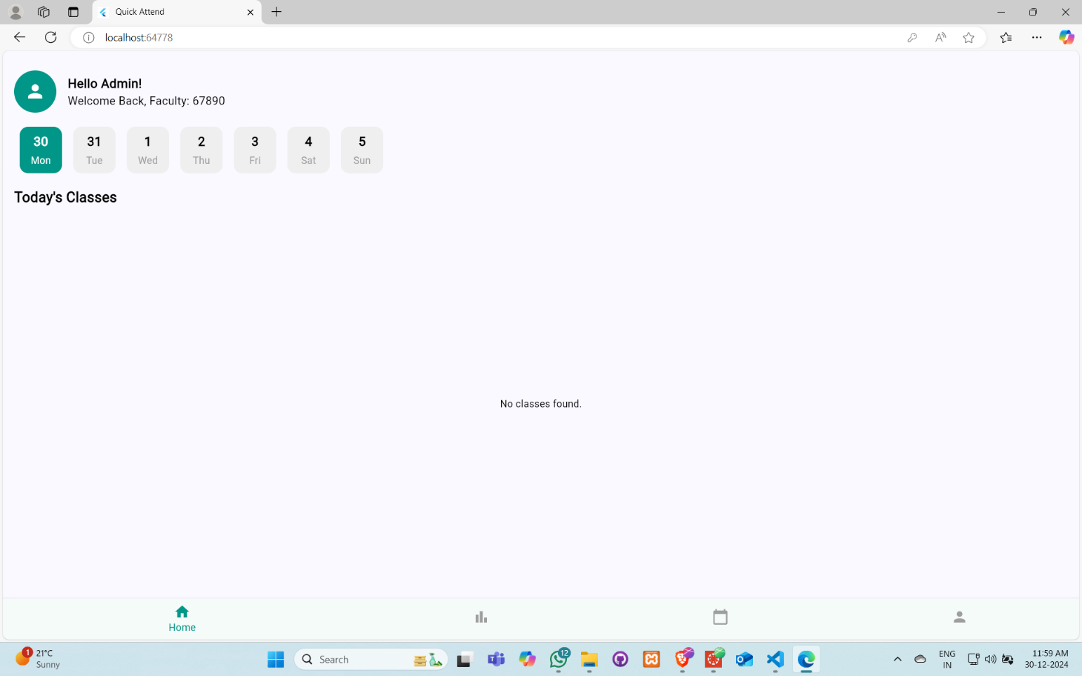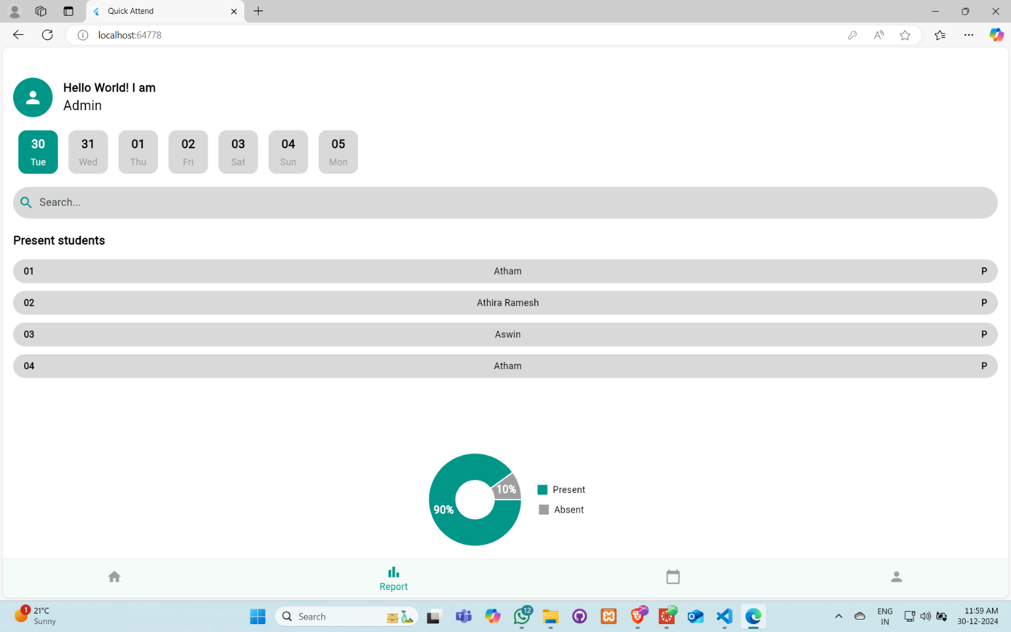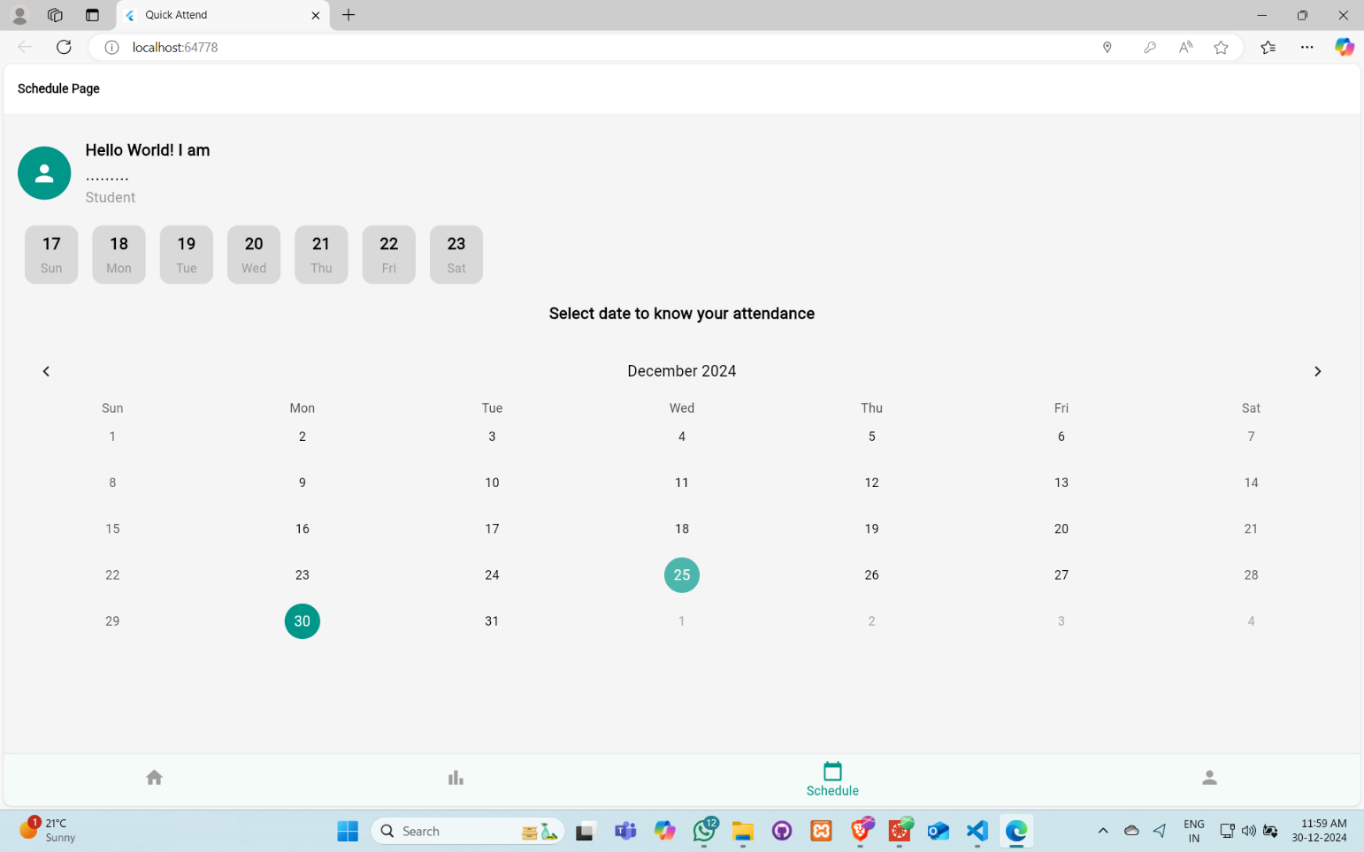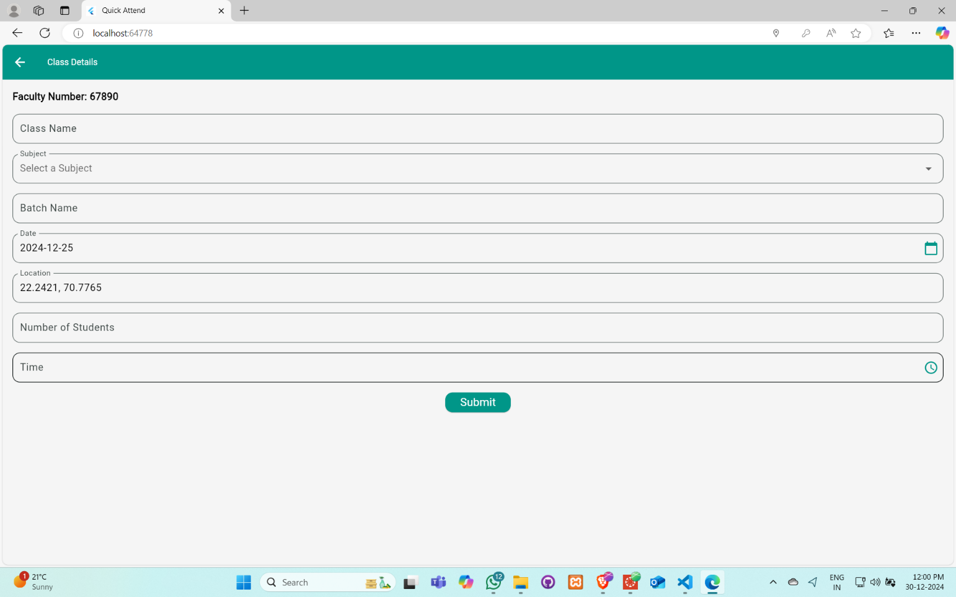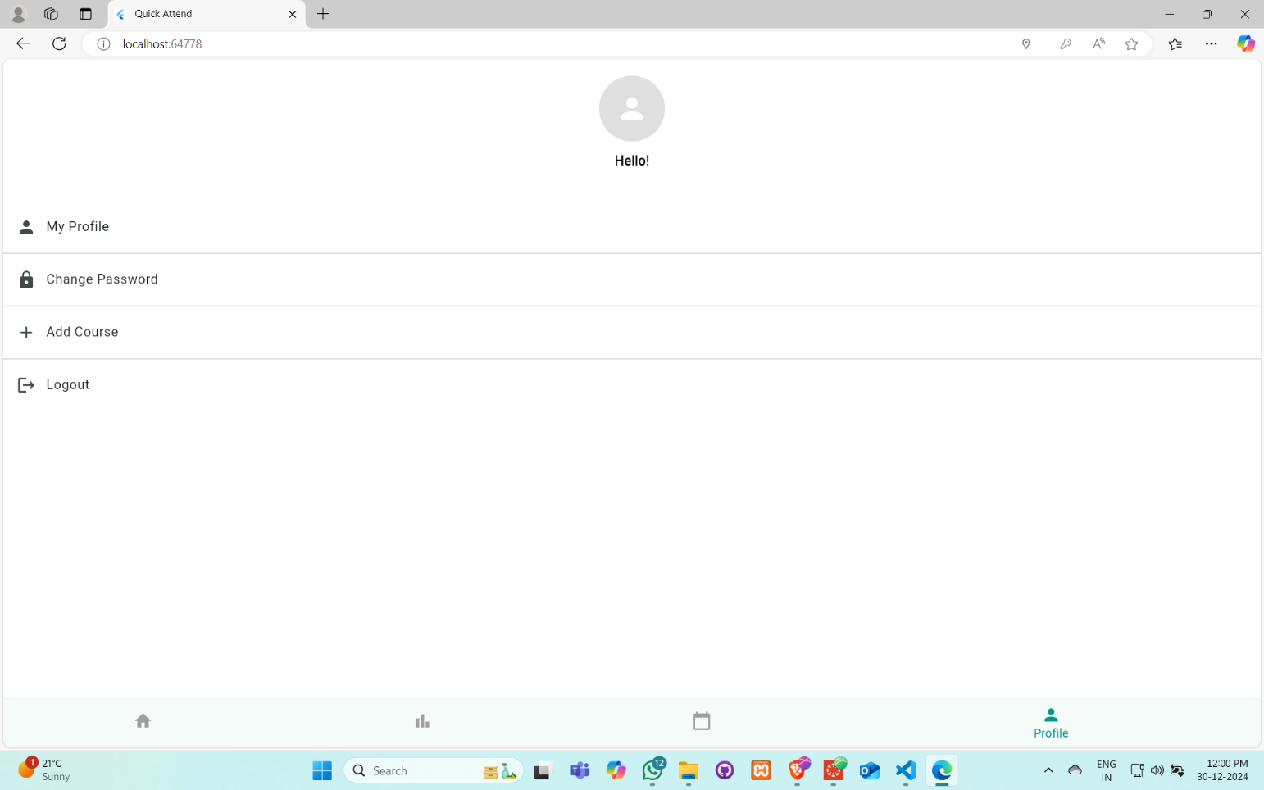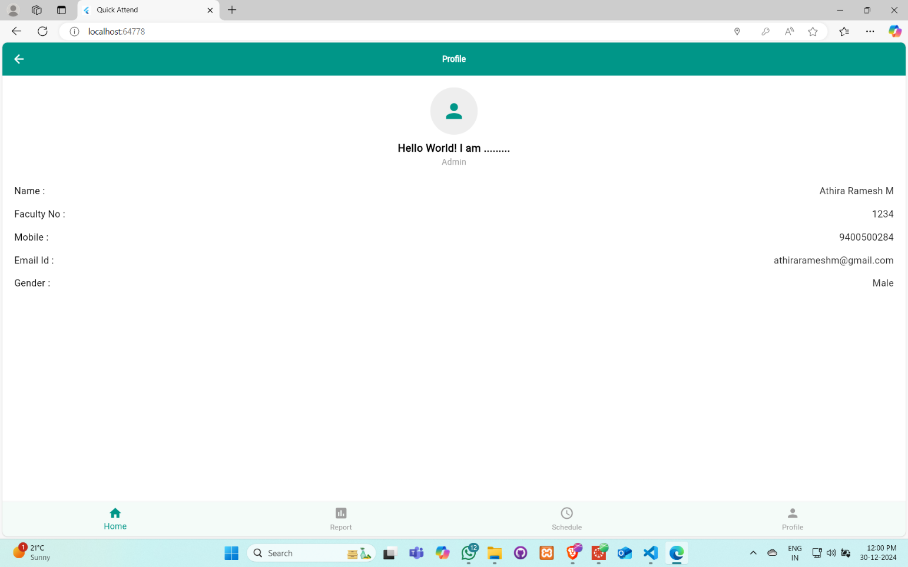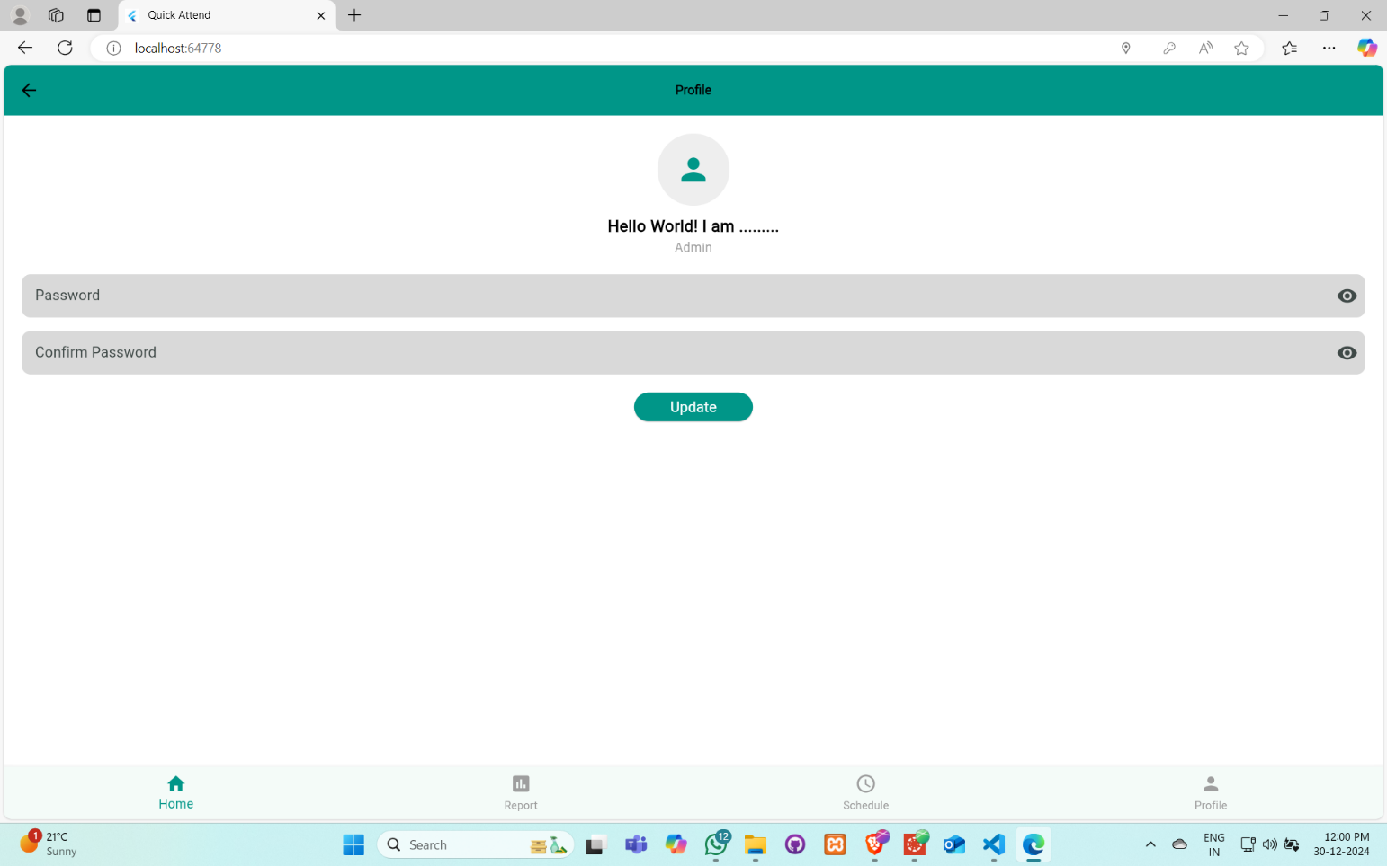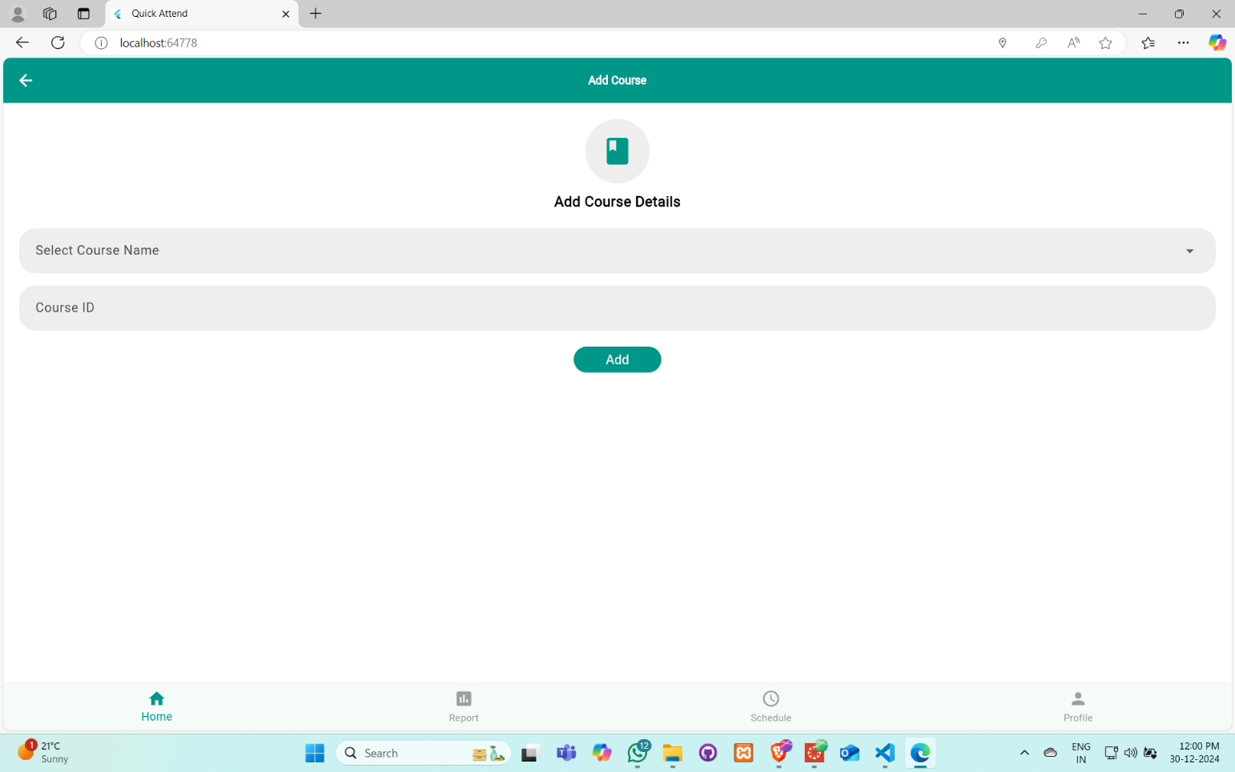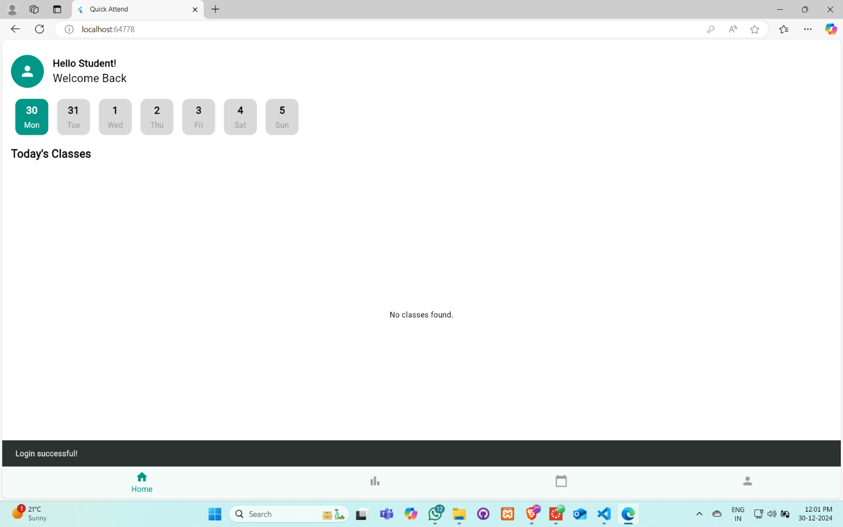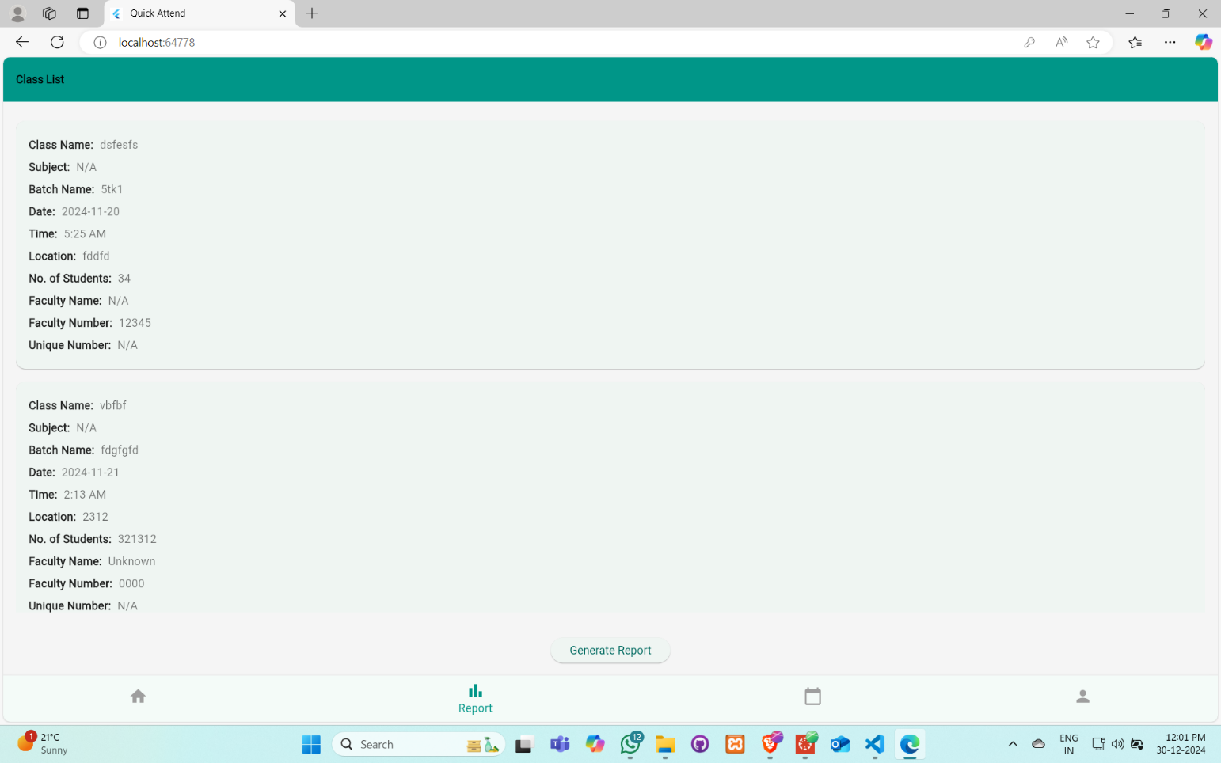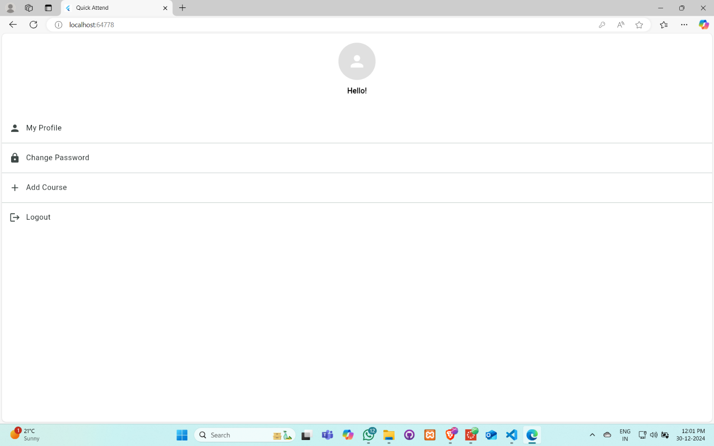

Source Code :-

<https://github.com/Aryanlanghanoja/Appathon_-_CPMAD.git>