**Session-10 Assignment**

**Name:-** Aryan Dilipbhai Langhanoja

**Enroll No:-** 92200133030

**AIM**: To understand application of Transistor as Switch.

**Objective:**

1. To understand various applications of transistors.
2. To become familiar with importance of biasing and operating point for various applications.
3. To design switch using transistor.

**Apparatus:**

1. Function generator
2. Dc power supply
3. Switch
4. Transistor (BC547)
5. Resistors
6. LED

**Task-1- Design the circuit for transistor as a switch.**

You need to verify that when V1 is 0V, transistor is off (cutoff region-open switch) and when V1=5V, transistor is on (saturation region-closed switch). You can measure voltage across collector and emitter (VCE)

**Sample Circuit diagram:**



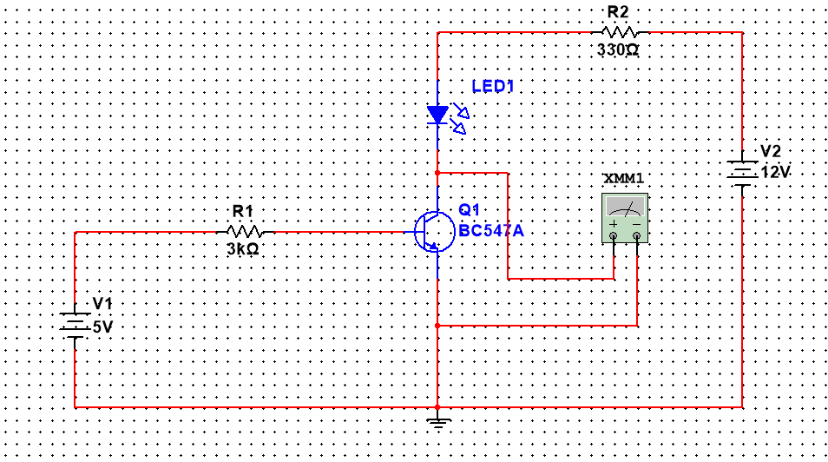**Simulation circuit in Multisim:**

**Task-2 Develop LED driver circuit using PNP transistor.**

**Simulation circuit in Multisim:**

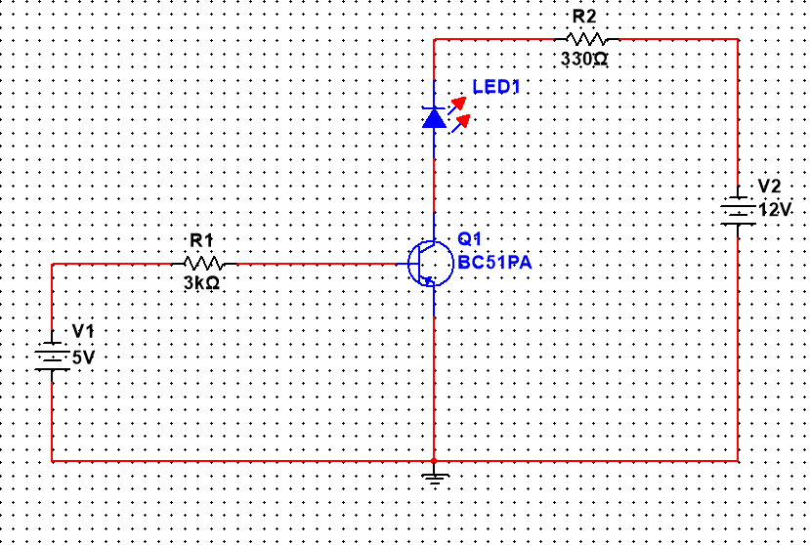

**Task-3 Any three applications of Transistor as a switch**

1. Used to Drive High Voltage or Large Current Circuits.
2. Used In Digital IC’s
3. Used to Make Logic Gates.

**Conclusion:**