**Session-7 Assignment**

**Name :-** Aryan Dilipbhai Langhanoja

**Enroll No :-** 92200133030

**AIM**: To analyze knee voltage of various color LEDs, composition of material and design seven segments LED circuit to display 0-9.

.

**Objective:**

1. To understand working principle of LED, photo diode and seven segment LED.
2. To analyze knee voltage of various color LEDs.
3. To create alphanumeric and digit displays on seven segment.

**Apparatus:**

1. Seven segment Display
2. SPST(Single Pole Single Throw) switches
3. DC power Supply

**Task-1 Knee voltage for various color LEDs**

|  |  |  |
| --- | --- | --- |
| **Sr. No.** | **Color** | **Knee voltage** |
| 1 | Red | 1.8 V |
| 2 | Green | 2.1 V |
| 3 | Yellow | 2.2V |
| 4 | Orange | 2.0 V |

**Task-2 Material composition for various color LEDs**

|  |  |  |
| --- | --- | --- |
| **Sr. No.** | **Color** | **Material** |
| 1 | Red | Aluminum indium gallium phosphide **(AlInGaP)** |
| 2 | Green | Gallium arsenide **(GaAs)** gallium indiumphosphide **(GaInP)** |
| 3 | Yellow | Aluminum gallium indium phosphide **(AlGaInP)** |
| 4 | White | Gallium-indium-nitride **(InxGa1-xN)** |

**Task-3 Seven Segment display to generate 0 to 9**

Note: Mention **ON** or **OFF** condition for a-g LEDs to generate specific number

|  |  |  |  |  |  |  |  |
| --- | --- | --- | --- | --- | --- | --- | --- |
| **Sr. No.** | **a** | **b** | **C** | **d** | **E** | **f** | **g** |
| 0 |  |  |  |  |  |  |  |
| 1 |  |  |  |  |  |  |  |
| 2 |  |  |  |  |  |  |  |
| 3 |  |  |  |  |  |  |  |
| 4 |  |  |  |  |  |  |  |
| 5 |  |  |  |  |  |  |  |
| 6 |  |  |  |  |  |  |  |
| 7 |  |  |  |  |  |  |  |
| 8 |  |  |  |  |  |  |  |
| 9 |  |  |  |  |  |  |  |

**Task-4 Simulation circuit in Multisim to display 0 to 9 on single seven segment display using different switches (10 switch):**

**Task-5 In the following figure find the value of ‘X’ and ‘Y’ (Decimal)**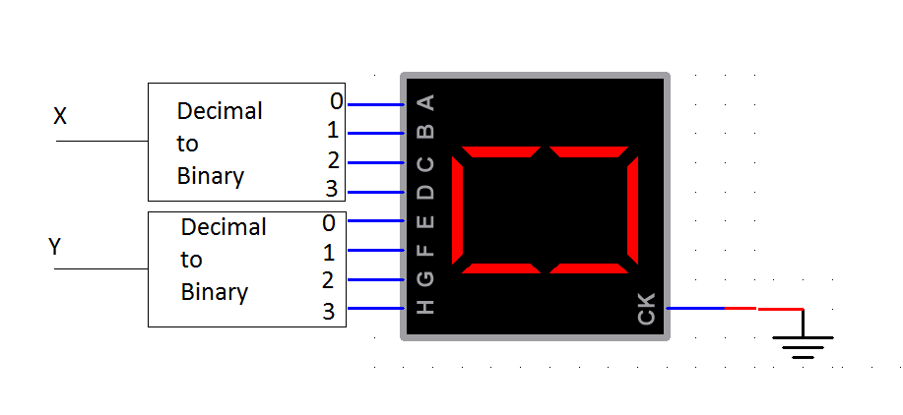

**Conclusion:**