**Session-9 Assignment**

**Name:-** Aryan Dilipbhai Langhanoja

**Enroll No:-** 92200133030

**AIM**: To understand Bipolar Junction Transistors and develop current-voltage characteristics of CE configuration.

**Objective:**

1. To understand various configurations like common base, common emitter and common collector.
2. To compare various parameters like input-output resistance, current and voltage gain etc for various configurations.
3. To become familiar with nomenclature used with transistors and formulas for gain, output current for various configurations and their relations with other configuration.
4. To explore applications of transistors.

**Apparatus:**

1. DC power Supply
2. Transistor (BC547)
3. Resistors

**Task-1- Develop current-voltage characteristics for CE configuration. Develop input characteristics (IB Vs VBE) and output characteristics (IC Vs VCE)**

**Sample Circuit diagram:**



**Simulation circuit in Multisim:**

**Note:** Verify correct polarity of DC voltage sources for proper operation in Active region such that base-emitter junction is in forward bias and collector-base junction is in reverse bias.

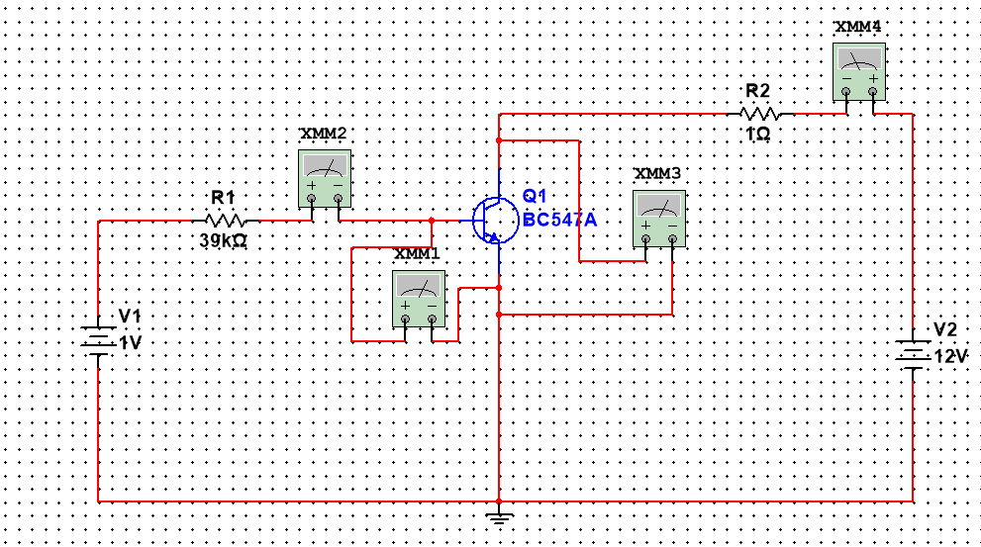

**Input Characteristics (IB Vs VBE): Keep collector supply voltage fix(V2). Measure VCE. Change V1 in steps of 0.1V (0 to 1.5V) and measure IB and VBE**

|  |  |  |  |  |  |
| --- | --- | --- | --- | --- | --- |
| **Fix V2=1V VCE= 999.9mV** | | **Fix V2=6V VCE=6 V** | | **Fix V2=12V VCE=12 V** | |
| **IB** | **VBE** | **IB** | **VBE** | **IB** | **VBE** |
| 91.593 pA | 99.996 mV | 41.633 pA | 99.998 mV | 18.041 pA | 100 mv |
| 210.942 pA | 199.992 mV | 160.982 pA | 199.994 mv | 99.92 pA | 199.996 mV |
| 705 pA | 299.972 mV | 655.573 pA | 299.974 mV | 596.051 pA | 299.977 mV |
| 9.308 nA | 399.637 mV | 9.258 nA | 399.693mV | 9.198 nA | 399.641 mV |
| 164.498 nA | 493.584 mV | 164.46 nA | 493.586 mV | 164.41 nA | 493.588 mV |
| 1.142 uA | 555.473 mV | 1.142 uA | 555.474 mV | 1.142 uA | 555.475 mV |
| 2.94 uA | 585.933 mV | 2.94 uA | 585.334 mV | 2.94 uA | 585.334 mV |
| 5.067 uA | 602.386 mV | 5.067 uA | 602.387 mV | 5.067 uA | 602.387 mV |

**Plot graph IB Vs VBE for different values of VCE**

**Output Characteristics (IC Vs VCE)**

**Keep base supply voltage fix(V1). Measure IB. Change V2 in steps of 1V (1V to 10V) and measure IC and VCE**

|  |  |  |  |  |  |
| --- | --- | --- | --- | --- | --- |
| **Fix V1=1V IB=9.697 uA** | | **Fix V1=1.1V IB=12.068 uA** | | **Fix V1=1.2V IB=14.487 uA** | |
| **IC** | **VCE** | **IC** | **VCE** | **IC** | **VCE** |
| 975.15 uA | 0.999 V | 1.26 mA | 0.998 V | 1.154 mA | 998.446 mV |
| 1.116 mA | 1.999 V | 1.445 mA | 1.999 V | 1.786 mA | 1.998 V |
| 1.257 mA | 2.999 V | 1.631 mA | 2.998 V | 2.018 mA | 2.998 V |
| 1.378 mA | 3.999 V | 1.816 mA | 3.998 V | 2.249 mA | 3.998 V |
| 1.539 mA | 4.998 V | 2.001 mA | 4.998 V | 2.481 mA | 4.998 V |
| 1.68 mA | 5.998 V | 2.186 mA | 5.998 V | 2.712 mA | 5.997 V |
| 1.882 mA | 6.998 V | 2.371 mA | 6.998 V | 2.944 mA | 6.997 V |
| 1.963 mA | 7.998 V | 2.557 mA | 7.997 V | 3.176 mA | 7.797 V |
| 2.104 mA | 8.998 V | 2.742 mA | 8.997 V | 3.407 mA | 8.997 V |
| 2.245 mA | 9.998 V | 2.927 mA | 9.997 V | 3.639 mA | 9.996 V |

**Plot IC Vs VCE for different values of IB**

**Task-2 Comparison of CB, CE and CC configuration**

|  |  |  |  |  |
| --- | --- | --- | --- | --- |
| **Sr. No.** | **Characteristics** | **CB** | **CE** | **CC** |
| **1** | Input Resistance | Small | Medium | Large |
| **2** | Outpour Resistance | Large | Medium | Small |
| **3** | Current gain | Almost 1 | Large | Large |
| **4** | Voltage Gain | Large | Large | Almost 1 |
| **5** | Leakage current |  |  |  |
| **6** | Phase shift | 0 | 180 Degree | 0 |
| **7** | Application | Current Buffer | Power Amplifier | Voltage Buffer |

**Task-3 Symbol used in transistor configurations and their meanings**

IB = DC Current Passes through Base.

ib = AC Current Passes Through Base.

IC = DC Current Passes through Collector.

iic = AC Current Passes Through Collector.

IE = DC Current Passes through Emitter.

ie = AC Current Passes Through Emitter.

VB = Voltage at Base with respect to ground.

VC = Voltage at Collector with respect to ground.

VE = Voltage at Emitter with respect to ground.

VBB = Volatge Given at Base and Emitter Terminal.

VCC = Volatge Given at Collector and Emitter Terminal.

VEE = Voltage Given at Emiiter and Base Terminal in CB Configuration. Or Voltage Given at Emiiter and Collector Terminal in CC Configuration.

**Task-4 : Relations and useful formulas**

α (Current Gain of CB configuration) = IC / IE

β (Current Gain of CE configuration) = IC / IB

γ (Current Gain of CC configuration) = IE / IB

For CE configuration:

Ic = Current Passing Through Collector

Vbb = External Voltage Given At Base and Emitter Terminal.

Vcc = External Voltage Given At Collector and Emitter Terminal.

**Task-5 Any five application of Transistor**

1. As a Electronic Switch .
2. As a Current Amplifier.
3. As a Voltage Amplifier.
4. As a Power Amplifier.
5. In Processors.

**Conclusion:**