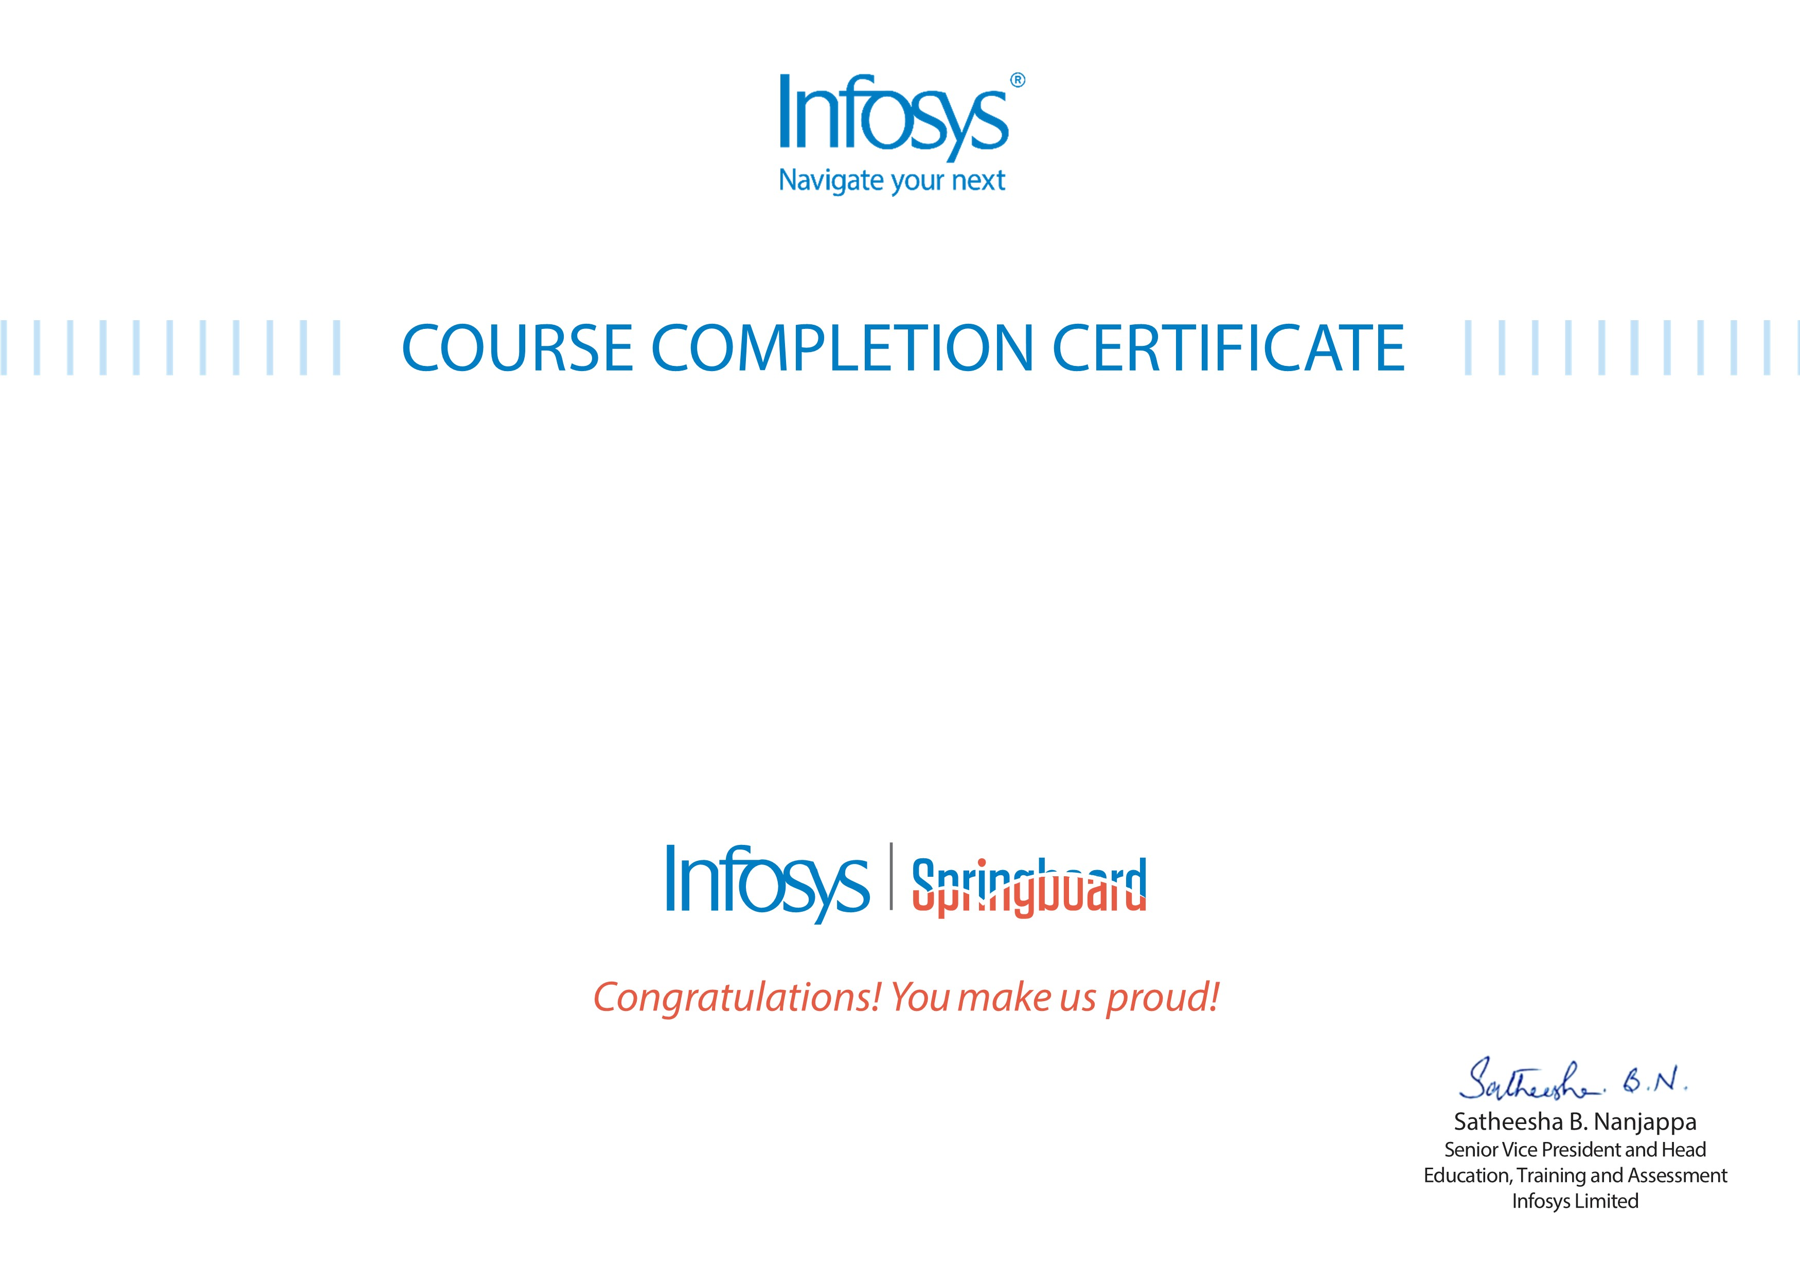
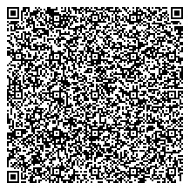
Radha Rasal
Artificial Intelligence and Machine Learning Training Course
The certificate is awarded to
for successfully completing the course
on November 01, 2025
Issued on:
Monday, November 02, 2025
To verify, scan the QR code at
htt
ps://verif
y
.onwin
g
span.co
m

