

<RFP Name>

Business Proposal for <Customer Name>

Prepared For:
Name
<Customer Name>

Prepared By:
<Sales spoc name>
iMocha
Sales email id |

The software and database described in this document are furnished under a license agreement or a non-disclosure agreement. The software and database may be used or copied only in accordance with the terms and conditions of the agreement.
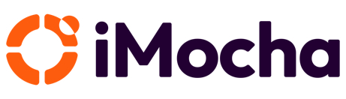
This document includes technical know-how that is not commonly known (confidential information). The user of this document warrants that such technical know-how shall only be used to fulfil the purpose for which iMocha presented this document to the user, for example user reference or evaluation of the software. Furthermore, the user warrants that such technical know-how will not be revealed to any third party.

This document, in whole or in part, may not be reprocessed or retransmitted in any form or by any means, electronic or mechanical, including photocopying, recording, or information storage and retrieval systems, for any purpose other than the license holder's internal use, without the express written permission of iMocha.

The software and database described in this document are furnished under a license agreement or a non-disclosure agreement. The software and database may be used or copied only in accordance with the terms and conditions of the agreement.

This document includes technical know-how that is not commonly known (confidential information). The user of this document warrants that such technical know-how shall only be used to fulfil the purpose for which iMocha presented this document to the user, for example user reference or evaluation of the software. Furthermore, the user warrants that such technical know-how will not be revealed to any third party.

Copyright © 2026 iMocha

Table of Content

Executive Summary

<How we are pleased to provide the solution>
<How we are aligned with customer goals and their requirement>
<How confident we are to deliver value>
Sincerely,

1. iMocha Overview

1.1 Company profile
iMocha’s vision is to build a skills-first future where organizations and individuals thrive through the power of validated skills. Our mission is to empower enterprises with AI-powered skills assessment and intelligence solutions that streamline talent acquisition and enable data-driven decisions—helping over 300 global customers, including Fortune 500 leaders, unlock workforce potential and drive business performance.
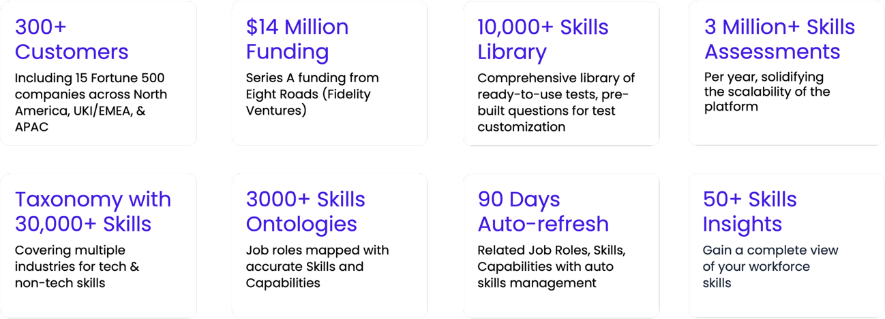
1.2 Global Footprints
Headquartered in Delaware, USA, iMocha operates in India through a subsidiary named Tecknack Technologies Private Limited.
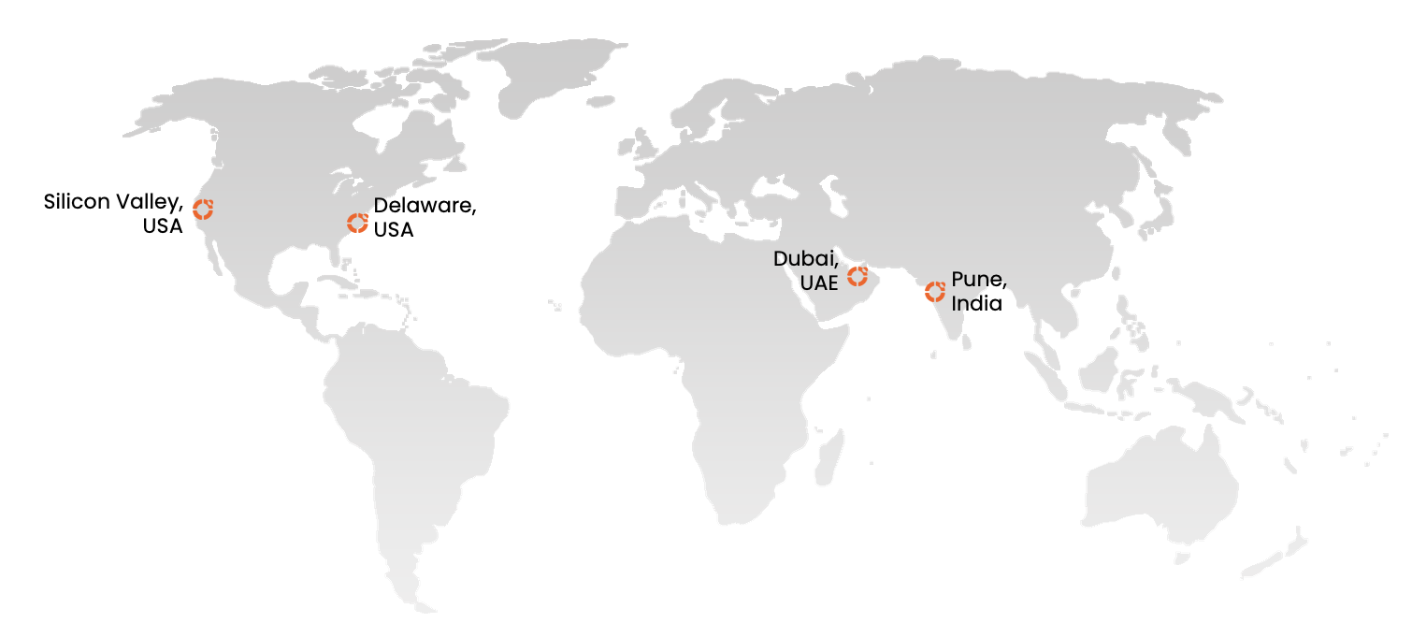

1.3 Key milestones and achievements
iMocha has consistently been recognized as a global innovator in skills intelligence and assessment. Our Skilling API was spotlighted by Microsoft CEO Satya Nadella for accelerating hiring and skills matching, reflecting the transformative impact of our solutions. We are proud to partner with leading platforms like SAP, Microsoft, and Degreed, further strengthening our ecosystem. Celebrated by G2 with multiple Leader awards across regions, including EMEA and Middle East & Africa, as well as recognition for Fastest Implementation and Best Estimated ROI, iMocha continues to deliver measurable value to customers worldwide.
Adding to these accolades, we were honored with the Brandon Hall Group Gold Award for Best Talent Management Technology Implementation in 2025—cementing our position as a trusted partner in enabling a skills-first future.
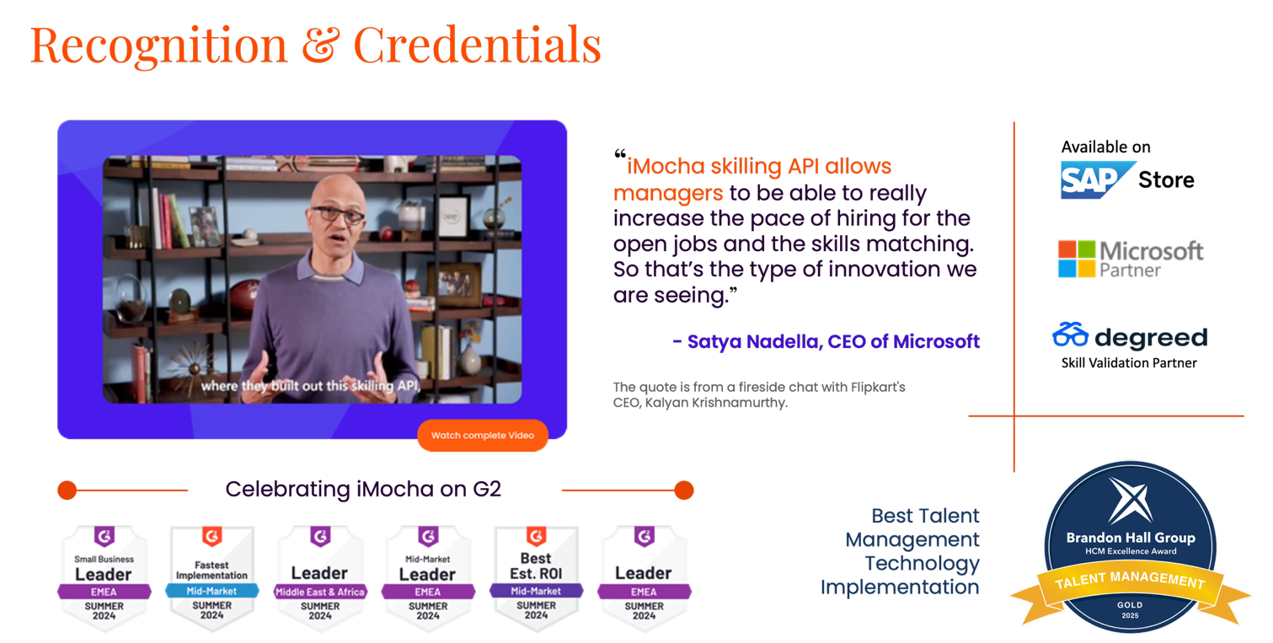
Read More on Brandon Hall

1.4 Certifications & Compliance

iMocha is committed to upholding the highest standards in security, privacy, and data protection. The platform is:

- ISO/IEC 27001:2022 Certified – for information security management systems.
- SOC 2 Type II Compliant – with independently audited controls covering security, availability, and confidentiality.
- GDPR & CCPA Compliant – with configurable consent messaging and data deletion workflows.
- WCAG 2.1 AA Certified – for accessibility support in assessments.
- Microsoft Responsible AI Compliant – aligning with fairness, transparency, and bias mitigation practices.

2. Scope of Work

<How scope is aligned to what iMocha can deliver>

2.1 In scope Key Deliverables

3. iMocha Solution
iMocha proposes a secure, scalable, and role-specific skills assessment platform that fully meets the functional, technical, and compliance requirements outlined by Customer Name (CUSTOMER NAME). This section outlines the end-to-end scope of services iMocha will deliver as part of the proposed solution
3.1 Assessment Capabilities Across Job Roles

iMocha provides AI-powered solutions to enhance skills assessments, ensuring precision in evaluating candidates across various domains.
Once the best-fit candidates are identified, iMocha takes the next step with its Comprehensive Assessment Library, offering 10,000+ validated skill tests across 300+ job roles. These assessments span technical, functional, cognitive, and soft skills—delivering structured evaluations that mirror real-world scenarios.
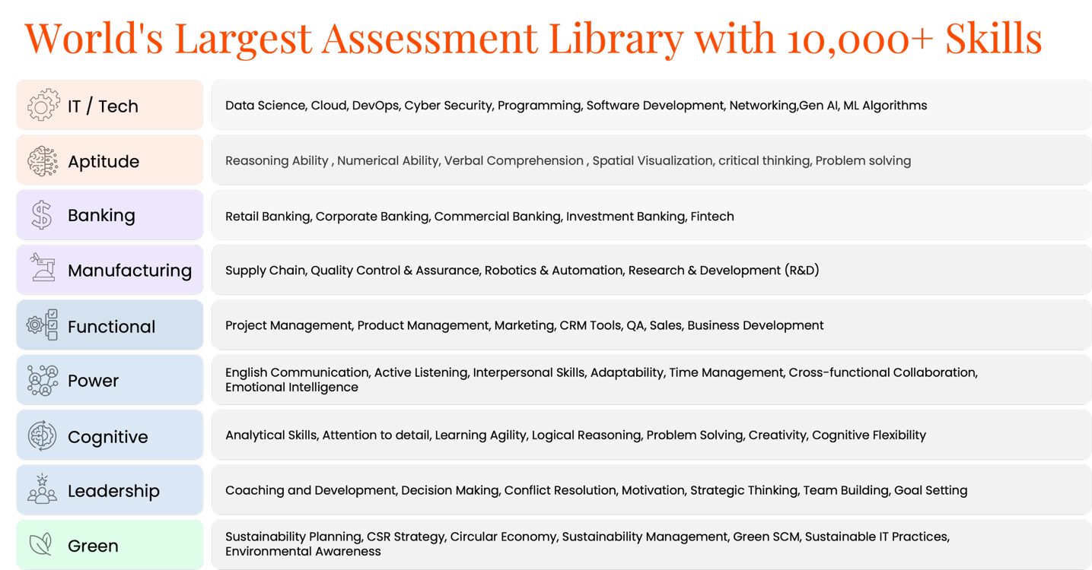
Assessment Library
iMocha provides evaluations across various job families such as:
- Frontline/Entry-Level Roles: Call center agents, retail associates, operations specialists
- Professional Roles: HR, finance, marketing, customer success
- Technical Roles: Software engineers, data analysts, IT support
- Specialized Licensed Professions: Legal, compliance, financial advisors
- Contractor Roles: Temporary and contingent workforce assessments
Assessment types include:
- Cognitive Ability Tests: Logical reasoning, numerical reasoning, verbal reasoning, attention to detail, abstract thinking
- Situational Judgment Tests (SJTs)
- Skills-Based Tests: Typing speed, data entry, math, CRM navigation
- Technical Assessments: Coding, DevOps, cybersecurity, software architecture
- Behavioral & Personality Assessments: Big Five, DISC, adaptability, teamwork
- Simulation-Based Assessments: Chat simulations, customer call handling, code review, multi-system navigation
- Compliance Knowledge Checks: Banking regulations, data privacy, etc.
- Custom Assessments: Created or modified at question level based on CUSTOMER NAME’s need
3.1.1. AI-EnglishPro
iMocha's AI-EnglishPro is a comprehensive solution for assessing English communication skills, enabling organizations to hire and upskill talent with confidence. It provides structured evaluations to measure proficiency in Listening, Speaking, Reading, and Writing (LSRW). For customer service or support roles, this test can be readily used.
The key AI-powered features include:
- Speaking: AI-driven assessments evaluate pronunciation, fluency, and coherence to provide an objective proficiency score.
- Writing: AI-powered evaluation ensures precise assessment of grammar, structure, and context, mapped to industry standards.
- Listening: Perfect for customer-facing roles as it can test comprehension, fluency, vocabulary and pronunciation.
- Reading: Ideal for customer-facing roles that require extensive reading or complex data processing.
- Context Check: AI evaluates contextual accuracy and relevance in responses, ensuring candidates stay on topic.
3.1.2. AI-LogicBox
iMocha’s AI-LogicBox is a patented, AI-driven pseudo-coding assessment tool that evaluates logical thinking, problem-solving, and coding logic without the need for traditional compilers. Designed to test real-world programming skills across various technologies, AI-LogicBox provides a seamless, interactive, and engaging assessment experience.
Why Choose iMocha's Coding Simulations?
- Code-Free Logic Assessment: Evaluate problem-solving abilities without syntax constraints.
- AI-Driven Auto Evaluation: Get instant, objective scoring with detailed insights.
- Enhanced Candidate Experience: Short, engaging assessments with higher completion rates.
- Scenario-Based Challenges: Assess logic implementation in real-world situations.

3.2 Assessment Creation, Customization & Management
- Job-Role Based Assessments: Create assessments aligned to business functions or skill clusters.
- Question-Level Control: CUSTOMER NAME users can view, edit, or create its own new questions.
- Version Control:
- Version names are maintained at the question bank level for traceability.
- Whenever new versions of a question bank are created, older versions remain unchanged and can be used again if required.
- All changes are logged with version IDs, author, and date.
- Question versions are audited at regular intervals to ensure compliance and integrity.
- Only the latest validated version is used for assessment delivery.
- Assessment Bundles: Assign multiple skills as part of a single assessment as a package per candidate.

3.3 Test Delivery Modes & Candidate Experience
iMocha supports a flexible test delivery and scheduling experience:
- Delivery Modes:
  - Unproctored
  - Proctored
- Candidate Experience Features:
  - Branded and white-labelled test portals with configurable messaging
  - Timed test settings
  - Practice tests and instructional content
  - Resume/save capability with expiration limits
  - Mobile-first, multilingual platform with accessibility features

3.4 Smart proctoring & Anti-Fraud Measures
iMocha's AI-Proctoring ensures integrity in online assessments by minimizing fraud and enhancing authentication. It leverages AI to detect and prevent cheating, ensuring credibility in hiring and upskilling programs.
The key powered features include:
- Smart Video Proctoring : AI analyzes candidate behavior to detect and flag suspicious activities during an assessment. More details can be referred here Video proctoring
- AI-Based Face Detection: Identifies multiple or unrecognized faces, preventing impersonation and unauthorized access.
- Safe Assessment Browser: Restricts access to external applications and browsers during assessments to prevent cheating. More details to be referred here Safe assessment browser
- Image Proctoring: Captures periodic snapshots during assessments to monitor candidate activity. More details here Image proctoring
- Candidate ID Verification: Easily verify your candidates' identity using any of the 12,000+ supported government IDs from 293+ supported government IDs, ensuring a seamless and secure authentication process. More details to be referred here Candidate ID verification
- Window Violation Detection: Keep your candidates focused and ensure a smooth testing experience to avoid any alerts that may disrupt their assessment. More details to be referred here Window violation
- Randomization of Questions: Each candidate receives a unique set of questions, guaranteeing a fair and unbiased assessment every time. More details to be referred here Randomization of Questions and answers
- Disabled Screen Sharing: Protect the test content by preventing the candidate from sharing or recording their screen during the assessment, safeguarding against unauthorized sharing of content.
- Disabled Copy/Paste: Ensure that the candidate cannot copy or paste any content during the test, maintaining the integrity of the assessment process.

3.6 Reporting & Analytics

With iMocha’s Reports and Analytics, recruiters gain actionable insights to make smarter, data-driven hiring decisions. Candidate reports are instantly generated after every assessment, providing a detailed breakdown of performance, strengths, and skill gaps. This empowers hiring teams to move beyond intuition and rely on measurable skill data to decide who to shortlist, interview, or develop further. Accessible through Live Data, Analytics, and My Tests, these reports not only speed up decision-making but also enhance the quality of hire by ensuring every choice is backed by evidence.
3.6.1 Summary

Gives basic information about the candidate, details of the test taken, score, time taken to complete the test, difficulty level, violation details (Window, Time, and Image), and candidate's feedback. You can see the candidate's rating of the test experience. Based on the test report, you can mark a candidate as Rejected, Shortlisted, On Hold, and so on.
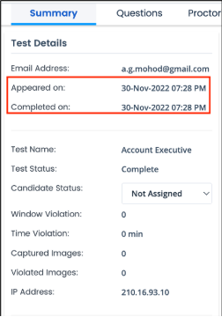

3.6.2. Test Details
The information about the candidate, such as the candidate's email address, timestamp of the test start time and test end time, name of the test, basic image proctoring details, and time violation details, are displayed here.
- Window Violation: When the candidate tries to leave the test window, the system raises a flag. The total number of window violations is displayed.
- Time violation: The time duration the candidate was outside the test window during an ongoing test is displayed.
- Captured Image: The system captures random images during the test within an interval of 10-40 seconds to detect any suspicious activity. The number of captured images is displayed.
- Violated Images: The number of images with suspicious activity is displayed.

3.6.3. Score Analysis
The proficiency level of the candidate according to the test scores is displayed here. The scoring categories can be customized in Report Settings.
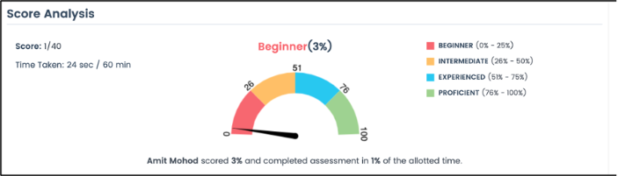
3.6.4. Section Score Analysis
The section-wise percentage scored by the candidate and the proficiency level based on the score is displayed.
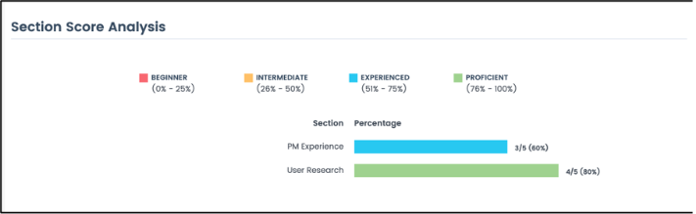

3.6.5. Benchmarking
iMocha's Benchmarking feature helps you understand the skill proficiency of the candidates with respect to the company average and the industry standards.
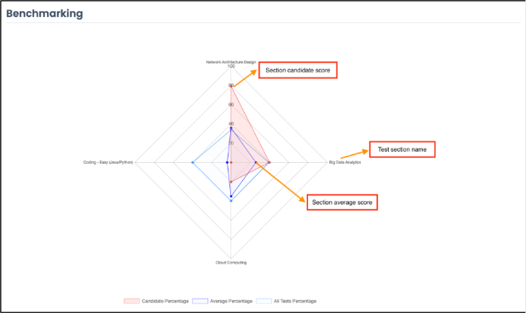
3.6.7 Section-Skill Analysis
The analysis of each section in the test is displayed. The total number of questions and the number of correct answers, wrong answers, and skipped questions are listed separately for each section.
The timestamp of the test is displayed. It has the test start time, test end time, the report generated time, and the captured IP address. This helps to know if the candidate took undue advantage of the time flexibility and did not finish the test within the allotted time.

3.7 Platform Accessibility

We are WCAG 2.1 Level AA Compliant. The Accessibility functionality is designed to enhance the usability of our Test platform for users with various disabilities. This widget ensures that everyone, regardless of their physical or cognitive abilities, can effectively interact with and navigate the platform. Below is an overview of the key features and how they can be beneficial:

Accessibility Functionality

- Motor Impaired: Optimizes the platform for users with limited motor skills. It may simplify navigation, increase clickable area sizes, and reduce the need for precise cursor movements.
- Blind: Provides support for screen readers and other assistive technologies. This profile ensures that all content is accessible through auditory means.
- Color Blind: Adjusts color schemes to make content distinguishable for users with color vision deficiencies. It prevents color-related confusion, ensuring all visual elements are clear.
- Low Vision: Enhances visibility by increasing text sizes, contrast, and overall readability, helping users with partial sight to navigate and interact with the platform more easily.
- Seizure & Epileptic: Reduces the risk of triggering seizures by eliminating flashing content, minimizing color contrasts, and adjusting animations.
- Dyslexia: Customizes text presentation to improve readability for users with dyslexia. This may include font adjustments and spacing changes to reduce cognitive load.
- Cognitive & Learning: Simplifies the interface and reduces clutter to assist users with cognitive or learning difficulties in understanding and navigating the platform.
- ADHD: Adapts the interface to reduce distractions, helping users with ADHD to focus better on the content.

iMocha enhances user experience with global accessibility and inclusive design, ensuring your product reaches a broader audience with:

- Global Accessibility: Interface available in over 35+ languages
- Enhanced Usability: Customizes UI for various accessibility needs
- Inclusive Design: Supports users with different disabilities
- Improved Readability: Enhances text clarity for visual and cognitive impairments
- Customization Options: Allows users to personalize their interface
- Compliance: Ensures adherence to accessibility standards and regulations

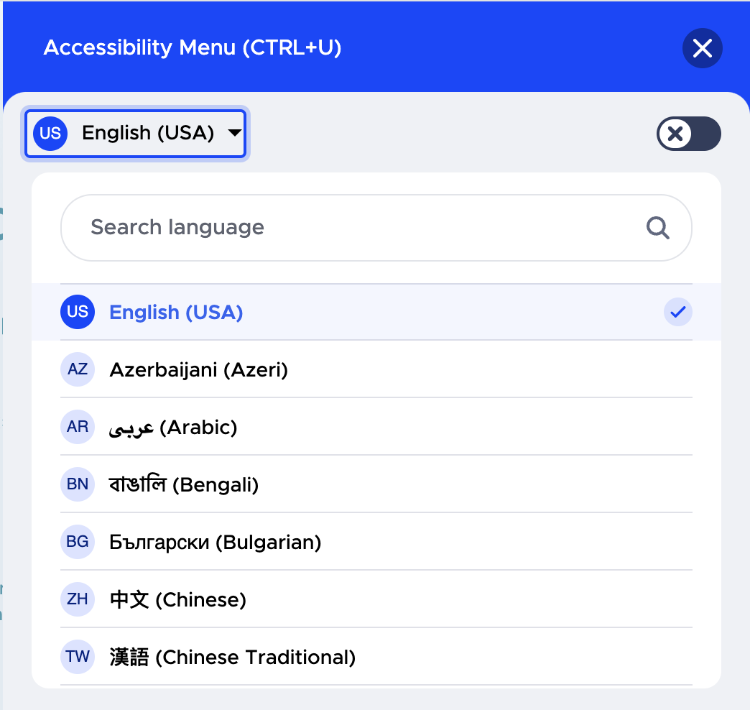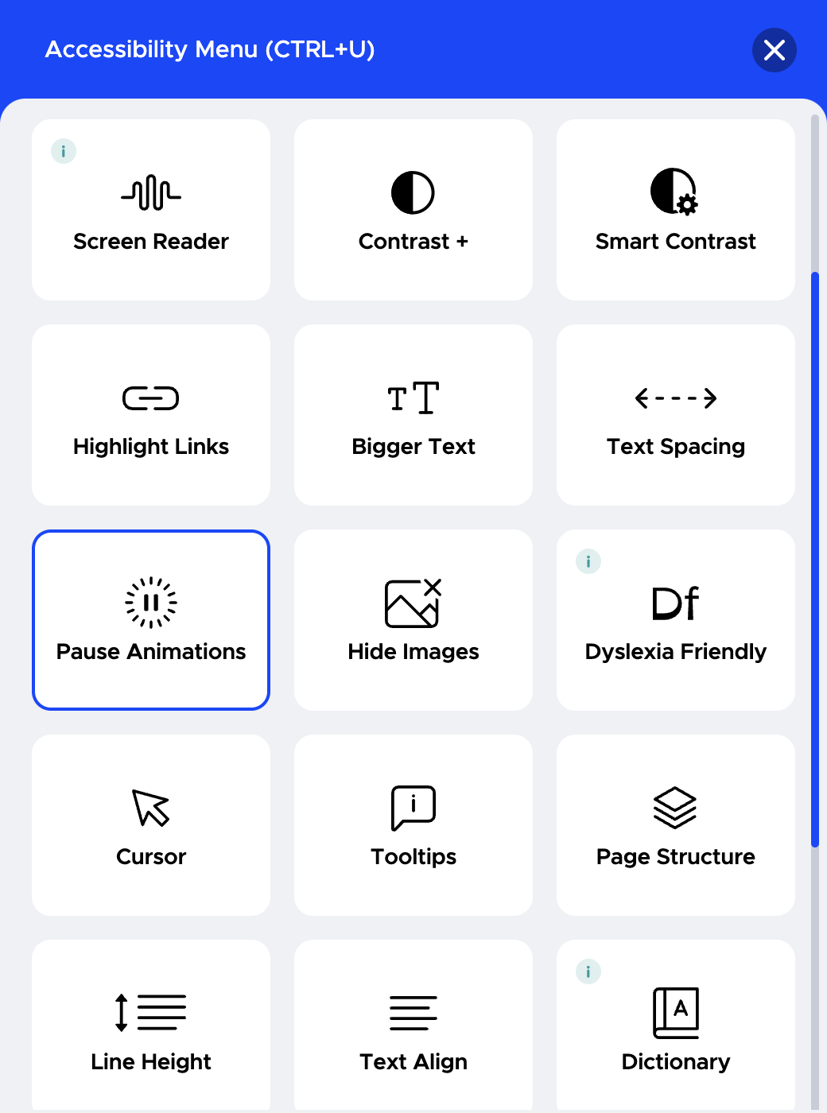
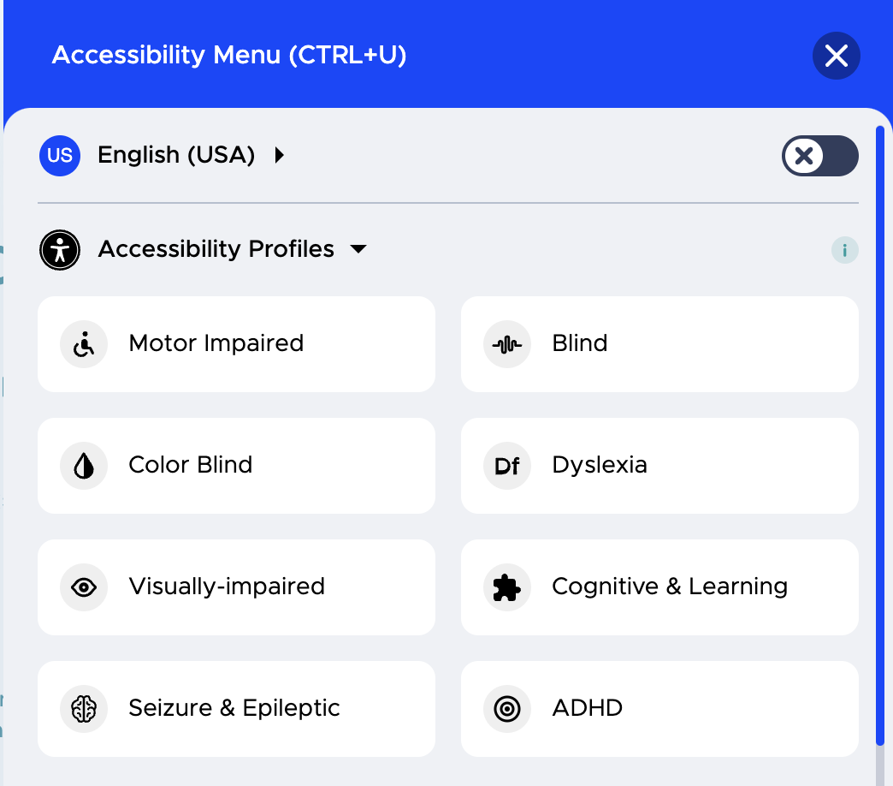

3.9 Regulatory Compliance & Data Protection
iMocha’s solution adheres to global and regional standards including:
- SOC 2 Type II & ISO/IEC 27001
- GDPR & CCPA with custom messaging support
- EEOC compliance with validation documentation
- Data Encryption at Rest (AES-256) & In Transit (TLS 1.2+)
- Data hosting strictly in U.S. (Azure)
3.10 Training, Onboarding

iMocha is fully equipped to brief and train CUSTOMER NAME Staff Members on how to effectively use our assessment platform. We offer comprehensive training and provide all necessary reference materials to ensure smooth adoption and usage of our off-the-shelf service.

Training Sessions:
- Training session: iMocha dedicated customer success manager offers training sessions designed to meet the specific needs of CUSTOMER NAME Staff Members. These sessions can be conducted virtually and will cover all aspects of using the platform, from setting up assessments to analyzing results.
- Hands-On Guidance: Our training includes practical, step-by-step instructions on using the platform’s features, ensuring that staff are comfortable and confident with the tools at their disposal.

Reference Documentation:
- Comprehensive Help Guides: iMocha provides help link https://help.imocha.io/ and data sheets that cover all aspects of the platform’s functionalities. These resources will help CUSTOMER NAME Staff Members navigate the platform independently after the initial training.
- Several Videos will be shared for training purpose to several stakeholders

Please find attached the Implementation Process document.
- Live, recorded, and portal-based training
- Training for all user types: recruiters, admins, hiring managers
- Change management and upgrade notifications aligned with CUSTOMER NAME expectations

3.11 Content creation process and customization
At iMocha, we ffer an all-services inclusive skill consulting framework that is divided into two phases:
Proactive (pre-assessment):
Deals with creating new skills, customization of existing skills, and use-case based job role test creation, competency mapping, skill mapping, and other L&D initiatives.
Reactive (post-assessment):
Deals with test analytics, hiring reports, customization based on candidate feedback, and a summary report.
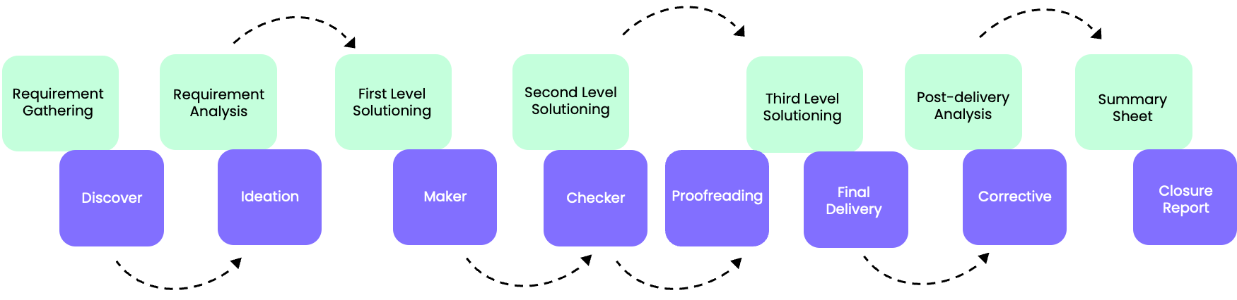
Our custom assessment creation process is backed by a community of over 1200+ Subject Matter Experts (SMEs) and follows a rigorous Maker-Checker model to ensure quality and accuracy. It adheres to EEOC-compliant quality guidelines and incorporates talent benchmarking to align assessments with industry standards. With skills updated every six months, a robust quality calibration process, and in-depth skill gap analysis, iMocha ensures that each assessment remains relevant, validated, and impactful for business needs.

3.12 Technical and Customer Support

iMocha is fully equipped to provide comprehensive 24/7 support via online (chat) and email, phone and a specialized tool to manage and track support tasks effectively. Our support team is well-trained to handle requests across all time zones, ensuring continuous coverage. Additionally, our support tool includes multiple notification channels, keeping our team updated on ticket statuses and enabling swift responses. With these resources, we ensure streamlined, reliable support and proactive communication with our clients.

- 24/7 Global Support Availability:
iMocha offers round-the-clock support to users worldwide through multiple channels—online chat, email, and phone. With clients from 180+ countries across USA, LATAM, EMEA and APAC, iMocha’s support team can handle requests from different time zones, ensuring seamless support for all users, regardless of location.

- Multichannel Support Options:
iMocha’s support team is accessible through multiple communication channels:
- Online Chat: iMocha application platform users can reach out via iMocha's online application chatbot feature for instant assistance.
- Phone Support: Phone support line is available for users who prefer direct, real-time communication.
- Email Support: For inquiries or detailed troubleshooting requests, users can reach out via email, where they can expect timely responses.
Each of these options ensures flexibility for users to choose the most convenient method for resolving their issues.
- Skilled Technical and Customer Support Team:
iMocha’s support team consists of highly trained professionals who are proficient in resolving both technical and user-related queries. These specialists are well-versed in troubleshooting issues related to:
- Assessment delivery and access: Resolving challenges with login, assessment start times, or assessment interruptions.
- Platform navigation: Assisting users in navigating iMocha’s assessment tools and features.
- Technical bugs: Identifying and resolving technical issues on the platform in real time.
For support, we provide assistance in English over calls, while our ticketing system uses translators for other languages to understand issues and respond accurately in the user’s language, ensuring clear and effective communication.

Additionally, our support tool includes multiple notification channels, keeping our team updated on ticket statuses and enabling swift responses. With these resources, we ensure streamlined, reliable support and proactive communication with our clients.

3.13 Platform accessibility and mobile compatibility

iMocha’s online assessment solution is robust, adaptable, and designed to function effectively even in low bandwidth or limited connectivity environments.
The test can be accessed through mobile web browser as well. However, iMocha does not have mobile application in place.

The minimum recommended hardware, software and network specification for the candidate’s machine for a smooth experience of the test is: https://help.imocha.io/imocha-assessment-platform-guidelines

iMocha’s platform is designed to deliver assessments that are fully responsive and compatible with mobile devices, allowing candidates to complete tests directly on their smartphones/tablets/iPad.
The test platform is compatible with both iOS and Android operating systems, offering a smooth and consistent user experience across different devices.

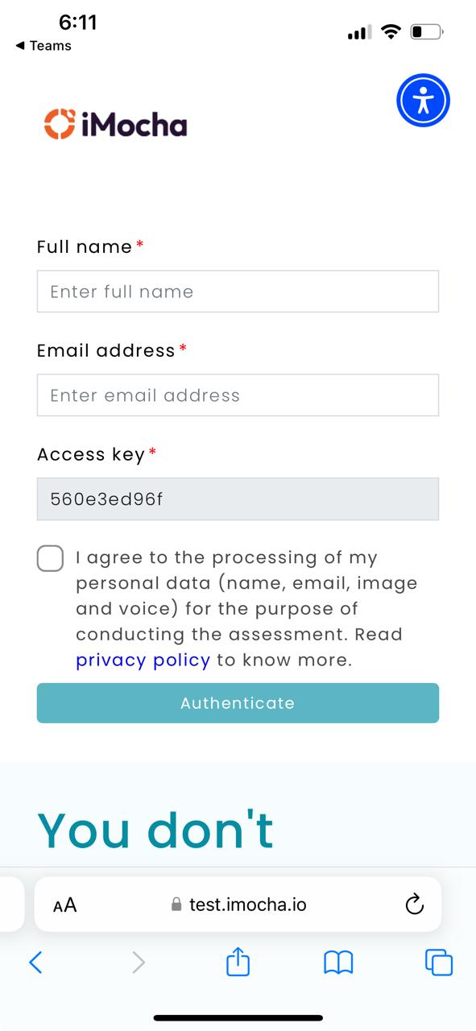

3.14 Architecture diagram

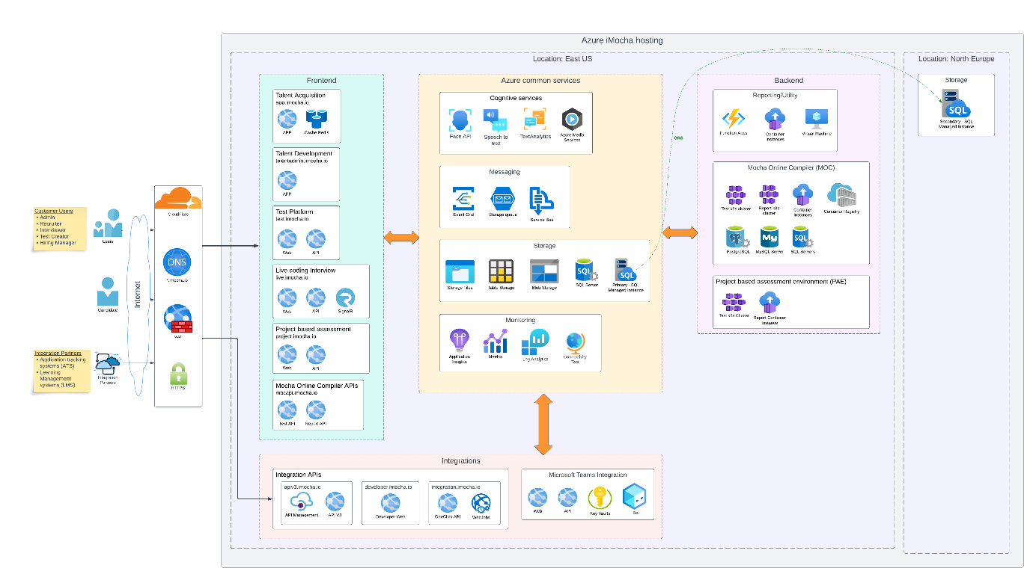

Security Architecture
- iMocha uses CloudFlare as a web application firewall (WAF). CloudFlare implements OWASP ModSecurity Core Rule Set(CRS). The CRS provides protection against many common attack categories, including DDoS, brute force, SQL Injection, Cross Site Scripting, Local File Inclusion.
- CloudFlare also used as a DNS server
- Website access HTTPS only; HTTP requests are redirected to HTTPS. Only allow HTTPS connections that support the TLS protocol version 1.2 or newer.
- Data is encrypted at Rest using Service-managed transparent data encryption from Microsoft Azure. We support OAuth2.0 standard, including OIDC and SAML-based Azure Active Directory Single Sign-On (SSO).
- Candidate facing websites are secured using Google reCAPTCHA v3.
- All Security aspects are tested as part of our Annual VAPT done by External vendors.

Deployment Architecture
- iMocha hosts multi-tenant applications. All the workloads are deployed in the Azure cloud.
- Application deployed as multi-instance for high availability. We provide 99.9% uptime.
- Azure SQL Server managed instance and Azure storage tables used for OLTP. Elastic cloud used for OLAP.
- SQL server deployed with Active geo-replication. The primary data center is in Virginia, USA and the secondary server location with real-time backup in Ireland, North Europe
- Global scalability: Whether the exam is for a small group or thousands of candidates worldwide (5000 assessment per min), iMocha’s system can handle large volumes of test-takers simultaneously, without performance degradation
- SendGrid is used for email communication.

3.15 Reliability, Validity and EEOC

iMocha places a strong emphasis on ensuring that the language used in all assessments is free of bias and promotes inclusivity.

Reliability: Our assessments are crafted by Subject Matter Experts (SMEs) who are industry leaders with extensive experience. Our SMEs ensure that the questions are consistently high-quality, relevant, and up-to-date with industry standards. This expertise guarantees a reliable measure of the competencies and skills being assessed.

Validity: Validity in our context is ensured through the practical and applied expertise of our SMEs, who design assessments to accurately reflect the skills and knowledge pertinent to specific job roles and industries. We maintain a strong foundation of validity through rigorous SME review and alignment with industry requirements.

Fairness: At iMocha, fairness is a top priority. We ensure that our assessments are unbiased and equitable for all candidates. Our question library undergoes regular scrutiny to eliminate any potential bias and to ensure inclusiveness. We adhere to best practices in assessment design to provide a fair evaluation environment for all test-takers.

Scalability: Our platform is designed to handle large volumes of assessments seamlessly, ensuring scalability for organizations of all sizes. Whether you need to assess a small team or thousands of candidates, our robust infrastructure supports efficient, scalable solutions without compromising performance or user experience. Additionally, our assessments can be administered across geographies, and our platform supports multiple languages, enabling you to assess a diverse, global workforce effectively.

EEOC Compliance: iMocha assessments are EEOC compliant, ensuring that our testing practices adhere to the guidelines set forth by the Equal Employment Opportunity Commission. This compliance underscores our commitment to fairness and equity, guaranteeing that our assessments are legally defensible and non-discriminatory.

Please find attached the EEOC compliance datasheet.

Integration with <HRMS, LMS, LXP

Hosting and Security

iMocha delivers its enterprise-grade assessment solution through a secure, scalable, and compliant cloud architecture, with a strong focus on data protection, availability, and operational resilience. Below are the details of our hosting and security capabilities:

5.1 Hosting Infrastructure
- Cloud Platform: iMocha is hosted on Microsoft Azure, leveraging Azure’s native security, scalability, and compliance capabilities.
- Hosting Region: All production infrastructure and data related to U.S. clients, including Customer Name (CUSTOMER NAME), is hosted exclusively within the continental United States to comply with data residency requirements.
- Architecture: Built on a microservices-based architecture, the platform supports dynamic scaling and high availability through containerized services and load balancing.

5.2 Data Encryption and Protection
- Encryption at Rest: Data is encrypted at Rest using Service-managed transparent data encryption from Microsoft Azure.
- Encryption in Transit: All communication and data transfer are secured using TLS 1.2 or higher protocols.
- Key Management: Keys are securely managed within Azure Key Vault

5.3 Availability, Business Continuity, and Disaster Recovery
- Availability SLA: iMocha offers a guaranteed uptime of 99.9%, supported by automated failover and high-availability configurations.
- Disaster Recovery (DR) Plan:
  - Recovery Time Objective (RTO): ≤ 1 hour
  - Recovery Point Objective (RPO): ≤ 5 minutes
  - Full system backups are performed daily, with incremental backups taken throughout the day.
- Business Continuity Plan (BCP): iMocha maintains a documented and annually tested BCP aligned with best practices. Plan testing reports can be shared upon request.

5.4 Security Controls & Intrusion Prevention
- Access Management:
  - Role-Based Access Controls (RBAC) for fine-grained user permissions
  - Support for Single Sign-On (SSO) using SAML 2.0
  - Multi-Factor Authentication (MFA) for administrative access
- Network Protection:
  - Intrusion Prevention Systems (IPS) are implemented via Cloudflare, protecting against DDoS, bot attacks, and intrusion attempts.
  - Continuous monitoring and alerting for abnormal behaviors or unauthorized access.

5.5 PII and Data Privacy
- PII Storage Minimization: iMocha adheres to the principle of data minimization. Only essential PII data (e.g., name, email ID) is collected and stored for candidate identification and communication.
- Data Retention & Deletion:
  - Supports custom retention policies as per client request.
  - Offers automated data purge utilities configurable by time or event triggers.
- Compliance: The platform is compliant with GDPR, CCPA, and other relevant U.S. data privacy regulations.

Project Approach and Implementation plan
iMocha adopts a structured, collaborative, and agile-based implementation methodology to ensure rapid deployment, seamless integration, and high adoption across stakeholder groups. The project approach is specifically designed to align with Customer Name’s operational requirements, compliance standards, and talent evaluation goals.

8.1 Onboarding and Implementation Timeline
A typical implementation for large enterprises like CUSTOMER NAME is completed within 5–6 weeks, with provisions to accelerate or adapt based on priority hiring cycles. The phases include:

Phase 1: Discovery & Planning (Week 1)
- Kick-off meeting with stakeholders
- Requirement gathering: job roles, assessment types, integration needs
- Implementation plan sign-off

Phase 2: Configuration & Content Mapping (Weeks 2–3)
- Platform configuration: branding, roles, permissions
- Assessment mapping to CUSTOMER NAME job families
- Custom assessment design (if required)

Phase 3: Go-Live (Weeks 4–5)
- Production rollout
- Real-time support for candidate onboarding
- Initial batch of assessments assigned

Phase 4: Post-Go-Live Support (Week 6 onward)
- Performance monitoring
- Continuous improvement planning
- Feedback incorporation and reporting review

8.2 Training and Onboarding
A structured enablement plan is provided for all user roles:
- Recruiters & Talent Acquisition Teams:
  - Assessment creation and assignment
  - Report interpretation and candidate communication
- Hiring Managers:
  - Dashboard navigation
  - Assessment outcome-based decisioning
- Admins:
  - User role management
  - Reporting, analytics, and system settings
Training is delivered via:
- Live Microsoft Teams sessions
- Recorded walkthroughs and documentation
- Ongoing refresher sessions (optional)

Security & Compliance
iMocha is an Enterprise-ready platform with proven commitment towards Security and Compliance.
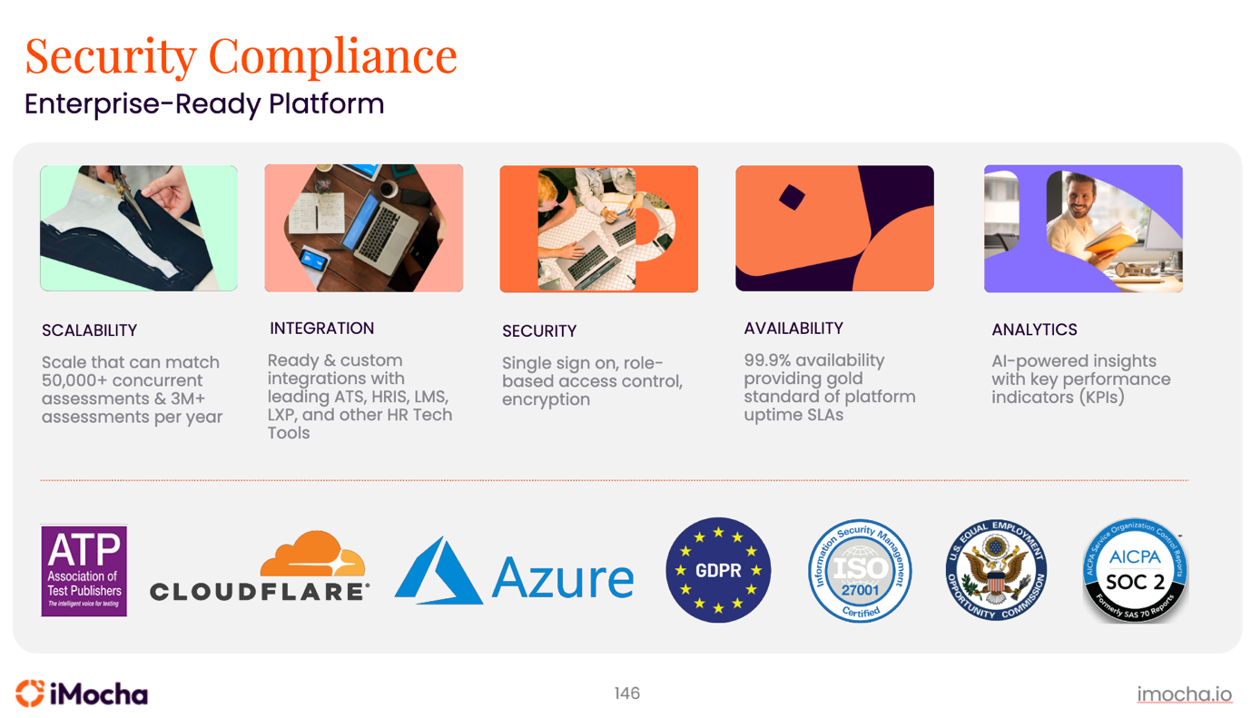
iMocha employs a comprehensive and multi-layered security and compliance framework that aligns with international standards, ensures data integrity and confidentiality, and supports enterprise-grade regulatory compliance.
Industry Certifications and Compliance Standards
- ISO/IEC 27001:2022 Certified
Ensures rigorous implementation of an Information Security Management System (ISMS) for managing company and customer information securely.
- SOC 2 Type II Compliant
Demonstrates operational effectiveness of internal controls related to security, availability, processing integrity, confidentiality, and privacy.
- GDPR Compliant
iMocha adheres to the principles of the General Data Protection Regulation (GDPR)
Data Encryption
- Data is encrypted in Transit using TLS min version 1.2.
- Data is encrypted at Rest using Service-managed transparent data encryption from Microsoft Azure.
Data Isolation & Integrity
Multi-tenant architecture with strict isolation ensures customer data integrity and privacy across clients.
Role Based Access Control
iMocha implements granular RBAC to enforce the principle of least privilege across all roles. Access is customizable based on organizational hierarchy.

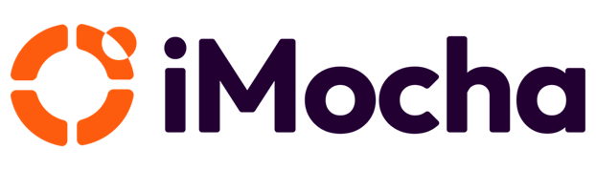

Brewing A Skills-First Planet
Call us +﻿1-408-915-5185 or write to us at ros@imocha.io
About iMocha

iMocha is an AI-powered Skills-First Cloud that helps enterprises to build a Skills-First and data-driven ecosystem of hiring, upskilling, and managing talent - at scale, for any job role, and any industry. More than 500 organizations are using iMocha's solution for taking a Skills-First approach to accelerated hiring, objective learning and development programs and to manage talent from candidate to alumni. Enterprises from Telecom, Banking, Financial Services, Insurance and Technology are using iMocha's Skills-First platform to make data driven talent decisions. The platform leverages patented technologies and includes innovative features to build employee skills profile, organizational skills inventory, skills taxonomy and skills ontology, skill benchmarking and skills analytics that helps to hire, develop and manage talent by taking a Skills-First approach.

To know more, visit us at www.imocha.io.

