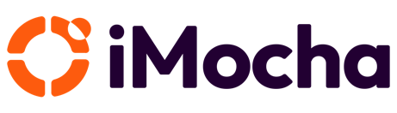


Business Proposal for

Customer (CUSTOMER)
<RFP Name>.

Prepared For:
CUSTOMER Team

Prepared By:
Sales person
iMocha
@imocha.io

The software and database described in this document are furnished under a license agreement or a non-disclosure agreement. The software and database may be used or copied only in accordance with the terms and conditions of the agreement.

This document includes technical know-how that is not commonly known (confidential information). The user of this document warrants that such technical know-how shall only be used to fulfil the purpose for which iMocha presented this document to the user, for example user reference or evaluation of the software. Furthermore, the user warrants that such technical know-how will not be revealed to any third party.

The software and database described in this document are furnished under a license agreement or a non-disclosure agreement. The software and database may be used or copied only in accordance with the terms and conditions of the agreement.

Copyright © 2026 iMocha

Document Revision Information

Version | Date | Amendment | Author
1.0 |  | First version

Cover Page 4
1. iMocha Overview 5
1.1 About iMocha 5
1.2 Proud Recognition 5
1.3 Key Customers 6
1.4 Strategic Partnerships 7
2. Understanding of CUSTOMER Objectives 8
3. Scope of Work & Requirement of CUSTOMER 9
4. Proposed Solution & approach 11
4.1. Competency Framework & Management 11
4.2. Assessments & Validation 16
4.3. Skill Gaps, Development & Learning Alignment 19
4.4. Workforce Analytics & Reporting 23
4.5. Talent Lifecycle Enablement 27
4.6. Security, Access & Integration 34
4.7. Brand & User Experience 35
5. Project plan 37
6. Value proposition 39
7. Enterprise readiness 40
8. Support & Engagement Model 42
9. Customer References 43

Cover Page
To:
CUSTOMER Team
From:
iMocha Inc.
2093 Philadelphia Pike #1395, Claymont, Delaware 19703, USA
Subject: Proposal Submission –<Mention subject for cover page>
Dear <Customer name>,
<Cover page details>
Sincerely,
Sales person

iMocha Overview

1.1 About iMocha
Founded in 2015, iMocha is an industry-leading AI-powered skills intelligence platform. We help global BFSI enterprises, government organizations, and NGOs make smarter workforce decisions by providing end-to-end solution for talent and hiring external candidates.
- Global presence: Operating in 120+ countries, serving 300+ Enterprise customers worldwide.
- Enterprise-ready platform: Trusted by BCBS, ABSA Bank, Vanguard, CGI, United Nations, EY, PwC and likes.
- 10,000+ skills library with over 3 Mn+ skills assessments covering technical, cognitive, behavioural, and language skills.
- Recognized by Gartner, Forrester, and IDC as a leader in AI-driven hiring solutions.
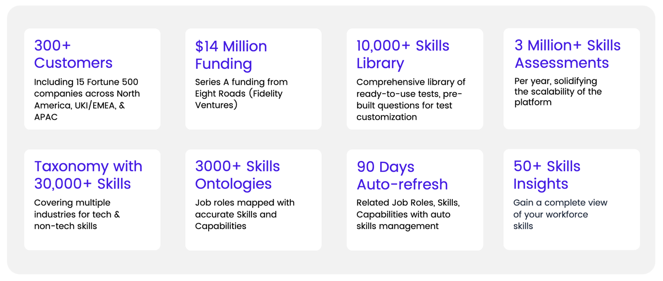

1.2 Proud Recognition
In a Conference on Digital Acceleration and the Role of Startups, Satya Nadella, Microsoft’s CEO, praised iMocha’s skilling API. He mentioned how our innovation helps reduce time-to-hire and makes the lives of recruiting professionals easier. Nadella, in the same discussion, went on to talk about how adapting to 'digital' during these times is vital to business continuity and makes organizations resilient to tail events (such as the one we're living in).

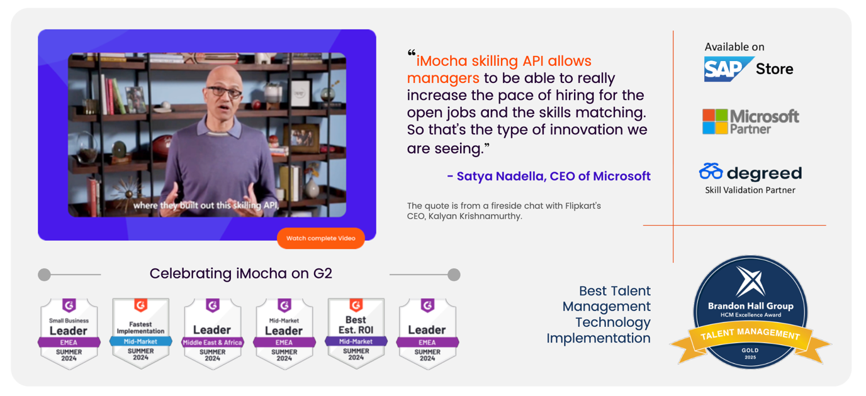
Read more>>
Recently, iMocha has also won Gold at the Brandon Hall Group HCM Excellence Awards 2025. This award recognizes iMocha’s transformational work in helping enterprise clients shift from traditional role-based models to a skills-first talent strategy, powered by iMocha’s Skills Intelligence Cloud™. The implementation demonstrated measurable improvements in hiring accuracy, internal mobility, learning agility, and workforce transformation efficiency.
Read more >>

1.3 Key Customers
Our customers globally include BCBS, Vanguard, ABSA Bank, BIBF, Capgemini, Deloitte, EY, L'Oréal, TCS, Public Group, Cognizant, PayPal, Ericsson, Aston Martin, Vanguard, 7-Eleven, Telstra, Daimler Trucks, ABSA SA, Avaya, Hexaware and 9 different United Nations Agencies.
300+ Enterprise customers across 3 continents (NA, UKI/EMEA and India/APAC) with 30 of the Fortune 500 companies use iMocha to deliver on their pre-employment assessment strategy.
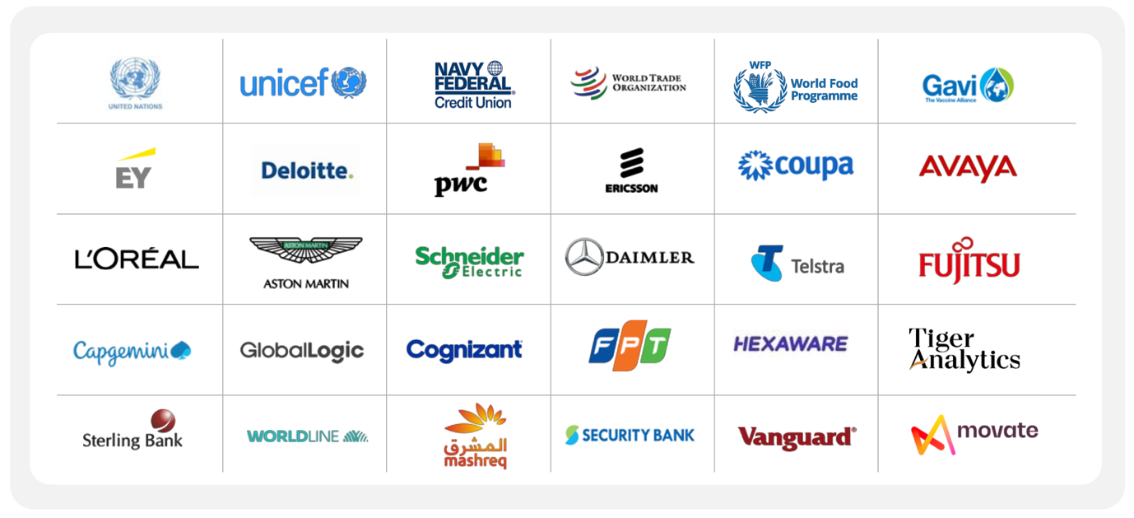

1.4 Strategic Partnerships
iMocha is an SAP Strategic partner with bi-directional integration with SAP SuccessFactors and SAP Fieldglass. PwC in UKI and EMEA offers iMocha "Skills-First" solution to its customers under a strategic and exclusive joint business relationship. Other strategic technology and GSI partners include –Degreed and Revature.



Understanding of CUSTOMER Objectives
Strategic Objectives
- <Write strategic objective of customer>

What CUSTOMER is looking for?
<Mention the details for what customer is looking for>

Scope of Work & Requirement of CUSTOMER
CUSTOMER requires a modern, scalable Skills & Competency Management System that details as follows:
<Instuction: Write the details scope of work and requirement from customer; do not assume anything>

Proposed Solution & approach
At Customer, talent management is a strategic priority- ensuring the right people are in the right roles, continuously developing their skills, and preparing them for future opportunities. iMocha’s platform directly supports this vision by aligning workforce capability with CUSTOMER’s Give, Grow, and Transform strategy.

<Instruction: Pick only those modules from below which are applicable to the customer requirements>

4.1. Competency Framework & Management
4.1.1 Define, create, and manage an organizational library of skills & competencies

With iMocha system, CUSTOMER can implement the right job architecture for with AI-generated skills taxonomy & ontology based on industry standards such as O*NET, Singapore Skills Framework and also custom frameworks of CUSTOMER.
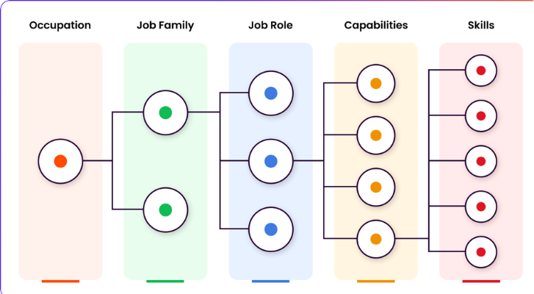

Skill taxonomies categorize capabilities into hierarchical groups, helping employers and employees understand and develop necessary skills. Skill ontology defines and measures relationships between skills at the organizational level, aiding in role definition and skill proficiency insights. Together, they provide a systematic approach to skill classification, talent development, and workforce management.
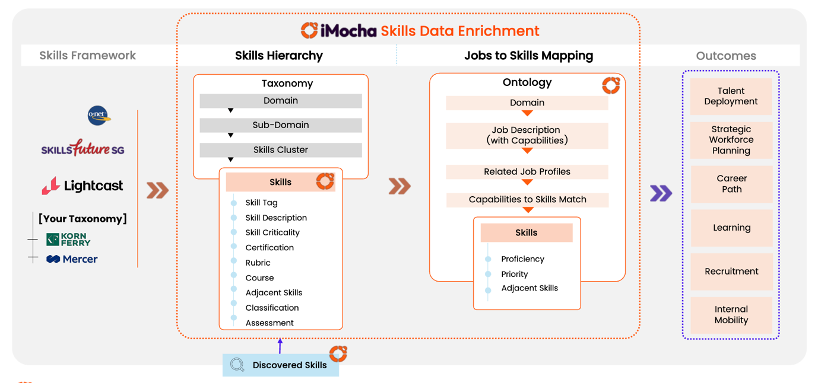
iMocha platform performs and suggests refurbishment on the taxonomy at regular intervals to ensure updation of taxonomy based on the industry changes. These suggestions also comes from Adjacent skills for the skills for each job profile. Also, iMocha also provides discovered skills that generates through AI Inferences from Learning Data, Performance Data, Certifications & Resume.
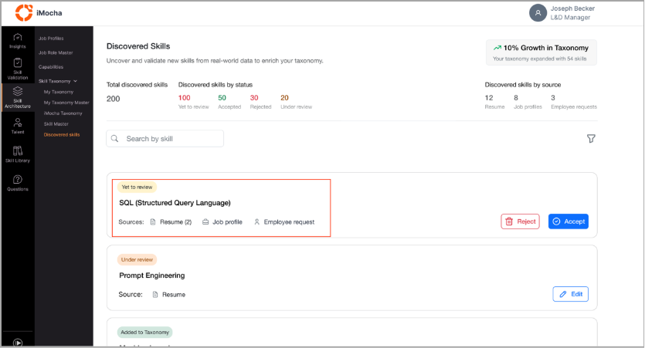

Key Highlights
- Accurate Skills Taxonomy: Helps L&D Managers and HR professionals maintain a precise, up-to-date skills taxonomy.
- Automatic Skill Identification: As employees add new skills (via resumes, job profiles, projects, or self-reports), the system automatically detects them.
- Manager Review & Control: Newly identified skills are not added directly; instead, they are listed for review, enabling managers to accept, reject, or further evaluate.
- Quality & Structure: Ensures skill accuracy, removes redundancies, and maintains a clean, structured skills framework aligned with organizational goals.
- Enhanced Visibility: Provides L&D Managers with greater control and visibility over skill updates.
- Future-Ready Database: Keeps the skills database accurate, current, and aligned with evolving workforce capabilities.

4.1.2 Establish proficiency scales (beginner → advanced) for clear skill measurement.

iMocha helps Customer (CUSTOMER) define clear proficiency levels for every skill, from beginner to expert. These proficiency levels can be customized based on CUSTOMER’s preference like 1-3, 1-4, 1-5, 1-10, etc. This uniform framework ensures fairness and transparency in evaluations, enabling CUSTOMER to measure capabilities, identify skill gaps, track progress, and align workforce strengths with business and member goals.
A structured skills taxonomy strengthens talent mobility, workforce planning, and organizational alignment, ensuring coordinated skill growth and deployment across all functions.
(Below is a consolidated image showcasing how L&D Managers and HR professionals view established proficiencies for each skill within iMocha’s taxonomy.)
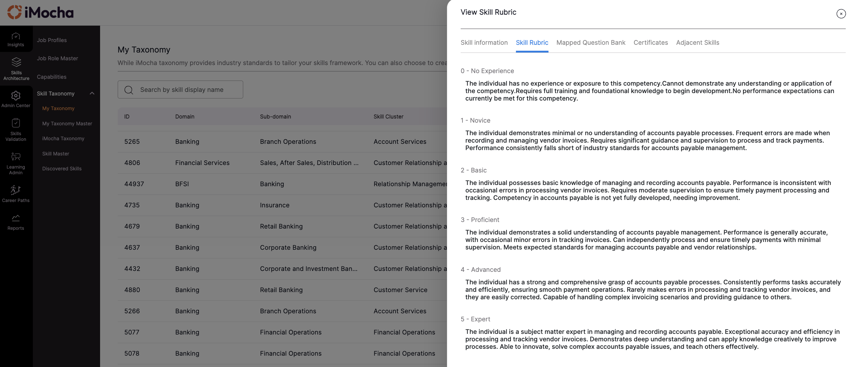
By standardizing skill definitions across the organization, CUSTOMER eliminates inconsistencies in how functions interpret skills. This consistency simplifies role-readiness assessments and allows employees—whether in capital markets, marketing, or HR—to upskill and transition using the same criteria.

4.1.3 Map competencies to job roles and levels

By linking each role at Customer to a defined set of skills and proficiency levels, iMocha provides a single source of truth for workforce capabilities. This clarity enables HR and business leaders to identify skill gaps, forecast future talent needs, and make data-driven staffing decisions. With role-to-skill mapping, CUSTOMER can align workforce planning directly to business growth and member service priorities.

Below screenshot refers to how mapped competencies within a specific job profile (Sr. Credit Risk Associate) can be mapped to skills from taxonomy based on the job description.
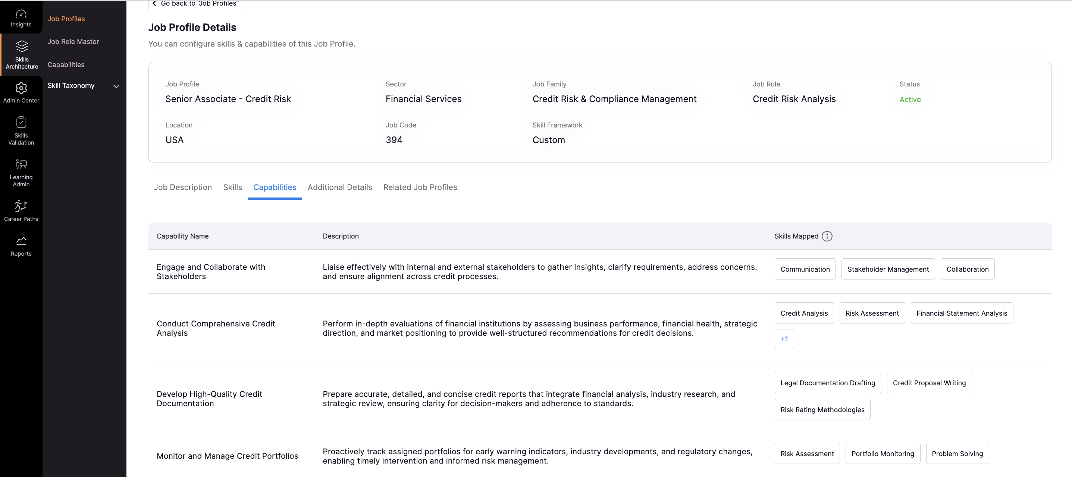
Below screenshot refers to how mapped skills to a job profile (Sr. Credit Risk Associate) can be viewed by HR Professionals.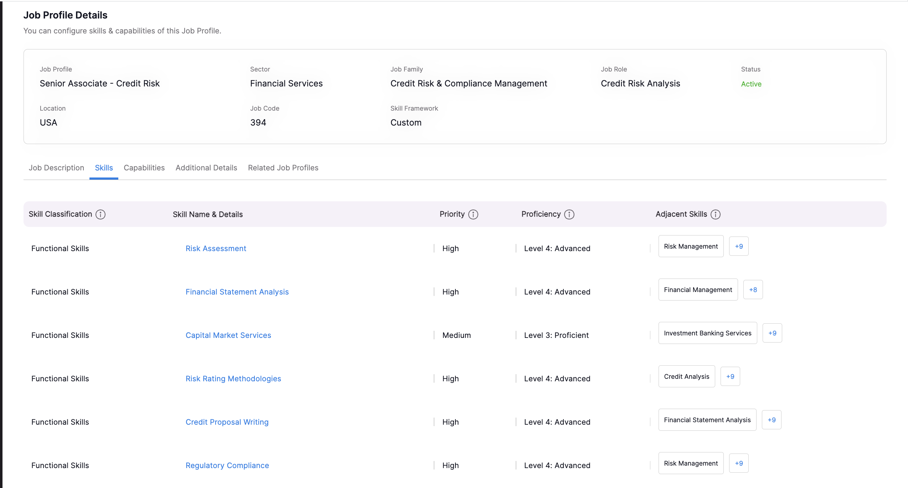

4.1.4 Support for industry benchmarking and customization of frameworks.

iMocha enables Customer to leverage industry-standard competency frameworks like O*NET, Singapore Skills Framework, Jadarat and likes built for BFSI, while also allowing full customization to CUSTOMER’s unique roles and culture. Benchmarking against external standards ensures competitive alignment in skills and pay practices, while customization empowers CUSTOMER to define competencies, behaviors, and role expectations that reflect its member-first values and business priorities.

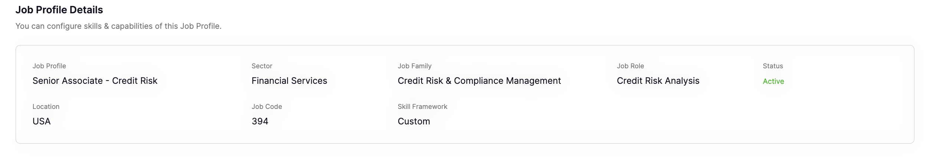

4.2. Assessments & Validation
4.2.1 Multi-channel validation:
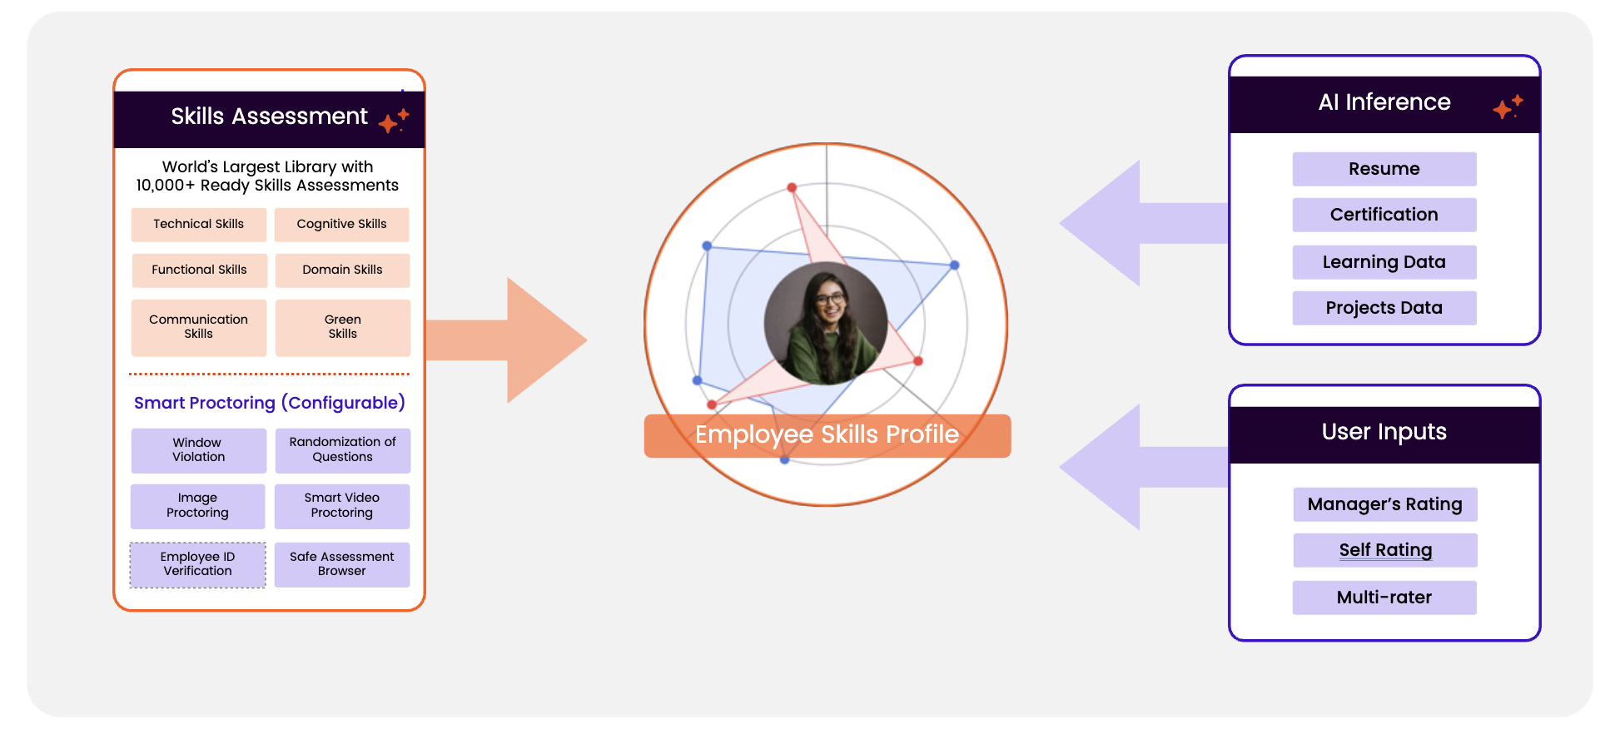
iMocha’s Skills Intelligence Platform offers robust multi-channel skill validation, combining human judgment with AI-driven analysis to ensure accurate, unbiased skill profiles. Validation sources include:
- Self-Validation: Employees rate their own proficiency using defined rubrics within their Skill Profiles.
- Manager Validation: Managers assess and confirm employee skills based on role performance.
- Multi-Rater Feedback: 360-degree feedback from peers, mentor, project leads and stakeholders
- Assessment-Based Validation: Objective skill validation through 10,000+ AI-powered assessments across technical, functional, and cognitive domains.
- AI Inference: Skills are inferred from resumes, certifications, project data, with up to 95% accuracy.
Each channel contributes to a weighted average proficiency score, configurable by the organization.
HR Professionals and L&D Managers can also define weightages to each channel of validation to have holistic evaluation of an employee for a respective skill.
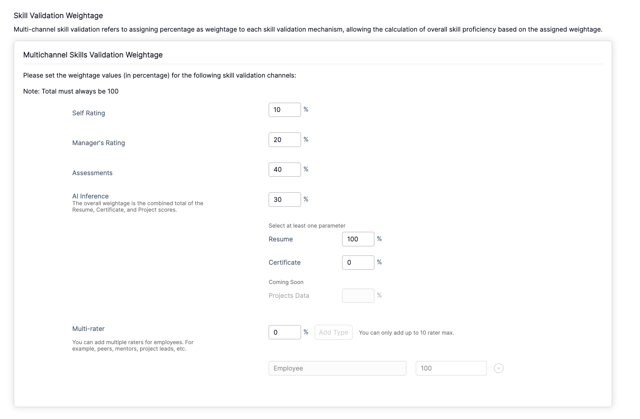
4.2.2 Automated assessment workflows with scheduling, notifications, and reminders.
iMocha enables HR professionals to streamline the assessment process for assigning the Assessments to employees enrolled to a specific job role. Assessments can be shared with built-in notifications and reminders, ensuring timely participation without administrative overhead. This automation not only reduces manual effort but also drives higher completion rates, consistency, and reliability in capturing skills data.
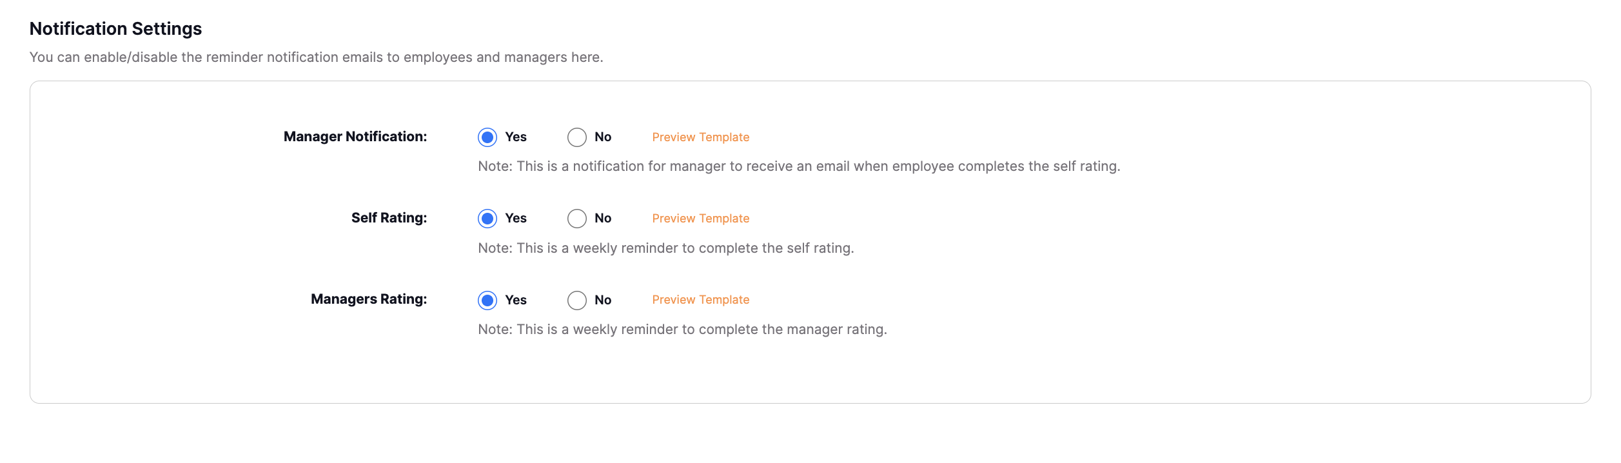
Also, for Assessments as a channel of validation, HR Professionals and Admins can auto set custom follow-ups based on preferred slots and follow-up window as shown in the below snippet:
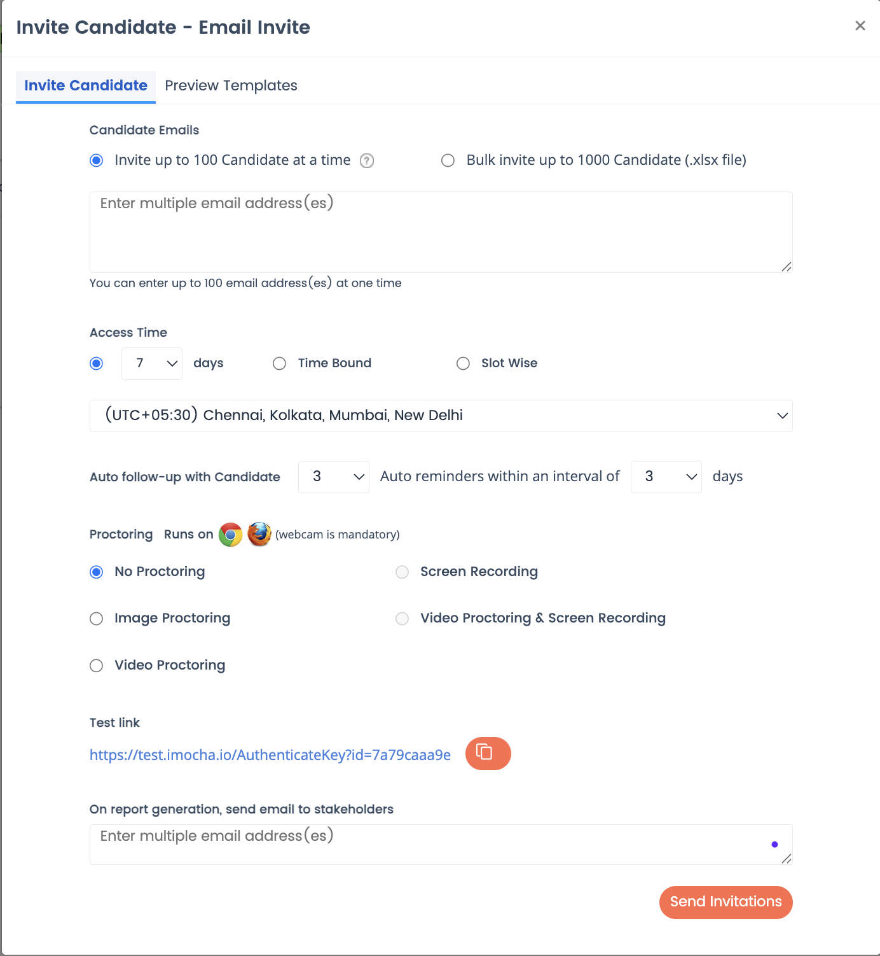
4.2.3 Evidence collection and validation to support competency verification.
iMocha enables Customer to systematically collect and validate evidence that supports skill verification. Employees can upload certifications, resumes, and learning records directly into the Employee Portal, where the platform’s AI can infer and update associated skills. Unlike employees, line managers can also have view of the skills updates of their repartee's in a systematic manner on real time basis as showcased in the sample snippet below:
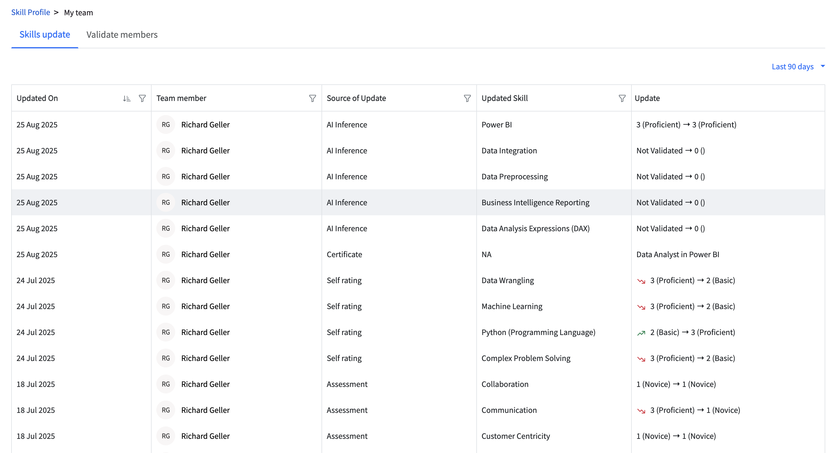
This ensures that every competency recorded is backed by credible evidence, creating a transparent and auditable framework that supports compliance, equitable development, and workforce planning.

4.3. Skill Gaps, Development & Learning Alignment
4.3.1 Gap analysis to identify discrepancies between required vs. actual competencies.
iMocha enables Customer to conduct precise gap analysis by comparing the skills required(flags in the below image) for each role with the actual validated skills of employees(blue bar in the below image). 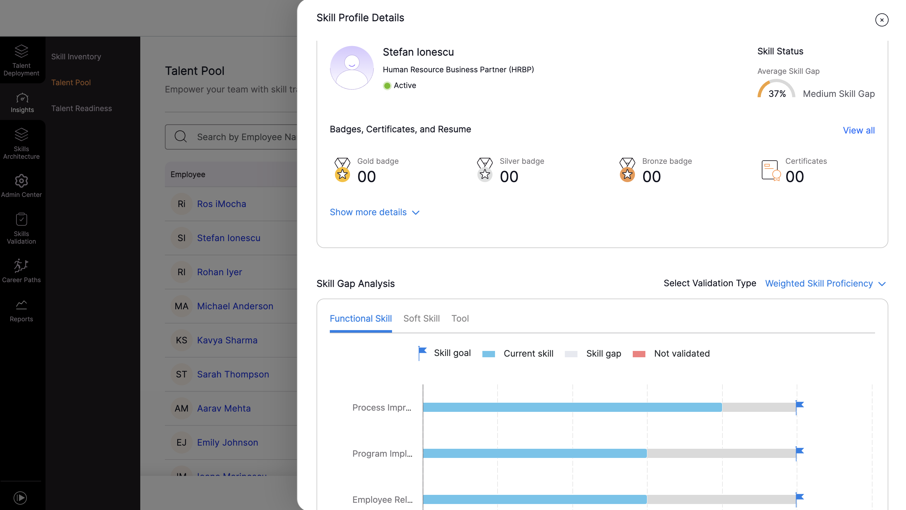
These insights allow HR and managers to prioritize upskilling, design targeted learning interventions and prepare employees for future opportunities. The platform highlights discrepancies at individual, team, and organizational levels, making it easy to pinpoint where development is needed most.
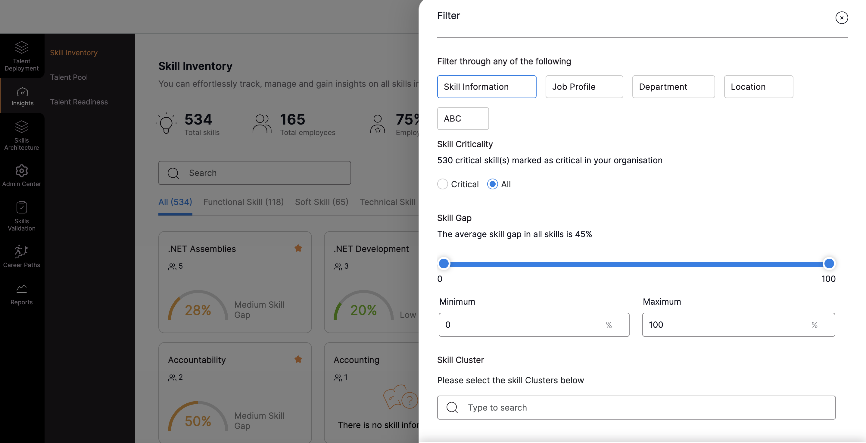
4.3.2 Personalized development plans based on assessments and career goals.
iMocha enables Customer to create individualized development plans for every employee, directly linked to their assessment results and skills-based career paths generated from multi-channel validation. The platform identifies skill gaps against defined role requirements and can give insights through skills-gaps data for learning recommendations from the learning content provider.
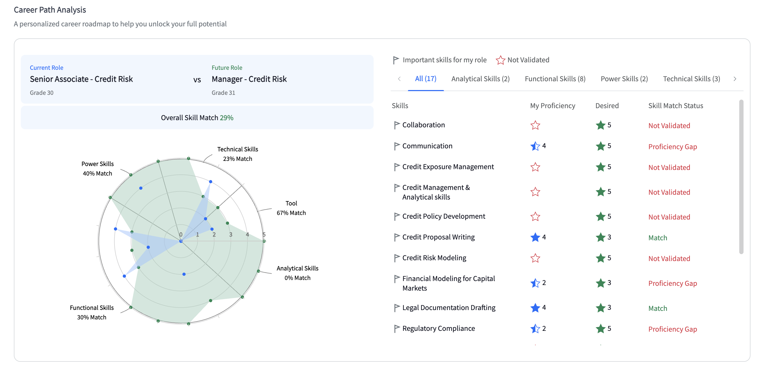
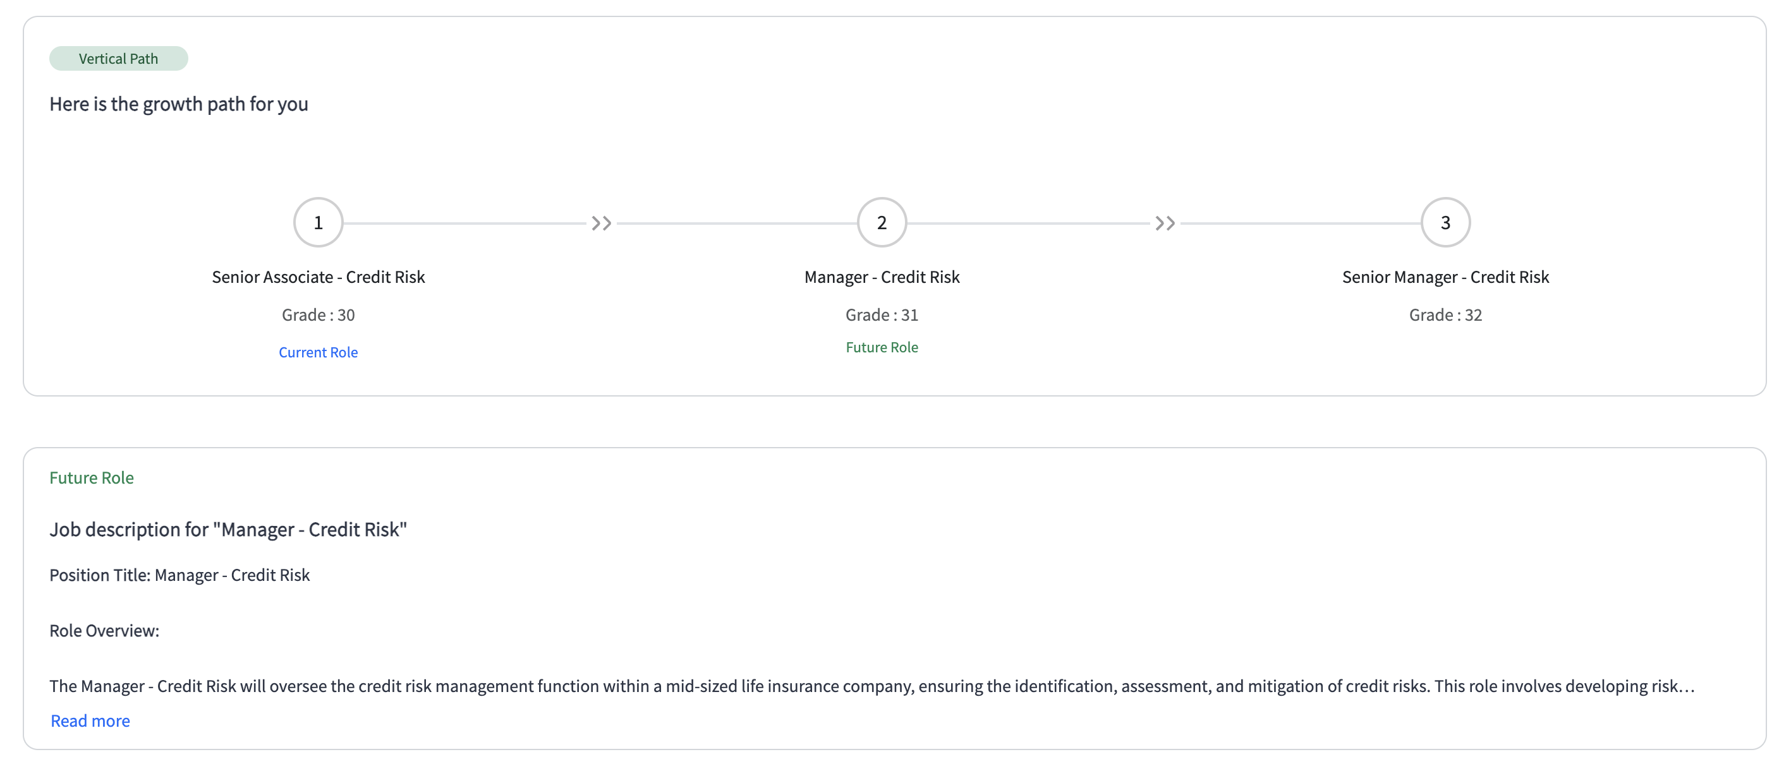

4.3.3 Learning recommendations linked to Docebo LMS for targeted upskilling.
iMocha seamlessly pull the learning content linked with Docebo to ensure that every employee at Customer receives personalized learning recommendations aligned to their role and identified skill gaps.
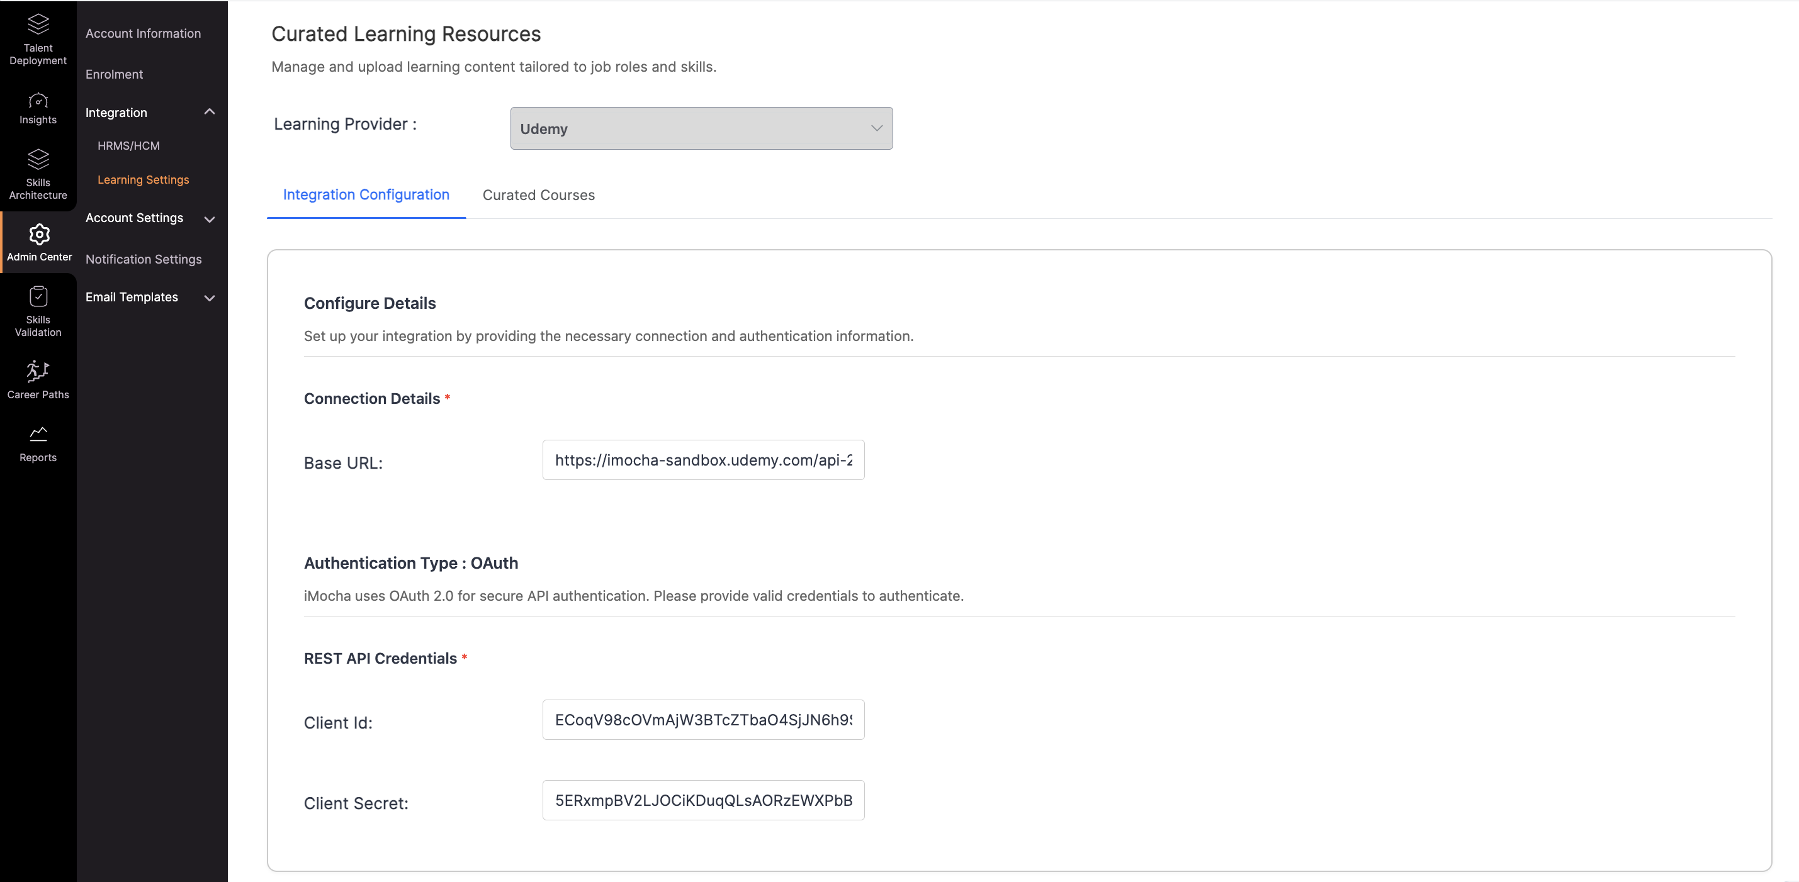
Once skills are validated, the platform can suggest targeted courses, of Docebo, eliminating guesswork and maximizing learning ROI.
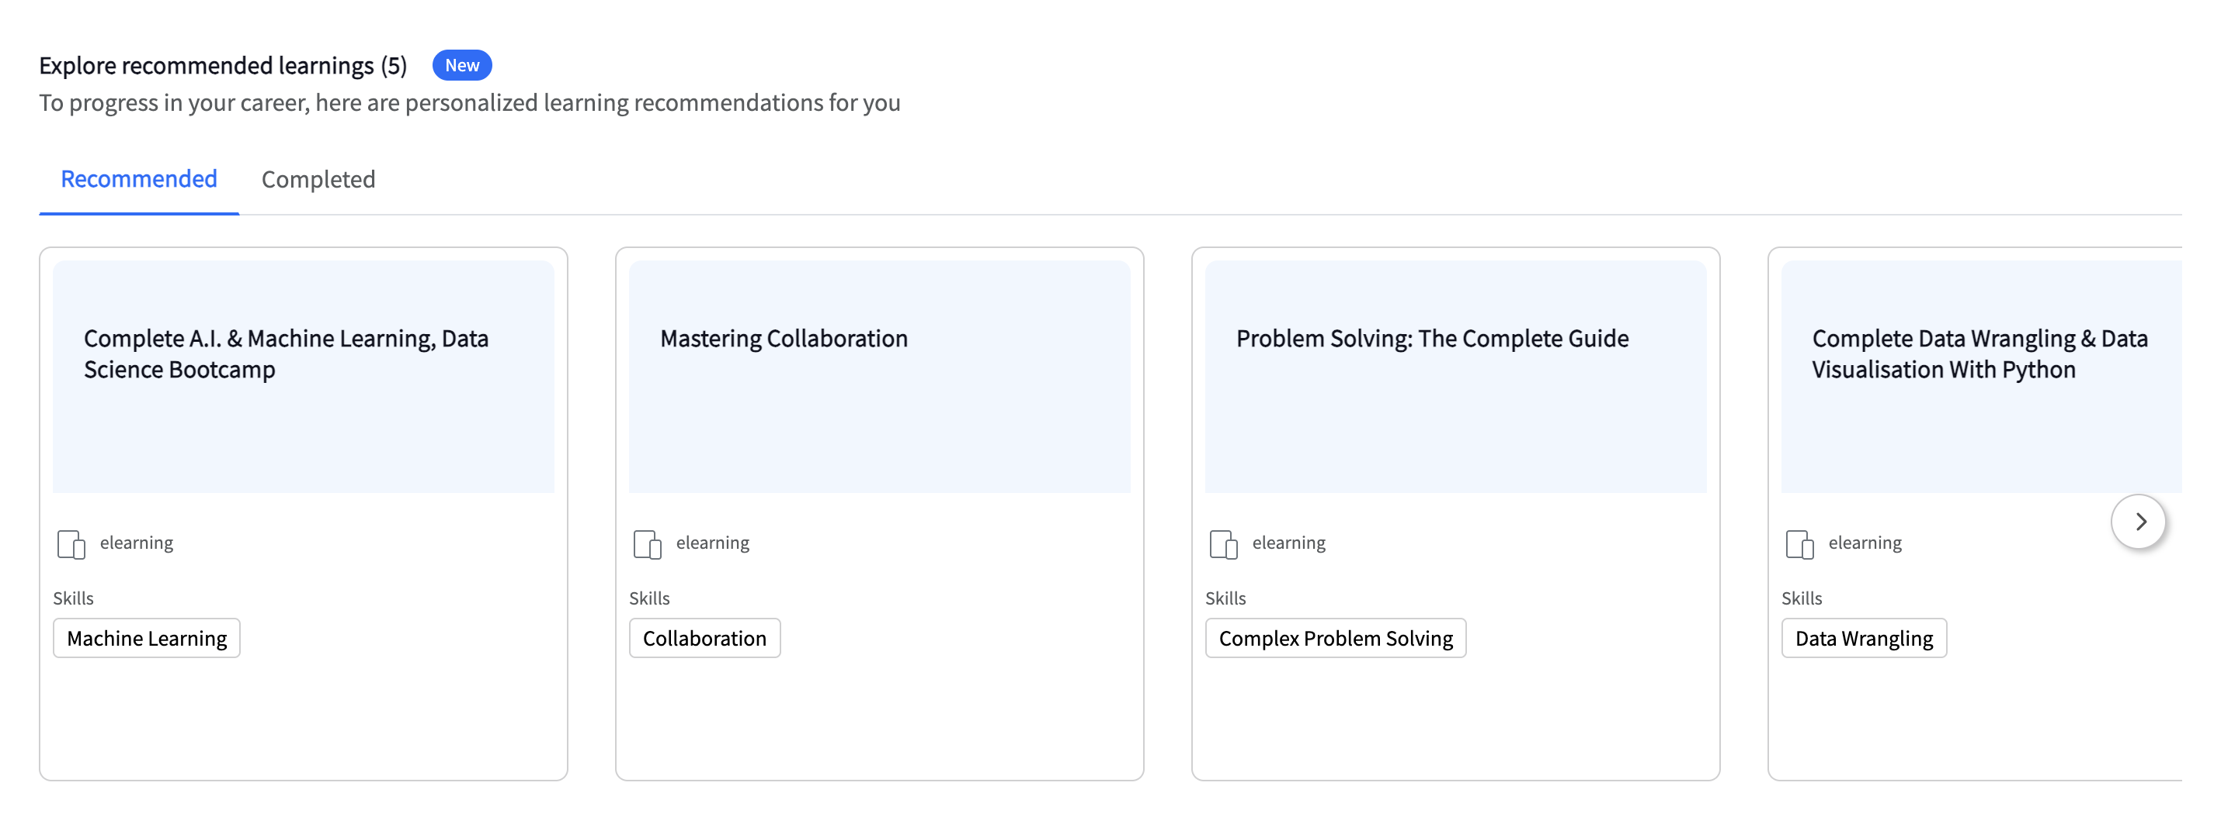
This integration ensures learning is not generic but strategically aligned to CUSTOMER’s workforce priorities and business outcomes.

4.3.4 Track progress of employees and contingent workforce in closing skill gaps.

iMocha enables Team managers to track the progress of team members on the skills updation that are part of their job profile through multi-channel validation mechanism as shown on the snippet below:

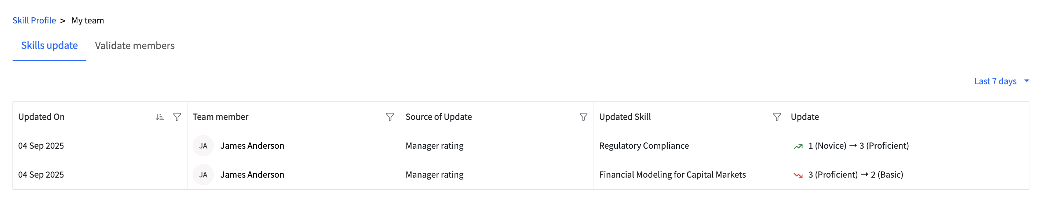

4.4. Workforce Analytics & Reporting
4.4.1 Competency reports at individual, team, and organizational levels.
iMocha provides multi-level skill reporting to support CUSTOMER’s HR and leadership teams.
- Individual: Employees and managers receive detailed reports of validated skills, proficiency levels, and identified gaps, with progress tracking against development goals.
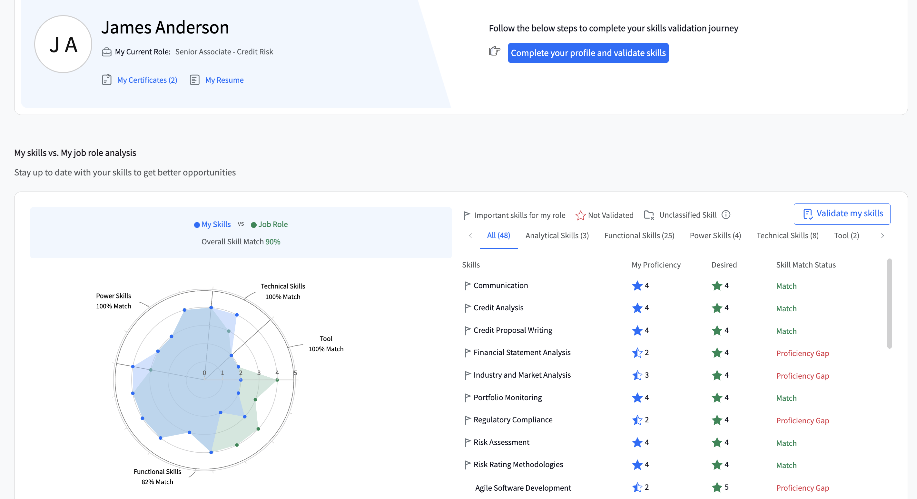
- Team: Managers can also get skills update view of their team members to understand their team members strengths, weaknesses, and training completions, enabling focused development initiatives.
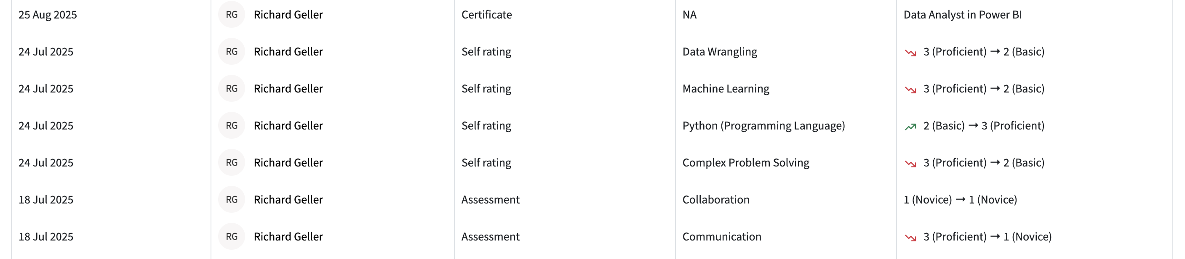
- Organizational: HR leaders can view enterprise-wide skill inventories and workforce readiness dashboards, supporting strategic planning, mobility, and succession pipelines. Reports are interactive and configurable to align with CUSTOMER’s organizational structures.
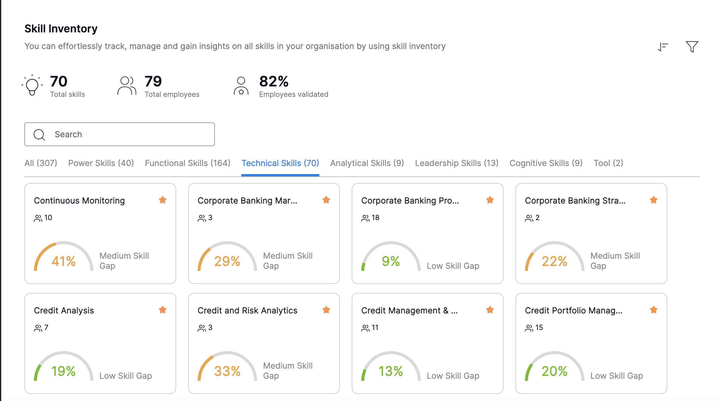

4.4.2 Skills matrix and dashboards for strengths, weaknesses, and distribution.
iMocha offers dynamic skills matrices and visual dashboards to present workforce competencies at a glance. HR professionals at CUSTOMER can view:
- Distribution of skills across roles, departments, and locations.
- Identification of organizational strengths and critical skill gaps.
- Filters by manager, band, grade, or role for targeted insights.
These dashboards act as a real-time skills inventory, ensuring CUSTOMER can align workforce capabilities with current business priorities and member service goals.
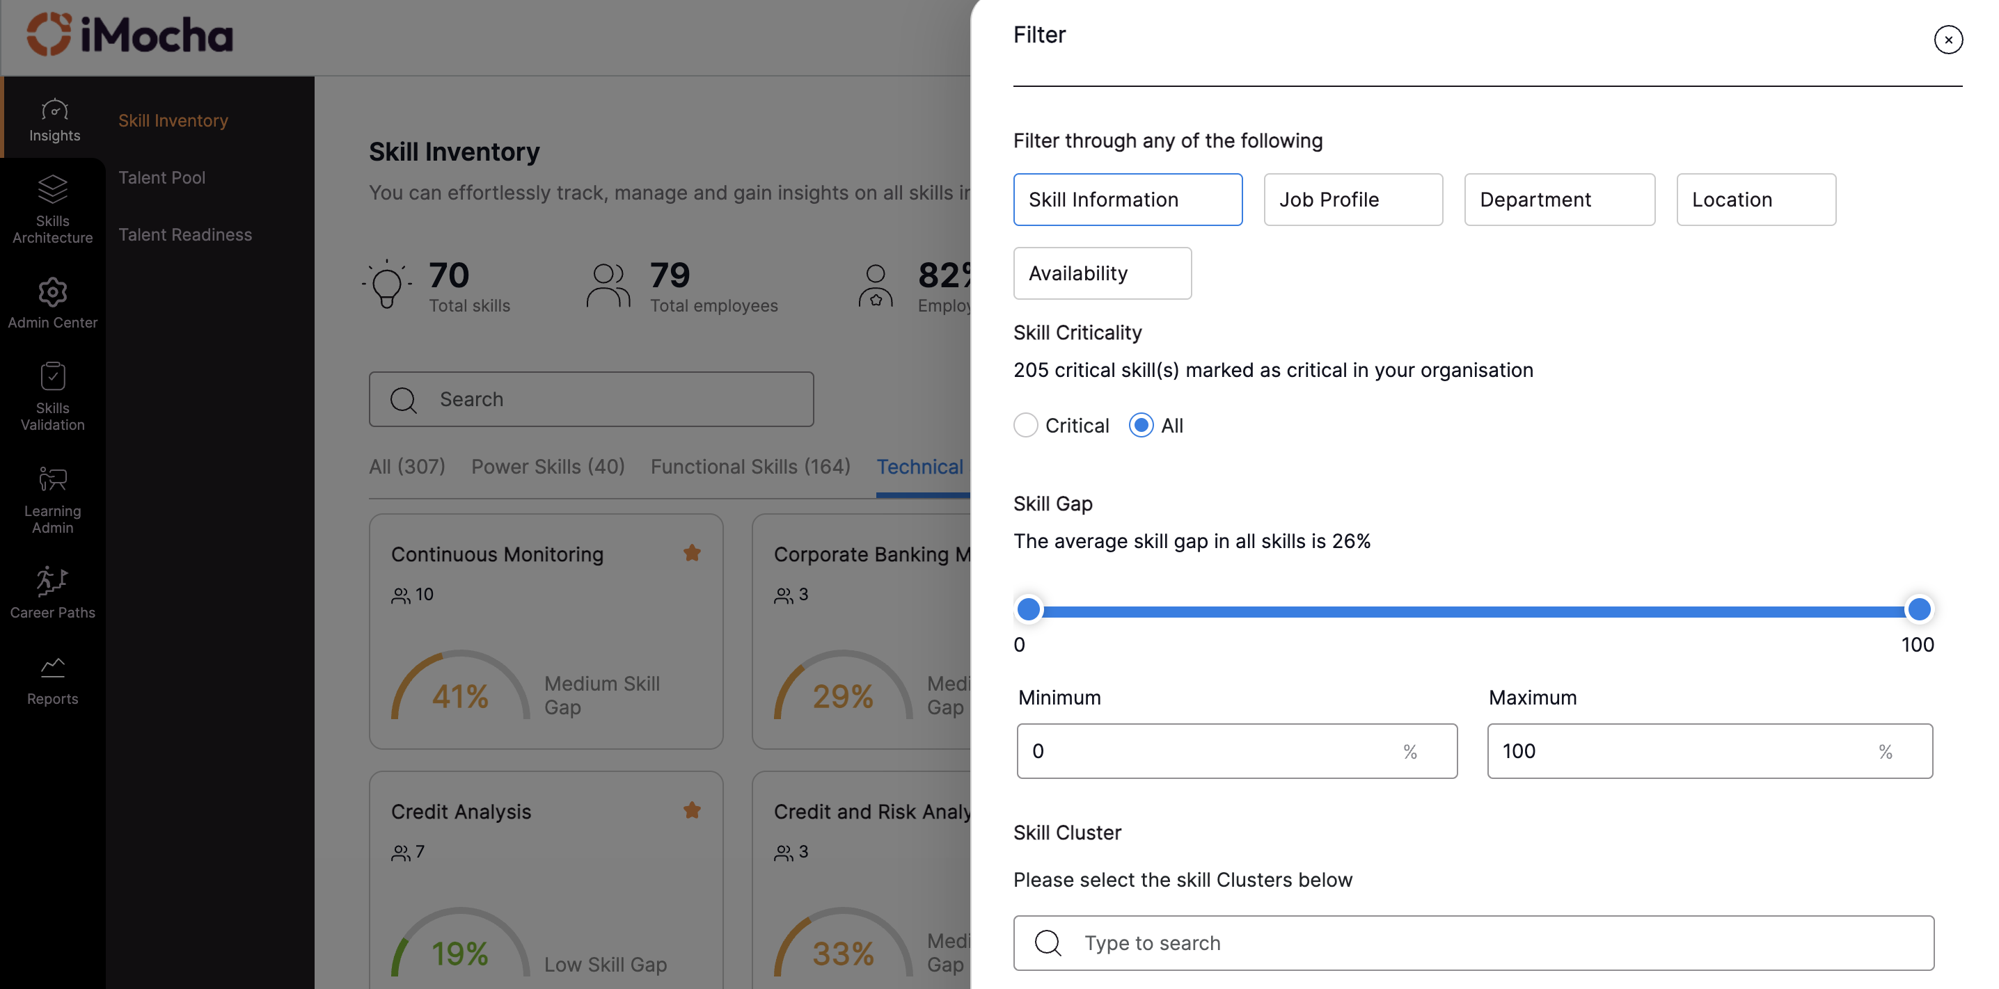
This guide is designed to help Customer fully leverage the Skills Inventory for organizational growth.
The Skills Inventory provides a consolidated view of all skills across CUSTOMER, along with validation status for each. It highlights the organization’s current progress in capturing skill data and displays proficiency levels determined through iMocha’s multi-channel skill validation (self, manager, peer, assessments, and evidence).
Skill Criticality: You can filter out the skills identified and marked to be critical as per the business objectives or view all the skills implemented for the organization.
Skill Gap: You can filter out the skills with certain skill gap ranges. The skill gaps are determined by the multi-channel skills validation including the weighted average assigned by the manager.

Critical skills are marked using a star sign, the priorities are color-coded based on their level of importance, and the number of employees who have completed the skills validation is displayed as shown in the image below.

4.4.3 Training effectiveness analysis to measure ROI of learning programs.
With direct integration to Docebo LMS, iMocha shall be able to pull the completion data of learnings completed by employees. Thus, enabling tracking of learning completions to measure the impact of training on competency improvement in the form of revised skills-gap data at multiple levels.
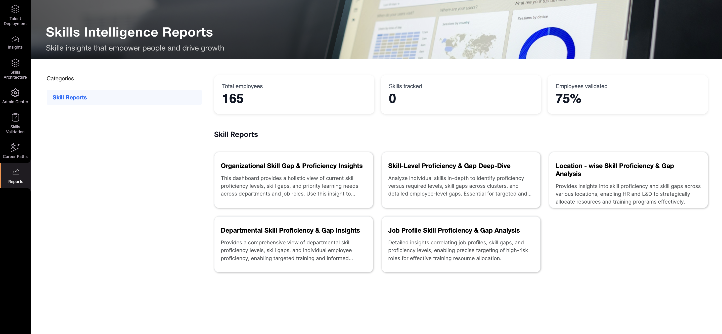
Through custom reports for CUSTOMER, HR leaders will be able to:
- Compare pre-training and post-training skill validation results.
- Identify whether training interventions closed the intended skill gaps through multiple channels.
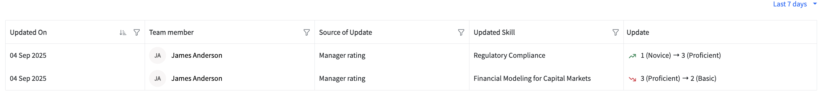

This ensures measurement ROI by linking training effectiveness to talent readiness for the skills of targeted role.

4.4.4 Compliance reporting to meet regulatory and internal audit requirements.
iMocha provides audit-ready compliance reports that demonstrate workforce adherence to regulatory and internal standards. With iMocha, CUSTOMER will be able to receive following for compliance reporting needs:
- Validating certifications and storing evidence within employee skill profiles.
- Generating detailed reports by individual, team, or department for auditors or internal reviews.
This functionality reduces manual tracking, strengthens risk management, and ensures CUSTOMER can demonstrate compliance with both financial regulations and internal governance policies.

4.5. Talent Lifecycle Enablement

<Instruction: This is only applicable and to be used for proposal generation only if the customer also requires talent acquisition solution along with talent management>

4.5.1 Recruitment & Selection:

iMocha enables skill assessments for technical, functional, domain and soft skills using the world’s largest skill library comprising 10,000+ skills across multiple ready job roles library.

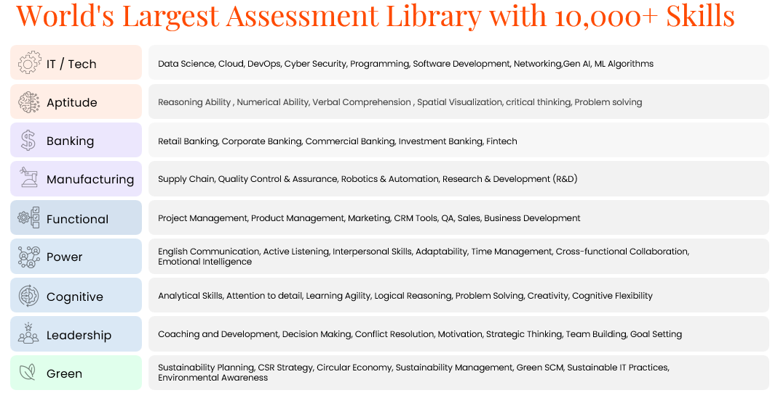

iMocha’s Innovative Assessment Environment configure niche technology skills with a workflow for premium hiring using skill assessments with patented technologies and best-in-class suite of innovative assessment solutions like AI-LogicBox, Projects, to help talent leaders transform their operations.

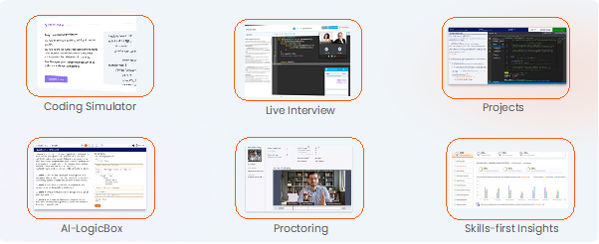
Customizable Assessment/Test Builder
- Adaptive Testing Engine adjusts difficulty levels dynamically based on performance.
- Covers 10,000+ pre-built assessments across various domains:
  - Technical Skills (Programming, Data Science, Engineering).
  - Cognitive Skills (Logical Reasoning, Problem-Solving).
  - Behavioural & Situational Judgment Tests (SJT).
  - English Language Proficiency (CEFR-aligned tests for English)
  - Based on WCAG Compliance, iMocha also supports 50+ global languages including French, Spanish, and Arabic.
- Live Coding Challenges supporting 35+ programming languages.

Language Evaluation with CEFR Framework
iMocha supports evaluating English communication through a comprehensive tool called AI-English Pro It helps you hire and upskill talent with precision using CEFR-aligned assessment, ensuring globally recognized standards for English-speaking and writing proficiency.
- The Test Measures 4 pillars of english communication: Listening Skills, Reading Skills, Speaking Skills & Writing Skills. (Please find the attached datasheet for more details on English communication assessment)

These are complimented by the Smart Proctoring Suite to put safeguards in place which ensure candidate identity verification, cheating prevention, non-repetitive, predictable assessments for averting malpractices and filtering out sub-par candidate selection The various cheating prevention measures provided are listed below.
- Image Proctoring
- Video Proctoring
- Window Violation
- IP Address
- Randomization of Questions and Answers
- Safe Assessment Browser
- Candidate Identity Verification

Additionally, iMocha provides complete proctoring enforcement, with the ability to terminate assessments if violations occur. This guarantees a secure, fair, and credible evaluation process.

Reporting Metrics for Recruiters & Hiring Managers
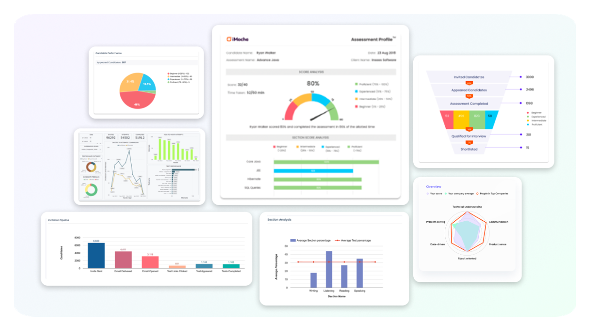
iMocha provides comprehensive assessment reports with key metrics to evaluate candidate performance effectively. The reports include:
- Performance Metrics:
  - Score & Accuracy – Overall test score and correctness percentage.
  - Completion Time – Total time taken to complete the test.
  - Section & Question-wise Analysis – Breakdown of performance by skill/topic.
  - Task Complexity – Difficulty level of questions attempted and accuracy per level.
- Comparative Insights:
  - Benchmarking – Comparison with other candidates (percentile ranking).
  - Industry & Peer Comparison – Performance benchmarking against industry standards.
- Integrity Metrics:
  - Proctoring & Violation Reports – Window violations, face detection, screen sharing attempts.

Apart from this, the platform also allows users to have other metrics like:
- Candidate Comparison
- Recruiter Performance
- Candidate Feedback
- Test Performance

Also, at test level, the system helps with Metrix like:
- Candidate Pipeline, Candidate Performance, Avg. attempt duration, Section Analysis.
- Candidate Responses: Invitation Pipeline, Delivery Rate, Test Invitation Rate, Test invitation open rate.

With iMocha, CUSTOMER can streamline its assessment processes, maintain test integrity, and identify the best candidates efficiently for both tech and non-tech job skill requirements across different locations globally.

Mobile Compatibility:
iMocha’s platform is designed to deliver assessments that are fully responsive and compatible with mobile devices, allowing candidates to complete tests directly on their smartphones/tablets/iPad.
The test platform is compatible with both iOS and Android operating systems, offering a smooth and consistent user experience across different devices.
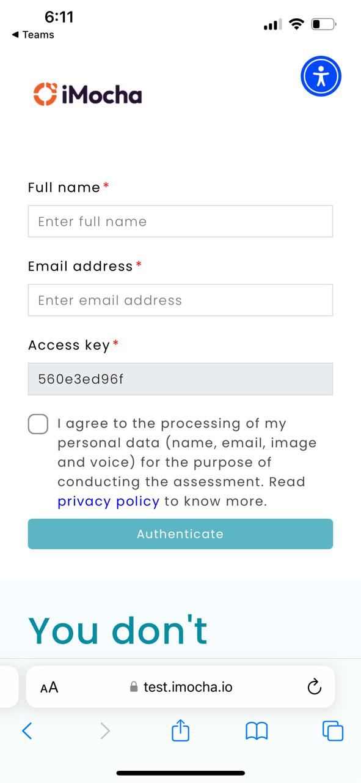
Note: iMocha recommends Coding assessment to be done on laptops/desktops/tablets as coding on mobile is not preferred or recommended anywhere.

Multilingual Support & Accessibility Compliance
We are WCAG 2.1 Level AA Compliant. Our platform supports multiple languages for test takers, making it easier for candidates from diverse linguistic backgrounds to participate effectively.
The Accessibility functionality is designed to enhance the usability of our Test platform for users with various disabilities. This widget ensures that everyone, regardless of their physical or cognitive abilities, can effectively interact with and navigate the platform.
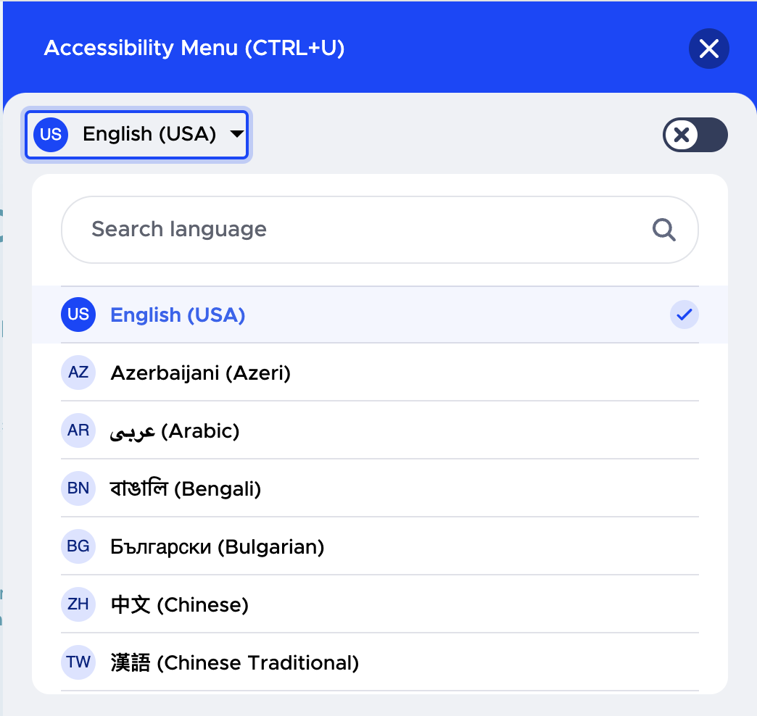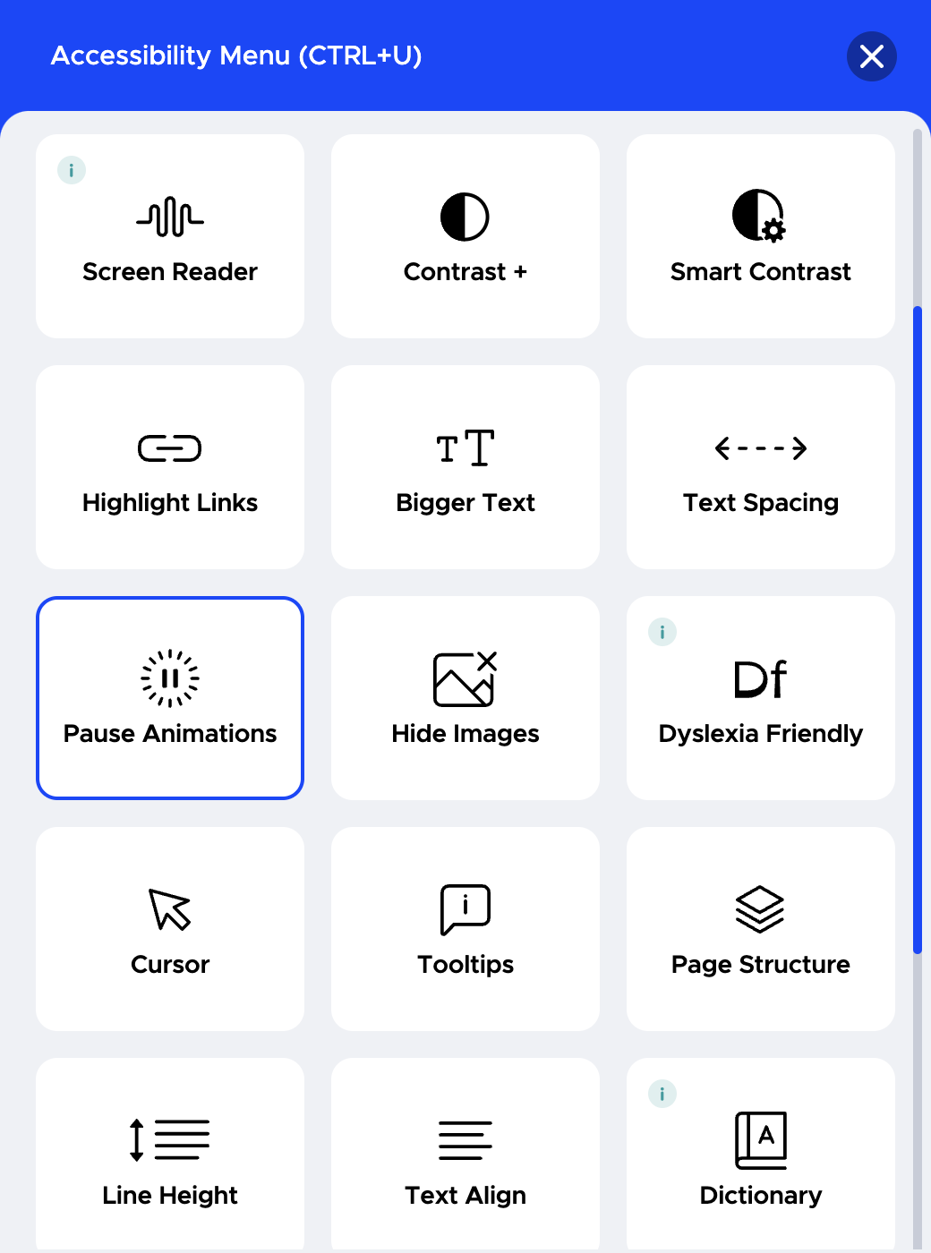

Candidate Data Reports
iMocha's Candidate Report gives the performance analysis of the test taken. The report is generated soon after the candidate completes the test. Please refer how the test creator will view the assessment reports https://help.imocha.io/how-to-review-a-report
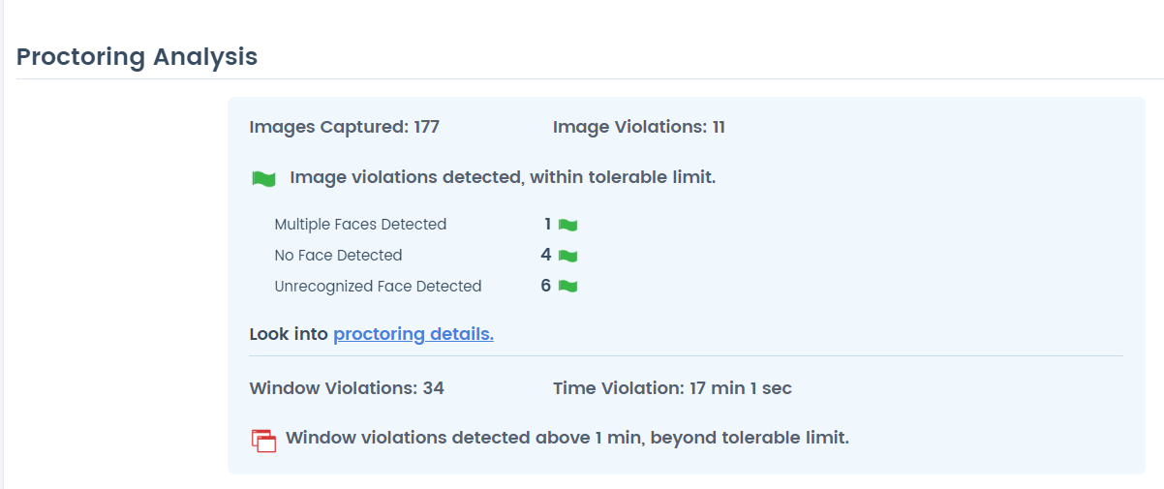

4.5.2 Performance Management: Integrate competency data into performance evaluations.
To integrate competency data into performance evaluations, iMocha provides:
- Skill Mapping: Aligns relevant skills with each job profile.
- Skills-Based Assessments: Evaluates employees’ skills and knowledge against defined job requirements.
- Seamless Data Integration: Ready APIs enable smooth transfer of assessment data into CUSTOMER’s performance management modules, offering a unified view of skills and performance.
In summary, iMocha ensures competency data is embedded into performance evaluations through robust assessments and seamless system integration.
For more details on iMocha’s ready APIs, visit: https://developer.imocha.io/talent

4.5.3 Succession Planning: Identify high-potential employees and track leadership pipelines.
iMocha product addresses the requirement of succession planning—specifically identifying high-potential employees and tracking leadership pipelines—through the following key features:
- Comprehensive Assessments: The platform offers technical, functional, and behavioral assessments, including soft skills and cognitive evaluations, to evaluate employee capabilities thoroughly and spot high-potential talent early.
- Skills Gap Analysis and Benchmarking: iMocha pinpoints skill gaps in individuals targeted for leadership development and provides benchmarking against industry standards and internal role requirements.
- Personalized Development and Career Pathing: The platform creates tailored learning recommendations to close development gaps, helping employees grow into higher roles with continuous skill development aligned to succession needs.
- AI-Powered Skills Intelligence: iMocha leverages AI-driven skills assessments and data analytics to identify readiness of employees who exhibit leadership potential. It uses skills inference and skill mapping to show readiness for higher roles accurately.
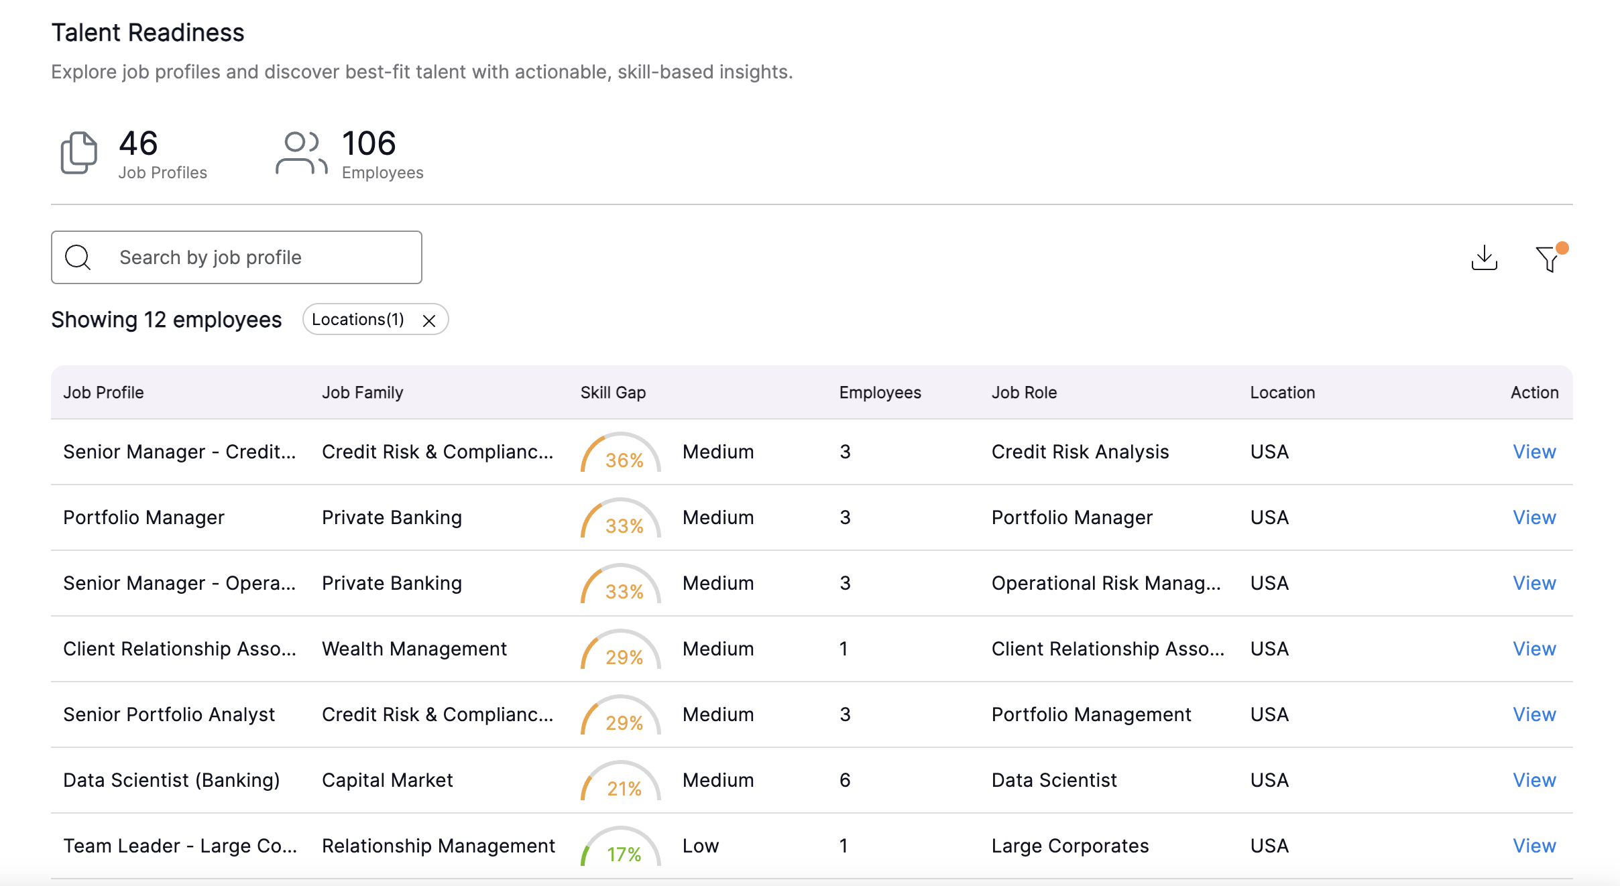

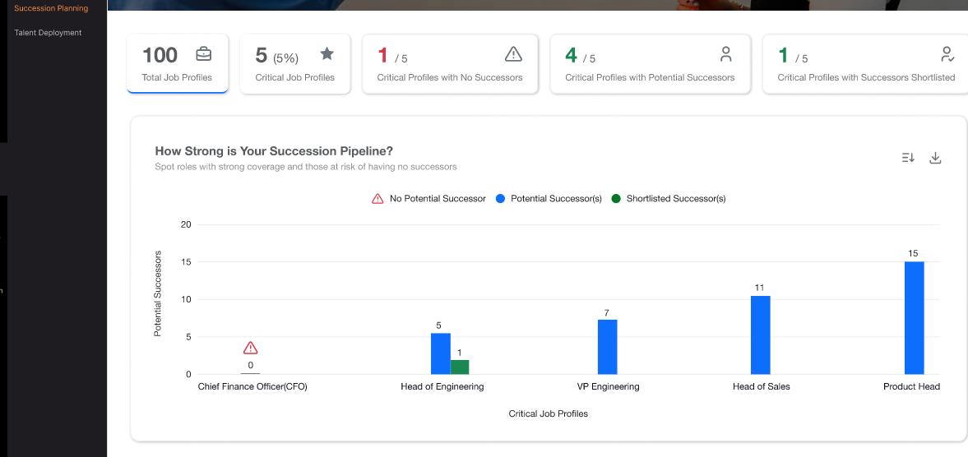
4.5.4 Career Pathing: Provide transparent skill-based career progression opportunities.
iMocha’s platform enables Customer to clearly define and publish the skills and competencies required for every role. This transparency ensures employees understand what is needed to advance, promotes fairness in career mobility, and empowers individuals to take ownership of their growth. By aligning opportunities with verified skills, CUSTOMER fosters trust, equity, and inclusive development across the workforce.
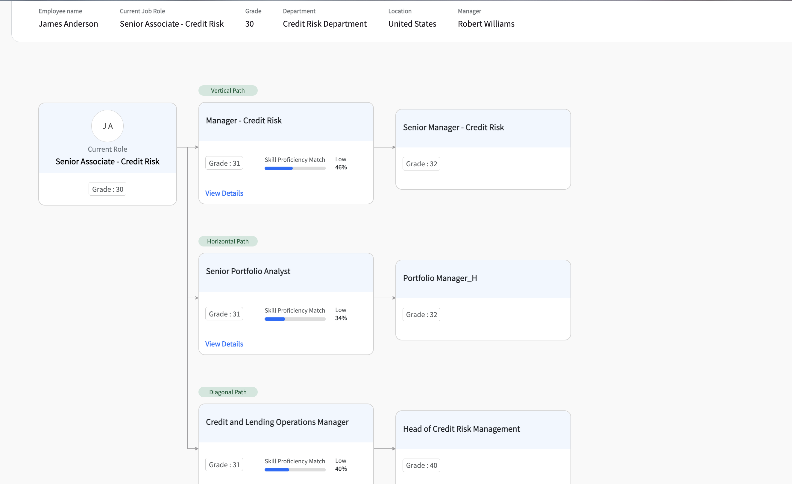

4.6. Security, Access & Integration
4.6.1 Integration with existing HR Tech ecosystem
iMocha provides pre-built connectors and open APIs to integrate its skills assessment platform into different areas of the talent ecosystem. More details on the ready APIs can be accessed from here: https://developer.imocha.io/
4.6.2 Role-based access control for employees, managers, HR admins.
iMocha provides role-based access control (RBAC) to ensure employees, managers, HR administrators, and recruiters access only the data and features relevant to their roles.
- Employees: Manage their own skill profiles, complete assessments, upload certifications, and track development progress.
- Managers: View team skills, identify competency gaps, validate proficiency, and assign targeted assessments.
- HR Administrators: Configure competencies, manage assessments, generate reports, and oversee integrations with UKG, Docebo, Phenom, and Payfactors.
- Recruitment Roles: Extended access for interviewers, hiring managers, and reviewers to support hiring workflows.
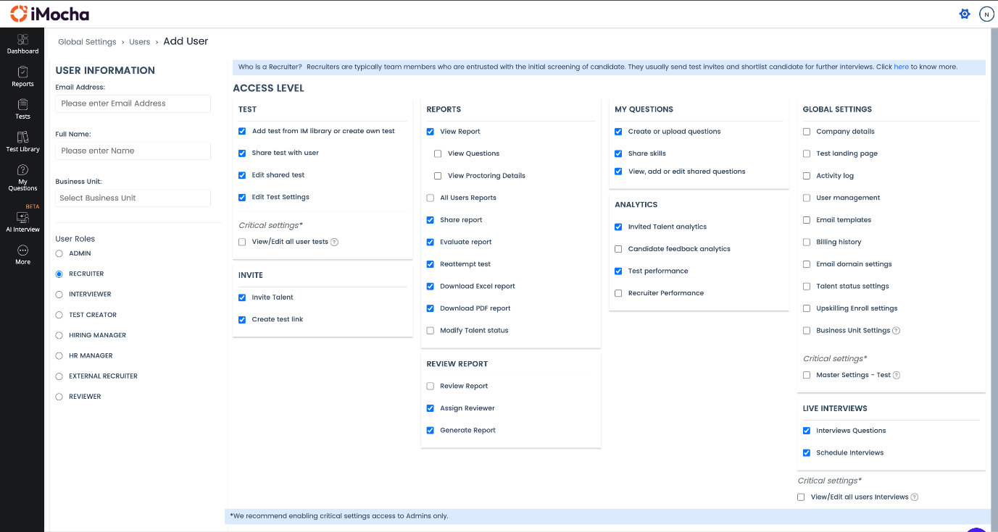

4.7. Brand & User Experience
4.7.1 White labelling to ensure employees experience CUSTOMER’s brand identity.
iMocha offers extensive white labelling capabilities that enable CUSTOMER to ensure employees experience the company's unique brand identity throughout the assessment and recruitment process. Key white labelling features include:
- Displaying CUSTOMER’s company logo, favicon with iMocha’s privacy policy within the iMocha platform to reflect brand visuals.
- Customizing email communication templates sent to employees, such as test invitations and reminders, with CUSTOMER’s branding and tone to maintain consistency.
- Customizing test landing pages and redirect URLs after test completion to CUSTOMER’s career or corporate pages for a seamless branded experience.
- Setting up support email addresses under CUSTOMER’s branding to handle candidate queries.
- Overall, these white-label options allow CUSTOMER to deliver a fully branded, consistent employee experience that strengthens brand perception and engagement during talent assessments and performance evaluations.
This approach helps create an immersive brand identity for employees from the moment they engage with iMocha product reinforcing CUSTOMER’s employer brand.

To know more about how to get CUSTOMER branding on iMocha, refer our help article: https://help.imocha.io/kb/article/245/how-to-get-your-company-branding-on-imocha

4.7.2 Intuitive, user-friendly interface to maximize adoption and engagement
iMocha provides an intuitive, user-friendly interface designed to maximize adoption and engagement among both HR professionals and employees. Key aspects include:
- A clean, easy-to-navigate dashboard that enables users to quickly create, invite, and manage assessments without technical expertise.
- Adaptive, human-like AI interviews with conversational interfaces that engage candidates naturally.
- Multilingual support and accessibility features to cater to diverse, global user bases, including differently abled users.
- Seamless integration through ready APIs with Applicant Tracking Systems (ATS) and Learning Management Systems (LMS) for a smooth user experience.
- The platform supports mobile and desktop access, allowing candidates and employees to participate anytime, anywhere.
- Real-time reporting and insightful analytics are presented in a clear, actionable format, simplifying decision-making for hiring managers and HR.
- Features like AI-driven scoring, proctoring, and video interviews are integrated within a consistent, easy-to-use experience, enhancing engagement and reducing time to hire.
iMocha can help CUSTOMER with onboarding, training, and supporting employees during the transition to the new assessment solution. Offering workshops, training modules, and change management resources can help employees understand the platform’s value and ease them into the new process.
Overall, iMocha’s UX design focuses on simplicity and effectiveness, ensuring a smooth workflow that encourages widespread platform adoption and high engagement levels.

Project plan

Key Deliverables:
Below are the tentative timelines for Talent Management requirement (approx 12-14 weeks):
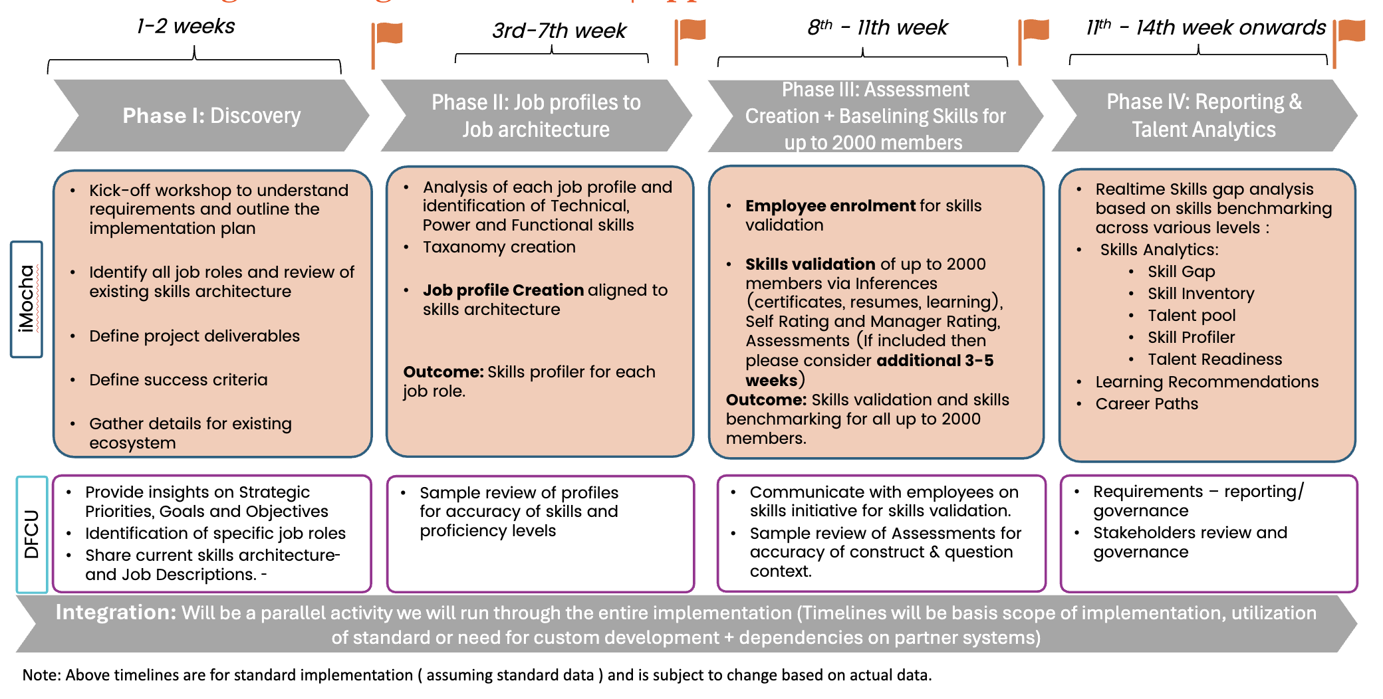
For Talent Acquisition, the typical timelines is maximum two weeks for skills part of iMocha skills Library. For any customization or custom creation involvement, the timelines vary on case-to-case basis.
Unlike Talent Management, Integration with ATS will be a parallel activity and will be scoped basis dependencies with the partner ecosystem)

Value proposition
iMocha’s solution delivers measurable value to Customer across five key dimensions:

Enterprise readiness

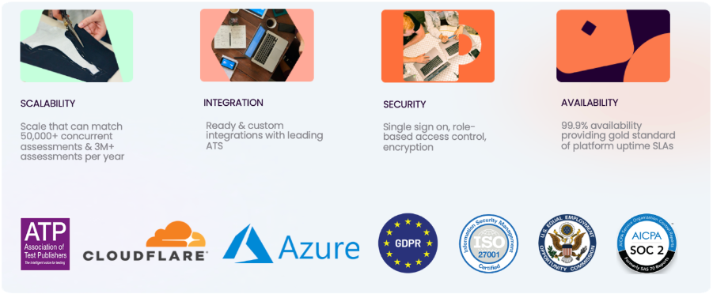

7.1.1 Data Encryption
- In-Transit: All data transmissions are secured with TLS 1.2+ encryption, ensuring protection against interception and unauthorized access.
- At-Rest: Data is encrypted using Microsoft Azure Transparent Data Encryption (TDE) with AES-256, covering databases, storage accounts, and backups.
- Key Management: Keys are managed through Azure Key Vault with role-based access and automated rotation policies.
- Additional Measures: End-to-end encryption is enforced across APIs, integrations, and backups, with audit trails for access attempts.

7.1.2 Privacy Compliance
iMocha is GDPR compliant. We take candidate’s consent before we process their personal data. Attached the compliance document for your reference. We have our privacy policy in place. Please find the link to privacy policy here https://www.imocha.io/privacy-policy

7.1.3 Data Retention and Deletion
- Policy & Governance: iMocha maintains a formal Data Retention & Disposal Policy aligned with GDPR and ISO 27001.
- Candidate Data Management Options:
  - Option 1: Right-to-be-Forgotten API – Clients can directly trigger anonymization/deletion via API using candidate identifiers.
  - Option 2: Support-Governed Utility – Clients may request deletion via iMocha’s Support Team; deletions are executed using a secured utility with logged audit trails.
  - Option 3: Automated Data Lifecycle – Configurable rules allow periodic data purges (e.g., delete all candidate data after X days post-assessment).
- Verification: Every deletion request is logged, verified, and auditable, ensuring defensibility during compliance reviews.
7.1.4 Business Continuity & Disaster Recovery (BC/DR)
- High Availability: Cloud-native SaaS hosted on Microsoft Azure with 99.9% uptime SLA.
- Data Resilience: Automated multi-zone replication, daily backups, and point-in-time recovery for databases.
- BC/DR Plans: Documented and tested annually, including failover drills and RPO/RTO benchmarks.
- Incident Response: 24x7 monitoring and a defined incident response plan aligned with NIST standards.
7.1.6 Access Controls & Identity Management
- SSO/MFA: Supports SAML, OAuth, and SCIM-based integrations for single sign-on and multi-factor authentication.
- Role-Based Access Control (RBAC): Granular access controls for employees, managers, admins, and contingent staff.
- Audit Logging: All access to sensitive data is logged and available for compliance review.

Support & Engagement Model
Whether it is customizing competency assessments, configuring integrations, or providing real-time assistance during live evaluations, our dedicated support team ensures a seamless experience for administrators, managers, and employees. We act as an extension of your team during critical talent initiatives—delivering proactive guidance, rapid issue resolution, and the reliability required to maintain confidence and continuity across CUSTOMER’s workforce programs.
- Implementation Support
- Customer Success
  - A named Customer Success Manager (CSM) assigned to CUSTOMER.
  - Ongoing engagement through quarterly business reviews (QBRs) to track outcomes, adoption, and ROI.
- Support Model
  - 24x5 ticketing support for global coverage.
  - Phone and chat support during U.S. business hours for immediate assistance.
  - Access to a comprehensive knowledge base and community portal for self-service resources.
- Training & Enablement
  - Onboarding training for HR administrators, managers, and employees.
  - Role-specific sessions to ensure each stakeholder group is confident in using the platform.
  - Optional train-the-trainer model to build internal expertise within CUSTOMER.

Customer References

Customer Name | SPOC Name | Designation | Email
Revature | Vivek Ravichandran | SVP & Head of Training, Technology & Product at Revature | vivek.ravichandran@revature.com
Philip Morris International | Fernando Ospina | Head Of Data Analytics at Philip Morris International Management SI | fernando.ospina@pmi.com
CGI | Sasidhar Nayudu | Vice President at CGI Inc | sasidhar.nayudu@cgi.com

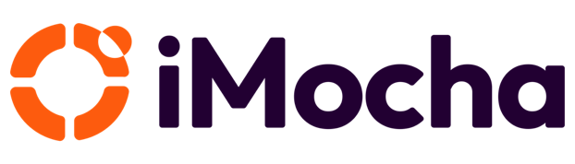

Brewing A Skills-First Planet
Call us +﻿ or write to us at @imocha.io
About iMocha

iMocha is an AI-powered Skills Intelligence Cloud that helps enterprises to build a Skills-First and data-driven ecosystem of hiring, upskilling, and managing talent - at scale, for any job role, and any industry. More than 500 organizations are using iMocha's solution for taking a Skills-First approach to accelerated hiring, objective learning and development programs and to manage talent from candidate to alumni. Enterprises from Telecom, Banking, Financial Services, Insurance and Technology are using iMocha's Skills Intelligence platform to make data driven talent decisions. The platform leverages patented technologies and includes innovative features to build employee skills profile, organizational skills inventory, skills taxonomy and skills ontology, skill benchmarking and skills analytics that helps to hire, develop and manage talent by taking a Skills-First approach.

To know more, visit us at www.imocha.io.

