

Skills-first Approach to Workforce Transformation
(Change this to reflect the customer’s RFP title)

Business Proposal: Skills Intelligence for [Customer Name]

Prepared For:
Name
Customer Name
[Customer/Partner Email]

Prepared By:
<iMocha Sales Representative>
iMocha
name@imocha.io | +91 xxxxx xxxxx

The software and database described in this document are furnished under a license agreement or a non-disclosure agreement. The software and database may be used or copied only in accordance with the terms and conditions of the agreement.
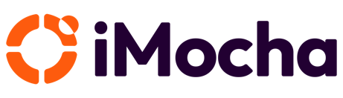
This document includes technical know-how that is not commonly known (confidential information). The user of this document warrants that such technical know-how shall only be used to fulfil the purpose for which iMocha presented this document to the user, for example user reference or evaluation of the software. Furthermore, the user warrants that such technical know-how will not be revealed to any third party.

This document, in whole or in part, may not be reprocessed or retransmitted in any form or by any means, electronic or mechanical, including photocopying, recording, or information storage and retrieval systems, for any purpose other than the license holder's internal use, without the express written permission of iMocha.

The software and database described in this document are furnished under a license agreement or a non-disclosure agreement. The software and database may be used or copied only in accordance with the terms and conditions of the agreement.

This document includes technical know-how that is not commonly known (confidential information). The user of this document warrants that such technical know-how shall only be used to fulfil the purpose for which iMocha presented this document to the user, for example user reference or evaluation of the software. Furthermore, the user warrants that such technical know-how will not be revealed to any third party.

Copyright © 2026 iMocha

Table of Content

1. iMocha Company Overview 5
1.1 About iMocha 5
1.2 Global Footprints 5
1.3 Key milestones and achievements 6
2. Build Real-Time Skills Profiles of Your Workforce 7
2.1 Introduction: Single Source of Truth for Employees’ Skills 7
2.2 iMocha’s AI-Powered Skills Validation Framework 7
3. iMocha withing [Company Name]’s HR Tech Ecosystem 9
4. Insightful Analytics for Data-driven Decisions 10
5. Customers & Success Stories 12
6. Company Financials 13
7. Security & Compliance 14

Executive Summary

We appreciate the opportunity provided by [Customer Name] to present iMocha’s Skills Intelligence Solution in building a future-ready, skills-first workforce. iMocha enables organizations to unify, validate, and activate employee skills data—forming a dynamic foundation for smarter talent decisions and sustained business agility.
Through this document, we highlight the critical shifts shaping workforce transformation and demonstrate why iMocha is the ideal partner to accelerate [Customer Name]’s journey toward skills intelligence. By combining AI-powered Skills Inference and Validation, enriched skills data, and advanced analytics for mobility, upskilling, and workforce planning, iMocha creates a continuous cycle of visibility and growth powered by real-time, validated skills insights.
We are confident that iMocha’s enterprise-grade Skills Intelligence will help [Customer Name] unlock measurable impact—bridging the gap between talent supply and business demand—while transforming how skills drive performance, mobility, and organizational readiness. We look forward to partnering on this strategic initiative.
Sincerely,
<Sales Representative>
Designation, iMocha
name@imocha.io | +91 xxxxx xxxxx

1. iMocha Company Overview

1.1 About iMocha
iMocha’s vision is to build a skills-first future where organizations and individuals thrive through the power of validated skills. Our mission is to empower enterprises with AI-powered skills intelligence solutions that streamline talent management, optimize workforce development, and enable data-driven decisions—helping over 300 global customers, including Fortune 500 leaders, unlock workforce potential and drive business performance.
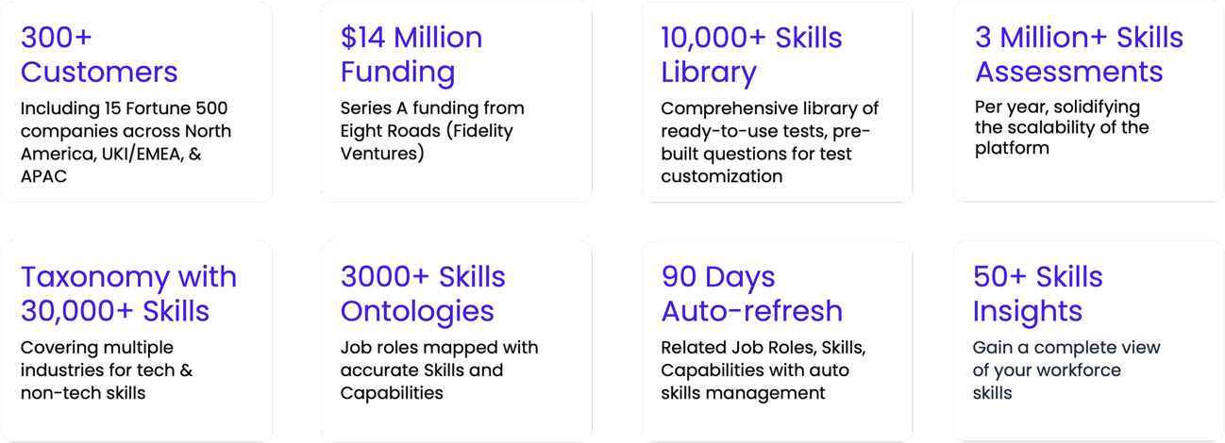
1.2 Global Footprints
Headquartered in Delaware, USA, iMocha operates in India through a subsidiary named Tecknack Technologies Private Limited.
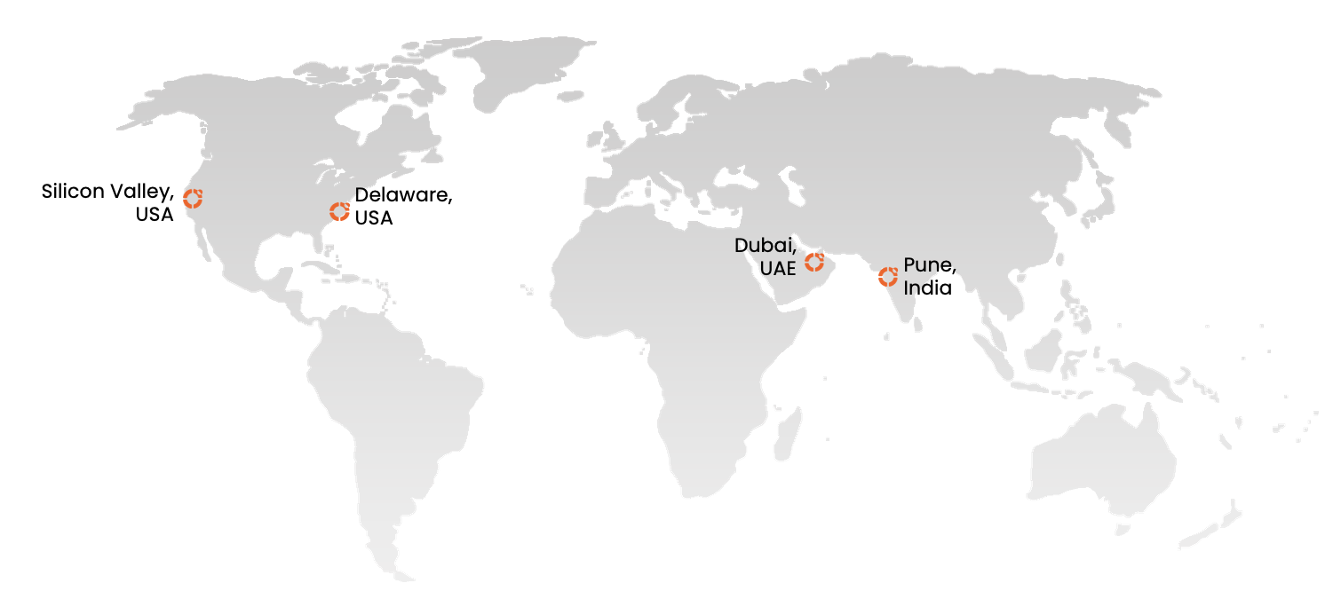

1.3 Key milestones and achievements
iMocha has consistently been recognized as a global innovator in skills intelligence and assessment. Our Skilling API was spotlighted by Microsoft CEO Satya Nadella for accelerating hiring and skills matching, reflecting the transformative impact of our solutions. We are proud to partner with leading platforms like SAP, Microsoft, and Degreed, further strengthening our ecosystem. Celebrated by G2 with multiple Leader awards across regions, including EMEA and Middle East & Africa, as well as recognition for Fastest Implementation and Best Estimated ROI, iMocha continues to deliver measurable value to customers worldwide.
Adding to these accolades, we were honored with the Brandon Hall Group Gold Award for Best Talent Management Technology Implementation in 2025—cementing our position as a trusted partner in enabling a skills-first future.
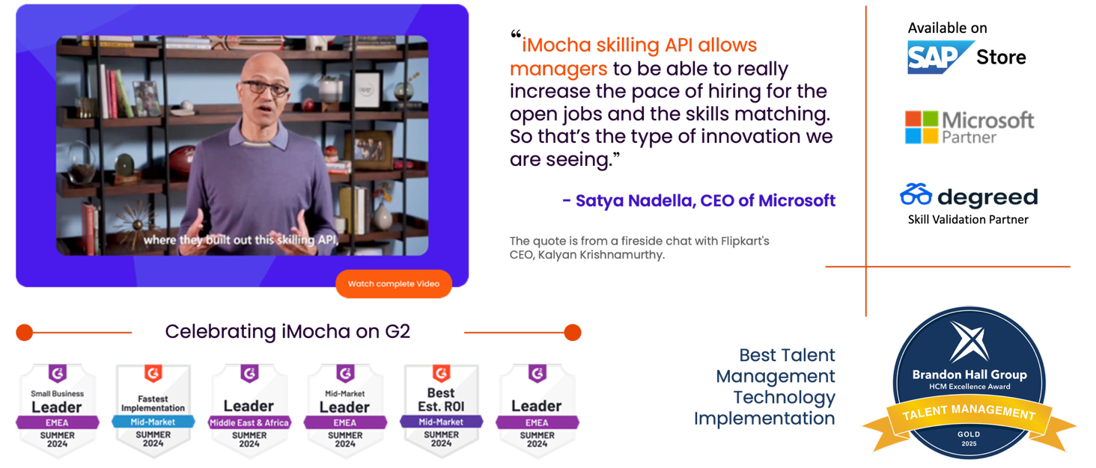
Read More on Brandon Hall

2. iMocha’s Skills Intelligence™ Overview

iMocha stands among the leading innovators in skills intelligence, setting the benchmark for how organizations transition from job-based to skills-based models. On the supply side, iMocha establishes a trusted skills baseline through AI-driven Skills Inference, further strengthened with multi-channel validation via Skills Assessments and AI Interviews. Orchestrated through agentic, explainable, and bias-aware AI, these capabilities converge to deliver high-value outcomes such as personalized learning recommendations, accelerated redeployment, and strategic workforce planning and more—placing iMocha at the forefront of workforce transformation. On the demand side, its AI-powered Job-to-Skills Agent automates the conversion of static job descriptions into dynamic skill and capability frameworks, enabling enterprises to move away from rigid roles and align talent strategies with business imperatives.

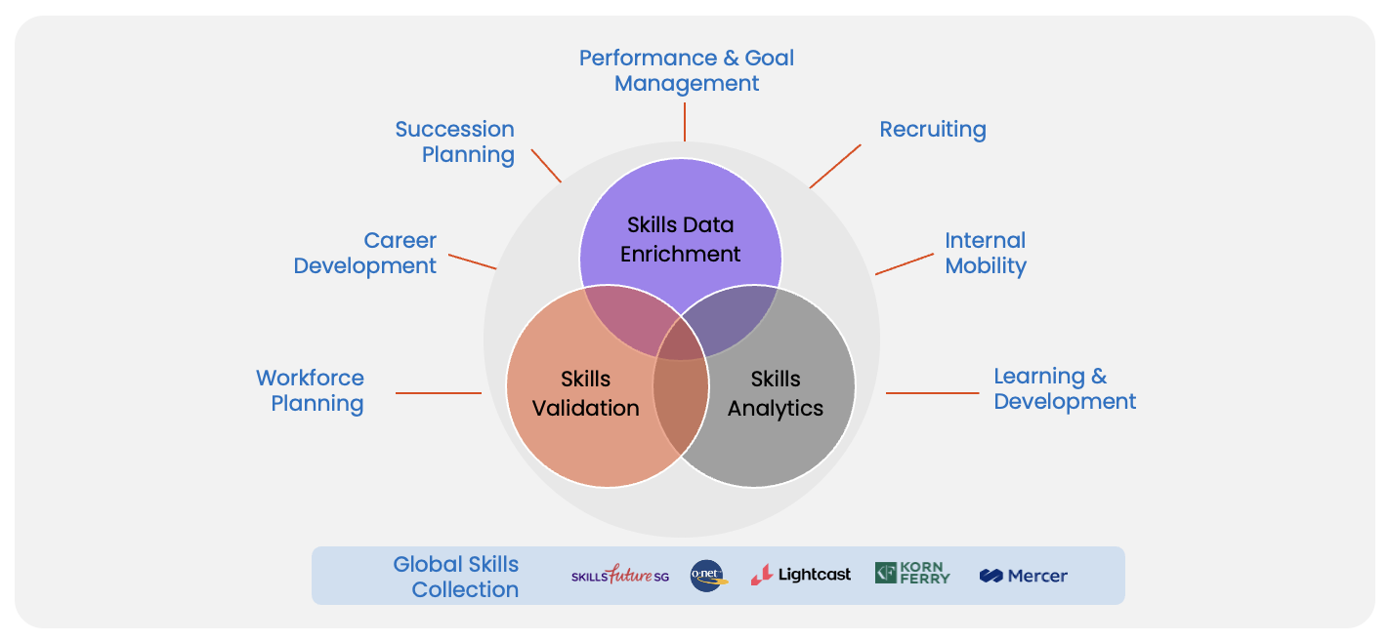
Fig 2.1 iMocha Skills Intelligence™
Further, iMocha is designed as a faceless intelligence layer that provides skills insights without disrupting existing HR and talent ecosystems. Our platform offers flexible cloud delivery and seamless integrations with leading systems such as Degreed, Cornerstone OnDemand, Udemy, and more, ensuring ease of adoption across diverse buyer environments. In addition, iMocha has established strong partnerships with major enterprise platforms — including SAP (Talent Acquisition & Talent Management), Workday (Silver Tier Partner), and Oracle HCM cloud— which reinforce our ability to scale securely within global enterprise architectures.

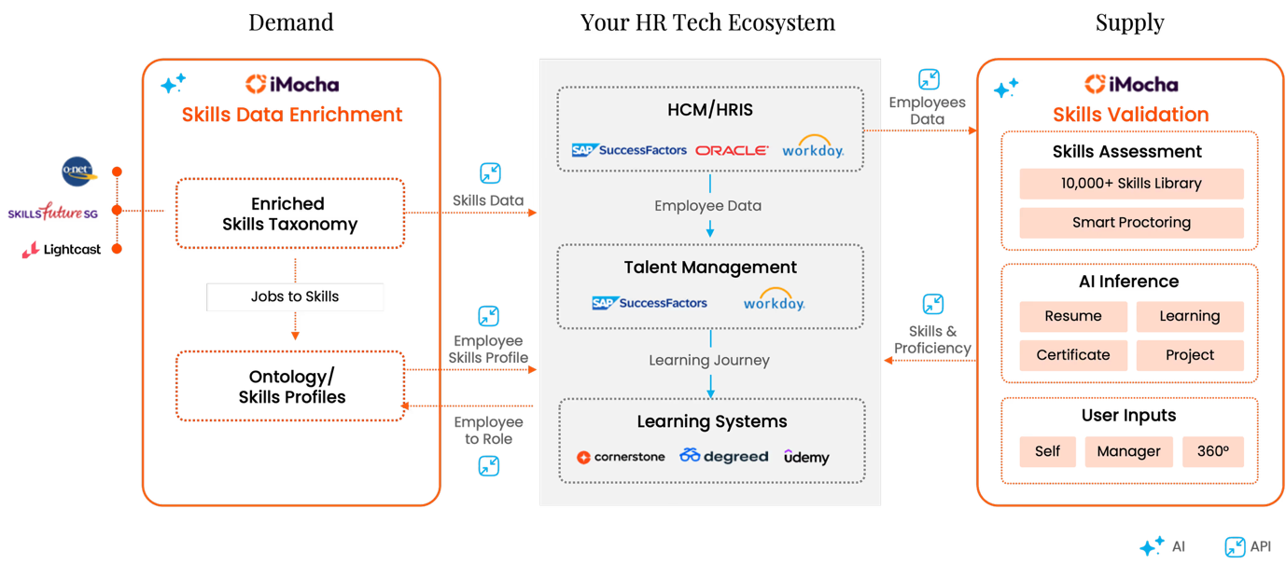
Fig 2.1 Making your HR Tech Eco-system Skills-first

3. Build Real-Time Skills Profiles of Your Workforce

iMocha’s AI-powered skills validation framework gives you trusted,
up-to-date insights into employee capabilities.

3.1 Introduction: Single Source of Truth for Employees’ Skills
IT organizations like [Company Name]’s are always looking to maintain accurate, up-to-date skills data. Traditional validation methods like manual check-ins, manager reviews, or self-assessments are time-consuming, prone to bias, and unscalable. In today’s fast-changing workforce, you need continuous, accurate validation, without burdening employees or HR teams.

iMocha’s AI-driven skills validation framework is designed to validate employee skills through multiple channels, maintain updated employee skills profiles, and power talent management workflows.

3.2 iMocha’s AI-Powered Skills Validation Framework
iMocha's innovative skills validation framework takes a multi-channel approach to transform the connection between job roles and employee capabilities, prioritizing what truly matters, i.e. their skills.
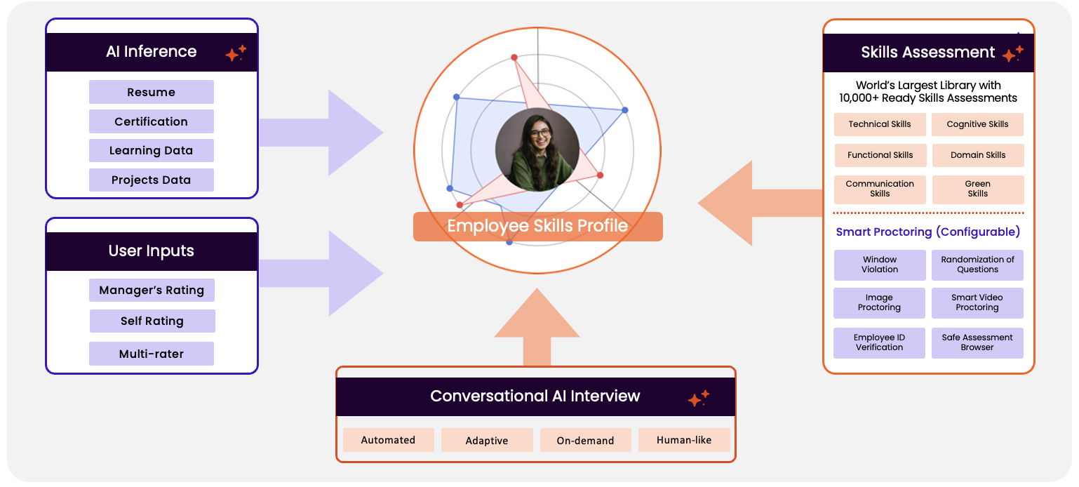
Fig 1. iMocha’s Skills Validation Framework

To provide continuous, real-time updates to employees’ skills profiles, iMocha offers [Company Name] its proven multi-channel skills validation framework which includes:
- AI Inference of Skills: iMocha pulls validated insights from resumes, project history, LMS data, certifications, and performance records. This multi-source approach ensures each skill is evidence-backed and contextually accurate.
  - Resumes & Profiles: Extract inferred skills from resumes/CVs from your [HCM / HRIS] name.
  - Learning Data: Ingest completions, courses, and career pathways from [LMS /LXP] (with content from [Content Provider])
  - Projects/Work Data: Capture skills from project experiences via [Project Management System].
  - AI-SkillsMatch: Contextual skill inference from role, project, and learning metadata.

- Skills Assessment: Evaluate job-role and skill-specific capabilities using validated, scalable assessments powered by iMocha’s industry-leading library of 10,000+ skills across technology, functional, cognitive, and language domains.

- Conversational AI Interview: iMocha’s AI-powered, on-demand interviews let candidates respond at their convenience while providing hiring teams with fast, scalable, and bias-free evaluation of technical, communication, domain, and critical thinking skills, complete with AI-driven scoring, insights, and full transcripts.

- User Inputs: iMocha builds comprehensive employee skills profiles by integrating data from self-evaluations, manager confirmations, and peer endorsements via [Talent Marketplace] feedback workflows. This multi-source approach ensures accurate, well-rounded profiles, reflecting both self-assessments and input from peers and managers, with weighted credibility added to validated skill levels to provide a trusted, actionable view of each employee’s capabilities.

4. iMocha withing [Company Name]’s HR Tech Ecosystem

Let’s outline the integration of iMocha's skills validation framework within [Company Names]'s HR Tech Ecosystem. The system is designed to seamlessly incorporate skills validation across multiple platforms, driving an efficient, scalable, and automated skills management process for large organizations.

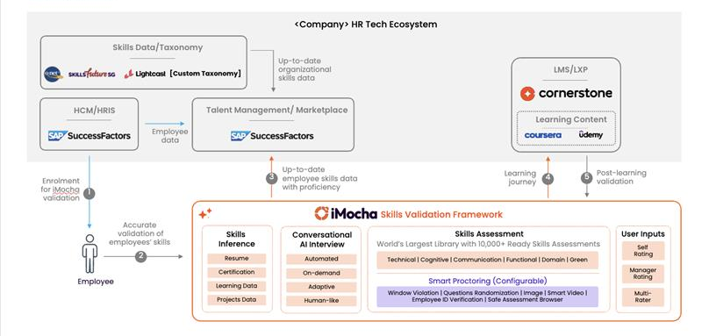
(Change this to reflect the customer’s HR Tech Ecosystem for eg. SAP SF, Workday etc)

The following sections outline how iMocha’s Skills Intelligence Solution delivers this transformation in action.
4.1 Employee Enrollment for iMocha Validation (HCM/HRIS Integration)
Employees are first enrolled through [HCM / HRIS], which serves as the foundational HRIS/HCM system of [Company Name]. This step integrates employee data into the workflow for accurate skills validation.

4.2 Accurate Skills Validation (iMocha’s Framework)
Once the employee data is integrated, iMocha validates skills using its comprehensive skills validation framework, which includes skills inference, assessments, conversational AI Interview and data from user inputs like manager and self ratings, which are gathered in [Talent Marketplace]. iMocha ensures skills remain current through regular validation and refresh cycles, prompting employees for reassessment every 12–18 months. Using skills decay logic, confidence levels are automatically reduced for skills that are not refreshed, keeping profiles accurate. Updated skills data is then synchronized back into [HCM / HRIS] employee records and the [Talent Marketplace] talent database, providing leaders with reliable, up-to-date workforce insights.

4.3 Talent Marketplace Data ([Talent Marketplace])
The [Talent Marketplace] platform captures up-to-date skills data, providing a Talent Marketplace for both skills proficiency and career growth insights. It aggregates data from multiple sources and ensures the skills inventory is current and accurate. [Company Name] infuses skills data from the taxonomy hosted in [Talent Marketplace]. iMocha provides up-to-date skills profiles of employees which powers [Talent Marketplace] to conduct accurate skills matching, this arriving at a skills-first approach to talent deployment.

4.4 Learning Journey (LMS/LXP Integration
[LMS/LXP] is [Company Name]’s Learning Platform which manages content from learning providers such as [Content Provider] and other third-party vendors. iMocha’s skills validation generates skill gap data, that allows employees to engage in personalized learning journeys aligned to their skills and career progression.

4.5 Post-Learning Validation (iMocha's Assessment and AI Interview) Post-learning validation is performed through iMocha’s Skills Assessments and Conversational AI Interview. The AI-driven interview process is adaptive, human-like, and on-demand, providing an efficient way to assess and validate learning outcomes based on real-time insights.
This integrated approach automates skills validation and career growth pathways, offering HR teams and leaders a unified, real-time view of organizational skills data. It helps organizations like [Company Name] ensure consistent skills validation, foster internal mobility, and optimize workforce planning.

5. Insightful Analytics for Data-driven Decisions

iMocha’s skill-level analytics provides [Company Name] with valuable insights to make informed decisions on upskilling, reskilling, strategic workforce planning, internal mobility, and skills-based hiring.
- Individual: My Skills Profile, Learning Recommendations, Career Path, Next Skills.
- Manager: Team Skill Heatmap, Gaps vs. Demand, BU/Geography-wise Skill gaps.
- Leadership: Enterprise Skills Inventory, Future-readiness Index.

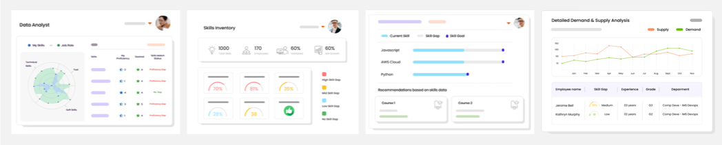
Fig 3. Snapshot: iMocha’s Comprehensive Skills Analytics

5.1 Outcomes
- Accurate Employee Skills Inventory → Drives workforce planning.
- Validated Skills for Project Staffing → Faster deployment via [Talent Marketplace].
- Skills-based Learning → Personalized Coursera/CSOD recommendations.
- Internal Talent Mobility → [HCM / HRIS] talent marketplace enriched with verified skills.
- Future-ready Organization → Continuous skills validation ensures agility for digital projects.
iMocha empowers [Company Name] to build real-time, accurate employee skills profiles that serve as a single source of truth across the HR ecosystem. By integrating multi-source data, including self-evaluations, manager confirmations, peer endorsements, assessments, and AI-driven inference—iMocha continuously validates and updates skills profiles, keeping them current and actionable. Seamlessly embedded within [HCM / HRIS], [Talent Marketplace], and Cornerstone, iMocha drives data-driven decisions for upskilling, reskilling, internal mobility, project staffing, and strategic workforce planning. With its scalable, automated, and trusted framework, iMocha ensures [Company Name] can foster internal talent growth, optimize workforce deployment, and future-proof its organization in an agile, skills-first manner.

6. Customers & Success Stories

Customer | Challenges | Solution | Results
L'Oréal (Paris HQ) | Managers lacked real-time visibility into team skills, causing unclear performance discussions and scattered development efforts. | Designed unified skills taxonomy, created role-based profiles, and launched tailored skill assessments integrated with SAP SuccessFactors and LXP.  Learn More | Shifted Beauty Tech from intuition to intelligence—enabling focused upskilling, data-driven reviews, and measurable employee growth.
Philip Morris International | Employees lacked career clarity and growth direction despite strategic efforts from headquarters across global locations. | Equipped managers with skills intelligence data to drive human-centric career conversations, not self-service portals. | Managers held meaningful 1:1s; employees gained clarity, motivation, and personalized growth paths across 30,000+ workforce.
Blue Cross Blue Shield | Planned layoffs risked losing 400+ skilled employees due to lack of visibility into internal workforce capabilities. | Mapped employee skills and redeployed redundant staff to open roles using skills intelligence and targeted upskilling. | Avoided large-scale layoffs, retained top talent, and filled internal roles efficiently—saving costs and boosting engagement.
Tiger Analytics | Lack of real-time visibility into workforce skills caused misaligned learning investments and limited internal mobility insights. | Built centralized, validated skills inventory delivering actionable insights and integrated learning recommendations for targeted development. | Achieved 90% adoption, 77% validation—skills data now drives every learning investment and workforce planning decision.
Ericsson | Couldn’t validate employee skills, lacked niche assessments and flexible certification tracks. | Built tailored assessments at associate-professional-expert levels, implemented flexible certification for 1,000+ employees.  Learn More | Scaled to 1,000+ employees, 4,000+ assessments; 30 % of employees deployed into billable roles.
Hexaware | Lacked robust, role-specific assessments and scalable certification for diverse technical, functional and soft-skills across the workforce. | Developed custom assessments mapped to 60+ roles, integrated with LMS, and rolled out internal certification at scale.  Learn More | Certified thousands of employees via 6000+ assessments; improved learning adoption and aligned skills to business demand.

Global Customer Landscape
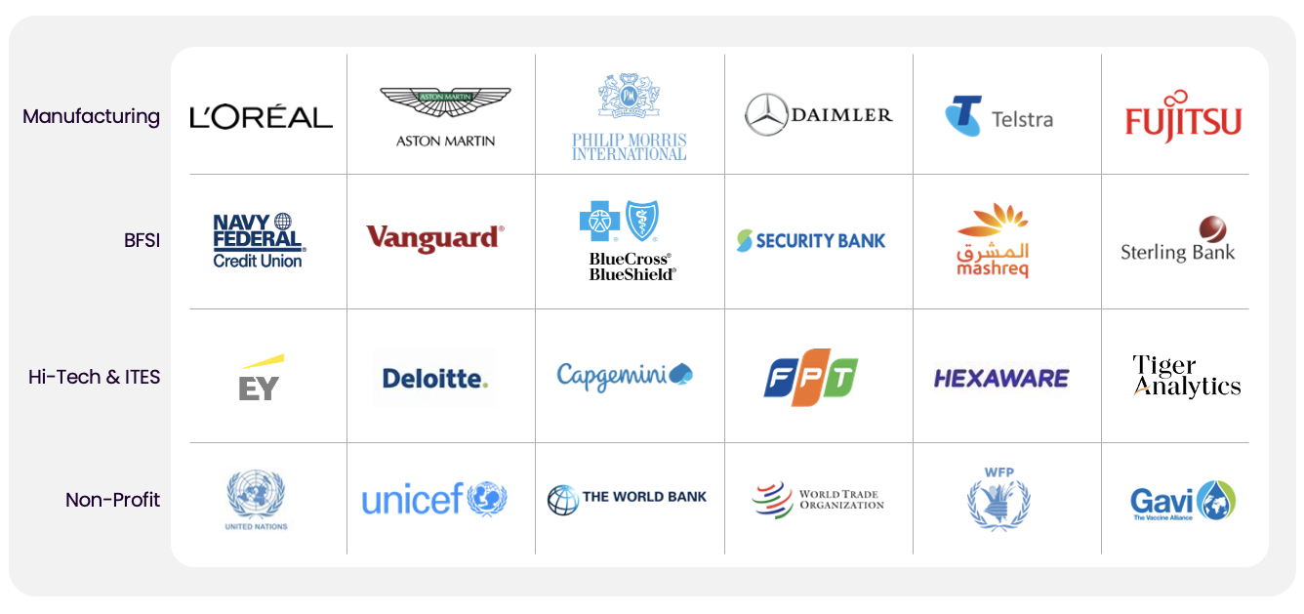

7. Proposal Summary

8. Security & Compliance
iMocha is an Enterprise-ready platform with proven commitment towards Security and Compliance.
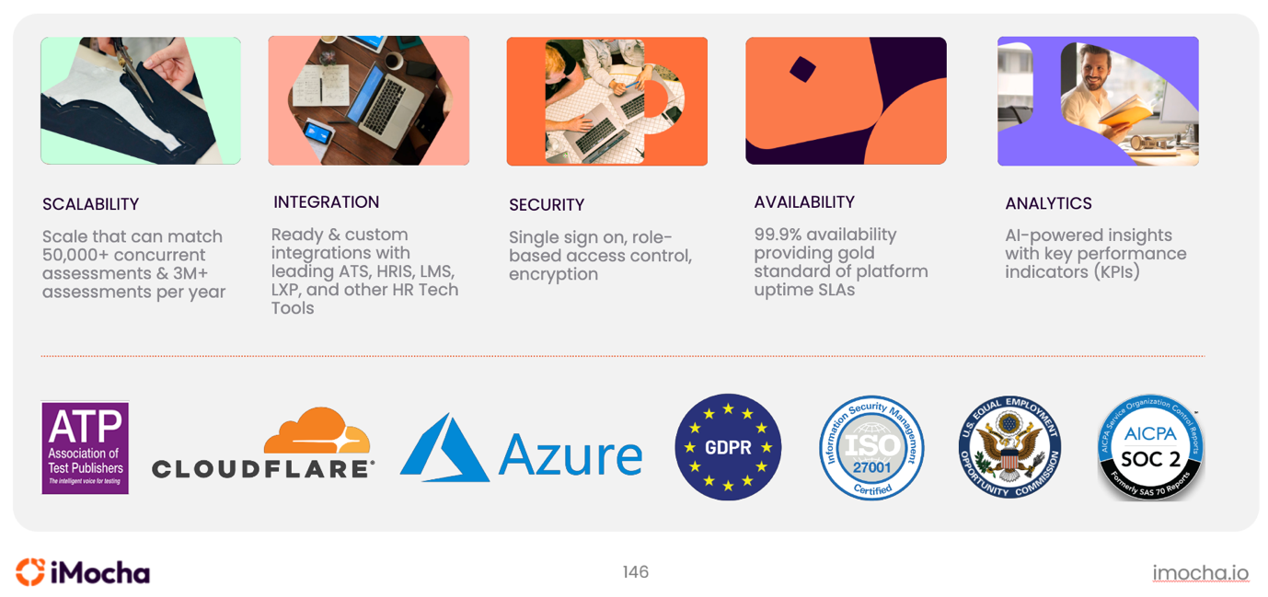
iMocha employs a comprehensive and multi-layered security and compliance framework that aligns with international standards, ensures data integrity and confidentiality, and supports enterprise-grade regulatory compliance.
Industry Certifications and Compliance Standards
- ISO/IEC 27001:2022 Certified
Ensures rigorous implementation of an Information Security Management System (ISMS) for managing company and customer information securely.
- SOC 2 Type II Compliant
Demonstrates operational effectiveness of internal controls related to security, availability, processing integrity, confidentiality, and privacy.
- GDPR Compliant
iMocha adheres to the principles of the General Data Protection Regulation (GDPR)
Data Encryption
- Data is encrypted in Transit using TLS min version 1.2.
- Data is encrypted at Rest using Service-managed transparent data encryption from Microsoft Azure.
Data Isolation & Integrity
Multi-tenant architecture with strict isolation ensures customer data integrity and privacy across clients.
Role Based Access Control
iMocha implements granular RBAC to enforce the principle of least privilege across all roles. Access is customizable based on organizational hierarchy.

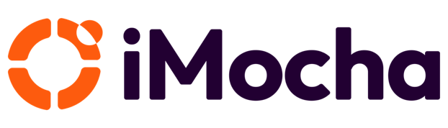

Look Beyond the Label
Call us +﻿1-408-915-5185 or write to us at support@imocha.io
About iMocha

iMocha is an AI-powered Skills-First Cloud that helps enterprises to build a Skills-First and data-driven ecosystem of hiring, upskilling, and managing talent - at scale, for any job role, and any industry. More than 500 organizations are using iMocha's solution for taking a Skills-First approach to accelerated hiring, objective learning and development programs and to manage talent from candidate to alumni. Enterprises from Telecom, Banking, Financial Services, Insurance and Technology are using iMocha's Skills-First platform to make data driven talent decisions. The platform leverages patented technologies and includes innovative features to build employee skills profile, organizational skills inventory, skills taxonomy and skills ontology, skill benchmarking and skills analytics that helps to hire, develop and manage talent by taking a Skills-First approach.

To know more, visit us at www.imocha.io.

