M.P. PUBLIC SCHOOL
Anand Nagar, Maharajganj (U.P.)
CBSE Affiliation No.: 2731551

CBSE SKILL EXPO & GUIDANCE FESTIVAL 2026–27
Regional Event · RO Prayagraj · Gorakhpur
· PROJECT REPORT ·
RUSH PARKOUR
A 3D Platformer Built in Unreal Engine 5
THEME | Animation, Visual Effects, Gaming & Comics
SUB-THEME | 3D Platformer Game
CATEGORY | Category I — Classes 6 to 10 (Hybrid Class X)
TAGLINE | Run. Jump. Beat the Clock.

TEAM — CLASS X (HYBRID)  Aryan Gupta · Game Design, Programming, 3D Assets  Aditi Tripathi · Level Design, Testing & Presentation | EVENT  Venue G.D. Goenka Public School, Ramnagar Karjaha, Gorakhpur – 273202  Date 30 September 2026 (Wednesday)

01 · PROJECT OVERVIEW
What we built, and why
Rush Parkour is a physics-driven 3D platformer where the player sprints, jumps, slides and wall-runs through a series of increasingly tricky obstacle courses against a countdown timer. The game is built end-to-end by two Class X students using Unreal Engine 5 — from modelling the environment in Blender to wiring the gameplay logic in Blueprints and packaging a standalone Windows build.
Reimagined in true 3D with keyboard controls so it can run on any standard school computer lab machine. The vision is simple — build a fun, replayable, performance-friendly game that other students can actually pick up and play.
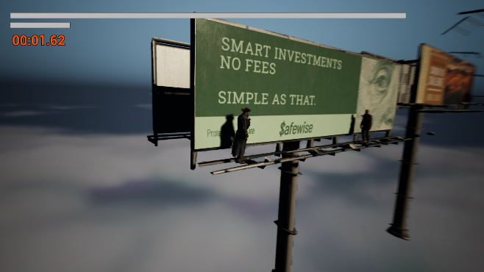
Gameplay — third-person platforming in a 3D environment

02 · TECHNICAL STACK
What it's made of
Game Engine | Unreal Engine 5.3.2 — Blueprint visual scripting, Niagara VFX, World Settings
3D Modelling | Blender — low-poly modular environments, rigged characters, hand-painted textures
Platform | Standalone Windows (.exe) build, full-screen capable, runs without internet
File Size | < 800 MB after packaging (Cooked content + shader strips)
Performance | 70+ FPS target on integrated graphics; scales to 240+ FPS on dedicated GPUs on High settings

03 · CORE GAMEPLAY
What the player does
MOVEMENT  A / D  Run left and right, jump with Spacebar, slide to fit through low gaps. Every move is physics-driven so jumps feel weighty and momentum carries over gaps. | CAMERA  Cine-style 2.5D  A 2.5D camera follows the player through the 3D world, keeping the action readable while still showing real depth, parallax and lighting. | RULES  Pause / Exit  P to change camera Perspective, Escape opens the menu. The countdown resets each level — reach the finish before time runs out for a 3-star rating.

04 · PERFORMANCE & HARDWARE
How we made it run everywhere
One of the hardest parts of building a 3D game in school is hardware. Most lab PCs only have integrated graphics, so our design rule was: if it runs on a standard school PC, it runs anywhere. Every asset is hand-tuned for size and polycount.
HARDWARE | GPU | TESTED FPS | VERDICT
Intel Core i5 + Iris Xe | Integrated | 60 – 70 FPS | Smooth play
Standard School PC (Intel UHD) | Integrated | 40 – 50 FPS | Playable
Gaming Laptop — NVIDIA GTX 1650 | Dedicated | 120+ FPS | Excellent

05 · HOW WE BUILT IT
Development pipeline
01  CONCEPT | 02  ASSETS | 03  LOGIC | 04  TEST
Storyboarded levels on paper; decided on timer-based scoring to keep each run short and replayable. | Modelled platforms, ramps and the character in Blender with low-poly, flat-shaded textures. | Wired movement, camera, timer, scoring and menus in Unreal Blueprints — no external code libraries. | Packaged into a Windows .exe and ran on three different hardware configs for FPS and stability.

06 · IN-GAME SCREENS
A look inside Rush Parkour
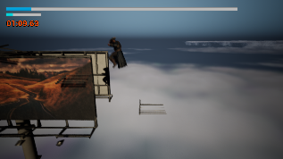 | 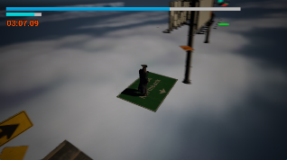

Submitted to CBSE Skill Expo 2026–27 · RO Prayagraj · Regional Level

LIVE PROJECT | Official Project Page https://rushparkour.netlify.app/expo

NOTES

