master-test
Aryan Singh
June 12, 2026

InkDown Master Test Document
This document exercises every rendering feature for visual QA.

1. Inline Formatting
This is bold, italic, bold-italic, strikethrough, and inline code.
Here is a hyperlink and an auto-link: https://example.com.
Superscript: H2O and E=mc² (if supported).

2. Headings

Third Level

Fourth Level

Fifth Level

Sixth Level

3. Blockquotes
Single-level blockquote with bold inside.
Nested blockquotes:
Second level
Third level — still readable?
Quote with other elements:
- Bullet inside a quote
- Another bullet
console.log("code inside a quote");

4. Lists

Unordered
- Item one
- Item two
  - Nested A
  - Nested B
    - Deep nested
- Item three

Ordered
- First
- Second
  - Sub-first
  - Sub-second
- Third

Task List
- Completed task
- Incomplete task
- Another done
- Still pending

Definition-style (if supported)
Term 1
Definition of term 1
Term 2
Definition of term 2

5. Code Blocks

JavaScript
function greet(name) {
const msg = `Hello, ${name}!`;
console.log(msg);
return msg;
}
// Arrow function
const add = (a, b) => a + b;

Python
from pathlib import Path
def convert(src: Path, dst: Path) -> None:
"""Convert markdown to PDF."""
content = src.read_text(encoding="utf-8")
# process...
dst.write_bytes(result)

Bash
#!/usr/bin/env bash
set -euo pipefail
for f in *.md; do
echo "Converting $f …"
inkdown convert "$f" --format pdf
done

JSON
{
"name": "inkdown",
"version": "1.1.0",
"scripts": {
"dev": "node server.js",
"test": "node scripts/test-16.js"
}
}

Plain / no language
This is a fenced code block
with no language specified.
Indentation preserved.

Indented code block (4 spaces)
This is an indented code block.
It should render as code as well.

6. Tables

Simple Table
Feature | PDF | DOCX
Headings | ✅ | ✅
Tables | ✅ | ✅
Mermaid | ✅ | ✅
Grid Tables | ✅ | ✅
Cover Page | ✅ | ❌

Aligned Columns
Left | Center | Right
left-aligned | centered | right-aligned
data | data | 1,234.56
more | more | 99.9

Wide Table
Col 1 | Col 2 | Col 3 | Col 4 | Col 5 | Col 6 | Col 7 | Col 8
A1 | B1 | C1 | D1 | E1 | F1 | G1 | H1
A2 | B2 | C2 | D2 | E2 | F2 | G2 | H2

Table with Inline Formatting
Name | Description
Bold | This cell has code and italics
Strike | Link in cell

7. Horizontal Rules
Above the rule.

Below the rules.

8. Images
Placeholder image
Placeholder image

9. HTML (raw)
Click to expand
This is inside a <details> block.
- Works in browsers
- May not render in PDF
Styled HTML box — does this render?

10. Footnotes (if supported)
Here is a sentence with a footnote.
And another.

11. Math (KaTeX / LaTeX)
Inline math: $E=mc^{2}$
Block math:
$$∫_0^{∞}e^{−x^{2}},dx=\frac{\sqrt{π}}{2}$$
$$∑_{n=1}^{∞}\frac{1}{n^{2}}=\frac{π^{2}}{6}$$

12. Mermaid Diagrams

12.1 Flowchart (TD)
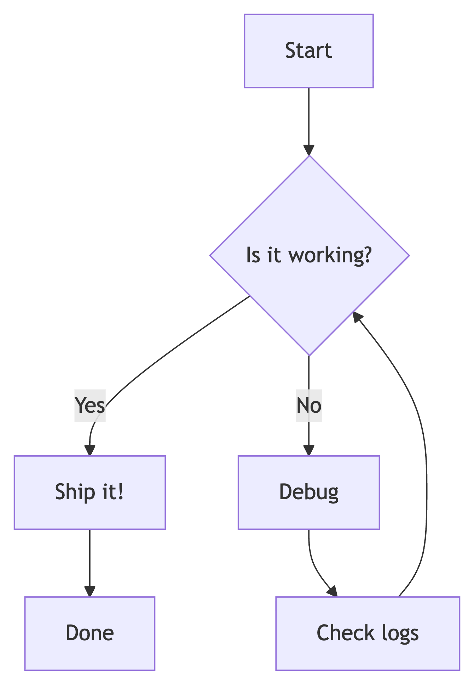
Mermaid Diagram 1

12.2 Flowchart (LR)
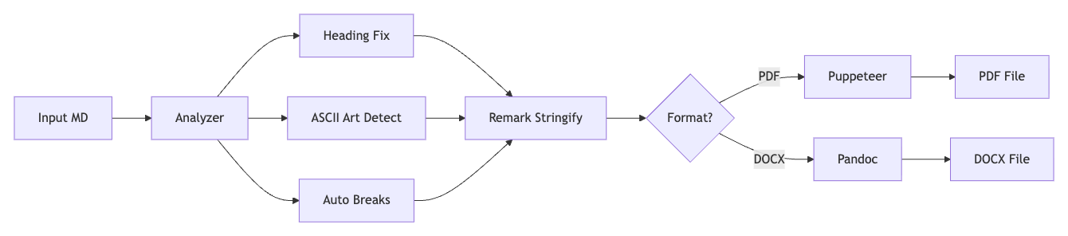
Mermaid Diagram 2

12.3 Sequence Diagram
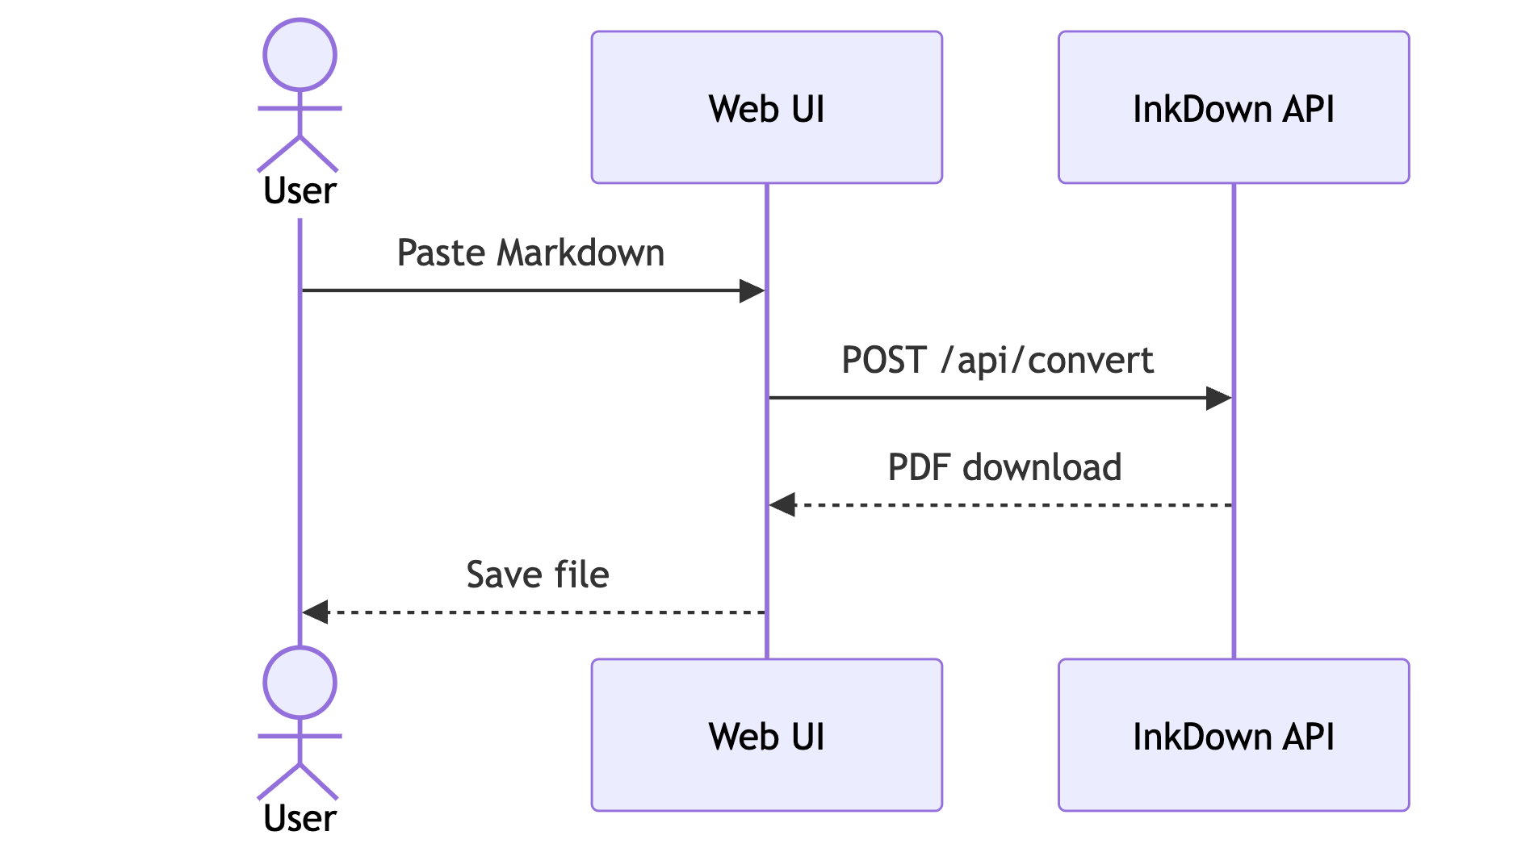
Mermaid Diagram 3

12.4 Class Diagram
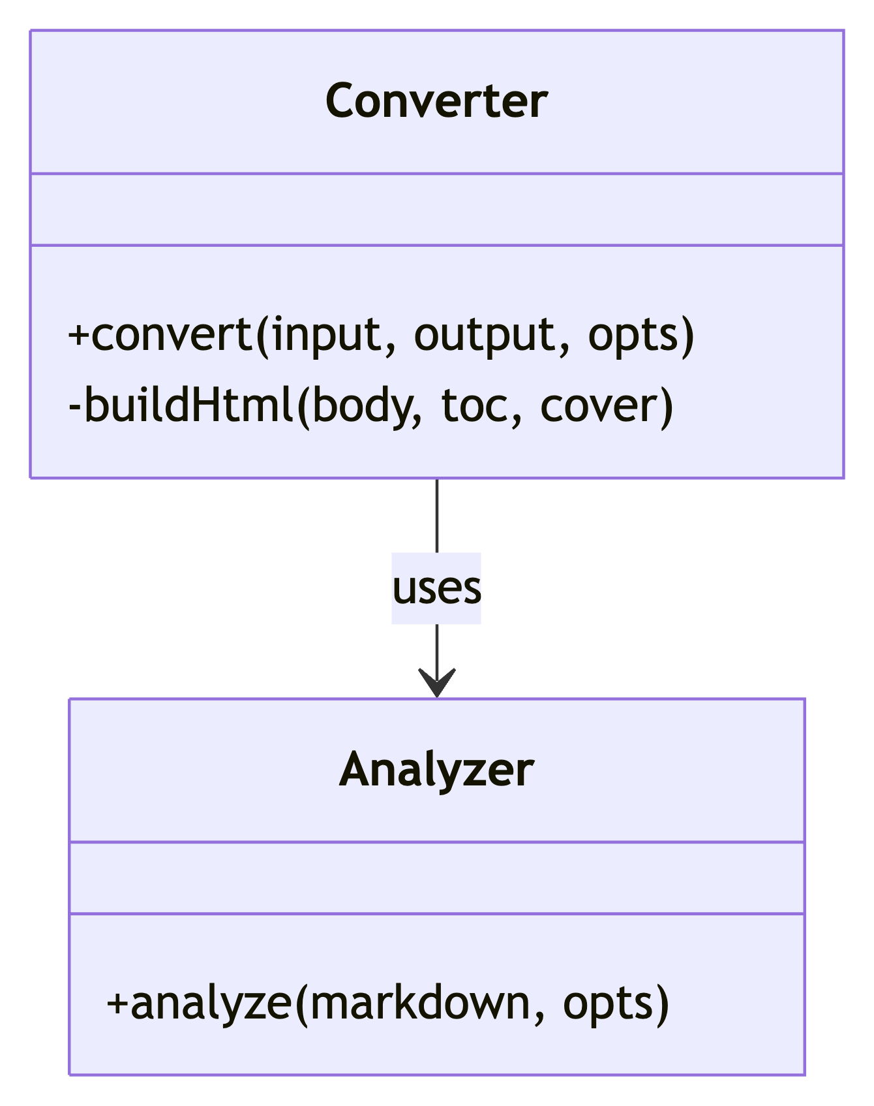
Mermaid Diagram 4

12.5 State Diagram
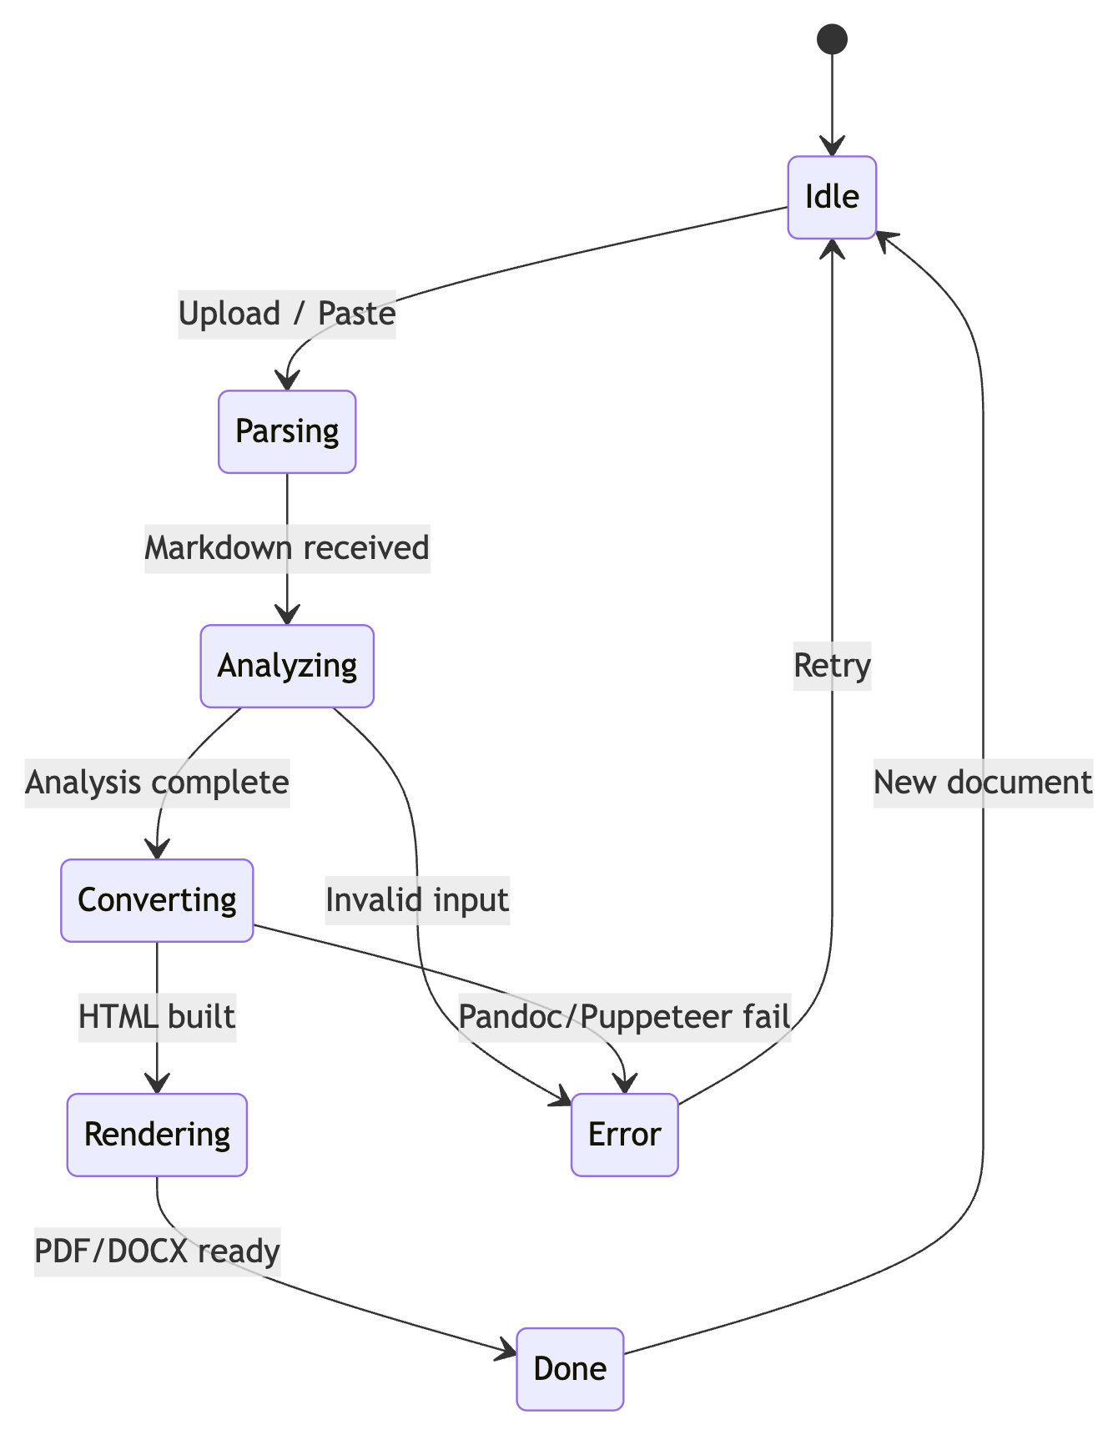
Mermaid Diagram 5

12.6 ER Diagram
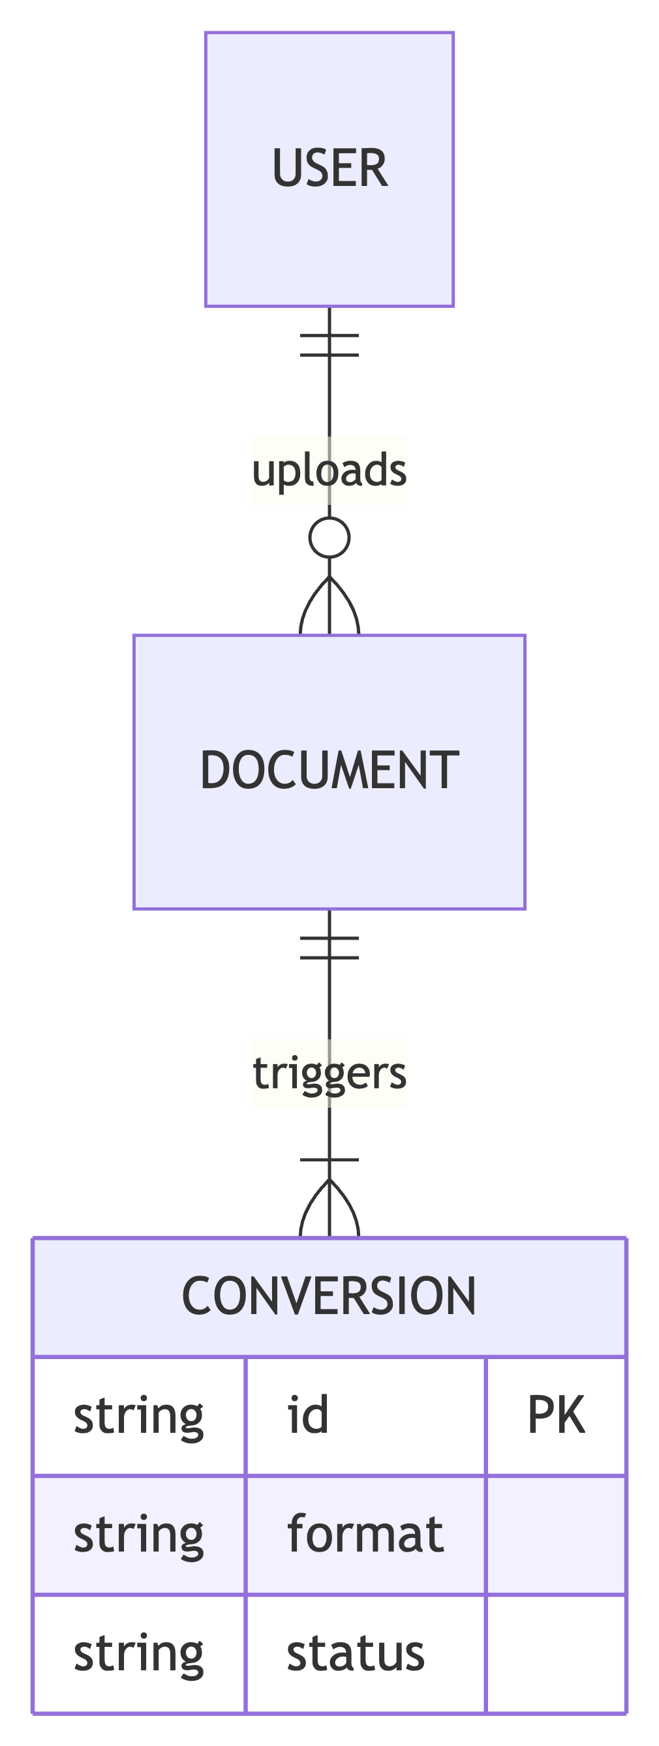
Mermaid Diagram 6

12.7 Gantt Chart
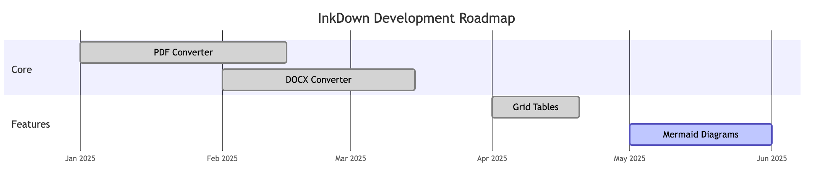
Mermaid Diagram 7

12.8 Pie Chart
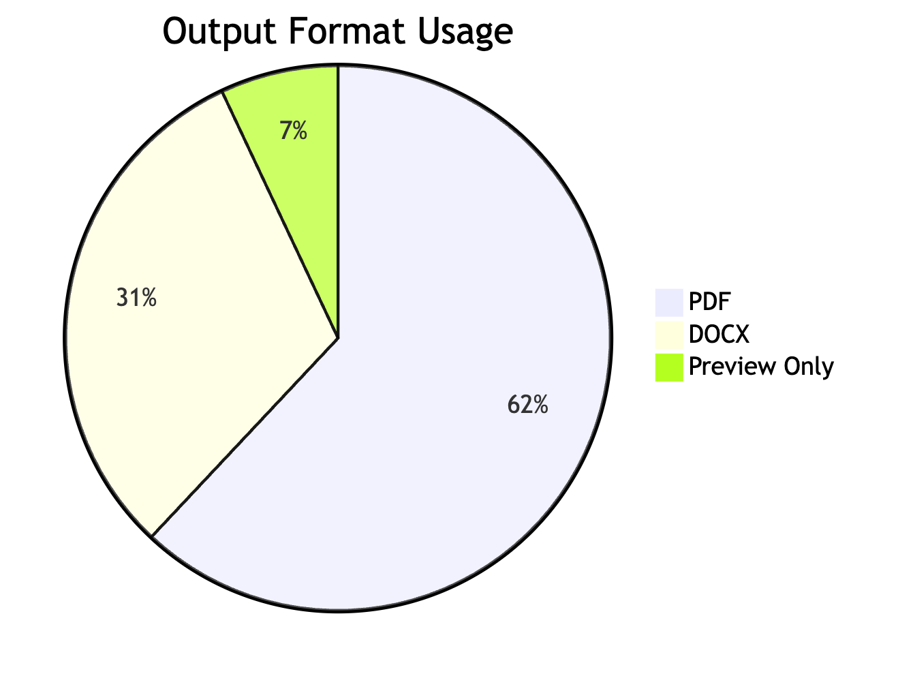
Mermaid Diagram 8

12.9 Git Graph
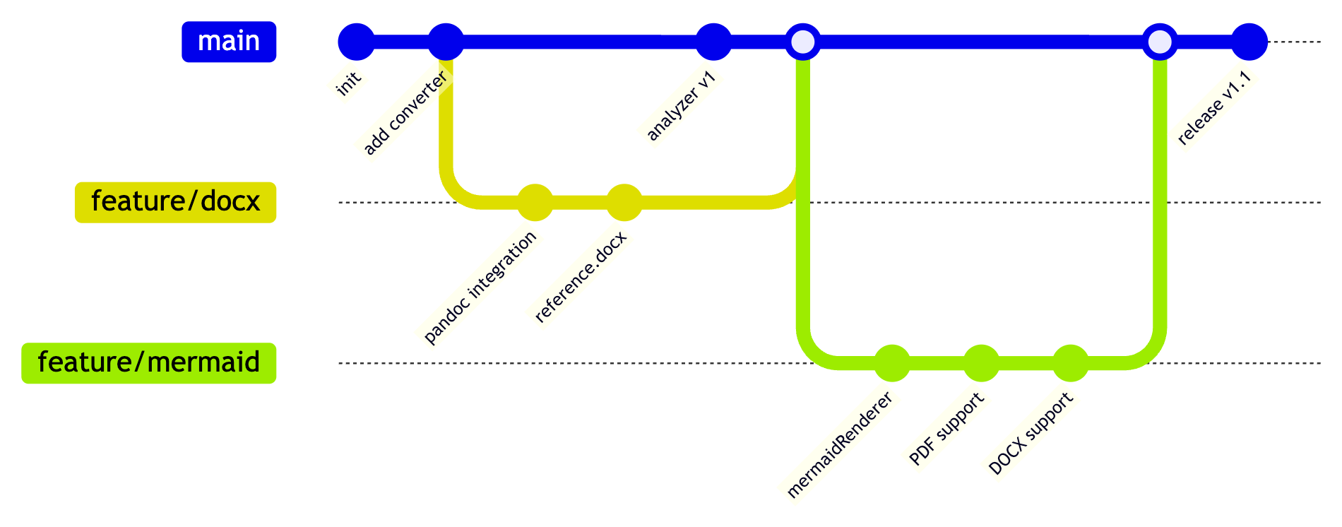
Mermaid Diagram 9

12.10 Mindmap
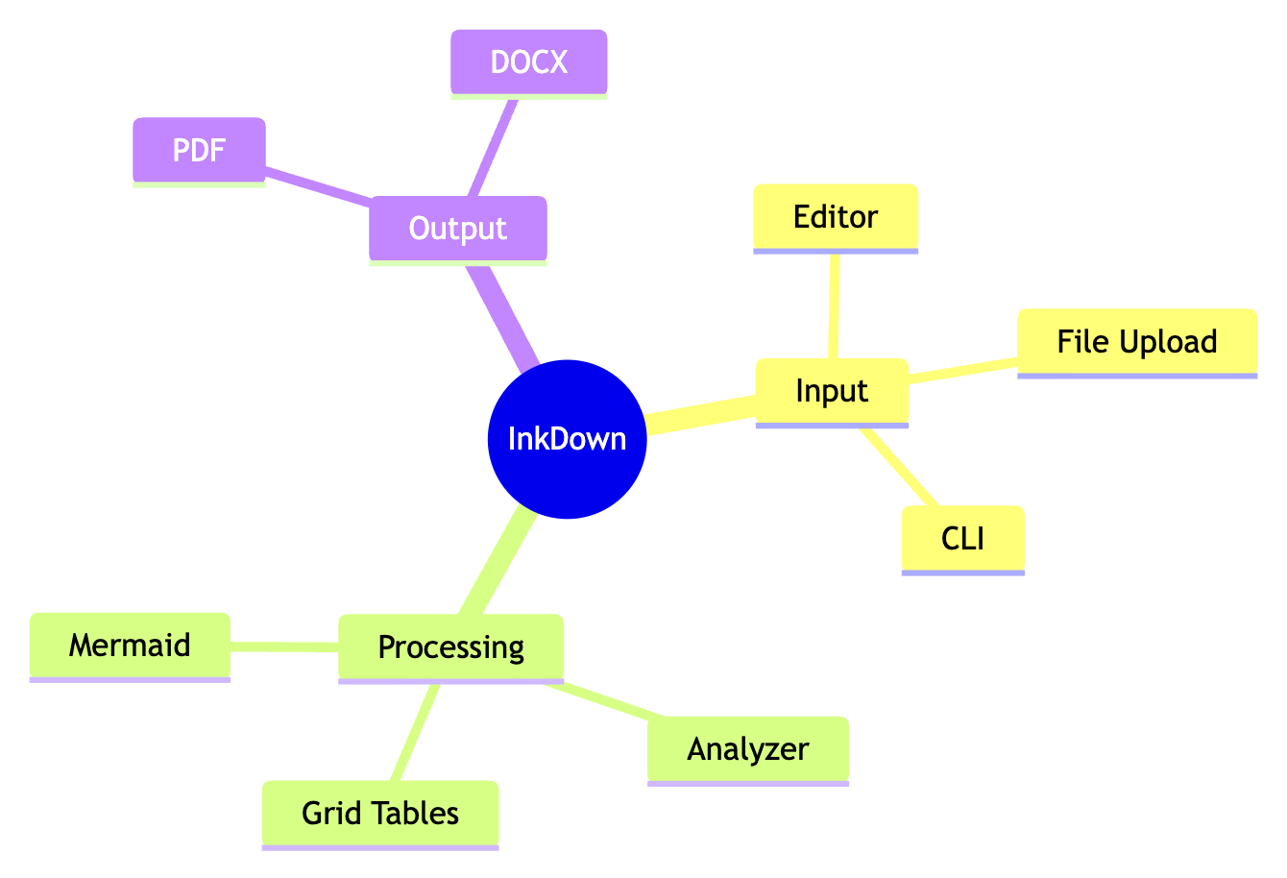
Mermaid Diagram 10

13. Nested / Mixed Content

Quote with a Table
A | B
1 | 2
And a code block:
print("inside a quote")

List with Code and Tables
- First, run the install:
- npm install
- Then check the config:
Key | Value
format | pdf
toc | true
- Finally convert:
- node server.js

14. Long Paragraph (Wrapping Test)
Lorem ipsum dolor sit amet, consectetur adipiscing elit. Sed do eiusmod tempor incididunt ut labore et dolore magna aliqua. Ut enim ad minim veniam, quis nostrud exercitation ullamco laboris nisi ut aliquip ex ea commodo consequat. Duis aute irure dolor in reprehenderit in voluptate velit esse cillum dolore eu fugiat nulla pariatur. Excepteur sint occaecat cupidatat non proident, sunt in culpa qui officia deserunt mollit anim id est laborum. Cras justo odio, dapibus ac facilisis in, egestas eget quam. Donec id elit non mi porta gravida at eget metus. Nullam quis risus eget urna mollis ornare vel eu leo.

15. Special Characters & Emoji
Arrows: → ← ↑ ↓ ↔ ⇒ ⇐
Symbols: © ® ™ § ¶ † ‡ • ° ± ÷ × ≈ ≠ ≤ ≥
Emoji: 🚀 📄 ✅ ❌ ⚡ 🎨 🔧 📦
Quotes: “curly doubles” ‘curly singles’ «guillemets»
Dashes: en–dash em—dash

16. Page Break Handling
Content before the break.
Content after the break — this should start on a new page in PDF.

End of master test document.

This is the first footnote.
This is a named footnote with bold text.

