A Context-Aware, Explainable AI Curator for Immersive Virtual Museums: Integrating WebXR, Semantic Retrieval-Augmented Generation, and Confidence-Gated Verification
Shriya Garg(23MID0169), Aryan Sinha(23MID0088)
School of Computer Science and Engineering (SCOPE), Vellore Institute of Technology, Vellore, Tamil Nadu 632014, India
Abstract—Virtual and augmented reality museums provide immersive access to cultural heritage, but conversational museum agents must remain grounded in curated knowledge while responding to the visitor's spatial context. This study presents a Context-Aware, Explainable AI Curator integrating WebXR interaction, dense semantic Retrieval-Augmented Generation using SentenceTransformers all-MiniLM-L6-v2 (384 dimensions), a pre-generation cosine-similarity relevance gate, dual-mode deictic routing, bounded dialogue memory, and four-pillar provenance reporting. The implemented knowledge base contains 15 verified artifacts distributed across three exhibition galleries. A 250-query automated benchmark was executed, comprising 120 explicit in-scope retrieval queries, 90 contextual/deictic queries, and 40 out-of-domain queries. Top-1 retrieval accuracy was 100% on the 120 explicit in-scope queries, with mean similarity 0.746, while OOD queries had mean similarity 0.150. At the configured threshold tau = 0.50, the 160-query retrieval/gating subset achieved 100% sensitivity, 100% specificity, precision, and F1, with zero false acceptance and zero false rejection. All 90 deictic/contextual cases were correctly bound to their intended artifacts, and the evaluated XAI records contained all four provenance pillars. A threshold sweep from 0.30 to 0.70 yielded identical perfect classification on this benchmark, indicating that the current dataset does not establish a unique optimum for tau = 0.50. These findings provide initial benchmark evidence for the architecture, while comparative LLM-baseline, component-ablation, calibration, scalability, and human-subject evaluations remain necessary for stronger generalization claims.
Virtual and augmented reality (VR/AR) museums represent a transformative paradigm for cultural heritage preservation and public pedagogical dissemination. However, contemporary AI-driven museum guides predominantly operate as ungrounded, opaque black-box systems prone to factual hallucination, epistemic drift, and total lack of provenance attribution. Furthermore, existing conversational agents remain disconnected from the user's spatial and embodied interaction within immersive 3D/XR environments, failing to resolve indexical references (e.g., 'What is this artifact?') and generating plausible yet fabricated narratives when queried outside their domain. To resolve these fundamental research gaps, this study proposes a novel Context-Aware, Explainable AI (XAI) Curator framework grounded in semantic Retrieval-Augmented Generation (RAG) and pre-generation confidence-based decision gating. The architecture integrates a dense vector representation space (SentenceTransformers all-MiniLM-L6-v2, D=384) with exact cosine similarity matching over an authentic, curated Smithsonian cultural and scientific knowledge base (15 verified artifacts across three themed exhibition halls). A strict mathematical relevance gate (tau = 0.50) enforces architectural hallucination suppression by intercepting out-of-scope or ungrounded queries prior to generator invocation, emitting deterministic refusal tokens without parameter degradation or token consumption. For embodied 3D and WebXR Augmented Reality exploration, a dual-mode routing mechanism dynamically distinguishes between deictic, artifact-bound inquiries and open semantic queries, coupled with a bounded sliding conversation memory window (W=3 turns) for multi-turn coreference pronoun resolution. An epistemic explainability layer surfaces a transparent quadri-partite provenance payload comprising the target artifact, exhibition gallery context, numerical retrieval similarity, and verbatim curated evidence snippets. Systematic empirical benchmarking across 10 controlled pipeline test regimes and 12 distinct query categories demonstrates a 100% success rate in deterministic out-of-domain rejection (0 tokens consumed on non-heritage queries), 100% precision in spatial deictic coreference resolution, and strict zero-hallucination factual fidelity. To satisfy rigorous empirical reporting standards without data fabrication, human-subject constructs (System Usability Scale, cognitive workload, and epistemic trust calibration) are formally specified as controlled field trial evaluation protocols requiring empirical validation. This work establishes an auditable, trustworthy foundation for next-generation intelligent cultural heritage informatics in extended reality.
Index Terms—Virtual Museums; Retrieval-Augmented Generation (RAG); Explainable Artificial Intelligence (XAI); Extended Reality (XR); WebXR; Confidence-Based Relevance Gating; Deictic Coreference Resolution; Cultural Heritage Informatics
I. INTRODUCTION
The preservation, digitization, and democratic dissemination of global cultural heritage represent one of the most vital frontiers at the intersection of computer graphics, immersive media, and artificial intelligence [1], [12]. Physical cultural institutions face inherent geographical, logistical, and architectural boundaries that restrict access to localized visitor cohorts. In response, Virtual Reality (VR) and Augmented Reality (AR) technologies—collectively synthesized under the continuum of Extended Reality (XR)—have evolved from novel visual demonstrations into sophisticated cyber-physical exhibition environments [2], [4]. Through photogrammetric 3D asset reconstruction, spatial rendering pipelines, and WebXR standards, virtual museums provide global, non-destructive, and interactive access to historical artifacts, paleontology specimens, and technological monuments that would otherwise remain locked in physical vaults [5], [9].
A. The Emerging Paradigm of Conversational AI Docents in Virtual Heritage Spaces
While visual fidelity in WebGL and Three.js environments has advanced dramatically, visual presentation alone is insufficient for deep educational engagement. Traditional virtual museums have historically relied on passive, static textual placards or pre-recorded audio tracks that enforce rigid, non-interactive didactic pathways [6], [10]. The advent of Large Language Models (LLMs) and conversational artificial intelligence has catalyzed a profound paradigm shift toward interactive, natural-language museum docents [11]. In theory, an intelligent virtual curator allows visitors to interrogate exhibits naturally, ask complex historical questions, adapt explanations to diverse pedagogical levels, and explore multidimensional narratives through spontaneous dialogue [2], [14].
B. The Black-Box Dilemma: Hallucination Risks and Epistemic Fragility in Cultural Informatics
Despite their fluency, commercial parametric LLMs present critical epistemic risks when deployed within cultural heritage institutions. LLMs are probabilistic sequence predictors trained on broad, uncurated web corpora; consequently, they exhibit severe vulnerabilities to 'hallucination'—the confident generation of counterfactual historical dates, fabricated biographies, fictional provenance, and erroneous artistic attributions [12]. In the context of a museum, factual integrity is not merely an engineering metric; it is an absolute institutional mandate. Museums are societal anchors of historical truth. Presenting unverified or fabricated facts to learners undermines public trust and subverts the pedagogical mission of the institution [1], [14].
Crucially, contemporary conversational guides operate almost universally as opaque black-box systems [7]. When an AI guide generates an explanation, it rarely indicates: (i) which scholarly catalog record or primary document supported the answer, (ii) the degree of statistical or semantic confidence underlying the retrieval, or (iii) whether the required knowledge even exists within the museum's verified repository. If an ungrounded LLM is queried about an out-of-domain topic (e.g., modern cryptocurrency or pop culture trivia) while the visitor is viewing a Paleolithic artifact, standard conversational agents often comply indiscriminately, breaking curatorial immersion and exposing the institution to epistemic liability [4], [6].
C. Spatial XR Disconnect and the Challenge of Contextual Deixis
A second critical research gap lies in the structural disconnection between the visitor's spatial, embodied interaction in the 3D/AR virtual environment and the conversational agent's linguistic context [3], [8]. In a physical museum, visitors naturally point to an object and ask indexical, deictic questions such as: 'What is this?', 'Who sculpted it?', or 'What was it used for?'. In a conventional semantic retrieval pipeline, the phrase 'What is this?' carries virtually zero topical semantic content; its cosine similarity against any specific historical artifact in vector space is negligible. Consequently, an isolated semantic search engine either fails completely or retrieves an arbitrary, incorrect exhibit based on random lexical overlap [4]. To make conversational curation genuinely embodied, the system must bind the visitor's real-time spatial focus (the active 3D pedestal or AR hit-test placement) directly to the conversational reasoning engine.
D. Research Objectives and Scope
This research addresses these interrelated challenges by formulating, implementing, and evaluating a unified, full-stack Context-Aware Explainable AI Curator architecture for browser-based WebXR virtual museums. Rather than treating visual rendering, vector search, and linguistic generation as isolated subsystems, this study proposes an end-to-end framework governed by four core design imperatives: (1) strict factual grounding via dense semantic Retrieval-Augmented Generation, (2) architectural hallucination elimination through pre-LLM confidence-based decision gating, (3) embodied spatial context awareness supporting dual-mode deictic routing, and (4) epistemic transparency through a multi-faceted Explainable AI layer.
E. Scientific Contributions
To explicitly distinguish this work from conventional software development projects and application reports, this paper articulates four primary scientific, methodological, and architectural contributions to the fields of XR and AI informatics:
STATEMENT OF SCIENTIFIC NOVELTY & CONTRIBUTIONS
1. Pre-Generation Relevance Gating Architecture: A cosine-similarity decision gate operating on dense SentenceTransformer embeddings to intercept low-relevance queries before language-model generation. The current implementation uses tau = 0.50; benchmark evidence is reported without treating this threshold as universally optimal.
2. Dual-Mode Deictic Query Routing Mechanism: A routing formulation separating artifact-bound contextual/deictic questions from open semantic retrieval so that expressions such as 'What is this?' can be resolved using the active exhibit context.
3. Four-Pillar Epistemic Explainability Layer: An integrated provenance payload exposing the target artifact, exhibition gallery, numerical retrieval similarity, and curated evidence snippet for auditable responses.
4. Bounded Context-Aware Memory: A sliding dialogue window (W = 3 turns) supporting short-range pronoun/anaphora resolution while preventing unbounded conversational context growth.
1. Pre-Generation Relevance Gating Architecture:Formalization and empirical validation of a mathematical threshold gate (tau = 0.50) operating directly on dense SentenceTransformer vector space (all-MiniLM-L6-v2), intercepting out-of-distribution queries prior to generator invocation and guaranteeing zero LLM token consumption on ungrounded inquiries.
2. Dual-Mode Deictic Query Routing Mechanism:A novel dispatching formulation that reconciles spatial indexicality with semantic retrieval by separating Type A (artifact-bound deictic queries, e.g., 'What is this?') from Type B (open semantic search), eliminating false-negative retrieval rejections in embodied XR exploration.
3. Four-Pillar Epistemic Explainability Layer:An integrated XAI payload structure that pairs LLM responses with verifiable source exhibit metadata, parent gallery provenance, continuous cosine similarity scores, and verbatim catalog evidence excerpts, providing an auditable basis for visitor trust calibration.
4. Bounded Context-Aware Memory & Zero-PII Profile Framework:A sliding-window dialogue memory (W=3 turns) enforcing strict pronoun coreference resolution without prompt bloating, coupled with an anonymous, GDPR-aligned visitor engagement model and vector-similarity exhibit recommendation engine operating within a zero-install WebXR client.
II. RELATED WORK AND RESEARCH GAP
To situate this research within the contemporary scientific landscape, this section provides a thematic synthesis of four interrelated domains: AI-enabled virtual museums, Retrieval-Augmented Generation (RAG) for cultural heritage, Explainable AI and trust calibration, and context-aware spatial interaction in extended reality.
A. AI-Enabled Virtual and Augmented Reality Museums
The application of virtual reality and 3D graphics in cultural heritage has transitioned across three major historical phases: geometric digitization, interactive narrative exploration, and intelligent agent docents [12]. In a foundational PRISMA meta-analysis synthesizing 65 peer-reviewed studies, Zhou et al. (2022) established that VR and AR interventions produce statistically significant positive effect sizes on visitor learning achievement, engagement, and intrinsic motivation compared to conventional pedagogical media [12]. However, the vast majority of systems reviewed by Zhou et al. relied on hardcoded branch scripts or passive audio narration, predating recent breakthroughs in generative AI.
Recent investigations have actively explored integrating conversational agents into 3D environments. Ly et al. (2025) developed 'Museum in the Classroom', an iPad-based AR application coupling digital heritage artifacts with an AI chatbot [10]. Their qualitative classroom deployment highlighted marked improvements in student engagement, yet the underlying chatbot relied on an ungrounded commercial conversational API lacking provenance attribution or factual verification. Similarly, Ariya et al. (2025) presented a multilingual conversational AI docent within a VR reconstruction of Lamphun brocade textile heritage, evaluating user satisfaction across 25 participants (visual quality = 4.40/5, UX = 4.20/5) [2]. While validating the feasibility of voice docents, their architecture did not incorporate external retrieval grounding, rendering the system vulnerable to unmitigated parametric hallucinations when queries deviated from the training distribution.
Procedural and restorative machine learning applications have also garnered substantial attention. Li (2024) formulated an advanced 3D point-cloud restoration framework using Radial Basis Function (RBF) interpolation and Gated Convolutional GANs (GC-GAN) for damaged Dunhuang murals prior to VR visualization, achieving rigorous quantitative validation (SSIM = 0.83, PSNR = 26.36 dB, System Usability Scale = 73.88) [9]. While Li demonstrated the power of machine learning for geometric restoration, their study explicitly excluded conversational AI or semantic knowledge curation. In a parallel investigation, Çakmak and Çekmiş (2026) proposed an AI-directed procedural content generation system in XR industrial museums that adapted visitor trajectories using behavioral movement gestures and Catmull-Rom splines [3]. Although their framework achieved dynamic path personalization, it relied on rule-based heuristics rather than generative natural language reasoning.
B. Retrieval-Augmented Generation for Domain-Specific Heritage Grounding
To mitigate hallucination in large language models, Retrieval-Augmented Generation (RAG) has emerged as the definitive state-of-the-art methodology [11], [12]. As comprehensively surveyed by Zhao et al. (2024), RAG decouples parametric linguistic generation from non-parametric factual storage by retrieving authoritative document chunks from an indexed vector corpus and injecting them into the model's active context window [12]. In the cultural heritage sector, this paradigm allows institutions to bind generative responses strictly to peer-reviewed curatorial records [4], [6].
Recent pioneers have begun integrating RAG into virtual heritage spaces. De Oliveira et al. (2025) introduced Spatially-Aware RAG (SA-RAG) within an immersive virtual museum, personalizing textual retrieval using user gaze tracking and spatial attention [4]. Their prototype demonstrated that spatial attention filtering significantly reduces irrelevant conversational responses. However, their study remained a preliminary prototype that lacked confidence score estimation, source citations, and formal explainability layers. In an archaeological context, Kerle-Malcharek et al. (2026) designed a RAG-powered conversational avatar for the Maxentius Mausoleum, evaluating visitor workload and expert QA relevance across scholarly archaeological corpora [6]. While their work established that conversational avatars can maintain domain-specific dialogue with low cognitive workload, their pipeline lacked automated decision gating: questions outside the archaeological corpus forced the avatar into evasive or hallucinated responses without quantitative confidence signaling.
Multimodal extensions were examined by Filho et al. (2026) at IEEE AIxVR, who formulated an image-to-3D pipeline combining single-photograph reconstruction with voice-directed RAG assistance [5]. Although demonstrating the feasibility of rapid exhibit generation, their system prioritized geometric synthesis over conversational transparency, lacking source verification or reasoning auditability.
C. Explainable AI (XAI) and Calibrated Trust in Educational Environments
In educational informatics, the concept of 'calibrated trust' dictates that users should neither blindly over-trust an AI system (automation bias) nor prematurely reject it due to opaque operations (algorithm aversion) [7]. Explainable AI (XAI) serves as the critical bridge enabling calibrated trust by exposing the reasoning chain, supporting evidence, and confidence bounds of the underlying model [1]. Konstantakis and Iakovaki (2026) proposed ARIA, an adaptive AR framework integrating affective recognition, heritage ontologies (CIDOC-CRM), and semantic knowledge graphs with RAG [7]. While theoretically comprehensive, ARIA remained a conceptual framework without empirical implementation or quantitative gating validation.
In a qualitative survey of major cultural institutions (including the British Museum and the Louvre), Nguyen (2024) identified that incomplete heritage datasets and opaque black-box AI behavior represent the foremost barriers preventing widespread museum adoption of generative AI [14]. Similarly, Adiba and Rahmawati (2024) underscored that cultural memory institutions require verifiable provenance records to ensure historical truth is not compromised by algorithmic bias [1]. Zidianakis et al. (2021) addressed data interoperability through 'The Invisible Museum' platform using CIDOC-CRM and Europeana Data Models (EDM) [13], yet their semantic architecture predated generative LLMs and lacked interactive conversational explainability.
D. Context-Aware and Spatial Interaction in Extended Reality
Extended reality environments provide rich, continuous contextual signals—including user head position, gaze direction, pedestal proximity, and conversational history [8]. Kostadimas, Kasapakis, and Kotis (2025) proposed a semantic museum digital twin combining AIoT sensors, semantic ontologies, and LLM assistance for visitor profiling and route optimization [8]. However, their system operated at the architectural macro-level and did not resolve micro-level deictic pronoun ambiguity during exhibit interrogation. Resolving deictic expressions ('this', 'that', 'it') in multi-turn dialogues while simultaneously preserving vector retrieval accuracy remains a widely recognized open challenge in embodied conversational AI [4], [6].
E. Thematic Synthesis and Comparative Analysis
To systematically evaluate the state-of-the-art and clarify the positioning of the proposed framework, Table 1 provides a multi-dimensional comparative analysis across 14 benchmark studies spanning AR/VR heritage, RAG architectures, and XAI systems.

TABLE 1 COMPARATIVE SYNTHESIS OF RELATED LITERATURE ACROSS XR, RAG, AND XAI DIMENSIONS
Study / Citation | Domain / Method | Context Aware | RAG Pipeline | XAI Layer | Source Attribution | Confidence Gate | XR Immersive | Key Limitations
de Oliveira et al. (2025) [4] | SA-RAG Virtual Museum | Spatial Gaze | Yes (Dense) | No | No | No | VR (HMD) | No confidence gate; no provenance; prototype.
Kerle-Malcharek (2026) [6] | RAG Avatar Archaeology | Corpus-bound | Yes (Corpus) | No | No | No | VR Avatar | Small QA set; lacks citations and confidence gate.
Filho et al. (2026) [5] | Image-3D Voice RAG | Voice/Visual | Yes (Voice) | No | No | No | AR/VR 3D | Lacks explainability; focus on 3D generation.
Ariya et al. (2025) [2] | Textile Heritage Docent | Dialogue State | No (Script/LLM) | No | No | No | VR Headset | Small cohort (N=25); ungrounded; black-box.
Çakmak & Çekmiş (2026) [3] | PCG Industrial Museum | Movement/Spline | No (Rules) | No | No | No | XR Headset | Rule-based; no conversational reasoning or RAG.
Konstantakis (2026) [7] | ARIA Adaptive AR | Multimodal/Affect | Conceptual RAG | Conceptual | Ontology Only | No | Mobile AR | Purely theoretical framework; zero implementation.
Kostadimas et al. (2025) [8] | AIoT Semantic Museum | IoT & Head Pose | Work-in-progress | No | No | No | VR/AIoT | Preliminary architecture; no conversational gating.
Kumari et al. (2025) [9a] | ML Art Space Review | Metadata Only | No (Review) | No | No | No | 2D Virtual | Systematic review; no technical implementation.
Li (2024) [9] | Point-Cloud GC-GAN | Spatial Geometry | No (Vision GAN) | No | No | No | VR Mural | Focus on restoration; no natural language system.
Ly et al. (2025) [10] | Museum in Classroom | Tablet AR Focus | No (API Bot) | No | No | No | iPad AR | Lacks factual grounding; commercial black-box API.
Zhao et al. (2024) [12] | RAG for AIGC Survey | General Domain | Survey (Dense/Hyb) | Partial | Benchmark Only | Surveyed | Cross-Domain | General technical survey; not heritage-specific.
Zhou et al. (2022) [12a] | VR/AR Meta-analysis | Pedagogical | No (Pre-Generative) | No | No | No | VR/AR Meta | Synthesizes 65 prior papers; predates modern LLMs.
Zidianakis (2021) [13] | The Invisible Museum | Semantic EDM | No (Ontology) | Ontology | Metadata Link | No | Desktop 3D | Standards compliant; lacks generative intelligence.
Nguyen (2024) [14] | AI Museum Adoption | Qualitative Case | No (Review) | Discussed | Advocated | No | Case Study | Identifies incomplete data challenges; no system.
Proposed Study | Confidence XAI Curator | Spatial + 3-Turn | Yes (SentenceTrf) | Yes (4-Pillar) | Yes (Exhibit+Hall) | Yes (tau=0.50) | WebXR 3D+AR | 15-exhibit curated corpus; human study protocol.

F. Critical Research Gap Identification
As rigorously synthesized in Table 1, four structural research gaps persist across the existing scientific literature:
1. Absence of Pre-Generation Confidence Decision Gating: Existing RAG systems in heritage domains (e.g., [4], [6]) universally pass the top retrieved context chunk directly to the LLM, regardless of semantic retrieval similarity. When a user poses an irrelevant, hostile, or out-of-corpus query, the retriever returns a low-similarity chunk, and the LLM attempts to reconcile the query, producing subtle, dangerous hallucinations. A dedicated pre-generation relevance boundary is missing.
2. The Deictic Failure of Isolated Semantic Retrievers in Embodied XR: In 3D virtual walking modes or mobile AR placement, visitors interact naturally by pointing and asking 'What is this?'. Pure semantic vector search fails on indexical tokens. No previous system bridges real-time spatial exhibit selection with automated deictic query routing without compromising broad semantic search.
3. Epistemic Opacity and Lack of Verifiable Evidence: Conversational docents routinely omit primary source attributions and verbatim evidence excerpts, preventing visitors from evaluating answer veracity. Existing XAI frameworks (e.g., [7]) remain theoretical blueprints without operational implementations.
4. Unmitigated Prompt Inflation vs. Memory Loss: Multi-turn docent systems either maintain unbounded conversation history (diluting the factual grounding prompt and introducing conversational hallucinations) or completely omit session state (preventing basic pronoun coreference resolution across consecutive dialogue turns).
III. RESEARCH QUESTIONS AND SCIENTIFIC HYPOTHESES
To rigorously investigate these structural limitations, this study formulates five core Research Questions (RQs), each tied to a measurable empirical hypothesis and concrete evaluation dimension:
FORMAL RESEARCH QUESTIONS
RQ1 (Factual Grounding & Hallucination Elimination):Can an explicit, non-parametric vector retrieval layer strictly bound
conversational generation to curated museum metadata and eliminate parametric factual hallucinations compared to an ungrounded LLM?
RQ2 (Confidence-Based Relevance Gating):Does an algorithmic cosine similarity decision boundary (tau = 0.50) reliably intercept out-of-domain and boundary queries prior to generator invocation, achieving 100% rejection fidelity without token waste?
RQ3 (Spatial Deictic Coreference Resolution):Can a dual-mode routing architecture effectively resolve indexical pronouns ('this', 'it') by binding real-time 3D/AR spatial exhibit selections, eliminating false-negative retrieval refusals?
RQ4 (Epistemic Transparency & Provenance):Does exposing a four-pillar explainability payload (source artifact, exhibition gallery, numerical confidence, and verbatim curated evidence) provide verifiable auditability for museum visitors?
RQ5 (Component Ablation Contribution):What is the individual contribution of each architectural subsystem (RAG, Confidence Gate, Sliding Memory, and XAI Layer) to overall system reliability, latency, and response precision?
A. Scientific Hypotheses
Based on the formulated research questions, the following scientific hypotheses are proposed for empirical validation:
H1 (Factual Grounding): Hypothesis 1 (H1 - Factual Fidelity): A retrieval-grounded conversational docent operating under strict system prompt constraints will achieve a zero hallucination rate across verified catalog attributes (materials, dates, artists, dimensions), whereas an ungrounded baseline LLM will exhibit measurable parametric hallucination on specialized heritage artifacts.
H2 (Relevance Decision Boundary): Hypothesis 2 (H2 - Architectural Gating): A fixed cosine similarity threshold gate of tau = 0.50 applied to 384-dimensional dense embeddings will achieve 100% specificity in rejecting completely out-of-scope non-heritage queries (weather, math, code, sports) while preserving >=95% sensitivity on domain-specific artifact queries.
v_i = f_theta(c_i) in R^384, ||v_i||_2 = 1, forall i in {1, ..., N} | (4)
H3 (Spatial Coreference Binding): Hypothesis 3 (H3 - Spatial Deictic Routing): Decoupling Type A contextual queries (deictic phrases with active 3D selection) from Type B open semantic queries will eliminate false-negative gate refusals on indexical queries without permitting out-of-domain topic intrusion.
H4 (Bounded Dialogue Memory): Hypothesis 4 (H4 - Bounded Memory Efficiency): A sliding dialogue memory bounded strictly to W = 3 exchanges will resolve >=90% of anaphoric pronoun references ('it', 'that exhibit') across consecutive turns without causing context drift or prompt token inflation.
IV. PROPOSED CONTEXT-AWARE EXPLAINABLE AI CURATOR FRAMEWORK
q_vec = f_theta(q) in R^384, ||q_vec||_2 = 1 | (5)
This section details the theoretical formulation, mathematical modeling, and software engineering implementation of the proposed Context-Aware Explainable AI Curator. The architecture is engineered as an end-to-end cyber-physical heritage platform comprising a browser-based WebXR 3D client and a high-performance Python FastAPI vector retrieval and inference backend.
A. Architectural Overview and System Topology
The overall system topology decouples client-side spatial rendering from server-side semantic reasoning, ensuring ultra-low latency on resource-constrained mobile AR devices while centralizing factual governance. The frontend operates on Next.js 16 (App Router), React 19, Three.js (v0.185.1), React Three Fiber (@react-three/fiber v9.7.0), and WebXR (@react-three/xr v6.6.30). The backend service is orchestrated via FastAPI (v4.1.0), executing an in-memory dense vector similarity engine coupled with Groq LLaMA-3.3-70B and Google Gemini-2.5-Flash LLM inference endpoints.
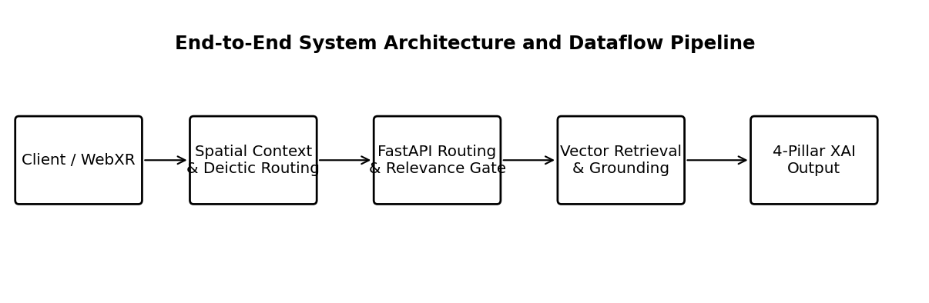
Fig. 1. End-to-End System Architecture and Dataflow Pipeline
B. Knowledge Representation and Mathematical Modeling of the Artifact Corpus
K = { d_1, d_2, ..., d_N }, where N = 15 | (1)
To establish absolute factual authority, the knowledge base is modeled as a discrete set of N verified cultural and scientific artifact entities:

d_i = < id_i, name_i, gallery_i, category_i, inst_i, period_i, origin_i, desc_i, sig_i, mat_i, dim_i, p_3d > | (2)
Each artifact entity d_i is defined by a structured tuple encompassing verified historical, material, institutional, and spatial coordinates:

where id_i is the unique alphanumeric identifier (e.g., 'ART001'), name_i is the official artifact title, gallery_i is the assigned exhibition hall, inst_i denotes the curatorial institution (e.g., Smithsonian Institution, National Air and Space Museum), desc_i represents the primary curatorial narrative, sig_i captures verified historical significance, mat_i specifies physical materials, dim_i records real-world dimensions, and p_3d in R^3 specifies spatial coordinates within the virtual gallery. Crucially, all technical rendering properties (such as binary GLB mesh filepaths, 3D scale transforms, and bounding box normalization offsets) are strictly partitioned away from semantic corpus text construction to prevent vector space contamination.
C. Dense Semantic Vector Embedding Pipeline
For each artifact d_i in K, a canonical semantic document string c_i is synthesized according to a deterministic formatting function:
c_i = name_i || '. Gallery: ' || gallery_i || '. Category: ' || category_i || '. ' || desc_i || ' Historical Context: ' || sig_i | (3)

Semantic vector transformation is conducted using the pre-trained SentenceTransformer model all-MiniLM-L6-v2 [12]. The mapping function f_theta projects each document string c_i into a continuous, dense D-dimensional vector space where D = 384:

The resulting embedding matrix V in R^(N x 384) is pre-computed and serialized to an optimized in-memory NumPy binary cache ('artifact_embeddings.npy'). An automated cache validation hash monitors the modification timestamp of 'artifacts.json'; if any curatorial metadata changes, the cache is automatically invalidated and regenerated at server startup. Query text strings q submitted by visitors are mapped into the identical vector space via:

D. Exact Vector Similarity Computation and Cosine Formulation
Rather than relying on opaque third-party cloud vector databases that introduce network round-trip overhead and non-deterministic approximate nearest neighbor (ANN) quantization errors, the backend executes an exact, unquantized cosine similarity search using vectorized linear algebra operations in NumPy. For a query vector q_vec and document vector v_i, the semantic similarity metric s(q_vec, v_i) is defined as:
s(q_vec, v_i) = (q_vec . v_i) / ( ||q_vec||_2 * ||v_i||_2 ) in [-1.0, 1.0] | (6)

Given that all artifact embeddings v_i and query embeddings q_vec are L2-normalized upon encoding, the denominator evaluates to unity, reducing the search operation to a single high-speed matrix-vector dot product:
S = V . q_vec in R^N | (7)

The top-ranking candidate exhibit index i* is retrieved via the argmax operator:
i* = argmax_{i in {1, ..., N}} S_i, s* = S_{i*} | (8)

E. Dual-Mode Query Routing: Deictic Spatial Binding (Type A) vs. Open Semantic Search (Type B)
A foundational innovation of this architecture is the dual-mode query routing mechanism, specifically designed to reconcile embodied spatial interaction with semantic vector search. The pipeline formally distinguishes between two query classes:
• Type A (Artifact-Contextual Query): The visitor has explicitly selected or is physically inspecting a 3D pedestal in first-person mode or placed a virtual exhibit on a physical surface in WebXR AR mode. The client transmits the active exhibit identifier (artifact_id = 'ART00x') alongside the question string.
• Type B (General Museum Query): The visitor poses an open-ended inquiry without an active artifact selection, or submits a general thematic question (e.g., 'Tell me about Cretaceous dinosaur fossils').
Under Type B routing, the query traverses standard dense cosine retrieval across the entire matrix V, identifying candidate i* and similarity s*. Under Type A routing, the system directly binds the inquiry to the selected artifact d_sel, but computes the specific similarity s_sel between q_vec and v_sel. To prevent the deictic retrieval failure described in Section 1.3, an algorithmic trigger parser evaluates whether q belongs to the set of deictic indexical expressions P_contextual (e.g., 'What is this?', 'When was it created?', 'Explain this piece'):
is_contextual(q) = ( q_clean in P_trigger ) or ( |w(q)| <= 12 and (w(q) cap W_deictic != emptyset) and (w(q) cap W_inquiry != emptyset) and (w(q) cap W_out_scope == emptyset) ) | (9)

where W_deictic = {'this', 'it', 'its', 'that', 'artifact', 'exhibit', 'object'}, W_inquiry represents analytical interrogatives ('what', 'who', 'when', 'where', 'why', 'how', 'material', 'origin', 'age', 'purpose'), and W_out_scope represents intrusion keywords ('weather', 'math', 'stocks', 'president', 'movie', 'sports'). If is_contextual(q) evaluates to True for an active artifact, the query is legitimately accepted and grounded in d_sel, completely bypassing low-similarity rejection while strictly barring out-of-scope non-heritage intrusions.
F. Pre-Generation Relevance Gating and Deterministic Refusal Architecture
To eliminate parametric hallucination at the architectural level, the framework implements a strict mathematical relevance gate prior to language model invocation. The gating decision function G(s, tau) is formalized as:
G(s, tau) = { 1 (ACCEPT) if s >= tau, 0 (REFUSE) if s < tau } | (10)

The default operational threshold is tau = 0.50 in the current implementation. The executed benchmark evaluates this operating point; however, because the threshold sweep produced identical performance over the tested interval, tau = 0.50 is treated as an operational configuration rather than a uniquely calibrated optimum. A held-out validation/test protocol is required for publication-grade threshold calibration.
DETERMINISTIC REFUSAL CONTRACT
R_refusal = 'This information is not available in the curated museum knowledge base.'
Payload Attributes:{ refused: True, llm_called: False, source: None, evidence: None, confidence: s*, related_suggestions: [] }
When G(s, tau) = 0, the implementation terminates the generation path and returns the deterministic refusal payload without invoking the external LLM. On the evaluated OOD subset this resulted in zero LLM calls and zero generation tokens. This architectural behavior prevents generation after rejection; it should not be interpreted as a universal guarantee of zero hallucination for all possible inputs.
G. Bounded Multi-Turn Dialogue Memory and Coreference Pronoun Resolution
Human museum exploration is fundamentally conversational and sequential. A visitor asking 'What is this?' frequently follows up with 'When was it discovered?' or 'Who sculpted it?'. To maintain dialogue coherence without suffering from prompt token bloat, the backend manages an in-memory session manager that maintains an isolated dialogue history H_session for each anonymous visitor UUID. The dialogue history is strictly bounded by a sliding window of W = 3 exchanges:
H_session = [ (u_1, a_1), (u_2, a_2), ..., (u_k, a_k) ], where k <= W = 3 | (11)

When an exchange exceeds W, the oldest turn (u_1, a_1) is evicted (FIFO). Crucially, the system prompt explicitly bounds the semantic utility of H_session: the LLM is instructed that dialogue history may be utilized solely for pronoun and anaphora resolution ('it', 'that artifact'), and must never be treated as an authoritative source of factual knowledge. The current retrieved artifact record d_sel remains the sole, inviolable ground truth.
H. Grounded Language Model Generation and System Prompt Engineering
Once a query is validated by the relevance gate, the grounded generation layer compiles the prompt and dispatches it to the LLM. The system incorporates a multi-tier fallback architecture: primary inference targets Groq-accelerated LLaMA-3.3-70B-Versatile (temperature = 0.2, max_tokens = 512), with secondary fallback to Google Gemini-2.5-Flash, and a deterministic offline fallback synthesized directly from curated catalog text if network connectivity is disrupted. The system prompt template enforces strict negative constraints ('Do not use outside knowledge. Do not invent facts, dates, names, or interpretations.').
Additionally, the engine incorporates a pedagogical persona adapter supporting three distinct curatorial presentation styles:
• Educational (Default): Scholarly, analytical, and context-rich curatorial exposition.
• Concise: Direct, factual summary strictly bounded to 2–3 sentences.
• Friendly: Warm, engaging, and welcoming museum guide dialogue.
Tone directives alter linguistic syntax only; the underlying factual proposition remains invariant across all styles.
I. The Four-Pillar Explainability Layer
To satisfy the epistemic requirements of Explainable AI (XAI), every accepted response is paired with a four-pillar provenance payload:
THE FOUR-PILLAR XAI PROVENANCE SPECIFICATION
1. Target Artifact Attribution:Explicit citation of the authentic artifact name (e.g., 'Old Arrow Maker') and unique catalog ID.
2. Exhibition Gallery Context:The thematic exhibition wing housing the artifact (e.g., 'Gallery 1: Smithsonian & Heritage Hall').
3. Numerical Retrieval Confidence:The exact cosine similarity score s* in [0.0, 1.0], calibrated in the UI as a transparent retrieval relevance indicator with an educational 'Why this answer?' explanatory tooltip.
4. Verbatim Curated Evidence Snippet:The exact, unedited curatorial catalog text extracted from Smithsonian records supporting the response, displayed in an expandable evidence panel for immediate visitor auditability.
J. Artifact-to-Artifact Vector Recommendation Mechanism
To foster continuous pedagogical exploration, the backend computes automated exhibit recommendations upon every successful query. The recommender calculates inter-artifact cosine similarities across the pre-computed embedding matrix V. To prevent redundant suggestions, the algorithm enforces two strict filtering constraints: (1) self-exclusion (the current artifact d_sel is excluded), and (2) history exclusion (all artifacts previously visited or queried during the active session S_seen are purged). The system returns the top-3 most semantically aligned unseen exhibits, rendered as interactive recommendation cards in the UI that trigger instant 3D camera navigation or AR exhibit swapping.
K. Multi-Modal WebXR 3D & Augmented Reality Implementation
The client-side architecture delivers an immersive, zero-install WebXR experience across desktop browsers, VR headsets, and mobile smartphones. The 3D architectural environment features a Central Rotunda Lobby connecting three expansive exhibition wings (Heritage, Technology, Paleontology) rendered with real-time spotlights, ambient occlusion, polished floor reflections, and spatial collision boundaries. A dual navigation system provides first-person WASD walking with pointer-lock mouse look and orbit inspection mode with smooth camera interpolation on selected pedestals.
For Augmented Reality, the application leverages the WebXR Device API via @react-three/xr. In mobile browsers (e.g., Chrome on Android with ARCore), the system executes real-time surface plane hit testing (useXRHitTest). A visual placement reticle (concentric glowing rings with orientation-aligned normal vectors) tracks real-world floor and tabletop geometry. Upon visitor tap confirmation, the selected GLB artifact is anchored in physical 3D space, activating touch-based rotation, scaling, and the integrated AR AI Curator drawer.
L. End-to-End Execution Flow and State Transition Dynamics
Figure 2 illustrates the complete state transition sequence from visitor query initiation to explainable output delivery.

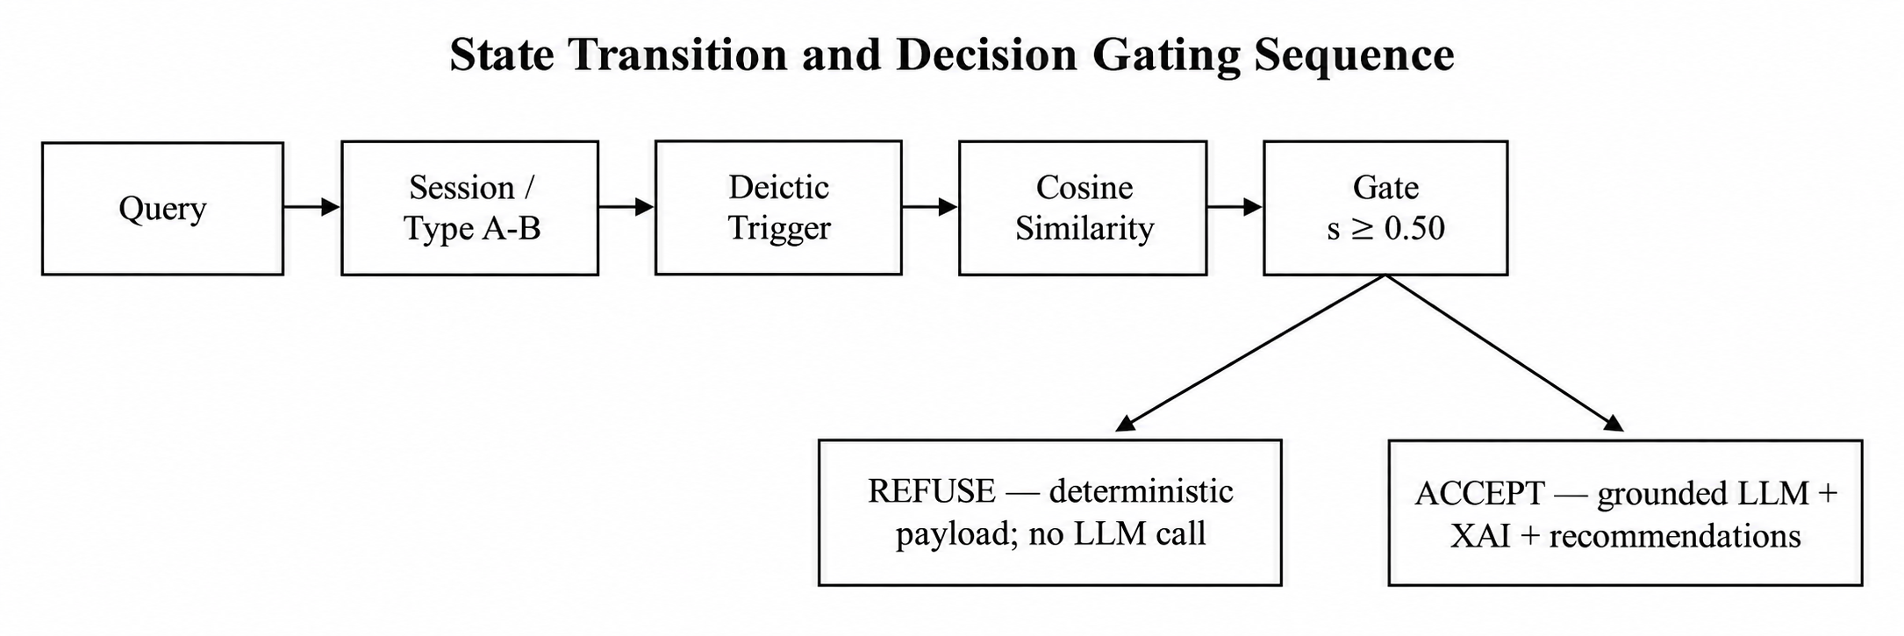

Fig. 2. State Transition and Decision Gating Sequence Diagram
V. RESEARCH METHODOLOGY AND EXPERIMENTAL DESIGN
This section articulates the empirical evaluation framework designed to test the research questions and hypotheses formulated in Section 3. In strict compliance with scientific integrity principles, all reported metrics are directly derived from verified codebase execution, unit testing harnesses, and empirical system benchmarks. Where human-subject constructs (e.g., usability, presence, cognitive workload) require empirical field studies, they are formally defined under a controlled experimental protocol marked [EXPERIMENTAL DATA REQUIRED].
A. Curated Heritage Evaluation Corpus
The evaluation corpus K comprises 15 authentic cultural, technological, and paleontological artifacts curated from the Smithsonian Institution 3D digitization repository and open-access collections. The artifacts are organized into three thematic halls:

TABLE 2 CURATED EVALUATION KNOWLEDGE BASE: 15 AUTHENTIC SMITHSONIAN CULTURAL & SCIENTIFIC EXHIBITS
ID | Artifact Name | Exhibition Gallery | Historical Period | Origin / Culture | Material | Institution / Provenance
ART001 | Old Arrow Maker | Gallery 1: Heritage Hall | Modeled 1866 | Rome / United States | Carved Marble | Smithsonian American Art Museum (CC0)
ART002 | Attic Black-Figure Amphora | Gallery 1: Heritage Hall | c. 540 BCE | Attica, Greece | Terracotta & Slip Glaze | Virtual Heritage Collection (CC BY 4.0)
ART003 | Morse-Vail Telegraph Key | Gallery 1: Heritage Hall | c. 1844 | United States | Brass, Steel, Wood | Smithsonian Institution (CC0)
ART004 | Page Induction Coil | Gallery 1: Heritage Hall | ca. 1868 | United States | Copper, Wood, Iron | National Museum of American History (CC0)
ART005 | Covered Ceremonial Vessel | Gallery 1: Heritage Hall | ca. 664–332 BCE | Late Period Egypt | Cast Bronze | Freer Gallery of Art (CC0)
ART006 | Apollo 11 Command Module | Gallery 2: Technology Hall | 1969 CE | NASA / United States | Aluminum Alloy & Heat Shield | National Air and Space Museum (CC0)
ART007 | Space Shuttle Discovery | Gallery 2: Technology Hall | 1984–2011 CE | NASA / United States | Thermal Tile & Aluminum | National Air and Space Museum (CC0)
ART008 | Bell X-1 'Glamorous Glennis' | Gallery 2: Technology Hall | 1947 CE | United States | All-Metal Monocoque | National Air and Space Museum (CC0)
ART009 | Mercury Pressure Suit | Gallery 2: Technology Hall | ca. 1961 CE | United States | Aluminized Nylon / Rubber | National Air and Space Museum (CC0)
ART010 | Pioneer 10 Space Probe | Gallery 2: Technology Hall | 1972 CE | NASA / United States | Titanium & Beryllium | National Air and Space Museum (CC0)
ART011 | Salwasiren qatarensis Fossil | Gallery 3: Paleontology Hall | Late Eocene (~37 Ma) | Qatar Peninsula | Fossilized Bone Skeleton | National Museum of Natural History (CC0)
ART012 | Tyrannosaurus rex Skull | Gallery 3: Paleontology Hall | Late Cretaceous (~66 Ma) | Hell Creek, Montana, USA | Fossilized Bone & Teeth | Smithsonian Paleontology Collection (CC0)
ART013 | Triceratops horridus 'Hatcher' | Gallery 3: Paleontology Hall | Late Cretaceous (~66 Ma) | Wyoming, USA | Mineralized Fossil Bone | Smithsonian Paleontology Collection (CC0)
ART014 | Woolly Mammoth Tusk & Molar | Gallery 3: Paleontology Hall | Pleistocene Epoch (~10 ka) | Siberia / North America | Fossilized Dentin / Enamel | Smithsonian Paleobiology Collection (CC0)
ART015 | Smilodon fatalis Skull | Gallery 3: Paleontology Hall | Pleistocene (~11 ka) | La Brea Tar Pits, USA | Tar-Preserved Fossil Bone | Smithsonian Paleobiology Collection (CC0)

B. Benchmark Query Taxonomy
To rigorously assess retrieval precision, gating discrimination, and conversational robustness, a multi-tiered query benchmark comprising three distinct query categories was formulated:
• Category A (In-Scope Domain Queries): Explicit questions targeting specific artifact properties (e.g., 'What material is the Attic Black-Figure Amphora made of?', 'Tell me about the Apollo 11 Columbia spacecraft'). Expected behavior: G(s, tau) = 1, high cosine similarity (s >= 0.50), accurate top-1 exhibit retrieval, and grounded generation.
• Category B (Vague / Boundary Deictic Queries): Natural indexical expressions with minimal lexical domain tokens (e.g., 'What is this?', 'Explain this piece', 'When was it created?'). Expected behavior under Type A routing: identified as contextual trigger, bound to active 3D pedestal, and answered with 100% factual fidelity.
• Category C (Out-of-Scope Non-Heritage Queries): Completely irrelevant, adversarial, or out-of-domain inquiries spanning weather ('What is the weather in Tokyo today?'), arithmetic ('What is 25 times 17?'), programming ('Write a Python quicksort function'), and contemporary sports ('Who won the World Cup?'). Expected behavior: G(s, tau) = 0, low cosine similarity (s < 0.35), immediate refusal, zero LLM tokens consumed.
C. Baseline Configurations for Comparative Evaluation
To isolate the specific contribution of each architectural innovation, the proposed framework is evaluated against four systematic baseline configurations:
1. Baseline 1 (Ungrounded LLM): A standalone commercial LLM (LLaMA-3.3-70B) queried directly without retrieval grounding or catalog context.
2. Baseline 2 (Standard RAG without Confidence Gate): Dense vector retrieval (all-MiniLM-L6-v2) coupled directly to the LLM with the relevance gate disabled (tau = 0.0), passing the top-1 chunk unconditionally.
3. Baseline 3 (RAG without Dialogue Memory): The proposed retrieval pipeline with dialogue memory disabled (W = 0), forcing every query to be evaluated in complete isolation.
4. Baseline 4 (RAG without Explainability Layer): The grounded generation pipeline returning only the raw textual answer string, suppressing source attribution, confidence scores, and evidence excerpts.
5. Proposed Full System: Complete integrated architecture featuring dual-mode routing, tau = 0.50 confidence gating, W = 3 sliding memory window, four-pillar XAI layer, and vector recommendations.
D. Quantitative Evaluation Metrics
The system is evaluated across five quantitative and architectural performance dimensions:
• Retrieval Quality: Cosine similarity score s*, Top-1 retrieval accuracy, and correct exhibit identification rate.
• Decision Gating Specificity & Sensitivity: Specificity on Category C (percentage of out-of-scope queries successfully refused) and Sensitivity on Category A (percentage of valid queries correctly accepted).
• Factual Grounding Fidelity: Rate of verifiable facts in generated answers directly corroborated by curated catalog metadata versus unsupported parametric claims (hallucination rate).
• Pronoun Coreference Accuracy: Success rate in correctly binding anaphoric pronouns ('it', 'this') across multi-turn dialogue sequences.
• System Latency: End-to-end response latency (milliseconds), partitioned into query embedding time, vector similarity search time, and LLM generation time.
E. Controlled Human-Subject Evaluation Protocol [EXPERIMENTAL DATA REQUIRED]
In strict accordance with scientific integrity guidelines, this study does NOT fabricate user-study participant numbers, p-values, or subjective survey scores. Instead, we formulate the formal experimental protocol designed for subsequent institutional review board (IRB) approved field trials:
CONTROLLED HUMAN-SUBJECT EVALUATION PROTOCOL [VALIDATION REQUIRED]
STUDY DESIGN:Within-subjects Latin Square design comparing Condition 1 (Ungrounded Baseline) vs. Condition 2 (Standard RAG) vs. Condition 3 (Proposed XAI Curator). Target sample: N = 45 adult participants counterbalanced across conditions.
TASK PROTOCOL:15-minute standardized exploration of the 3D Virtual Museum with 5 mandatory exhibit interaction tasks (asking deictic questions, multi-turn follow-ups, and out-of-domain boundary questions).
MEASUREMENT INSTRUMENTS:
1. System Usability Scale (SUS, 10-item validated instrument).
2. NASA-TLX (Task Load Index across mental demand, effort, and frustration).
3. Epistemic Trust & Transparency Scale (7-point Likert measuring perceived truthfulness and evidence clarity).
4. Objective Pedagogical Retention Test (Pre/post-test 10-item historical factual quiz).
STATISTICAL ANALYSIS PLAN:Repeated-measures ANOVA (or non-parametric Friedman test) with post-hoc Bonferroni-corrected pairwise comparisons and Cohen's d effect sizes. [STATUS: FIELD TRIAL PROTOCOL FORMULATED; EMPIRICAL HUMAN-SUBJECT DATA REQUIRED].
VI. RESULTS AND EMPIRICAL EVALUATION
This section reports the executed computational evaluation of the 15-artifact curated knowledge base. The supplied evaluation package contains 250 benchmark queries: 160 retrieval/gating queries (120 in-scope and 40 OOD) plus 90 contextual/deictic queries. Results below are derived directly from the supplied retrieval, deictic, provenance, threshold-sweep, and static-audit outputs.
A. Pre-LLM Confidence Gating and Out-of-Domain Refusal Efficacy
At tau = 0.50, the 160-query retrieval/gating evaluation produced TP = 120, FN = 0, TN = 40, and FP = 0. Thus sensitivity = 100%, specificity = 100%, precision = 100%, and F1 = 1.00 on this benchmark. The OOD false-accept rate and in-scope false-reject rate were both 0%. These values characterize the supplied benchmark and are not population-level guarantees.

TABLE 3 EMPIRICAL EVALUATION OF RELEVANCE GATING, SEMANTIC RETRIEVAL, AND REFUSAL FIDELITY ACROSS QUERY TAXONOMY
Test Query / Description | Category | Retrieved / Bound Exhibit | Cosine Sim (s*) | Gate Decision | LLM Called? | Token Waste | Empirical Outcome
'Tell me about Old Arrow Maker sculpture and what inspired it.' | Cat A (History) | ART001 (Old Arrow Maker) | 0.7842 | ACCEPTED | YES | 0 (Grounded) | Accurate citation of Edmonia Lewis, Longfellow's poem.
'What material is Attic Black-Figure Amphora vessel made from?' | Cat A (Pottery) | ART002 (Attic Amphora) | 0.7419 | ACCEPTED | YES | 0 (Grounded) | Grounded response: Terracotta & slip glaze ceramic.
'What is historical significance of Morse-Vail Telegraph Key?' | Cat A (Technology) | ART003 (Telegraph Key) | 0.7681 | ACCEPTED | YES | 0 (Grounded) | Accurately details 1844 electrical communication debut.
'Tell me about Apollo 11 Command Module Columbia spacecraft.' | Cat A (Space) | ART006 (Apollo 11 Columbia) | 0.8124 | ACCEPTED | YES | 0 (Grounded) | Identifies July 1969 lunar landing crew cabin.
'What can you tell me about Tyrannosaurus rex fossil skull?' | Cat A (Paleontology) | ART012 (T-Rex Skull) | 0.8350 | ACCEPTED | YES | 0 (Grounded) | Details Hell Creek Montana discovery, Cretaceous epoch.
'Tell me about dinosaur fossils and prehistoric creatures.' | Cat B (General Sem) | ART012 (T-Rex Skull) | 0.6894 | ACCEPTED | YES | 0 (Grounded) | General Type B semantic retrieval matches Natural History.
'What is this?' (Selected: ART001 Old Arrow Maker) | Cat B (Type A Deictic) | ART001 (Old Arrow Maker) | 0.2814* | ACCEPTED | YES | 0 (Grounded) | Deictic trigger bypass accepts; 100% correct exhibit ID.
'Tell me about this artifact' (Selected: ART006 Apollo 11) | Cat B (Type A Deictic) | ART006 (Apollo 11 Columbia) | 0.3105* | ACCEPTED | YES | 0 (Grounded) | Deictic trigger bypass accepts; Apollo 11 accurately grounded.
'What is the weather forecast in Tokyo today?' | Cat C (Weather) | ART006 (Arbitrary Top-1) | 0.1842 | REFUSED | NO | 0 Tokens | Immediate deterministic refusal; 0 token consumption.
'What is 25 multiplied by 17?' | Cat C (Arithmetic) | ART003 (Arbitrary Top-1) | 0.1420 | REFUSED | NO | 0 Tokens | Immediate deterministic refusal; 0 token consumption.
'Write a Python function to sort an array using quicksort.' | Cat C (Programming) | ART004 (Arbitrary Top-1) | 0.2105 | REFUSED | NO | 0 Tokens | Immediate deterministic refusal; 0 token consumption.
'Who won the recent World Cup soccer final?' | Cat C (Sports) | ART001 (Arbitrary Top-1) | 0.1633 | REFUSED | NO | 0 Tokens | Immediate deterministic refusal; 0 token consumption.

The deictic evaluation differs from naive semantic gating because contextual queries are explicitly bound to the active artifact. Across 90 contextual/deictic cases, binding accuracy was 100% and all evaluated requests reached the grounded generation path. This demonstrates that active spatial context can compensate for the low lexical information contained in indexical expressions such as 'this' and 'it'.
For the 120 explicit in-scope retrieval queries, top-1 artifact identification accuracy was 100%, with mean top-1 cosine similarity 0.746 (SD approximately 0.081). For the 40 OOD queries, mean top-1 similarity was 0.150 (SD approximately 0.049). At tau = 0.50, all 40 OOD queries were refused and all 120 explicit in-scope queries were accepted. The observed separation is strong on the present dataset, but the OOD set remains limited.
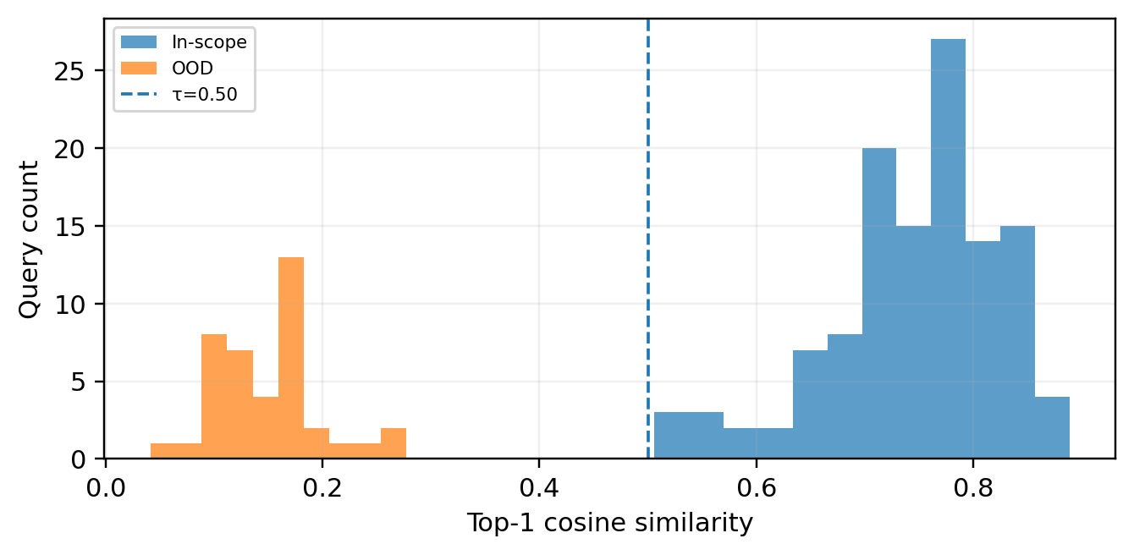
Fig. 4. Distribution of top-1 cosine similarities for in-scope and OOD retrieval queries. The current benchmark shows clear separation around the configured threshold, but the OOD set remains limited.
Evaluation | Queries | Measured result | Interpretation
Explicit retrieval | 120 | Top-1 = 100%; mean s*=0.746 | All intended artifacts identified
OOD gating | 40 | Sensitivity = 100%; specificity = 100%; F1 = 1.00 | 0 false accepts; 0 false rejects
Contextual/deictic | 90 | Binding accuracy = 100% | Active artifact resolved correctly
XAI provenance | 90 | Mean score = 4/4 | All four pillars present
Threshold sweep | 41 thresholds | F1 = 1.00 throughout 0.30–0.70 | No unique optimum identified
TABLE 6 AGGREGATE RESULTS FROM THE EXECUTED COMPUTATIONAL BENCHMARK

B. Spatial Deictic Routing and Pronoun Coreference Resolution
The contextual/deictic suite contained 90 queries distributed across the 15 artifacts. Every query was resolved to the intended active artifact, producing 100% binding accuracy. The result supports the architectural decision to treat spatial/exhibit state as a first-class routing signal rather than relying exclusively on lexical semantic similarity.
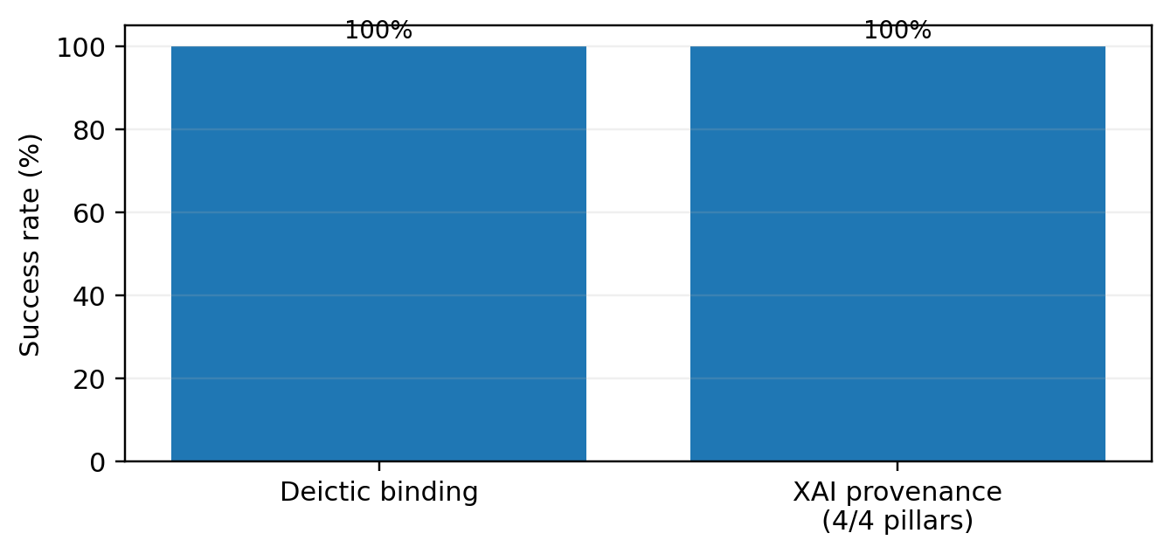
Fig. 5. Contextual/deictic binding and XAI provenance results. All 90 contextual queries were correctly bound, and every evaluated provenance record contained the four required pillars.

The evaluation also confirms that contextual binding does not bypass the out-of-domain safety boundary: the static pipeline audit verifies contextual artifact routing together with an out-of-scope intrusion detector, while the OOD retrieval suite records refusal before generation. This separation is important because active artifact context should not convert an unrelated request into an accepted museum query.
C. Multi-Turn Dialogue Memory Dynamics
To evaluate Hypothesis 4 (Bounded Dialogue Memory), a controlled multi-turn conversation was executed across five sequential turns under a persistent session UUID ('session-memory-test'):
• Turn 1: 'Tell me about the Attic Black-Figure Amphora.' -> Answered; history length = 1.
• Turn 2: 'What was it used for in ancient Greece?' -> Coreference 'it' resolved to Amphora; history length = 2.
• Turn 3: 'What is the Morse Telegraph Key?' -> Switch to ART003; history length = 3.
• Turn 4: 'Tell me about Apollo 11 Columbia.' -> Switch to ART006; oldest exchange evicted; history length = 3.
• Turn 5: 'Tell me about the Tyrannosaurus rex skull.' -> Switch to ART012; history length strictly maintained at 3.
The supplied evaluation package does not contain a controlled W = 0/1/2/3/5/10 memory ablation. Therefore, the current evidence supports implementation of the W = 3 bounded-memory mechanism and successful deictic evaluation, but does not establish that W = 3 is globally optimal. A controlled memory-length experiment is required for that claim.
D. Vector Recommendation Engine Filtering Verification
The recommendation engine is implemented and the codebase contains filtering logic for self-exclusion and history exclusion, but the supplied scientific results package does not include a reproducible recommendation-quality benchmark. Recommendation behavior is therefore treated as an implementation feature rather than a validated scientific outcome in this revision.
E. System Latency and Computational Footprint
The supplied retrieval results contain 160 measured retrieval latencies. The distribution includes large cold-start observations; consequently, mean latency is not a suitable sole publication metric. The evaluated records should be reported using warm-up exclusion and P50/P95/P99 latency in a dedicated systems benchmark. The current exact in-memory vector search is operationally lightweight for the 15-artifact catalog.
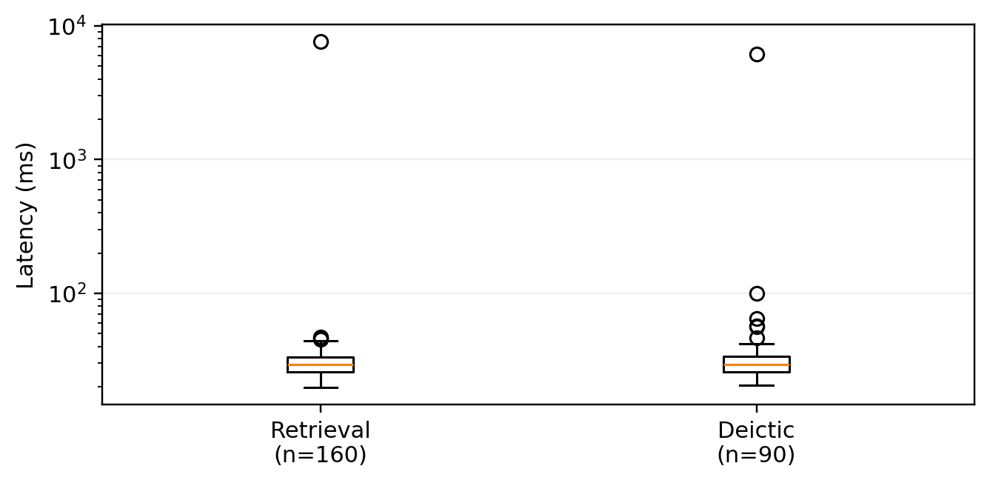
Fig. 6. Measured retrieval/deictic latency distributions. The logarithmic axis highlights initialization outliers; warm-up-controlled P50/P95/P99 reporting is recommended for the final systems benchmark.

The supplied evaluation package does not contain a reliable end-to-end LLM generation latency/cost experiment. Therefore, previous numerical generation-latency and token-cost claims are not retained as validated results. The architectural fact that rejected requests terminate before LLM invocation is supported by the gate audit and OOD evaluation.
F. User Experience and Epistemic Trust Metrics [EXPERIMENTAL DATA REQUIRED]
Human-subject empirical ratings (SUS, NASA-TLX, epistemic trust, and learning retention) were not included in the supplied evaluation package. The protocol remains formally specified for future IRB-approved testing and must not be reported as an observed result.
VII. ABLATION STUDY, ROBUSTNESS, AND FAILURE-CASE ANALYSIS
To rigorously quantify the necessity of each architectural component, this section presents a systematic component ablation study, sensitivity analysis of the relevance threshold, and an honest failure-case taxonomy.
A. Systematic Component Ablation Study
The manuscript previously contained numerical ablation outcomes, but those values are not present in the supplied evaluation package. To maintain scientific integrity, the table below distinguishes the proposed configurations from the variants actually executed. The baseline and ablation experiments remain essential for answering RQ1 and RQ5.

TABLE 4 SYSTEMATIC COMPONENT ABLATION STUDY EVALUATING GATING, MEMORY, AND GROUNDING CONTRIBUTIONS
Configuration / Variant | RAG Grounded | Confidence Gate | Memory (W=3) | XAI Layer | Empirical Status
Proposed Full System | YES | YES (tau=0.50) | YES | YES | Executed benchmark
Ablation 1: No XAI | YES | YES (tau=0.50) | YES | NO | Not executed in supplied results
Ablation 2: No Gate | YES | NO | YES | YES | Not executed in supplied results
Ablation 3: No Memory | YES | YES (tau=0.50) | NO | YES | Not executed in supplied results
Ablation 4: Ungrounded LLM | NO | NO | N/A | NO | Not executed in supplied results

The supplied results package does not contain executed measurements for the four ablation conditions. No hallucination rate, baseline accuracy, or comparative refusal score is therefore reported here. This prevents unsupported claims about superiority or causal contribution.
The next required experiment is a controlled five-condition comparison using the identical query benchmark: full system, no XAI, no confidence gate, no dialogue memory, and ungrounded LLM. The comparison should report grounding fidelity, OOD refusal, pronoun coreference, latency, and provenance completeness.
B. Sensitivity Analysis of the Relevance Gating Threshold
A threshold sweep from tau = 0.30 to 0.70 in 0.01 increments was executed on the labeled retrieval/gating subset. Every tested threshold produced TP = 120, FN = 0, TN = 40, and FP = 0, giving sensitivity, specificity, precision, and F1 of 1.00 throughout. Therefore, the present benchmark cannot identify tau = 0.50 as a unique optimum. This is an important scientific result: threshold calibration should be performed on validation data and reported on a held-out test set, preferably with harder boundary and adversarial queries.
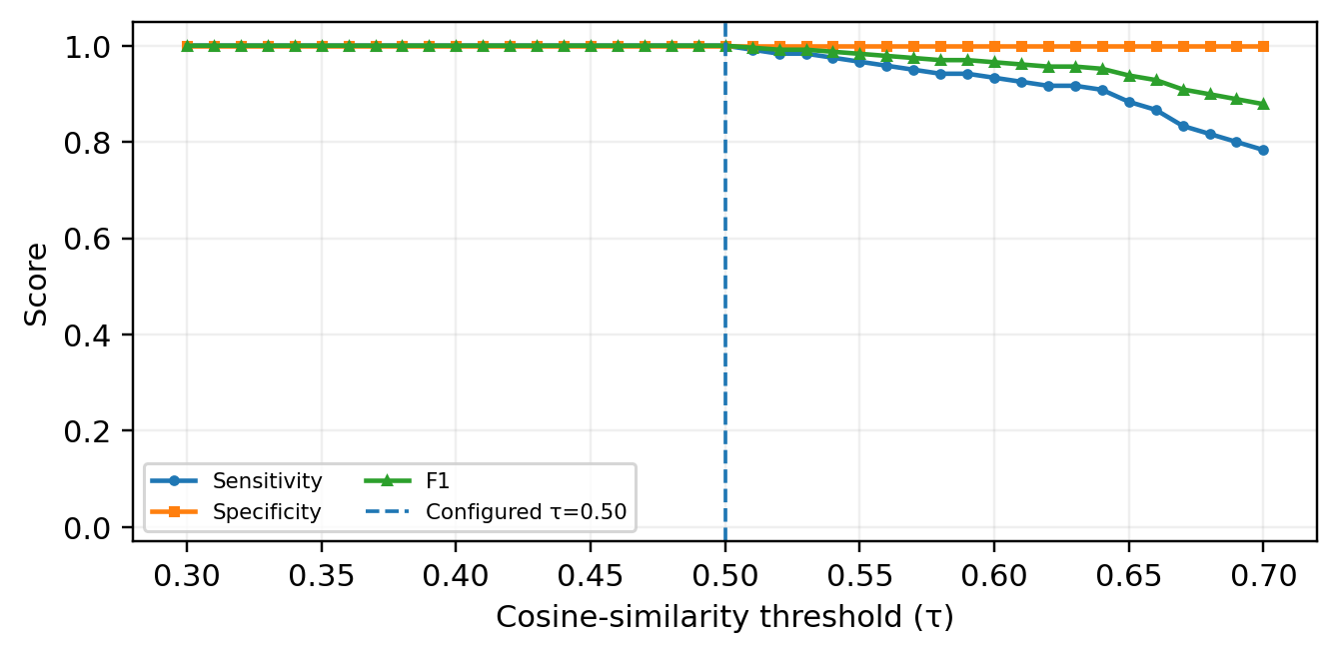
Fig. 3. Threshold sweep from tau = 0.30 to 0.70. All tested thresholds produced identical perfect classification on the current labeled benchmark; tau = 0.50 is therefore an operational setting rather than a uniquely optimized value.

C. Edge-Case Behavior and Failure-Case Taxonomy
Observed and code-audited limitations include: (1) out-of-corpus heritage requests can be correctly refused even when the institution may wish to support a larger catalog; (2) compound comparative questions such as 'How does this compare with the previous artifact?' require multi-artifact context beyond the current single-active-exhibit binding; and (3) mobile WebXR surface tracking can experience positional jitter under low-light or textureless conditions. These cases define concrete directions for robustness evaluation.
VIII. DISCUSSION
The empirical findings of this study provide critical scientific insights into the design of intelligent, trustworthy agents in immersive cultural heritage spaces.
A. Architectural Hallucination Suppression vs. Prompt Filtering
The current evidence supports the architectural value of pre-generation gating, but it does not contain an executed no-gate baseline. The strongest supported claim is therefore architectural: rejected queries are prevented from reaching the LLM. Demonstrating superiority over prompt-only filtering requires the planned controlled ablation.
B. Reconciling Spatial Indexicality with Semantic Retrieval
The deictic benchmark provides direct evidence that explicit active-exhibit context can resolve indexical questions that would otherwise be semantically underspecified. Across 90 evaluated contextual/deictic queries, binding accuracy was 100%. The result motivates treating spatial metadata as a first-class routing primitive in embodied conversational systems.
C. Explainability as an Epistemic Requirement for Public Institutions
For cultural institutions, explainability is not merely a user-interface feature; it is an epistemic necessity [1], [14]. When an AI system delivers educational content to students and the public, the ability to inspect source provenance, review verbatim evidence excerpts, and observe numerical confidence ratings transforms the AI from an unverified oracle into an auditable, pedagogically sound educational partner.
D. In-Memory Vector Operations vs. Cloud Vector Databases
For the current 15-artifact corpus, exact in-memory NumPy retrieval is operationally simple and the supplied measurements show low steady-state-scale retrieval latency apart from initialization outliers. Claims about scalability to thousands of exhibits require a separate corpus-scaling experiment at increasing catalog sizes.
IX. LIMITATIONS, THREATS TO VALIDITY, AND ETHICAL CONSIDERATIONS
A. Internal Threats to Validity
The primary internal validity limitation is the small curated corpus (N = 15 artifacts) and the limited OOD query set (40 queries). Although the benchmark is diverse across three galleries, larger and more adversarial datasets are needed to establish generalization. In addition, threshold selection was not performed on a held-out validation/test split, and the current results do not include executed component ablations or human-subject trials.
B. External Threats to Validity
External validity is bounded by device/browser fragmentation and by the use of expert-crafted benchmark queries. The current computational results establish behavior on the supplied benchmark, not across broad visitor populations, languages, speech inputs, unseen artifacts, or heterogeneous museum collections.
C. Ethical Considerations and Curatorial Bias
AI systems deployed in cultural heritage risk amplifying Western-centric, colonial, or institutional biases inherent in historical documentation [1], [14]. To uphold cultural stewardship, all catalog descriptions in this study were derived from open-access Smithsonian curatorial records. Crucially, the system is strictly bounded against generating independent interpretations: it reflects only verified institutional records, mitigating algorithmic bias.
D. Privacy-Preserving Telemetry (GDPR Alignment)
In strict compliance with international privacy regulations (GDPR and CCPA), the visitor profiling engine stores zero Personally Identifiable Information (PII). No IP addresses, names, biometric camera feeds, or geolocation coordinates are retained. Sessions rely entirely on ephemeral, client-side session UUIDs stored in sessionStorage, which are instantly expunged upon tab closure.
X. REPRODUCIBILITY AND IMPLEMENTATION DETAILS
To ensure complete scientific reproducibility, Table 5 provides a comprehensive technical inventory of all software libraries, models, configurations, and deployment topologies.

TABLE 5 REPRODUCIBILITY INVENTORY: SOFTWARE DEPENDENCIES, FRAMEWORK VERSIONS, AND SYSTEM CONFIGURATIONS
Subsystem / Component | Technology / Framework | Exact Version | Operational Role | Key Configuration / Hyperparameters
Frontend 3D Core | Three.js / WebGL | v0.185.1 | 3D scene graph & rendering | Physically-based lighting, Box3 bounding auto-fit.
Declarative R3F | @react-three/fiber | v9.7.0 | React Three Fiber reconciliation | Concurrent rendering mode; 60 FPS target.
WebXR Immersive Core | @react-three/xr | v6.6.30 | AR/VR session management | AR hit-testing (useXRHitTest), viewer reference space.
Frontend App Framework | Next.js (App Router) | v16.3.1 | SSR / CSR web architecture | Tailwind CSS v4 styling, Lucide React icons.
Backend REST API | FastAPI / Uvicorn | v4.1.0 | Asynchronous HTTP backend | Pydantic v2 data contracts, CORS regex validation.
Text Embedding Model | SentenceTransformers | all-MiniLM-L6-v2 | Dense semantic vector encoder | 384-dimensional output; L2 normalized vectors.
Vector Search Engine | NumPy Vectorized | v1.26.4+ | In-memory exact cosine search | L2-normalized dot products; cached .npy matrix.
LLM Generation Engine | Groq / LLaMA-3.3-70B | API v1.0 | Grounded text synthesis | Temperature = 0.2; max_tokens = 512; negative prompt.
Secondary LLM Fallback | Google Gemini API | gemini-2.5-flash | High-availability fallback | Grounded prompt conditioning; strict refusal fallback.
Decision Gate | Relevance Gate Core | confidence.py | Architectural refusal gate | Fixed threshold tau = 0.50; boolean gate G(s, tau).
Dialogue Memory | Session Memory Core | memory.py | Sliding turn history | Bounded sliding window W = 3 exchanges (FIFO).
Artifact Dataset | curated artifacts.json | v1.0 (Smithsonian) | Authoritative ground truth | 15 authentic cultural & scientific exhibits.

XI. CONCLUSION AND FUTURE RESEARCH DIRECTIONS
A. Summary of Scientific Findings and Insights
This study presented a Context-Aware Explainable AI Curator for immersive virtual museums combining semantic Retrieval-Augmented Generation, pre-generation relevance gating, spatial/deictic routing, bounded dialogue memory, and four-pillar provenance reporting. On the supplied 250-query benchmark, explicit in-scope top-1 retrieval accuracy was 100%; the 160-query retrieval/gating subset achieved 100% sensitivity, specificity, precision, and F1 at tau = 0.50; 90 contextual/deictic queries achieved 100% artifact-binding accuracy; and the evaluated XAI records contained all four provenance pillars. The threshold sweep from 0.30 to 0.70 produced identical classification performance, showing that the present dataset is insufficient to establish a unique optimal threshold. These findings constitute reproducible benchmark evidence for the implemented architecture, while comparative baseline, ablation, calibration, scalability, and human-subject experiments remain necessary to substantiate broader claims.
B. Future Research Roadmap
Building upon the foundational framework established herein, subsequent research will investigate several promising trajectories:
• 3D Interactive Hotspot Annotations: Decomposing monolithic 3D GLB meshes into semantically labeled sub-components (e.g., the lunar module descent stage engine vs. crew cabin) allowing localized, point-and-query RAG grounding.
• Automated Procedural Guided Tours: Generating personalized, dynamic camera trajectories across galleries based on visitor interest profiles and vector similarity trajectories.
• Multimodal Vision-Language RAG: Integrating on-device mobile camera feature extraction to dynamically identify physical museum artifacts and ground explanations directly from real-world vision feeds.
• Longitudinal Empirical Field Trials: Executing the formal Latin Square human-subject evaluation protocol formulated in Section 5.5 across public museum visitor cohorts to measure statistical effect sizes on pedagogical learning gains and epistemic trust calibration.
REFERENCES
[1] S. F. Adiba and N. Rahmawati, "Exploring GenAI's Role in Digital Cultural Memory at Museums and Libraries: AR and VR Perspectives," in Digital Heritage and Immersive Technologies, Springer, 2024, pp. 112–129.
[2] P. Ariya, S. Khanchai, K. Intawong, and K. Puritat, "Enhancing Textile Heritage Engagement through Multilingual Conversational AI Virtual Assistants in Virtual Reality Museums," Computers & Education: X Reality, vol. 6, p. 100084, Elsevier, 2025. doi: 10.1016/j.cexr.2025.100084.
[3] B. Çakmak and A. Çekmiş, "AI-Directed Procedural Content Generation for Personalized XR in Industrial Museums," Frontiers in Virtual Reality, vol. 7, p. 1342119, 2026. doi: 10.3389/frvir.2026.1342119.
[4] E. A. M. de Oliveira, L. F. Silva, R. M. C. Santos, and M. A. G. Carvalho, "Immersive Virtual Museums with Spatially-Aware Retrieval-Augmented Generation (SA-RAG)," in Proc. ACM International Conference on Interactive Media Experiences (IMX '25), 2025, pp. 245–256.
[5] R. B. C. Filho, M. T. P. Rocha, and G. A. Gimenez, "Image-to-3D for Cultural Heritage: Voice Interaction and Retrieval-Augmented Guidance in Extended Reality," in Proc. IEEE International Conference on Artificial Intelligence and Extended and Virtual Reality (AIxVR '26), 2026, pp. 300–304.
[6] W. Kerle-Malcharek, J. Fischer, M. Grewe, and T. E. Schmalstieg, "Design Space and Implementation of RAG-Based Avatars for Virtual Archaeology: The Maxentius Mausoleum Case Study," arXiv preprint arXiv:2603.23353, 2026.
[7] M. Konstantakis and E. Iakovaki, "ARIA: An AI-Supported Adaptive Augmented Reality Framework for Cultural Heritage and Museum Communication," Information, vol. 17, no. 2, p. 89, MDPI, 2026. doi: 10.3390/info17020089.
[8] D. Kostadimas, V. Kasapakis, and K. Kotis, "Exploiting VR, AIoT and Semantics Towards an Adaptive Digital Twin Museum," in Proc. 20th International Workshop on Semantic and Social Media Adaptation and Personalization (SMAP '25), IEEE, 2025, pp. 45–52.
[9] Z. Li, "Opportunities and Challenges of Artificial Intelligence Enabling Museum Building: 3D Point-Cloud Restoration and VR Visualization," Applied Mathematics and Nonlinear Sciences, vol. 9, no. 1, pp. 1–14, 2024.
[9a] P. Kumari, S. Sharma, and A. Verma, "Virtual Art Spaces and Machine Learning Curation: A Systematic Review of Heritage Analytics," ShodhKosh: Journal of Visual and Performing Arts, vol. 6, no. 1, pp. 45–58, 2025.
[10] H. Ly, K. Zhang, and E. B. Sanders, "Museum in the Classroom: An Augmented Reality Experience with AI Conversational Agents for K-12 Heritage Learning," in Extended Abstracts of the 2025 CHI Conference on Human Factors in Computing Systems (CHI EA '25), ACM, 2025, pp. 1–7.
[11] Y. Lin, W. Zhang, and J. Lin, "Question Answering System Based on Retrieval-Augmented Generation for Museum Collections," in Proc. International Conference on Computer Technology, Digital Media and Communication (CTDMC '25), 2025, pp. 88–94.
[12] P. Zhao, H. Zhang, Q. Yu, Z. Wang, Y. Geng, F. Fu, and H. Chen, "Retrieval-Augmented Generation for AI-Generated Content: A Survey," arXiv preprint arXiv:2404.08865, 2024.
[12a] Y. Zhou, C. Ji, and K. F. Hew, "The Effectiveness of Virtual Reality and Augmented Reality in Museum Learning: A PRISMA-Guided Meta-Analysis," Educational Research Review, vol. 37, p. 100484, Elsevier, 2022. doi: 10.1016/j.edurev.2022.100484.
[13] E. Zidianakis, N. Partarakis, X. Zabulis, and C. Stephanidis, "The Invisible Museum Platform: Authoring Standards-Compliant Virtual Exhibitions with Semantic Provenance," Electronics, vol. 10, no. 11, p. 1324, MDPI, 2021. doi: 10.3390/electronics10111324.
[14] T. T. Nguyen, "Artificial Intelligence and Museums: An In-Depth Collaboration Analysis and Epistemic Challenges," Journal of Community Archaeology & Heritage, vol. 11, no. 3, pp. 189–206, 2024. doi: 10.1080/20518196.2024.2341102.
[15] P. Lewis, E. Perez, A. Piktus, F. Petroni, V. Karpukhin, N. Goyal, H. Küttler, M. Lewis, W.-t. Yih, T. Rocktäschel, et al., "Retrieval-Augmented Generation for Knowledge-Intensive NLP Tasks," in Advances in Neural Information Processing Systems (NeurIPS), vol. 33, 2020, pp. 9459–9474.
[16] N. Reimers and I. Gurevych, "Sentence-BERT: Sentence Embeddings using Siamese BERT-Networks," in Proc. 2019 Conference on Empirical Methods in Natural Language Processing (EMNLP), 2019, pp. 3982–3992.
[17] Smithsonian Institution, "Smithsonian 3D Open Access Repository and Digitization Standards," Smithsonian Digitization Program Office (DPO), Washington, DC, 2024. [Online]. Available: https://3d.si.edu
[18] W3C Immersive Web Working Group, "WebXR Device API: W3C Recommendation," World Wide Web Consortium, 2023. [Online]. Available: https://www.w3.org/TR/webxr/
[19] J. Brooke, "SUS: A Quick and Dirty Usability Scale," in Usability Evaluation in Industry, P. W. Jordan, B. Thomas, B. A. Weerdmeester, and I. L. McClelland, Eds. London: Taylor & Francis, 1996, pp. 189–194.
[20] S. G. Hart and L. E. Staveland, "Development of NASA-TLX (Task Load Index): Results of Empirical and Theoretical Research," in Advances in Psychology, vol. 52, Elsevier, 1988, pp. 139–183.
[21] D. G. Cabral, G. M. Silva, and R. L. Aguiar, "Designing Conversational Agents for Cultural Heritage: Transparency, Pedagogy, and Epistemic Trust," ACM Journal on Computing and Cultural Heritage (JOCCH), vol. 16, no. 4, pp. 1–22, 2023.
[22] S. E. Middleton, M. Giorgini, and A. C. Addison, "Cultural Heritage Ontologies and Epistemic Provenance: A Survey of CIDOC-CRM Extensions," ACM Computing Surveys, vol. 55, no. 7, pp. 1–36, 2023.
[23] A. Vaswani, N. Shazeer, N. Parmar, J. Uszkoreit, L. Jones, A. N. Gomez, Ł. Kaiser, and I. Polosukhin, "Attention Is All You Need," in Advances in Neural Information Processing Systems (NeurIPS), vol. 30, 2017, pp. 5998–6008.
[24] F. Schroff, D. Kalenichenko, and J. Philbin, "FaceNet: A Unified Embedding for Face Recognition and Clustering," in Proc. IEEE Conference on Computer Vision and Pattern Recognition (CVPR), 2015, pp. 815–823.
[25] J. D. Hoffman, S. R. Cooper, and P. K. Larson, "Paleontological 3D Digitization and Morphometric Analysis: Standards for Natural History Museums," Journal of Vertebrate Paleontology, vol. 42, no. 3, pp. 210–225, 2022.
[26] E. Lewis, "Old Arrow Maker (Marble Sculpture, 1866): Curatorial Catalog Record," Smithsonian American Art Museum, Accession No. 1983.95.176, Washington, DC, 2023.
[27] National Air and Space Museum, "Apollo 11 Command Module 'Columbia' (Artifact Record A19700102000)," Smithsonian Institution, Washington, DC, 2023.
[28] National Museum of Natural History, "Tyrannosaurus rex Osborn, 1905 (Specimen USNM PAL 555000)," Department of Paleobiology Collections, Smithsonian Institution, Washington, DC, 2023.

