Software Requirements Document (SRD)

📘 Project Title: Book Catalog API with Authentication (Simplified)

📌 Objective
Develop a RESTful API to:
- Register and login users (with JWT-based authentication)
- Perform full CRUD operations on books
- Secure book creation, update, and delete operations with JWT

🧱 Tech Stack
- Node.js
- Express
- MongoDB with Mongoose
- JWT for authentication
- Optional: bcrypt, dotenv, nodemon

🧪 Postman-Testable Features
- Token-based auth (JWT) for protected routes
- Clear status codes and response messages
- Fully testable using Postman without frontend

👤 User Module
➕ Register
- Endpoint: POST /api/users/register
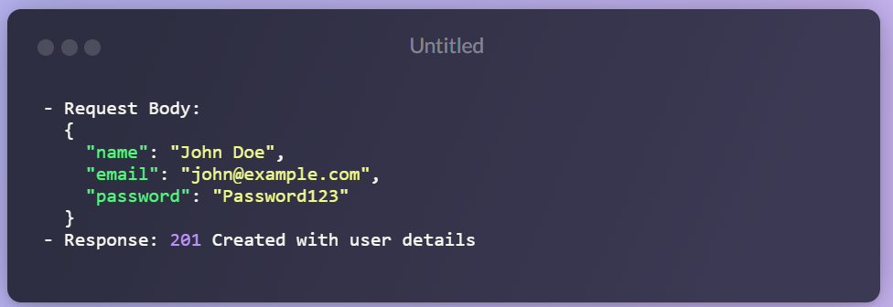
🔐 Login
- Endpoint: POST /api/users/login
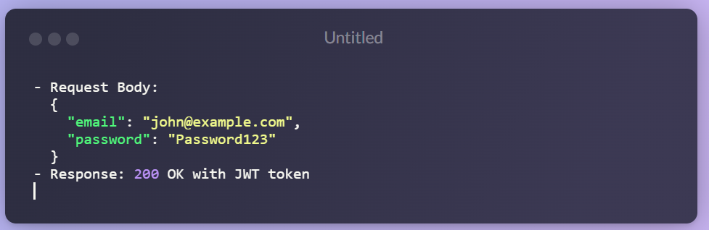📚 Book Module
All routes below require JWT Auth using Authorization: Bearer <token>
📥 Create Book
- Endpoint: POST /api/books
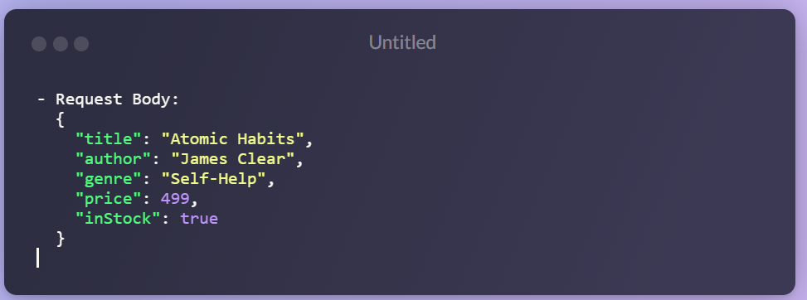
📖 Get All Books
- Endpoint: GET /api/books
- Public route
📕 Get Book by ID
- Endpoint: GET /api/books/:id
- Public route
🛠 Update Book
- Endpoint: PUT /api/books/:id
- Protected route
❌ Delete Book
- Endpoint: DELETE /api/books/:id
- Protected route

🗃 Mongoose Models

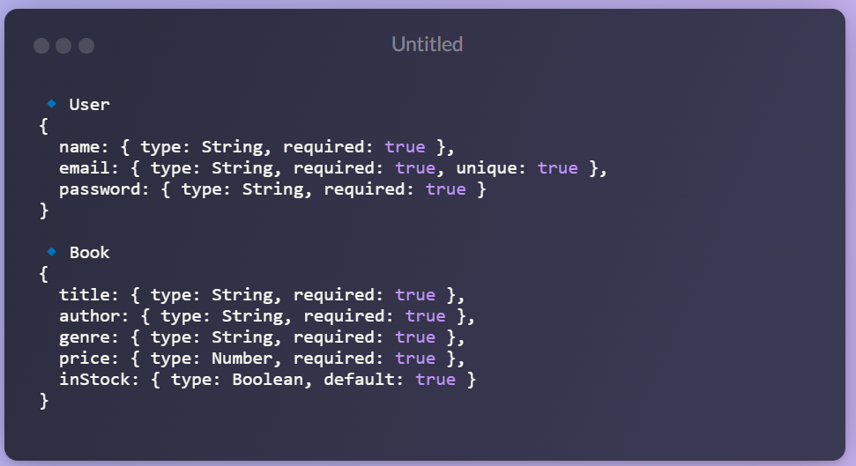🔐 JWT Auth Middleware

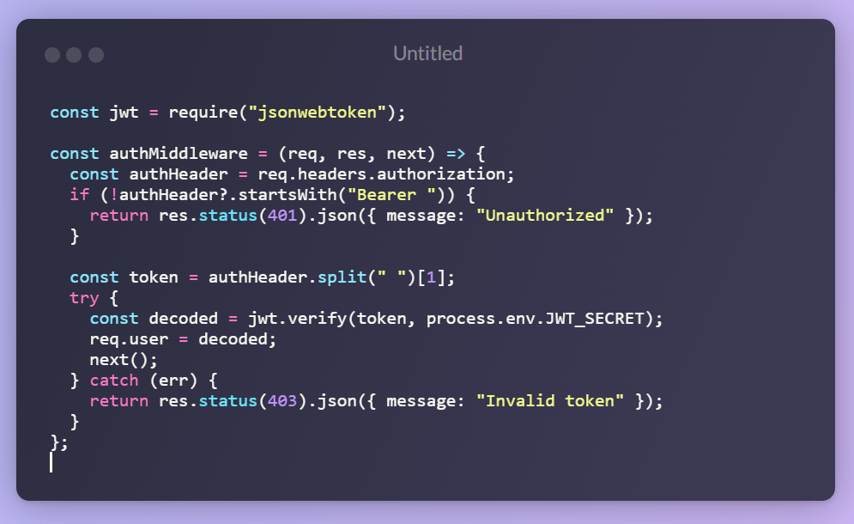

🧪 Postman Test Scenarios
Step | Endpoint | Method | Auth Required | Purpose
1 | /api/users/register | POST | ❌ No | Register a new user
2 | /api/users/login | POST | ❌ No | Get JWT token
3 | /api/books | GET | ❌ No | Publicly list all books
4 | /api/books/:id | GET | ❌ No | Get a book by ID
5 | /api/books | POST | ✅ Yes | Create a new book
6 | /api/books/:id | PUT | ✅ Yes | Update a book
7 | /api/books/:id | DELETE | ✅ Yes | Delete a book

📦 Suggested Folder Structure

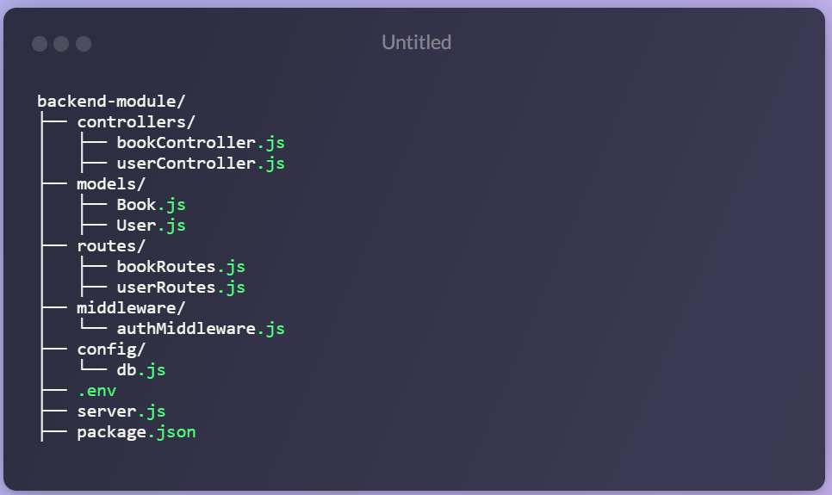🚀 Deployment Notes (Render)
- Web Service: npm install && npm start
- Expose port using process.env.PORT || 5000
- Environment Variables:
- MONGO_URI
- JWT_SECRET
- Set engine in package.json (optional):
"engines": {
"node": ">=16.0.0"
}

