CRUD using EF Core in VS Code (Step-by-Step)
“In VS Code, we use .NET CLI (Command Line Interface) instead of GUI.”

Step 1: Install Required Tools
Make sure these are installed:
- .NET SDK → check using:
dotnet --version
- VS Code Extensions:
  - C#
  - NuGet Package Manager (optional)

Step 2: Create Project using CLI
Open terminal in VS Code:
dotnet new console -n StudentCRUDApp

cd StudentCRUDApp

code .
Explain:
- dotnet new console → creates project
- code . → opens project in VS Code

Step 3: Install EF Core Packages
Run in terminal:

Step 4: Create Folder Structure
Create folders manually:
StudentCRUDApp
│
├── Models
├── Data
└── Program.cs

Step 5: Create Model Class
Models/Student.cs
using System.ComponentModel.DataAnnotations;

namespace StudentCRUDApp.Models
{
public class Student
{
public int Id { get; set; }

public string Name { get; set; } = string.Empty;

public int Age { get; set; }

public string Course { get; set; } = string.Empty;
}
}

Step 6: Create DbContext
Data/AppDbContext.cs

using Microsoft.EntityFrameworkCore;
using StudentCRUDApp.Models;

namespace StudentCRUDApp.Data
{
public class AppDbContext : DbContext
{
public DbSet<Student> Students { get; set; }

protected override void OnConfiguring(DbContextOptionsBuilder optionsBuilder)
{
optionsBuilder.UseSqlServer(
"Server=(localdb)\\MSSQLLocalDB;Database=StudentDB;Trusted_Connection=True;");
} }
}

Explain:
- Here we directly configure connection string (no appsettings.json)

Step 7: Install EF CLI Tool (Important)

dotnet tool install --global dotnet-ef

Step 8: Run Migration (Create DB)

sqllocaldb create MSSQLLocalDB
sqllocaldb start MSSQLLocalDB
sqllocaldb info MSSQLLocalDB
dotnet ef migrations add InitialCreate
dotnet ef database update

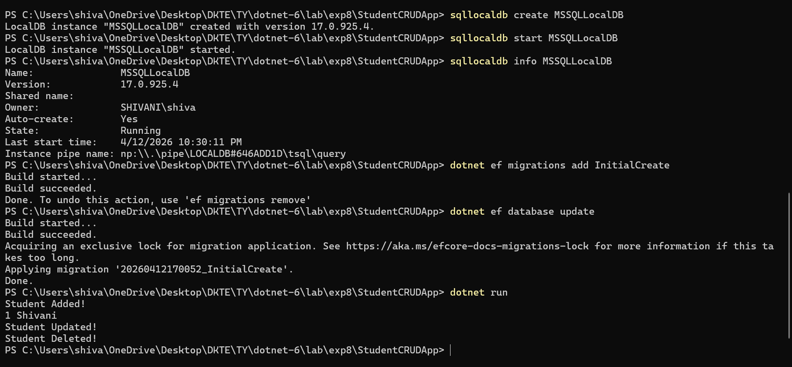
Explain:
- This will create:
  - Database → StudentDB
  - Table → Students

Step 9: Write CRUD Code in

Program.cs

using System;
using System.Linq;
using StudentCRUDApp.Data;
using StudentCRUDApp.Models;

class Program
{
static void Main()
{
using (var context = new AppDbContext())
{
// CREATE
var student = new Student
{
Name = "Shivani",
Age = 22,
Course = "IT"
};
context.Students.Add(student);
context.SaveChanges();

Console.WriteLine("Student Added!");

// READ
var students = context.Students.ToList();
foreach (var s in students)
{
Console.WriteLine($"{s.Id} {s.Name}");
}

// UPDATE
var firstStudent = context.Students.FirstOrDefault();
if (firstStudent != null)
{
firstStudent.Name = "Updated Shivani";
context.SaveChanges();
Console.WriteLine("Student Updated!");
}

// DELETE
var deleteStudent = context.Students.FirstOrDefault();
if (deleteStudent != null)
{
context.Students.Remove(deleteStudent);
context.SaveChanges();
Console.WriteLine("Student Deleted!");
}
}
}
}

Step 10: Run Project

dotnet run

