# Workplace Harassment Incident Report

## Generated Narrative

Okay, here's a draft of a formal incident report based on the provided evidence. Remember that this is a template, and the individual submitting the report should carefully review and adjust it to ensure accuracy and completeness. I've kept it anonymous as requested.

**Subject: Formal Incident Report - Potential Harassment**

**Date:** October 26, 2023 (Assuming today's date for report creation, to be adjusted as needed)

**To:** HR Department / PoSH Committee

**From:** Anonymous

**Department:** (Finance Team - inferred from "finance team workspace" note)

**Incident Date:** August 4, 2023

**Incident Time:** Approximately 6:00 PM

**Location:** Finance Team Workspace

**Nature of Complaint:** Harassment / Threat / Unwelcome Advances

**Description of Incident:**

This report details an incident of harassment and intimidation that occurred on August 4, 2023, at approximately 6:00 PM in the Finance Team Workspace. The incident involves a series of unwelcome and inappropriate communications.

The following evidence is submitted in support of this report:

1. **Audio Recording Transcript:** An audio recording captures the phrase, "hey baby let's meet in the office room we can meet and talk about important stuff if you want". This statement is perceived as an unwelcome advance and creates a hostile and uncomfortable work environment.

2. **Screenshot of Text Messages:** A screenshot of text messages reveals a series of harassing and threatening communications. The messages include:

* "why are you not talking to me"

* "please talk to Me"

* "come to room with Me"

* "iwill darling"

* "please"

* "CMON"

* "letss have some fun"

* "don't resist"

* "or else | will complaint against you" (Note the spelling error is preserved for accuracy)

* "fake allegations"

* "COME OVER"

* "last 5 messages" followed by a numbered list.

These messages are perceived as persistent, unwanted advances, and the threat of a complaint is intimidating and creates a hostile work environment. The rapid succession of messages within a short timeframe (indicated by the timestamps) further amplifies the feeling of being harassed.

**Impact:**

The aforementioned incident has caused me significant distress and anxiety. I feel unsafe and uncomfortable in the workplace as a result of these unwelcome advances and threats. This incident has negatively impacted my ability to concentrate on my work and has created a hostile and intimidating work environment.

**Desired Action:**

I request that the HR Department/PoSH Committee conduct a thorough investigation into this matter and take appropriate disciplinary action to prevent future occurrences. I also request assurance of a safe and respectful work environment, free from harassment and intimidation.

**Additional Information:** (Optional - Include any other relevant details)

* I am available to provide further details or clarification as needed.

* I am concerned about potential retaliation and request confidentiality to the extent possible during the investigation.

**Thank you for your prompt attention to this serious matter.**

**Important Considerations for the User:**

* **Review and Edit:** Carefully review this draft and edit it to accurately reflect your experience and perspective. Add any details or context that you feel are important.

* **Identify the Perpetrator (If Known):** If you know the identity of the person involved, include their name and department. If you are unsure, provide any identifying information you have.

* **Company Policy:** Familiarize yourself with your company's harassment policy. This will help you understand your rights and the company's obligations.

* **Keep a Copy:** Retain a copy of this report and all supporting documentation for your records.

* **Seek Support:** Consider seeking support from a trusted friend, family member, or therapist. Dealing with harassment can be emotionally challenging.

* **Legal Advice:** If you feel it's necessary, consult with an attorney to understand your legal options.

* **Consider adding witnesses**: If others witnessed the events or are aware of the situation, consider including their names (with their permission) as potential witnesses.

* **Delivery Method:** Determine the appropriate method for submitting the report (e.g., email, in-person delivery).

I hope this report helps you in addressing this difficult situation. Please let me know if you have any questions or need further assistance.

## Attached Screenshot

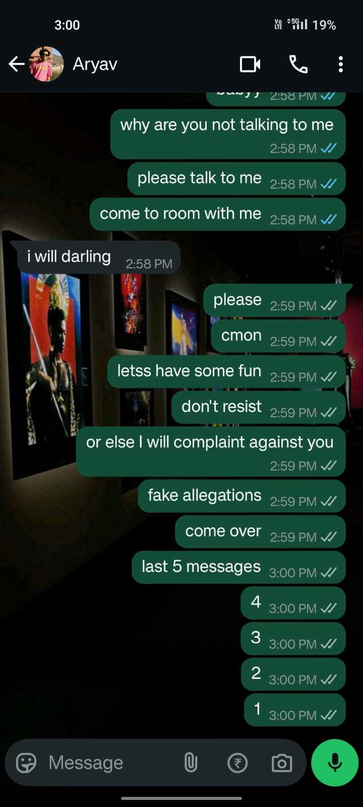

## Attached Audio Evidence

[Audio File Attached Separately: test2.wav]