# Workplace Harassment Incident Report

## Generated Narrative

Okay, here is a draft of a formal harassment incident report based on the evidence you provided. Please remember that I am an AI and this is for informational purposes only. This report is structured to be easily adaptable and thorough. You should review it carefully and make any necessary changes to ensure accuracy and completeness before submitting it.

**Incident Report**

**Report Date:** August 05, 2025

**Subject:** Formal Complaint of Harassment

**Complainant:** Anonymous (For now, if you wish to reveal your name at any point, please let HR know and the report will be updated.)

**Alleged Harasser:** Aryav (Name as it appears in screenshot)

**Date of Incident:** August 05, 2025

**Time of Incident:** Approximately 10:00 AM

**Location of Incident:** HR Cubicle

**1. Summary of Incident:**

This report details an incident of harassment that occurred on August 05, 2025, at approximately 10:00 AM in the HR cubicle. The complainant experienced unwanted and offensive behavior from Aryav, including sexually suggestive language, persistent unwanted contact, and threats of retaliation. This behavior created a hostile and intimidating environment.

**2. Detailed Description of the Incident:**

On August 05, 2025, at approximately 10:00 AM, while in the HR cubicle, the following occurred:

* **Verbal Harassment (Audio Evidence):** An audio recording captures Aryav saying, "hey baby let's meet in the office room we can meet and talk about important stuff if you want." This language is sexually suggestive, unwanted, and created a feeling of discomfort.

* **Text Message Harassment (Screenshot Evidence):** A series of text messages from Aryav to the complainant were received, demonstrating persistent and escalating unwanted contact. The messages include:

* "why are you not talking to me"

* "please talk to Me"

* "come to room with Me"

* "iwill darling"

* "please"

* "CMON"

* "letss have some fun"

* "don't resist"

* "or else | will complaint against you"

* "fake allegations"

* "COME OVER"

* Several messages consisting of numbers 4, 3, 2, 1, which suggest an escalating pressure and countdown-like approach.

The messages demonstrate persistent unwanted advances, pressure to engage in conversation and meet in private, sexually suggestive language ("letss have some fun," "don't resist"), and a threat of retaliation ("or else | will complaint against you").

**3. Evidence Provided:**

* **Audio Transcript:** A transcript of the audio recording capturing the verbal harassment.

* **Screenshot of Text Messages:** A screenshot of text messages sent by Aryav to the complainant.

**4. Impact of the Incident:**

The complainant feels intimidated, harassed, and threatened by Aryav's behavior. The persistent unwanted contact, sexually suggestive language, and threat of retaliation have created a hostile and uncomfortable work environment. This incident has caused significant distress and anxiety.

**5. Requested Action:**

The complainant requests that [Company Name/HR/PoSH Committee] conduct a thorough investigation into this matter and take appropriate disciplinary action against Aryav to prevent further harassment and ensure a safe and respectful work environment for all employees. The complainant requests to be informed of the steps taken to address this complaint.

**6. Witness Information (If Applicable):**

* (If there were any witnesses to the events, please list their names and contact information here. If there were no witnesses, state "None.")

**7. Additional Information:**

* (Include any other relevant information, such as past interactions with the alleged harasser, previous complaints, or any other details that might be relevant to the investigation.)

**Declaration:**

I declare that the information provided in this report is true and accurate to the best of my knowledge.

**Signature:**

____________________________

**Date:** August 05, 2025

**Important Considerations:**

* **Review and Edit:** Carefully review this draft and make any necessary changes to ensure accuracy and completeness.

* **Company Policy:** Familiarize yourself with your company's harassment policy and reporting procedures.

* **Legal Advice:** Consider seeking legal advice from an attorney specializing in employment law.

* **Keep a Copy:** Retain a copy of this report and all supporting documentation for your records.

* **Follow Up:** Follow up with HR or the PoSH committee to ensure that your complaint is being addressed.

I hope this helps. Please let me know if you have any other questions or need further assistance. Remember to prioritize your well-being and seek support from trusted friends, family, or professionals.

## Attached Screenshot

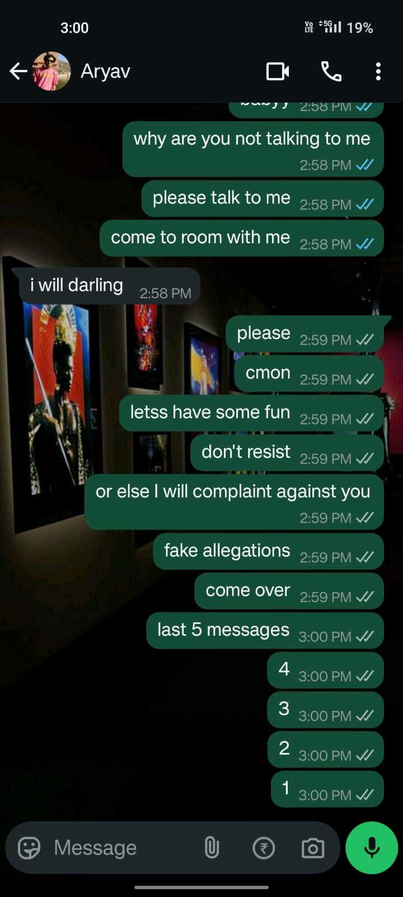

## Attached Audio Evidence

[Audio File Attached Separately: test2.wav]