# Workplace Harassment Incident Report

## Generated Narrative

Okay, here is a formal harassment incident report based on the provided evidence, ready for submission to HR or a PoSH committee. Because the user did not provide her name, the report will be submitted anonymously.

**Incident Report**

**Date:** August 05, 2025

**Subject:** Report of Harassment and Threat

**Reporting Party:** Anonymous

**Date of Incident:** August 05, 2025

**Time of Incident:** Approximately 10:00 AM

**Location of Incident:** HR Cubicle

**Description of Incident:**

This report concerns an incident of harassment and threat that occurred on August 05, 2025, at approximately 10:00 AM in the HR cubicle. I am deeply disturbed and fearful due to the nature of this incident.

**Details:**

On the above-mentioned date and time, I was subjected to a direct verbal threat within the HR cubicle. Furthermore, I have received threatening messages via electronic communication.

* **Verbal Threat (Audio Transcript):** I was confronted and subjected to the following statement: "finally here don't you that try to run away or tell anyone you are mine you are finally mine only mine".

* **Electronic Communication (Screenshot Text):** I received a series of messages, which I believe are intended to intimidate and threaten me. The content of these messages included the following:

* Claims of familiarity and attempts to re-establish contact.

* Explicit warnings against filing a complaint. Specifically, "don't you dare complain against me" and "I dare you."

* Disclosure of my personal address: "I have your address...I know you live in Kandivalli, Nisarg Appartment, room number 401."

* A threat of physical presence at my residence: "I will come over...I will bring Hrishikesh with me."

* A general threat of potential harm: "and you don't know what all things can happen to you."

* Demands for compliance: "so do as I say."

* A deadline for compliance: "you have time till 11 today...be on time."

* A demand to meet at a specific location: "meet me in the smoke room."

**Impact:**

I feel extremely threatened, intimidated, and unsafe as a result of these actions. I fear for my personal safety and well-being, both within the workplace and at my home. This incident has caused me significant emotional distress and anxiety.

**Evidence:**

The following evidence is being submitted in support of this report:

1. Audio transcript of the verbal threat made in the HR cubicle.

2. Screenshot of the threatening text messages received.

3. Additional Notes detailing the incident date, time and location.

**Request:**

I request an immediate and thorough investigation into this matter. I ask that appropriate action be taken to ensure my safety and to prevent any further harassment or threats. I would also appreciate being informed of the steps that will be taken to address this situation. I request that my identity be protected to the fullest extent possible.

**Contact Information:**

As I am submitting this report anonymously, please communicate through [Specify a preferred method of anonymous communication, e.g., a secure email address or a trusted third party within the company].

Thank you for your prompt attention to this serious matter.

## Attached Screenshot

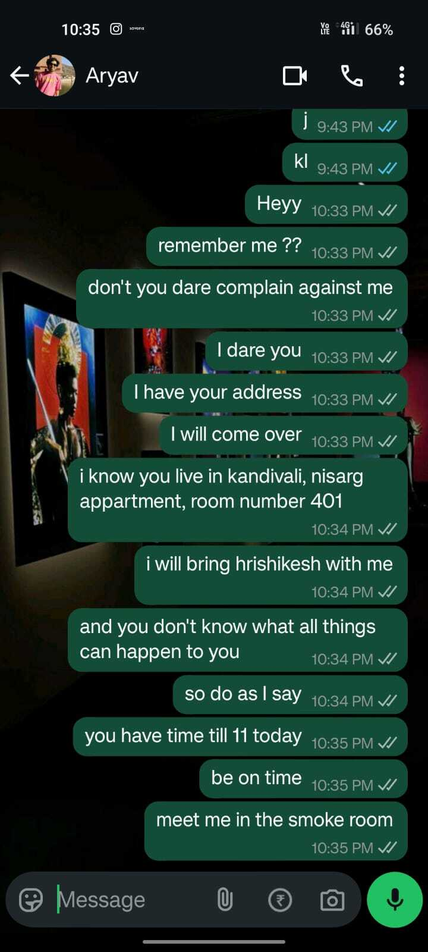

## Attached Audio Evidence

[Audio File Attached Separately: test3.wav]