

K.R. Mangalam University
School of Engineering & Technology

Lab Assignment-2

Analysis and Design of Algorithms (ADA)

Implementation and Performance Analysis of Divide and Conquer, Greedy, Dynamic Programming, and TSP Algorithms

Submitted by: Submitted to:
NAME: ARYAVEER SINGH Dr.Aarti
ROLL NO: 24010101273
PROGRAM: B. TECH CSE CORE
Section – C

ADA LAB (Assignment-2)

Task 1: Divide and Conquer Algorithms

Deliverables
- Timing results
- Performance plots

Code-

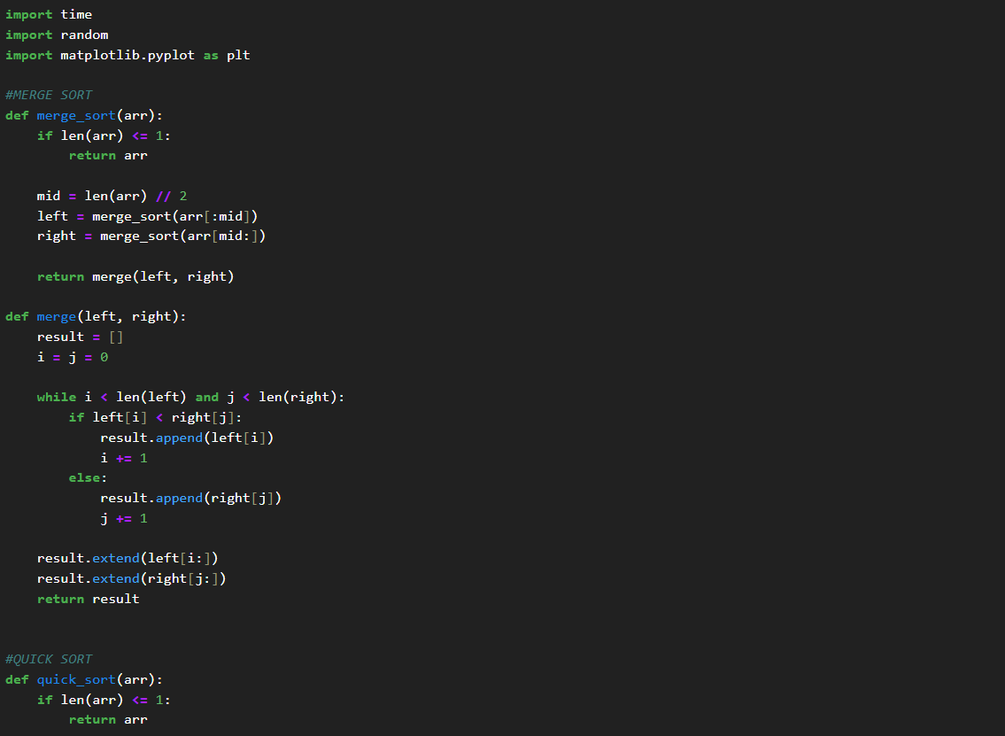

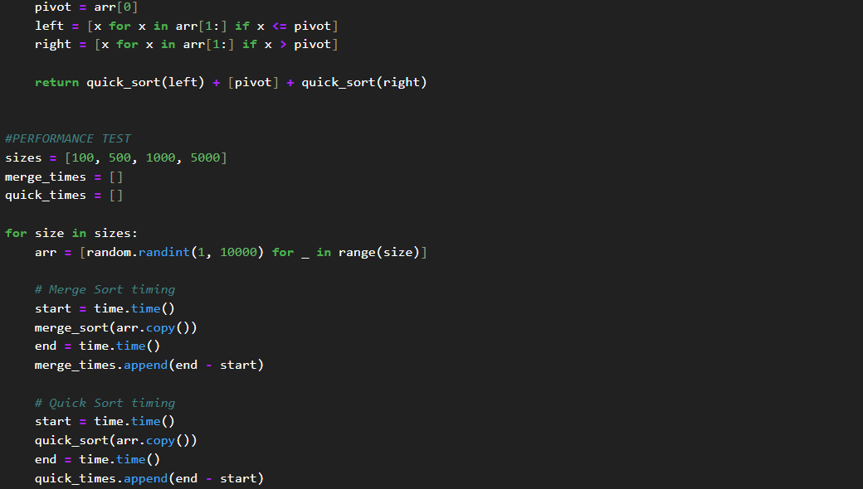

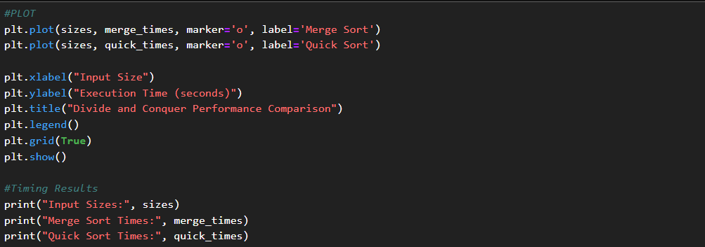

Output-
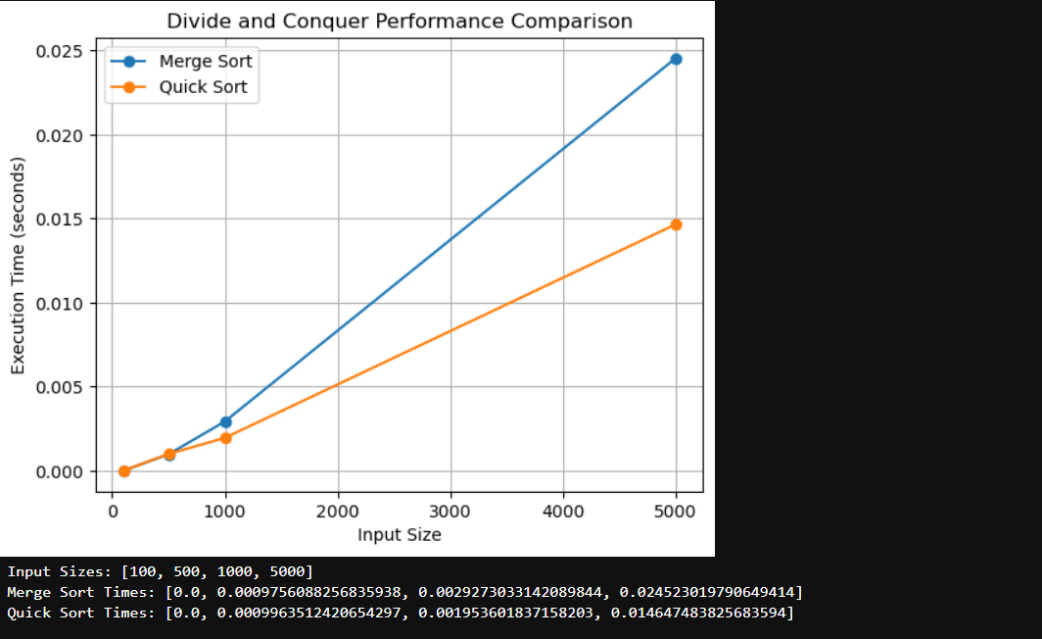
Task 2: Sorting Performance Comparison

Deliverables
- Comparison plots
- Observations in comments or markdown cells

Code-
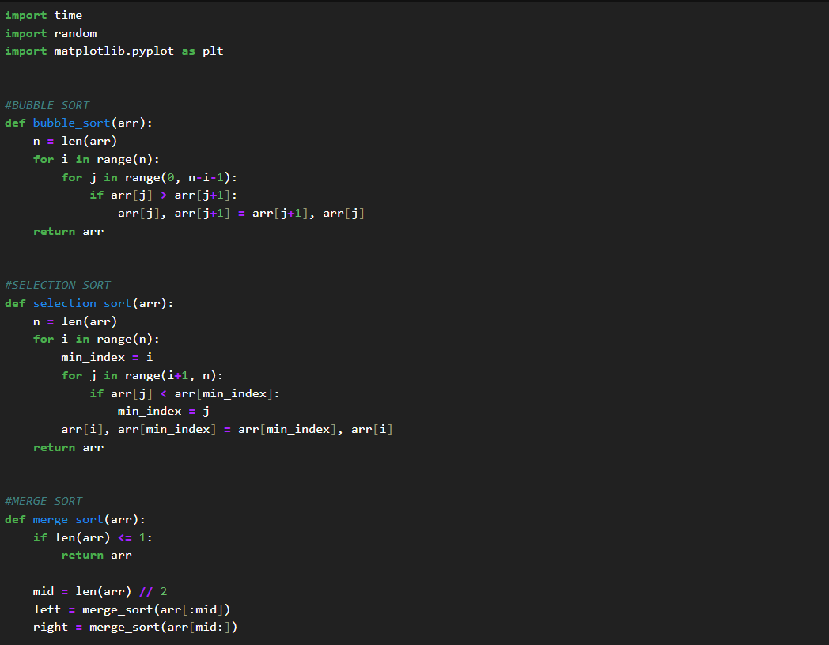
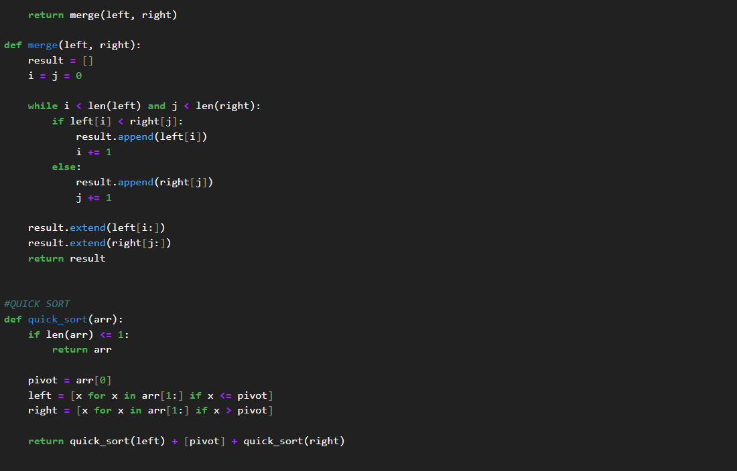

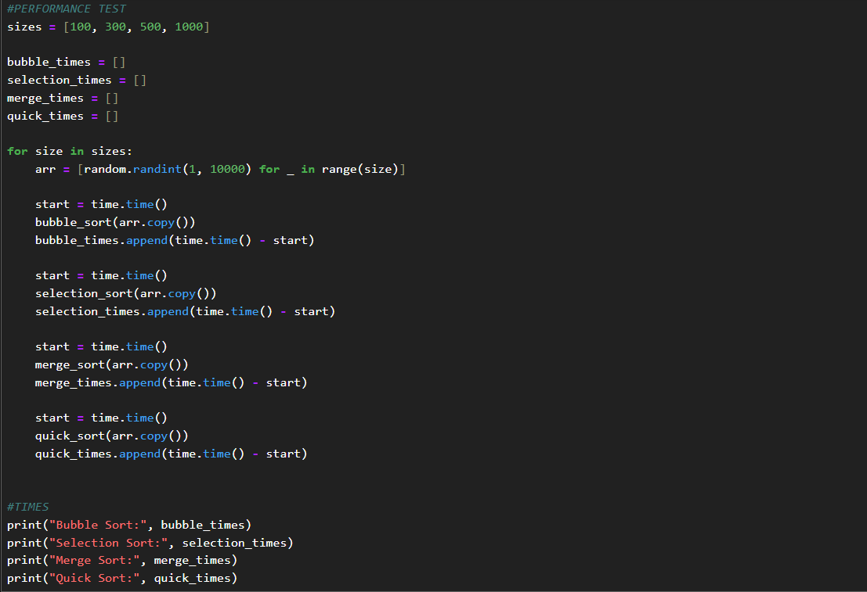
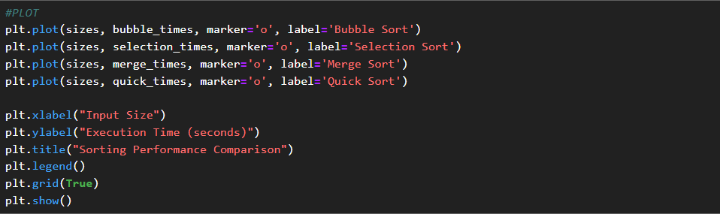

Output-

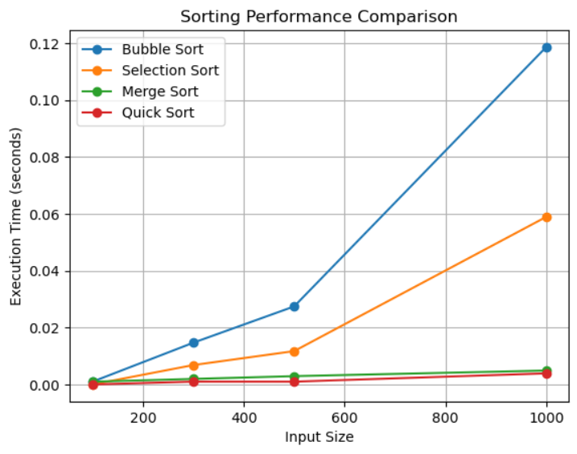
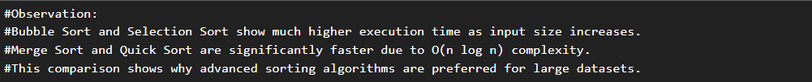

Task 3: Greedy Algorithms

Deliverables
- Output screenshots or Logs
- Brief observations in comments

Code-
Activity Selection
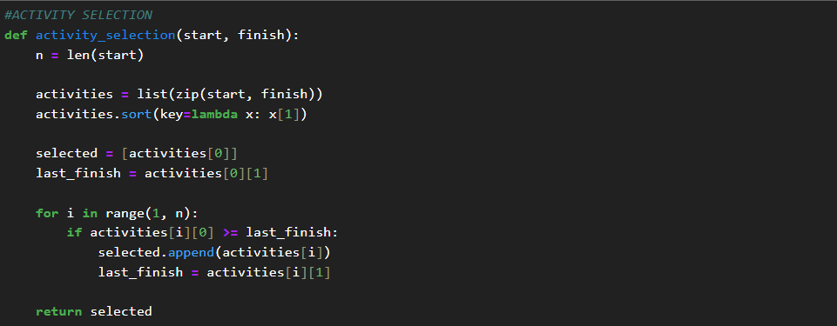
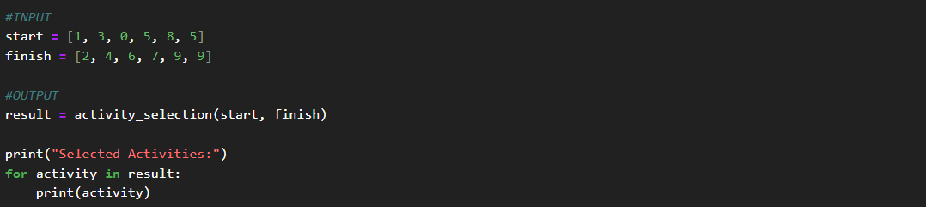

Fractional Knapsack
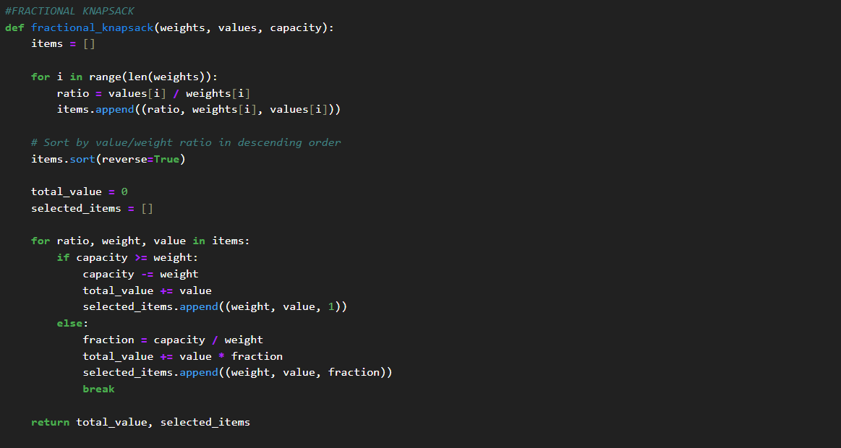
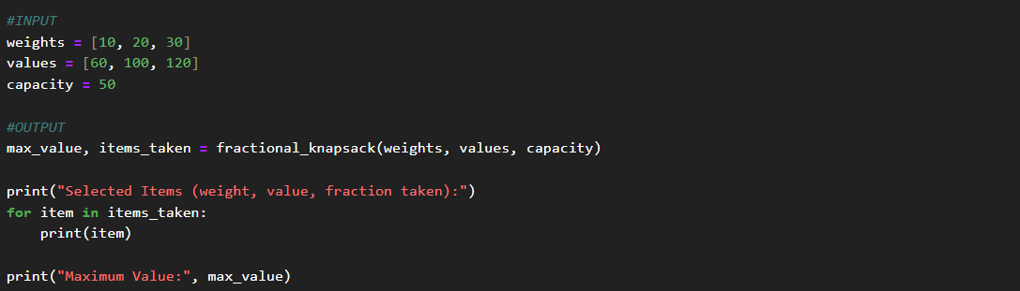

Output-
Activity Selection
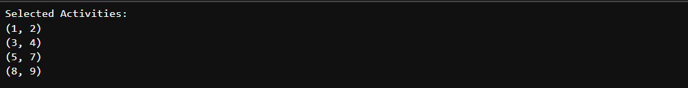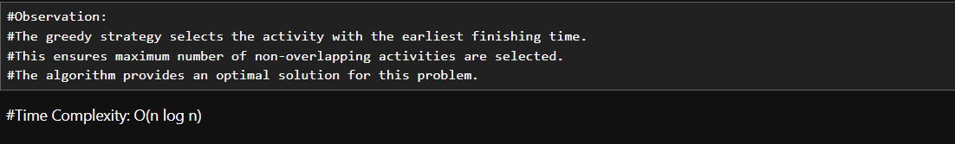
Fractional Knapsack
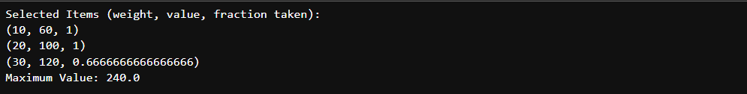

Task 4: Dynamic Programming Fundamentals

Deliverables
- DP tables or printed Output
- Execution time comparison

Code-
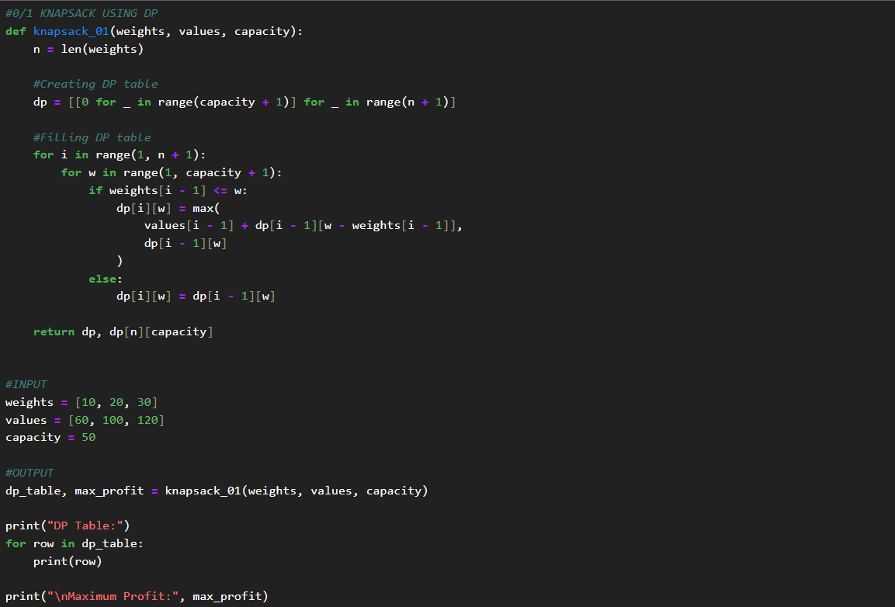

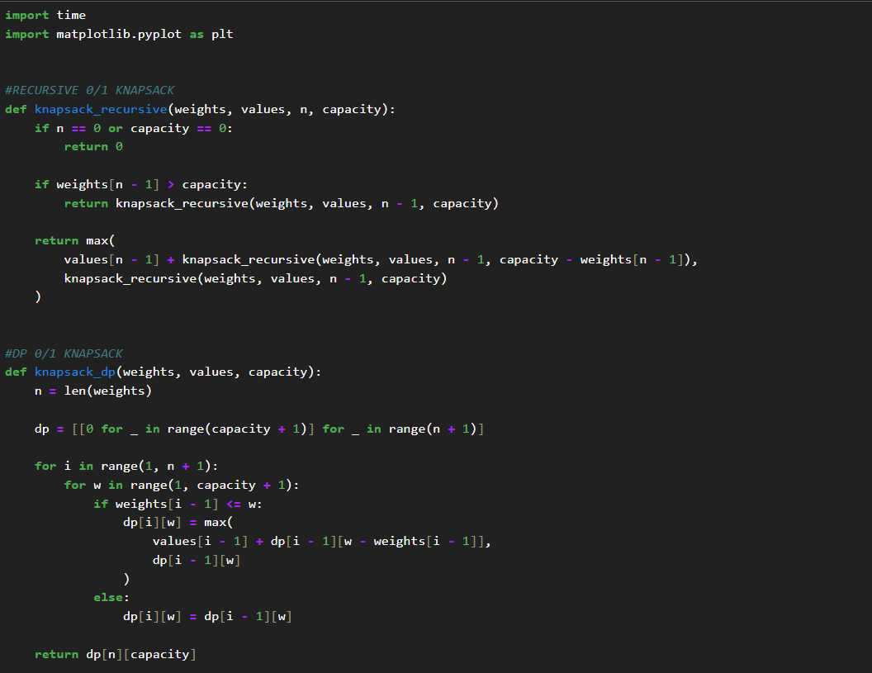
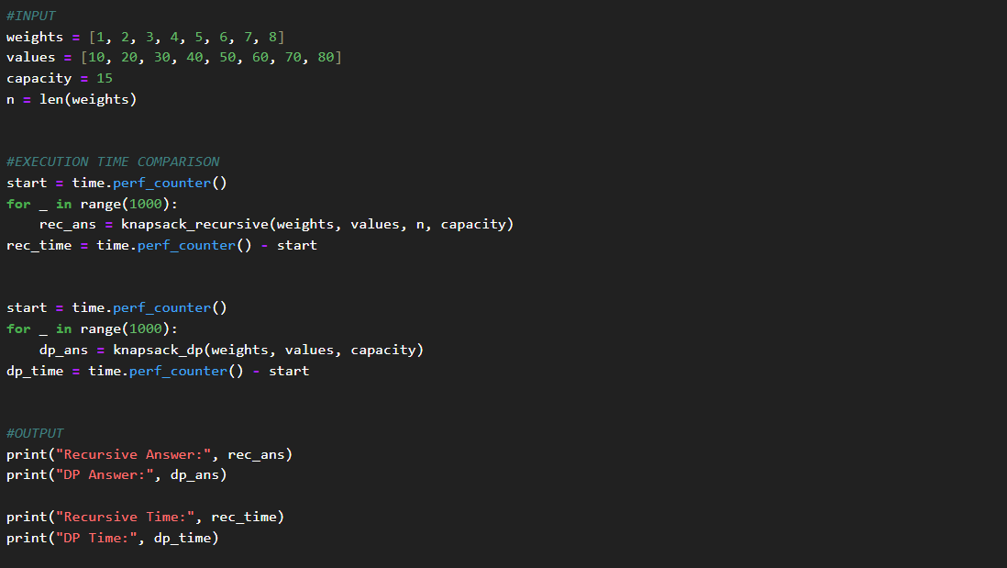

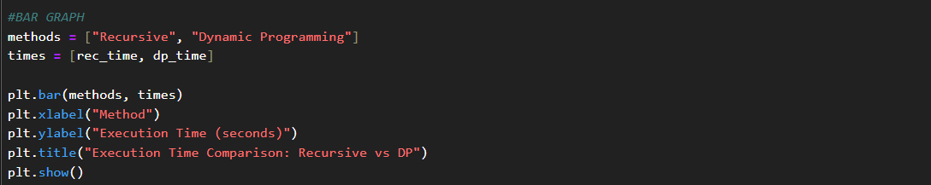

Output-

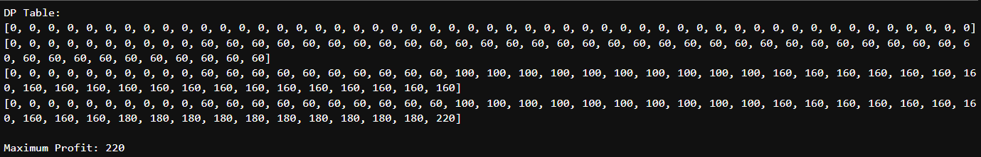

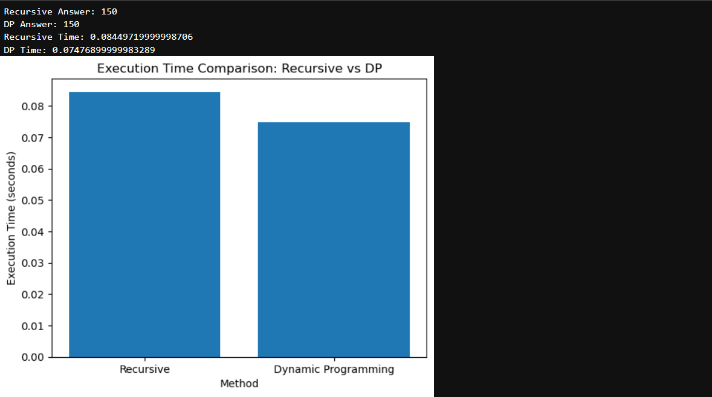

Task 5: Travelling Salesman Problem (TSP)

Deliverables
- TSP implementation
- Observations on exponential growth

Code-
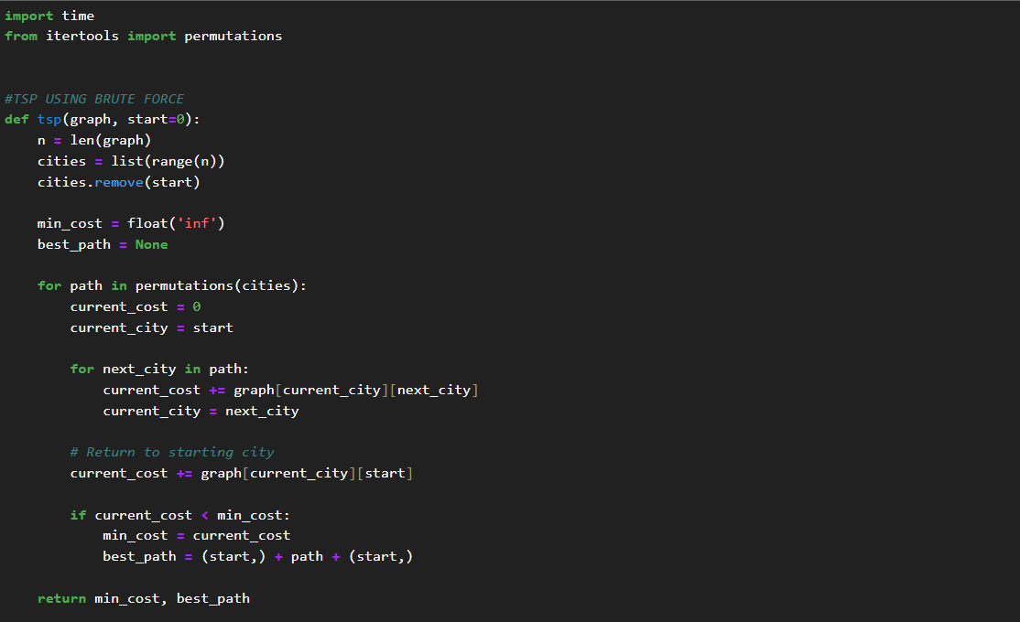

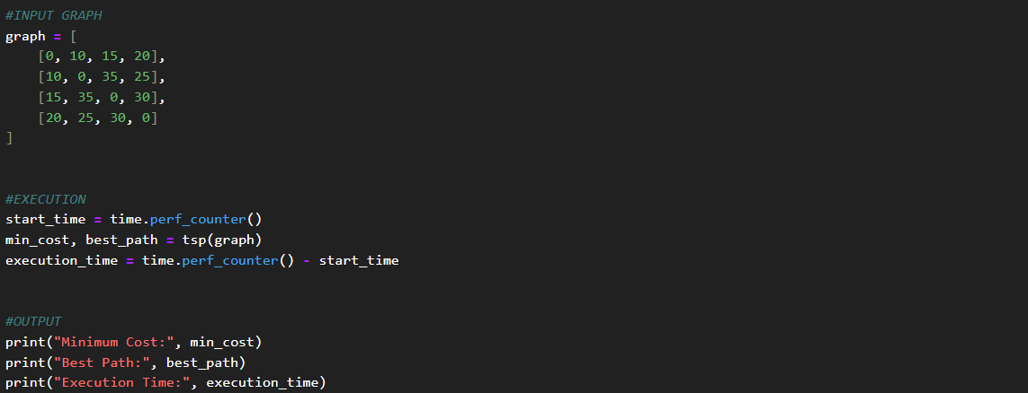

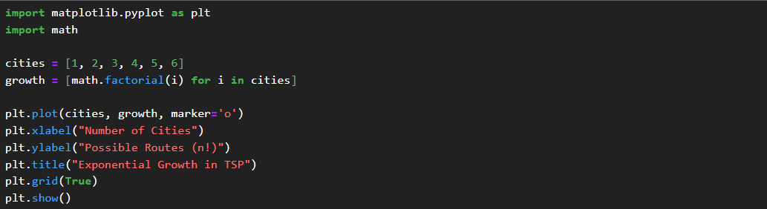

Output-

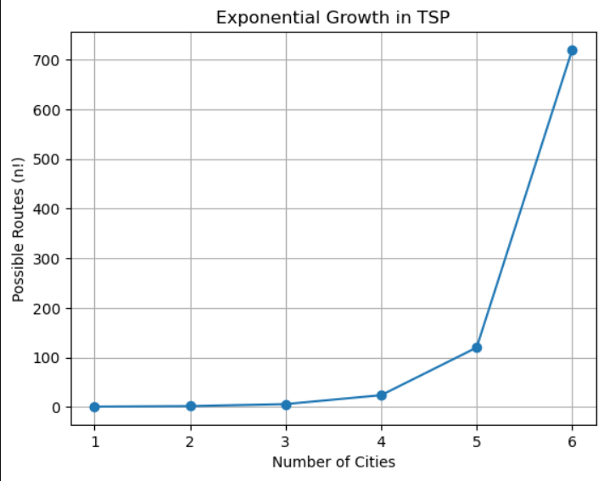

Reflection & Discussion

1. Trade-off Analysis
Among all the problems, Dynamic Programming (0/1 Knapsack) benefited the most from its chosen strategy.
The recursive method recalculates the same subproblems multiple times, which increases execution time.
Dynamic Programming stores the results of intermediate subproblems in a table and reuses them whenever needed. This significantly reduces time complexity and improves efficiency.
Hence, DP provides better performance compared to recursion.

2. Real-world Suitability
Different algorithmic strategies are suitable for different real-world problems.
- Divide and Conquer is suitable for sorting and searching large datasets.
- Greedy Algorithms are used in scheduling, network routing, and resource allocation.
- Dynamic Programming is suitable for optimization problems such as knapsack, shortest path, and sequence matching.
- TSP is used in route optimization, delivery systems, and logistics.
Thus, each strategy has important real-world applications.

3. Recursion Depth
Algorithms such as Merge Sort, Quick Sort, and Recursive Knapsack use recursion.
For large input sizes, deep recursion may lead to:
- increased memory usage
- stack overflow risk
Dynamic Programming reduces recursion overhead by using iterative tabulation.
Therefore, DP is more memory-efficient for large problems.

Conclusion-
In this lab assignment, various algorithmic strategies such as Divide and Conquer, Greedy Algorithms, Dynamic Programming, and Travelling Salesman Problem were implemented and analyzed.

The performance comparison and visualization helped in understanding the efficiency, time complexity, and practical suitability of each strategy. Dynamic Programming showed better optimization for repeated subproblems, while Greedy methods provided efficient solutions for specific optimization tasks.

GitHub Repository Link:
https://github.com/Aryaveersingh14

