

K.R. Mangalam University
School of Engineering & Technology

Analysis and Design of Algorithms (ADA)
Lab Assignment-4

Implementation and Analysis of Backtracking, Branch and Bound,
and String-Matching Algorithms with Performance Comparison

Submitted by: Submitted to:
Name: Aryaveer Singh Dr. Aarti
Roll no.: 2401010273
Program: B. Tech-CSE CORE
Section – C

ADA LAB (Assignment-4)

Task 1: Backtracking Algorithms

Deliverables
- Recursive solution in notebook

Code-
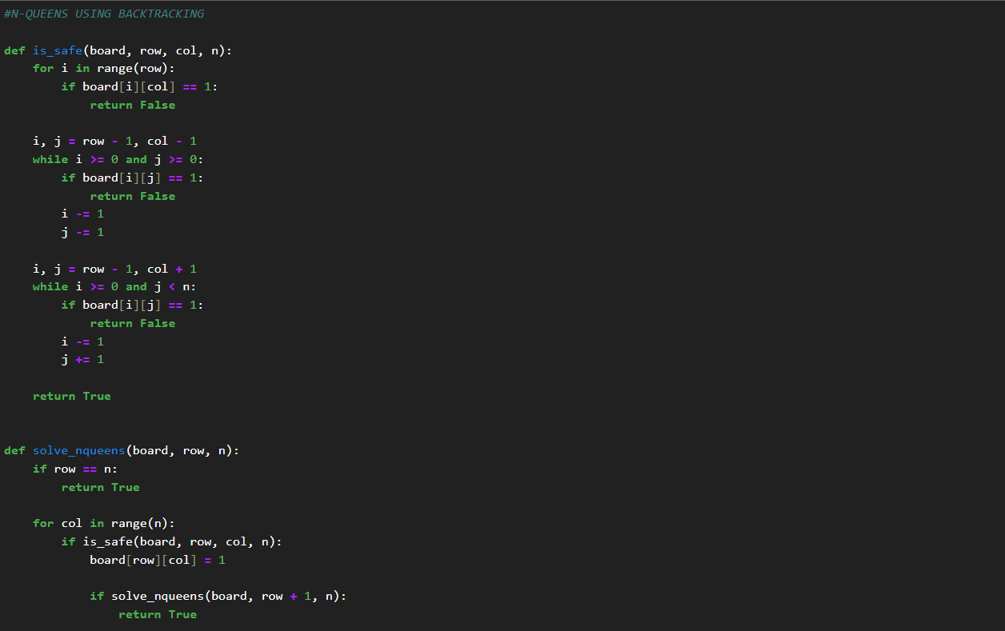
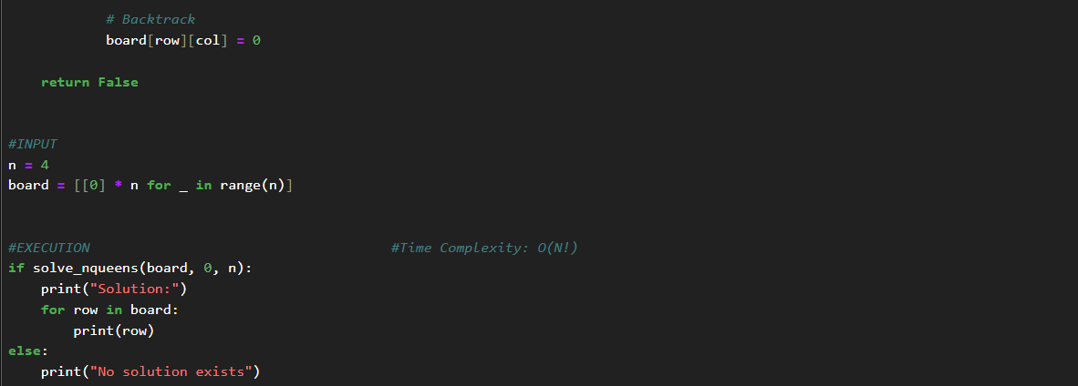

Output-
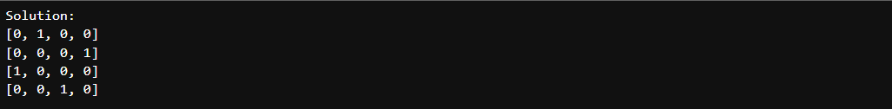

Task 2: Branch and Bound Algorithms

Deliverables
- Implement bounding functions to prune the
search space

Code-
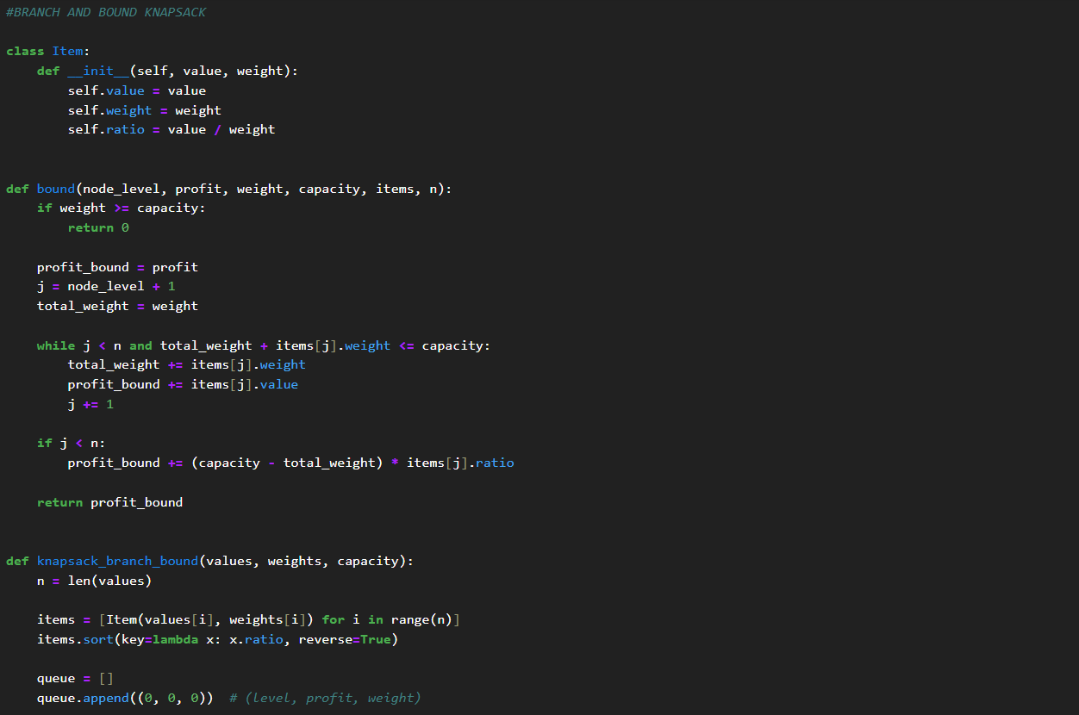
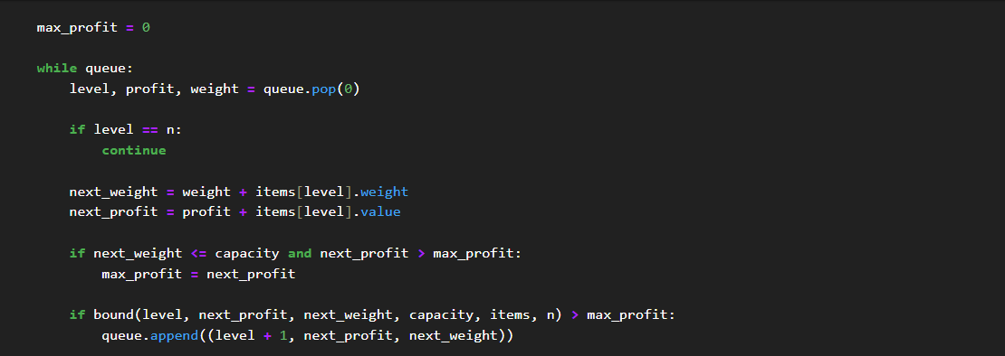
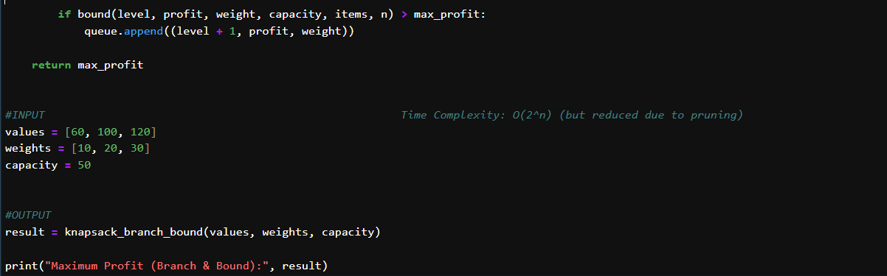

Output-

Task 3: String Matching Algorithms

Deliverables
- Search for a given pattern in a text
- Count number of character comparisons
- Compare performance of algorithms for
increasing text size.

Code-
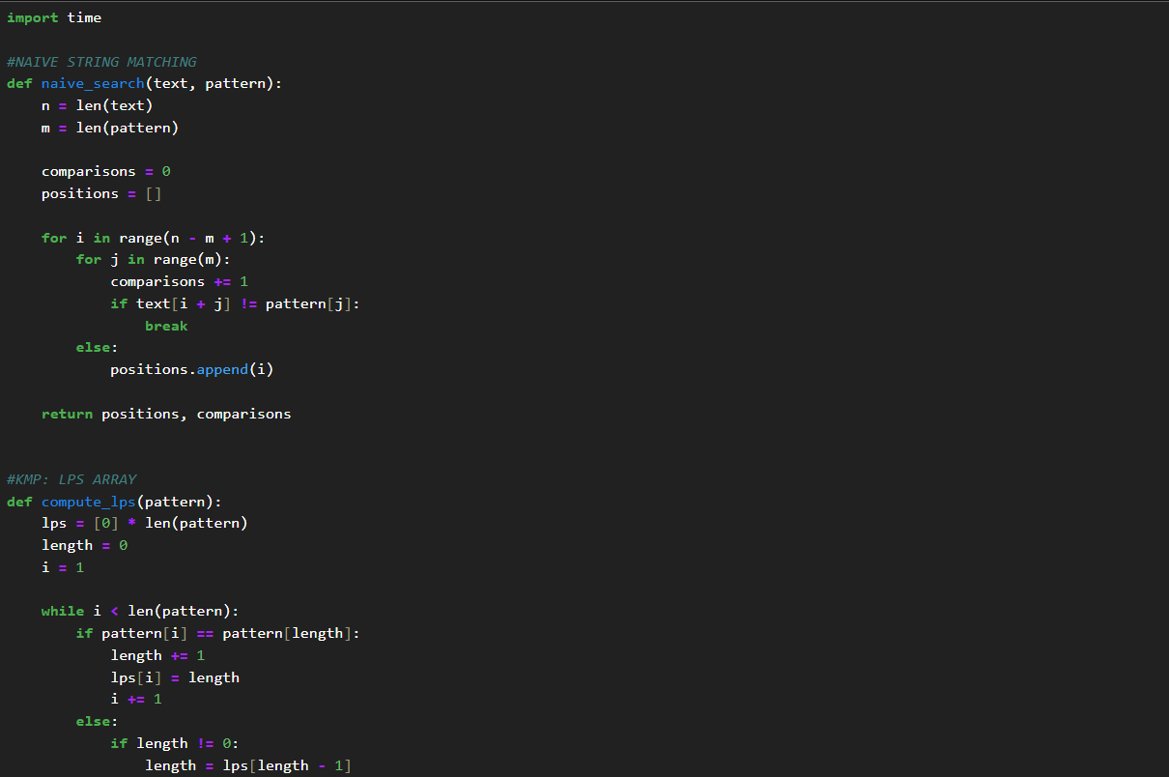



Output-
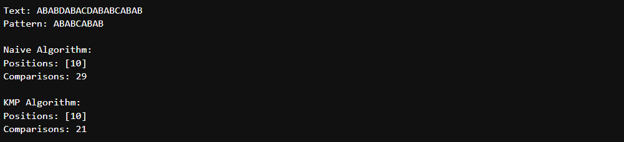

Task 4: Experimental Comparison of String Matching

Deliverables
- Observations on algorithm efficiency

Code-
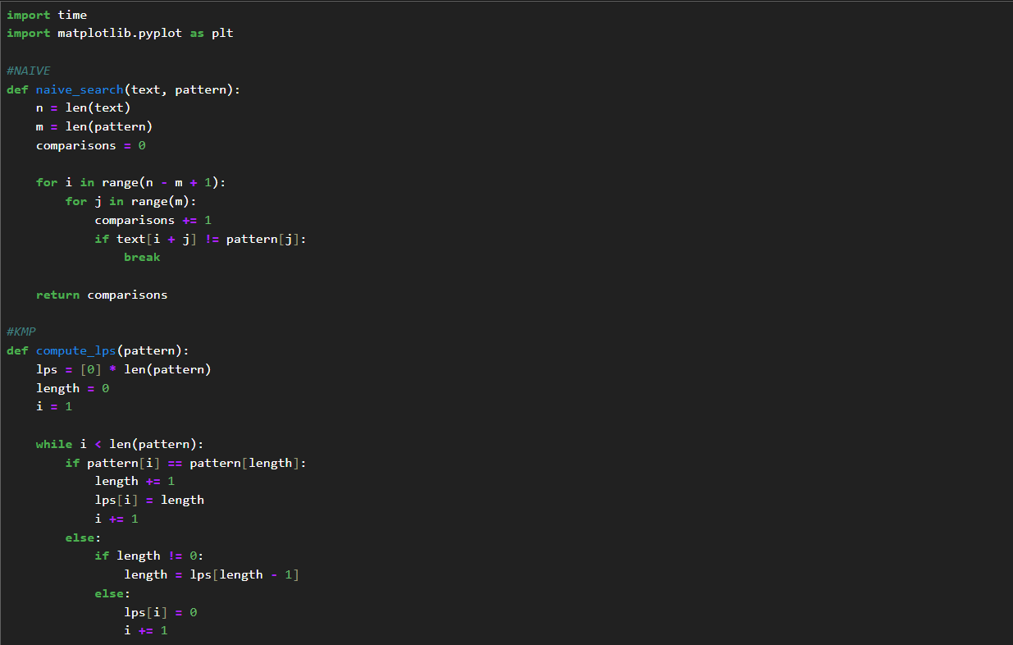
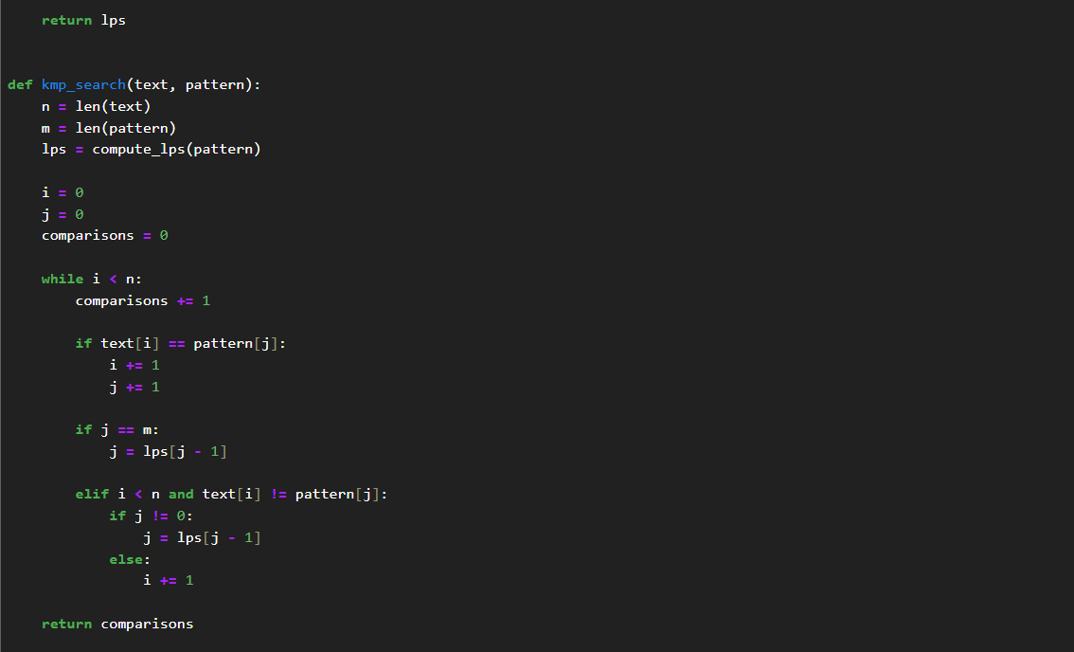
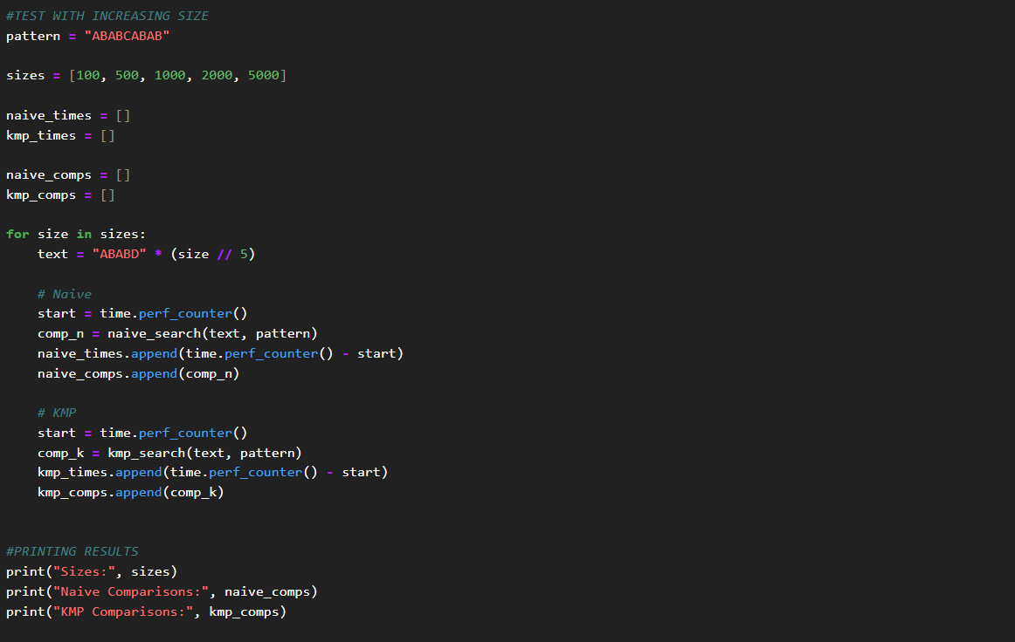
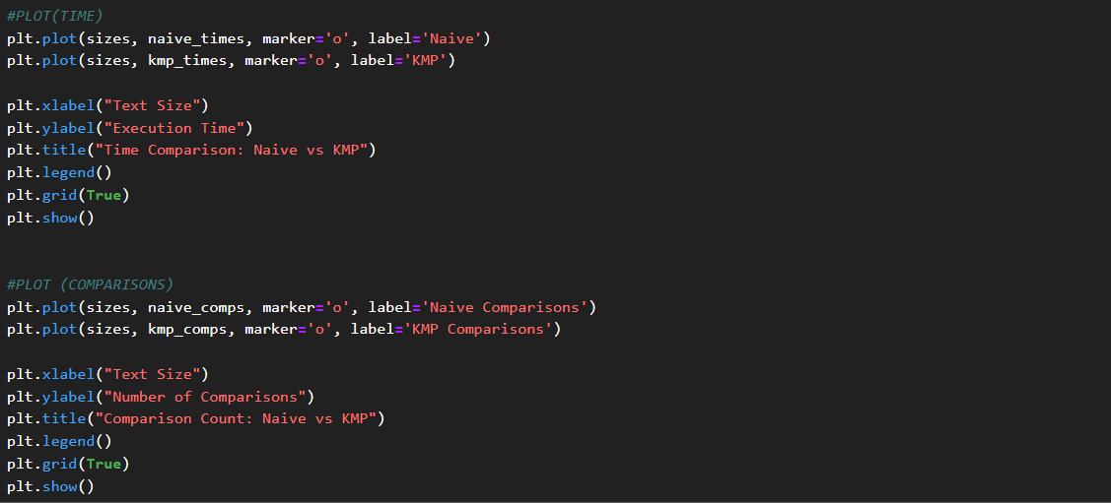

Output-

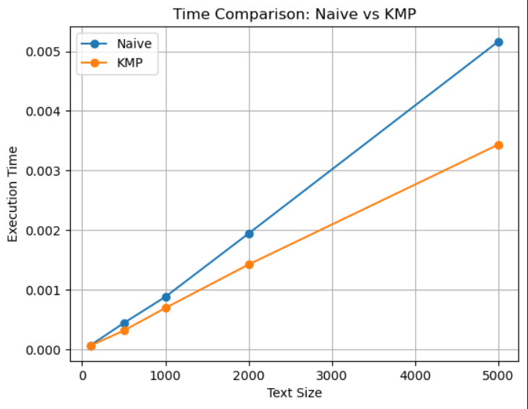

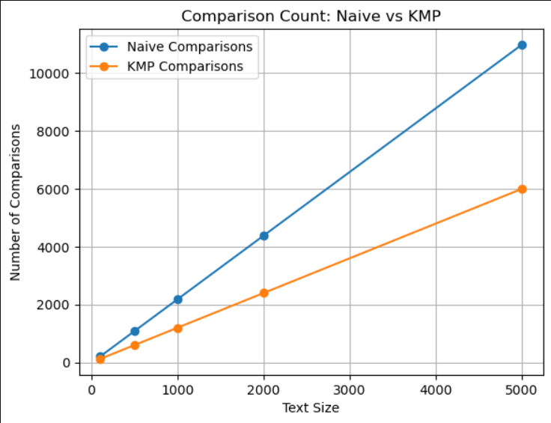

Task 5: Conceptual Programming Tasks

Deliverables
- Inline explanation in comments

- Backtracking vs Branch and Bound
Backtracking is a technique used to explore all possible solutions and discard invalid ones based on constraints. It is mainly used for feasibility problems.

Branch and Bound is used for optimization problems. It reduces the search space by using a bounding function to eliminate branches that cannot produce better solutions.
Thus, backtracking focuses on correctness, while branch and bound focuses on efficiency and optimization.

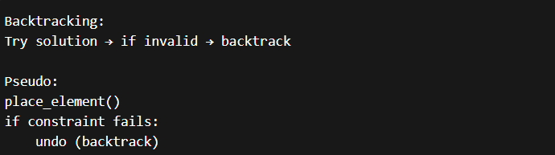
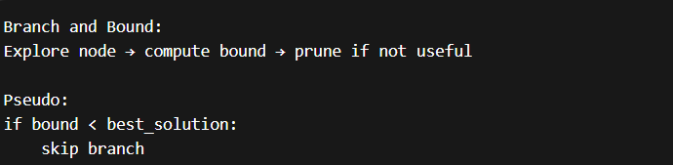

- When to use Backtracking
Backtracking is used when all possible combinations or configurations need to be explored under certain constraints.

It is suitable for problems such as N-Queens, Sudoku solving, and subset generation, where we need to check multiple possibilities and select valid solutions.
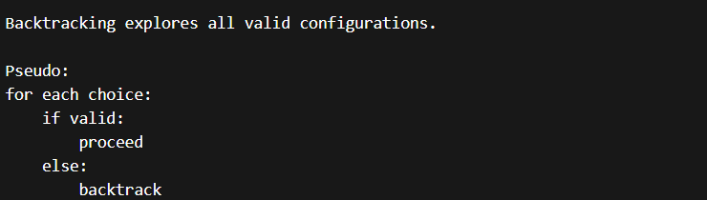

- Why KMP is more efficient than Naive
The KMP algorithm is more efficient than the Naive string-matching algorithm because it avoids redundant comparisons.

It uses the LPS (Longest Prefix Suffix) array to skip unnecessary checks when a mismatch occurs, resulting in a time complexity of O (n + m), whereas the naive approach takes O (n × m).

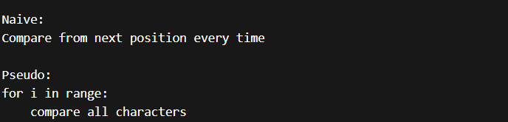
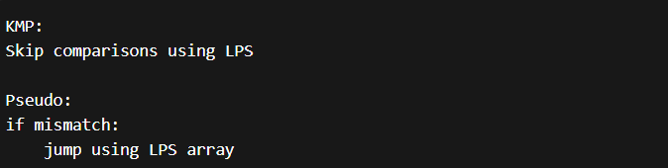

- Role of Bounding Function
The bounding function provides an estimate of the maximum possible solution from a node in the search space.
If this estimated value is less than the current best solution, the branch is pruned, reducing unnecessary computations and improving efficiency.

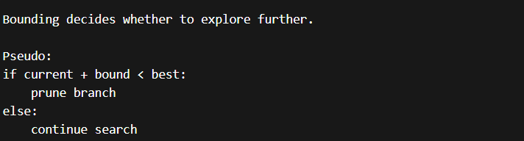

- Real-world Applications
Backtracking is used in solving puzzles, games, and constraint satisfaction problems.

Branch and Bound is used in optimization problems such as job scheduling, route planning, and resource allocation.
String matching algorithms are widely used in search engines, DNA sequence analysis, and text processing applications.

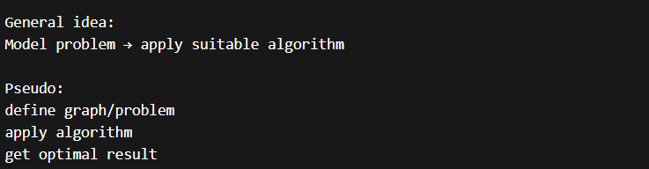

Reflection & Discussion
- Complexity Awareness
Backtracking fails to scale beyond 10–10+ elements because its time complexity grows exponentially. It explores all possible combinations, leading to a rapid increase in computation time as input size increases.
This exponential growth makes backtracking inefficient for large-scale problems, which is why optimization techniques like Branch and Bound are preferred for larger inputs.

- Constraint Handling
Among different constraints, overlap constraints are generally harder to enforce programmatically compared to rest-time constraints.

Overlap requires checking multiple conditions simultaneously across different elements, while rest-time constraints are simpler and usually involve comparing time differences between consecutive elements.

- Heuristics & Optimization
Heuristic techniques can significantly reduce the search space in problems involving backtracking and optimization.

For example, greedy heuristics, pruning strategies, and intelligent ordering of choices can help reach optimal or near-optimal solutions faster. AI-based approaches like genetic algorithms or heuristic search (A*) can also be used to improve efficiency.

- Visualization Usefulness
Visualization tools such as graphs and charts help in understanding and validating algorithm performance.

Plots comparing execution time and number of comparisons make it easier to verify correctness and efficiency. They also help identify trends, such as how one algorithm scales better than another.

- Extensibility
To make the model more realistic, additional real-world factors such as cost, location, resource constraints, and priority levels can be included.

Incorporating such parameters can improve the applicability of algorithms in real-world scenarios like scheduling, route optimization, and resource allocation.

Conclusion
In this lab assignment, various algorithmic techniques including Backtracking, Branch and Bound, and String-Matching algorithms were implemented and analyzed.

Backtracking demonstrated how exhaustive search can be used to solve constraint-based problems, while Branch and Bound improved efficiency by pruning unnecessary branches in optimization problems. String matching algorithms such as Naive and KMP highlighted the importance of reducing redundant computations for better performance.
The experimental comparison showed that KMP outperforms the Naive approach for larger input sizes due to its linear time complexity. Overall, this assignment provided valuable insights into different problem-solving strategies and their practical applications in areas such as optimization, pattern searching, and decision-making systems.

GitHub Repository Link:
https://github.com/Aryaveersingh14/ADA-LAB-ASSIGNMENTS

