**HIGHLIGHTS OF 01-09-18**

* Special assembly was organized to emphasize the importance of cleanliness.
* Students and teachers took pledge to keep surroundings clean and green.
* Students shared their views in classrooms to make peers aware about the need of hygiene and sanitation to remain healthy.
* To ensure active participation of parents, Swachhata Awareness message has been posted on Vidyalaya’s website.

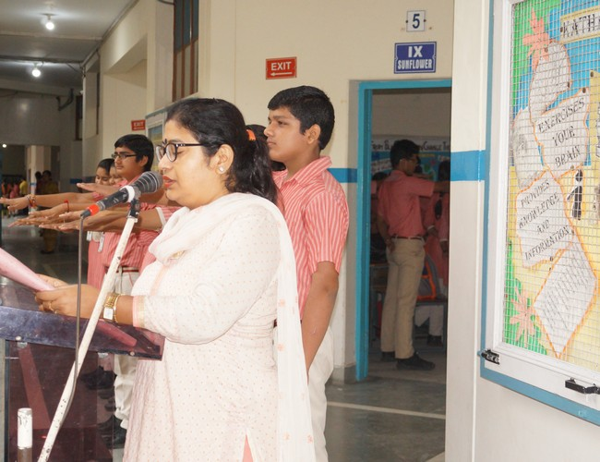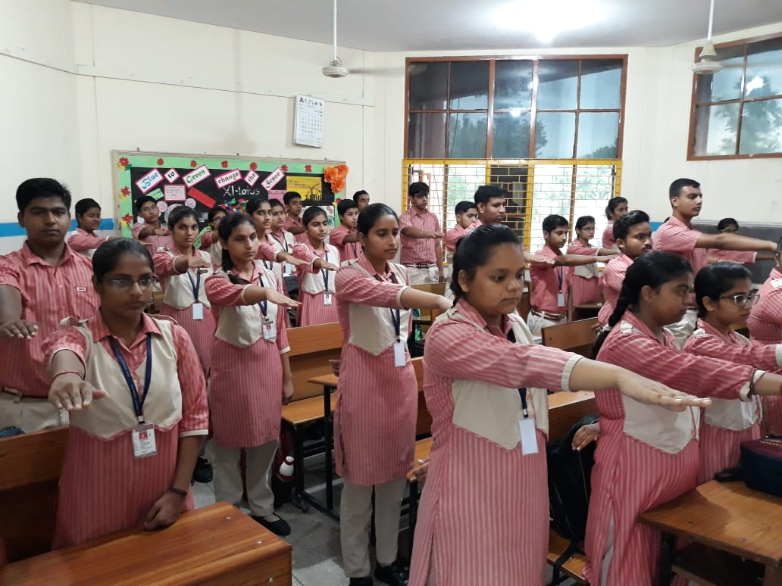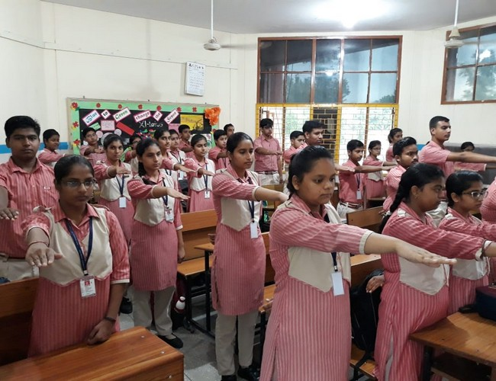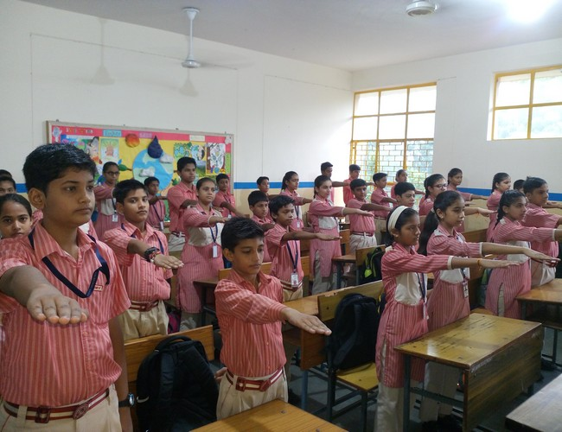

**HIGHLIGHTS OF 02-09-18**

* Pivotal role of cleanliness and sanitation in our life was discussed with students.
* Children were motivated to maintain proper hygiene in school as well as home.
* Sanitary facilities in each and every corner of our vidyalaya were inspected.
* Washrooms, kitchen, classrooms, fans, windows were extensively cleaned.

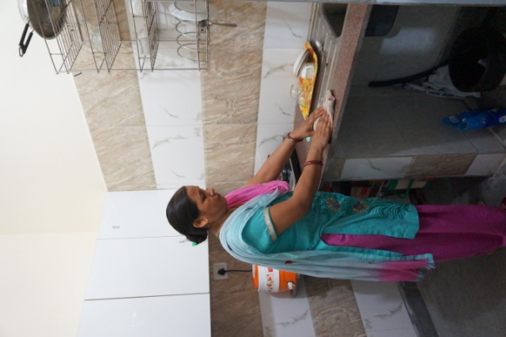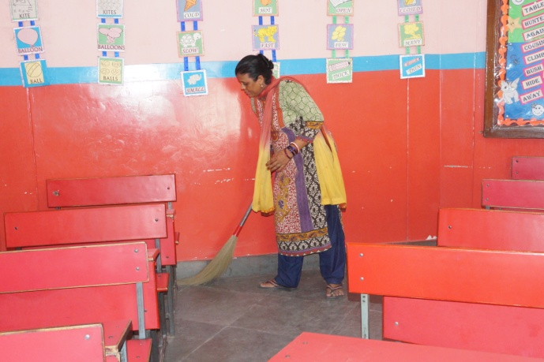

**HIGHLIGHTS OF 05-09-18**

* Childern were made aware about classification of wastes and encouraged to use blue and green coloured dustbin for recyclable and non-recyclable wastes respectively.
* Students were motivated for tree plantation through plantation drive.
* Students were motivated to adopt the principle of 3R’s – Reduce, Reuse and Recycle. They were guided to reuse of waste materials to make best out of wastes.
* All kinds of waste materials like broken furniture, unusable equipment were already been removed from school premises.

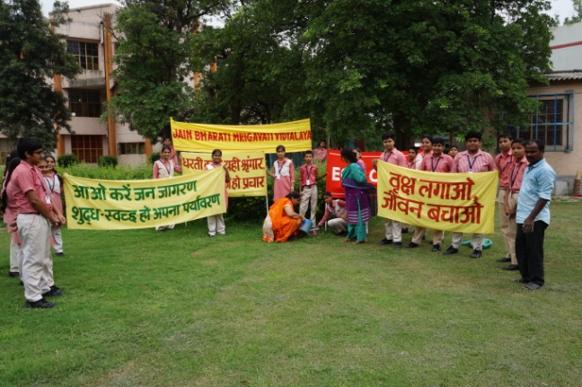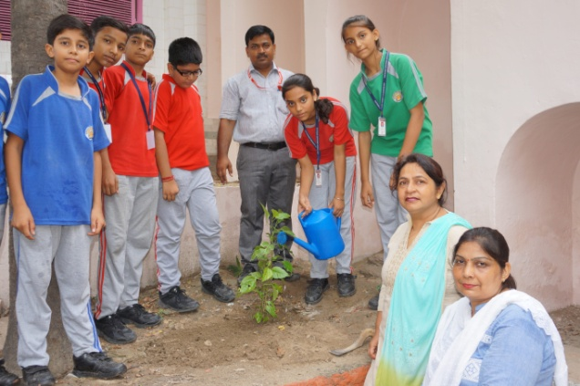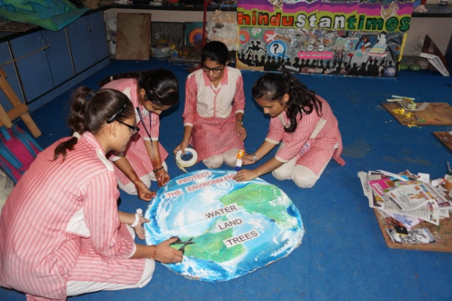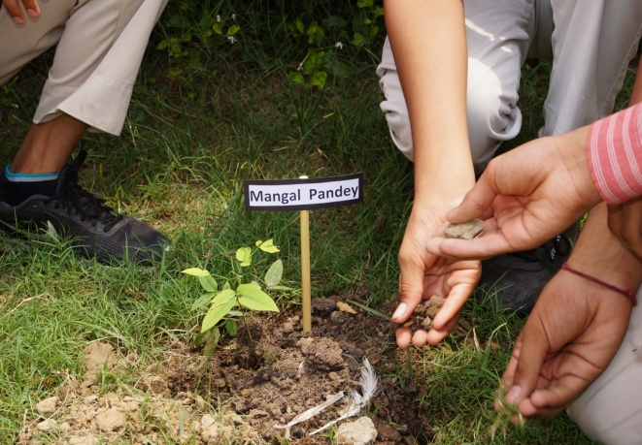

**HIGHLIGHTS OF 06-09-18**

* Painting competition, Poem and essay writing competition were held for making everyone aware of significant role of cleanliness and Hygiene practices in school and as well as at home.

