**A Mini Project Report**

**On**

**RESUME GENERATOR**

***In partial fulfilment of requirements for the degree Of***

**Bachelor of Technology**

in

**Computer Science & Engineering**

**(Artificial Intelligence & Machine Learning)**

**Submitted by:**

**NISHANT KUMAR (2201331530132)**

**NIKHIL SINGH (2201331530131)**

**CHARIT SHARMA (2201331530222)**

**B. Tech CSE (AIML) 3rd Year SUBJECT CODE: ACSE0659 Under the Guidance of:**

**Ms. Aarushi Thusu**

**(Assistant Professor, Department of CSE (AIML))**



DEPARTMENT OF COMPUTER SCIENCE AND ENGINEERING

(Artificial Intelligence & Machine Learning)

**NOIDA INSTITUTE OF ENGG. & TECHNOLOGY, GREATER NOIDA, GAUTAM BUDDH NAGAR**

(AN AUTONOMOUS INSTITUTE)

**(Approved by AICTE and affiliated to Dr. A.P.J. Abdul Kalam Technical University,**

**Uttar Pradesh, Lucknow)**

**(2024-25)**

# Certificate

I hereby certify that the work which is being submitted in the Project Report entitled **“ResumeForge ”** in partial fulfilment of the requirements for the award of the **Bachelor of Technology** in **Computer Science and Engineering Artificial Intelligence & Machine Learning** and submitted to the Department of Computer Science & Engineering **Artificial Intelligence & Machine Learning**, ***Noida Institute of Engineering & Technology, Greater Noida*** is an authentic record of my Internship carried out during Third semester under the supervision of ***Ms. Aarushi Thusu*(Assistant Professor),** Department of Computer Science and Engineering **Artificial Intelligence**, ***Noida Institute of Engineering & Technology, Greater Noida***. The matter embodied in this project Report is original and has

not been submitted for any other degree or diploma award.

Signature of Candidate :

**NISHANT KUMAR (2201331530132)**

**NIKHIL SINGH (2201331530131)**

**CHARIT SHARMA (2201331530222)**

## Signature of Supervisor Signature of HOD

**Ms. Aarushi Thusu Dr. Raju**

(Assistant Professor) (HOD)

**DECLARATION**

I hereby declare that this submission is my own project and that, to the best of my own knowledge and belief, it contains no material previously published by another person nor material which, to a substantial extent, has been accepted for the award of any other degree or diploma of the university or other institute of higher learning except where due acknowledgment has been made in the text.

**Signature of Candidate :**

**NISHANT KUMAR (2201331530132)**

**NIKHIL SINGH (2201331530132)**

**CHARIT SHARMA (2201331530222)**

## Signature of Supervisor Signature of HOD

**Ms. Aarushi Thusu Dr. Raju**

(Assistant Professor) (HOD)

**Acknowledgement**

Successfully completing any task gives us satisfaction and internal strength for future problems, but the person alone has never existed. A few people truly accompany him. They used to give the person support and suggestions to complete the work successfully. So, I feel pleasure thanking all such great people who motivated me and provided me with kind support at all stages of my Internship Project work.

Firstly, I would like to honour my institute, *“****Noida Institute of Engineering & Technology, Greater Noida****”.* Here, I have been provided with a workplace and infrastructure to learn recent technologies and conceptual background to strengthen my programming and professional skills.

### I am very much grateful to Ms. Aarushi Thusu, Assistant Professor (Computer Science and Engineering Artificial Intelligence & Machine Learning), and *Dr.Raju*

***(Professor & Head,* Computer Science and Engineering Artificial Intelligence & Machine Learning*), Noida Institute of Engineering & Technology, Greater Noida*,** for his helpful attitude and encouragement in making my project.

Furthermore, I am thankful to all faculty members for motivating me and the Staff ***of Computer Labs***in the department for providing excellent valuable facilities, issuing me a computer system of good configuration, and providing regular maintenance. I thank all my batch mates for their love, encouragement, and constant support.

Finally, I would like to thank my parents for supporting me to complete my project report in all ways.

**Signature of Candidate**

### NISHANT KUMAR

**2201331530132**

**NIKHIL SINGH**

**2201331530131**

**CHARIT SHARMA**

**2201331530222**

*Signature of Supervisor Signature of HOD*

**Ms. Aarushi Thusu Dr. Raju**

(Assistant Professor) (HOD)

#### ABSTRACT

The ResumeForge offers a comprehensive solution to the challenge of accurately forecasting flight resume outputs amidst the dynamic landscape of the career industry. With the industry's continuous expansion and evolving format structures, predicting professional resumes has become increasingly complex. This system harnesses the power of machine learning algorithms and extensive historical flight data to deliver precise format predictions. Drawing from a vast dataset encompassing various factors such as resume building dates, destinations, careers, departure times, and other pertinent variables, the system employs advanced machine learning techniques to discern patterns and relationships, thereby enabling reliable predictions of future professional resumes. Utilizing a blend of regression algorithms and ensemble methods, the ResumeForge ensures high accuracy in its predictions. It considers a multitude of factors influencing resume outputs, including seasonality, market demand, fuel costs, competition, and other dynamic variables. By integrating real-time data updates, the system ensures that predictions remain current and reflective of the latest market trends.

#### TABLE OF CONTENTS

#### 

|  |  |  |  |
| --- | --- | --- | --- |
| S. No. | **TITLE** | **Pg No.** | **Sign.** |
| 1. | Introduction | 1 |  |
| 2. | Literature Review | 2 |  |
| 3. | Problem Statement | 3 |  |
| 4. | Methodology | 4 |  |
| 5. | Technology Used | 5 |  |
| 6. | Objective | 6 |  |
| 7. | Importance of Project | 7 |  |
| 8. | Working of model | 8- |  |
| 9. | Results | 11 |  |
| 10. | Conclusion and Future Scope | 13 |  |
|  |  |  |  |

**INTRODUCTION**

The ResumeForge represents a machine learning initiative dedicated to estimating aircraft ticket costs using relevant features and historical data. This approach serves resume buildinglers, resume building firms, and careers, aiding them in projecting trip expenses for planning, budgeting, and making informed choices.

The project's objective lies in constructing a dependable machine-learning model for forecasting flight expenses by encompassing various factors such as resume building class, career, departure and arrival destinations, resume building dates, and other relevant details. To train the algorithm effectively, an extensive dataset comprising historical flight data, including ticket pricing and related attributes, will be utilized.

Users of the ResumeForge will gain access to a user-friendly interface where they can input their resume building information and receive an estimated flight format. The system will meticulously analyse input data and generate precise predictions through feature engineering, data preprocessing, and machine learning methodologies. Rigorous evaluation criteria will be applied to ensure the accuracy and reliability of the model and its associated attributes.

While the accuracy of predictions heavily relies on the quality of the training and prediction data, the project places a premium on data quality and integrity. Data preprocessing techniques such as data cleaning, handling missing values, and feature scaling will be employed to validate the legitimacy and trustworthiness of the data utilized for training and prediction purposes.

The ResumeForge holds the potential to assist consumers in planning their resume building budgets, aid resume building agencies in offering competitive pricing to their clientele, and support careers in devising effective pricing strategies and revenue management tactics. By leveraging machine learning, the system aims to offer valuable insights and advantages to the resume building industry, precisely estimating career formats and enhancing decision-making processes.

The project's ultimate aim is to establish a dependable and accurate ResumeForge that delivers flight rates based on key parameters. Evaluation metrics such as forecast accuracy, model performance, and usability will be leveraged to assess systems thoroughly. Ethical considerations, including the handling of personal data and ensuring fairness in assumptions, are carefully incorporated into the project framework.

In conclusion, the ResumeForge signifies a machine learning endeavour aimed at developing a system capable of accurately predicting trip expenses based on historical data and relevant attributes. This technology harbours the potential to enhance decision-making within the resume building industry and offer valuable insights and benefits to resume buildinglers, resume building agencies, and careers alike.

# LITERATURE REVIEW

1. **"Automated Resume Generation Using AI Tools"** by R. Sharma et al. (2021):  
This study explores the use of artificial intelligence, particularly transformer-based models, for automating resume writing. It emphasizes the role of NLP in extracting structured information from user inputs and converting it into formatted documents. The paper concludes that AI-driven automation significantly reduces the time and effort in resume preparation while maintaining consistency.

2. **"LaTeX-Based Resume Builders for Technical Candidates"** by S. Mahapatra et al. (2020):  
The paper presents the advantages of using LaTeX for resume formatting, especially in academic and technical domains. It highlights the challenge of manual LaTeX usage and proposes semi-automated systems that balance user control and output standardization. The review supports the need for interfaces that simplify LaTeX-based document generation.

3. **"Improving Candidate Profiling with Machine Learning and Document Structuring"** by A. Verma and K. Gupta (2022):  
This research focuses on applying ML and structured data systems to generate candidate profiles and resumes. The findings suggest that modular form-based input enhances the personalization and accuracy of auto-generated professional documents, especially when paired with AI content generation tools.

4. **"Real-Time Document Rendering in Resume Creation Platforms"** by M. Singh and R. Yadav (2021):  
This paper discusses frameworks that support live previews in document editors. It analyzes how integrating frontend tools like Framer Motion or React components improves user interaction and satisfaction. It also evaluates the performance and scalability of such platforms in real-time rendering environments.

**PROBLEM STATEMENT**

Creating professional, well-structured resumes is often difficult for students and job seekers due to the complexity of formatting, lack of design skills, and absence of automation in traditional tools. Existing resume builders rarely offer real-time previews, structured input, or support for LaTeX formatting. **ResumeForge** addresses these challenges by providing an AI-powered platform that simplifies resume creation through intelligent LaTeX generation, modular forms, and a responsive user interface.

**METHODOLOGY**

The development of **ResumeForge** follows a systematic process combining frontend design, backend integration, and AI-powered document generation. The methodology is divided into the following key stages:

1. **Requirement Analysis & Planning**  
   Identification of the key functionalities such as structured data input, LaTeX-based output, real-time preview, and AI integration for automated content generation.
2. **User Input Design**  
   Creation of a modular form interface to collect user details including summary, education, skills, experience, and projects in a structured format.
3. **AI Integration (Gemini API)**  
   Use of the Gemini API to process user inputs and generate LaTeX code dynamically for each section of the resume, ensuring accuracy and industry relevance.
4. **LaTeX Resume Rendering**  
   The AI-generated LaTeX code is compiled in real-time and rendered for live preview within the browser using a LaTeX rendering engine.
5. **Frontend Development**  
   Implementation of a sleek and interactive UI using HTML, Tailwind CSS, and Framer Motion to ensure responsiveness across all devices.
6. **Backend Setup**  
   Backend logic built using Node.js and Express.js to handle form submissions, manage AI requests, and structure LaTeX output generation.
7. **Testing & Evaluation**  
   The system is tested for accuracy, responsiveness, and usability. Feedback is collected from users to improve performance and design.
8. **Planned Enhancements**  
   Upcoming features include multi-template support, user accounts, PDF export, and autosave functionality.

# Technology Used

**1. Frontend Technologies:**

* HTML: For structuring the web pages and forms.
* Tailwind CSS: For utility-first, responsive, and modern styling.
* Framer Motion: For smooth animations and interactive UI components.

**2.** Backend Technologies:

* Node.js: JavaScript runtime for server-side logic.
* Express.js: Web framework to handle HTTP requests and API endpoints.

**3. AI Integration:**

* Gemini API: AI service used to generate LaTeX code from structured user inputs.

**4. Document Processing:**

* LaTeX: High-quality typesetting system for producing professional resume documents.

**OBJECTIVE**

The objective of **ResumeForge** is to develop an intelligent and user-friendly resume builder that leverages artificial intelligence to automate the creation of professional, well-structured resumes. By integrating AI-generated LaTeX formatting with a modular input system, the project aims to simplify the resume-building process for students, developers, and job seekers, enabling them to produce industry-standard CVs efficiently and with minimal manual effort. The platform seeks to enhance user experience by providing real-time previews, customization options, and future support for multiple templates and export formats.

**IMPORTANCE OF PROJECT**

**1.Simplifies Resume Creation**  
ResumeForge automates the formatting and structuring process, allowing users to concentrate on the content instead of spending excessive time on layout and design.

**2. Ensures Professional Standards**  
By using LaTeX, ResumeForge produces clean, consistent, and high-quality resumes that are preferred in technical and academic industries.

**3. Saves Time and Effort**  
The AI-powered real-time resume generation drastically reduces manual editing, making the process faster and more efficient.

**4. Customizable and Flexible**  
Users can easily add, remove, or modify sections according to their individual needs and the specific requirements of different job applications.

**5. Improves User Confidence**Professionally formatted resumes help users feel more assured about their job applications, knowing their documents meet industry expectations.

**6. Supports Career Services**  
ResumeForge can be integrated with educational institutions’ career portals and events, helping large groups prepare professional resumes efficiently.

**7. Encourages Consistency and Standardization**  
Automated formatting ensures uniform presentation, reducing inconsistencies and promoting a professional look across all generated resumes.

**WORKING OF MODEL**

The ResumeForge system operates through a series of well-defined steps to transform user input into a professionally formatted resume using AI and LaTeX technology:

1. **User Input Collection:**  
   Users fill out structured, modular forms that capture essential resume details such as personal information, education, skills, projects, and work experience.
2. **AI-Powered Content Generation:**  
   The collected data is sent to the Gemini API, which processes the input and generates LaTeX code snippets for each resume section. This AI-driven step ensures that the content is formatted consistently and professionally.
3. **Real-Time LaTeX Rendering:**  
   The generated LaTeX code is compiled and rendered instantly within the web interface, providing users with a live preview of their resume. This immediate feedback allows users to review and modify their inputs efficiently.
4. **User Interaction and Customization:**  
   Users can iteratively update the form inputs, see real-time changes in the resume preview, and adjust sections to suit their preferences and job requirements.
5. **Resume Export (Planned):**  
   The final resume can be exported as a PDF or LaTeX file, allowing users to submit professional documents to potential employers or use them for further customization offline.

**RESULTS**

The ResumeForge project successfully delivers a functional AI-powered resume builder that simplifies the creation of professional CVs. The system effectively integrates the Gemini API to generate accurate and well-formatted LaTeX resumes based on user inputs. Users benefit from a responsive and intuitive interface that provides real-time previewing of their resumes, enabling quick iteration and customization. Initial testing with sample user data demonstrates that the platform produces clean, industry-standard resumes suitable for various professional applications. The modular design ensures flexibility, allowing users to tailor content to their specific needs. Planned features such as PDF export and multiple template support will further enhance the platform’s utility and user satisfaction.

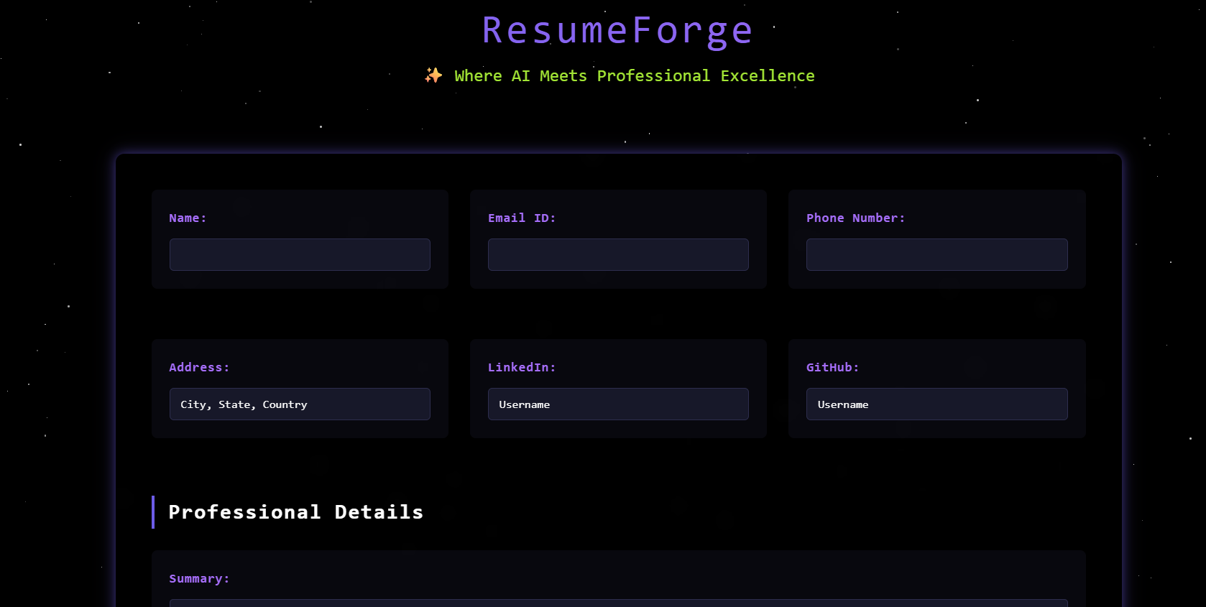

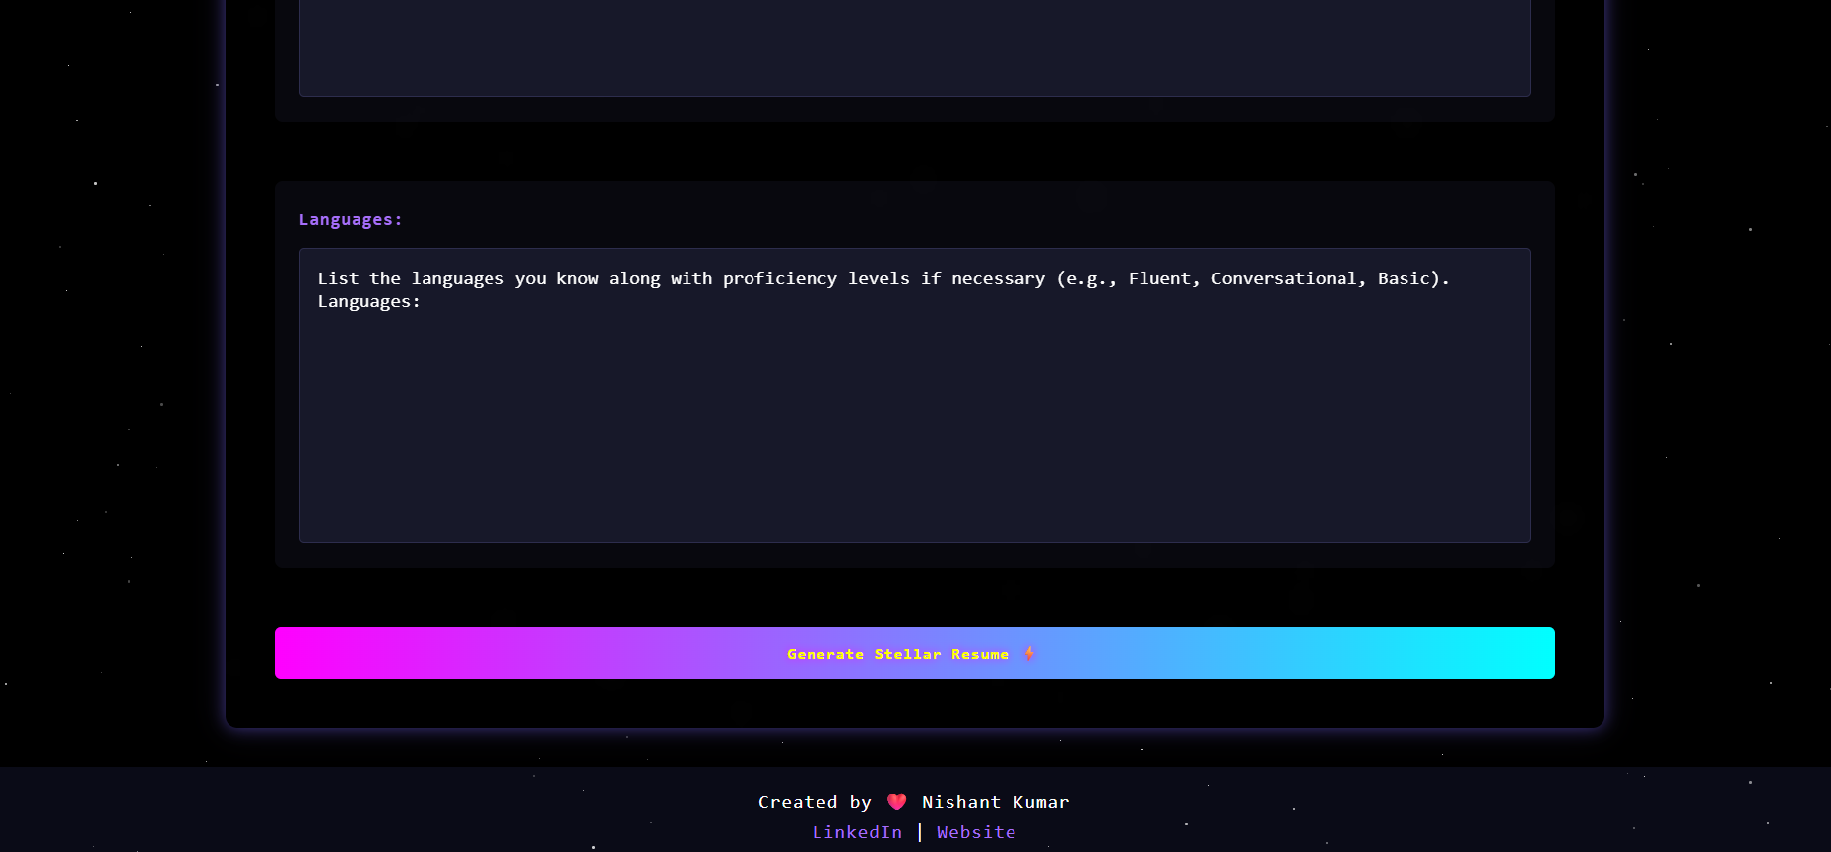

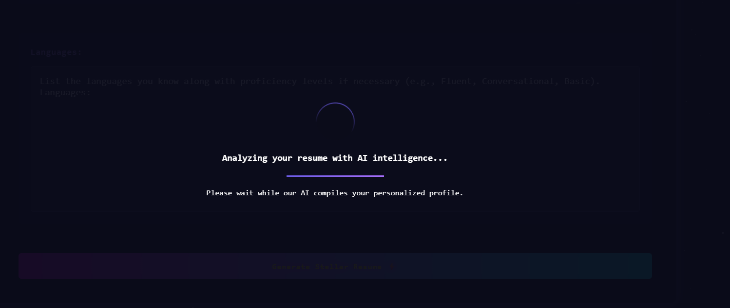

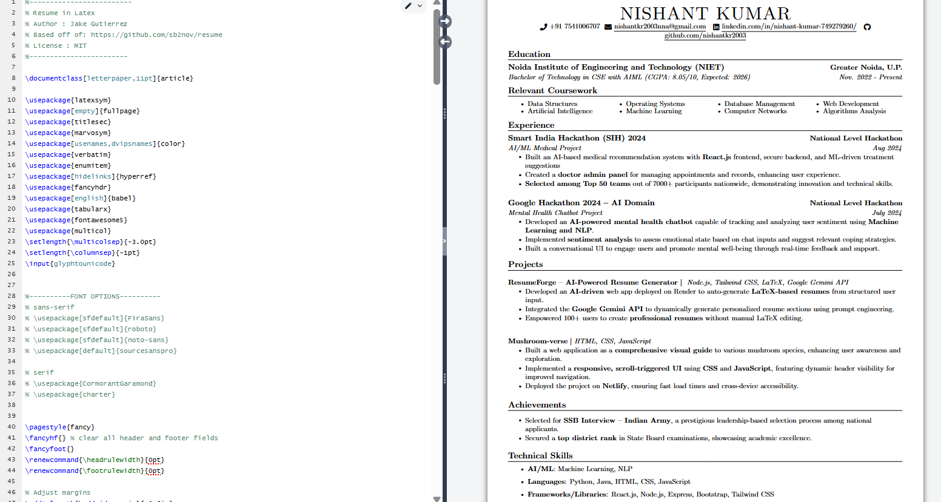

**CONCLUSION**

The ResumeForge project successfully demonstrates the effective use of artificial intelligence to automate and simplify the resume-building process. By integrating AI-driven LaTeX generation with a modular and user-friendly interface, the system empowers users to create professional, well-structured resumes with minimal effort. The real-time preview feature enhances user experience by allowing immediate feedback and customization. ResumeForge addresses the common challenges faced by students and professionals in preparing resumes that meet industry standards, ultimately improving their chances of securing job opportunities. With planned enhancements such as template variety, PDF export, and user account management, ResumeForge has strong potential to become a valuable tool for job seekers and career services alike.

**FUTURE SCOPE**

1. **Multi-Template Support:** Introduce a gallery of LaTeX resume templates allowing users to select styles that best suit their industry or personal preference.
2. **Direct PDF Export:** Enable one-click export of resumes into PDF format for easy sharing and submission to employers.
3. **User Accounts and Data Persistence:** Implement user authentication to save multiple resume drafts, manage versions, and allow editing across sessions.
4. **Enhanced AI Suggestions:** Integrate advanced AI capabilities for content recommendations, such as skill enhancement, phrasing improvements, and personalized career tips.
5. **Collaboration and Sharing:** Add features that allow users to share resumes with mentors, peers, or career counselors for feedback and collaborative editing.
6. **Mobile Application:** Develop a mobile-friendly app to expand accessibility and allow resume editing on the go.
7. **Integration with Job Portals:** Partner with job platforms and college career services to provide seamless resume submission and application tracking.
8. **Accessibility Improvements:** Enhance support for users with disabilities by integrating accessibility tools and compliance with standards such as WCAG.