

                                                 ​​

Web Technologies

Final Project

**Students**: Arystan Tlemisov, Dariga Syzdykova, Almaz Turdin, Amina Kabykenova

**Group**: Team 3

Nur-Sultan, 2021

# **Overview**

**About our team:**

Our team consists of 4 members – Arystan Tlemisov, Dariga Syzdykova, Almaz Turdin, Amina Bayetova

1. Arystan Tlemisov

Student id: 202189; Email: mckennytommy@gmail.com; Role: Was responsible for the **html/css**

1. Dariga Syzdykova

Student id: 203014; Email: [dariga.syzdykova05@gmail.com](mailto:dariga.syzdykova05@gmail.com); Role: Was responsible for the **JavaScript**

1. Almaz Turdin.

Student id: 203034; Email: [turdin.a261@gmail.com](mailto:turdin.a261@gmail.com); Role: Was responsible for the **JavaScript**

1. Amina Bayetova

Student id: 203051; Email: bayetova.amina09gmail.com; Role: Was responsible for the **bootstrap, presentation**

**Communication strategy:**

Our team organized meetings within the walls of the university to make website creation more efficient. We have created conferences on the Microsoft Teams corporate platform for meetings and discussions. Everyone took part in the decision on the distribution of work. We also tried to help each other with some problems during the creation of final large-scale project.

**Motivation**:

The calculator website is designed to find out which of the two teams won the football game by entering the names of the team's players and the number of goals scored.

**High-level project scope** - **This is a brand-new website**

**Target audience/market** - The site is intended for visitors of all ages who are interested in football or are fans of a certain team.

# **Project goals and team interests**

**Project goals:**

* simplifying the understanding of the winner of the game
* detailed layout of possible combinations of goals scored by each player
* establishing communication with team contacts
* providing access to team photos and video games

**Team interests:**

* Practice the acquired knowledge in HTML, CSS, Bootstrap skills, JavaScript, express.js by building a website to recognize the winner of a football
* Teamwork represents and improves principles such as:

-common and significant goals of each of the participants;

-complementary skills;

-clear requirements for productivity;

-mutual responsibility;

# **Content structure**

**Site map:**

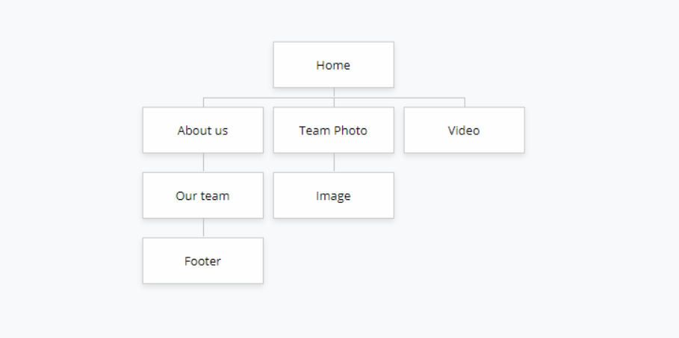

**Content types:**

* Homepage
* About us
* Team photo
* Video

**Design:**

There are ways which we used to provide design assets:

* Reference links
* Image files
* **Fonts**
* **Colors**
* **Layout**
* **Shapes**
* **Spacing**

**Functionality:**

We have made 2 pages, these are "Home" and "About us". There are two inputs on the main page in the container, the first two are for entering the names of the players of the team number 1 and number 2, and two inputs for the goals scored by the first and second. When you click on the "Get a winner" button, the winner and a list of points with a detailed result are displayed on the display. The "About us" page contains detailed information about our team and photos of each participant individually. If you select a “Team Photo”, you can see a photo of us together. When you switch to "Video", you are redirected to YouTube, where you can see the video of our powerful team.

**Hosting:**

Steps:

1. Create app.js file
2. Create package.json using ‘npm init’ command in terminal
3. Install the express node ‘node i express’
4. Develop an express commands to support server work
5. Run the routing using gitBash ‘nodemon app.js’

**Accessibility:**

Website is designed and developed so that people with disabilities can use it. More specifically, people can: perceive, understand, navigate, and interact with the Web.

* Headings, lists, input fields, and content structures are marked-up properly
* Color is not used as the only way of conveying information
* Default foreground and background color combinations provide sufficient contrast
* Text reflows in small windows
* Pages have clear titles and are organized using descriptive section headings

**Deadlines:**

* Phase 1 – November 13, 12:00
* Phase 2 – November 15, 15:00
* Phase 3 – November 17, 18:00
* Phase 4 – November 19, 23:00
* Phase 5 – November 21, 01:00

# **Summary**

Summing up and summarizing the results obtained, we come to the conclusion that all the goals and objectives set in the introduction have been fulfilled. It was very exciting and interesting to create this large-scale project for us. On the way to implementation, we encountered problems and difficulties, for example, the use of html in certain parts, so we turned to the Internet at some points to find useful information and apply it to our advantage (ejs). The project included the acquired knowledge, such as front-end (html, css, JavaScript) and back-end (Node.js, Express.js) after completing the course "Web-technologies", and we think that the acquired knowledge will be applied and useful to us in the future.