最终效果

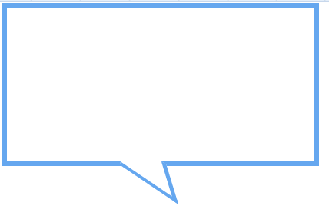

CSS代码：

.line {

position: relative;

display: block;

width: 400px;

height: 200px;

border: 6px solid #65A7EF;

}

.line::after {

content: '';

position: absolute;

top: 188px;

width: 82px;

height: 30px;

border-right: 8px solid #65A7EF;

border-bottom: 4.5px solid #65A7EF;

transform: rotate(34deg) skew(51deg);

left: 133px;

top: -18.7px;

z-index: 1;

background: #fff;

}