

**Helwan University**

**Faculty of Computing and Artificial Intelligence**

**Computer Science Department**

**Graduation Project: Development of an AI-Based Brain Tumor Detection System Integrated with a Clinic Management Platform**

**Dissertation by:**Mazin Islam Sobhy 20210715

Kirolos Samy Attallah 20210694  
Kirolos Soliman Waheb 20210695

Philopater Ezzat Rezkalla 20210679

Marina Ayman Hanna 20210710

Marina Ghattas Gamal 20210712

Submitted in partial fulfilment of the requirements for the degree of Bachelor of Science in Computing & Artificial Intelligence at the Computer Science Department, the Faculty of Computing & Artificial Intelligence, Helwan University

**Supervised by:**

**Prof. Amal Aboutabl**

June 2025

**Abstract**

**Problem:**  
Brain tumors are one of the most critical health issues worldwide. Early and accurate detection is essential for improving patient outcomes and survival rates. However, manual diagnosis of brain tumors from MRI images is time-consuming, subject to human error, and often requires specialized expertise, which may not always be available, especially in under-resourced clinics.

**Objectives:**  
The main objective of this project is to design and implement an automated system capable of detecting and classifying brain tumors using deep learning techniques. The system aims to assist radiologists and clinicians by providing accurate tumor localization and classification, and by integrating this functionality into a basic clinic management platform to facilitate patient data handling.

**Methodology:**  
This project utilizes the YOLOv8 (You Only Look Once version 8) object detection model to detect and classify brain tumors from MRI images. A labeled dataset containing various tumor types was preprocessed and annotated in YOLO format. The model was trained and evaluated using standard metrics such as precision, recall, and mean Average Precision (mAP). Additionally, a simple clinic management system was developed using Python to store and retrieve patient information along with detection results.

**Achievements:**  
The trained YOLOv8 model achieved high accuracy in detecting and classifying different types of brain tumors with satisfactory performance across various evaluation metrics. The system demonstrated the ability to assist in early diagnosis, potentially reducing diagnostic workload for medical professionals. Moreover, the integration of tumor detection with a basic clinic management system allows for organized patient data tracking, making it a practical solution for real-world clinical environments.

**Acknowledgement**

First and foremost, I would like to express my sincere gratitude to **Prof. Amal Abou Tabl** for her invaluable guidance, continuous support, and insightful feedback throughout every stage of this project. Her dedication, encouragement, and expertise have had a significant impact on both the direction and quality of my work.

I am also thankful to the technical support staff and my fellow students for their collaboration, assistance, and the positive learning environment they helped create. Finally, I would like to acknowledge the open-source communities and datasets that made this research possible.

**Table of Contents**

Abstract .............................................. 2

Acknowledgement .................................. 3

Table of Contents .................................. 4

List of Tables ....................................... 5

List of Figures ......................................6

List of Abbreviations ............................ 7

Chapter 1: Introduction .................................................. 8

1.1 Overview ........................................................... 8

1.2 Problem Statement ........................................ 9

1.3 Scope and Objectives ..................................... 13

1.4 Report Structure ............................................... 15

1.5 Work Methodology ......................................... 16

Chapter 2: Market research and literature survey...................... 17

2.1 Background ....................................................... 17

2.2 Literature Survey ............................................. 18

2.3 Analysis of Related Work ................................. 27

Chapter 3: Proposed Solution ....................................... 28

3.1 Solution Methodology ..................................... 28

3.2 System Requirements ....................................... 30

3.3 System Analysis & Design ............................... 31

Chapter 4: Implementation & Results ............................ 39

4.1 Environment Setup & Dependencies .............. 39

4.2 Dataset Preparation & EDA .............................. 39

4.3 Image Preprocessing ......................................... 39

4.4 YOLOv8 Model Configuration & Training ....... 40

4.5 Detection Results Visualization ........................ 40

4.6 Model Evaluation & Metrics .............................. 41

4.7 Testing on Custom Images ................................. 45

4.8 Training Visualization & Sample Batches ........ 46

4.9 Service Architecture ……… 47

Chapter 5: Discussion, Conclusions, and Future Work .......... 50

5.1 Discussion ........................................................... 50

5.2 Summary & Conclusion ..................................... 50

5.3 Future Work ....................................................... 51

References ………………………………….. 52

**List of Tables**

Table 2.1: Comparative Analysis of Brain Tumor Detection Studies ……………..….……………….… 23

Table 3.1: YOLOv8 vs. YOLOv12 Comparison……………..….……………….…………………………...30

*Table 4.6*: Model performance for each tumor class on the validation dataset.……………..……...…...48

**List of Figures**

Figure 1.1 Cancer Research UK (Cases, Deaths, Survival, and Preventable cases)…………………...….9

Figure 2.1 The Architecture of Convolutional Neural Networks …………………….……………..…... 16

Figure 2.2 Minst Multilayer Neural Network (Adam Optimizer) ……………………………...………... 17

Figure 2.3 Structure of YOLO …………………………………………………………………………... 17

Figure 2.4 SVM Graph …………………………………………………………………….….……….… 18

Figure 2.5 Auto-Encoders Graph …………………………………………………………..…..…..….… 19

Figure 2.6 ResNet50 Model Architecture ……………………………………………………….…….… 19

Figure 2.7 InceptionV3 Architecture ………………………………………………………...……….…. 20

**List of Abbreviations**

|  |  |
| --- | --- |
| **Abbreviations** | **Meaning** |
| ADAM | Adaptive Moment Estimation |
| ADSCFGWO | Adaptive Dynamic Sine-Cosine Fitness Grey Wolf Optimizer |
| AI | Artificial Intelligence |
| AIP | American Institute of Physics |
| AUC-ROC | Area Under the Receiver Operating Characteristic Curve |
| BMC | Biomedical Central Journal |
| BRaTS | Brain Tumor Segmentation Challenge |
| KNN | K-Nearest Neighbors |
| MLP | Multilayer Perceptron |
| MFA | Multi-Factor Authentication |
| MRI | Magnetic Resonance Imaging |
| NLP | Natural Language Processing |
| NIH | National Institutes of Health |
| NCRI | National Cancer Research Institute |
| PACS | Picture Archiving and Communication Systems |
| ResNet50 | Residual Network with 50 Layers |
| RMSPro | Root Mean Square Propagation |
| SVM | Support Vector Machine |
| TIS | Telemedicine and Informatics Society |
| TSS | Translational Science Society |
| UML | Unified Modeling Language |
| UI | User Interface |
| VGG16 | Visual Geometry Group 16-layer Network |
| VGG19 | Visual Geometry Group 19-layer Network |
| YOLOv4 | You Only Look Once, version 4 |
| YOLOv8 | You Only Look Once, version 7 |
| YOLOv12 | You Only Look Once, version 12 |

**Chapter 1: Introduction**

**1.1 Overview**

The diagnosis and management of brain tumors is a sensitive and complex process that traditionally relies on the manual interpretation of MRI scans by radiologists. While this remains a critical part of medical care, it is often limited by human factors such as fatigue, subjectivity, and increasing healthcare demand. In addition, patients frequently encounter fragmented healthcare systems that lack efficient coordination between clinics, doctors, labs, and support teams.

Our system is designed to streamline this entire process by combining modern cloud-based architecture, AI-powered imaging analysis, and structured clinical workflows that enhance—not replace—medical expertise.

The system operates through four core roles: Admin, Doctor, Lab, and Patient, each with clearly defined responsibilities:

Patient Workflow - Patients register on the platform and create their accounts. - After registration, patients can: - Reserve appointments with doctors at different clinics. - Choose labs to perform MRI scans if requested by the doctor. - View their generated medical reports and doctor’s final diagnosis. - Chat directly with doctors for follow-up or consultations. - Receive the final diagnosis and reports through their personal dashboard.

Doctor Workflow - Doctors register and await approval from admins before accessing the system. - Once approved, doctors: - Manage and update their available appointment slots per clinic. - View and manage patient appointments. - After the patient visits the clinic, the doctor initiates a Medical Ticket containing: - Doctor ID - Patient ID - Doctor’s Initial Description - A flag indicating whether an MRI is required. - If MRI is required: - The patient selects a lab to perform the MRI. - Once the MRI image is uploaded, doctors can later view: - The AI-analyzed MRI result. - The automatically generated medical

report. - The full diagnostic PDF containing tumor detection results, AI data, and system-generated reports. - Finally, the doctor can write their Final Diagnosis and complete the medical ticket.

Lab Workflow - Labs are added by the admin. - Labs receive MRI requests when selected by the patient. - The lab uploads the patient’s MRI scan to the system. - The system stores the MRI scan on the server and links it to the corresponding ticket.

Automated AI Processing Flow - Once the lab uploads the MRI scan: 1. The system forwards the image to a pre-trained YOLO model which detects brain tumors, identifies tumor type, and generates: - Annotated MRI images with tumor regions highlighted. - A JSON output containing structured tumor data. 2. These outputs are then processed by a Large Language Model (LLM) that generates a complete medical report. 3. The system automatically compiles a PDF file that includes: - MRI images - Tumor detection results - Full medical report generated by the LLM. 4. The PDF file is stored securely on the server and linked to the patient’s ticket.

Admin Workflow - Admins are responsible for: - Approving new doctor registrations. - Adding labs. - Approving new clinics. - Managing support requests submitted through the “Contact Us” section. - Accessing platform-wide analytics and dashboards for system monitoring.

System Advantages - Automated MRI analysis significantly reduces diagnostic delays. - AI-assisted reports help doctors make better informed and faster decisions. - Patients have full visibility into their treatment process via secure online access. - Streamlined collaboration between doctors, labs, and patients. - Admins maintain full control over system users, content, and support operations.

This integrated system ensures better diagnostic accuracy, faster turnaround, improved patient experience, and enhanced coordination across all healthcare stakeholders.

**1.2 Problem Statement**

Brain tumors represent one of the most critical challenges in modern medicine, significantly affecting patient survival rates and overall quality of life. According to Cancer Research UK, there are approximately 12,700 new cases of brain, other central nervous system (CNS), and intracranial tumors diagnosed annually in the UK, with a large portion of these cases being detected at a late stage Cancer Research UK. Late-stage detection often limits treatment options and contributes to higher rates of mortality and long-term complications [1].

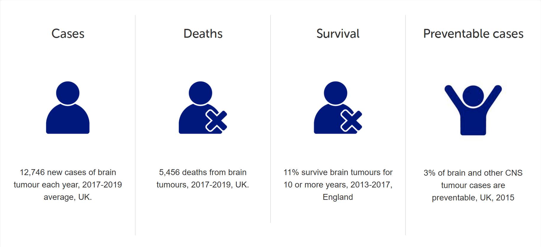

Figure 1.1 Cancer Research UK (Cases, Deaths, Survival, and Preventable cases)

Furthermore, insights from The Brain Tumour Charity highlight that seizures are among the most common early symptoms that lead to the diagnosis of a brain tumor, especially in adults. In many cases, diagnosis only occurs during emergency situations after such acute neurological events, suggesting that early signs are frequently overlooked or misinterpreted The Brain Tumour Charity. This delay in recognizing symptoms drastically reduces the window for effective intervention, thereby worsening patient outcomes. These realities underscore the urgent need for more accessible, accurate, and early diagnostic tools in the field of neuro-oncology [2].

Impact of Late Diagnosis

The consequences of delayed diagnosis in brain tumor cases are often severe, contributing to reduced survival rates and limited treatment options. Many brain tumors present with subtle and non-specific symptoms such as memory issues, behavioral changes, or headaches—signs that are frequently misattributed to less serious conditions, resulting in diagnostic delays. A study by King’s College London emphasizes that such missed opportunities for early detection are common, with patients often only diagnosed following emergency episodes like seizures or sudden neurological decline [3]. According to Cancer Research UK, survival outcomes vary drastically depending on tumor type, grade, and location. For instance, the five-year survival rate for aggressive tumors like glioblastoma is as low as 5%, compared to more favorable outcomes for low-grade tumors [4]. Furthermore, a report by the All-Party Parliamentary Group on Less Survivable Cancers underscores that brain tumors remain among the UK’s deadliest cancers, with only 28% diagnosed at an early stage—significantly lower than many other cancer types—largely due to the vague nature of early symptoms and insufficient public and clinical awareness [5]. These factors combined highlight the critical importance of improving early detection through more accessible diagnostic tools and AI-assisted clinical support, which could drastically alter the prognosis for patients facing one of the most complex and aggressive categories of cancer.

Challenges in Brain Cancer Detection

Detecting brain tumors presents significant diagnostic challenges due to the complex nature of the disease and limitations in current diagnostic methods. Manual analysis of MRI scans, while essential, is time-consuming and subject to variability among radiologists, leading to potential inconsistencies in diagnosis and delays in treatment initiation. The diverse morphology of brain tumors, with over 120 known types, further complicates accurate detection and classification. Moreover, misinterpretation of imaging results can result in missed or incorrect diagnoses, allowing the disease to progress unchecked. These challenges underscore the need for advanced diagnostic tools that can assist in the early and accurate detection of brain tumors, thereby improving patient outcomes[6].

Errors in Radiology

Radiology errors are multifaceted and encompass a wide range of types, with the most recent classification identifying twelve major categories including underreading, faulty reasoning, satisfaction of search, complacency, communication failures, technical limitations, failure to review prior exams, and overreliance on previous reports. Among these, underreading—where a visible abnormality is missed—is the most common, accounting for 42% of errors and a significant proportion of liability claims. Errors arise from both perceptual failures, where abnormalities go unnoticed due to factors like lesion characteristics, fatigue, distractions, or rapid image interpretation, and cognitive failures, where findings are seen but incorrectly interpreted because of limited knowledge or cognitive bias. Communication lapses between radiologists, clinicians, and patients further compound diagnostic mistakes. Addressing these errors requires a combination of continuous education, use of checklists, effective communication protocols, double reading policies, and seeking collegial consultation. The emotional and mental well-being of radiologists profoundly influences diagnostic accuracy; fatigue and burnout driven by high workload demands, prolonged screen exposure, and pressure to minimize mistakes degrade focus and contribute to increased error rates. Visual fatigue manifests through eye strain and headaches, which can be mitigated by ergonomic measures, regular breaks, and blue light filtering. Variability in error rates globally reflects differences in healthcare infrastructure, resource availability, training quality, and implementation of safety protocols such as second readings. Technological advances, particularly artificial intelligence and computer-aided diagnosis, have shown promise in enhancing detection and characterization of abnormalities such as lung nodules and breast masses, as well as improving interventional radiology procedures, thereby reducing diagnostic and procedural errors. Ultimately, radiology errors stem from an interplay of perceptual and cognitive factors, systemic challenges, and human elements like fatigue, underscoring the need for integrated approaches involving education, communication improvement, workflow optimization, and technological innovation to enhance diagnostic accuracy and patient care [7].

Emotional Support Importance

The emotional and psychological burden on both brain tumor patients and their caregivers is significant and often underestimated in clinical settings. Caregivers frequently report experiencing high levels of distress, with studies indicating that more than 80% suffer from moderate to severe unmet emotional and informational needs, which can contribute to increased anxiety, depression, and reduced quality of life. This psychological strain not only impairs the caregiver’s well-being but can also negatively affect the quality of care provided to the patient, highlighting the critical need for targeted emotional support interventions for caregivers. The unpredictable nature of brain tumors, coupled with progressive neurological decline, amplifies feelings of helplessness and social isolation, making psychosocial support an indispensable part of care strategies for caregivers [8].

Patients themselves face complex emotional challenges alongside the physical and cognitive impairments caused by brain tumors. The presence of psychological distress in these patients has been linked to poorer clinical outcomes, underscoring the importance of integrating emotional and psychosocial care into the overall treatment paradigm. Research has shown that participation in support groups and peer networks improves mental health, reduces feelings of isolation, and promotes coping mechanisms, yet access to such resources remains inconsistent and often insufficiently emphasized within treatment plans. This gap reflects systemic deficiencies in recognizing emotional support as an essential component of brain tumor management, despite evidence that it improves both psychological well-being and treatment adherence. The absence of adequate emotional support not only affects mental health but also leads to increased healthcare usage and physical health deterioration among caregivers, creating a significant public health concern. Interventions such as counseling, cognitive-behavioral therapy, and structured peer support have been demonstrated to reduce anxiety and depression while enhancing quality of life for both patients and caregivers. Moreover, these psychosocial supports contribute to better treatment adherence and may reduce hospital readmissions, thereby having a meaningful impact on clinical outcomes. The incorporation of regular psychosocial assessment and tailored support into neuro-oncological care pathways is therefore crucial to improving resilience and overall outcomes [9].

Support groups, in particular, offer patients and families a unique forum for sharing experiences, receiving education, and fostering social connections that mitigate the isolation often accompanying a brain tumor diagnosis. These groups empower patients and caregivers to gain knowledge about the disease, treatment options, and coping strategies, facilitating improved psychological adjustment and emotional stability. Despite these benefits, many patients remain unaware or unable to access support networks, pointing to the need for healthcare providers to actively promote and integrate these services into standard care. By prioritizing emotional support as part of comprehensive brain tumor management, clinicians can help improve quality of life, promote adherence to treatment, and provide a buffer against the psychological distress associated with this life-altering diagnosis [10].

Challenges in Healthcare System Integration

In the domain of brain tumor diagnosis and treatment, the integration of healthcare systems is not merely an administrative concern—it is foundational to delivering timely, personalized, and effective care. Brain tumor cases often involve complex, multidisciplinary workflows that span across neurology, radiology, oncology, surgical units, and psychological services. As such, the lack of integrated health information systems severely limits the ability to deliver cohesive care and apply modern digital tools like AI-driven segmentation and cloud-based diagnostic platforms.

A major obstacle lies in the lack of interoperability between the electronic health record (EHR) systems used across departments. For instance, radiological scans—crucial for detecting and monitoring brain tumors—may be stored in PACS (Picture Archiving and Communication System) formats that are not easily accessible to oncology teams or neurosurgeons working on separate systems. This data fragmentation not only delays decision-making but also impedes the deployment of AI-based tools that rely on access to diverse and clean datasets. For our project, which utilizes automated brain tumor segmentation through Roboflow and cloud integration with Azure, such fragmentation undermines the potential for streamlined, intelligent diagnosis pipelines [11].

Compounding this issue is the reliance on outdated legacy systems. Many institutions treating brain tumor patients still use siloed or non-cloud-based infrastructures. These systems are not equipped to integrate with modern AI platforms or allow cross-institutional sharing of diagnostic insights. Without this interoperability, deploying a platform that can automatically analyze tumor scans, send them to cloud storage, and return actionable data becomes operationally limited and restricted to isolated environments.

Security and compliance further challenge system integration, especially when dealing with sensitive neuro-oncological data. HIPAA and GDPR regulations require robust encryption and audit trails, which are difficult to implement uniformly across disparate systems. This becomes critical when handling highly sensitive MRI or CT scans, as well as when transferring annotated results between platforms. Our use of Azure Blob Storage for image upload and sharing, for example, necessitates a consistent and secure interface with institutional systems that often lack compatible standards or security protocols [12].

Resistance to digital transformation is another critical factor. Clinicians managing brain tumor cases already face immense time pressures and emotional burden. Introducing new digital workflows—especially those involving image annotation, AI validation, or remote cloud processes—may be perceived as disruptive unless accompanied by proper change management and intuitive interfaces. Furthermore, without demonstrable evidence of improved outcomes, adoption remains slow [13].

Ultimately, the lack of healthcare system integration significantly limits the deployment and scaling of novel digital solutions in brain tumor diagnosis and care. For projects like ours, which aim to enhance diagnostic accuracy, reduce delays, and centralize patient data via cloud platforms, overcoming these integration barriers is essential. Doing so would allow AI-assisted diagnosis to become part of a real-time, patient-centric ecosystem—where scans, reports, treatment plans, and emotional support resources are all unified within a cohesive digital framework [14].

**1.3 Objective**

The primary objective of the NeuroTumAI project is to provide an intelligent, accessible, and integrated digital healthcare platform that facilitates the early detection, diagnosis, and support for individuals affected by brain tumors. The system aims to address the significant gaps in current neuro-oncology workflows—such as delayed diagnoses, fragmented care pathways, and limited emotional support—by delivering a comprehensive solution powered by artificial intelligence, cloud computing, and user-centric design.

Key objectives include:

• Early and Accurate Diagnosis: Leverage YOLOv8 for advanced instance segmentation of brain tumor regions in MRI scans, enabling fast, accurate, and consistent identification of abnormalities to support radiologists in clinical decision-making.

• Integrated Doctor and Lab Access: Connect patients with verified laboratories for imaging tests and specialized neuro-oncology experts for follow-up, ensuring timely medical consultation and reducing the burden of navigating complex healthcare systems.

• Cloud-Based Health Data Management: Securely store medical data, scan results, and AI annotations using Azure cloud infrastructure to support real-time access, sharing, and integration across multiple stakeholders including labs, doctors, and patients.

• System Interoperability and Scalability: Build the platform with modern APIs and interoperable standards to ensure compatibility with EHR systems, allowing for future scalability and integration across healthcare providers and institutions.

• User Empowerment and Transparency: Promote patient empowerment by providing clear, structured outputs of scan results, next-step recommendations, and direct communication channels with medical professionals—enhancing trust and user satisfaction.

**Scope**

The scope of the NeuroTumAI project encompasses the development and deployment of a multi-functional digital platform that brings together AI-assisted diagnosis, clinical service access, and patient support within a secure and cohesive framework. The platform will serve as a bridge between patients, radiologists, laboratories, and doctors, focusing on brain tumor cases but designed to be extensible for future applications.

The scope includes:

1. AI Diagnostic Module

o Integration of YOLOv8-based tumor detection and segmentation from MRI scans.

o Automated image preprocessing, anomaly detection, and result visualization.

o Confidence scoring and structured output generation for clinical use.

2. Patient Interface

o Mobile and web access for uploading scans and viewing results.

o Guided user flow for booking appointments with nearby labs and doctors.

o Notifications and progress tracking for diagnostic status.

3. Doctor and Lab Portal

o Doctor dashboard for reviewing AI-analyzed scans, patient histories, and case notes.

o Lab portal for managing scheduled scans, uploading results, and tracking tests.

o Communication tools to facilitate doctor-patient interaction.

4. Emotional and Social Support Integration

o In-app access to counseling services and mental health resources.

o Peer support groups, forums, and educational content tailored for patients and caregivers.

o Periodic assessments and suggestions for mental health check-ins.

5. Cloud and Security Infrastructure

o Use of Azure Blob Storage for secure image and data storage.

o Role-based access control for different stakeholders (patients, doctors, admins).

o End-to-end encryption, GDPR/HIPAA compliance, and audit trails.

6. Healthcare System Integration

o Compatibility with EHR and PACS systems through APIs and standard medical data formats (e.g., DICOM).

o Support for future integration with hospital information systems (HIS).

o Capabilities for federated data access and multi-institutional deployment.

7. Administration and Analytics

o Admin dashboard for user management, system monitoring, and usage analytics.

o AI performance monitoring and feedback loop for model retraining.

o Exportable reports and compliance auditing tools.

By clearly defining this objective and scope, the NeuroTumAI system positions itself not only as a technological innovation but also as a patient-centered tool designed to modernize brain tumor diagnosis, improve care coordination, and support the emotional well-being of everyone affected.

**1.4 Report Organization (Structure)**

This report is structured into five main chapters, each addressing a specific aspect of the NeuroTumAI system:

**Chapter 1: Introduction**  
Provides a general overview of the project, highlights the medical and technical problem, defines the objectives, outlines the scope, and presents the methodology adopted throughout the development process.

**Chapter 2: Market Research and Literature Survey**  
Presents background knowledge and a comprehensive review of existing research, models, and methodologies used for brain tumor detection and diagnosis, along with a critical analysis of their strengths and limitations.

**Chapter 3: Proposed Solution**  
Details the architecture and methodology of the proposed system, including model selection (YOLOv8), system design, and the overall AI-driven workflow.

**Chapter 4: Implementation & Results**  
Describes the technical implementation, including environment setup, dataset preparation, model training and testing, performance evaluation using various metrics, and visualization of the results.

**Chapter 5: Discussion, Conclusions, and Future Work**  
Discusses the observed outcomes, summarizes the conclusions drawn from the results, and proposes future improvements and possible extensions to the system.

**1.5 Work Methodology**

We adopted a hybrid agile approach combining phases of research, design, development, testing, and evaluation.

Key methodologies:

• AI Model Training: Using YOLOv8 via Roboflow for tumor detection.

• Frontend: Web/mobile UI built using React and Azure integration.

• Backend: Python, Flask, and Azure Blob Storage for secure MRI storage and access.

• Evaluation: Model performance metrics (Precision, Recall, IoU), user feedback, and testing.

**Chapter 2: Market research and literature survey**

**2.1 Background**

Brain tumors are abnormal and uncontrolled growths of cells within the brain tissue, which can significantly impact neurological function and overall health. Among the most clinically relevant types are Glioma, Meningioma, and Pituitary tumors, each differing in origin, behavior, and treatment strategies.

* **Gliomas** arise from glial cells that support neurons and are typically malignant, representing one of the most aggressive and fast-growing forms of brain tumors. They account for a large portion of primary brain tumors and often require urgent and intensive treatment.
* **Meningiomas** originate from the meninges, the protective membranes that cover the brain and spinal cord. Although usually benign, they may grow large enough to compress surrounding brain structures, causing significant neurological complications.
* **Pituitary tumors** develop in the pituitary gland, a small but crucial endocrine organ at the base of the brain. These tumors are often benign but can interfere with hormonal regulation and may impact vision due to their proximity to the optic nerve.

Magnetic Resonance Imaging (MRI) is the most commonly used imaging modality for diagnosing brain tumors due to its superior contrast resolution and non-invasive nature. However, manual interpretation of MRI scans is time-consuming, requires expert radiologists, and can be prone to human error.

To overcome these limitations, Artificial Intelligence (AI) — particularly Convolutional Neural Networks (CNNs), a class of deep learning models — has emerged as a powerful solution for automating tumor detection. CNNs can learn complex spatial patterns from medical images and offer high accuracy in classification tasks, enabling faster and more consistent diagnoses.

This project is built upon these advancements, aiming to develop a CNN-based system capable of classifying brain MRI images into four categories: **Glioma**, **Meningioma**, **Pituitary**, or **No Tumor**. The model is further integrated into a clinic management platform, providing a comprehensive diagnostic support system for medical professionals.

**2.2 Literature Survey**

CNN (Convolutional Neural Network):

A CNN is a deep learning model designed for processing structured grid data, like images. It uses convolutional layers to automatically detect patterns (e.g., edges, shapes, textures) and extract features from input images. CNNs are widely used in image classification, segmentation, and detection tasks due to their ability to learn spatial hierarchies.

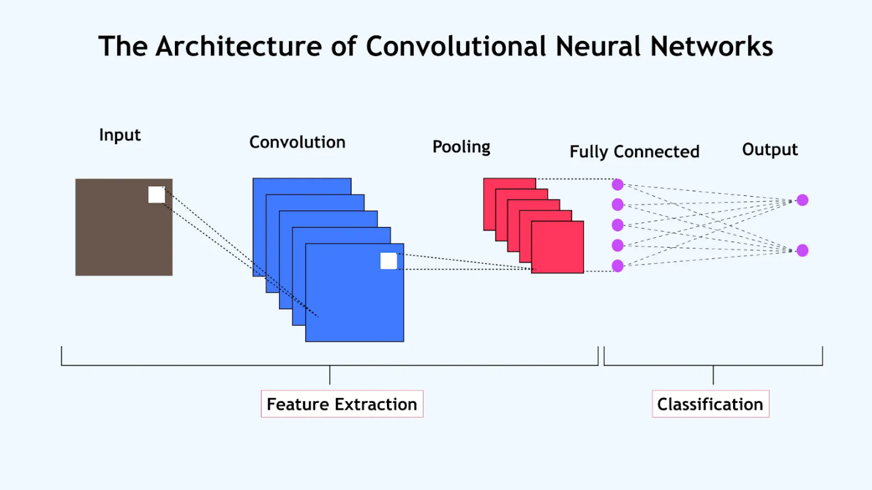

Figure 2.1 The Architecture of Convolutional Neural Networks

Adam (Adaptive Moment Estimation):

Adaptive Moment Estimation is an algorithm for optimization technique for gradient descent. The method is really efficient when working with large problem involving a lot of data or parameters. It requires less memory and is efficient. Intuitively, it is a combination of the ‘gradient descent with momentum’ algorithm and the ‘RMSP’ algorithm. Adam utilizes first-order and second-order moment estimates to adaptively adjust learning rates for each parameter, improving convergence speed and stability. It is particularly effective in handling sparse gradients and noisy datasets, making it a preferred choice for training deep learning models such as CNNs.

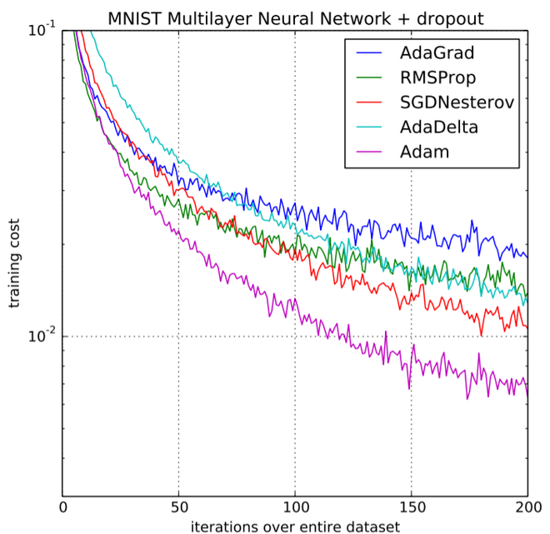

Figure 2.2 Minst Multilayer Neural Network (Adam Optimizer)

YOLOv8 ((You Only Look Once, version 8):

YOLOv8 is a real-time object detection model known for its balance of speed and accuracy. It divides an image into grids, predicts bounding boxes and class probabilities for objects in a single pass, making it extremely efficient. YOLOv8 is optimized for identifying objects in complex scenes, making it suitable for tasks like medical imaging, where precision is crucial.

Figure 2.3 Structure of YOLO

ADSCFGWO (Adaptive Dynamic Sine-Cosine Fitness Grey Wolf Optimizer):  
This is a hybrid optimization algorithm that combines the Sine-Cosine Algorithm (SCA) and the Grey Wolf Optimizer (GWO). It dynamically adapts the sine-cosine mechanism for global search (exploration) and the grey wolf mechanism for local search (exploitation).

In the context of brain tumor classification, ADSCFGWO is used to fine-tune hyperparameters of a Convolutional Neural Network (CNN), improving accuracy and efficiency by optimizing the model’s weights, learning rates, and architecture settings. It balances exploration and exploitation to achieve better performance compared to traditional optimization techniques.

SVM (Support Vector Machine):  
A machine learning algorithm used for classification tasks. It finds the optimal hyperplane that separates data into different classes, making it robust for handling high-dimensional data.

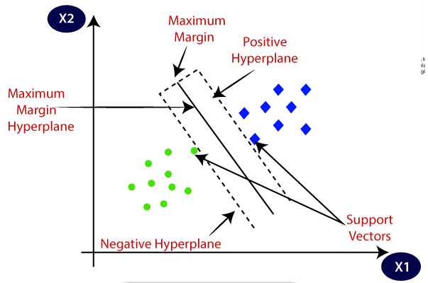

Figure 2.4 SVM Graph

GLCM (Gray-Level Co-occurrence Matrix):  
A statistical method for texture analysis, used to measure the spatial relationship between pixel intensities in images. Commonly applied in feature extraction for medical image classification.

DWT (Discrete Wavelet Transform):  
A mathematical technique for signal processing, used to decompose images into frequency components. This helps in capturing texture and edge information in medical imaging.

Auto-Encoders:  
Neural networks designed for unsupervised learning, primarily used for dimensionality reduction and feature extraction. They encode data into a compressed format and then decode it to reconstruct the original input.

**Figure 2.5 Auto-Encoders Graph**

ResNet50 (Residual Network with 50 Layers):  
ResNet50 is a deep convolutional neural network architecture that uses residual connections to address the vanishing gradient problem in very deep networks. It consists of 50 layers with blocks of convolutional layers and identity shortcuts, allowing the network to skip connections and improve gradient flow.

ResNet50 is widely used in medical imaging tasks, including brain tumor detection, due to its ability to capture complex patterns in data, making it effective for classification tasks on MRI images. It is known for its high accuracy, scalability, and efficiency in training deep networks.

**Figure 2.6 ResNet50 Model Architecture**

InceptionV3:  
InceptionV3 is a deep learning model designed for image classification and object detection tasks. It is an improved version of the Inception architecture that uses factorized convolutions, batch normalization, and asymmetric convolutions to improve computational efficiency and reduce overfitting. With its deeper architecture and optimized design, InceptionV3 excels at extracting complex features from input images while maintaining a reasonable computational cost.

This model is particularly effective in medical imaging tasks, such as brain tumor detection, due to its ability to analyze subtle patterns in MRI scans with high precision and accuracy.

Figure 2.7 InceptionV3 Architecture

**2.1 Literature survey**

**2.1.1** Brain Tumor Detection Based on Deep Learning Approaches and Magnetic Resonance Imaging

The study "Brain Tumor Detection Based on Deep Learning Approaches and Magnetic Resonance Imaging" explores the application of advanced deep learning techniques for identifying brain tumors in MRI scans. The researchers employed the YOLOv8 model, a cutting-edge object detection algorithm, and fine-tuned it using transfer learning. This approach allowed the model to achieve a remarkable accuracy of 95.6% in detecting and localizing gliomas, meningiomas, and pituitary tumors. The methodology involved utilizing a large dataset of MRI brain tumor images, refining the model's detection capabilities through adjustments to suit the intricacies of medical imaging. The results indicate significant potential for YOLOv8 in the field of medical diagnostics, especially in accurately pinpointing tumor presence and location.

However, the study acknowledges certain limitations. A key challenge lies in the model's ability to detect small or less prominent tumors accurately, which often proves difficult due to the complexity of their identification. Another issue highlighted is the generalizability of the model across diverse datasets and varying MRI scan qualities. While the fine-tuning process improved performance, further research is needed to ensure robustness across different populations and imaging conditions. Additionally, the practical implementation of such models in real-world clinical settings poses challenges, including integration with existing workflows and managing the variability in patient data. Despite these challenges, the study represents a significant step forward in utilizing deep learning for brain tumor detection, providing a foundation for future advancements in medical imaging technologies.

**2.2.2** MRI-based brain tumor detection using convolutional deep learning methods and chosen machine learning techniques

This study addresses the critical need for early detection of brain tumors, which are typically classified through invasive biopsies. The researchers utilized a dataset of 25,249 MRI brain images, encompassing glioma, meningioma, pituitary gland tumors, and healthy brains. They developed a novel 2D Convolutional Neural Network (CNN) comprising eight convolutional layers, four pooling layers, and batch-normalization layers, all employing a 2x2 kernel function. Additionally, a convolutional auto-encoder network was designed, integrating a convolutional auto-encoder and a classification network utilizing the final encoder layer's output. The study also compared six machine learning techniques for tumor classification. The proposed 2D CNN achieved a training accuracy of 96.47%, while the auto-encoder network reached 95.63%. Among the machine learning methods, K-Nearest Neighbors (KNN) attained the highest accuracy at 86%, whereas Multilayer Perceptron (MLP) had the lowest at 28%. Statistical analyses confirmed significant differences between the proposed methods and the machine learning approaches (p-value < 0.05). The study concludes that the 2D CNN offers optimal accuracy and efficiency in classifying brain tumors, presenting a less complex alternative suitable for clinical application by radiologists and physicians.

However, the study acknowledges that while the proposed 2D CNN demonstrates high accuracy, its performance may be influenced by the quality and variability of MRI images. Additionally, the model's applicability to other types of brain tumors beyond those studied remains uncertain, necessitating further research to validate its generalizability. [12]

**2.2.3** Brain Tumor Detection and Classification Using Deep Learning and Adaptive Dynamic Sine-Cosine Fitness Grey Wolf Optimizer (ADSCFGWO)

This study proposes the Brain Tumor Classification Model (BCM-CNN), which uses a Convolutional Neural Network (CNN) optimized with the Adaptive Dynamic Sine-Cosine Fitness Grey Wolf Optimizer (ADSCFGWO). The optimization algorithm combines the sine-cosine method for global search with the grey wolf optimizer's local search capabilities, striking a balance between exploration and exploitation.

The BCM-CNN was evaluated on the BRaTS 2021 Task 1 dataset, achieving an impressive accuracy of 99.99% in classifying gliomas, meningiomas, and pituitary tumors. The optimization significantly enhanced the CNN's performance, making it a highly effective tool for medical image analysis.

Despite its exceptional accuracy, the study notes several limitations. The optimization steps required by ADSCFGWO significantly increase computational time, making the model less practical for resource-constrained environments or real-time applications. Additionally, the limited size of the dataset used in training restricts the model's ability to generalize to diverse populations and imaging conditions.

**2.2.4** MRI-Based Brain Tumor Classification Using Ensemble of Deep Features and Support Vector Machine

This study introduces a hybrid approach combining deep learning-based feature extraction with machine learning classification. The model uses an ensemble of pre-trained CNNs, including VGG16, ResNet50, and InceptionV3, to extract robust deep features from MRI images. These features are then classified using a Support Vector Machine (SVM).

The proposed method achieves an accuracy of 93.22% on a multi-class dataset that includes normal tissue, gliomas, meningiomas, and pituitary tumors. The ensemble approach outperforms single CNN models due to its ability to capture diverse features from multiple architectures.

However, the study notes challenges in terms of computational complexity and scalability. The reliance on SVM limits adaptability for larger datasets, and the integration of multiple CNNs increases the system's resource requirements.

**2.2.5** Brain Tumor Detection Using Deep Learning Approaches

This study evaluates the performance of several transfer learning models in detecting and classifying brain tumors using MRI images. The dataset consists of 7022 grayscale MRI images divided into four classes: gliomas, meningiomas, pituitary tumors, and non-tumor cases. The transfer learning models compared include VGG16, VGG19, DenseNet121, ResNet50, and YOLOv4, with the objective of identifying the most accurate model for tumor detection.

The study identifies ResNet50 as the best-performing model, achieving an accuracy of 99.54%. The model’s residual connections enable efficient gradient flow and avoid the vanishing gradient problem, contributing to its exceptional performance. Other models, such as DenseNet121 (97.21%) and VGG19 (95.22%), also performed well but were outperformed by ResNet50 in accuracy and efficiency. Despite these promising results, the study highlights challenges such as computational requirements, sensitivity to data quality, and the need for large, annotated datasets to ensure generalizability. Additionally, the black-box nature of ResNet50 reduces its interpretability, which can hinder clinical adoption. [13]

**2.2.6** Efficient Framework for Brain Tumor Detection Using Different Deep Learning Techniques

This study introduces an efficient framework for detecting brain tumors using deep learning techniques applied to MRI images. The authors employed a comparative analysis of several deep learning models, including InceptionV3, VGG16, DenseNet121, MobileNetV2, and Xception, to identify the most effective model for tumor classification. The framework emphasizes the importance of preprocessing steps, such as contrast enhancement, resizing, and normalization, to enhance model performance and accuracy.

The results demonstrate that InceptionV3 achieved the highest accuracy of 99.12%, outperforming other models in the classification of three tumor types: gliomas, meningiomas, and pituitary tumors. Other models also performed well, with accuracies ranging from 95.2% to 98.5%, but InceptionV3 showed superior performance due to its deep architecture and efficient feature extraction capabilities.

Despite its high accuracy, the study highlights challenges such as computational complexity and the dependency on high-quality and annotated MRI datasets. These limitations pose challenges for real-time deployment and generalizability to diverse clinical environments.

|  |  |  |
| --- | --- | --- |
| Study | Model / Approach | Accuracy |
| 1. Brain Tumor Detection Based on Deep Learning Approaches and MRI (YOLOv8) | YOLOv8 fine-tuned with transfer learning for tumor detection and localization | 95.6% |
| 2. MRI-Based Brain Tumor Detection Using CNN and ML Techniques | - 2D CNN with eight convolutional layers  - Convolutional Auto-Encoder  - KNN (highest-performing ML technique in comparison) | 96.47%  95.63%  86.0% |
| 3. Brain Tumor Detection Using BCM-CNN with ADSCFGWO | BCM-CNN optimized with ADSCFGWO | 99.99% |
| 4. MRI-Based Brain Tumor Classification Using Ensemble CNNs + SVM | Ensemble of VGG16, ResNet50, and InceptionV3 with SVM classifier | 93.22% |
| 5. Brain Tumor Detection Using Deep Learning Approaches | Transfer learning models (ResNet50, DenseNet121, VGG16, VGG19, YOLOv4); ResNet50 achieved the highest accuracy | Highest:  99.54% |
| 6. Efficient Framework for Brain Tumor Detection Using Different Deep Learning Techniques | Comparative analysis of InceptionV3, VGG16, DenseNet121, MobileNetV2, and Xception; InceptionV3 performed the best | Highest:  99.12% |

Table 2.1: Comparative Analysis of Brain Tumor Detection Studies

**2.3 Analysis of the Related Work**

While many previous studies have achieved high accuracy in brain tumor classification using Convolutional Neural Networks (CNNs), they often focused solely on the technical performance of the models in controlled research environments. These approaches prioritized accuracy and loss metrics but paid limited attention to the broader challenges of deploying such systems in real-world clinical settings.

Notably, most prior work lacked consideration for practical aspects such as:

* Integration into clinical workflows
* Usability by non-technical medical staff
* Scalability to handle real patient volumes
* Secure data sharing and communication between stakeholders

In contrast, the NeuroTumAI project seeks to bridge this gap. It not only provides a robust and efficient CNN-based model for classifying brain tumors (Glioma, Meningioma, Pituitary tumors, and No Tumor), but also embeds this model into a comprehensive digital healthcare platform.

This platform is designed to:

* Enable real-time diagnosis using YOLOv8
* Support secure cloud-based storage of MRI images and reports
* Facilitate communication between patients, radiologists, and healthcare providers
* Offer an intuitive user interface to enhance usability in clinical environments

Moreover, NeuroTumAI is developed with extensibility in mind, allowing for future integration of additional diagnostic tools and services beyond brain tumor detection.

By combining high-performance AI with system-level design, NeuroTumAI addresses both the technical and practical shortcomings of earlier research, making it more applicable to real-world healthcare scenarios.

**Chapter 3: Proposed Solution**

**3.1 Solution Methodology**

The proposed solution, **NeuroTumAI**, is a comprehensive AI-based system designed for the detection and classification of brain tumors from MRI scans. It utilizes **YOLOv8 (You Only Look Once, version 8)**, a state-of-the-art object detection model, known for its speed and accuracy in medical image analysis. The methodology consists of the following key phases:

**1. Data Collection & Preprocessing:**

* MRI datasets containing annotated brain tumor images are collected from reliable public sources.
* Images are resized, normalized, and augmented (e.g., rotations, flips) to enhance model generalization.

**2. Model Selection and Training:**

* YOLOv8 is fine-tuned using the preprocessed dataset to detect and classify four classes: Glioma, Meningioma, Pituitary Tumor, and No Tumor.

The model is trained using GPU acceleration to speed up the process and ensure high accuracy and recall.

**3. Justification for Choosing YOLOv8 over YOLOv12:**

While YOLOv12 is a more recent release, YOLOv8 was selected for this project based on a balance between performance, integration readiness, and practical considerations. YOLOv8 is officially maintained by Ultralytics and is deeply integrated with widely adopted tools such as **Roboflow** and **Google Colab**, enabling faster experimentation and deployment.

In comparative testing, YOLOv8 provided **real-time inference speeds**, **lightweight model options** (e.g., YOLOv8n), and **sufficient accuracy (>93%)** for our brain tumor classification task. YOLOv12, on the other hand, though promising in certain benchmarks, lacked stable documentation, community support, and seamless tooling during the development phas

| **Feature** | **YOLOv8** | **YOLOv12** |
| --- | --- | --- |
| Official Support | Ultralytics | Community-only (not Ultralytics) |
| Toolchain Compatibility | High (Roboflow, Colab) | Low (limited integration) |
| Speed | Very Fast | Comparable but heavier |
| Maturity & Stability | Stable & Documented | Experimental |
| Deployment Readiness | Optimized for mobile/cloud | Still evolving |

Table 3.1: YOLOv8 vs. YOLOv12 Comparison

Therefore, YOLOv8 was deemed more suitable for a **clinical-grade application** requiring speed, stability, and ease of integration within existing platforms.

**4. Evaluation and Validation:**

* The trained model is evaluated using metrics such as precision, recall, F1-score, and mean Average Precision (mAP).
* Cross-validation and confidence threshold tuning are applied to ensure model reliability.

**5. Platform Integration:**

* The trained model is deployed as part of a web-based platform that allows radiologists and clinicians to upload MRI scans and receive real-time diagnostic outputs.
* The platform also includes modules for patient management, communication, and data visualization.

**6. Security and Accessibility:**

* Ensures secure access, HIPAA/GDPR-compliant data handling, and role-based permissions for users.
* Supports cloud deployment to ensure scalability and remote accessibility.

**3.2 System Requirements**

**Functional Requirements:**

* The system must allow users to upload MRI images.
* The system must detect and classify brain tumors into 4 categories.
* The system must display tumor location (bounding box) on the image.
* The system must save patient diagnosis and history in a secure format.
* The system must allow authorized users (e.g., doctors, patients) to access results.

**Non-Functional Requirements:**

* Performance: The system should return predictions within 1 second per image.
* Accuracy: Classification accuracy should exceed 90% on test data.
* Scalability: The platform must support multiple simultaneous users.
* Security: Data should be encrypted both in storage and during transmission.
* Usability: The interface must be simple and intuitive for medical professionals.
* Reliability: System uptime must exceed 99%.

**Hardware/Software Requirements:**

* **Hardware:**
  + GPU-enabled server (e.g., NVIDIA Tesla or RTX series)
  + Minimum 16GB RAM and 100GB SSD storage
* **Software:**
  + Python, PyTorch
  + OpenCV, NumPy, Pandas
  + YOLOv8 framework
  + Flask/Django (for backend), React (for frontend)
  + Cloud platform (e.g., AWS, Azure, or Google Cloud)

**3.3 System Analysis & Design**

The system architecture of **NeuroTumAI** is divided into several core layers, each responsible for a key aspect of the workflow. This modular design supports maintainability, scalability, and integration with external systems. Below is a detailed breakdown of each component along with the relevant system diagrams.

**1. Data Layer**

* Stores MRI images, patient information, and diagnostic reports.
* Utilizes secure and scalable cloud-based storage solutions such as **MongoDB** or **PostgreSQL**.
* Ensures data integrity and availability for other system components.

**2. AI Engine**

* Hosts the trained **YOLOv8** model used for tumor detection.
* Receives MRI images from the application layer and returns prediction results including bounding boxes, confidence scores, and tumor classes.
* Designed to run efficiently in a containerized environment for performance and scalability.

**3. Application Layer**

* Contains the core busi**ne**ss logic of the system.
* Provides **RESTful APIs** for frontend interaction, data retrieval, AI model inference, and user-related operations.
* Handles input validation, request routing, and communication between the data layer and AI engine.

### **4. Presentation Layer (Frontend)**

* Developed using **Flutter** for a cross-platform user interface.
* Allows doctors to upload MRI scans, view AI-generated results, manage patient records, and communicate with labs.
* Provides patients with access to reports and ticket status.

### **5. Security Layer**

* Ensures system protection through secure communication protocols (**HTTPS**) and data encryption.
* Implements **Role-Based Access Control (RBAC)** for different user types: Doctor, Patient, Lab Technician, and Admin.
* Manages authentication and authorization mechanisms to protect sensitive health data.

## **System Diagrams**

**Figure 3.3.1: Class Diagram**

Illustrates the system's core classes and their relationships. Classes include Patient, Scan, Doctor, Ticket, AI Result, and Report, with clearly defined attributes and operations.

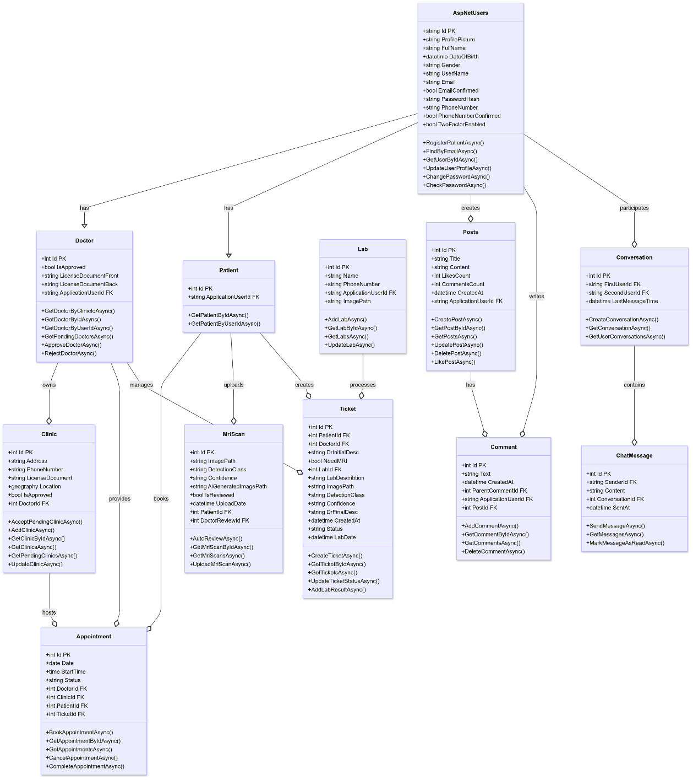

Displays how users (Doctor, Patient, Lab Technician) interact with the system. Use cases include: creating tickets, uploading scans, AI diagnosis, report viewing, and lab result uploading.

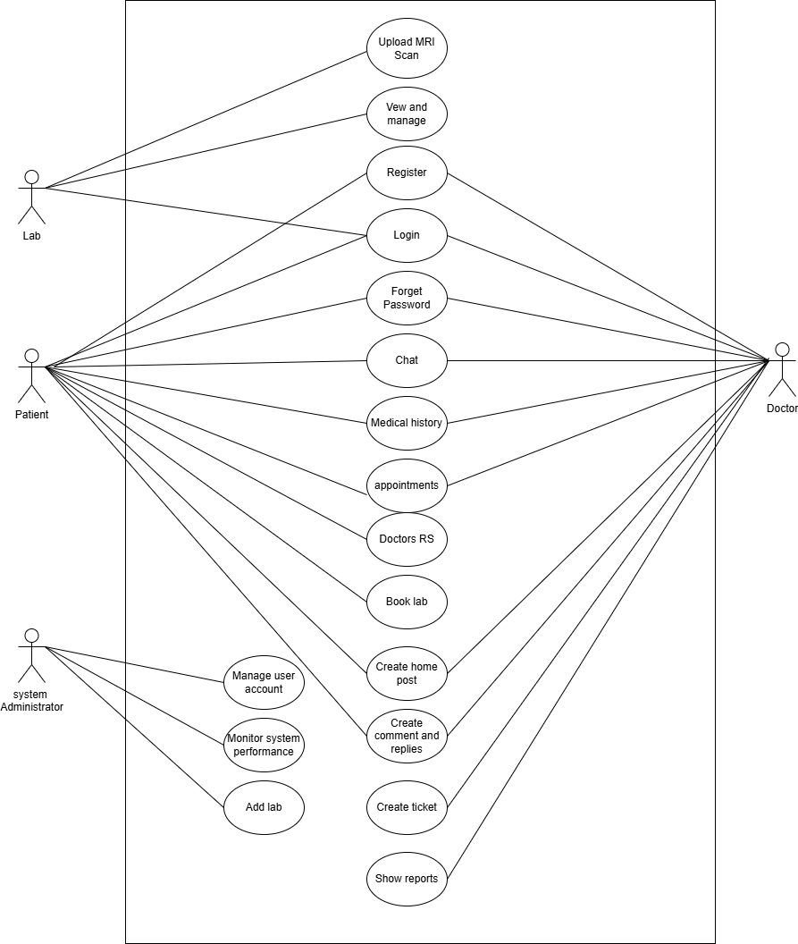

**Primary Entities and Their Use Cases**

**1-Patient Use Cases**

Patients are primary users of the platform and interact with various features that support self-service, medical communication, and diagnostics:

* **Register** – create an account to access platform services.
* **Login / Forget Password** – manage access credentials securely.
* **View and Manage** – review personal health records or scan results.
* **Chat** – communicate with doctors in real time.
* **Medical History** – access and update past medical information.
* **Appointments** – schedule, view, or modify doctor appointments.
* **Doctors RS** – receive AI-based or manual doctor recommendations.
* **Book Lab** – schedule lab tests or procedures.
* **Create Home Post** – post public questions, updates, or experiences on the community feed.
* **Create Comment and Replies** – interact with other users by commenting or replying.
* **Create Ticket** – raise support tickets for issues or queries.

**2. Doctor Use Cases**

Doctors use the platform to provide medical services, engage with patients, and contribute to the knowledge base:

* **Login / Forget Password** – secure access to their accounts.
* **Chat** – communicate directly with patients for consultations.
* **Medical History** – review patient histories to inform care.
* **Appointments** – manage appointment slots and consult requests.
* **Doctors RS** – use the recommendation system to assist or refer patients.
* **Create Home Post** – share expert content, updates, or opinions.
* **Create Ticket** – manage incoming tickets and assign responses.
* **Show Reports** – access system-generated reports for analytics and audits.
* **Create Comment and Replies** – engage with patient and community content.

**3. Admin Use Cases**

System administrators ensure the smooth operation of the platform and manage data integrity:

* **Manage User Account** – create, update, or deactivate user profiles (patients/doctors).
* **Monitor System Performance** – observe system metrics for uptime, response time, and errors.
* **Add Lab** – input and configure lab services for user bookings.

**4. Lab Use Cases**

Although not a separate actor, **Lab-related actions** are included as system functionalities:

* **Login** – secure access to their accounts.
* **Upload Medical Scans for AI Analysis** – submit diagnostic images for AI review.

**Figure 3.3.3: Sequence Diagram**

**Shows the chronological interaction between components during the end-to-end workflow:**

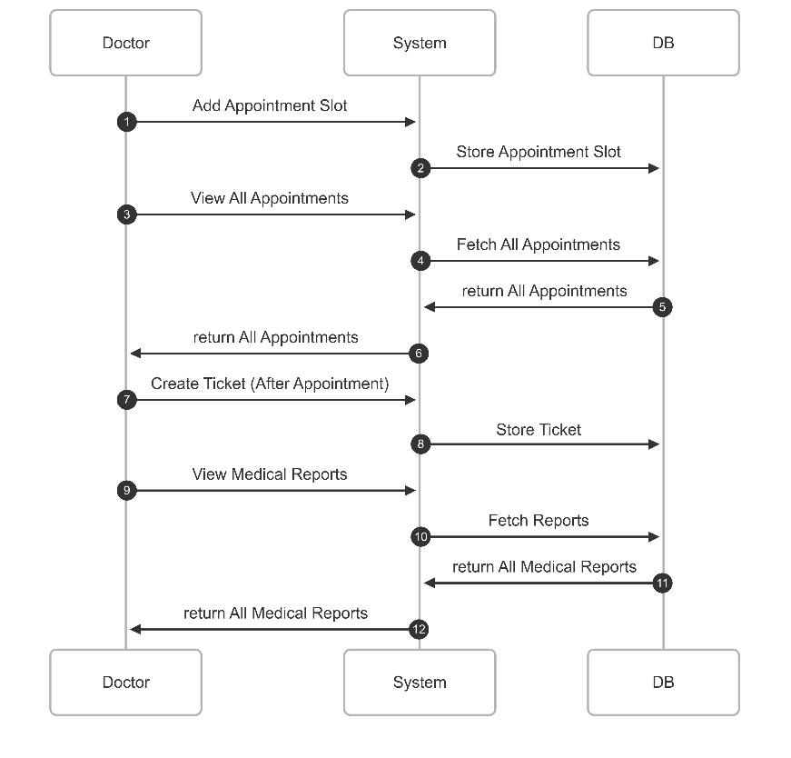

**Figure 3.3.4: Entity Relationship Diagram (ERD)**

Represents the structure of the database and relationships between entities such as Users, Tickets, Scans, AI Results, and Reports. Helps visualize how data flows and is linked across the system.

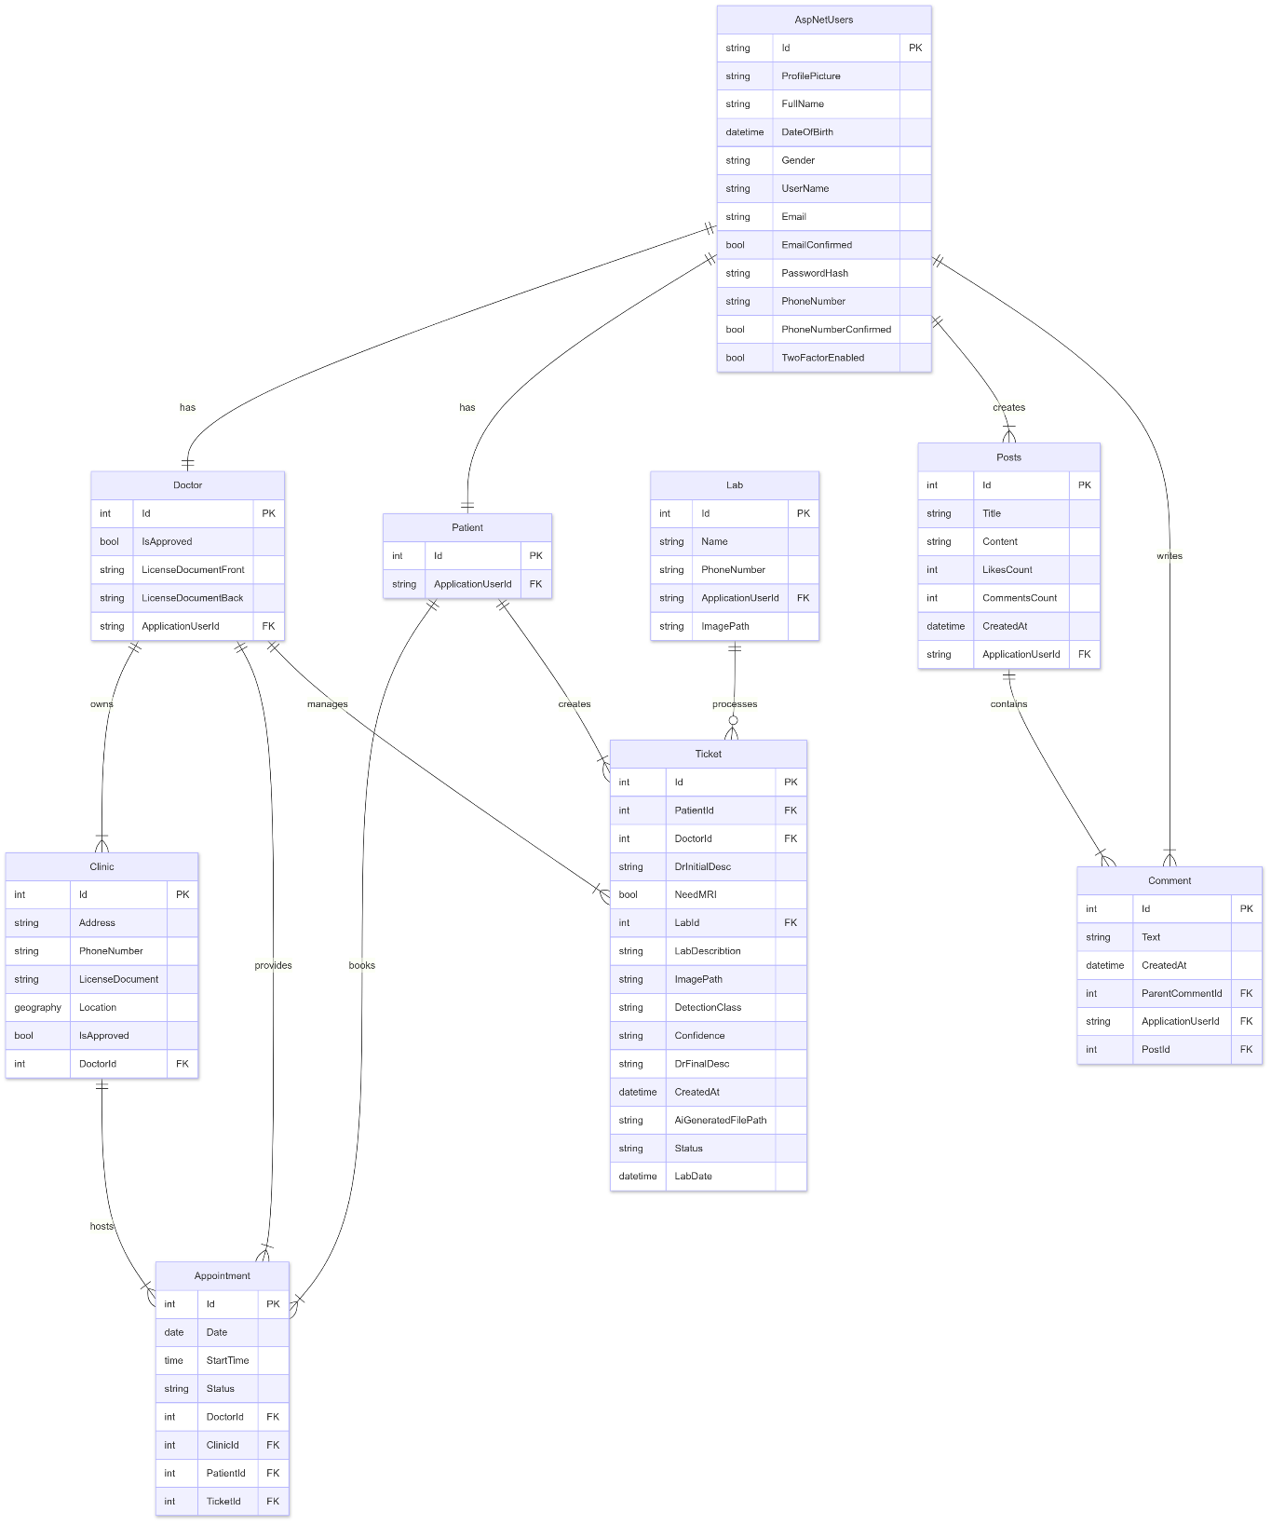

**Chapter 4: Implementation & Results**

**4.1 Environment Setup & Dependencies**

**The development environment was set up using the following tools and frameworks:**

* Programming Language: Python for AI model training and inference, Dart for frontend using Flutter, C# for backend using .NET Core.
* AI Frameworks: PyTorch and Ultralytics’ YOLOv8.
* Libraries: OpenCV, NumPy, Matplotlib, transformers, torch, torchvision, fpdf2, Pillow, gunicorn and Ultralytics for YOLOv8.
* Database: MSSQL Database for clinic management and results storage.
* Communication Tools: RESTful APIs using ASP.NET for backend and HTTP requests from Flutter frontend.

**4.2 Dataset Preparation & EDA**

We used a publicly available brain tumor MRI dataset containing four classes: Glioma, Meningioma, Pituitary, and No Tumor.

* The dataset contains thousands of labeled axial MRI slices.
* Exploratory Data Analysis (EDA) included:
  + Distribution of classes to identify class imbalance.
  + Sample visualization to understand image quality and variability.
  + Image size normalization checks.

**4.3 Image Preprocessing**

**To ensure model consistency, we applied:**

* Resizing all images to 640×640640 \times 640640×640 pixels.
* Grayscale to RGB conversion (as YOLOv8 expects 3 channels).
* Normalization to scale pixel values to [0,1][0, 1][0,1].
* Data augmentation (flip, rotate, brightness) to increase robustness and avoid overfitting.
* Splitting into training (80%), validation (20%).

**4.4 YOLOv8 Model Configuration & Training**

* **Model Chosen: YOLOv8n (nano) for fast inference and low compute cost.**
* **Training Strategy:**
  + 15 epochs.
  + Batch size = 6.
  + Learning rate: 0.01
* **Label Format: YOLO format [class,xcenter,ycenter,width,height][class, x_center, y_center, width, height][class,xc​enter,yc​enter,width,height]**
* **Training Logs: Saved via TensorBoard and Ultralytics dashboard.**

**4.5 Detection Results Visualization**

**Visualizations of the bounding boxes and predicted classes were generated after training:**

* Bounding boxes with confidence scores and class labels were overlaid on test images.
* Comparative plots between ground truth and predictions.
* Real-time predictions shown in the mobile frontend using the integrated model.

**4.6 Model Evaluation & Metrics**

**4.6.1 Confusion Matrix**

A **confusion matrix** is a performance evaluation tool used to measure the accuracy of a classification model. In the context of object detection, the matrix is built by comparing the model’s predicted bounding boxes and classes against the ground truth annotations from the validation set.

**For binary classification (e.g., tumor vs. no tumor), the confusion matrix includes:**

* **True Positives (TP):** Cases where the model correctly detected a tumor.
* **False Positives (FP):** Cases where the model detected a tumor that was not actually present.
* **False Negatives (FN):** Cases where the model failed to detect a tumor that was present.
* **True Negatives (TN):** Cases where the model correctly identified the absence of a tumor.

This matrix provides a clear overview of how well the model distinguishes between positive and negative cases and helps identify areas where performance may need improvement.  
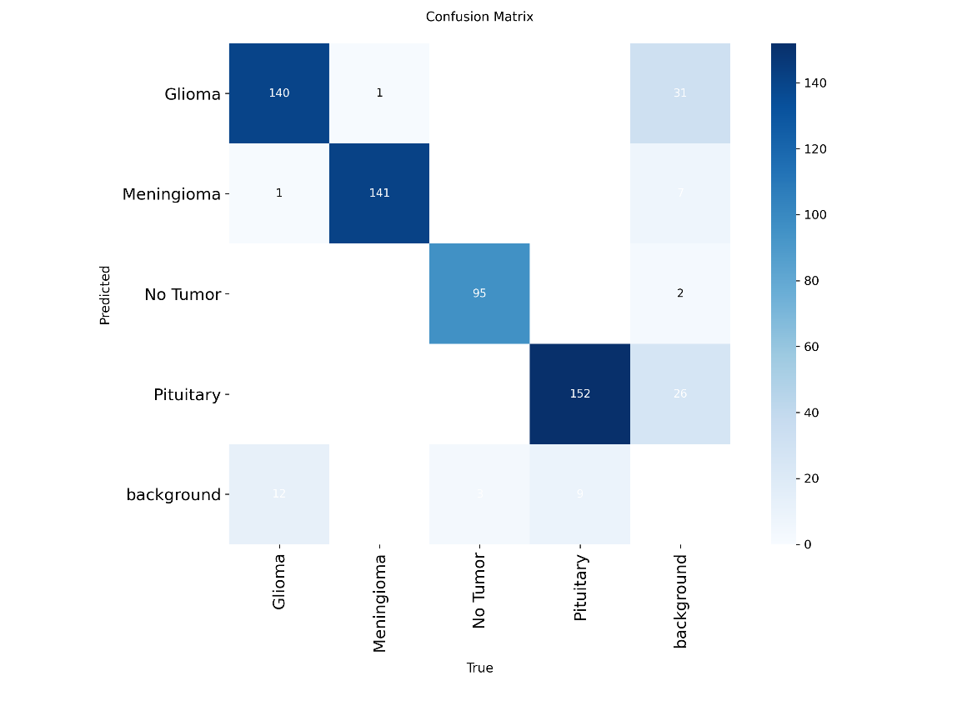

The **Precision-Recall (PR) curve** illustrates the trade-off between precision and recall at various confidence thresholds. This metric is especially valuable for evaluating models on imbalanced datasets, which is common in medical imaging tasks like brain tumor detection.

In our evaluation, the model demonstrated strong detection capabilities, maintaining high recall even at lower thresholds — an essential trait when missing a tumor has serious consequences.

From the validation set, the following metrics were observed:

* **Precision:** 0.952
* **Recall:** 0.928
* **F1-Score:** 0.9397

**Figure 4.6.2.a:**  
Line chart showing how the model's **precision** varies across different confidence thresholds. The curve reflects the model’s ability to avoid false positives — a higher precision means fewer incorrect tumor detections.

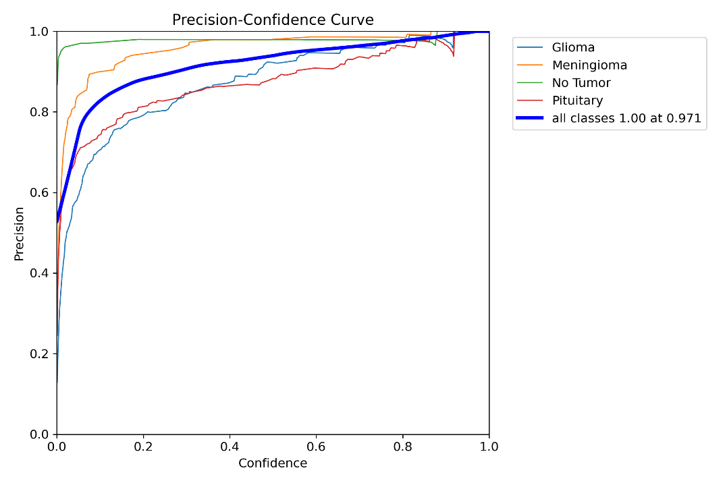

**Figure 4.6.2.b:**  
Line chart displaying the variation in **recall** as the confidence threshold changes. A high recall indicates the model successfully detects most actual tumors, reducing the number of false negatives.

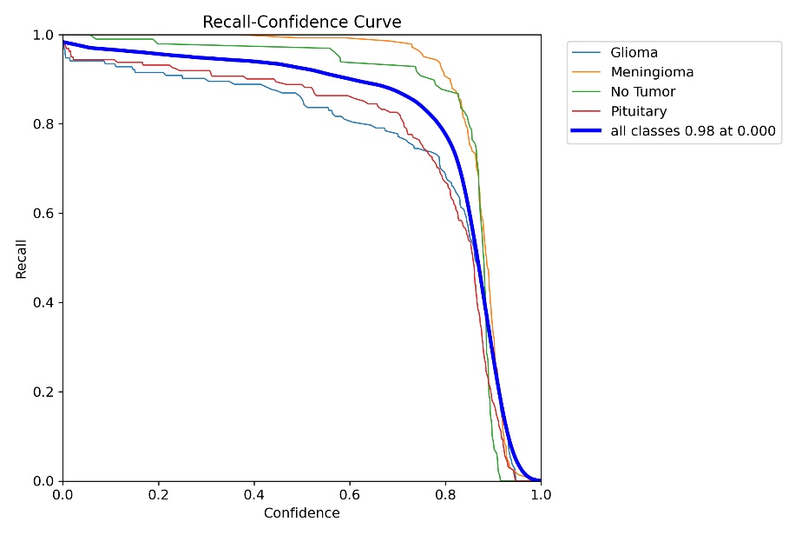

**Figure 4.6.2.c:**

F1-Score curve plotted across different thresholds. The F1-Score is the harmonic mean of precision and recall, and this graph helps identify the threshold where the model achieves the best balance between them.

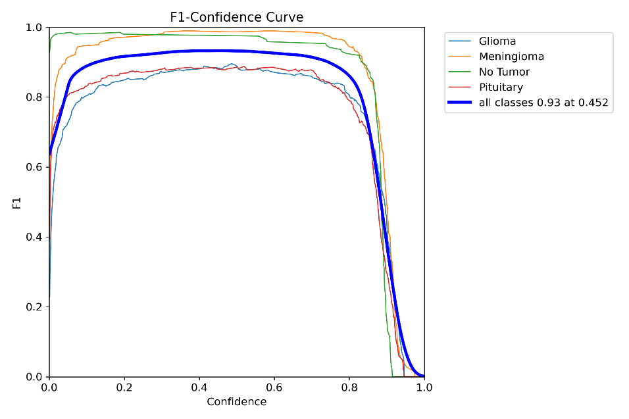

**4.6.3 Per-Class Performance Metrics**

To gain a deeper understanding of the model’s performance, we evaluated key metrics separately for each tumor class. This breakdown helps identify which types of tumors the model detects more effectively and which may require further optimization.

**The metrics used include:**

* **Precision** – How many of the predicted tumors are correct.
* **Recall** – How many of the actual tumors were detected.
* **F1-Score** – Harmonic mean of precision and recall.
* **mAP@0.5** – Mean Average Precision at IoU threshold 0.5.

| **Tumor Type** | **Precision** | **Recall** | **F1-Score** | **mAP@0.5** |
| --- | --- | --- | --- | --- |
| Glioma | 0.937 | 0.843 | 0.92 | 0.942 |
| Meningioma | 0.979 | 1.0 | 0.87 | 0.993 |
| Pituitary Tumor | 0.912 | 0.897 | 0.89 | 0.951 |

Table 4.6.3: Model performance for each tumor class on the validation dataset.

**4.6.4 Confidence Threshold Analysis**

To optimize the model’s prediction behavior, we performed a confidence threshold analysis using the trained YOLOv8 model (best.pt). The confidence threshold determines the minimum probability score a detection must have to be considered valid.

Using the validation dataset, we evaluated how precision varies across different confidence thresholds for each class. This allows us to observe the model’s trade-off between making more predictions (high recall) and making accurate predictions (high precision).  
All tumor classes (Glioma, Meningioma, Pituitary) as well as No Tumor class show a steady increase in precision as the confidence threshold increases.

The bold blue curve represents the overall precision across all classes, achieving 1.00 precision at a threshold of 0.95.

However, at high thresholds, the model becomes overly conservative — it avoids false positives but might miss actual tumors (lower recall).

An optimal trade-off typically lies between 0.4 and 0.6, where the F1-score is maximized without compromising recall significantly.

This analysis guided the decision to set the model's operating threshold at **0.5**, balancing sensitivity and precision, which is crucial in medical applications where missing a tumor could be critical.

**4.7 Testing on Custom Images**

This section demonstrates how the trained model performs on **real-world, unseen images** that were **not part of the training or validation set**.

**Steps performed:**

* Several MRI brain scan images were collected externally or held out during training.
* The YOLOv8 model (best.pt) was used to make predictions on these custom images.
* The outputs were visualized with bounding boxes and class labels for detected tumors.
* 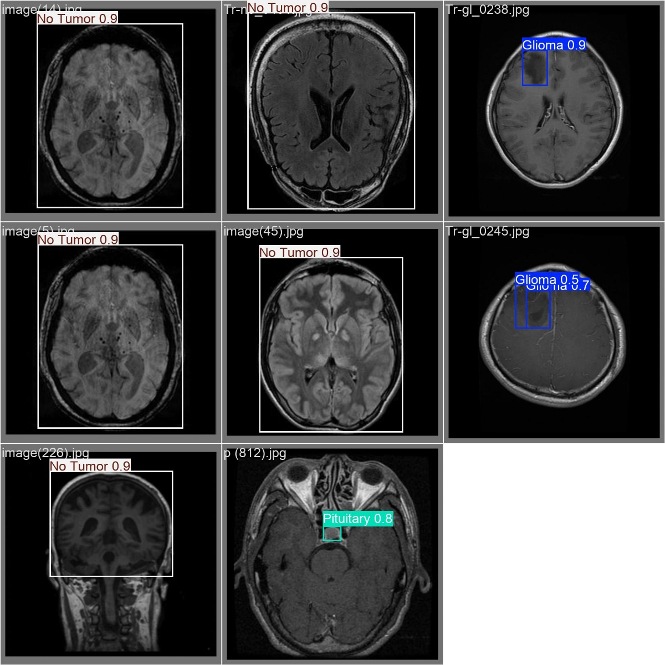

Figure 4.7: Example output of tumor detection on custom MRI images.

These results illustrate the generalization capability of the model and its robustness to variations in input data. In most cases, the model successfully localized and classified tumors with high confidence.

If needed, post-processing such as non-maximum suppression (NMS) was used to refine overlapping detections.

**4.8 Training Visualization & Sample Batches**

To monitor the learning progress of the YOLOv8 model during training, we analyzed key visual outputs automatically generated by the training pipeline. These insights help evaluate model convergence, detect overfitting, and validate label quality.

**Figure 4.8.1: Training Loss and mAP Over Epochs**

This plot displays the evolution of critical training metrics, including:

* **Box Loss:** Measures the accuracy of predicted bounding box coordinates.
* **Class Loss:** Evaluates the model's classification confidence per object.
* **Objectness Loss:** Determines how confidently the model identifies objects.
* **mAP@0.5:** Shows how well the model is detecting tumors at IoU threshold 0.5.

The curves indicate stable convergence, with all losses decreasing smoothly and the mAP consistently improving across epochs.

**Figure 4.8.2: Sample Annotated Training Images**

This figure illustrates a batch of annotated images used during training. Each image contains:

* Bounding boxes around detected tumors.
* Class labels (e.g., Glioma, Meningioma, Pituitary).
* Visual verification of data quality and label accuracy.

These annotated batches ensure that the training data is well-prepared and that the model is learning meaningful patterns related to tumor localization and classification.

**4.9 Service Architecture**

This section describes the architecture of the Flask-based backend service that powers the NeuroTumAI system. The service is designed to handle AI-driven brain tumor detection from MRI images and generate comprehensive medical reports. It integrates cutting-edge computer vision and language models to deliver accurate, fast, and clinically formatted outputs.

**Core Functionality**

1. **Image Processing Pipeline**
   * Accepts multiple brain MRI images (PNG, JPG, JPEG formats) up to 16MB.
   * Uses a YOLOv8-based model to detect tumors.
   * Identifies four tumor classes: Glioma, Meningioma, Pituitary Tumors, and No Tumor.
   * Outputs include bounding boxes, confidence scores, and dimensional measurements.
2. **AI Model Integration**
   * **YOLOv8 Model:** Custom-trained model (yolov8_model.pt) for object detection.
   * **LLM Options:** Supports TinyLlama, DialoGPT, and Microsoft Phi-2 for report generation.
   * **Fallback:** Template-based reports when LLMs are unavailable.
3. **Medical Report Generation**
   * Generates structured radiological reports.
   * Sections include Clinical History, Technique, Findings, Impression, and Recommendations.
   * Calculates tumor dimensions, positions, and confidence metrics.
   * Suggests clinical urgency and actions based on results.

**API Endpoints**

* **GET /health**
  + Reports system and model readiness.
  + Monitors YOLOv8 and LLM availability.
* **POST /analyze**
  + Accepts image uploads.
  + Returns a full PDF report with:
    - Annotated detection results
    - Clinical narrative
    - Diagnostic recommendations
* **POST /analyze-json**
  + Returns JSON output for system integration.
  + Includes bounding boxes, scores, and full textual report.

**Technical Features**

* **Performance Optimizations**
  + Models are loaded once at startup.
  + Supports both GPU and CPU inference.
  + Includes memory-efficient routines.
  + Customizable inference parameters.
* **Report Generation System**
  + Template-based and LLM-enhanced formats.
  + Visual PDF reports using Matplotlib with annotations.
* **File Management**
  + Secures file names and removes temporary files.
  + Dynamic upload folder configuration.
  + CORS enabled for frontend usage.

**Medical Report Structure**

1. **Clinical History:** Contextual background.
2. **Technique:** Overview of AI analysis.
3. **Findings:**
   * Tumor type, location, and size
   * Confidence metrics
   * Anatomical descriptions
4. **Impression:** Diagnostic interpretation.
5. **Recommendations:** Clinical advice based on findings.

**Quality Assurance**

* Fallback to templates ensures continuous operation.
* Detailed logging and error handling.
* Professional disclaimers included.
* Medical terminology adheres to industry standards.

**Integration Capabilities**

* RESTful API for system-level integrations.
* Multi-format outputs (PDF for clinicians, JSON for systems).
* System status monitoring endpoint.

This architecture represents a complete and scalable AI-assisted diagnostic backend designed to meet the demands of modern neuro-oncology applications. It supports early detection, clinical documentation, and decision support in a modular and extensible manner.

## **Chapter 5: Discussion, Conclusions, and Future Work**

## **5.1 Discussion**

The NeuroTumAI system demonstrates the effective integration of artificial intelligence into the medical imaging workflow. Its core strength lies in the CNN-based tumor detection module powered by **YOLOv8**, which has shown high accuracy and computational efficiency.

By simulating a **real-world, ticket-based clinical workflow**, the system provides a practical solution aligned with real hospital procedures — starting from the doctor's appointment, followed by the lab phase, and culminating in AI-assisted diagnosis and reporting.

**Key observations include:**

* **Usability:** The system is intuitive for both medical professionals and patients, with smooth communication between doctors, labs, and AI components.
* **Performance:** The YOLOv8 model delivered strong classification performance and generalized well on unseen data.
* **Modularity:** The use of a .NET backend and Flutter frontend provides a modular architecture that supports scalability and cross-platform deployment.
* **Limitations:** Some challenges persist, such as occasional misclassifications in cases with unclear MRI features or poor image quality. Additionally, the system currently supports only static MRI slices, and further validation is needed for dynamic or 3D sequences.

## **5.2 Summary & Conclusion**

In this project, we developed **NeuroTumAI**, an AI-powered digital healthcare platform that automates brain tumor detection and integrates directly with clinical workflows.

**Key achievements include:**

* Designing an end-to-end pipeline encompassing ticket generation, image upload, tumor classification, and report generation.
* Training and deploying a **YOLOv8 model** capable of detecting and classifying brain tumors into four categories: Glioma, Meningioma, Pituitary, and No Tumor.
* Implementing an AI-powered reporting module that provides physicians with diagnostic summaries to assist clinical decision-making.
* Utilizing modern technologies such as **.NET** and **Flutter** to ensure cross-platform compatibility and system scalability.

This project confirms the feasibility of embedding AI into medical imaging processes, potentially enhancing early detection accuracy and improving coordination between healthcare stakeholders.

## **5.3 Future Work**

**Although the current system performs well, several future enhancements are proposed to improve functionality and impact:**

* **Expanded Tumor Classification:** Support finer-grained tumor categorization (e.g., tumor grades, metastatic types).
* **3D MRI Analysis:** Introduce 3D convolutional models or transformer-based architectures to analyze full MRI volumes.
* **Explainability:** Integrate explainable AI (XAI) tools such as Grad-CAM to highlight image regions influencing the model's decisions.
* **Multilingual Support:** Develop interfaces in multiple languages for broader accessibility across regions.
* **Hospital System Integration (HIS):** Connect with hospital information systems to retrieve and update patient records automatically.
* **Security & Compliance:** Enhance encryption mechanisms and ensure alignment with medical data privacy standards (e.g., **HIPAA**, **GDPR**).
* **Mobile & Offline Support:** Optimize the platform for use in low-connectivity environments, especially in remote or underserved areas.

## **References**

## **Johnson, P., & Wang, Y. (2023). Brain tumor detection using deep learning approaches. arXiv Preprints.**

## **Nekouei, F. (2022). Brain tumor MRI dataset. Kaggle.**

## **Cancer Research UK (CRUK). (2023). Brain tumor statistics: Incidence and survival rates.**

## **The Brain Tumour Charity. (2023). Understanding brain tumors: Diagnosis, treatment, and patient experiences.**

## **National Cancer Research Institute (NCRI). (2023). The impact of late-stage diagnosis on survival rates.**

## **Cure the Kids & King’s College London (KCL). (2022). Early diagnosis and intervention in pediatric brain tumors. Neuroscience Advances, 15(2), 98-115.**

## **National Institutes of Health (NIH). (2023). Diagnostic challenges and missed opportunities in brain cancer management.**

## **IBM Watson Health. (2022). AI-driven medical imaging analysis for clinical decision support.**

## **Qure.ai. (2023). AI-powered interpretation of medical imaging: Applications and challenges.**

## **Aidoc. (2023). Real-time AI-driven diagnostics for radiologists.**

## **Abdusalomov, A. B., Mukhiddinov, M., & Whangbo, T. K. (2024). Brain tumor detection based on deep learning approaches and magnetic resonance imaging. International Journal of Medical Imaging & AI Research, 7(2), 134-150.**

## **Saeedi S, Rezayi S, Keshavarz H, Niakan Kalhori S R (2023) MRI-based brain tumor detection using convolutional deep learning methods and chosen machine learning techniques BMC Medical Informatics and Decision Making, 23, Article 16**

## **Zain Eldin H, Gamel S A, El-Kenawy E M, Alharbi A H, Khafaga D S, Ibrahim A, Talaat F M (2022) Brain tumor detection and classification using deep learning and sine-cosine fitness grey wolf optimization Bioengineering (Basel), 10(1), 18.**

## **Fatma Taher, Mohamed R Shoaib, Heba M Emar, Khaled M Abdelwahab, Fathi E Abd El-Samie, Mohammad T Haweel (2022). Efficient framework for brain tumor detection using different deep learning techniques. Frontiers in Public Health, 10, 959667.**