## FOOD ORDERING PORTAL

SWADD

SUBMITTED BY-ARIJIT PANDA

EMAIL-ARIJIT43.143@GMAIL.COM

TECHNOLOGY USED-

HTML

TAILWIND

CSS

JS

PHP

MYSQL

APACHE

### SWADD HAS MAJOR TWO COMPONENTS

### ONE IS Buyer and another is seller

### Swadd is connect two components means it is the gateway between them

### Swadd has many subcomponents components like

## Buyer has->

### login.php

### signup.php

### cart.php

### index.php

### Seller has->

### login.php

### add.php

### orders.php

## using of five tables

1.buyer

2.seller

3.cart

4.order

5.products

## seller

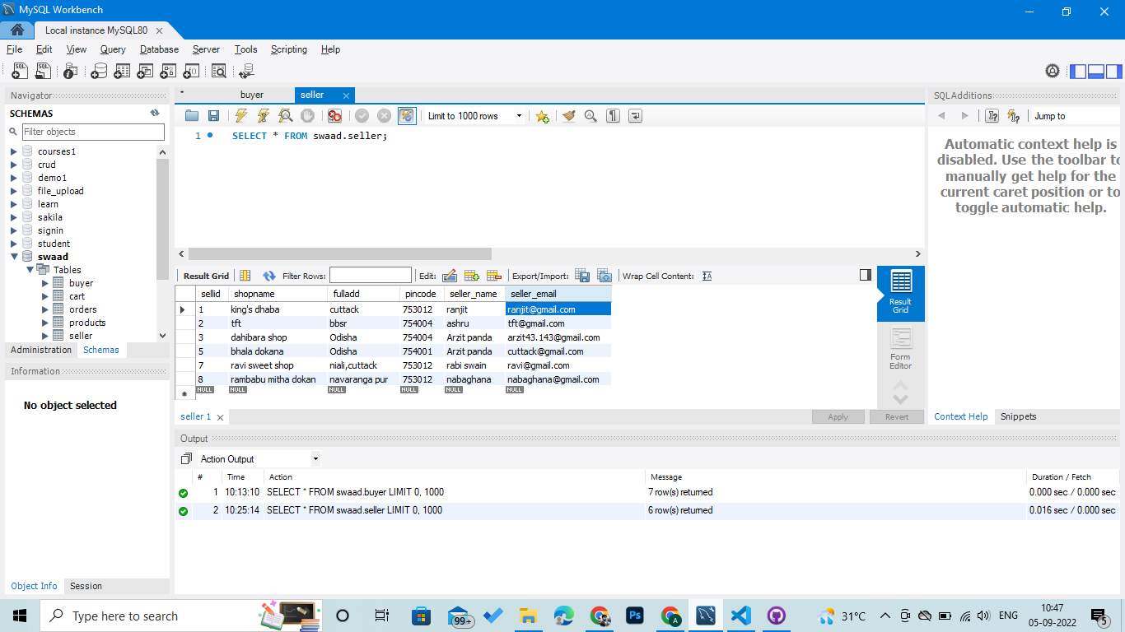

## products

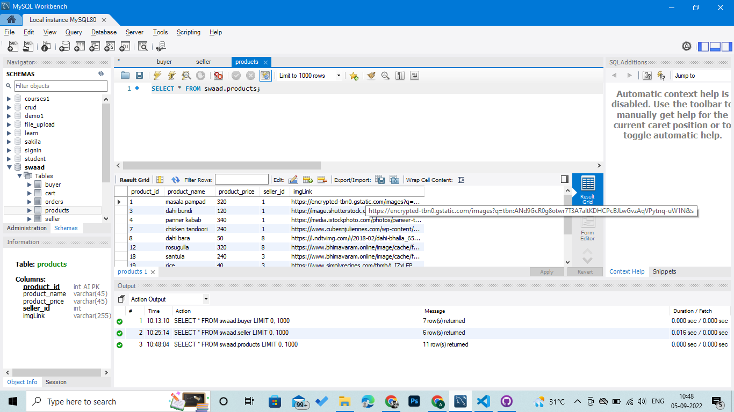

## Orders table

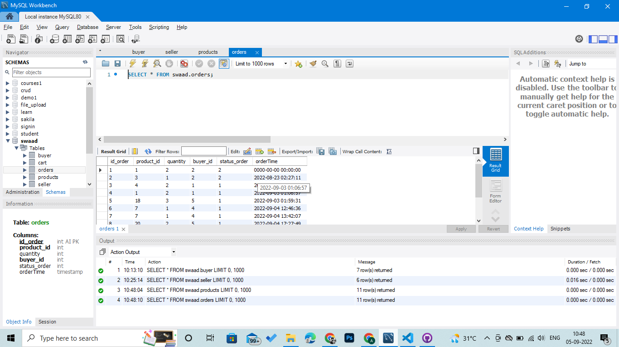

cart

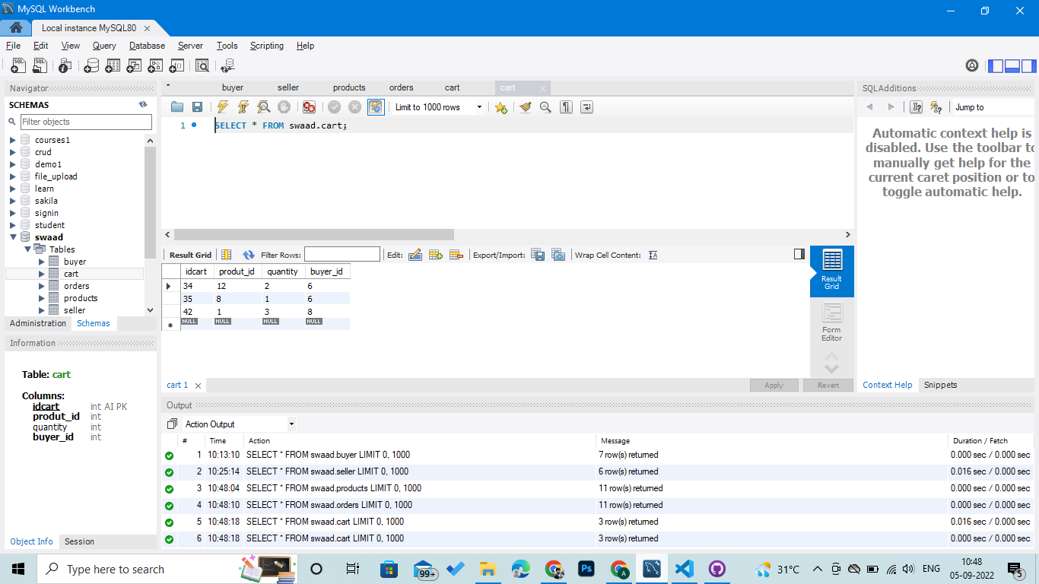

BUYER

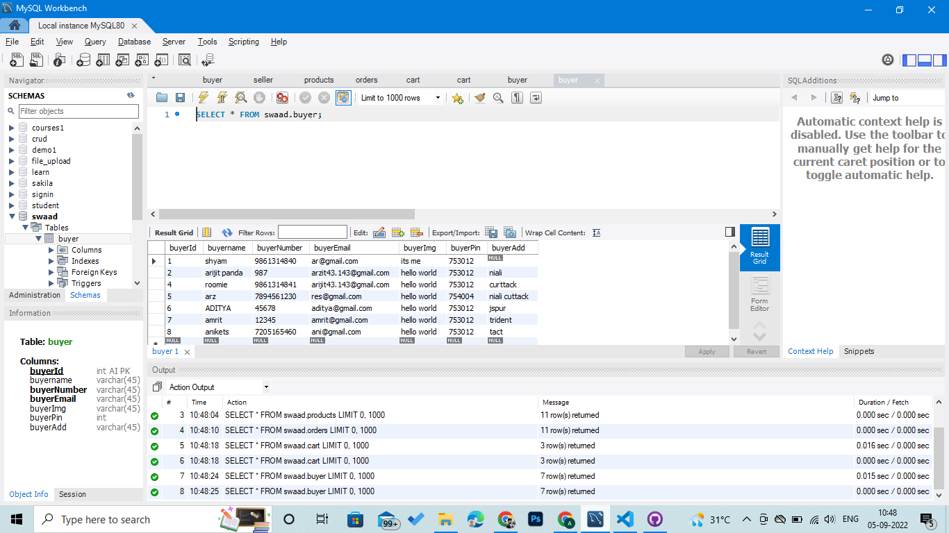

# BYUYER PERSPECTIVE

# THE BUYER HAVE TO SIGN UP BY GIVING HIS CREDENTIALS LIKE NAME ,PHONE NUMBER,EMAIL,PINCODE,ADDRESS

# OR LOGIN BY GIVING HIS PHONE NUMBER

# ONCE HE/SHE LOGIN THE WEBSITE TAKES TO THE INDEX PAGE

# AND SHOW THEM THE STORES AND PROSUCTS NEAR TO THEM

# THE QUERY IS-

“SELECT * FROM products

INNER JOIN

seller

ON

products.seller_id=seller.sellid

WHERE

FLOOR(pincode/10)=75301;”

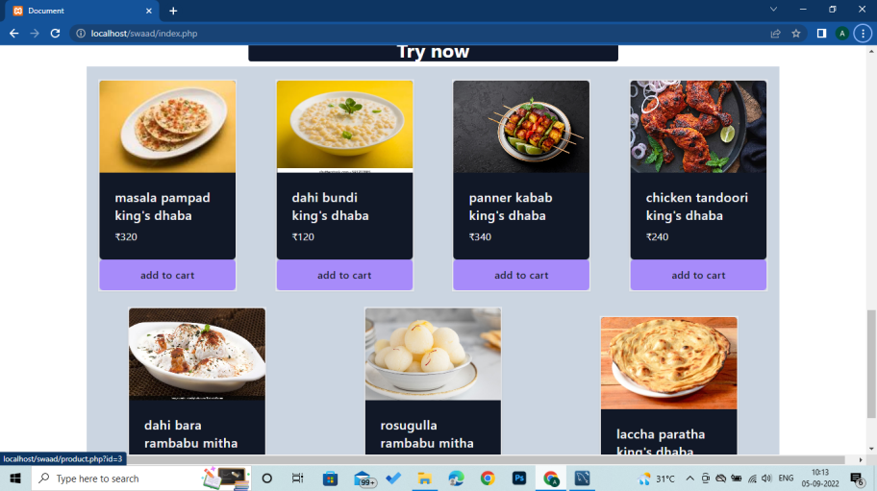

# WHEN SOMEONE CLICK THE PRODUCT IT ADD TO CART AND IF THE NEXT PRODUCT IS OTHERS SHOP THEN ALL THE PRODUCTS ARE REMOVE AND THE NEST SHOP ITEM ADDED

SELLER PAGE

### A SELLER CAN SIGN UP BY GIVING THE NAME ,SHOPNAME,EMAIL,NUMBER,ADDRESS

### A SELLER CAN ALSO LOGIN BY GIVING ITS EMAIL

### AFTER LOGIN IT REDIRECTS TO THE SELLER PAGE

### WHERE THE SHOP OWNER CAN ADD PRODUCTS AND EDIT AND DELETE THE PRODUCTS OF THE PARTICULAR SHOP

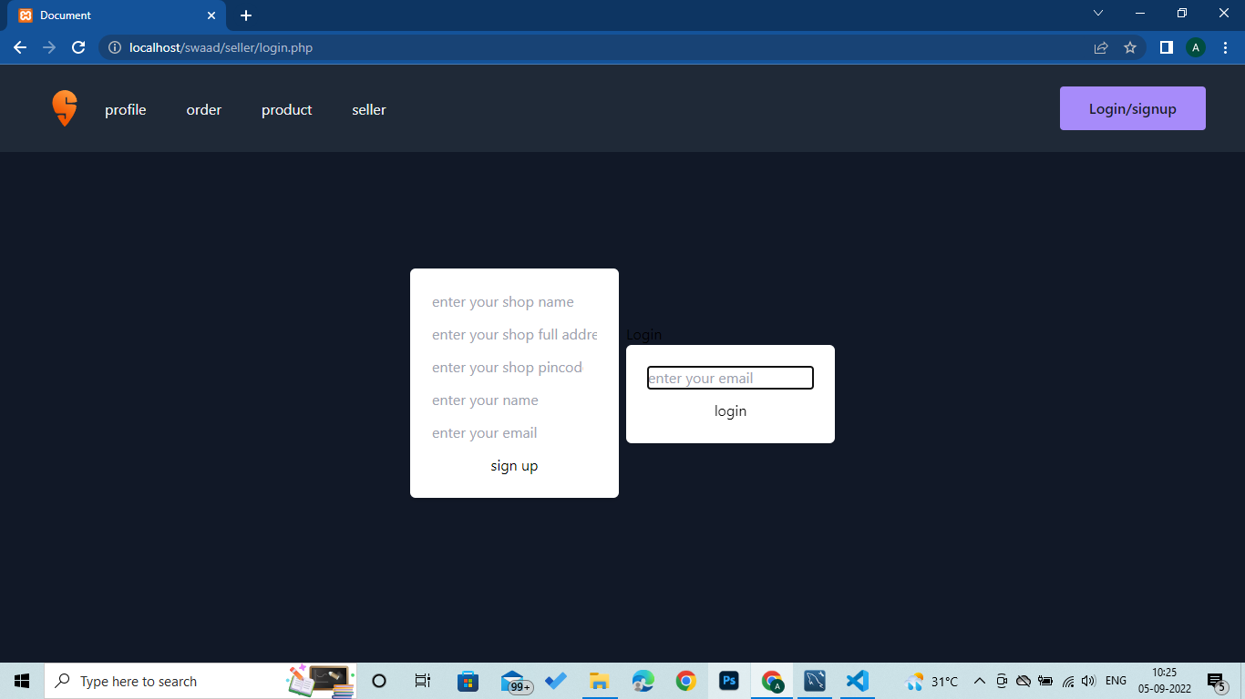

## SELLER CAN GET THE ORDER THAT The buyer ordered and give status of the orders and the shop only get the orders of that particular shop

