In grids ‘s’ indicates start point and ‘e’ indicates end point. Grid 1 has single end point and grid 2 has two end points.

Grid 1:

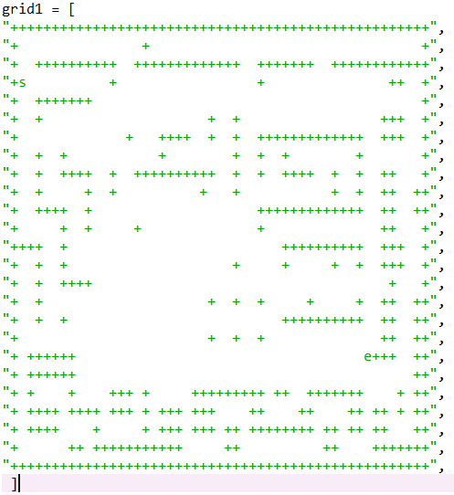

Grid 2:

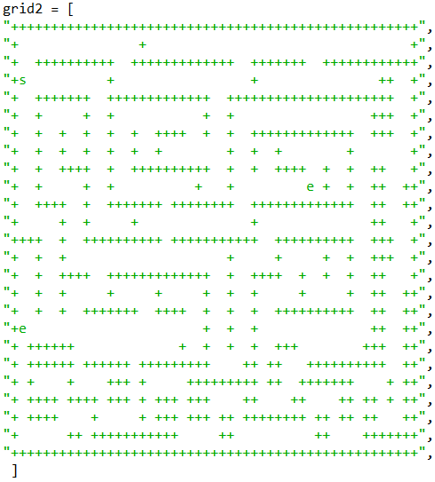

**BFS grid 1:**

Time: 11.252827167510986

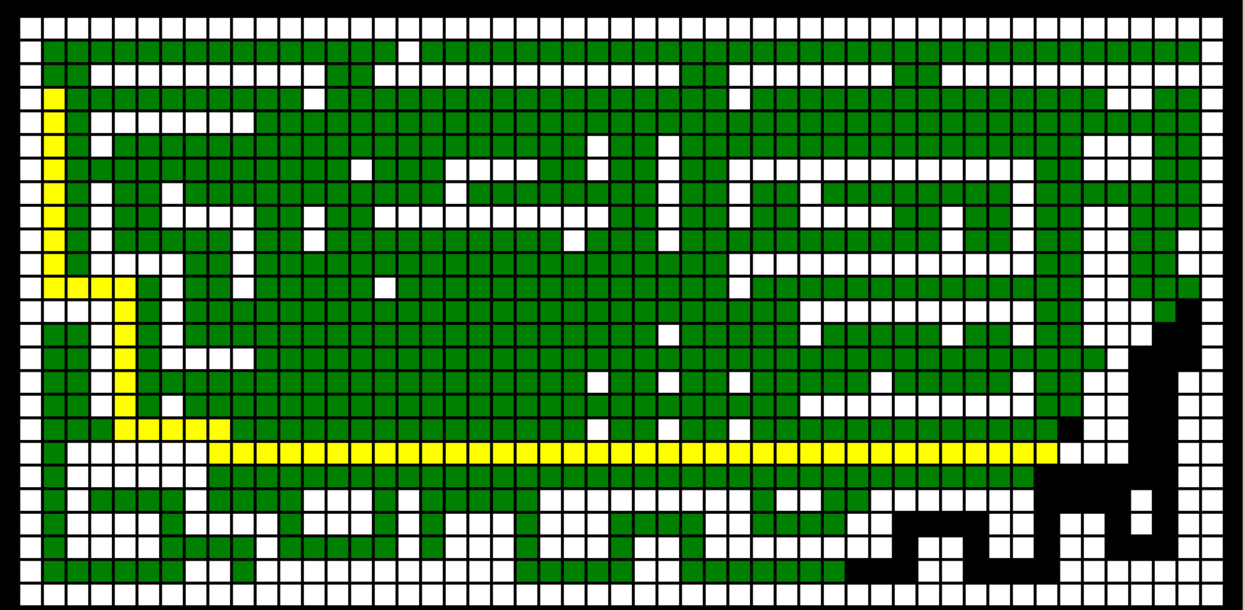

**DFS grid 1:**

Time: 3.829895257949829

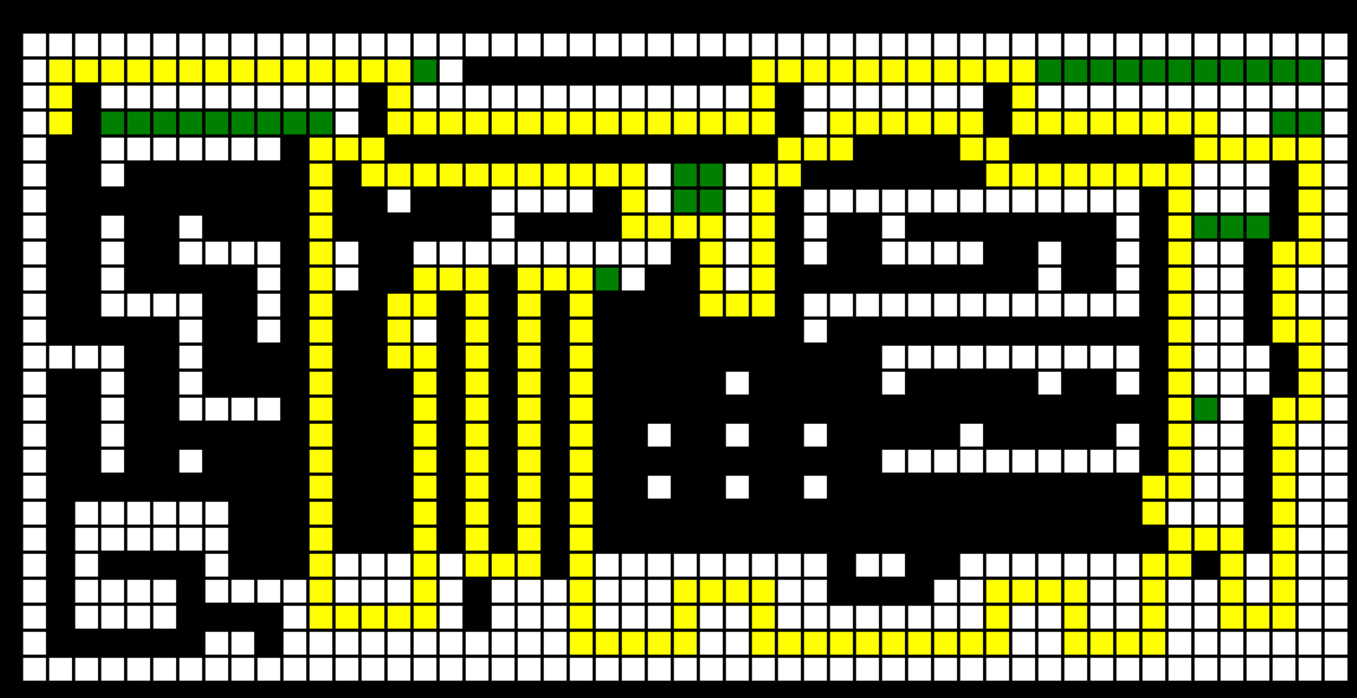

**A star grid 1:**

Time: 3.922494888305664

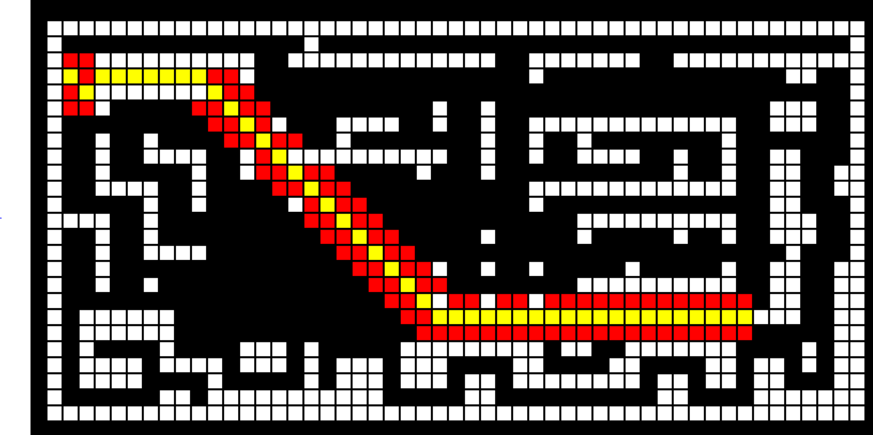

**Modified BFS grid 1:**

Time: 10.335736989974976

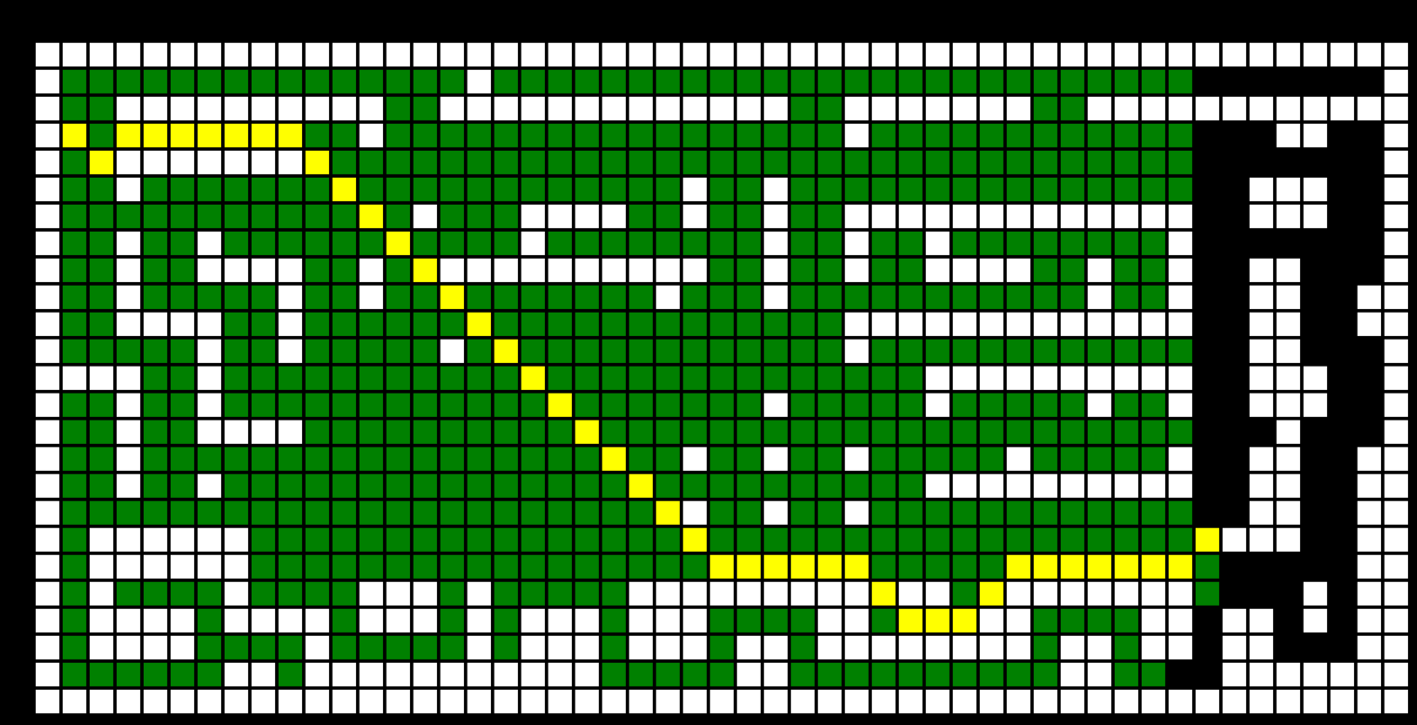

**Modified DFS grid 1:**

Time: 11.209647178649902

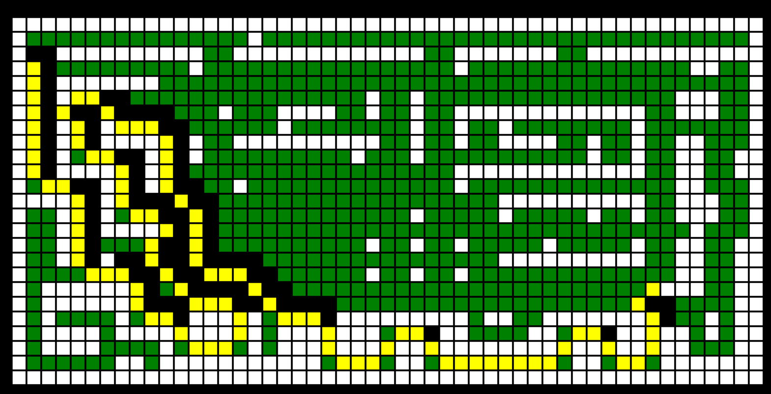

**BFS grid 2:**

Time: 6.6316306591033936

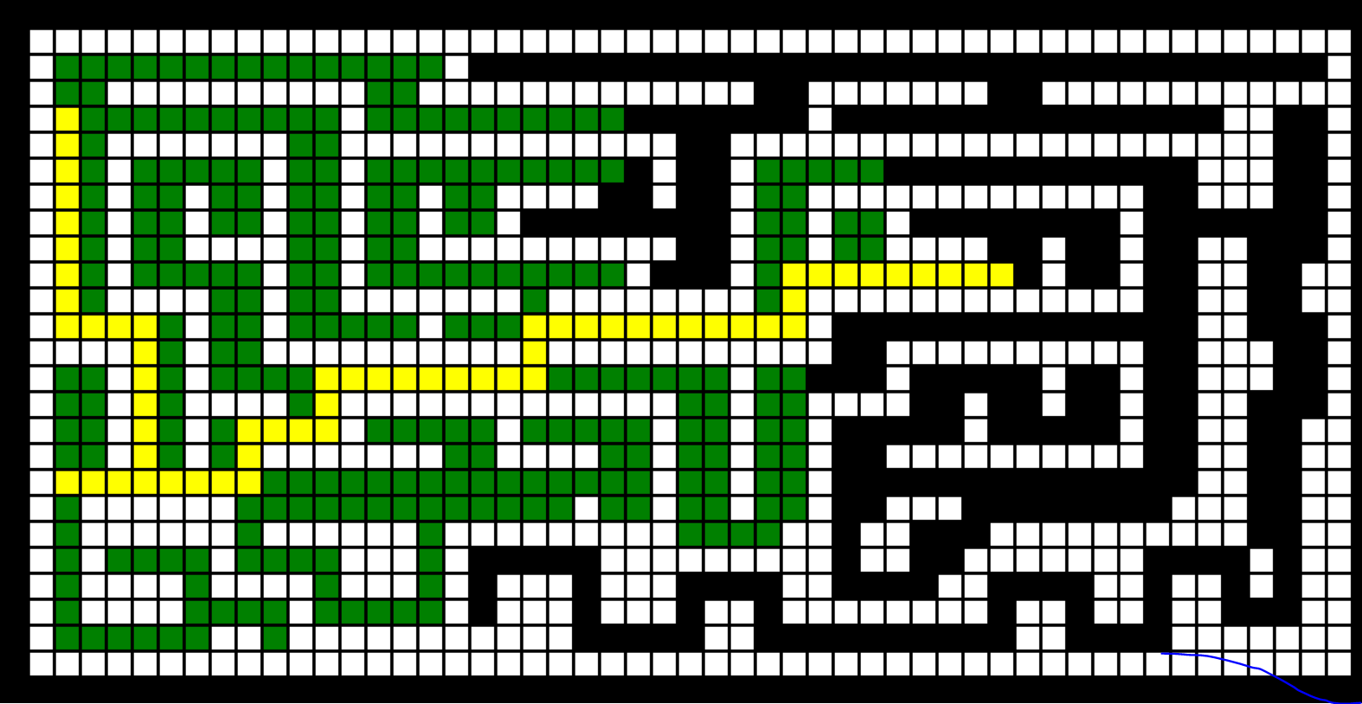

**DFS grid 2:**

Time: 13.5961434841156

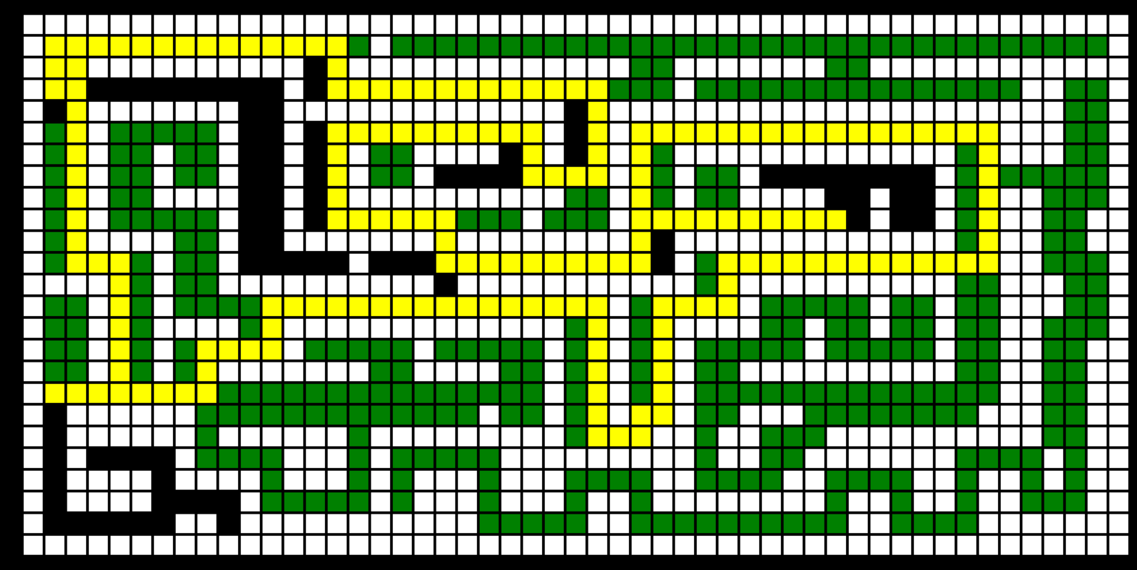

**A star Grid2:**

Time: 3.3740410804748535

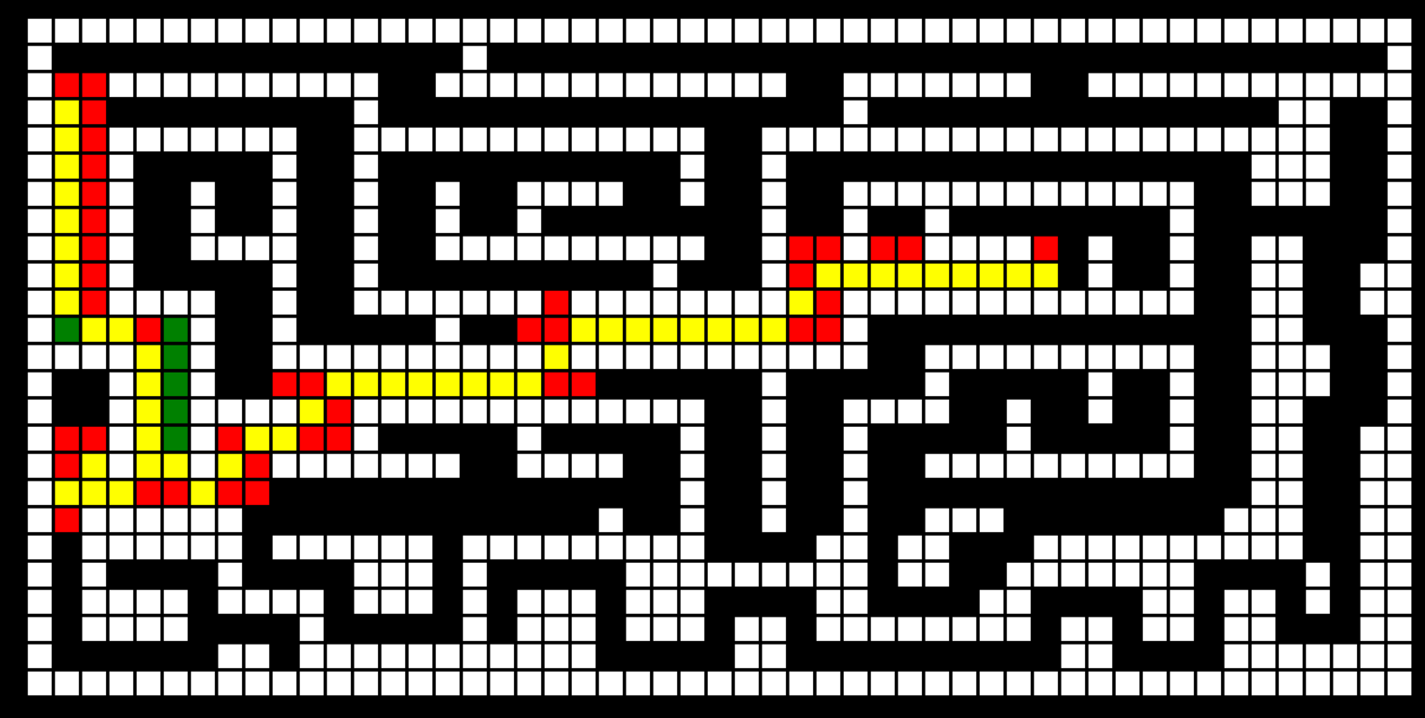

**Modified BFS Grid 2:**

Time: 6.557369947433472

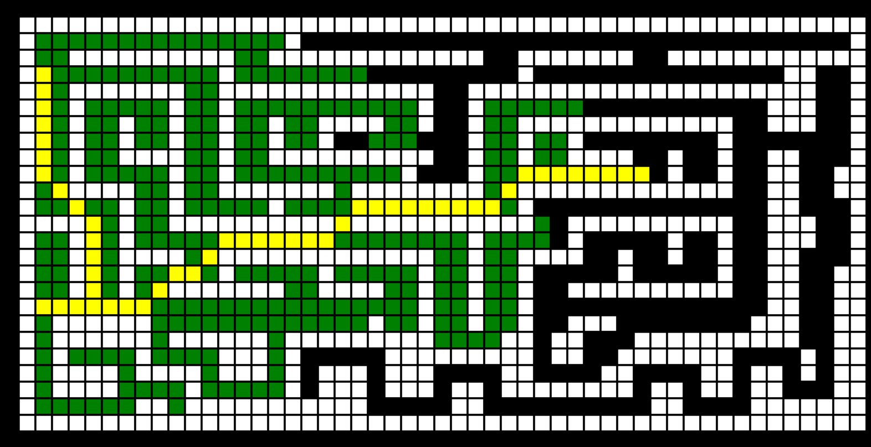

**Modified DFS Grid 2:**

Time: 7.340572834014893

