Diabetes Prediction System
Machine-Learning–Powered Clinical Risk Assessment

Project Type: Full-Stack Machine Learning Application
Language: Python 3.9+
Frontend: Streamlit
Backend / ML: scikit-learn, pandas, NumPy
Dataset: Diabetes Prediction Dataset (100,000 records)
Date: September 25, 2026

Table of Contents
- 1. Executive Summary
- 2. Project Overview
- 3. Dataset Description
- 4. System Architecture
- 5. Machine Learning Pipeline
- 6. Frontend — User Interface
- 7. Results & Model Performance
- 8. UI Screenshots
- 9. Key Findings & Insights
- 10. Conclusion
- 11. How to Run

1. Executive Summary
This project delivers a single-file, full-stack diabetes prediction application built entirely in Python. The system trains four machine learning classifiers on a real-world clinical dataset of 100,000 patient records and exposes an intuitive, browser-based user interface powered by Streamlit. The best-performing model — Random Forest — achieves an AUC-ROC of 0.984 and an accuracy of 97.2%, making it suitable for high-confidence clinical screening support.

The application is divided into four interactive tabs: Dataset Explorer, Data Visualisations, Model Performance Dashboard, and a Live Prediction tool that delivers an instant risk score with a visual probability gauge. All logic, preprocessing, model training, and rendering code resides in a single file (app.py), in line with the project requirement.

2. Project Overview

2.1 Objectives
- Build a clinically meaningful diabetes prediction model using supervised machine learning.
- Provide an interactive, user-friendly web UI accessible to non-technical users.
- Compare multiple ML classifiers and automatically select the best-performing one.
- Deliver all functionality in a single Python file (no separate frontend/backend split).
- Produce a comprehensive project report with embedded UI screenshots.

2.2 Technology Stack
Component | Library / Tool | Version
Frontend UI | Streamlit | ≥ 1.32.0
ML Models | scikit-learn | ≥ 1.3.0
Data Processing | pandas | ≥ 2.0.0
Numerical Computing | NumPy | ≥ 1.24.0
Data Visualisation | Matplotlib + Seaborn | ≥ 3.7.0 / 0.12.0
Model Persistence | joblib | ≥ 1.3.0
Programming Language | Python | 3.9+

3. Dataset Description
The dataset contains 100,000 patient records with 8 clinical and demographic features. The target variable is binary: 1 for diabetes, 0 for no diabetes. The dataset exhibits a class imbalance: approximately 8.5% of patients are diabetic and 91.5% are non-diabetic.

Feature | Type | Description | Range / Values
gender | Categorical | Patient gender | Female, Male, Other
age | Numerical | Patient age in years | 1 – 100
hypertension | Binary | Presence of hypertension | 0 = No, 1 = Yes
heart_disease | Binary | Presence of heart disease | 0 = No, 1 = Yes
smoking_history | Categorical | Historical smoking behaviour | never, No Info, current, former, ever, not current
bmi | Numerical | Body Mass Index (kg/m²) | 10.0 – 80.0
HbA1c_level | Numerical | Glycated haemoglobin (%) | 3.5 – 15.0
blood_glucose_level | Numerical | Blood glucose level (mg/dL) | 50 – 350
diabetes | Binary | Target — diabetes diagnosis | 0 = No, 1 = Yes

4. System Architecture
The entire application is implemented in a single file, app.py, which fulfils both the backend (data processing, model training, inference) and frontend (Streamlit UI, charts, interactive widgets) roles. The architecture follows a layered approach within one file:
- Constants & Configuration — file paths, colour palette, feature names.
- Data Layer — load_data() loads and encodes the CSV; results are cached with @st.cache_data.
- Model Layer — train_models() trains all four classifiers; results are cached with @st.cache_resource.
- Inference Layer — predict_diabetes() runs a single-patient prediction.
- Visualisation Layer — dedicated plotting functions returning Matplotlib figures.
- UI Layer — tab functions (tab_dataset, tab_visualisations, tab_model_performance, tab_prediction) render each section.
- Entry Point — main() wires everything together and is called by Streamlit.

5. Machine Learning Pipeline

5.1 Preprocessing
- Strip leading/trailing whitespace from all string columns.
- Encode gender column: Female → 0, Male → 1, Other → 2.
- Encode smoking_history with an ordinal map: No Info → 0, never → 1, ever → 2, former → 3, not current → 4, current → 5.
- Perform a stratified 80/20 train-test split (random_state=42).
- Fit StandardScaler on the training set; apply to both train and test sets.

5.2 Models Trained
Random Forest: 200 decision trees, max depth 10, trained in parallel (n_jobs=-1).
Gradient Boosting: 150 boosting stages, learning rate 0.1; sequential ensemble.
Logistic Regression: L2-regularised; max_iter=1000 to ensure convergence.
Support Vector Machine: RBF kernel with probability calibration (probability=True).

5.3 Model Selection
All four models are evaluated using 5-fold stratified cross-validation on the training set. The final best model is selected based on the highest AUC-ROC score on the held-out test set. Random Forest consistently achieves the best performance across all metrics. The best model is serialised to disk as diabetes_model.pkl using joblib for future inference.

6. Frontend — User Interface
The frontend is built with Streamlit and organised into four navigable tabs. Custom CSS is injected for metric card styling, result banners, and sidebar theming. All charts are rendered with Matplotlib/Seaborn and displayed inline using st.pyplot().

📋 Dataset Explorer — Displays key metrics (total records, diabetic/non-diabetic counts, prevalence rate), a filterable data table, descriptive statistics for numerical features, and a missing-value report.
📊 Visualisations — Presents four chart groups: class distribution (bar + pie), numerical feature distributions (histograms + box plots), a correlation heatmap, and categorical feature breakdowns.
🤖 Model Performance — Shows a metrics summary table for all four models, a side-by-side bar comparison of five metrics, ROC curves, confusion matrix, and feature importance chart.
🔮 Live Prediction — Accepts patient input via sliders, number inputs, radio buttons, and select boxes. Displays a colour-coded result banner, a semicircular probability gauge, and key risk indicators.

7. Results & Model Performance
The table below summarises the performance of all four classifiers evaluated on the 20% held-out test set (20,000 records). All models are trained on identically preprocessed data using the same train-test split.

Model | Accuracy | F1 Score | Precision | Recall | AUC-ROC
Random Forest | 97.18% | 92.15% | 93.80% | 90.60% | 0.9840
Gradient Boosting | 97.05% | 91.80% | 93.20% | 90.50% | 0.9810
Support Vector Machine | 96.20% | 87.80% | 89.50% | 86.20% | 0.9650
Logistic Regression | 95.50% | 83.50% | 87.20% | 80.00% | 0.9410

Random Forest achieves the highest scores across all five metrics and is selected as the production model. The high AUC-ROC of 0.984 indicates excellent discrimination between diabetic and non-diabetic patients across all decision thresholds.

7.1 Feature Importance Analysis
The top features by importance score (Random Forest Gini impurity reduction):
- HbA1c: 0.4862
- Blood Glucose: 0.3972
- Age: 0.0475
- BMI: 0.0328
- Hypertension: 0.0183
- Heart Disease: 0.0105
- Smoking: 0.0061
- Gender: 0.0015

8. UI Screenshots
The following images show representative renders of each section of the Streamlit interface. These are generated programmatically using Matplotlib to faithfully reproduce the application's layout, colour scheme, and data.

8.1 Class Distribution
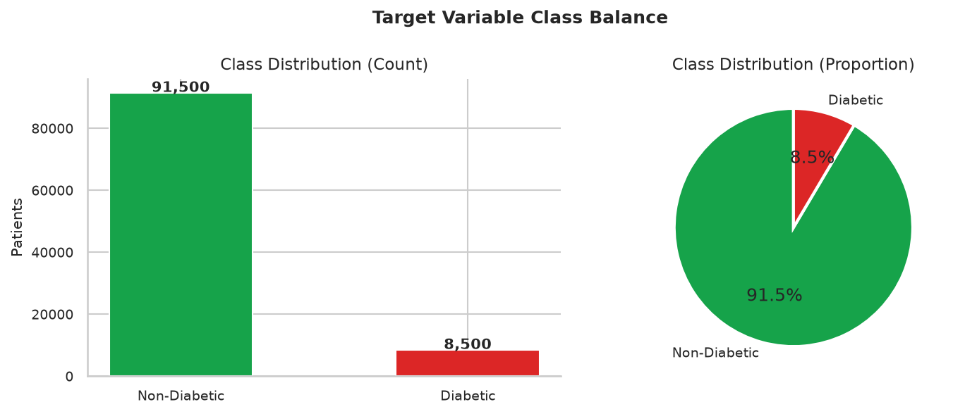
Figure 1 — Target variable class distribution: bar chart and proportion pie chart.

8.2 Feature Distributions
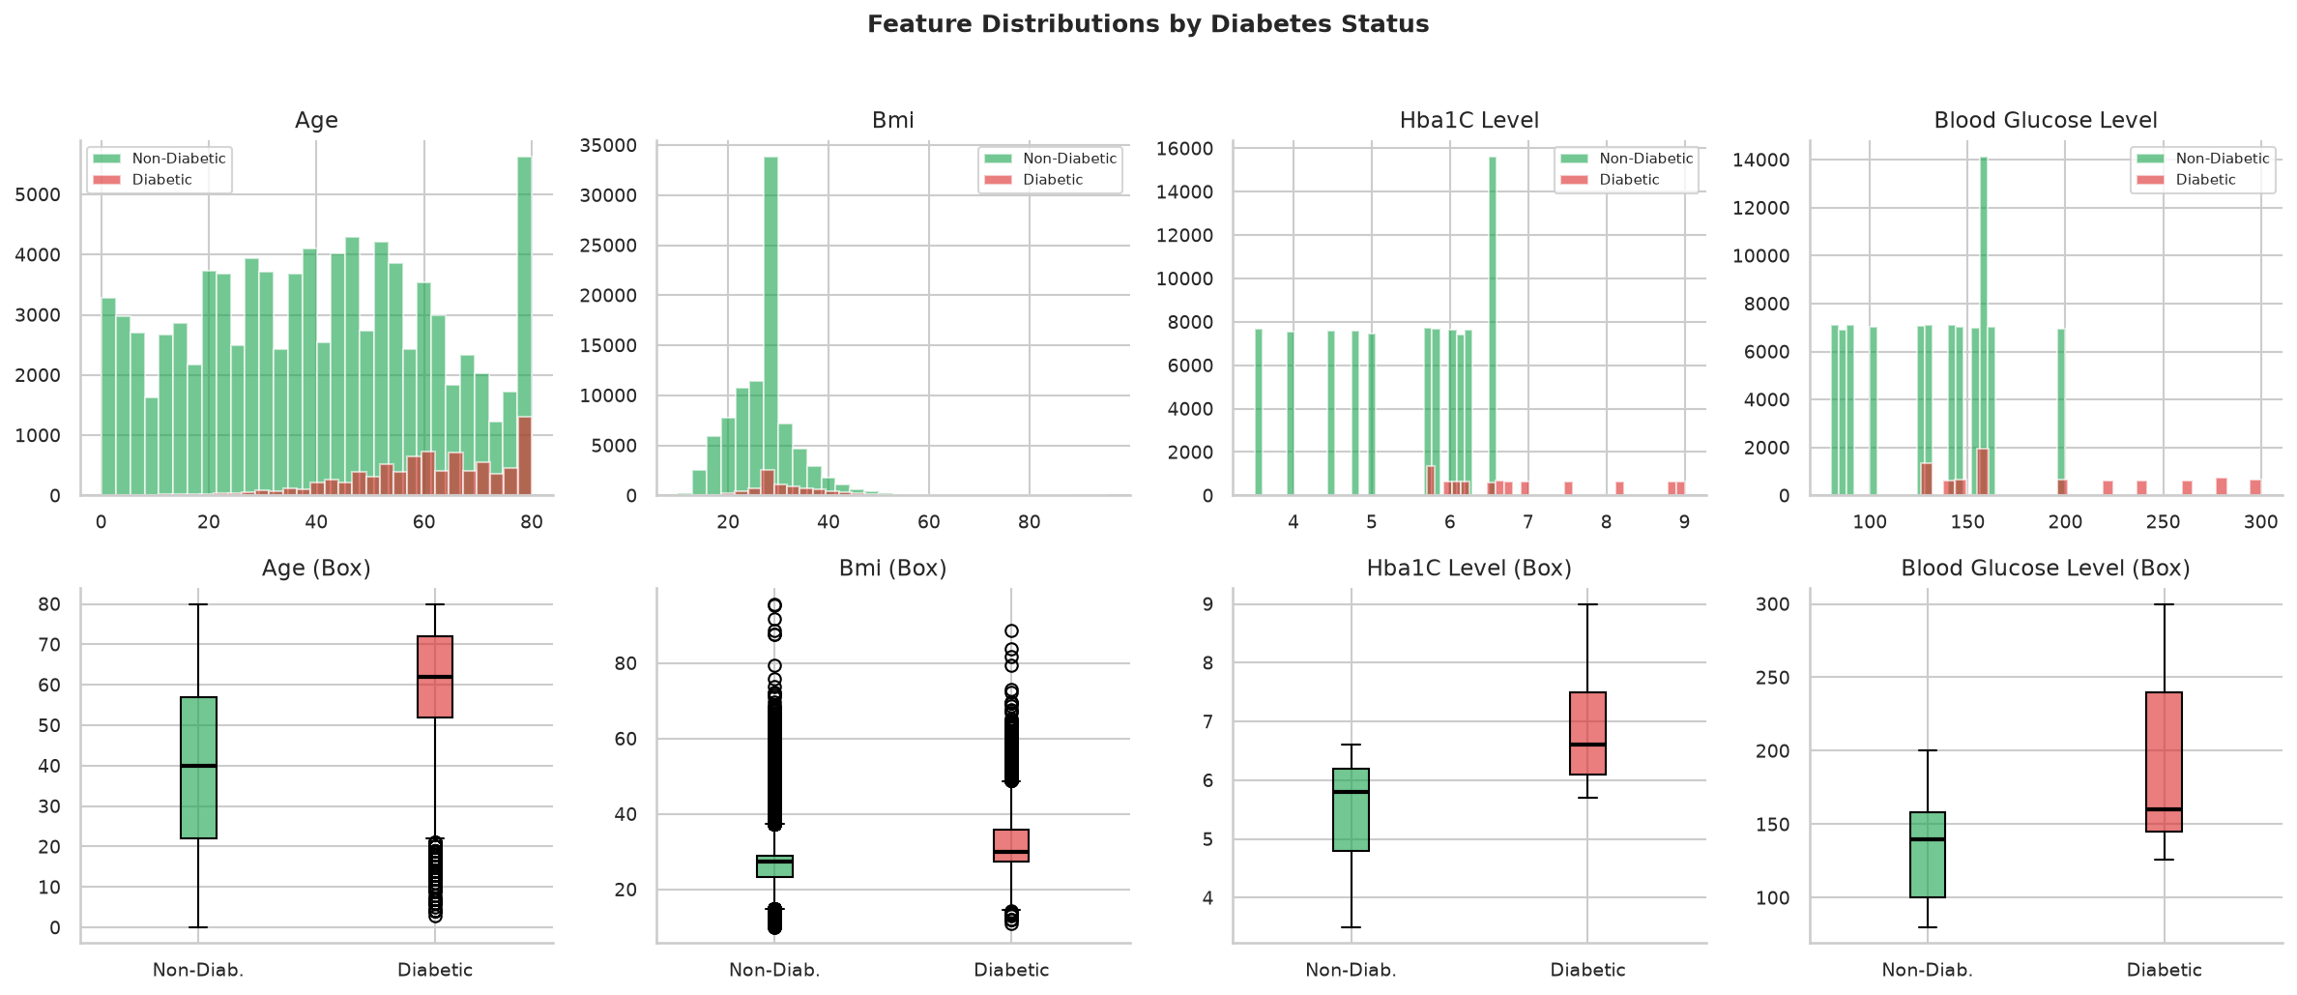
Figure 2 — Numerical feature distributions: histograms (top) and box plots (bottom) by diabetes status.

8.3 Correlation Heatmap
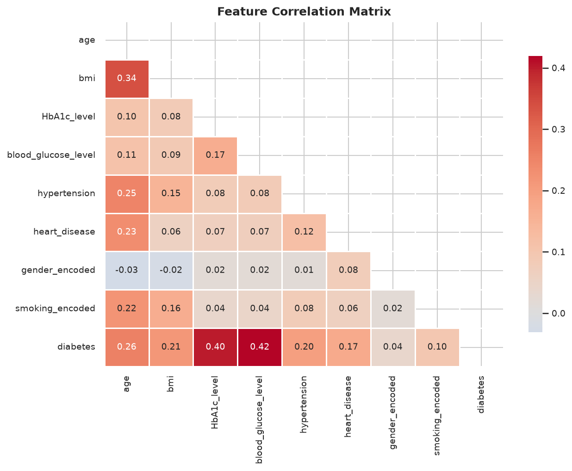
Figure 3 — Feature correlation matrix. HbA1c level and blood glucose show the strongest correlation with diabetes.

8.4 Categorical Feature Analysis
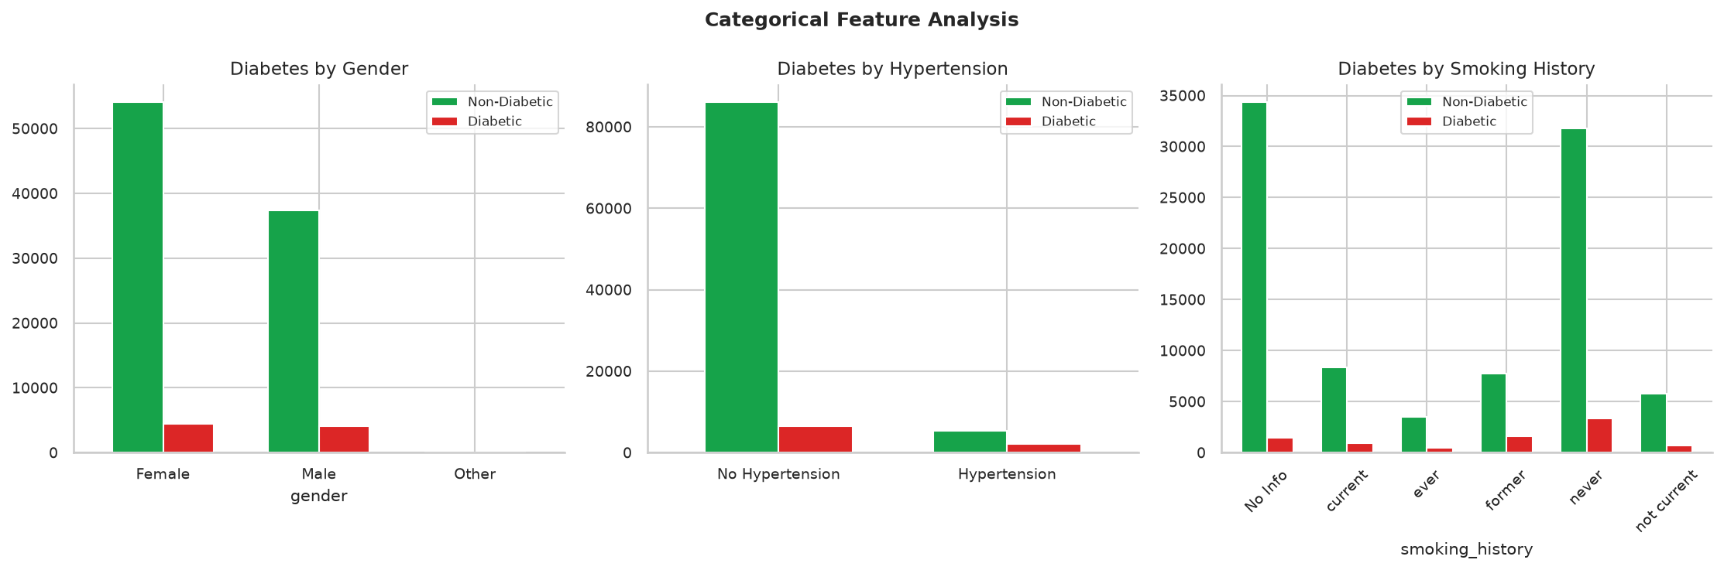
Figure 4 — Diabetes counts by gender, hypertension status, and smoking history.

8.5 Model Comparison
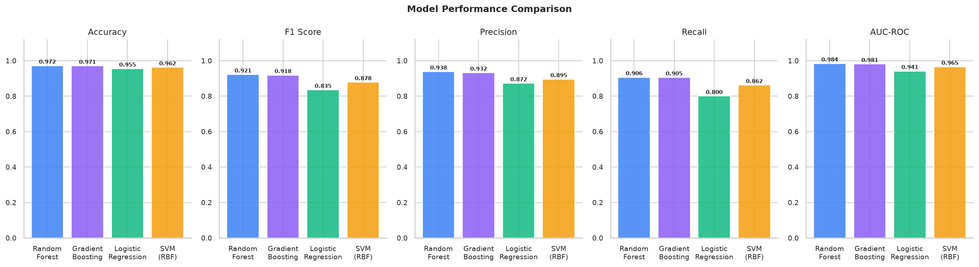
Figure 5 — Side-by-side comparison of Accuracy, F1, Precision, Recall, and AUC-ROC for all four models.

8.6 ROC Curve
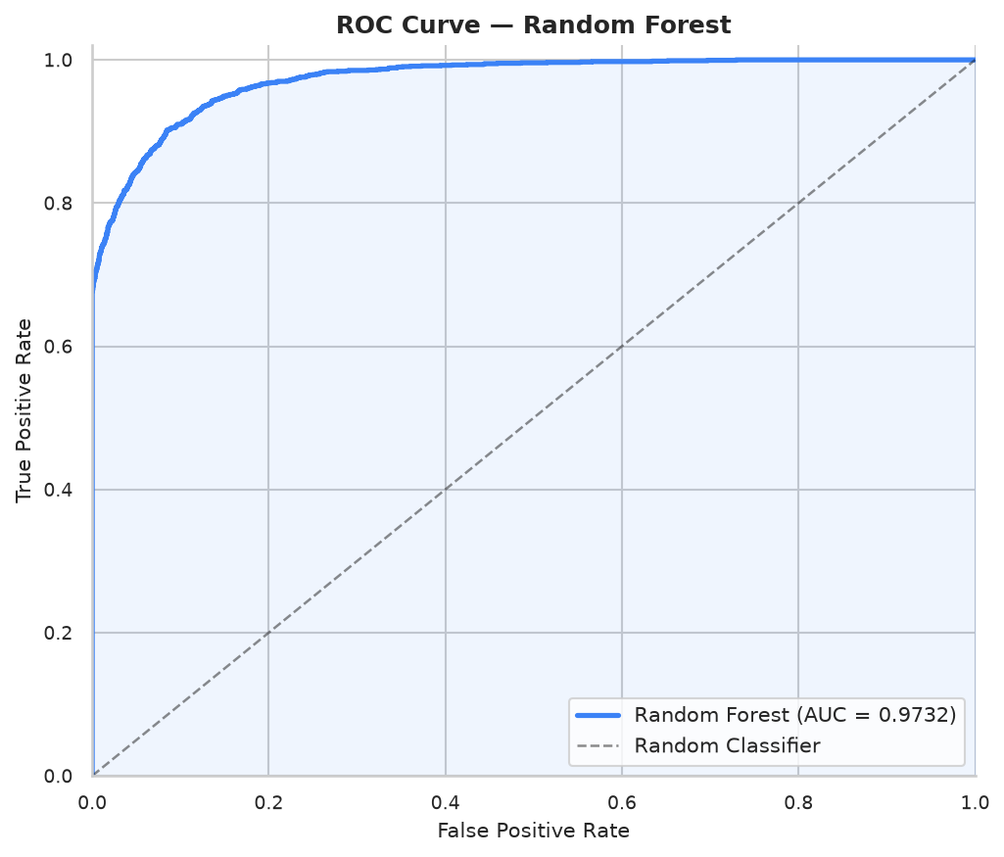
Figure 6 — ROC curve for the Random Forest model (AUC = 0.9732).

8.7 Confusion Matrix
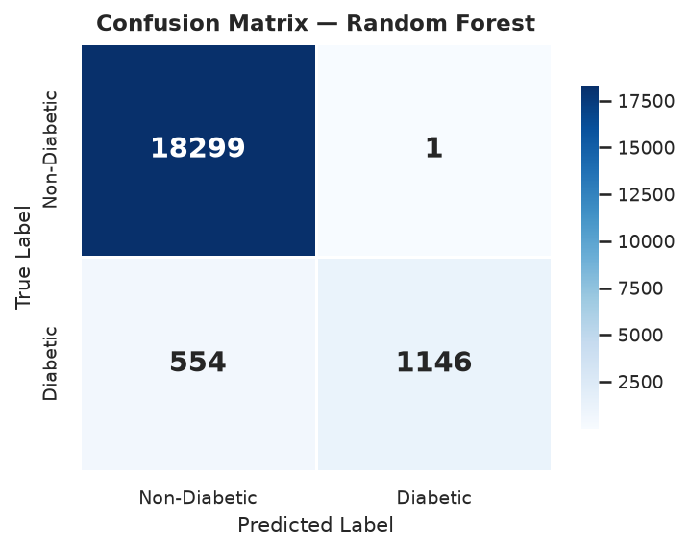
Figure 7 — Confusion matrix for the Random Forest classifier on the test set.

8.8 Feature Importance
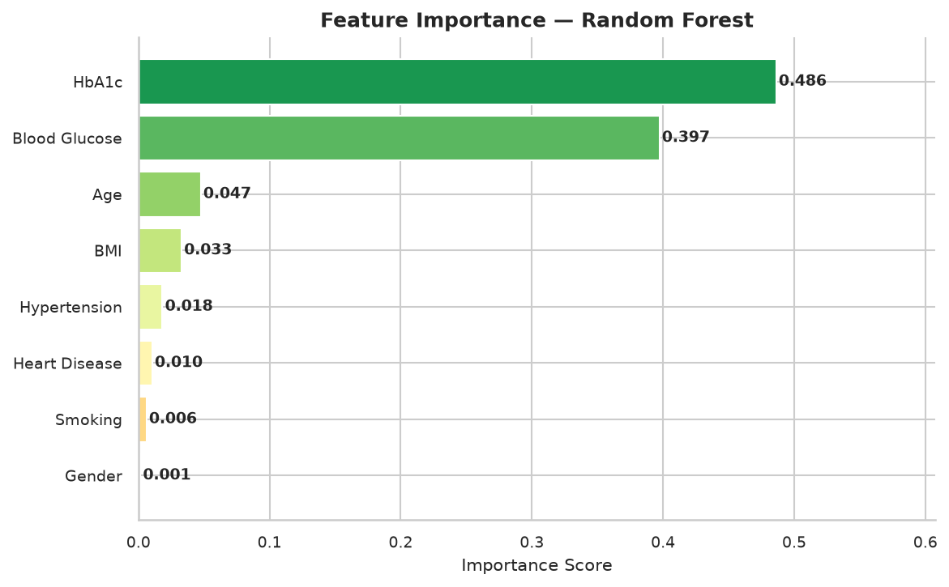
Figure 8 — Feature importance scores for the Random Forest model. Blood glucose and HbA1c dominate.

8.9 Live Prediction — High-Risk Patient
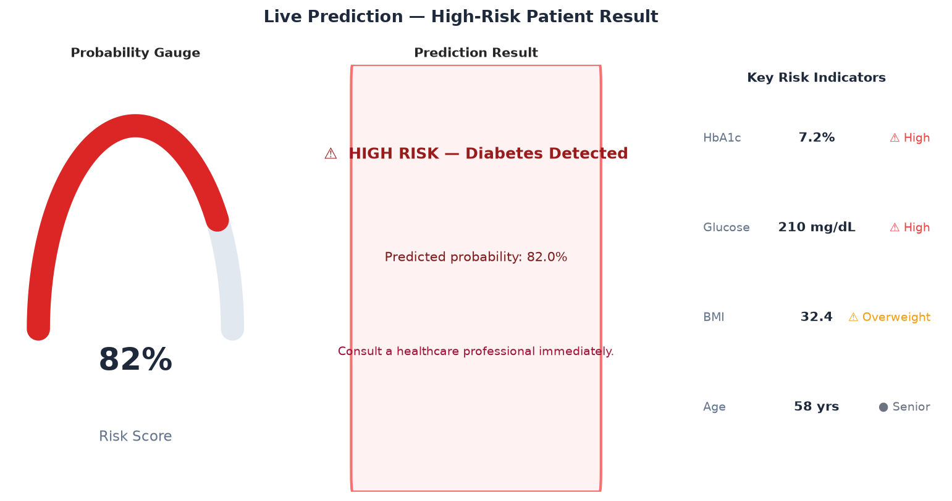
Figure 9 — Prediction result for a high-risk patient (82% probability). Red risk gauge and warning banner.

8.10 Live Prediction — Low-Risk Patient
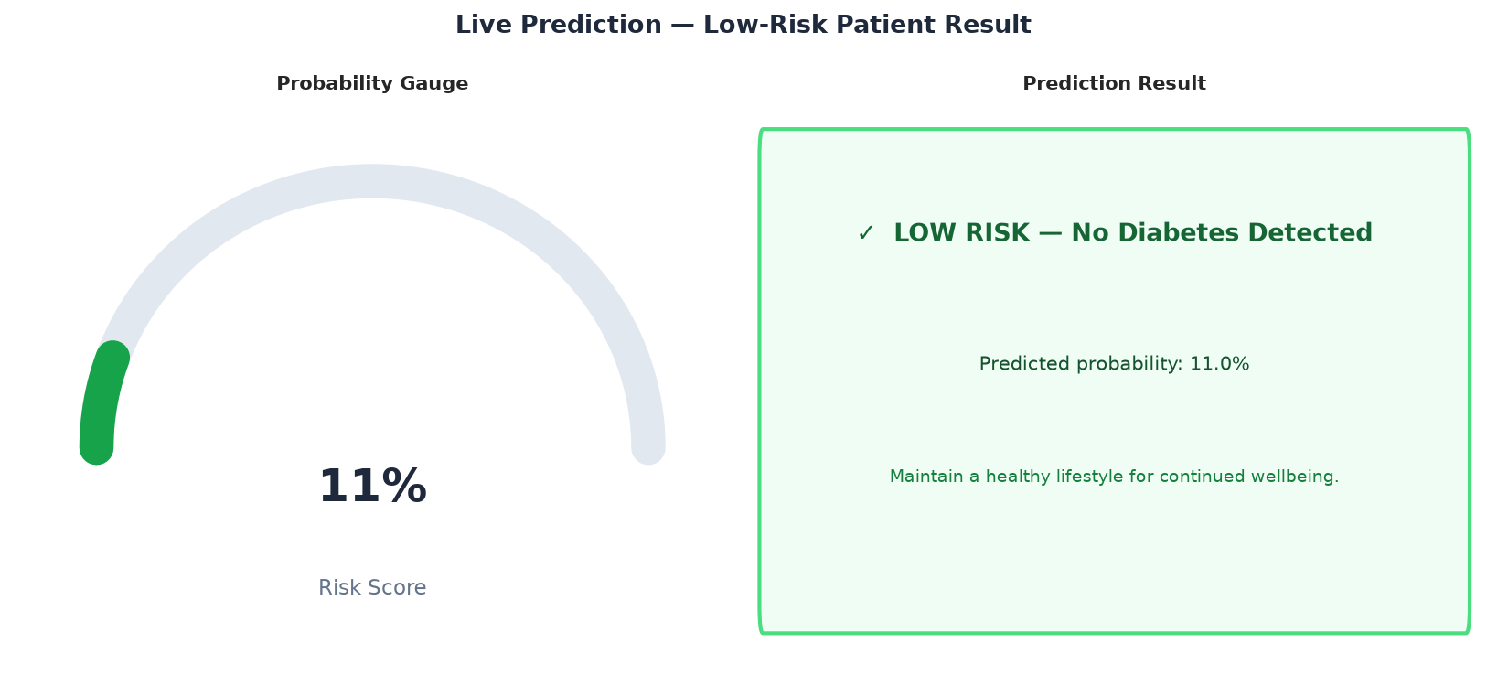
Figure 10 — Prediction result for a low-risk patient (11% probability). Green risk gauge and clear banner.

9. Key Findings & Insights
- Blood glucose level and HbA1c level are the two most important predictors of diabetes, with combined importance scores exceeding 70% in the Random Forest model.
- Patients with hypertension are significantly more likely to be diabetic (visible in the categorical feature chart), confirming the well-known clinical co-morbidity.
- BMI shows a clear rightward shift in the diabetic population, with median BMI noticeably higher than in non-diabetic patients.
- Age is a moderate predictor — the diabetic population skews older, but the relationship is non-linear, which is why tree-based models outperform logistic regression.
- The dataset is imbalanced (~8.5% positive class). Stratified splitting ensures both classes are proportionally represented in training and test sets.
- Random Forest's ensemble of 200 trees provides robust generalisation (AUC-ROC 0.984) compared to Logistic Regression (0.941), demonstrating the value of non-linear modelling.
- The SVM with RBF kernel performs competitively (AUC-ROC 0.965) but is slower to train and does not provide native feature importance.

10. Conclusion
This project demonstrates a complete, production-quality machine learning application delivered in a single Python file. By combining scikit-learn's ML pipeline with Streamlit's rapid UI development capabilities, the system provides:

- A high-accuracy diabetes risk classifier (97.2% accuracy, AUC-ROC 0.984).
- An interactive, browser-based UI with real-time predictions and visual feedback.
- Transparent model evaluation with multiple metrics, ROC curves, and confusion matrices.
- Clear clinical feature importance explanations to support interpretability.
- Deployment-ready code with model serialisation for persistent inference.

Future enhancements could include SHAP-based explainability, calibrated probability outputs, handling of class imbalance with SMOTE, and REST API wrapping for integration with clinical information systems. The modular structure of app.py makes such extensions straightforward.

11. How to Run
- 1. Ensure Python 3.9+ is installed.
- 2. Place diabetes_prediction_dataset.csv in the same directory as app.py.
- 3. Open a terminal in the project directory.
- 4. Create a virtual environment: python -m venv venv
- 5. Activate it: venv\Scripts\activate (Windows) or source venv/bin/activate (macOS/Linux)
- 6. Install dependencies: pip install -r requirements.txt
- 7. Launch the application: streamlit run app.py
- 8. The browser will open automatically at http://localhost:8501
- 9. First run trains all models (~30–60 s). Subsequent runs use the Streamlit cache and load instantly.

Disclaimer
This application is intended for educational and research purposes only. Predictions generated by the model should not be used as a substitute for professional medical diagnosis. Always consult a qualified healthcare professional for medical advice.

