**FEDERAL STATE AUTONOMOUS EDUCATIONAL INSTITUTION FOR HIGHER PROFESSIONAL EDUCATION NATIONAL RESEARCH UNIVERSITY**

**«HIGHER SCHOOL OF ECONOMICS»**

***Faculty of Computer Science***

Seliverstov Aleksei

Классификация состояний мозга с использованием жидких нейронных сетей на EEG данных

Brain State Classification Using Liquid Neural Networks on EEG Data

Qualification paper – Master of Science Dissertation

Field of study 01.04.02 «Applied Mathematics and Informatics»

Program: Data Science

Student

Seliverstov Aleksei

Supervisor

Majid Sohrabi

Lecturer, Ph.D. Student,

Department of Data Analysis and Artificial Intelligence

Junior Research Fellow,

Laboratory for Models and Methods of Computational Pragmatics

Moscow, 2025

**Table of contents**

Abstract 3

Абстракт 3

1. Introduction 5

2. Literature review 6

3. Data Description 7

4. Methodology 10

Statistical analysis 10

Training setup 10

Quality metrics 11

Models 13

5. Experimental Results 13

Baseline 13

Implemented models 14

Temporal Embeddings for Enhanced Representation 15

Convolutional Embedding 16

Summary of Final Model Performance 20

Model Interpretability with SHAP Analysis 22

6. Conclusions 25

7. Future work 25

References 27

**Brain State Classification  
Using Liquid Neural Networks on EEG Data**

## Abstract

This thesis explores the application of deep learning techniques for classifying cognitive states from EEG data, focusing on confusion detection. Electroencephalography is widely used for non-invasive monitoring of brain activity, which offers real-time insights into mental states such as attention, fatigue, and confusion. Despite its potential, analyzing EEG signals remains difficult due to noise, variability among individuals, and complex brain dynamics. Also, there are challenges with the interpretability of the analysis. Recent developments in machine learning, particularly deep learning, have made it more feasible to decode EEG signals. Traditional classifiers like Support Vector Machines and Naive Bayes have achieved good results in detecting clear mental states like drowsiness. However, recognizing more subtle states, like confusion during learning, requires models capable of capturing temporal dependencies and non-linear interactions. Recurrent Neural Networks, especially Long Short-Term Memory networks and Gated Recurrent Units, are well-suited for this task since they model EEG data as time series. Nonetheless, even the most advanced RNNs often struggle with non-stationary signals and changing contexts. Liquid Neural Networks present a promising alternative. They dynamically adapt to new patterns without retraining, thanks to evolving internal states. This makes them more suitable for real-time applications, especially on low-resource devices. In this work, I compare the performance of three neural network architectures – GRUs, LSTMs, and LNNs – for classifying confusion from EEG recordings. The data was collected from students during controlled learning sessions, using a low-cost EEG headset. The goal was to assess each model’s ability to recognize cognitive states based on temporal patterns in the recorded signals. The findings suggest that while GRUs and LSTMs perform well in capturing long-term dependencies, Liquid Neural Networks show some advantages in adaptability and efficiency, however, the current implementation is significantly slower, and GRU still outperforms it on the best iteration. The results support the potential of LNNs for real-time cognitive state monitoring, however some improvements in the implementation are required.

*Keywords:* liquid neural networks, EEG data, recurrent neural networks, cognitive state classification, confusion detection, deep learning, temporal data analysis

**Source code:** <https://github.com/As17-01/brain_signals>

## Абстракт

В этой работе исследуется применение методов глубокого обучения для классификации когнитивных состояний на основе данных ЭЭГ с акцентом на выявление состояния запутанности. Электроэнцефалография широко используется для неинвазивного мониторинга активности мозга, обеспечивая получение информации в реальном времени о таких ментальных состояниях, как внимание, усталость и замешательство. Несмотря на потенциал, анализ сигналов ЭЭГ остается сложной задачей из-за шума, межиндивидуальной изменчивости и сложной динамики мозга. Также остается интерпретабельность анализа остается сложной задачей. Недавние достижения в области машинного обучения, особенно глубокого обучения, значительно улучшили возможности декодирования сигналов ЭЭГ. Традиционные классификаторы, такие как машины опорных векторов и наивные байесовские модели, показали хорошие результаты при распознавании очевидных ментальных состояний, например, сонливости. Однако для распознавания более тонких состояний, таких как запутанность во время обучения, требуются модели, способные учитывать временные зависимости и нелинейные взаимодействия. Рекуррентные нейронные сети, особенно сети длинной цепи элементов краткосрочной памяти и управляемые рекуррентные блоки, хорошо подходят для этой задачи, поскольку они моделируют данные ЭЭГ как временные ряды. Тем не менее, даже самые продвинутые RNN часто сталкиваются с трудностями при работе с нестационарными сигналами и меняющимися контекстами. Жидкие нейронные сети представляют собой перспективную альтернативу. Они динамически адаптируются к новым паттернам без повторного обучения благодаря эволюционирующим внутренним состояниям. Это делает их особенно подходящими для приложений в реальном времени, особенно на устройствах с ограниченными ресурсами. В данной работе проводится сравнение трех архитектур нейронных сетей – GRU, LSTM и LNN – для классификации замешательства на основе ЭЭГ-записей. Данные были собраны со студентов в ходе контролируемых обучающих сессий с использованием недорогого ЭЭГ-гарнитуры. Целью было оценить способность каждой модели распознавать когнитивные состояния на основе временных паттернов в записанных сигналах. Полученные результаты показывают, что GRU и LSTM хорошо справляются с моделированием долгосрочных зависимостей, однако жидкие нейронные сети демонстрируют преимущества в адаптивности и эффективности, однако их существующая имплементация значительно медленнее, и GRU также превосходит их по качеству в лучшей итерации. Эти результаты подтверждают перспективность LNN для мониторинга когнитивных состояний в реальном времени, однако некоторые улучшения имплементации в них необходимы.

## Introduction

Understanding and recognizing human cognitive states without using invasive methods has been an important goal for neuroscience for many years. They could benefit multiple fields such as education, human-computer interaction, and psychological support and so on. Out of many technologies developed for this purpose, electroencephalography is especially notable because it is affordable, portable, and can capture brain activity in real time. EEG data, which is complex both in time and frequency aspects, has shown to be useful for detecting mental states like attention, fatigue, drowsiness, and confusion. But interpreting such data is still a technical challenge, mainly because EEG signals are susceptibility to noise, vary a lot between people, and brain dynamics are very complex.

Recently, machine learning has improved our ability to analyze EEG signals. Traditional models like Support Vector Machines and Naive Bayes have already reached high accuracy in identifying obvious mental states like drowsiness or epileptic seizures. However, more subtle cognitive states – for example, confusion during learning – are much harder to detect. For this, models must take into account time-related dependencies and nonlinear interactions inside EEG signals. Deep learning models like Long Short-Term Memory networks and Gated Recurrent Units have been promising in this task, as they can model EEG as time-series data. Because they can remember and process information across longer time periods, they are good for continuous monitoring, such as in adaptive learning systems or brain-computer interfaces.

Still, even the best recurrent models have some problems with adapting and generalizing, especially when EEG signals are non-stationary or when the context changes. Liquid Neural Networks can be a good alternative to traditional approaches. They are inspired by how biological neurons work and have internal states that evolve over time, which lets them adjust in real time to new patterns without retraining. Because they have internal memory and usually fewer parameters, they are well-suited for real-time EEG analysis on devices with limited resources or where data is not stable.

This thesis explores and compares the performance of three neural architectures – GRUs, LSTMs, and Liquid Neural Networks – for the task of classifying cognitive confusion from EEG data. The dataset comes from an experiment where students were watching educational videos marked as either confusing or not confusing. EEG signals were recorded from the frontal part of the brain using a low-cost headset, and activity across eight standard frequency bands was collected. The goal is to see how well each model can recognize the student's cognitive state only from the time-based patterns in EEG data and compare each model by performance.

By doing this, the work adds to the bigger goal of building real-time, scalable systems for brain state classification that can be used in personalized education, mental workload tracking, medical support, and future BCI applications. Special focus is on the adaptability and efficiency of Liquid Neural Networks, to see if their biologically inspired design can perform better than traditional recurrent models in dealing with the complexity and variability in EEG signals related to cognitive states.

In addition to model comparison, this work also contributes to the broader analysis of EEG data itself. By applying machine learning to raw brainwave signals, the study explores how cognitive states like confusion are reflected in temporal and spectral patterns of EEG activity. Using techniques like SHAP value analysis, I tried to identify interpretable signal features and critical time points that could be linked to moments of mental struggle or increased cognitive load. These findings may provide useful insights into how the brain processes confusing information, and they could help guide future research in neuroscience, psychology, or educational technologies that rely on EEG interpretation.

The main research question addressed in this thesis is: How effectively can Liquid Neural Networks classify cognitive states, specifically confusion, from EEG data compared to traditional recurrent models like GRUs and LSTMs? This study contributes to the field in several key ways:

* Model evaluation and comparison: The performance of GRUs, LSTMs, and LNNs is systematically compared using real EEG data collected during controlled learning sessions. Special focus is given to how well these models capture temporal patterns and handle non-stationary brain signals. The results show that while LNNs are more computationally demanding, they demonstrate strong adaptability and robustness, making them a promising option for real-time cognitive state monitoring.
* EEG-based insight and interpretability: Beyond pure classification, the work also contributes to the analysis of EEG signals by exploring interpretable patterns linked to confusion. SHAP-based analysis is used to examine the role of specific frequency bands and time segments, which could support further research in neuroscience and adaptive learning technologies.
* Practical implications and limitations: The study highlights both the advantages and current limitations of Liquid Neural Networks in this context, offering a clearer view of where these models can be improved or combined with other techniques in future applications.

The structure of this thesis is organized as follows. In Section 2, I present a comprehensive literature review that covers previous studies on EEG data classification and the use of deep learning techniques. Section 3 provides a detailed description of the data and preprocessing steps. Also, it includes statistical analysis of the dataset. Section 4 discusses the architecture and implementation of the neural networks used in this study, with a focus on GRUs, LSTMs, and Liquid Neural Networks. In Section 5, I present the experimental results, including performance evaluation and comparative analysis. Finally, Sections 6 and 7 summarize the findings, discusses the implications, and outlines possible directions for future research.

## Literature review

Electroencephalography (EEG) has already been known for a long time as non-invasive and low-cost method to observe brain activity [25]. It helps to get important information about cognitive states like fatigue, confusion, and mental workload [20]. With development of machine learning and deep learning methods, interpretation and classification of EEG signals became much better in terms of accuracy, scalability, and stability [23]. The use of neural network models like GRUs, LSTMs, and Liquid Neural Networks has created new possibilities for decoding brain signals with higher precision [4, 29].

Machine learning applied to EEG data has already given good results in detecting different mental and physical states. For example, Support Vector Machines showed excellent results for classifying driver drowsiness by using features from various EEG frequency bands, reaching accuracy up to 99.3% [26]. They also worked very well in detecting epileptic seizures in controlled conditions [27]. But for more complex cognitive states like confusion, simpler models like Gaussian Naive Bayes did not perform so well and gave only moderate accuracy [24]. These early experiments showed that better methods are needed to model time-based complexity and noise that exists in EEG signals.

Deep learning has brought strong improvements in this field. For example, Deep Belief Networks (DBN) could extract high-level features directly from raw EEG data, and gave better performance compared to older methods like PCA [31]. In predicting driver’s cognitive state, DBNs also worked better than shallow models [26]. Convolutional DBNs went even further, learning both spatial and temporal relations in EEG data, and helped to classify brain states more reliably [23]. Since EEG signals are naturally sequential, Recurrent Neural Networks – especially Long Short-Term Memory models – became a good option [29]. These models are made to handle time-series data and showed success in detecting long-term patterns, like in early diagnosis of Alzheimer’s or in real-time confusion tracking during MOOC learning [13, 28]. To make training faster and more stable, researchers started to use batch normalization in deep models. Applying it to recurrent structures like LSTMs helped to increase training speed and final results, which made these models more suitable for practical use with EEG data. This improvement is especially important in real-time systems like adaptive learning or brain-computer interfaces [23].

Lately, Liquid Neural Networks became an interesting alternative to standard RNNs and LSTMs. These models have parameters that change based on the input data, which means they can adapt to new situations without retraining [4]. This is very useful for EEG systems, where signals often change a lot because of noise, environment, or person-specific factors [18]. LNNs showed better results than fixed models, especially when the data changes suddenly. Their ability to deal with difficult, noisy signals – like those from aircraft magnetic fields – also shows that they can be helpful in filtering EEG noise, which is usually a big problem [9].

Also, the use of LNNs goes beyond just neuroscience. For example, they were used in improving urban communication systems and in aeromagnetic compensation, and they managed to keep good performance without frequent retraining [1, 16]. These skills are similar to what is needed in EEG processing, where high adaptability and reliability are necessary.

Some architectural upgrades of LNNs were made too. Neural Circuit Policies were created based on how real nervous systems work. They use sparse Liquid Time-Constant neurons and result in models that are more efficient and easier to understand [6]. Also, Continuous-Time Liquid Neural Networks made training and inference simpler by removing the need for numerical solvers, which is a big advantage for real-time applications [3]. These updates show that LNNs are becoming more relevant in EEG-related research, especially for fast adaptation and low-resource scenarios [11].

While deep learning models like LSTMs and GRUs showed good results for EEG time-series data, they still have problems with changing input or adjusting to new situations without retraining. On the other hand, LNNs offer a biologically inspired solution that naturally deals with data variability and signal noise [4]. Because they can model time more flexibly, they may work better than fixed models in real-time EEG analysis and cognitive state recognition [11].

Besides model design, another challenge in EEG is to handle confounding factors. Techniques like Select-Additive Learning and confounder-aware training were introduced to reduce impact from unrelated data, but they often need extra models or complex changes to architecture [12]. LNNs might have advantage here, since their dynamic design can remove unnecessary patterns more naturally, and the modeling process becomes simpler [4].

The integration of LSTM, GRU, and Liquid Neural Network models in EEG analysis shows the move toward more adaptive, noise-resistant, and efficient systems. Each model type has its own strong sides: LSTMs are good for long-term memory [29], GRUs give faster results with fewer parameters [29], and LNNs are great for changing and noisy environments [4]. This thesis will continue with comparison of these models for EEG-based cognitive state classification, showing their benefits and how they can improve brain-computer interface systems and learning technologies that react to user’s mental state.

## Data Description

## General description

This thesis is based on a publicly available dataset originally designed to explore cognitive responses – specifically confusion – in students viewing online educational video content. The data were collected under controlled experimental conditions, with the aim of studying how EEG signals reflect varying levels of cognitive load during learning.

The dataset includes recordings from ten college students, who viewed a set of ten distinct educational videos. These videos were selected and categorized prior to the experiment into two groups:

* Non-confusing: Topics presumed to be familiar and readily understandable to the average student, such as introductory algebra or geometry.
* Confusing: Advanced topics such as quantum mechanics or stem cell research, selected for their potential to induce confusion in students unfamiliar with the material.

All students watched the same ten videos, evenly split between the two categories. Each video was approximately two minutes long, but only the central one-minute segment was used for EEG data analysis. The beginning and end of each clip were trimmed to minimize transitional and non-content-related cognitive responses.

EEG signals were recorded using a single-channel wireless EEG headset positioned to monitor activity over the frontal lobe. The headset recorded data using one electrode on the forehead and two reference electrodes placed near the ears. The device sampled neural activity every 0.5 seconds, resulting in approximately from 120 to 144 EEG samples per video per participant.

Each EEG sample consists of power values across multiple standard brainwave frequency bands:

* Delta
* Theta
* Alpha1, Alpha2 (or lower and higher Alpha bands)
* Beta1, Beta2 (or lower and higher Beta bands)
* Gamma1, Gamma2 (or lower and higher Gamma bands)

These bands reflect different types of brain activity and are commonly used in neuroscience research. Delta (0.5–4 Hz) and Theta (4–8 Hz) are low-frequency bands typically associated with deep sleep and drowsiness, or relaxed, meditative states. The Alpha band (8–13 Hz) is often linked to calm wakefulness and mental rest. However, since different parts of the alpha range can reflect different mental processes, it is often split into Alpha1 (8–10 Hz) and Alpha2 (10–13 Hz). Alpha1 is more related to relaxation and internal focus, while Alpha2 can indicate alertness and active attention. The Beta band (13–30 Hz), which is linked to concentration, cognitive effort, and anxiety, is also divided into Beta1 (13–20 Hz) and Beta2 (20–30 Hz) to better capture subtle changes in mental workload. Finally, the Gamma band (30–100 Hz), involved in higher-level cognitive functions like perception, attention, and memory, is split into Gamma1 and Gamma2 to provide more granular features, with Gamma2 often representing more complex neural processes. This division into sub-bands allows the models to capture more specific patterns in brain activity, which can be especially important when trying to detect nuanced states like confusion.

|  |  |  |  |  |  |  |  |  |
| --- | --- | --- | --- | --- | --- | --- | --- | --- |
|  | **Delta** | **Theta** | **Alpha1** | **Alpha2** | **Beta1** | **Beta2** | **Gamma1** | **Gamma2** |
| count | 12811 | 12811 | 12811 | 12811 | 12811 | 12811 | 12811 | 12811 |
| mean | 605785 | 168053 | 41384 | 33183 | 24318 | 38144 | 29593 | 14416 |
| std | 637624 | 244135 | 72431 | 58314 | 38380 | 79066 | 79826 | 36035 |
| min | 448 | 17 | 2 | 2 | 3 | 2 | 1 | 2 |
| 25% | 98064 | 26918 | 6838 | 6852 | 6140 | 7358 | 4058 | 2168 |
| 50% | 395487 | 81331 | 17500 | 14959 | 12818 | 15810 | 9763 | 5116 |
| 75% | 916623 | 205276 | 44780 | 34550 | 27406 | 35494 | 24888 | 12670 |
| max | 3964663 | 3007802 | 1369955 | 1016913 | 1067778 | 1645369 | 1972506 | 1348117 |

**Table 1.** General data statistics

These eight EEG frequency bands were the only features used in this study. All other available information, like participant age, gender, or educational background, was excluded. Also, I did not include any specific data about the videos, such as their topic or complexity level. The goal was to train the model to recognize confusion based purely on brain signals, without any help from external factors. This makes the task more difficult, but it is essential because the main focus of the research is on understanding how confusion is reflected in EEG activity.

Excluding personal and video-specific information also allows the results to be more general. The brain should work in a similar way across different people when they experience confusion, so the model should be able to detect this state from EEG data regardless of who the person is. By focusing only on the signals, I test whether confusion can be identified based on universal patterns in brain activity, which makes the findings more interpretable and easier to apply to other datasets or future studies.

The primary label used in this thesis is the predefined confusion label, assigned based on the categorization of each video as either “confusing” or “non-confusing.” This classification was made independently of the participants' self-assessments and remains consistent across all viewers. The use of this label enables an investigation into whether confusion can be predicted from EEG features alone. In the dataset there was also a participant’s self-defined label of confusion whether or not the person felt confused. The reason I did not use that as a target is because the subject might be reluctant to say that a video was confusing or misidentify the confusion with other mental states. The individual familiarity with a complex topic should be offset by the number of participants so that it should not significantly affect the results.

The dataset comprises over 12,000 EEG samples, corresponding to 100 individual recording sessions (10 participants × 10 videos). These data were used to develop and evaluate predictive models aimed at distinguishing between confusing and non-confusing learning experiences based solely on patterns in brainwave activity. Each sample includes:

* A timestamp (0.5-second intervals)
* Eight EEG frequency band values (delta through gamma2)
* The predefined confusion label (binary)

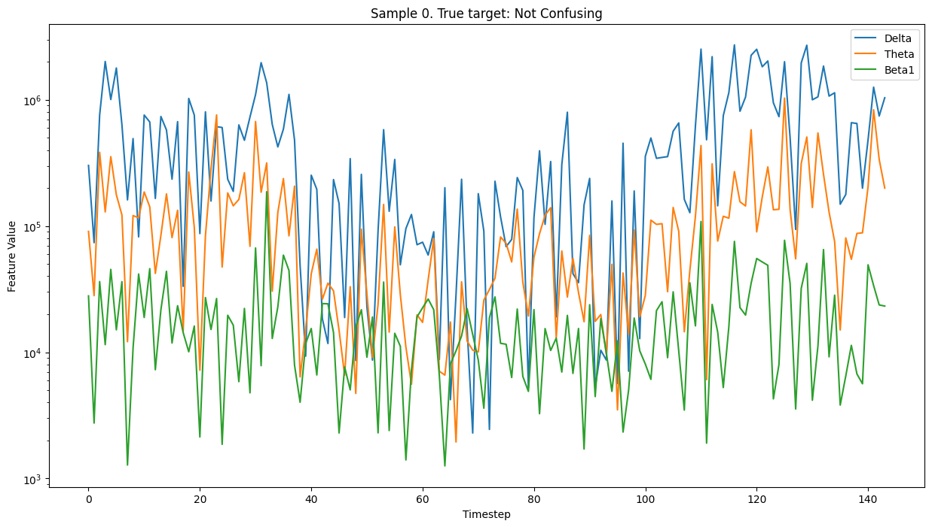

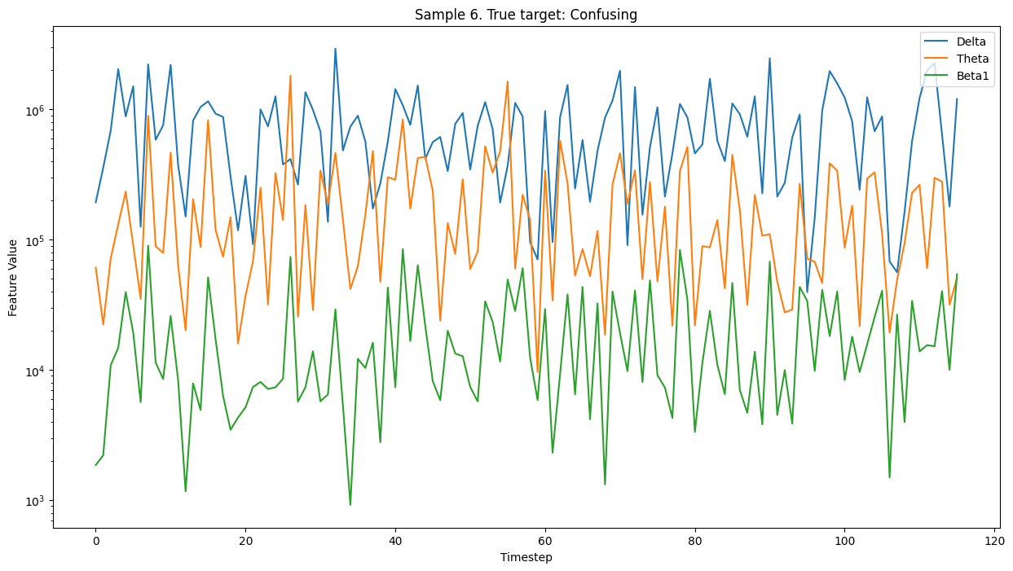

**Figure 1.** Signal value dynamics of two samples for Delta, Theta and Beta1 signal bands

### Statistical analysis

Understanding the statistical properties of EEG signals is an important step before applying machine learning models. Since EEG data is inherently noisy, varies across individuals, it is necessary to explore the basic distribution of the signals to identify potential patterns. By comparing the signal distributions between different classes – confusing and non-confusing video segments – we can gain insight into whether certain frequency bands are more informative about cognitive states like confusion. This also helps to understand if the labels are reflected in the data in a consistent way and whether some EEG features may be more relevant for classification.

To investigate this, I analyzed the distributions of each EEG frequency band separately for both confusion labels (Figure 2). The results show that while most signal types had overlapping distributions, there were significant differences in Beta2, Gamma1, and Gamma2 bands. These findings are meaningful when interpreted through the known roles of these bands. Beta2 (20–30 Hz) is linked to mental workload, cognitive effort, and sometimes stress, all of which are expected to increase during confusing moments. Gamma1 and Gamma2 (30+ Hz), which reflect high-level cognitive processes such as attention, perception, and memory integration, also showed strong shifts in distribution between the two classes. This might suggest that when a subject is confused, the brain engages more in active information processing on average. However, when considered individually for each person, this conclusion becomes less obvious. On the (Figure 3) the similar distribution is plotted only for Subject 1 of the trials. It highlights the noisy nature of the dataset, when individual characteristics influence the signals much more, than general patterns. Overall, it creates additional challenges to extrapolation and decision making based purely on signal values, and it contributes to the necessity of advanced algorithms.

To further demonstrate why this dataset is difficult to solve using simple analytical methods, I performed a basic OLS regression. The results are presented in (Table 2) and (Figure 4). Before fitting the model, the data was normalized and aggregated using basic statistical features such as minimum, maximum, and average values for each signal type. I also tested including standard deviation, but it had little effect on the outcome. None of the resulting coefficients were statistically significant, which suggests that the static values of the EEG signals alone are not enough to determine whether a person is confused. Instead, it seems that the relationship between different signals and how they change over time plays a much more important role. This result supports the idea that more advanced, dynamic models are needed to effectively capture the patterns in EEG data.

## Methodology

### Training setup

The models in this study were trained using only EEG-derived features – specifically, the power values across eight standard frequency bands: delta, theta, alpha1, alpha2, beta1, beta2, gamma1, and gamma2. No participant demographic data or video metadata were included. This design choice allowed for an isolated exploration of how neural signals alone relate to cognitive confusion. If they were included, it would be easier to achieve much higher accuracy, however, it is not as valuable because it would limit the possibilities of extrapolation of the conclusions on other EEG data.

Each EEG time series corresponds to a one-minute segment, sampled at 0.5-second intervals, resulting in from 120 up to 144-time steps per recording. To ensure consistency across samples, each sequence was padded to a fixed length of 144-time steps, using zero-padding at the end of each signal. This allowed all models to accept uniform input dimensions while preserving the temporal structure of the original signals.

The dataset was split into training and testing subsets using a 70–30 ratio. For the final model evaluation, the split was performed by user, i.e. 7 users were used to train a model, the rest 3 were used for validation. I made this decision to exclude the possibility of data leaks, when the model might learn specific patterns of confusion for one person, but it would be unable to extrapolate the patterns on another. However, after the switch to the user split, the validation metrics were not significantly affected. Additionally, to ensure robust and reliable evaluation, multiple distinct and fixed data splits were created. All models were trained and evaluated on the same series of partitions, ensuring comparability across experiments while mitigating the effect of variance due to random sampling. Each model was trained for the same number of epochs, standardizing training duration across all experiments. All experiments were run on the same machine. However, one epoch for LNNs took approximately 5 times as long as it took for the other models. For LSTM and GRU the duration of each epoch was very similar. Also, for the best models overall I doubled the number of training epochs to observe their metric dynamics further.

In some experiments, a lagged embedding of the EEG signal was applied to enrich the input with temporal dependencies beyond the original sampling rate. This involved concatenating delayed versions of the input signal to provide the models with access to past temporal context within a given time window.

### Quality metrics

Model performance was assessed using a combination of three evaluation metrics. All of them a very popular and widely used for binary classification:

* Accuracy: This metric shows how many samples the model classified correctly out of all predictions. It gives a basic idea of how well the model performs overall. However, it can be misleading if the classes are imbalanced, because the model might predict the majority class more often and still get high accuracy. Also, the result depends a lot on the decision threshold. Still, accuracy is useful for giving a general sense of model quality.

TP = True Positives

TN = True Negatives

FP = False Positives

FN = False Negatives

* AUC (Area Under the Receiver Operating Characteristic Curve): Evaluates the trade-off between true positive rate and false positive rate across different classification thresholds. A higher AUC indicates better model discrimination between the classes.

For example, the ROC curve in the figure shows the trade-off between the true positive rate (TPR) and false positive rate (FPR) at various classification thresholds. The blue line represents the model’s performance, while the red dashed line indicates a random classifier. The AUC, which is the area beneath the blue line, quantifies how well the model separates the classes. The closer the curve follows the top-left border, the better the model is at correctly classifying positive and negative instances.

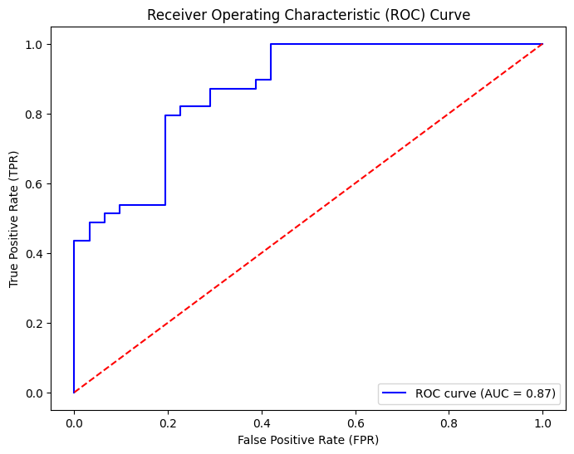

**Figure 5.** ROC Curve visualization on a sample

* Entropy: Used as a measure of prediction uncertainty. Lower entropy indicates higher confidence in the model’s prediction. For binary classification, entropy of a prediction with probability is calculated as:

where is the Shannon entropy. A lower entropy value means the model is more confident in its decision, while higher entropy suggests the model is unsure. One advantage of entropy is that it works independently of any threshold and gives additional insight into how confident the model is, even if the prediction is correct. However, a disadvantage is that entropy doesn't tell whether the prediction was actually right or wrong – it only reflects confidence. Still, it is useful for identifying uncertainty.

For the primary metric of this research, I chose the **entropy** because of the limited number of testing samples. Accuracy has a much larger variance, which makes the metric quite noisy to analyze. However, I still reported it for all experiments to be more consistent with other papers, which use this dataset. AUC also would be a great metric for the result comparison, however for the similar reason, the metric is measured very granularly, which makes it hard to track quality improvements.

Neural networks trained on small datasets are often highly sensitive to initial conditions such as random weight initialization and data splits. This sensitivity can lead to large variations in model performance across different training runs. Additionally, when the number of test samples is limited, individual outlier predictions can disproportionately influence evaluation metrics, making the results less reliable. To address these issues, I used multiple fixed data splits and averaged the evaluation metrics across them. Each model was trained multiple times – for each of the splits on the respective training set – and evaluated on the respective validation. (Table 3) illustrates how the splits were organized. There were 5 splits in total. This approach helps to reduce variance and provide a more robust estimate of each model’s true performance. It ensures that the reported results are less dependent on a specific train-test configuration or random seed.

|  |  |  |  |  |  |  |  |  |  |  |  |  |  |  |
| --- | --- | --- | --- | --- | --- | --- | --- | --- | --- | --- | --- | --- | --- | --- |
| User ID | | | | | | | | | |  |  |  |  |  |
| 0 | 1 | 2 | 3 | 4 | 5 | 6 | 7 | 8 | 9 |  |  | - train | | |
| 0 | 1 | 2 | 3 | 4 | 5 | 6 | 7 | 8 | 9 |  |  | - validation | | |
| 0 | 1 | 2 | 3 | 4 | 5 | 6 | 7 | 8 | 9 |  |  |  |  |  |

**Table 3.** Train – validation strategy.

### Models

The predictive models employed in this work consisted of three major types of neural network architectures, each with multiple internal variations:

* GRU-based networks: These models leveraged Gated Recurrent Units, which are well-suited for capturing temporal dependencies in sequential data while maintaining a relatively compact architecture. Several variations were tested with different numbers of layers and hidden dimensions.
* LSTM-based networks: Networks built with Long Short-Term Memory units were also explored due to their effectiveness in retaining long-range dependencies and mitigating vanishing gradient issues. As with the GRU models, multiple architectures were tested.
* Liquid State Neural Networks (LNNs): Inspired by biologically plausible models, these networks incorporate liquid time-constant dynamics, allowing them to adapt their memory and response patterns over time. LNNs were included to investigate whether models with non-static internal dynamics could outperform more traditional RNN variants on EEG time series data.

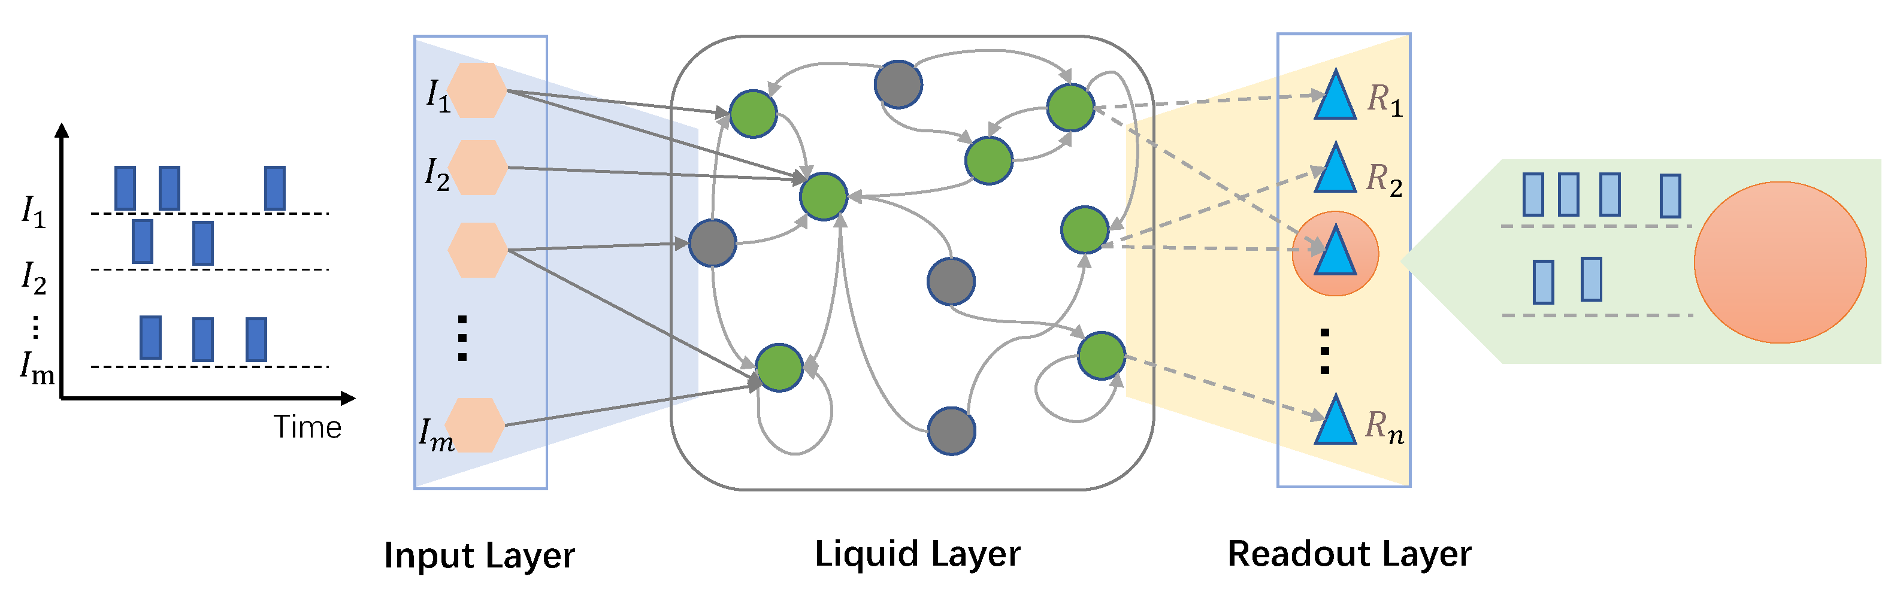

**Figure 6.** LNNs architecture. Source: <https://www.mdpi.com/2076-3417/12/20/10484>

I will not dive deep into the full details of how Liquid Neural Networks work, but I will give a quick overview – more comprehensive explanation can be found in [4]. The structure of the LNN model used in this work is shown in (Figure 6). In the liquid layer, unlike in traditional neural networks, neurons are not static. Their internal states evolve over time according to a system of differential equations, which makes them sensitive to both current input and past history. These neurons are recurrently connected with a sparse and structured topology, so the output of one neuron can influence a limited set of others within the same layer. This recurrent structure forms an internal feedback loop, which enables the network to store temporal information and model complex signal dynamics. Instead of updating the state at fixed time steps like in GRUs or LSTMs, the state in LNNs evolves continuously and is numerically integrated during training. The final output is generated by a relatively simple readout layer. This design allows the network to better handle non-stationary and time-dependent signals, such as EEG data, while being more robust to overfitting and noise.

In each category, a range of architectures was evaluated to explore the design space and identify the most effective configurations for confusion detection. All hyperparameters – including learning rate, batch size, number of layers, and hidden unit size – were manually tuned based on preliminary testing and domain knowledge. These settings were held constant across similar models within each experimental group to ensure fair comparisons.

## Experimental Results

### Baseline

As a baseline, a fully connected (FC) network architecture was implemented based on a previous study [8]. This model flattened the EEG signal across time and frequency dimensions before feeding it into a deep multilayer perceptron. The architecture consisted of five sequential dense layers with decreasing units (200 → 100 → 50 → 16 → 1), each followed by a ReLU activation function except for the output layer, which used a sigmoid activation for binary classification. This FC model achieved an average validation accuracy of 63%. This model contained too many parameters and it quickly overfitted on the train dataset.

I slightly modified the model and decreased the number of units to (48 → 32 → 16 → 8 → 1), included batch normalization and heavy dropouts before FC layers (0.75 → 0.5 → 0.25 → 0.25), which allowed to achieve the validation accuracy of 66.7%. Taking into account that I used a different validation strategy, and that Attention, Meditation and some user-specific features were excluded from my dataset, the accuracy is likely to be consistent with the one they received in the paper (74%). Still, the model performs poorly in comparison to the to time-series-oriented approaches **even considering their best accuracy of 74%**. These FC models contained too many parameters, required huge dropouts, and their inability to account for temporal dynamics limited their effectiveness. Also, the model performances are very dependent on the initial condition. In some variations the validation metrics did not improve at all during training runs.

### Implemented models

To better capture the temporal structure of the EEG signals, three categories of neural network models were evaluated: Gated Recurrent Units (GRU), Long Short-Term Memory networks (LSTM), and Liquid State Neural Networks (LNN). All models were trained exclusively on the raw EEG frequency band features (delta, theta, alpha1, alpha2, beta1, beta2, gamma1, gamma2) and used the same training conditions:

* Adam optimizer with binary crossentropy loss
* Learning rate: 0.002
* Weight decay: 1e-7
* EMA (Exponential Moving Average): enabled
* Same number of training epochs and fixed data splits across models

Each model processed input sequences of 144-time steps per experiment, padded to a uniform length. Batch normalization did not affect the model’s performance, so it was removed for simplicity. Their architectures are described schematically below:

|  |  |  |  |
| --- | --- | --- | --- |
| **Name** | **GRU** | **LSTM** | **LNN** |
| **Architecture** | Input: (144 time steps, 8 EEG features)  GRU(20 units, return sequences)  GRU(20 units, return sequences)  GRU(10 units, return sequences)  GRU(10 units, return final)  Dense(1 unit, sigmoid activation) | Input: (144 time steps, 8 EEG features)  LSTM(20 units, return sequences)  LSTM(20 units, return sequences)  LSTM(10 units, return sequences)  LSTM(10 units, return final)  Dense(1 unit, sigmoid activation) | Input: (144 time steps, 8 EEG features)  LTC layer configured with an AutoNCP topology of 64 neurons and 32 interconnections (return sequences)  LTC layer configured with AutoNCP topology of 32 neurons and 16 interconnections (return final)  Dense(1 unit, sigmoid activation) |
| **Dropout** | 0.2 | 0.2 | No |
| **Best epoch\*** | 185 | 96 | 332 |
| **Num params** | 5951 | 7691 | 27105 |

**Table 4.** Model architectures.

* - This is the best performing epoch for each of the models on non-embedded validation data averaged by folds. Binary cross-entropy was used for selection

|  |  |  |  |
| --- | --- | --- | --- |
|  | **Accuracy** | **Entropy** | **AUC** |
| **GRU** | **89.3 %** | **0.237** | **0.971** |
| **LSTM** | 84.0 % | 0.303 | 0.946 |
| **LNN** | 82.0 % | 0.239 | 0.949 |
| **FC** | 66.7% | 0.599 | 0.755 |

**Table 5.** Metrics comparison

The LNN architecture in this study used the Neural Circuit Policy (NCP) structure to enhance both training efficiency and performance. Despite having a relatively high number of parameters, the model delivered competitive results, showing that NCP-based LNNs are capable of effectively modeling cognitive states from EEG data. However, the **GRU model still reached better performance metrics in a shorter time**. One clear advantage of LNNs is the stability of their training dynamics – compared to GRU and LSTM, they are noticeably less prone to overfitting and their validation metrics fluctuate less during training. That said, occasional spikes in the loss curve were observed, which could suggest sensitivity to certain data segments. Another limitation is the training speed: each epoch took about five times longer than for the other models. Considering that the best results for LNNs were achieved only after 332 epochs, the overall training process becomes significantly more time-consuming. The reason why LNNs are outclassed on this dataset might be the limited number of features, therefore the adaptability of the networks might not fully benefit them here. The small number of signal bands makes a more compact model like GRU a better choice.

Overall, all three temporal models clearly outperformed the fully connected baseline across all evaluation metrics. Among them, the GRU-based model achieved the best performance while maintaining a relatively low number of parameters, making it an optimal choice in terms of both efficiency and accuracy. The LNN, while having the highest parameter count, still demonstrated strong performance, indicating its potential for modeling complex temporal dynamics in EEG data.

### Temporal Embeddings for Enhanced Representation

In addition to evaluating the models on raw EEG frequency-band signals, further experiments explored the integration of temporal embeddings to enrich the input representations. These embeddings were designed to expose temporal dynamics more explicitly by incorporating historical context into each time step.

The following types of lag-based embeddings were considered:

* Lag-1 embedding: Each timestamp was augmented with the feature values from the immediately preceding time step.
* Lag-2 embedding: The EEG signal at each timestamp was additionally augmented with the values from two steps before.
* Lag-1 + Lag-2 embedding: Both first and second-order lagged values were concatenated to each current timestamp, resulting in a broader temporal window for each input vector.
* First-order difference (Δlag-1): Rather than using raw lagged values, this embedding encoded the difference between the current timestamp and the one immediately before it, highlighting the change in brain activity over time rather than the absolute value.

These augmentations provided the models with richer temporal features, potentially aiding in the identification of subtle signal shifts indicative of cognitive states such as confusion.

### Convolutional Embedding

In a parallel approach, temporal feature engineering was explored via causal convolution. A 1D convolutional layer with 50 filters, a kernel size of 3, ReLU activation, and causal padding was applied to the raw EEG signals. This method created new time-dependent embeddings that preserved the sequence’s chronological order while capturing short-term local patterns. The convolutional layer effectively summarized nearby temporal trends within the signal and passed the enriched representation to subsequent model layers. Other hyperparameters of the layer were also tried, but they provided either worse or similar performance benefits.

To assess the impact of different temporal embeddings, performance metrics – accuracy, loss, and AUC – were monitored across training epochs for each embedding type and model architecture. These evaluations were conducted across GRU, LSTM, and LNN-based models, allowing for a comprehensive comparison of embedding effectiveness. In the case of the best-performing LNN architecture, not all embeddings were included in the final evaluation phase. This decision was based on earlier results, where certain embeddings consistently underperformed relative to others, and were therefore omitted to streamline experimentations. Also, the best experiments were extended to 400 epochs to observe the metrics dynamics further.

Among all embedding strategies, the lag-1 embedding and the convolutional embedding consistently led to the most significant improvements across models. These two approaches not only increased predictive accuracy but also tended to stabilize the training process, reducing variance and preventing overfitting in several configurations.

The lag-1 embedding provided a minimal but meaningful temporal context, enriching the model’s ability to recognize transitions in brain signal patterns associated with cognitive states. Similarly, the convolutional embedding, by leveraging local temporal filters, effectively captured short-range dependencies that were often missed by raw features alone.

Overall, both of these embedding methods generally enhanced model performance, suggesting that even lightweight temporal transformations of EEG data can provide substantial benefits when predicting cognitive states like confusion. Also, it highlights that interactions between different signal bands are important for confusion detection.

### Summary of Final Model Performance

To provide a comprehensive comparison, a summary graph (Figure 10) is included that illustrates the final validation – for the best-performing configuration of each model type: GRU, LSTM, and LNN. These models were selected based on their performance across all previous experiments, including variations with and without temporal embeddings.

The plotted results clearly show that GRU-based models outperform the others across all metrics. Notably, the GRU model enhanced with lag-1 embedding achieved the best overall results, with accuracy exceeding 0.90 and AUC surpassing 0.95. This performance reflects a substantial improvement over the baseline fully connected model from the referenced paper, which reported an average validation accuracy of only 66.7%. It is worth mentioning, however, that the model quickly became overfitted, and other networks gradually became better. Towards the end of the training LNN with lag-1 embedding even became the best model by performance.

These findings emphasize the importance of sequence-aware architectures and temporal embeddings when working with EEG signals. The GRU’s ability to model temporal dependencies effectively, especially when coupled with lightweight lagged context, appears to be particularly well-suited for confusion detection tasks using frontal EEG data. Liquid neural networks, on the other hand, require some optimizations to train with a comparable speed to its counterparts. However, in the long run they show some potential when we deal with the dataset.

### Model Interpretability with SHAP Analysis

To explore the interpretability of the trained models, I employed SHAP (SHapley Additive exPlanations) values, a widely adopted method for explaining predictions made by machine learning models. SHAP assigns an importance value to each feature for individual predictions, enabling insight into how specific EEG signals contribute to the final output.

In the SHAP summary plots (Figure 11, 12), each point represents a feature contribution for a single sample. The size of the point corresponds to the absolute magnitude of the SHAP value, indicating the strength of that feature's influence. Red-colored points indicate positive SHAP values, meaning that the feature increased the model’s predicted probability of confusion, while blue-colored points reflect negative contributions, lowering the predicted probability.

To maintain clarity across signal types, the same EEG channel was consistently represented with the same shade of red or blue, allowing visual tracking of individual signal behavior across samples. This consistent color-coding helped highlight the relative importance of each frequency band (e.g., delta, theta, alpha1, etc.) throughout the dataset.

In experiments involving temporal embeddings, such as lagged values, I aggregated the SHAP values of the lagged features with their corresponding original features. This allowed for a more interpretable comparison across models and provided a clearer understanding of the role each signal type played in both its original and embedded forms.

A particularly striking observation from the SHAP summary plots is the presence of specific timestamps where all EEG signal features exhibit notably high importance. At these moments, the absolute SHAP values across all frequency bands increase sharply, suggesting that the model places disproportionate weight on certain temporal segments within the one-minute recording. This implies that cognitive confusion may manifest more strongly at specific points in the video, potentially aligning with moments of conceptual difficulty or topic transitions. While this observation is consistent across multiple samples and models, it warrants further investigation to verify whether these signal spikes consistently correspond to semantically confusing segments in the educational content itself.

While the GRU and LSTM models yielded interpretable patterns through SHAP analysis, LNN models unfortunately did not provide useful insights into signal importance. The SHAP value distributions for LNNs were generally less consistent and failed to highlight meaningful temporal patterns. This may be attributed to the architectural sparsity and internal dynamics of neural circuit policies, which can lose direct attribution of output predictions to input features. As a result, while LNNs demonstrated reasonable predictive performance, their interpretability using SHAP remains limited, reducing their utility for detailed analysis in this context.

## Conclusions

This thesis has studied how well three deep learning models – Gated Recurrent Units, Long Short-Term Memory networks, and Liquid Neural Networks – can classify confusion states from EEG data. By conducting detailed experiments on EEG recordings collected during controlled learning tasks, I analyzed how each model deals with temporal, noisy, and non-stationary aspects of brain signals.

The results show that all three models – GRU, LSTM, and LNN – are capable of learning meaningful patterns from EEG time series and distinguishing between cognitive states with reasonable accuracy. GRUs and LSTMs performed well in capturing long-term dependencies, with GRUs slightly outperforming LSTMs due to their simpler structure, lower computational cost, and fewer parameters. GRUs also converged faster, making them more practical for this specific task. Liquid Neural Networks, implemented using the Neural Circuit Policy architecture, demonstrated competitive performance and were especially strong in terms of training stability and resistance to overfitting. Their validation metrics fluctuated less compared to GRU and LSTM models, which suggests they are more robust to noise and individual variation. In this particular setup, where the input space is limited to just eight EEG frequency bands, the full adaptability of LNNs may not have been fully utilized. This makes more compact models like GRU more efficient and effective under such constraints, even though LNNs remain promising for more complex, high-dimensional, or highly dynamic data.

However, the study also revealed some important limitations of the proposed approach. One major drawback of using Liquid Neural Networks is the increased computational time during training compared to GRU and LSTM models. Each epoch took approximately five times longer, making the training process significantly more resource-intensive. Moreover, while LNNs demonstrated stable performance during longer training sessions, they were prone to occasional spikes in the loss metric, which might indicate sensitivity to specific segments of the data. Additionally, the model interpretability of LNNs using SHAP was somewhat limited. Unlike GRUs and LSTMs, which allowed for relatively clear SHAP value analysis, LNNs produced less consistent feature importance patterns because of the recurrent and input dependent nature of their liquid layers. This limits their utility in applications where understanding the decision-making process is crucial.

Another limitation is related to the dataset itself. The data was collected from a relatively small number of participants (ten students) and consisted of recordings taken only during educational video sessions. While this controlled environment allowed for systematic analysis, it may not fully represent more diverse real-world scenarios, where cognitive confusion might arise from a broader range of tasks and environments. Consequently, the model's generalizability to other contexts remains uncertain.

## Future work

Future work could address these limitations by exploring several promising directions. First, improving the training efficiency of LNNs would make them more practical for real-world applications. Optimizing their architecture, possibly by reducing the number of neurons or implementing more efficient training techniques, could help reduce training time. Additionally, exploring hybrid architectures that combine the temporal modeling capabilities of GRUs and LSTMs with the adaptive features of LNNs might result in models that balance accuracy, efficiency, and interpretability.

Another important direction would be integrating attention mechanisms into LNN-based architectures. Attention can help focus the model on the most informative parts of the EEG signals, potentially increasing accuracy while reducing the computational burden. Moreover, using transfer learning could allow the model to generalize better when applied to different EEG datasets or cognitive states beyond confusion, such as stress, concentration, or mental fatigue.

Furthermore, expanding the dataset to include multimodal signals, such as combining EEG with eye-tracking or physiological signals like heart rate variability, could enhance model accuracy by providing richer context. Conducting experiments with a more diverse participant group and varied cognitive tasks would also make the findings more generalizable.

In conclusion, this thesis contributes to the growing field of cognitive state classification by demonstrating that Liquid Neural Networks can offer substantial advantages over traditional RNNs for real-time EEG analysis. Despite some limitations related to training time, interpretability, and data diversity, the promising results suggest that LNNs are worth further exploration and development. As brain-computer interfaces and adaptive educational systems continue to evolve, incorporating more flexible and efficient neural architectures will be essential to improving user experience and cognitive monitoring accuracy.

## Appendix

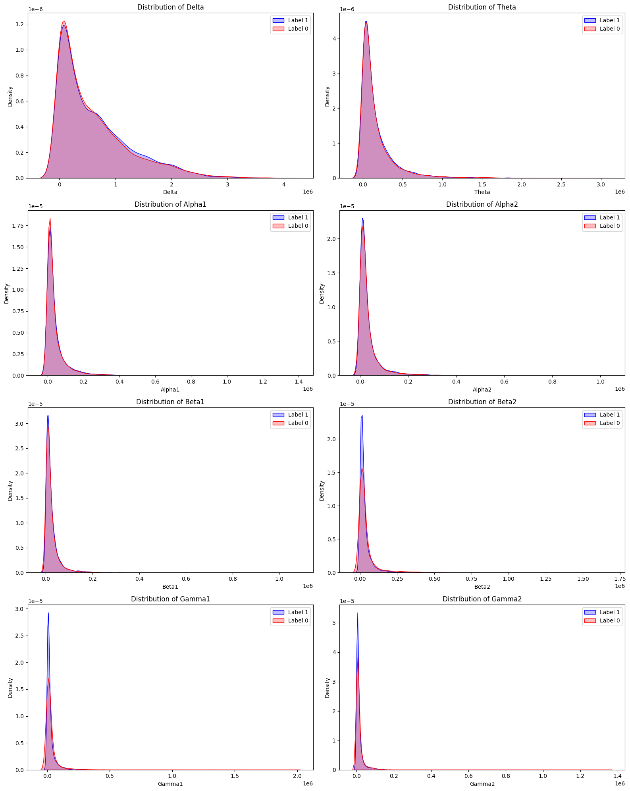

**Figure 2.** Signal distribution differences for label 1 and label 2

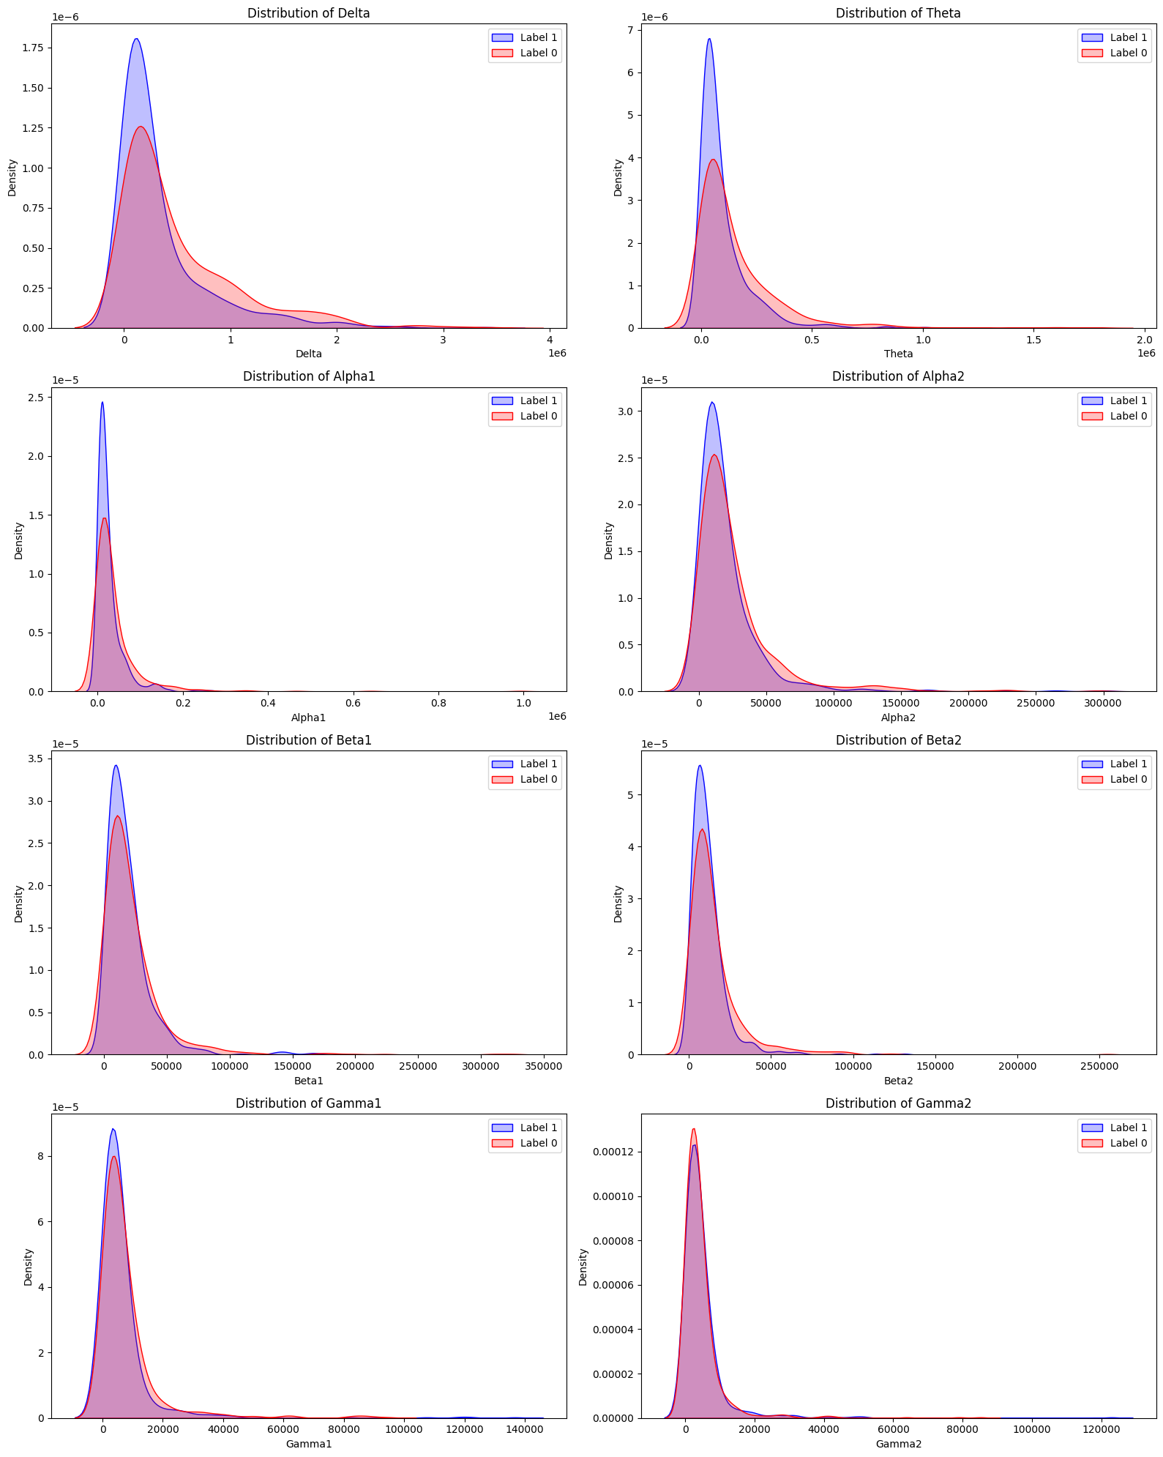

**Figure 3.** Signal distribution differences for label 1 and label 2 for Subject 1

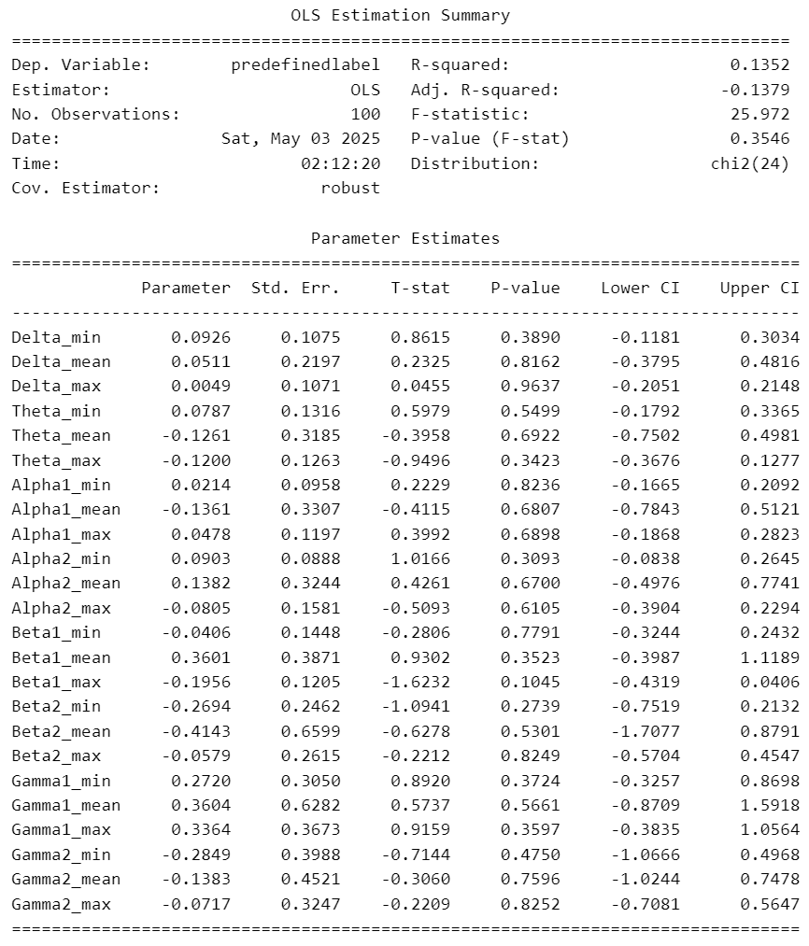

**Table 2.** OLS regression results (normalized signal values)

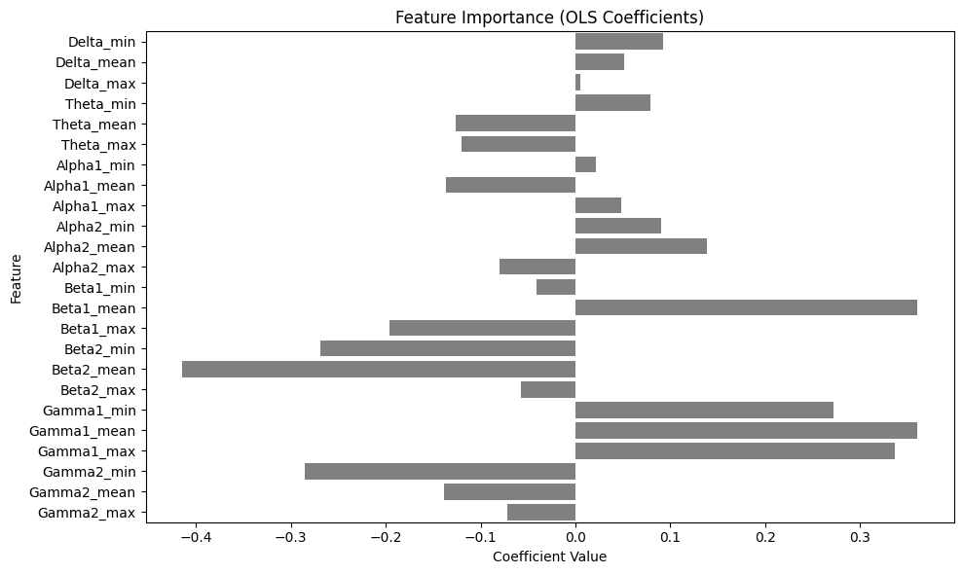

**Figure 4.** OLS regression results (normalized signal values)

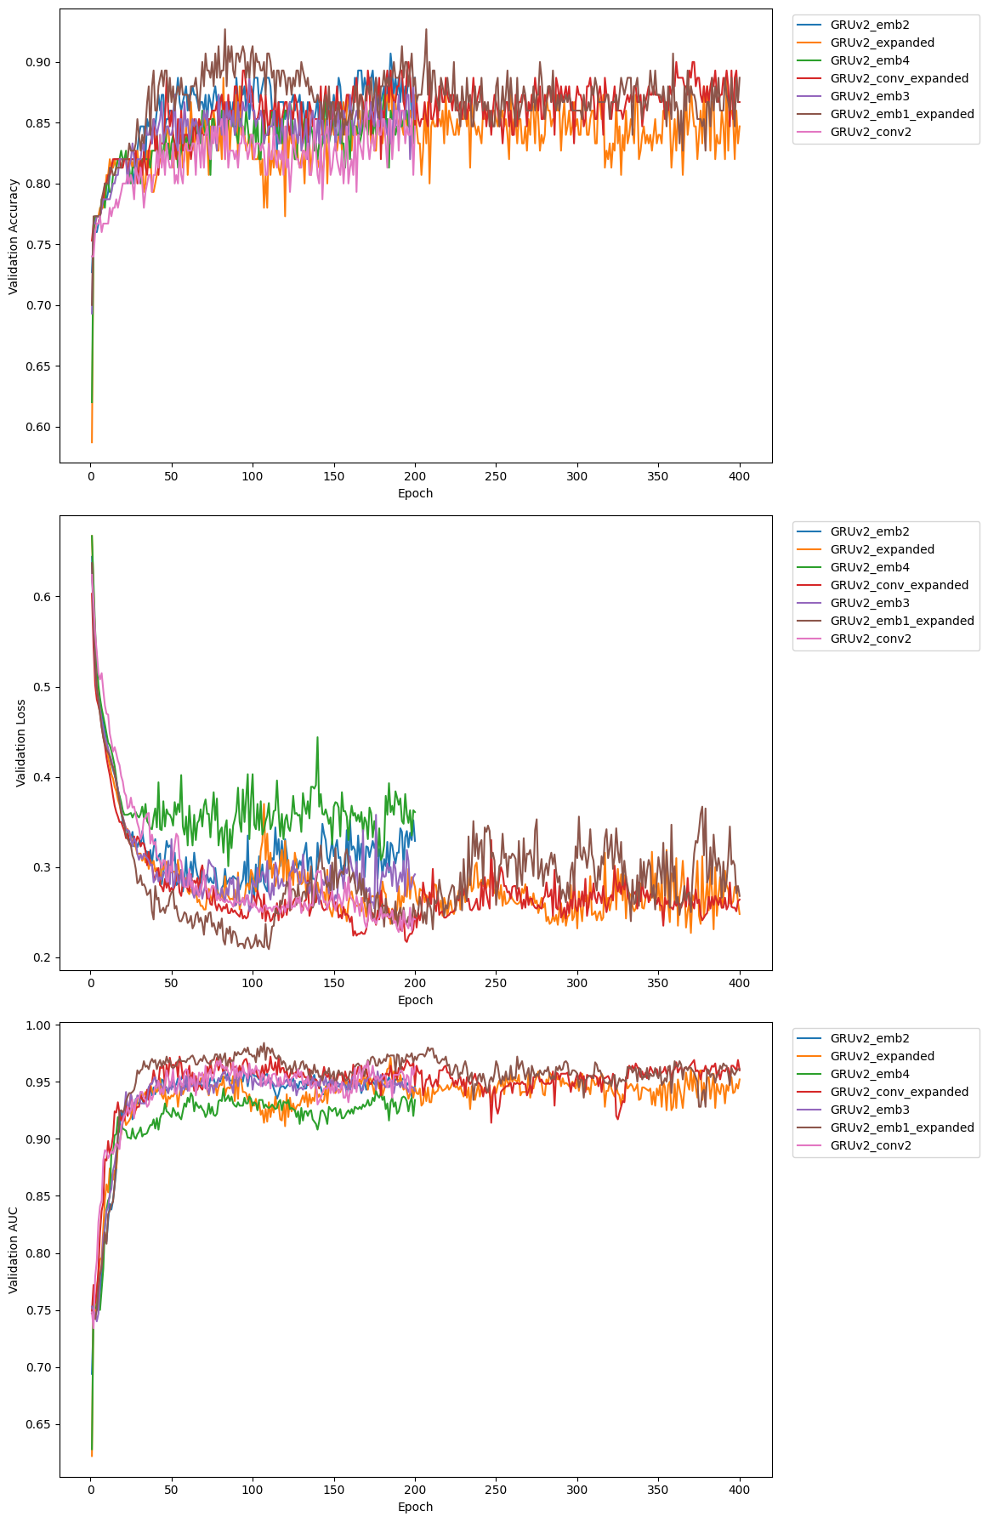

**Figure 7.** Best GRU performance

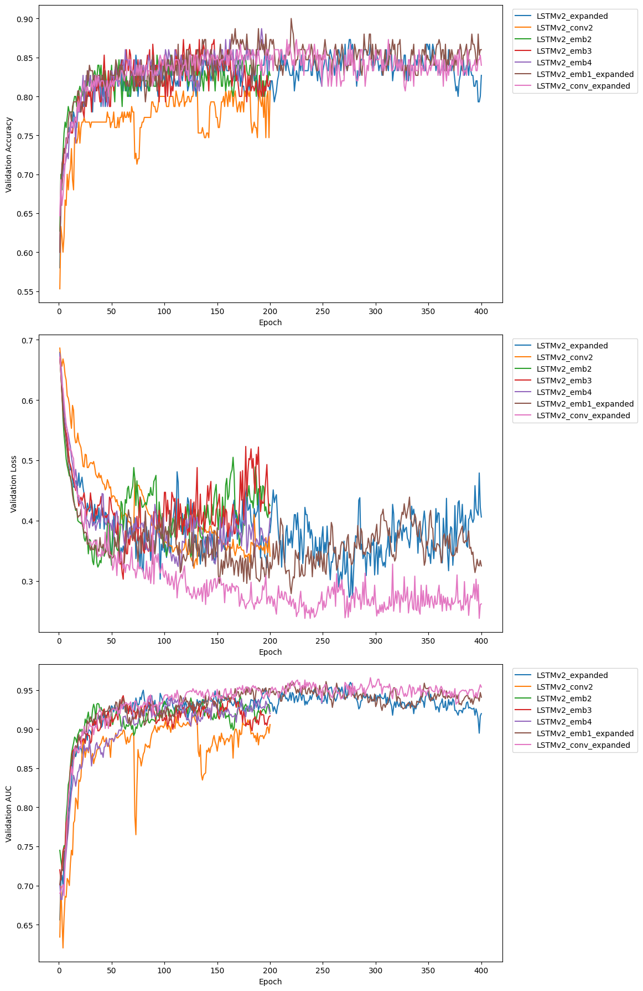

**Figure 8.** Best LSTM performance

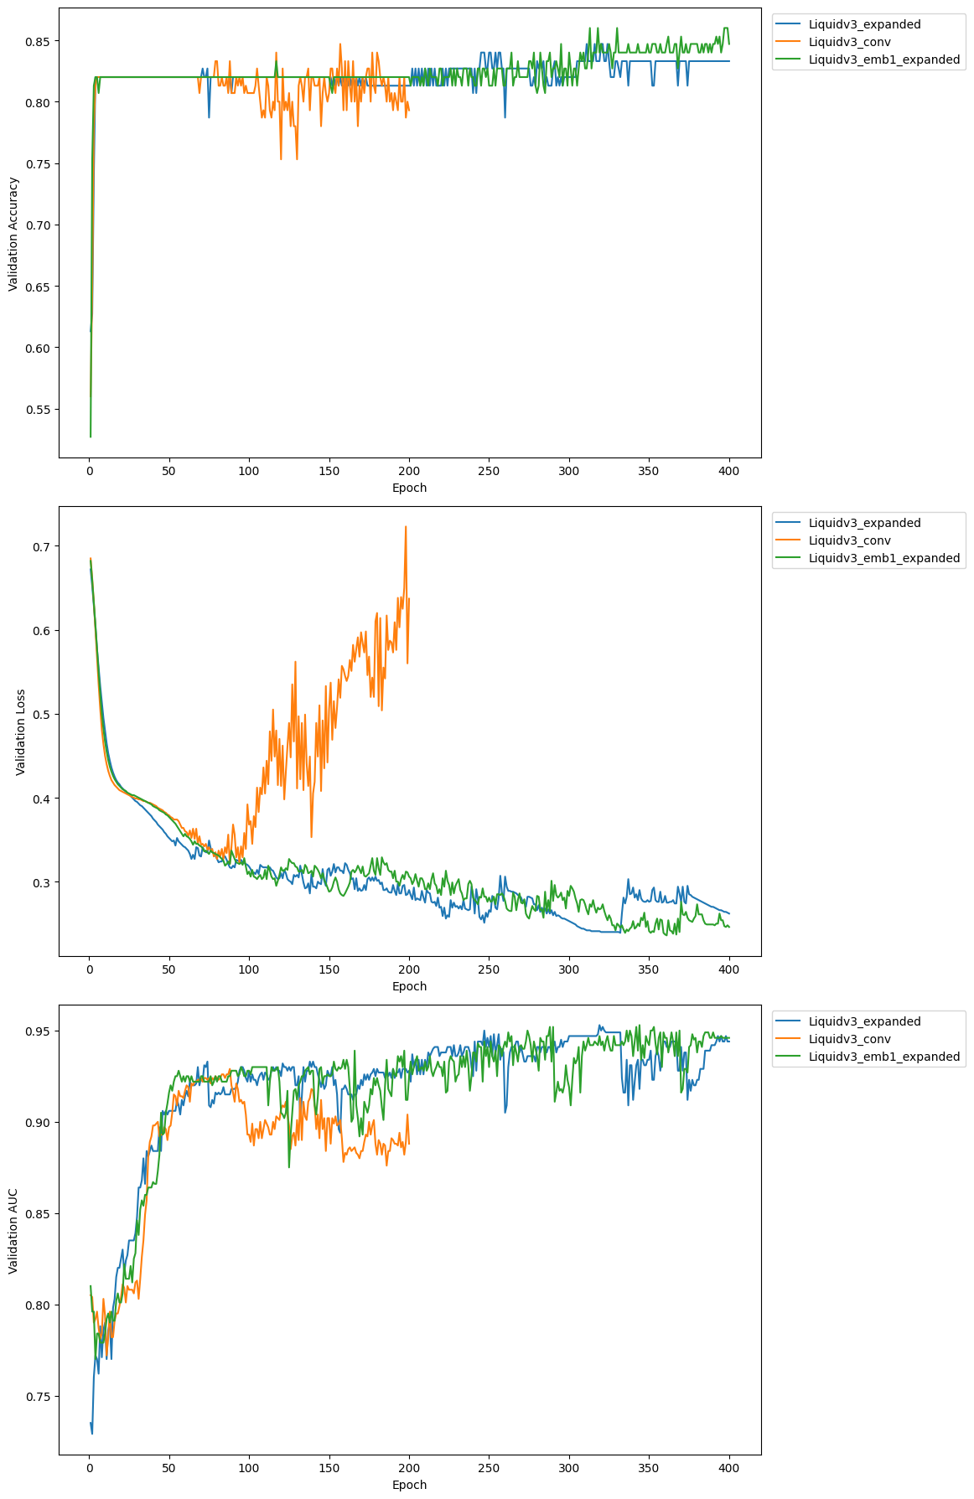

**Figure 9.** Best LNN performance

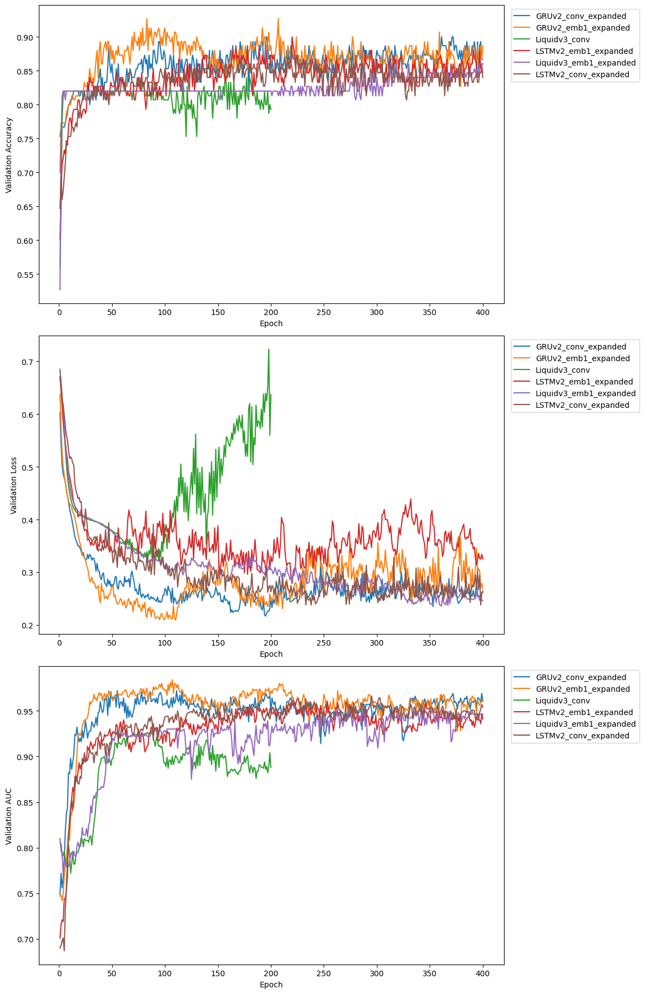

**Figure 10.** Final model performance

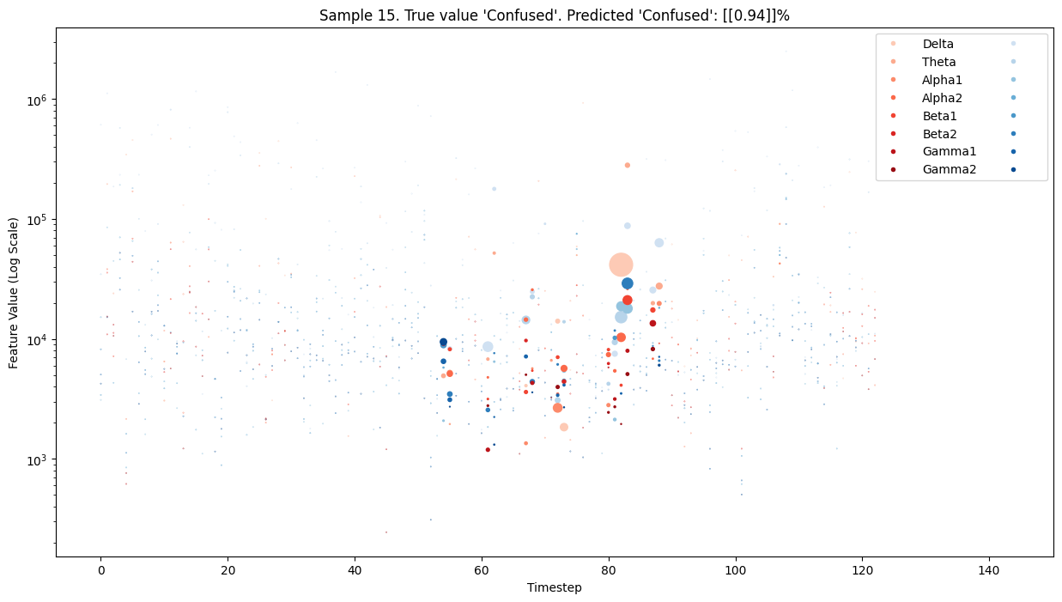

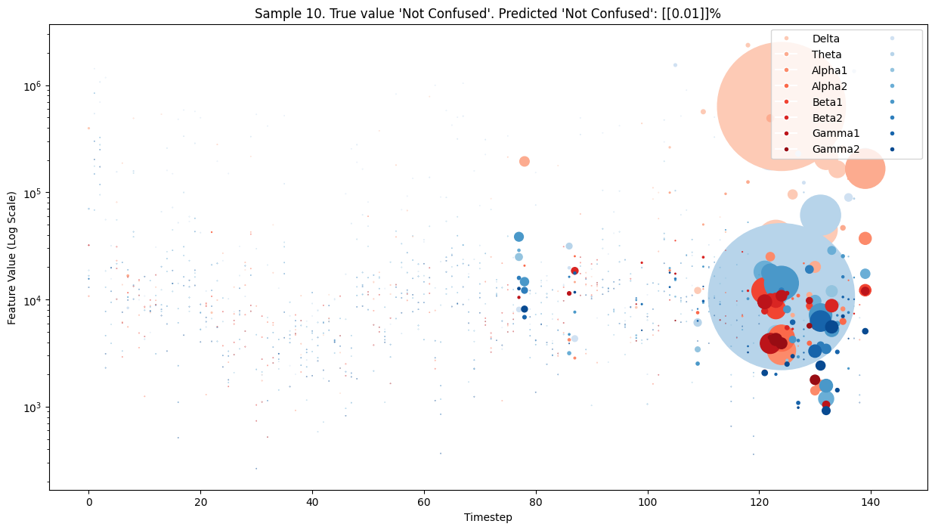

**Figure 11.** SHAP for Samples 10 and 15 for GRU with lag-1 embeddings

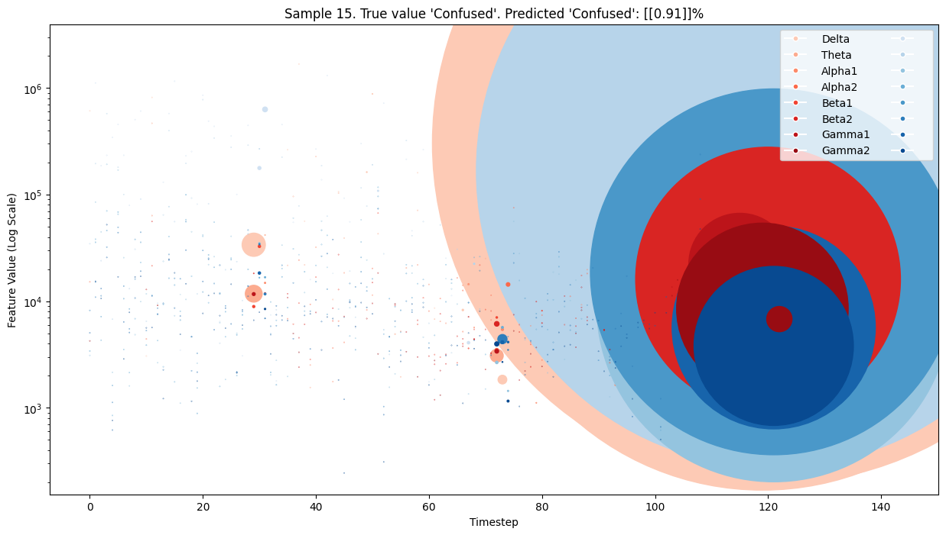

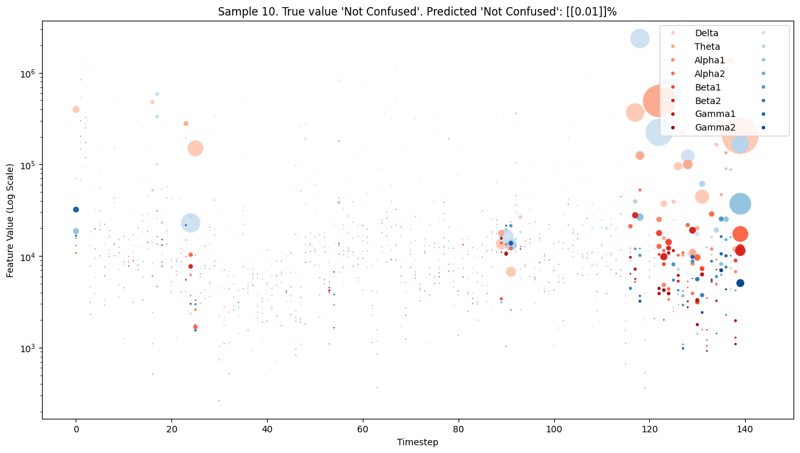

**Figure 12.** SHAP for Samples 10 and 15 for GRU with lag-1 embeddings and convolution

## References

1. **Ayoub, O., Andreoletti, D., Knapińska, A., Goścień, R., Lechowicz, P., Leidi, T., Giordano, S., Rottondi, C., & Walkowiak, K.** (2024). Liquid Neural Network-based Adaptive Learning vs. Incremental Learning  for Link Load Prediction amid Concept Drift due to Network Failures. arXiv (Cornell University). <https://doi.org/10.48550/arxiv.2404.05304>
2. **Bidollahkhani, M., Atasoy, F., & Abdellatef, H.** (2023). LTC-SE: Expanding the potential of Liquid Time-Constant Neural Networks for scalable AI and embedded systems. arXiv (Cornell University). <https://doi.org/10.48550/arxiv.2304.08691>
3. **Hasani, R., Lechner, M., Amini, A., Liebenwein, L., Ray, A., Tschaikowski, M., Teschl, G., & Rus, D.** (2022). Closed-form continuous-time neural networks. Nature Machine Intelligence, 4(11), 992–1003. <https://doi.org/10.1038/s42256-022-00556-7>
4. **Hasani, R., Lechner, M., Amini, A., Rus, D., & Grosu, R.** (2021). Liquid Time-constant Networks. Proceedings of the AAAI Conference on Artificial Intelligence, 35(9), 7657-7666. <https://doi.org/10.1609/aaai.v35i9.16936>
5. **Huang, Z., Contreras, L. F. H., Leung, W. H., Yu, L., Truong, N. D., Nikpour, A., & Kavehei, O.** (2024). Efficient Edge-AI models for robust ECG abnormality detection on Resource-Constrained hardware. PubMed. <https://doi.org/10.1007/s12265-024-10504-y>
6. **Lechner, M., Hasani, R., Amini, A., Henzinger, T. A., Rus, D., & Grosu, R.** (2020). Neural circuit policies enabling auditable autonomy. Nature Machine Intelligence, 2(10), 642–652. <https://doi.org/10.1038/s42256-020-00237-3>
7. **Lechner, M., Hasani, R. M., & Grosu, R.** (2018). Neuronal circuit policies. arXiv (Cornell University). <https://doi.org/10.48550/arxiv.1803.08554>
8. **Miah, M. O., Habiba, U., & Kabir, M. F.** (2024). ODL-BCI: Optimal deep learning model for brain-computer interface to classify students' confusion via hyperparameter tuning. *Brain Disorders*, 13, 100121. <https://doi.org/10.1016/j.dscb.2024.100121>
9. **Nerrise, F., Sosanya, A. S., & Neary, P.** (2024). Physics-Informed Calibration of Aeromagnetic Compensation in Magnetic Navigation Systems using Liquid Time-Constant Networks. arXiv (Cornell University). <https://doi.org/10.48550/arxiv.2401.09631>
10. **Ni, Z., Yuksel, A. C., Ni, X., Mandel, M. I., & Xie, L.** (2017). Confused or not confused? Disentangling brain activity from EEG data using bidirectional LSTM recurrent neural networks. *ACM-BCB '17: Proceedings of the 8th ACM International Conference on Bioinformatics, Computational Biology, and Health Informatics*, 241–246. <https://doi.org/10.1145/3107411.3107513>
11. **Nye, L.** (2023). Digital twins for patient care via knowledge graphs and Closed-Form Continuous-Time liquid neural networks. arXiv (Cornell University). <https://doi.org/10.48550/arxiv.2307.04772>
12. **Wang, H., Wu, Z., & Xing, E. P.** (2019). Removing confounding factors associated weights in deep neural networks improves the prediction accuracy for healthcare applications. *Pacific Symposium on Biocomputing*. <https://doi.org/10.48550/arXiv.1803.07276>
13. **Wang, H., Li, Y., Hu, X., Yang, Y., Meng, Z., & Chang, K.-M.** (2013). Using EEG to improve massive open online courses feedback interaction. *CEUR Workshop Proceedings*, 1009, 59–66.
14. **Yang, J., Shi, R., & Ni, B.** (2021). MedMNIST Classification Decathlon: A Lightweight AutoML Benchmark for Medical Image Analysis. In 2021 IEEE 18th International Symposium on Biomedical Imaging (ISBI) (pp. 191-195). Nice, France. <https://doi.org/10.1109/ISBI48211.2021.9434062>
15. **Zheng, Z., & Jia, X.** (2023). Complex Mixer for MEDMNIST Classification Decathlon. arXiv (Cornell University). <https://doi.org/10.48550/arxiv.2304.10054>
16. **Zhu, F., Wang, X., Huang, C., Jin, R., Yang, Q., Alhammadi, A., Zhang, Z., Yuen, C., & Debbah, M.** (2024). Robust Continuous-Time Beam Tracking with Liquid Neural Network. arXiv (Cornell University). <https://doi.org/10.48550/arxiv.2405.00365>
17. **Miah, M. O., Muhammod, R., Mamun, K. A. A., Farid, D. M., Kumar, S., Sharma, A., & Dehzangi, A.** (2021). CluSem: Accurate clustering-based ensemble method to predict motor imagery tasks from multi-channel EEG data. Journal of Neuroscience Methods, 364, 109373.
18. **Saha, S., Mamun, K. A., Ahmed, K., Mostafa, R., Naik, G. R., Darvishi, S., Khandoker, A. H., & Baumert, M.** (2021). Progress in brain-computer interface: Challenges and opportunities. Frontiers in Systems Neuroscience, 15, 578875.
19. **Mashrur, F. R., Rahman, K. M., Miya, M. T. I., Vaidyanathan, R., Anwar, S. F., Sarker, F., & Mamun, K. A.** (2022). BCI-based consumers’ choice prediction from EEG signals: An intelligent neuromarketing framework. Frontiers in Human Neuroscience, 16.
20. **Men, X., & Li, X.** (2022). Detecting the confusion of students in massive open online courses using EEG. International Journal of Education and Humanities, 4(2), 72–77.
21. **Hassouneh, A., Mutawa, A., & Murugappan, M. (2020).** Development of a real-time emotion recognition system using facial expressions and EEG based on machine learning and deep neural network methods. Information in Medicine Unlocked, 20, 100372.
22. **Jeon, J., & Cai, H. (2022).** Multi-class classification of construction hazards via cognitive states assessment using wearable EEG. Advanced Engineering Informatics, 53, 101646.
23. **Lawhern, V. J., Solon, A. J., Waytowich, N. R., Gordon, S. M., Hung, C. P., & Lance, B. J.** (2018). EEGNet: A compact convolutional neural network for EEG-based brain–computer interfaces. Journal of Neural Engineering, 15(5), 05601.
24. **Renosa, R. R. M., Bandala, A. A., & Vicerra, R. R. P.** (2019). Classification of confusion level using EEG data and artificial neural networks. 2019 IEEE 11th International Conference on Humanoid, Nanotechnology, Information Technology, Communication and Control, Environment, and Management (HNICEM), IEEE, 1–6.
25. **Vezard, L., Legrand, P., Chavent, M., Faïta-Aïnseba, F., & Trujillo, L.** (2015). EEG classification for the detection of mental states. Applied Soft Computing, 32, 113–131.
26. **Yeo, M. V. M., Li, X., Shen, K., & Wilder-Smith, E. P. V.** (2009). Can SVM be used for automatic EEG detection of drowsiness during car driving? Safety Science, 47(1), 115–124.
27. **Subasi, A., & Gursoy, M. I.** (2010). EEG signal classification using PCA, ICA, LDA, and support vector machines. Expert Systems with Applications, 37(12), 8659–8666.
28. **Petrosian, A. A., Prokhorov, D. V., Lajara-Nanson, W., & Schiffer, R. B.** (2001). Recurrent neural network-based approach for early recognition of Alzheimer's disease in EEG. Clinical Neurophysiology, 112(8), 1378–1387.
29. **Hochreiter, S., & Schmidhuber, J.** (1997). Long short-term memory. Neural Computation, 9(8), 1735–1780.
30. **Jirayucharoensak, S., Pan-Ngum, S., & Israsena, P.** (2014). EEG-based emotion recognition using deep learning network with principal component-based covariate shift adaptation. The Scientific World Journal, 2014.
31. **Zheng, W.-L., Zhu, J.-Y., Peng, Y., & Lu, B.-L.** (2014). EEG-based emotion classification using deep belief networks. IEEE International Conference on Multimedia and Expo (ICME).
32. **Ni, Z., Yuksel, A. C., Ni, X., Mandel, M. I., & Xie, L.** (2017). Confused or not confused?: Disentangling brain activity from EEG data using bidirectional LSTM recurrent neural networks. Proceedings of the 8th ACM International Conference on Bioinformatics, Computational Biology, and Health Informatics (ACM-BCB ’17). New York, NY, USA: ACM.
33. **Marosi, E., et al.** (2002). Narrow-band spectral measurements of EEG during emotional tasks. International Journal of Neuroscience, 112(7), 871–891.