

Educational Cycling Game for Younger Audience

Final Year Project



April 16, 2018

Kristina Blinova

P4076882

Table of Contents

ABSTARCT 3

ACKNOWLEDGMENTS 4

1. INTRODUCTION 5

1.1. Problem Definition 5

1.2. Scope 5

2. METHODOLOGY 6

2.1. Tools 6

Hardware 6

Software 6

2.2. Process 6

3. RESEARCH 8

3.1. Introduction 8

3.2. Educational Aspect 8

3.2.1. Subject choice 8

3.2.2. National Curriculum 8

3.2.3. Student book review 9

3.2.4. Types of educational games 9

3.2.5. Motivation to play educational games 10

3.3. Exercising Aspect 10

3.3.1. Effects of active video games 10

3.3.2. Feasibility and best practices 10

3.4. Games for Children 10

3.4.1. Rating 10

3.4.2. Engaging elements and human values 11

4. DESIGN 12

4.1. Goals 12

4.2. Concept 12

4.3. Backstory 12

4.4. Avatar Creation Component 12

4.5. Maths Quiz Component 13

5. IMPLEMENTATION 14

5.1. Overview 14

5.2. Extensibility 14

5.3. Persistence 14

5.4. Visual and audio elements 14

6. EVALUATION 15

6.1. Prototype evaluation 15

6.2. Applications 16

6.3. Future work 17

7. REFLECTION ON THE PROCESS 18

8. CONCLUSION 18

9. BIBLIOGRAPHY 19

10. APPENDICES 22

# ABSTARCT

# ACKNOWLEDGMENTS

I would like to thank my research supervisor Dr Julie Porteous, for her enthusiastic encouragement, professional guidance and invaluable support. I would also like to thank Sarah O’Brien, Julien Cordry and Alison Innerd, who inspired me to pick this project as well as provided useful and constructive recommendations on this research. I am particularly grateful for the assistance given by Dmytro Stratiychuk-Dear for his advice and assistance in keeping my project on schedule.

Finally, I would like to offer my special thanks to the University of Teesside and School of Computing.

# INTRODUCTION

## Problem Definition

According to statistics (Ukie, 2018), more than 32 million of the United Kingdom residents regularly played video games in 2017, making UK the 5th largest game market in the world. Children form a significant part of this phenomena. 66% of 8-11-year-olds play console games at home on weekly basis (Statista, 2018) and even more participate in PC and mobile gaming (Prigg, 2014).

It is debatable whether playing video games has positive (Chuang & Chen, 2009) or negative (Skoric, et al., 2009) impact on children, however criticism often stresses that gaming prevents children from getting “enough active play and exercise” and negatively affects “how well kid does in school” (Kids Health, 2014).

The aim of this project is to combat these stereotypes and use gamification in order to improve both activity level and school results of children. A successful prototype must be a fun to play video game demo, which provides exercising opportunities and learning outcomes.

## Scope

The project will not focus on maximising physical benefits, but rather use exercising aspect to increase engagement and concentration among players. Cycling hardware will be used as the main interface due to its availability at the university.

The success of the project will be determined experimentally and at this stage will not involve testing with the focus group. The assessment criteria will be obtained via a literature review. The game will be aimed at 7-8 year-old school children.

# METHODOLOGY

## Tools

The research utilises both hardware and software tools.

### Hardware

The set of hardware equipment consists of a mini exercise bike (Oypla, 2018) and a sensor with appropriate SDKs (Cyberbiking, 2016). Available output includes pedalling information of going forward, but not backwards. Controller, mouse or keyboard can be used in parallel with the sensor.

The mini cycle has a display which shows key workout data, such as travelled distance, session time and burned calories. This data cannot be accessed by software due to the sensor’s limitation but can be used during life testing to obtain information about physical activity level during the play. The mini cycle allows manually modifying the resistance to make cycling harder or easier. Resistance cannot be changed via software.

This set of hardware was chosen due to its availability at university.

### Software

The game demo is developed in Unity3d (Unity 3d, 2018) utilised the 2D framework (Unity 3d , 2015). All the scripts are written in C#. Visual Studio 2017 (Visual Studio, 2017) was used as an IDE.

In addition to programming software, Adobe Photoshop (Adobe, 2018) was used to create some of the visual assets for the game. Throughout the development GitKraken (Axosoft, 2018) was used as a source control.

## Process

As shown on figure Blah there are six main elements of the project development, which can be divided into three stages: research, planning and implementation.

Literature review

Design

Modify plan

Implementation

Testing

Refactoring

Bug testing

Alternatives,

Suggestions,

Clarification

*Research stage*

*Planning stage*

*Implementation stage*

Design testing

The research starts with the literature review, which helps to identify best practices and approaches of creating an educational exercise game for children. All the literature findings are reviewed during the planning stage. It starts with the design so that the changes of the game concept, mechanics, goals, and other components are decided. After the design was modified, the plan needs to be adjusted with regards to deadlines and available resources.

Once requirements are clearly defined the implementation stage starts. The initial goal is to produce working code as quickly as possible, even if it means efficiency compromise or hardcoding. This approach allows reaching the testing stage relatively fast to examine whether the theoretical design solution works in practice. After the initial test the refactoring process starts to optimise the code. It is followed by another testing with the main focus being errors and bugs. At any point during the testing an extra literature review can be required. In this case the cycle starts over.

Top-down modular approach

Initially the problem was broken into smaller self-contained modules which were then broken again. This approach was synonymous with object oriented paradigm and unity component system.

Pretty diagram GOES HERE

# RESEARCH

## Introduction

Similar product: Educational game developed for 7-11 year-old children. Similarly, to this project, the research used feet for input, but utilised dance pad rather than bicycle interface. The learning aspect was focused around nutrition. (Mellecker, et al., 2013).

The aim of this research was to gain understanding of what can be achieved by utilising learning and exercising elements in one game.

## Educational Aspect

Something about serious games

### Subject choice

The educational program of the Key Stage 2 students can differ depending on the type of school they attend REF. The only compulsory events across all the educational institutions are the National tests in English and maths. Figure blah shows the pass rate of the National test exams among the Key Stage 2 students. In 2016 and 2017 the lowest results were achieved in reading and mathematics.

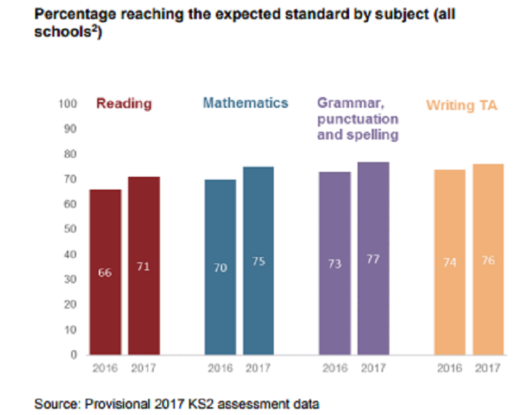Since mathematical questions can be procedurally generated as opposed to reading tasks REF, it was decided to base the game around maths curriculum.

### National Curriculum

Mathematics programmes of study for the key stage 2 in England is defined by the National curriculum. (Department for Education, 2014). Among others, the statutory requirements for the Year 2 and Year 3 students include:

1. Add and subtract mentally, including:

* a two-digit number and ones
* a two-digit number and tens
* two two-digit numbers

1. Recognise and use symbols for pounds (£) and pence (p); combine amounts to make a value
2. Solve simple problems in a practical context involving addition and subtraction of money of the same unit, including giving change

### Student book review

In order to decide on the best approach to introduce those tasks three student books were consulted: “Let’s do Mental Maths” (Brodie, 2013), ”Mental Maths” (Collins, 2017) and “Mental Arithmetic 3” (Schofield & Sims, 2017). All of these books were published in London in the recent years and support the national curriculum. Figure Blah shows a comparison analysis of the books.

Firstly, it can be noted that the number of tasks per session varies from book to book, however those always include questions where the use of language is kept to a minimum and questions using number vocabulary. Secondly, the concept of currency adds an extra layer of complexity to the arithmetic question e.g. 25+9 and 25p + 9p follow the same numerical pattern (A + B) but are considered different types of questions. Finally, each book has a reward system which provides visually clear feedback about the success of the student and a non-learning activity e.g. colouring.

|  |  |  |  |
| --- | --- | --- | --- |
|  | Let’s Do Mental Maths | Mental Maths | Mental Arithmetic 3 |
| Number of questions per test | 20 questions | 15 questions | 3 parts, 12 questions each |
| Age group | 8-9 | 7-9 | 7-11 |
| Addition/Subtraction question examples | * 58p + 22p * What is the total of 18 and 23? * What is my change from 1£ when I spend 56p? | * 100 – 5 * 25p + 9p * Work out the change from 1£ | * 43 + 47 * Find the total of 29 and 81 * What must be added to 75p to make 1.50£? |
| Reward and feedback | Reward stickers + numerical score value | Colouring objects to represent score. Objects are a part of an illustration. Illustrations differ for each test. | Colouring cells in the grid to represent score. |

### Types of educational games

Educational games can be divided into teaching games or testing games (Kapp, et al., 2014). Testing games require the learner to know the information to be successful. Games such as Trivia ref and Jeopardy ref are classified as testing games. The aim of the Teaching games, on the other hand, is to help the learner accumulate new knowledge or new skills. For example, it is not enough to know how to move pieces to win a chess game. Instead, a player is required to come up with new tactics, plan, adapt and adjust.

Testing games are often criticised for not being engaging with children, however it can be an excellent way of learning things that require lots of repetitive practice (Prensky, 2007). As arithmetic falls under that category, it was decided to use testing game approach for this project.

### Motivation to play educational games

Research shows that children’s motivation to learn maths concepts is increased when the problem is presented in a game context. Interestingly, this remains true even if it the game is perceived as “full of maths” (Kamran, 2008). Similar results were achieved by studying educational games focused on other learning areas, such as nutrition (Mellecker, et al., 2013). Users, children aged 7-11, positively reacted to a game which “help you learn while having fun”. In other words, users can consciously work towards the curriculum goals, but still find the process enjoyable.

The elements of games that provide motivation include engaging graphics, onscreen rewards and progress feedback (Prensky, 2007). As long as the learning context does not supress those game features, it can be expected to keep players engaged.

## Exercising Aspect

With introduction of Microsoft Kinect REF, Wii REF, and Sony Eye Camera REF, exercising video games are becoming popular among gamers. Study shows that 40% of adolescents play active and non-active video games, and 3% play active games exclusively. (Monique, et al., 2014). This section of the research summarises relevant information about exercise games obtained via literature research.

### Effects of active video games

Research suggests that regularly playing active video games can result in positive effects on children’s overall physical activity level. (Cliona Ni Mhurchu, et al., 2008) Health benefits of exercising games are comparable to those of gym work outs. Studies show that the effect of active video gaming on the heart rate did not differ significantly from traditional physical activities (Peng, et al., 2011). It is also proven that active video games can be used to fight against children’s obesity, reduce body fat and result in positive change in waist circumference (Maddison, et al., 2011). Interactive cycling games in particular, can result in a higher exercise intensity and provide significantly greater enjoyment than conventional exercise (Monedero, et al., 2015).

Another area, which is affected by exercising games is non-active gaming. Research consistently shows that the daily time spent in non-active video games is decreased, if users have access to active games (Maddison, et al., 2011), (Cliona Ni Mhurchu, et al., 2008), (Simons, et al., 2015).

### Feasibility and best practices

Research shows that the level of enjoyment from playing active video game steadily decreases over time. Within a session of a basic cycling game, a significant drop of interest can be noticed within 20-30 minutes of play time (Monedero, et al., 2015). In the long-perspective, the boredom becomes noticeable within 7-10 weeks (Mellecker, et al., 2013). Both observations can be explained with the general tendencies towards engagement in sports overtime (Monedero, et al., 2015) and poor game design, which becomes evident once the novelty factor of the active interface disappears (Mellecker, et al., 2013). This can be overcome by investing more resources into the “gaming aspect” of the application. For example, study suggests that active video games with narrative show greater physical activity than non-narrative games among 8-11-year-old children (Lu, et al., 2016).

## Games for Children

### Rating

In order for the game to be available to elementary school children, it should not contain any elements inappropriate for their age. PEGI. There are five PEGI rating categories recognised in the UK. The successful prototype of this research project can be labelled as 3+ or 7+ however mustn’t have any features of the 12+ rating or higher. The breakdown of the requirements is shown in table Blah.

|  |  |  |
| --- | --- | --- |
| 3+ | 7+ | 12+ |
| May contain some violence in a comical context (e.g. very mild cartoon slapstick) | May contain occasional violence to non-realistic fantasy characters, pictures or sounds likely to be scary or frightening to young children, and nudity in a non-sexual context. | May contain graphic violence towards fantasy characters, non-graphic violence towards humans or animals, explicit sexual descriptions or images (nude people in a sexual context, although not necessarily explicit in content), and mild swearing. |

### Engaging elements and human values

It is hard to objectively evaluate the level of players engagement or make conclusions about how different game elements contribute towards it REF. What is known, is that a game event must trigger some human value to provoke emotion (Tynan, 2013). For example, loosing a piece at the late stage of the chess game provokes great emotional response because the victory/defeat human value is shifted. The same action in the early game results in smaller engagement as there are many other pieces left on the board and the impact on the human value is smaller.

For the purpose of this research, it is essential not to discourage children in their learning and exercising efforts REF. Therefore, the literature review was focused on “less dramatic human values” such as [unique, personalised vs standard], [skilled vs unskilled], [knowledge vs ignorance] as opposed to [life vs death] human value, which is commonly used in the games for adults. Table Blah summarises the common ways of incorporating engaging elements in games.

|  |  |  |
| --- | --- | --- |
| *Value* | Incorporation | Game examples |
| *Unique, Personalised vs Standard* | Avatar creation/modification | * Sims REF * Pokémon Go REF * Hogwarts Mystery REF |
| Building creation/ modification for nun-functional purposes | * Tycoon Zoo * Fantasy Life * Sims Mobile |
| *Skilled vs Unskilled* | Challenge, which requires player to develop a set of skills in real life e.g. reflexes, abstract thinking | * Mario * Crash Bandicoot * Civilization |
| *Knowledge vs Ignorance* | As player progresses through the game, the narrative is unravelled, and mysteries are revealed | * Professor Layton * Stardew Valley * To the Moon |
| Exploration, discovery of new territories or secret pathways | * Rayman Origins * Minecraft * The Legend of Zelda |

# DESIGN

## Goals

Based on the literature research, a list of requirements for the successful prototype was developed.

1. The game must utilise learning and exercising aspects in similar proportion (see section).
2. The learning focus of the game must be addition and subtraction of money, (see section 3.2.2).
3. The game must have narrative (see section 3.3.2)
4. The game must provide on-screen rewards (see sections )
5. The game must be engaging and therefore trigger a shift in human values (see section)
6. The game must have appealing graphics (see section)
7. The game content must be suitable for 7 -9-year-old children according to UK game rating system (see section)

## Concept

Once the goals were clearly formulated, the design of the prototype game was developed.

The game consists of the two main scenes which are avatar creation and maths quiz.

Single player

It can be assumed that all the players have similar background knowledge about the problem (curriculum)

“The Incredible Adventures of Bob the Bicycle”.

Player

## Backstory

Because narrative is essential (REF) there was an extra effort to develop an appealing backstory.

The game is aimed at 7-9 year old children to use at home or at school.

Key decisions were identified

Testing game (REF)

Maths – questions can be procedurally generated

## Avatar Creation Component

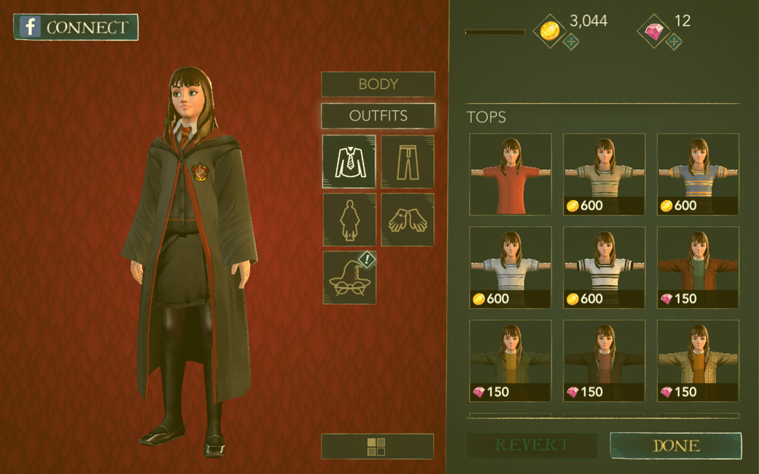

Fun part

Reward, motivation

## Maths Quiz Component

Maths

Inspired by student books

Questions are randomly generated

Test

Code snippet (implementation?)

# IMPLEMENTATION

## Overview

* Unity
* C sharp

## Extensibility

* Avatar elements loaded

|  |  |  |  |
| --- | --- | --- | --- |
| Category | Colour | Changes colour | Number of variation |
| Skin colour | Skin | Yes | 3 |
| Face shape | Skin | - | 5 * 3 colours |
| Body | Skin | - | 3 * 3 colours |
| Hair Colour | Hair Colour | Yes | 5 |
| Hair up (fringe) | Hair Colour | - | 5 * 5 colours |
| Hair down | Hair Colour | - | 4 * 5 colours |
| Eyes | - | - | 7 |
| Mouth | - | - | 7 |
| Nose | - | - | 4 |

In total there are 95 sprites.

* Procedural question simulation

## Persistence

* Between scenes

## Visual and audio elements

An important aspect of the implementation of ST involved adding features that would make the game more fun for children. Most children like sharp and bright colors, so colors and patterns were used to create a sense of motion and change as well as beauty. As a player moves from one puzzle to the next, the colors and patterns of puzzle pieces change. Each level employs different colors to give a different sense to the activity. Level 3, for example, uses fractal patterns and has a mystical feel. Different puzzles have different music playing in the background. Extrinsic encouraging comments such as “Well done!” with graphics and cartoons are presented each time a puzzle is completed. Comments of strong praise like “You are a genius!” result only when puzzles are completed with minimum number of transformations (Kamran, 2008)

# EVALUATION

## Prototype evaluation

The final product was analysed using an Activity Theory-based Model of Serious Games (ATMSG) to provide a comprehensive view of the structure of the game, including both its high-level purpose and concrete implementation. The original model was modified by adding an “exercise” category to match project’s goals. Figure BLAH represents the game sequence and implemented components. Table BLAH shows the way gaming, learning and exercising are integrated into the key stages of the game in a greater detail.

No

Yes

More rounds?

More

puzzles?

More

levels?

No

Yes

No

1. Main Menu

2. Avatar Creation

3. Puzzle

4. Reward

5. End of round

6. End of level

Anytime

Yes

|  |  |  |  |  |
| --- | --- | --- | --- | --- |
| Game Node | Gaming | Learning | Exercise | Comments |
| 1. Main menu | Standard game element. Provides access to options, credits, start of the game and exit from the application. | - | Player navigates through the menu by cycling from one option to another. This provides a warm-up prior to any gameplay. | Main menu is a safe place to adjust the equipment and ensure that player’s position is comfortable. |
| 1. Avatar Creation | Player creates a character by choosing elements from given categories, such as hair colour or face shape. Unlocking new elements requires spending in-game currency. Avatar is visible in later stages of the game. | Game simulates real-life shopping experience. Player has a limited amount of money and can choose how to spend it. Interface prevents players from purchasing items unless they have enough coins. | To apply a new element to the avatar, player must deliver it by bicycle. Bicycle moves as the player cycles forward. | Interest to avatar creation among children and teenagers is outlined by multiple researches (Kafai, 2009). |
| 1. Puzzle | Player answers a series of quiz questions. If the answer is incorrect, the player has to try again. | Puzzle after puzzle, player’s arithmetic skills are testes. Questions gradually become harder with each level. | The question is only visible if the player is cycling. If cycling is stopped, then the questions fades away. | Questions are procedurally generated, which aids replay ability. |
| 1. Reward | Correct answers open treasure chests which contain a certain number of coins and a quest item e.g. part of the map. Sound and visual effects empathise the importance. | - | - | Rewards vary depending on the player’s level. |
| 1. End of round | Chests change colour and become are harder to open, more correct answers are required. Player’s progress is saved. | Player is pushed to solve multiple questions at a time before taking a break. This is similar to test conditions. | - | Difficulty is increased via gaming rather than learning element. |
| 1. End of level | At the end of the level player is offered to level up by completing a special challenge. Player can choose when to do it. Successful completion grants great rewards and story progression. Background picture, music and the quest change. | After answering ten questions player is offered to complete a test. The same skill is tested as during normal puzzles, but the wording of the question is different. There is a 30 second time limit. If unsuccessful, the player can try again. | - | Wording of the questions is taken from the student book. REFERENCE |

There is a number of conclusions which can be made based on the ATMSG diagram.

Most of the game stages provide outcomes of different areas.

## Applications

Schools

## Future work

#### Persistence

The application can be expanded by introducing a database to save player’s progress and achieve persistence between gaming sessions. This functionality was a part of the project proposal, however after careful consideration, it was decided that implementation of this feature should become a separate independent research. Successful design must consider various computing aspects including security, authentication algorithms and server creation, which are not a part of my project.

In order to make future work simpler, all the information which must be persistent was separated into four classes. The result was tested by successfully keeping track of player’s progress after scene transitions.

#### Live testing

To obtain better results a testing with a group of children is required.

#### Next step

# REFLECTION ON THE PROCESS

Half a page to a page

Journey

# CONCLUSION

# BIBLIOGRAPHY

Adobe, 2018. *Adobe Photoshop CC.* [Online]   
Available at: https://www.adobe.com/ca/products/photoshop.html  
[Accessed 19 April 2018].

Axosoft, 2018. *GitKraken.* [Online]   
Available at: https://www.gitkraken.com/  
[Accessed 19 April 2018].

Brodie, A., 2013. *Let's So mental Maths.* London: Bloomsbury.

Chuang, T.-Y. & Chen, W.-F., 2009. Effect of Computer-Based Video Games on Children: An Experimental Study. *Journal of Educational Technology & Society,* 12(2), pp. 1-10.

Cliona Ni Mhurchu, R. M. et al., 2008. Couch potatoes to jumping beans: A pilot study of the effect of active video games on physical activity in children. *International Journal of Behavioral Nutrition and Physical Activity,* 5(1).

Collins, 2017. *Mental Maths.* 1st ed. London: Collins.

Cyberbiking, 2016. *Cyber ExerCycle.* [Online]   
Available at: http://www.cyberbiking.com/buy_now.html  
[Accessed 27 January 2018].

Department for Education, 2014. *National curriculum in England: mathematics programmes of study.* [Online]   
Available at: https://www.gov.uk/government/publications/national-curriculum-in-england-mathematics-programmes-of-study  
[Accessed 20 April 2018].

Kafai, Y. B., 2009. World of Whyville: An Introduction to Tween Virtual Life. *Games and Culture,* V(1), pp. 3-22.

Kamran, S., 2008. From Play to Thoughtful Learning: A Design Strategy to Engage Children With Mathematical Representations. *Journal of Computers in Mathematics & Science Teaching,* 25(1), pp. 65-103.

Kapp, K. M., Blair, L. & Mesch, R., 2014. *The Gamifaction of Learning and Instruction Fieldbook.* 1st ed. San Francisco: Wiley.

Kids Health, 2014. *Are Video Games Bad for Me?.* [Online]   
Available at: https://kidshealth.org/en/kids/video-gaming.html  
[Accessed 18 April 2018].

Lu, A. S. et al., 2016. The Narrative Impact of Active Video Games on Physical Activity Among Children: A Feasibility Study. *Journal of Medical Internet Research,* 18(10).

Maddison, R. et al., 2011. Effects of active video games on body composition: a randomized controlled trial. *The American Journal of Clinical Nutrition,* 94(1), pp. 156-163.

Mellecker, R. R., Lisa, W. & Tom, W., 2013. Active Learning: Educational Experiences Enhanced Through Technology-Driven Active Game Play. *Journal of Educational Research,* pp. 352-360.

Mellecker, R. R., Witherspoon, L. & Watterson, T., 2013. Active Learning: Educational Experiences Enhanced Through Technology-Driven Active Game Play. *The Journal of Educational Research,* pp. 352-359.

Monedero, J., Lyons, E. J. & O’Gorman, D. J., 2015. Interactive Video Game Cycling Leads to Higher Energy Expenditure and Is More Enjoyable than Conventional Exercise in Adults. *Plos One,* 10(3).

Monique, S. et al., 2014. Active and non-active video gaming among Dutch adolescents: Who plays and how much?. *Journal of Science and Medicine in Sport,* 17(6), pp. 597-601.

Oypla, 2018. *Arm/Leg Mini Cycle Pedal Exercise Resistance Bike Fitness Gym.* [Online]   
Available at: https://oypla.com/sports-leisure/indoor-sports/arm-leg-mini-cycle-pedal-exercise-resistance-bike-fitness-gym?gclid=Cj0KCQiAgZTRBRDmARIsAJvVWAtT_wgCcWoOd6NEFGbHXO0w9VllEauSzxZuGxKAoFV1rXVZEktWGQUaAvPZEALw_wcB  
[Accessed 27 January 2018].

Peng, W., Lin, J.-H. & Crouse, J., 2011. Is Playing Exergames Really Exercising? A Meta-Analysis. *CYBERPSYCHOLOGY, BEHAVIOR, AND SOCIAL NETWORKING,* 14(11), pp. 681-689.

Prensky, M., 2007. Digital Game-Based Learning. In: *How Game Teach and How they Work.* s.l.:Paragon House, pp. 145-180.

Prensky, M., 2007. Digital Game-Based Learning for Kids. In: *Digital Game-Based Learning.* s.l.:Paragon House, pp. 180-200.

Prensky, M., 2007. Fun, Play and Games. In: *Digital Game-Based Learning.* s.l.:Paragon House, pp. 106-145.

Prigg, M., 2014. *How the iPad replaced the toy chest: Researchers find children play with touchscreens more than traditional toys.* [Online]   
Available at: http://www.dailymail.co.uk/sciencetech/article-2565061/How-iPad-replaced-toy-chest-Researchers-children-play-touchscreens-traditional-toys.html  
[Accessed 18 April 2018].

Schofield & Sims, 2017. *Mental Arithmetics 3.* 6 ed. London: Page Brows (Norwich) Ltd.

Simons, M. et al., 2015. Replacing Non-Active Video Gaming by Active Video Gaming to Prevent Excessive Weight Gain in Adolescents. *PLoS ONE,* 10(1).

Skoric, M. M., Teo, L. L. C. & Neo, R. L., 2009. Children and Video Games: Addiction, Engagement,. *CyberPsychology & Behavior,* 12(5), pp. 567-572.

Statista, 2018. *Use of games consoles and players among children to consume media at home in the United Kingdom (UK) from 2013 to 2017, by age group.* [Online]   
Available at: https://www.statista.com/statistics/274418/use-of-games-consoles-and-players-among-children-in-the-uk-by-age/  
[Accessed 18 April 2018].

Ukie, 2018. *The games industry in numbers.* [Online]   
Available at: http://ukie.org.uk/research  
[Accessed 18 April 2018].

Unity 3d , 2015. *Unity 2D.* [Online]   
Available at: https://docs.unity3d.com/ru/current/Manual/Unity2D.html  
[Accessed 19 April 2018].

Unity 3d, 2018. *Unity 3d.* [Online]   
Available at: https://unity3d.com/ru  
[Accessed 19 April 2018].

Visual Studio, 2017. *Visual Studio IDE.* [Online]   
Available at: https://www.visualstudio.com/ru/vs/  
[Accessed 19 April 2018].

# APPENDICES

Images of the student books

Evaluation? – test appendix

A game rather than a learning app

What makes digital games so engaging?

They give us enjoyment and pleasure (fun)

They give us intense and passionate involvement (play)

They give us structure (rules)

They give us motivation (goals)

They give us doing (interactivity)

They give us flow (adaptive)

They give us learning (outcomes and feedback)

They give us ego gratification (win state)

They give us adrenaline (conflict, challenge, opposition)

They spark our creativity (problem solving)

They give us social groups (interaction)

They give us emotion(representation and story) (Prensky, 2007)