Git Branching

Section 1

22. Create an empty directory ‘Assignments’ & cd to ‘Assignments’.

23. Create a file README.txt inside ‘Assignments’ & write few lines about the contents of

‘Assignments’ folder.

24. Commit README.txt file.

25. Now create a new branch ‘html-assignments’.

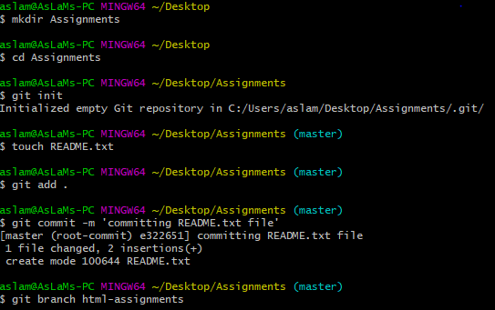

26. Switch to ‘html-assignments’ branch.

27. Copy all HTML assignments inside ‘Assignments’ folder.

28. Commit HTML assignments into ‘html-assignments’ branch.

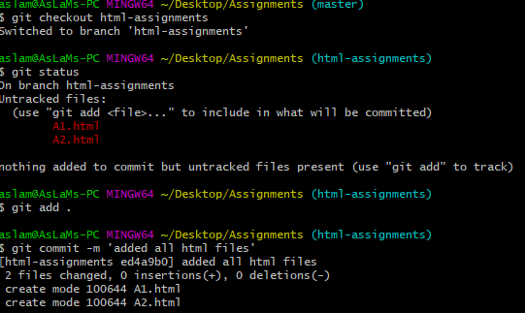

29. Make minor changes into few files belonging to ‘html-assignments’ branch.

30. Commit those changed files.

31. Switch to master branch.

32. Make minor changes into README.txt file & commit those changes into master.

33. Again switch to ‘html-assignments’ branch.

34. Make minor changes into few files belonging to ‘html-assignments’ branch.

35. Commit those changes.

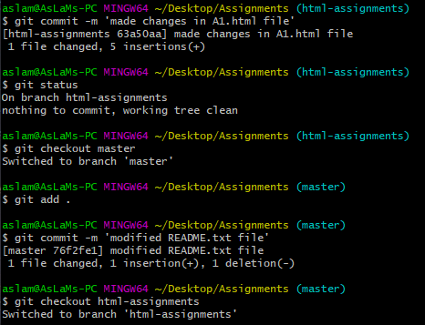

36. Switch to master.

37. Merge ‘html-assignments’ branch into master. Confirm all html assignments are shown

in master.

38. Finally delete the ‘html-assignments’ branch.

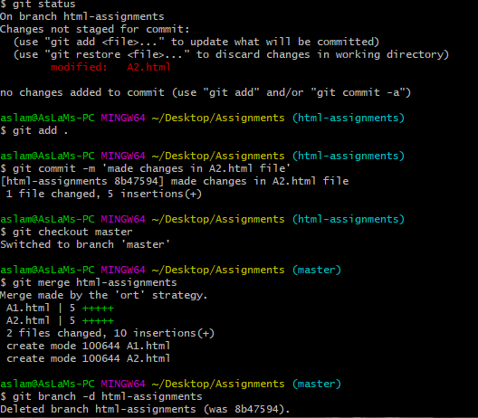

SECTION-2 - (CSS assignments) Steps to follow:

1. Create a new branch ‘css-assignments’.

2. Switch to ‘css-assignments’ branch.

3. Copy all CSS assignments inside ‘Assignments’ folder.

4. Commit CSS assignments into ‘css-assignments’ branch.

5. Make minor changes into README.txt file on line 1 belonging to ‘css-assignments’

branch.

6. Commit those changed files.

7. Switch to master branch.

8. Make minor changes into README.txt file on line 3 & commit those changes into

master.

9. Again switch to ‘css-assignments’ branch.

10. Make minor changes into few files belonging to ‘css-assignments’ branch.

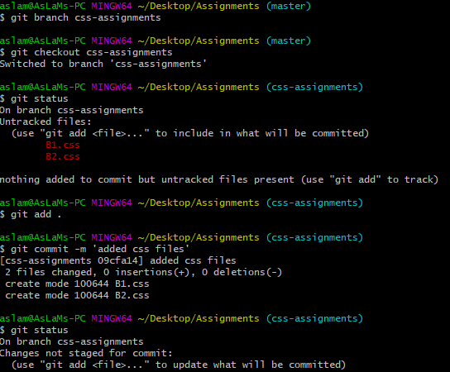

11. Commit those changes.

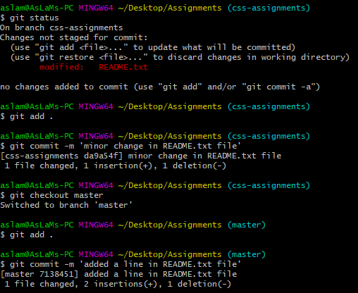

12. Switch to master.

13. Merge ‘css-assignments’ branch into master. Confirm all css assignments are shown in

master.

14. Finally delete the ‘css-assignments’ branch.

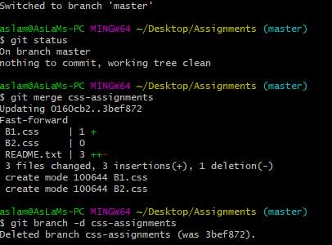

SECTION-3 - (JavaScript assignments) Steps to follow:

1. Create a new branch ‘js-assignments’.

2. Switch to ‘js-assignments’ branch.

3. Copy all JavaScript assignments inside ‘Assignments’ folder.

4. Commit JavaScript assignments into ‘js-assignments’ branch.

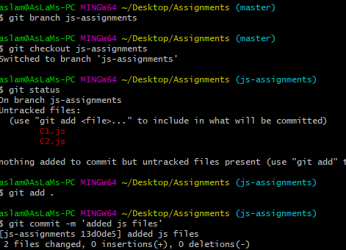

5. Make minor changes into README.txt file on line 1 belonging to ‘js-assignments’ branch.

6. Commit those changed files.

7. Switch to master branch.

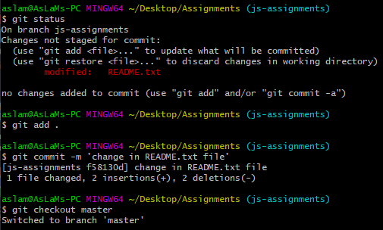

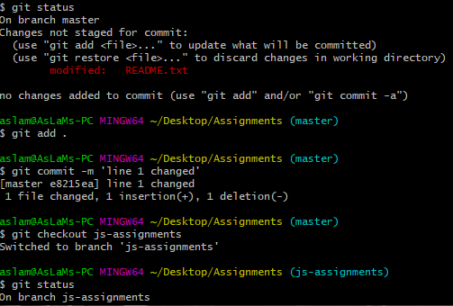

8. Make minor changes into README.txt file on line 1 & commit those changes into

master.

9. Again switch to ‘js-assignments’ branch.

10. Make minor changes into few files belonging to ‘js-assignments’ branch.

11. Commit those changes.

12. Switch to master.

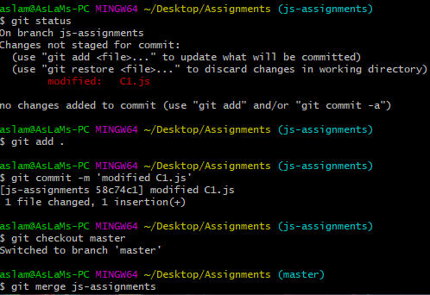

13. Merge ‘js-assignments’ branch into master. Confirm all JavaScript assignments are

shown in master.

14. Finally delete the ‘js-assignments’ branch.

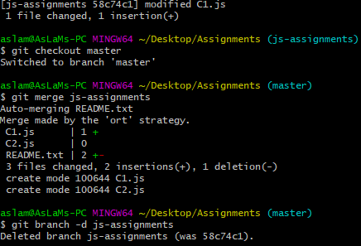

Git Remoting

Objective: Pushing source code into GITHUB & collaborate team members.

SECTION-1 (Pushing assignments to remote repository) - Steps to follow:

39. Create a github account if you do not have already.

40. Login on into github account.

41. Create new public repository ‘freshersbatch-oct16’.

42. Commit & push any sample file to this repository under ‘Assignments’ directory.

