PAINTX
User guide
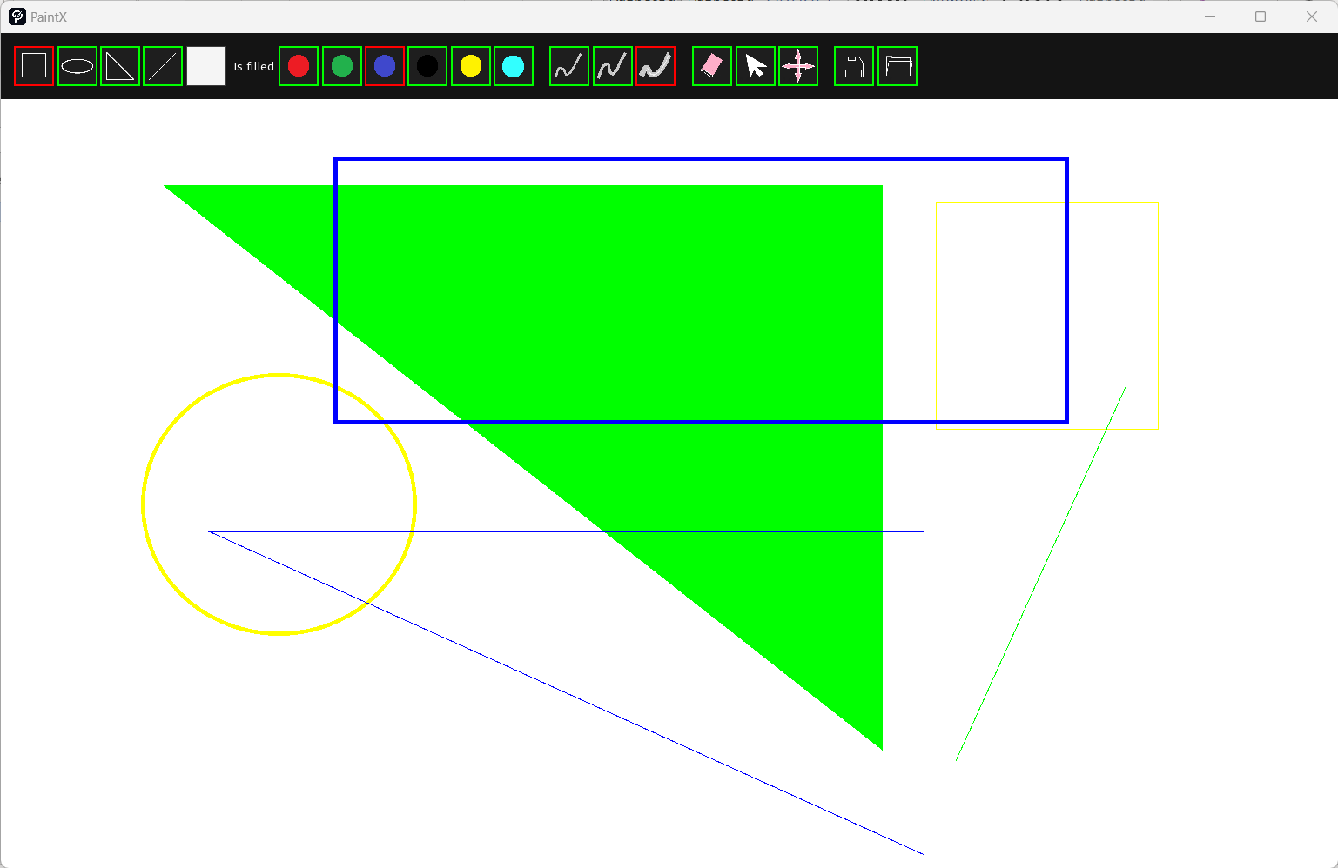

Getting Started
When you launch PaintX, you'll be greeted with a clean interface divided into the following areas:
- Shape Selector: On the top bar, you'll find various shapes like rectangles, ellipses, lines, triangles. Click on any shape to select it for drawing on the canvas.
- Color Selector: Next to the shapes, there's a color palette. Click on any color to change the drawing color. The selected color applies to both the outline and fill of shapes.
- Line Size: Adjust the slider to set the thickness of the lines for your shapes
- Tools:
  - Eraser: Removes parts(shapes) of your drawing.
  - Mover: Allows you to reposition shapes on the canvas.
  - Resizer: Lets you adjust the size of the selected shapes.
- Save/Load Buttons: Use these to save your current drawing or load a previous one.

Drawing Shapes
- Select a shape from the Shape Selector.
- Choose your desired color from the Color Selector.
- Adjust the line size if necessary.
- Click and drag on the canvas to draw the shape.

Editing Shapes
- To erase, select the eraser tool and rub it over the area you want to clear.
- To move a shape, select it with the mover tool, then click and drag to the new location.
- To resize a shape, select it with the resizer tool and drag the handles that appear to adjust its dimensions.

Saving and Loading
- To save your drawing, click the save button. PaintX saves files in the .pnx format.
- To load a drawing, click the load button. Your previous work will appear on the canvas, ready for further editing.

Program documentation
Window class
The Window class encapsulates the main application window functionality using SFML and TGUI libraries. It handles the creation and management of the main window, GUI elements, and rendering loop.

Constructors and Destructor

Window()
Constructs a Window object.
- Initializes the window to 80% of the desktop resolution.
- Sets up the TGUI Gui object and binds it to the SFML window.
- Loads and sets the window icon from an image file.
- Calculates the canvas size and initializes the Canvas object.
- Initializes the UIBar object which contains the GUI elements for the application.
- Ensures proper memory management by deleting allocated resources upon object destruction.

~Window()
Destructor for the Window class.
- Safely releases the dynamically allocated Canvas, Gui, and UIBar objects.

Public Methods

void run()
Begins the main event and rendering loop of the application window.
- Handles window events such as close and resize.
- Enforces minimum size constraints on window resize.
- Updates the view to the new size of the window when resized.
- Processes mouse events to determine interaction with the canvas or UI bar.
- Clears the window and draws all elements, updating the window at a specified frame rate.

sf::RenderWindow& getWindow()
Provides access to the underlying sf::RenderWindow object.
- Returns a reference to the sf::RenderWindow object used by the Window class.

Canvas
The Canvas class is a part of the PaintX application and it manages the drawing area where users can create and manipulate graphical objects. It handles drawing operations, input events related to drawing, and the management of graphical objects.

Constructors and Destructor

Canvas(int width, int height)
Constructs a Canvas object with the specified width and height.
- Initializes a sf::RenderTexture to the given dimensions.
- Creates a sf::Sprite that will display the content of the render texture.
- Clears the render texture with a white color to start with a blank canvas.

~Canvas()
Destructor for the Canvas class.
- Safely releases the sf::Sprite and sf::RenderTexture resources.

Public Methods

void handleEvent(const sf::Event& event, sf::RenderWindow& window)
Handles input events for the canvas, such as mouse clicks and movements.
- Responds to mouse button presses to initiate drawing or object manipulation.
- Responds to mouse button release to finalize drawing or object manipulation.
- Responds to mouse movements to update drawing or object manipulation.

void draw(sf::RenderWindow& window)
Renders the canvas and all contained graphical objects onto the provided window.
- Draws the canvas sprite.
- Iterates through and draws all objects managed by the Controller.
- Draws the currently active object, if any.

void setPosition(float x, float y)
Sets the position of the canvas within the window.
- Updates the position of the canvas sprite.

sf::Vector2f getPosition() const
Returns the current position of the canvas within the window.
- Retrieves the position of the canvas sprite.

int getWidth() const
Returns the width of the canvas.
- Provides the width as specified during construction.

int getHeight() const
Returns the height of the canvas.
- Provides the height as specified during construction.
UIBar
The UIBar class represents a user interface (UI) bar in the PaintX application. It is responsible for aggregating and managing different UI components that provide functionality such as shape selection, color picking, line thickness adjustment, tool selection, and file operations.

Constructors and Destructor

UIBar(int width, int height, tgui::Gui& gui)
Constructs a UIBar object.
- Creates and initializes a render texture to the specified width and height.
- Attaches a sprite to the render texture for displaying the UI bar.
- Sets the UI bar's background color to a dark grey.
- Positions the UI bar at the top of the window (0, 0).
- Initializes various selectors (ShapeSelector, ColorSelector, LineSelector, ToolSelector) and FileTool, passing in the tgui::Gui reference and appropriate widths for positioning.

~UIBar()
Destructor for the UIBar class.
- Releases the dynamically allocated sf::RenderTexture and sf::Sprite objects.

Public Methods

void draw(sf::RenderWindow& window)
Renders the UI bar and its components.
- Calls the display method of renderTexture to update the texture.
- Draws the UI bar sprite onto the window.
- Invokes the draw methods of each UI component (ShapeSelector, ColorSelector, LineSelector, ToolSelector, and FileTool).

void handleEvent(sf::Event& event)
Handles user input events related to the UI bar.
- Currently, this method is empty and can be implemented to respond to specific events affecting the UI bar.

int getWidth()
Returns the width of the UI bar.
- Retrieves and returns the width of the renderTexture.

int getHeight()
Returns the height of the UI bar.
- Retrieves and returns the height of the renderTexture.

sf::Vector2f getPosition()
Returns the position of the UI bar.
- Retrieves and returns the position of the UI bar sprite.
Controller
The Controller class serves as a central hub for managing the state and interactions within the PaintX application. It tracks the current drawing tool, color, line size, fill status, and holds the collection of drawn objects.

Static Members
- Shapes shape: Holds the current shape to be drawn.
- sf::Color color: Holds the current color selected for drawing.
- std::vector<Object*> objects: Stores all the objects that have been drawn.
- Object* currentObject: Points to the object currently being drawn or manipulated.
- LineSize lineSize: Specifies the current line size for drawing.
- bool isFilled: Indicates whether shapes should be drawn filled or not.
- Tool instrument: Represents the current tool selected (e.g., pen, eraser, selector).

Public Methods

void setShape(Shapes shape)
Sets the current shape to be drawn.
- shape: The Shapes enum value representing the new shape to be drawn.

Shapes getShape()
Returns the current shape to be drawn.

void AddObject(Object* object)
Adds a new object to the collection of drawn objects.
- object: A pointer to the Object to be added to the collection.

const std::vector<Object*> getObjects()
Returns a constant reference to the collection of drawn objects.

void setCurrentObject(Object* object)
Sets the current object being manipulated.
- object: A pointer to the Object that is currently being manipulated.

Object* getCurrentObject()
Returns the current object being manipulated.

void setLineSize(LineSize lineSize)
Sets the current line size for drawing.
- lineSize: The LineSize enum value representing the new line size.

sf::Color getColor()
Returns the current color selected for drawing.

void setColor(sf::Color color)
Sets the current color for drawing.
- color: The sf::Color value representing the new color.

void setIsFilled(bool isFilled)
Sets the fill status for shapes.
- isFilled: A boolean indicating whether shapes should be drawn filled.

bool getIsFilled()
Returns the fill status for shapes.

LineSize getLineSizeParameter()
Returns the current LineSize parameter.

void setTool(Tool instrument)
Sets the current tool selected for interaction.
- instrument: The Tool enum value representing the new tool to be used.

Tool getTool()
Returns the current tool selected for interaction.

void RemoveObject(Object* object)
Removes an object from the collection and deletes it from memory.
- object: A pointer to the Object to be removed.

void ClearObjects()
Clears all objects from the collection and deletes them from memory.

void setMovingObject(Object* object)
Sets the current object being moved or resized.
- object: A pointer to the Object that is being moved or resized.

Object* getMovingObject()
Returns the current object being moved or resized.

void ClearController()
Clears the controller state, including all objects and the current object.

float getLineSize()
Returns the numerical value representing the current line size.
ObjectFactory
The ObjectsFactory is a static class designed to facilitate the creation of drawable objects based on the current settings specified in the Controller. It serves as a factory that abstracts the instantiation of various Object types like Line, Rectangle, Ellipse, and Triangle.

Public Methods

static Object* createObject(const sf::Vector2f& start, const sf::Vector2f& end)
Creates and returns a pointer to a new Object instance based on the current shape selected in the Controller.
- start: A sf::Vector2f representing the starting point of the object.
- end: A sf::Vector2f representing the ending point of the object.
The method checks the current shape selected in the Controller and creates an object of the corresponding type. It sets the object's properties such as color, line size, and fill status based on the current settings in the Controller.

Return Value
Returns a pointer to the newly created object, or nullptr if the shape is not recognized or no shape is selected.
Saver
The Saver class is responsible for saving and loading the state of drawn objects to and from a file. It interacts with the Controller class to access the current set of objects and uses file I/O to persist their properties.

Public Methods

void Save(const std::string& filename)
Saves the current set of drawable objects to the specified file.
- filename: A string representing the path to the file where the objects will be saved.
The method opens the file, erasing its current contents (std::ios::trunc), and iterates over the objects managed by the Controller. It writes the type, start point, end point, color, line width, and fill status of each object to the file in a human-readable format.

void Open(const std::string& filename)
Loads drawable objects from the specified file and adds them to the Controller's management.
- filename: A string representing the path to the file from which to load the objects.
The method reads the file line by line, reconstructing each object's properties and creating a new instance of the corresponding drawable object. It then adds the new object to the Controller.
Ellipse
The Ellipse class is a drawable object representing an ellipse. It extends from the base Object class and is designed to be used within a graphical application that utilizes SFML for rendering. The Ellipse class provides functionality to draw both filled and outlined ellipses, check if a point is inside the ellipse, and retrieve the type of shape.

Public Methods

void draw(sf::RenderWindow& window)
Draws the ellipse on the provided SFML RenderWindow.
- window: The SFML RenderWindow where the ellipse will be drawn.
The method calculates the size and center of the ellipse based on the current window size. It then creates a set of vertices that define the shape of the ellipse with the specified number of points for smoothness. If isFilled is true, it draws a filled ellipse using a sf::ConvexShape. If isFilled is false, it draws an outline of the ellipse using a series of quadrilaterals (quads) constructed from the vertices.

bool isInside(sf::Vector2f point, sf::RenderWindow& window)
Determines if a given point is inside the ellipse.
- point: The point to check, specified in window coordinates.
- window: The SFML RenderWindow used for context in calculations.
The method adjusts the point's coordinates relative to the ellipse's center and checks if the point lies within the bounds of the ellipse using its equation. For outlined ellipses, it checks if the point is between the boundaries of the outer and inner ellipses.

std::string getType()
Returns the type of the shape as a string.
- This method always returns "Ellipse".

Drawing and Calculation Explanation

Filled Ellipse Drawing
When isFilled is true, the method draws a filled ellipse by creating a sf::ConvexShape with a set number of points, forming a smooth circular shape. Each point on this shape is calculated using trigonometric functions (cos and sin) to determine its position on the circumference based on the calculated radii a and b.

Outlined Ellipse Drawing
For an outlined ellipse, the method calculates two sets of vertices: one for the outer edge and one for the inner edge of the outline. These vertices form quads that visually create the outline with the specified width (realWidth). The outline is constructed by connecting each consecutive pair of outer and inner vertices, forming a series of narrow shapes around the ellipse's perimeter.

Point-Inside Calculation
The isInside function calculates whether a given point is inside the filled ellipse or near the boundary of the outlined ellipse. For a filled ellipse, the standard ellipse equation is used with the adjusted point to determine if it lies within the ellipse. For an outlined ellipse, the method checks if the point is within the outer ellipse and outside the inner ellipse, creating a band representing the outline width.
Rectangle
The Rectangle class is a concrete implementation of the Object interface for drawing rectangles on the PaintX application canvas.

Member Functions

void draw(sf::RenderWindow& window)
Draws a rectangle on the given sf::RenderWindow.
- Parameters: window - the sf::RenderWindow object on which the rectangle will be drawn.
- Functionality:
  - For a filled rectangle (isFilled is true), it creates an sf::RectangleShape with the size calculated from start and end, sets the fill color, and draws the filled rectangle onto the window.
  - For an unfilled rectangle (isFilled is false), it calculates the vertices for the four sides of the rectangle's outline and uses sf::Quads to draw a thick outline by overlapping the extended sides at the corners.

bool isInside(sf::Vector2f point, sf::RenderWindow& window)
Determines whether the given point is inside the rectangle.
- Parameters:
  - point - the point to check, in window coordinates.
  - window - the sf::RenderWindow object used for reference dimensions.
- Returns: true if the point is inside the rectangle, false otherwise.
- Functionality:
  - For a filled rectangle, it checks whether the point's coordinates fall within the rectangle's boundaries.
  - For an unfilled rectangle, it creates sf::FloatRect objects representing the area of each side including the line width and checks if the point falls within any of these areas.

std::string getType()
Returns the type of the object, in this case, "Rectangle".
- Returns: A string representing the type of the drawable object.
Triangle

