Software Requirements Specification
for
PakWork
Version 1.0 approved
Prepared by Asaad Noman (1912297), Muhammad Ahsan (1912310)
9th November 2022
Table of Contents
Table of Contents ii
Revision History ii
1. Introduction 1
1.1 Purpose 1
1.2 Document Conventions 1
1.3 Intended Audience and Reading Suggestions 1
1.4 Product Scope 1
1.5 References 1
2. Overall Description 1
2.1 Product Perspective 1
2.2 Product Functions 2
2.3 User Classes and Characteristics 2
2.4 Operating Environment 3
2.5 Design and Implementation Constraints 3
2.6 User Documentation 3
2.7 Assumptions and Dependencies 3
3. External Interface Requirements 3
3.1 User Interfaces 3
3.2 Hardware Interfaces 7
3.3 Software Interfaces 7
3.4 Communications Interfaces 7
4. System Features 7
4.1 Freelancer Registration / Verification System 8
4.2 Gig / Job Creating & Posting 10
4.3 Profile Dashboard 12
5. Other Nonfunctional Requirements 16
5.1 Performance Requirements 16
5.2 Safety Requirements 17
5.3 Security Requirements 17
5.4 Software Quality Attributes 17
5.5 Business Rules 17
6. Other Requirements 17
Appendix A: Glossary 17
Appendix B: Analysis Models 17
Appendix C: To Be Determined List 18

Revision History
Name | Date | Reason For Changes | Version

Introduction

Purpose
A Freelancing platform for freelancers. Where freelancers can easily sell their gigs and offer services to potential clients/businesses. We aim to provide a fully featured platform that provides everything necessary for a seamless process of a transaction between two entities.

Document Conventions
The format of this SRS is simple. Indentation is used on general topics and or specific points of interest with ‘Times font’ and are in a larger font size compared to the regular text. The headings have been Bold and the text size used is 14 and for the regular text the text size used is 12.

Intended Audience and Reading Suggestions
This document is to be read by the intended for project manager and teachers. This document is particularly intended for users of the website for understanding the product.

Product Scope
We aim to create a platform that targets freelancers with much easier policies and regional service charges. On the other hand, to tackle the issue of unprofessional and unskilled freelancers, we aim to provide a customized filtering process to ensure that only professional and skilled freelancers can be allowed to work on the platform. We also provide a customized test related to the job that is being bided by freelancers so that only matched freelancers can bid on outsourced projects by businesses, as this way we can tackle much of the filtering part we can offer to the clients. To tackle the issue of the order policy we will make sure that the freelancer has the choice to accept or decline customer job offers made by the client.

References
- IEEE Template for System Requirement Specification Documents: https://goo.gl/nsUFwy

Overall Description

Product Perspective

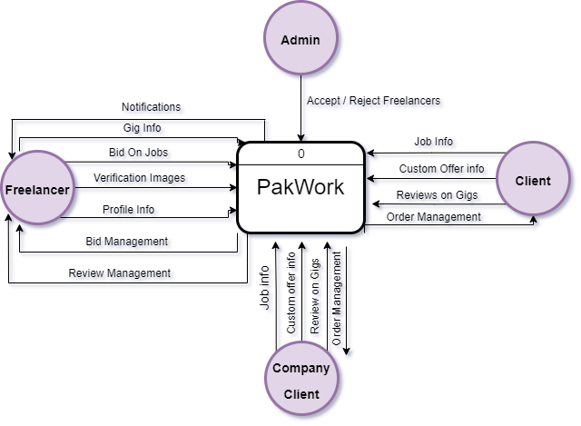

Product Functions
- Freelancer Registration & Verification System
- Gig / Job Creation & Posting
- Order Management
- Buyer Requests
- Search System
- Profile Dashboard
- Bidding System
- Push Notification System
- Custom Offers
- Chat System
- Rating/Feedback System
- Personalized Testing System

User Classes and Characteristics
There will be technically 4 types of users in the system

- Freelancer: The person that will be providing the services to the clients and the companies
- Administrator: The person responsible for verifying the freelancer’s identity
- Client: The person that will publish jobs and custom offers to freelancers to do tasks.
- Company Client: Company that will publish jobs and custom offers to freelancers to do tasks.

Operating Environment
- Software Preferences: The website requires internet access to the internet and browsers such as Chrome, Firefox, MS Edge, Safari
- Hardware Preferences: Website can be accessed using PC/Laptop or Mobile/Tablet

Design and Implementation Constraints
Some system design limitation constraints come from a payment holding system. Which is a common feature which is used by these platforms to cater claims/disputes. Since we are not implementing a payment gateway system or wallet system, hence we are also not implementing this feature.

User Documentation
The website is self-explanatory for the user, that’s why no user manual is provided.

Assumptions and Dependencies
- User must have an active internet connection to access the website
- User must enter valid details into the website
- Proper identification documents are provided to be verified to use the platform

External Interface Requirements

User Interfaces
Main Page



Freelancer Registration



Client Registration
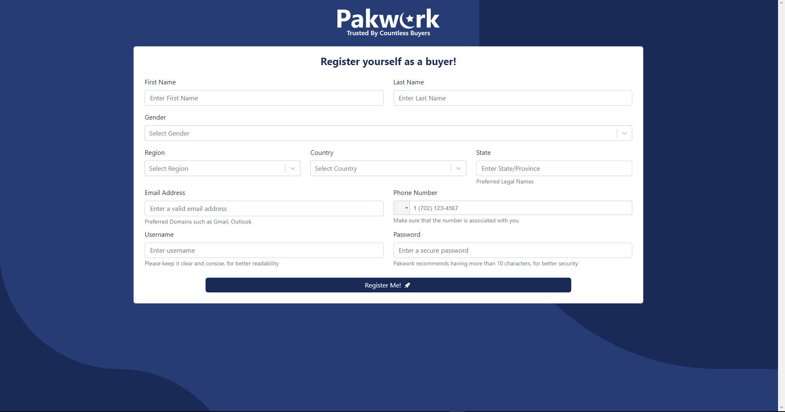

Company Client Registration

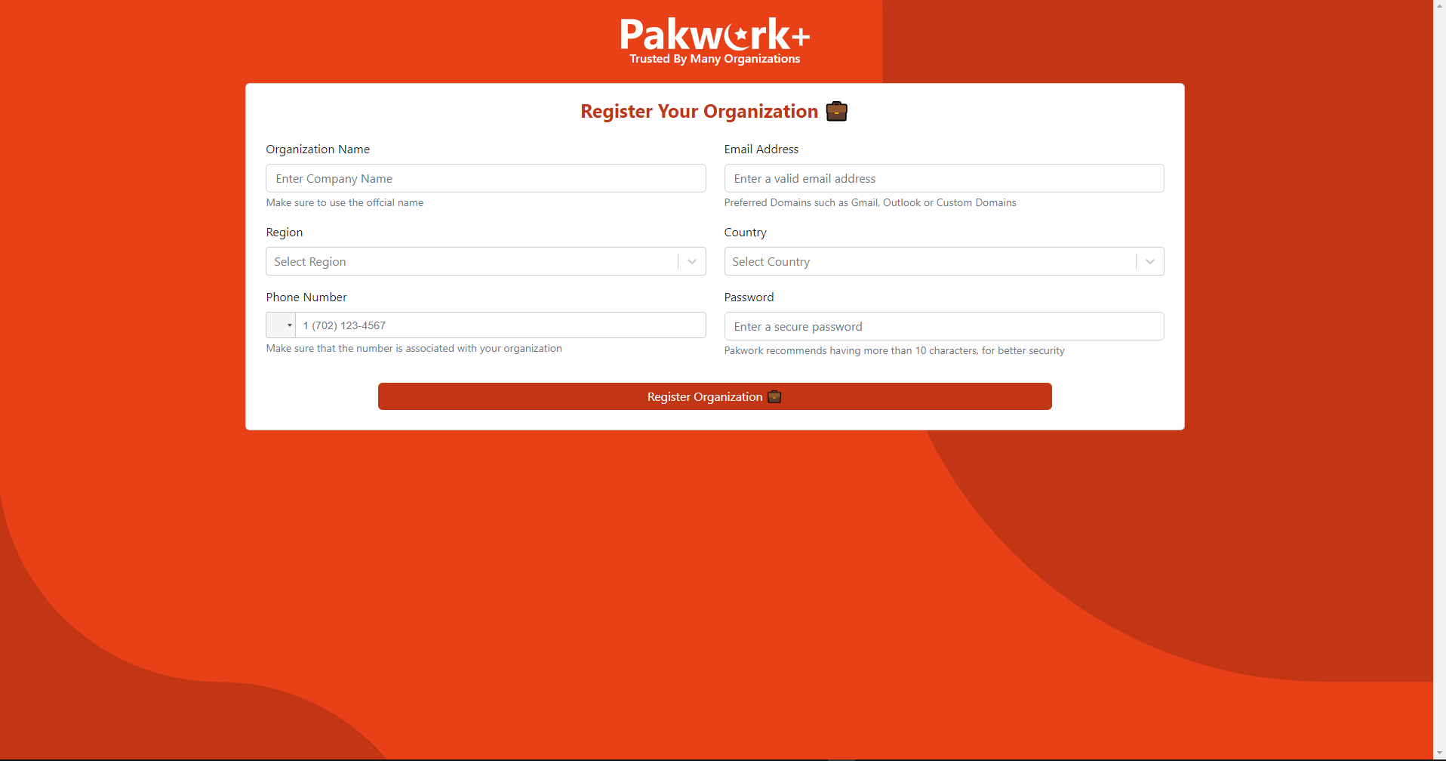

Profile Dashboard

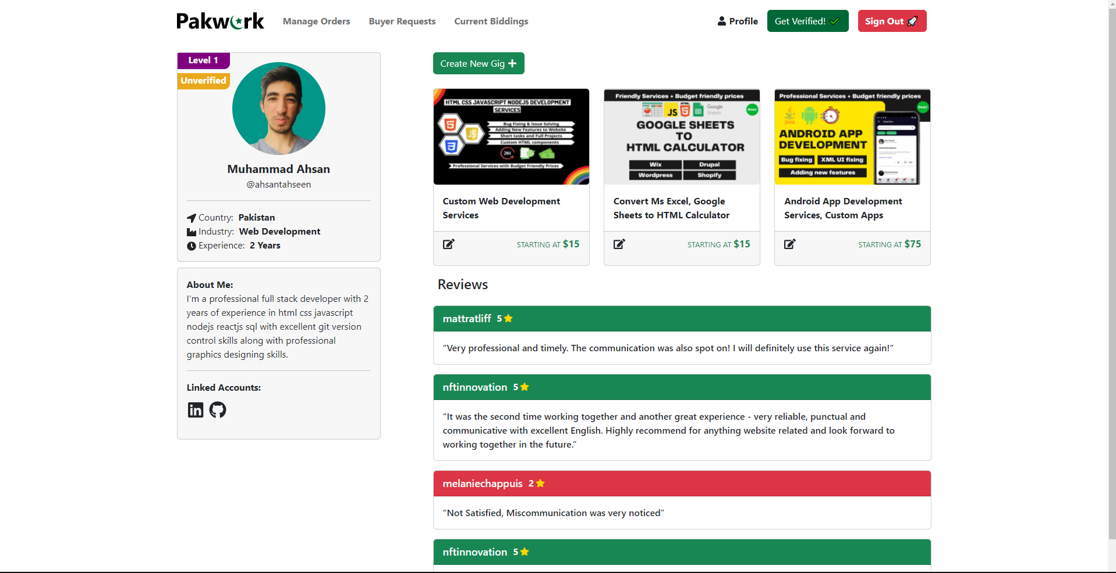

Upload Verification Images

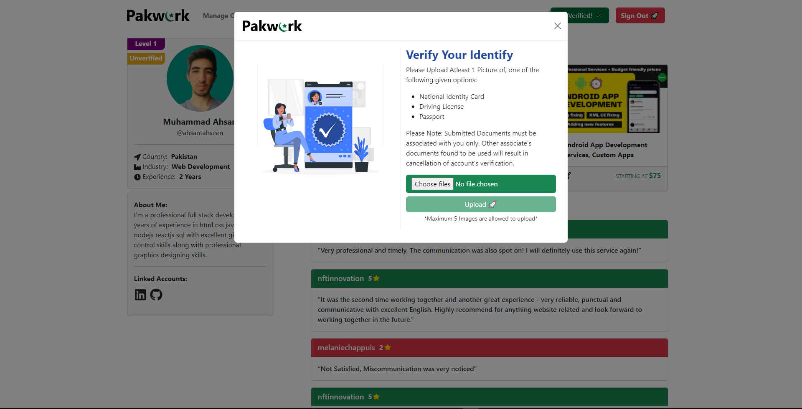

Administrator Login
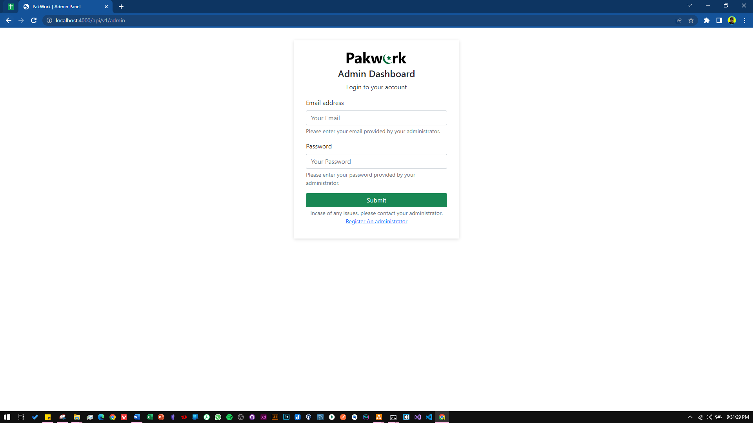

Displaying Unverified Freelancers

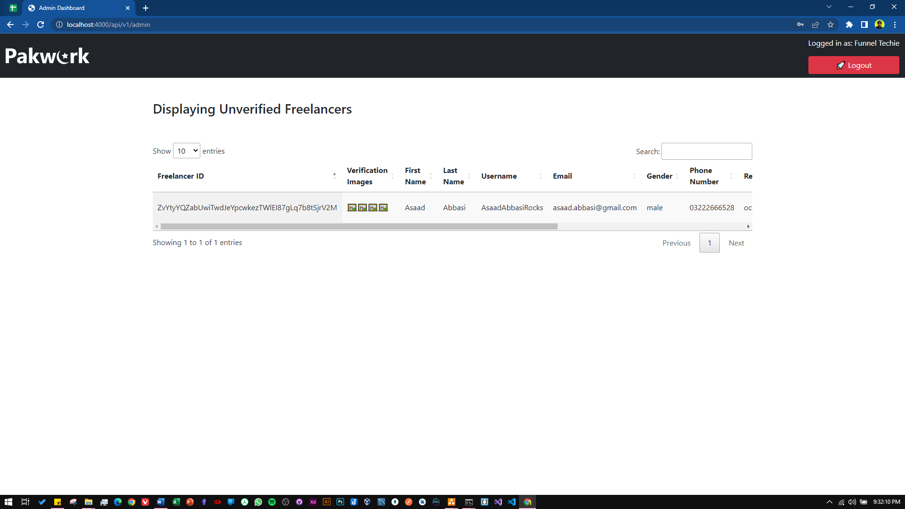

Hardware Interfaces
No hardware interfaces are required since the software has no direct relation or dependability on an external hardware device. But a good fast internet connection is recommended for usage of the website

Software Interfaces
- Visual Studio Code
- MySQL
- MongoDB
- Sockets IO

Communications Interfaces
Communication interface used in this system is HTTP (Hyper Text Transfer Protocol) and WebSocket protocol with polling as a fallback option for chat messages.

System Features

Freelancer Registration / Verification System

Description and Priority
This system is used to register and verify the freelancer before they can start posting gigs and bidding on jobs.

Stimulus/Response Sequences
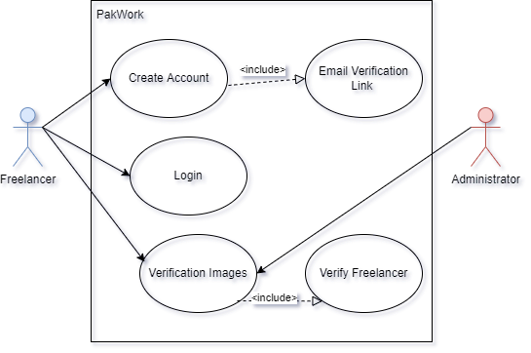

Use Case Name: |  |  | Freelancer Registration / Verification System
Summary: |  |  | Register and verify freelancer before they use the platform
User/Actor: |  |  | Freelancer, Administrator
Preconditions: |  |  | - Internet connection necessary  - Valid information for registering
Basic Course of events/happy path
Step |  | User Actions |  |  | System Actions
1 |  | Freelancers inputs all valid information in registration field |  |  | Wait for the registration button to click
2 |  | Registration button clicked |  |  | - System sends an email verification link to user’s email address  - Saves data to database
3 |  | User Logs In & Uploads verification images |  |  | - Save verification images in database  - Send’s pending request to administrator to foresee
Alternate Flow
Step | User Actions |  |  | System Actions
1 | Wrong Username or password entered when logging in |  |  | Displays an error message “Invalid username or password”
Post conditions
- Verification request is accepted/rejected by the administrator after which freelancer can use the platform
Author
Asaad Noman

Functional Requirements
Test Case ID |  | PW_001 | Test Case Description |  | Testing Freelancer Registration / Verification System
Created By |  | Asaad | Reviewed By |  | Ahsan |  | Version |  | 1.9
QA Tester’s Log |  | N/A
Tester's Name |  | Asaad | Date Tested |  | 9th November 2022 |  | Test Case (Pass/Fail/Not Executed) |  | Pass
S # | Prerequisites: |  |  |  | S # | Test Data
1 | Access to Chrome Browser |  |  |  | 1 | email = asaad@gmail.com
2 |  |  |  |  | 2 | Password = 1234567890
3 |  |  |  |  | 3 | First_name = Asaad
4 |  |  |  |  | 4 | Last_name = Abbasi
 |  |  |  |  |  | Country = Pakistan
 |  |  |  |  |  | State = Karachi
 |  |  |  |  |  | Region = Asia
 |  |  |  |  |  | Phone_number = 03002119222
 |  |  |  |  |  | Username= AsaadNA
Test Scenario | Verify on entering the credentials the freelancer account is created and an email verification link is sent
Step # | Step Details |  | Expected Results |  | Actual Results |  |  | Pass / Fail / Not executed / Suspended
1 | Navigate to http://localhost:3000/ |  | Site should open |  | As Expected |  |  | Pass
2 | Click “Sell your services” |  | Credential can be entered |  | As Expected |  |  | Pass
3 | Click Register |  | Freelancer registered |  | As Expected |  |  | Pass
4 | Email verification link sent |  | Link sent |  | As Expected |  |  | Pass

Gig / Job Creating & Posting

Description & Priority
This feature is used by the freelancer, client & the company client to post gigs, jobs, custom offers respectively

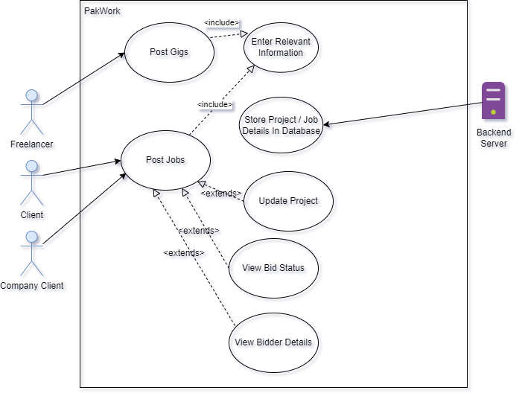
Stimulus/Response Sequences

Use Case Name: |  |  | Gig/Job Creation & Posting
Summary: |  |  | Feature used by freelancers, client & company clients to post job, gigs & send custom offers
User/Actor: |  |  | Freelancer, Client, Company Client
Preconditions: |  |  | The users of the system must be logged in.
Basic Course of events/happy path
Step |  | User Actions |  |  | System Actions
1 |  | The User clicks the create gig/job button |  |  | System displays a modal dialog for user to enter the necessary details
2 |  | User Clicks Post Button |  |  | - Job/Gig gets saved in the database  - Displayed on the profile dashboard
Alternate Flow
Step | User Actions |  |  | System Actions
1 | Some Details are left out and post button is clicked |  |  | Displays an error message to fill the empty fields
Post conditions
The website is refreshed and updated information is displayed on the dashboard
Author
Asaad Noman

Functional Requirements
Test Case ID |  | PW_002 | Test Case Description |  | Testing Gig/Job Posting
Created By |  | Asaad | Reviewed By |  | Ahsan |  | Version |  | 1.0
QA Tester’s Log |  | Testing this from the freelancer side
Tester's Name |  | Asaad | Date Tested |  | 9th November 2022 |  | Test Case (Pass/Fail/Not Executed) |  | Pass
S # | Prerequisites: |  |  |  | S # | Test Data
1 | Should be logged in |  |  |  | 1 | title = Sell Scripts for automation
2 | Should be verified & activated |  |  |  | 2 | startingPrice= 10
3 |  |  |  |  | 3 | detail = lorem ipsum
Test Scenario | Verify on posting that the gig is posted properly and is displaying
Step # | Step Details |  | Expected Results |  | Actual Results |  |  | Pass / Fail / Not executed / Suspended
1 | Navigate to http://localhost:3000/profile/ |  | Site should open |  | As Expected |  |  | Pass
2 | Click create Gig button |  | Credential can be entered |  | As Expected |  |  | Pass
3 | Click Post |  | Gig has been posted |  | As Expected |  |  | Pass

Profile Dashboard

Description & Priority
This feature is basically a dashboard for the user whether it be client. Company client or freelancer. They can view, create their jobs/gigs, change profile picture or update their bio or upload verification images.

Stimulus/Response Sequences
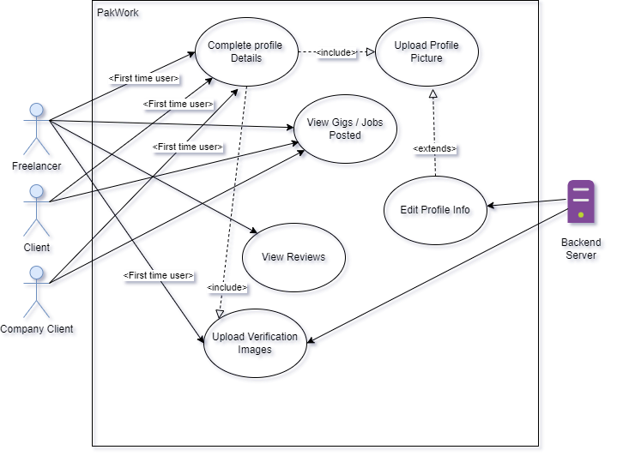

Use Case Name: |  |  | Profile Dashboard
Summary: |  |  | A Feature that allows the users to see and update their profile bio, upload profile pictures, verification images and their gig and jobs posted
User/Actor: |  |  | Freelancer, Client, Company Client
Preconditions: |  |  | The users of the system must be logged in.
Basic Course of events/happy path
Step |  | User Actions |  |  | System Actions
1 |  | The user clicks on profile dashboard |  |  | If profile not completed system tells to complete profile information
2 |  | User completes profile info |  |  | System allows user to view all the necessary information on the profile dashboard
Alternate Flow
Step | User Actions |  |  | System Actions
1 | User tries to view profile without completing profile info |  |  | System continues to show error to complete profile information.
Post conditions
Every information is available in the profile dashboard for the user to see.
Author
Asaad Noman

Functional Requirements
Test Case ID |  | PW_003 | Test Case Description |  | Testing the profile dashboard
Created By |  | Asaad | Reviewed By |  | Ahsan |  | Version |  | 1.0
QA Tester’s Log |  | Reviewing the freelancer profile
Tester's Name |  | Asaad | Date Tested |  | 9th November 2022 |  | Test Case (Pass/Fail/Not Executed) |  | Pass
S # | Prerequisites: |  |  |  | S # | Test Data
1 | Should be loggedin |  |  |  | 1 | N/A
Test Scenario | Verify if all the data on profile dashboard is displaying correctly
Step # | Step Details |  | Expected Results |  | Actual Results |  |  | Pass / Fail / Not executed / Suspended
1 | Navigate to http://localhost:3000/profile |  | Site should open |  | As Expected |  |  | Pass
2 | Profile is displayed |  | All Information is being displayed |  | As Expected |  |  | Pass

Search System

Description & Priority
This feature will allow the clients and freelancer respectively to search for gigs / jobs on the platform

Stimulus/Response Sequences

Other Nonfunctional Requirements

Performance Requirements
<If there are performance requirements for the product under various circumstances, state them here and explain their rationale, to help the developers understand the intent and make suitable design choices. Specify the timing relationships for real time systems. Make such requirements as specific as possible. You may need to state performance requirements for individual functional requirements or features.>

Safety Requirements
<Specify those requirements that are concerned with possible loss, damage, or harm that could result from the use of the product. Define any safeguards or actions that must be taken, as well as actions that must be prevented. Refer to any external policies or regulations that state safety issues that affect the product’s design or use. Define any safety certifications that must be satisfied.>

Security Requirements
<Specify any requirements regarding security or privacy issues surrounding use of the product or protection of the data used or created by the product. Define any user identity authentication requirements. Refer to any external policies or regulations containing security issues that affect the product. Define any security or privacy certifications that must be satisfied.>

Software Quality Attributes
<Specify any additional quality characteristics for the product that will be important to either the customers or the developers. Some to consider are: adaptability, availability, correctness, flexibility, interoperability, maintainability, portability, reliability, reusability, robustness, testability, and usability. Write these to be specific, quantitative, and verifiable when possible. At the least, clarify the relative preferences for various attributes, such as ease of use over ease of learning.>

Business Rules
<List any operating principles about the product, such as which individuals or roles can perform which functions under specific circumstances. These are not functional requirements in themselves, but they may imply certain functional requirements to enforce the rules.>

Other Requirements
<Define any other requirements not covered elsewhere in the SRS. This might include database requirements, internationalization requirements, legal requirements, reuse objectives for the project, and so on. Add any new sections that are pertinent to the project.>
Appendix A: Glossary
<Define all the terms necessary to properly interpret the SRS, including acronyms and abbreviations. You may wish to build a separate glossary that spans multiple projects or the entire organization, and just include terms specific to a single project in each SRS.>
Appendix B: Analysis Models
<Optionally, include any pertinent analysis models, such as data flow diagrams, class diagrams, state-transition diagrams, or entity-relationship diagrams.>
Appendix C: To Be Determined List
<Collect a numbered list of the TBD (to be determined) references that remain in the SRS so they can be tracked to closure.>

