1. The website is a website for the company Partners Powers
2. Partners Powers offers after market parts to mechanics and individuals. They can add their cars information such as vin # or make and model and purchase the part for their vehicle.
3. The 3 processes :
   1. Follow instructions: The user can order parts. In order to do this the UI will guide them on the information they need to enter.
   2. Absorb Information: The user can about different car parts and how to install them.
   3. Communicate: The users can write reviews on product or give recommendations on which type of product to chose (low or high end).
4. My semantic network: 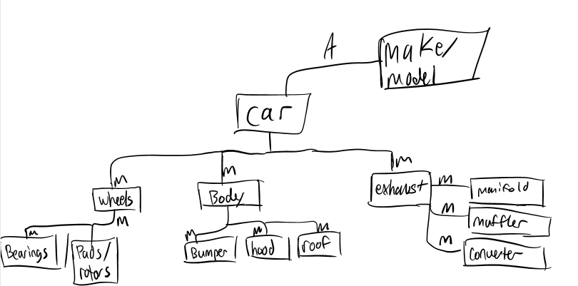
5. Croquis on the following 3 pages.
6. 10 heuristiques:
   1. Coherence: I will have the same top bar throughout all the pages. (you can see this on the croquis).
   2. Familiar Language and Metaphors: The buttons on the top navigation bar are very simple such as: Catalogue, Part Number, Vin and Search. The rest is just information about car so very simple.
   3. Simple Design: Serious font, theme that will persist of blue/white colors. Not too much information on the screen at once. Most of the information will be on the left-hand side.
   4. Liberty: The user has the choice to look for the part any way he would like. He’s able to quickly find multiple different parts for different cars and he isn’t restricted in any parts of the website. He can watch whatever video he likes and browse the parts for any car.
   5. Flexibility: If the expert already knows the part number he can just enter it and order instantly, also if someone is unable to acquire the information needed to find the part through the catalogue he can always enter the VIN number.
   6. Reconnaissance sur le rappel: All makes and model are listed on the left hand side alphabetically.
   7. Etat clair: Its very clear what make/model you have chosen on the left hand side. Your choices are bolded to make them clearer and the part number will be in larger font. It will also give you a list of your choice of make/model in order to ensure that it is the right part for the right car.
   8. Error Prevention: We will only provide the makes/models that currently have a purchasable part. Also, if the part is not yet manufactured it will not appear.
   9. Recuperation of errors: If the page requested does not exist will display a nice message in the UI that we could not find that page and will give him a link to the home page.
   10. Aide: If you have trouble finding the part you could always call partners powers company and speak to a salesman. He will find the part for you and you can come pick it up at the shop.

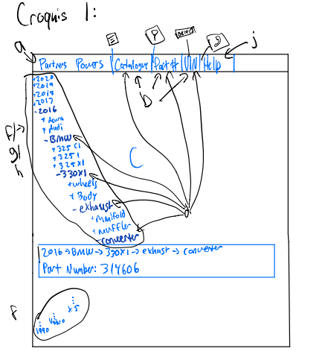

* 1. 