**Deggua**

**Chapter One (DegguaLessons)**

1. **Deggua Bihil (Definition)**

Deggua means sophisticated or fine. Opinion givers say this name is given to it because of the fine nature of the calligraphy and the multiplicity of its signs. Others say Deggua is a collection of hymns, or a book of plain songs. This is because Deggua is a collection of the year’s songs of praise. It is not known whether this name was given to it at the time of St. Yared or afterwards. It is generally believed, however, that St. Yared himself named his works as “Waay Zaima” and did not give the name “Deggua” to it. It is the scholars that came after him that gave the name Deggua to the book and who explained its purposes. Basically, Zaima means sound marking. It also means a sorrowful and plaintive song. In any case, the book of Deggua is the greatest of all of St. Yared” works containing church music to be sung throughout the year.

But it is difficult to assume that this book was written exclusively by St. Yared. The style of the scripts appearing in the introduction and in some portions of the book does not suggest that St. Yared alone is the author. It is believed that some of the writings were added to the book by scholars who lived during the reign of Zara Yacob. This is indicated in the preface of the Deggua book which says, “Isme lezintau metsaf menfeku terekbe imetsahift kahnat kedemt wemenfequ tetsihife Bemewaile Zara Yacob Negus,” (see preface of Deggua.)Whatever the case, it is not clearly indicated when the additions were incorporated. Generally speaking, however, Deggua is believed to have been the brainchild of St. Yared. The notations of Deggua are eight in number; they are all the works of St. Yared. But other notations were later on added to Deggua by St. Yared’s disciples known as Behawira, Besawira, Beiskindiriya, Bepaiskindiriya and Be’abdira. Yet other notations were added by scholars of Tedbaba Mariam known as Azaz Gera and Azaz Raguel who lived during the reign of Atse Sertse Dingil. These scholars were compelled to add these notions in the fear that the disappearance of most of the writings during the invasion of Gragn had made matters worse. So they wanted to make up for the previous losses. The original eight notations that existed at the time of St. Yared are the following: Yizet, Deret, Difat, Heed, Qurt, Rikrik, Qinat and Chiret. These conform to the eight notations of the Europeans.

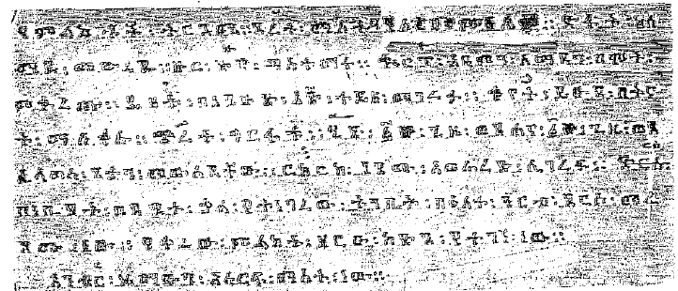

Later on, two other notations called Dirs and Anbir were added thus bringing the total number of notations to ten. These conform to the ten strings of Begena, Ethiopia’s musical instrument. Ethiopian music scholars subsequently added yet other signs they consider will be useful for the hymns. However, it is only the ten notations that are made use of in Ezil, Ge’ez and Araraay hymns. In other words, only the ten are formally recognized although other signs have been added afterwards. Therefore, Deggua hymns are chanted in Ezil, Ge’ez and Araraay melodies making use of the ten primary notations alone.

Ge’ez Zaima (hymn) is the first stage of song which is loud and strong in kind. Ezil Zaima is the second stage to be sung together with the first which is gentler and more melodious voice. Araraay Zaima is a sorrowful and plaintive song. Scholars teach that no musical tone is outside these three melodies. It is said that Ge’ez symbolizes God the Father, Ezil symbolizes God the Son and Araraay symbolizes God the Holy Spirit. Ge’ez means the beginning or the eloquent one while Ezil means complementary meaning that God the Son endured suffering to save Adam. Araraay means sweet referring to the treasure of the Holy Spirit. Ezil means complementary because it complements Ge’ez while Araraay means melancholic and attracting sympathy.

The three melodies of Ge’ez, Ezil and Araraay can be put together in praise of the three members of the Holy Trinity. It is sung as Ahadu Ab Kidus in Ge’ez, AhaduWold Kidus in Ezil and Ahadu Wuyitu Menfes Kidus in Araraay. One can also compose Ezil and Araraay melodies from Ge’ez. It gives the meaning that the Son came from God the Father and that the Holy Spirit came from the Son. We have said that lessons in Zaima are classified in to Ge’ez, Ezil and Araraay. But the three can be composed in one hymn or two of them sung together as indicated below:

1. **In Ge’ez Araraay and Ezil**

“Bahire Girmite, gebre arefte, webewustefa Araya finote, Beide Melaku aqeboma begedam lehizbu arba amet, weseseyomu mena hibist, kine tibebu zealbo mesferte”. This can be sung in all there Ge’ez, Ezil and Araraay melodies.

1. **Ezil and Ge’ez**

“Etkil tekebto hager, inte tehantsit mel’ilte debir, yi’itke sibketat ze hawariyat etkil tekebto hager”. This is sung in Ge’ez and Ezil melodies.

1. **Araraay and Ezil**

“We azeze dudiyanos negus Agbere lotu Ase’ine Zehatsin we’asteseanwo le kidus Giorghis temetive sirwe wetekiwe demu Le kidus Giorghis, temetre sirwu wetekiwe demu, wesobe si’ine segire dibute hore tserha Giorghis Beabiye qal weybe ifo iyile keme amlakiye teseqele dibe itsemesfel.” This is sung in Araraay and Ezil.

1. **Ge’ez and Araraay together**

“Zebedamit tenebeye webe Yohannes (up to Ge’ez) Timkete Hariye Bekana Zegelila maye weyine reseye Me’aza Kalike Yitnekef tselotiye. This is sung in Araraay.

1. **Ge’ez and Ezil together**

“Simani egziyo (Ge’ez) tgelotye halelujah (Ezil) weybitah kidmeke (Ge’ez) ge’ariye halelulja weitmit getseke imneye (beilete mindabeye atsimya iznek (Ge’ez) habeye halelujah (Ezil) ameilete ifswuake fitune (Ge’ez) simari hallelujah le’alem welealemalem (Ezil) we’ame sidus nesiomu (Ge’ez).

Iyesus le Pefros wele Yacob wele Yohannes we airegomu Debre Newaha (Ezil) inte bahititomu wetewelete arayahu bekidmehomu.”

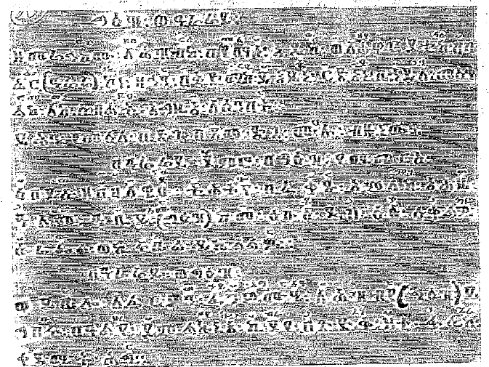

These hymns are composed taking into account the needs of the various dispensations of time as well as holidays so they could be sung all year round as the occasion dictates.

Deggua is the first music composed by St. Yared. It is described as Yared’s masterpiece with its superb poetic value and wonderful literary style. It is said that St. Yared himself composed the poetry besides putting it into melodies. This can be verified by carefully scrutinizing the nature of the poems which indicate that they are all the style of St. Yared. This is particularly observed in the lesson which reads, “Bahire girmite gebre arefte, webewusteta araye finote, be’ide melaku akebomu begedam Lehizbe arba amete wesesayoonu mena hibiste kine tibebu ze albo mesferte”. It also appears in poetry form like this, “Atmeqe Wetetemeke Lelike, kal fenewete nebiye leul tesemeyke. “There are many others like this. The poems may be of different kinds with different styles of ending like in “halelujah Le’ab Mikael bihil, itsub neger, halelujah Le Gabriel bihil welde egziabher, or haleluja we Lemenfes Kidus zergib, kinefihu ze’isat, neyasteseri hatiyate hizb,” (This is called Ariyam zehamus). Others may appear in different forms. These are 1. Prose but written in the form of poetry 2. Like the European style of poems 3. Other styles.

Well, we may assume that these songs might have been composed by St. Yared. But we don’t know for sure to whom he taught these hymns or who his disciples were. Some historians assume, however, that his major followers like Menkira, Sawira, Hawira, Iskindira, Paiskindira, Abidara, and others were his own students who later built on the hymns. But his life history proved that the clergy had been travelling to the St. Yared monastery in the north to study the hymns which later spread all over the country. (Yared’s life history). But these music heritages were destroyed during the reign of Yodit Gudit who destroyed all Christian church treasures. Whatever documents that managed to survive were later on collected, assembled and preserved during the reign of Zara Yacob. It is also said that St. Yared’s followers, especially Hawira and Mankira, played vital role in preserving the works of St. Yared including the kines (poem), Deggua hymns and others. It is during this time that the doctrines of the Ethiopian Orthodox Church and its services began to take shape.

1. **Collection of Deggua**

Deggua hymns have later been recollected from wherever they have been scattered. Following Yared’s death and the destruction caused by Yodit Godit’s era, Deggua was destroyed for the most part. It was during the reign of Atse Zara Yacob that these were recollected under the auspices of Abba Giorghis. Historians attest to the fact that many people learned Deggua hymns from Abba Giorghis who is generally credited for giving the hymns a proper shape. But these ones were again destroyed during the invasion of Gragn. Scholars were deeply disturbed by this until it was discovered that a Bethlehem monk by the name of Abba Lisane Ifret had secretly kept a collection. So the Deggua was again recomposed for the third time both in its wording and singing. It other words, the Deggua hymns composed and sung by St. Yared were first destroyed by Yodit Gudit. Secondly, Deggua hymns were collected by Abba Giorghis Zegascha and put to use. Thirdly, Deggua hymens were restored from the collection found with the Bethlehem monk known as Abba Lisane Ifret. This monk is popularly known as Abba Lisane Ifret merahi of Bethlehem. The present Deggua hymns were recomposed by him and his disciple called Abba Zekale Ab. It was from this time onwards that the present Deggua hymns had been sung without any alteration. It was preserved by Abba Zekale Ab and his successors listed in the following order: Abba Zekale Ab taught Kale Awad who replaced him. Abba Kale Awad was a teacher in Debre Libanos. He held the title of Ichege, a title reserved for monks. All Bethlehem administrators were known as Icheges. Others like Ichege Betre were the more popular ones at the time. Kale Awad then taught Hintsa Haymanot and Tetemkemedhin. Hintsa Hayimanot taught Wolde Melekot, and Wolde Melekot taught Sertse Mariam. Again Sertse Mariam taught Kinfe Michael. Some of the hymns like koma, tegulet, Achabrew and Winchere were put aside while the rest were introduced into other parts of the country. Accordingly, Deggua hymns were introduced further in to Begemidir, Debre Gerima of Tigray, Debre Negodguad of Wello, Debre Egziabher, AtronsMariam. Tedbaba Mariam, Mekane Sellasie, Shoa, Debre Lebanos and other places. Deggua hymns were particularly popular in all of Begemidir. Later on, Deggua hymns reached all parts of the country. Subsequently, Knife Michael taught Deggua to Gebre Egziabher (Merigeta Derso), and Debre Egziabher taught Gebre Medhin who is also known as Aleqa Mersha. There were ten Degguascholars between Abba Lisane Ifret and Aleqa Amsalu. It was Gebre Medhin that taught Aleka Amsalu. We were able to trace these scholars as they all served in the famous Deggua School at Bethelehem monastery. It was not possible to trace the genealogy of church scholars especially on church lessons like kine, akuakuam and others. Other Deggua students testified that they were taught by this or that monk or they were disciples of this or that teacher. Such students often served in a number of places and they found it difficult to trace their teachers correctly. But it was only the Bethlehem monastery that issued certificates. It was from this monastery that they traced their history of training.

**Chapter Two (Parts of Deggua)**

Deggua hymn book is divided into four major parts for convenience of singing. This classification into four parts symbolized the four gospel writers. These are:

1. **Yohannes part**

The first part is known as Yohannes. This is because Yohannes is a bridge between the Old Testament and the New Testament. That is why Deggua’s beginning came to be known as Yohannes. The Deggua begins with the words, “You are blessed, Yohannes.”

This begins with the life history of Yohannes and then goes on to explain the New Testament. In terms of its complexity and number of melodies, Yohannes is most difficult. There are a total of 3,577 melodies to be sung in Yohannes form Meskerem 1 to 8 (September 11 to 18).

1. **Astemirho**

Astemirho means that which reveals the Lord’s teachings. It recounts our Lord’s teaching. The songs are sung based on these teaching. Astemirho is not limited to one period. It comes in different times and eras. It is sung repeatedly. There are a total of 3,477 songs in this part.

**Tsome Deggua:** The next one is Tsome Deggua which is sung only during the Lent season. Many scholars say this should be included in Astemirho. But it is believed by many that it be a separate part. (see page 85 of original for details).

1. **Fasika**

This is sung from Easter Sunday up to Aba Gerima. It has 3,469 songs. This on its own is divided into 22 chapters. The number of 22 represents the 22 creation types. This is further explained on page 72. The word Fasika means praises.

1. **Deggua: Number and time dispensation**

|  |  |  |  |  |  |  |  |  |  |  |  |
| --- | --- | --- | --- | --- | --- | --- | --- | --- | --- | --- | --- |
| No | Zeyohannes | Size | No | Astemirho | Size | No | Zefasika | Size | No | General  Name | Total |
| 1 | Mismak | 19 | 1 | Mismak | 15 | 1 | Mismak | 22 | 1 | Mismakoch | 56 |
| 2 | WaZaima | 176 | 2 | WaZaima | 227 | 2 | WaZaima | 157 | 2 | Wazemoch | 560 |
| 3 | Beamist | 51 | 3 | Beamist | 43 | 3 | Beamist | 56 | 3 | Beamistoch | 150 |
| 4 | Egziabher Negise |  | 4 | Egziabher Nigese | 24 | 4 | Egziabher Nigese | 52 | 4 | Egziabher Negise | 119 |
| 5 | Yitbarek | 43 | 5 | Yitbarek | 46 | 5 | Yitbarek | 58 | 5 | Yitbarek | 166 |
| 6 | Selest | 62 | 6 | Selest | 320 | 6 | Selest | 579 | 6 | Selest | 1220 |
| 7 | Selam | 321 | 7 | Selam | 591 | 7 | Selam | 579 | 7 | Selam | 1630 |
| 8 | Mezmur | 460 | 8 | Mezmur | 53 | 8 | Mezmur | 72 | 8 | Mezmur | 171 |
| 9 | Arbait | 46 | 9 | Arbait | 216 | 9 | Arbait | 289 | 9 | Arbait | 752 |
| 10 | Ezil | 247 | 10 | Ezil | 176 | 10 | Ezil | 214 | 10 | Ezil | 585 |
| 11 | Mahlet | 195 | 11 | Mahlet | 59 | 11 | Mahlet | 54 | 11 | Mahlet | 195 |
| 12 | Sebhat Negih | 82 | 12 | Sebhat Negih | 58 | 12 | Sebhat Negih | 88 | 12 | Sebhat Negih | 185 |
| 13 | Zeyise |  | 13 | Zeyise | 15 | 13 | Zeyise | 19 | 13 | Zeyise | 38 |
| 14 | Zeamlakiye | 39 | 14 | Zeamlakiye | 17 | 14 | Zeamlakiye | 14 | 14 | Zeamlakiye | 48 |
| 15 | Zenahu Senay | 4 | 15 | Zenahu  Senay | 4 | 15 | Zenahu | 16 | 15 | Zenahu Senay | 16 |
| 16 | Aryam | 415 | 16 | Aryam | 252 | 16 | Aryam |  |  | Aryam | 667 |
| 17 | Esme le alem | 926 | 17 | Esme le alem |  | 17 | Esme le alem | 17 |  | Esme le alem | 17 |
| 18 | Abun | 458 | 18 | Abun | 437 | 18 | Abun | 447 | 18 | Abun | 1342 |
| 19 | Hyente Kinewoch | 3 | 19 | Hyente Kinewoch |  | 19 | Hyente Kinewoch |  | 19 | Hyente Kinewoch | 3 |
| 20 | Me’ewad | 1 | 20  21  22  23  24  25 | Me’ewad  Mewedese  Kibir ye’eti  Zaimare  Etane Moger  Miknay | 5  3  1  1  1  1 | 20  21  22  23  24 | Me’ewad  Mewedese  Mibezehu  Bet’su’e  Zeyelebu  Kolekimu | 1  1  1  1  1 | 20  21  22  23  24  25  26  27  28 | Me’ewad  Mewedese  Kibir ye’eti  Zaimare  Etane Moger  Miknay  Mibezehu  Bet’su’e  Zeyelebu  Kolekimu | 7  4  1  1  1  1  1  1  1 |
|  | Total | 3577 |  | Total | 3474 |  | Total | 3469 |  | Total | 10520 |

The above are songs that are traditionally sung from year to year. It is possible that a song may be omitted for lack of time space. Only limited ones are selected and sung on public holidays. They are classified as songs to be sung on public holidays, annual songs, annual Abun and Isme Le’alem.

These are printed in a hymnal called the five Tsewate songs. These are sung on occasions on a selective basis.

1. **Deggua lessons over the years**

Education in Ethiopia has shown changes and improvements over the years but Deggua lessons have not shown any changes. New kines may come every time but they maintain their ancient style and form. It is said that somebody has computed a new poem. But they are sung in their ancient liturgical styles and their poetic value, although appreciated; remain obscured for the most part, except in Silelulka And Debre Abbay. There are slight changes in Kome, Achabrew and Tegulete kines but they are even more ancient than those of Bethlehem. In fact, most kines have lost their original identities and people are observed going to Bethlehem to trace their organs. Lessons on Akuakuam (manner of standing) have shown some improvements. Of late, there has emerged new lessons on Akuakuam known as Tekle Akuakuam, but Deggua has made no change.

Depending on the competence of the Merigeta (song leader), however, it is possible to compose new songs and include them in the standard ones.

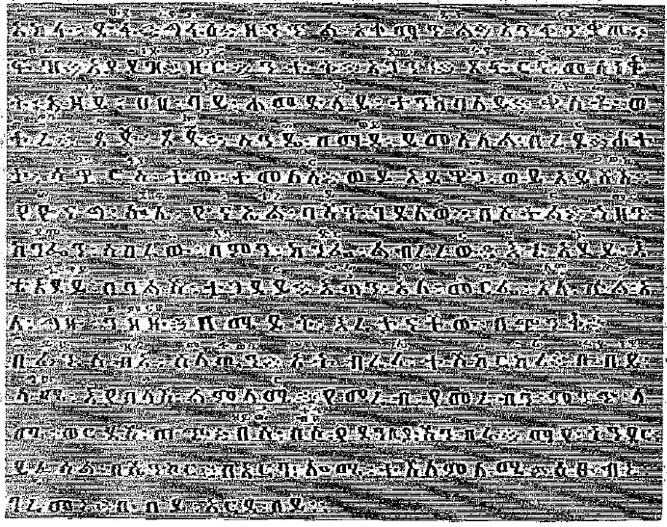

In this regard, it is observed that there are some strange songs inserted in Deggua known as Awalid, but nobody knows when and how these are inserted. One opinion giver differs from the other one in this regard. There have been some new notations added here and there. For example, it is said:

Iyasu of Gondar

Wears a golden crown

Never retreats, but fights on

Such prose in praise of the Gondar Kingdom is inserted from time to time. Other Awalids like the Daniel Deggua is also inserted here and there. A witness’s Deggua is classified into three in Bethlehem.

1. Daniel

2. Getayehu Ingidayehu

and 3. Berhane Alem. There is also another collection called Senbet Amigne. This is considered to be an improvement, but scholars widely disagree on this one. As its origin is not known for sure, it has failed to gain any acceptance. Bat it is generally assumed that a student of Gondar Akuakuam composed this one. It is also assumed that this one is the work of the kingdom of Gondar. This is because it contains the annual songs including Isme Lealem and Abun zimares. Others say this is the collection from Shoa because it is widely used there. It is however believed by scholars that it is possible to make improvements on all these works, if necessary.

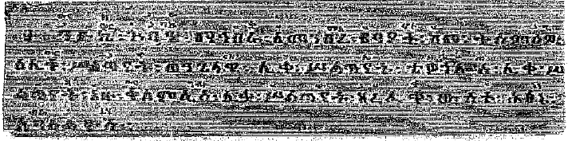

Merigeta Tibebu Mengistu believes that it is possible to compose modern prose.

**Chapter Three (Tsome Deggua)**

Tsome Deggua is one part of the Deggua series particularly intended for the fasting seasons. As first, it was included in the part of Astemirho. Scholars believe that this was made on autonomous part by the religious heads of Debre Negoduad and Debre Egziabher under the Atse Zara Yacob era. Abba Giorgis played a major role in this.Others say that it was St. Yared himself, who is the original author that put it in a separate classification.

**Details of Tsome Deggua**

Mahatiwa is a threshold to WaZaima song. It begins with Zeworede just before WaZaima. Then it goes on as “Kunu inke”.Then comes the part known as Beamist, followed by Egziabher Negise, Yitbarek, Selest and Selam. These are together called WaZaima and they number eight altogether.

1. **Mezmur Zesenbet**

There are 21 kinds of Tsome Deggua sung on Sundays including the following ones:

1. Tekeneyu

2. Zeamlakiye

3. Beamist

4. Arbait

5. Beamist (2)

6. Egziabher Negise

7. Ezil

8. Mahlet

9. Zeyize

10. Sebhat Negih

11. Arat Isme Lealem

12. and Abun

13. Selest

14. Selam

**2. Zeworede songs**

Tsome Deggua sung from Monday to Saturday are the following:

Monday zeworede begins with Negih Ezil and continues with mahlet, sibhat Negih, isme lealem, kiniwat, abun, Aserkot mariam or Tirf Ariyam, Abun Arbait and selam. They are ten in total. At selest hour, Ariyam, Abun, Arbait, selest, and selam are sung and these are six in total. At 12 o’clock, Ariyam, Abun, Zeamlakiye, Kinwat, Selest and Selam are sung and these also number six.

One WaZaima, one Amist, one Arbait, Selest and Selam are also sung. Eighteen songs are sung each day, out of which six are WaZaima. That is to say the following songs are sung each day.

Monday 34,

Tuesday 34,

Wednesday 34,

Thursday 34,

Friday 34,

and Saturday 8 including Negih Ezil, Mahlet, Sebhat Negih, Isme Lealem (2), Abun, Selest and Selam.

The following are the names of Tsome Deggua songs sung from eve of Saturday to dawn of Sunday:

1. Wazeme
2. Beamist
3. Egziabher negise
4. Yitbarek
5. Selest
6. Selam
7. Mezmur
8. Zeamlakiye
9. Arbait
10. Mewedis
11. Ezil
12. Zeyize
13. Mahlet
14. Sebhat negih
15. Isme lealem
16. Abun
17. Ariyam
18. Kinwat
19. Kibir yi’iti
20. .Zimare and
21. Itane Moger.

The following ones are extra ones:Hosanna, mi’iwad, crucifixion week, abun, ile, simwoke, Hawariyatihu Kebebe zeyehatseb, ile, Nizenu ile wetseiho zekedam si’ur ke Ezil iske Itane Moger. These are 1,172 in total.

The other ones are Hawariyat (8) Meskel (8), Arba Hara Semay (15) Tewokritos (8), Megabit Mariyam(8) Tisbi’it 21 and these are 66 in total.

In between tirf bemisbak songs are also sung such others like hiyinte tseliyu, hiyinte eleilek songs. Others including Arhaw hohote, manu wuyitu zintu, Egziabher amlake hyal’an, Kiristos amlakine, risebiho kiryalayion, leamlak yidelu, lemeskelike nisegid, wewedeyu, gifomu, amrestifi, nisebiho ame tensiya, imeskelu Kiristos yitnesah te’awuke wezikulu albomu holqu. These are songs about the Passion of Christ. These are only written in Tsome Deggua, not taught.

There are 55 days in the Lent fasting season. Together with the Zeworede Saturday and Sunday, they become 57. The songs sung each day of Lent are the following:

Ezil, Mahlet, Sebhat Negih, Isme Le’alem, Kiniwat, Ariyam, Abun, Arbait, Selest, Selam, Zeamlakiye, Zeyize, Mezmur, Mewedis, WaZaima, Beamist, Egiziabher Negise, Yitbarek, Mihilaw Bemuln, Kiir Yi’iti, Zimare and Itane Moger. See the following table for details of the weeks:

**Weeks**

|  |  |  |  |  |  |  |  |  |
| --- | --- | --- | --- | --- | --- | --- | --- | --- |
|  | **Zeworede** | **Kidist** | **Mikurab** | **Metsagu** | **D.Zeit** | **G.Her.** | **Niko.** | **Hosanna** |
| Saturday | 8 | 15 | 15 | 16 | 15 | 15 | 16 | 16 |
| Sunday | 21 | 21 | 21 | 22 | 22 | 24 | 21 | 28 |
| Monday | 34 | 32 | 32 | 32 | 32 | 32 | 32 | 4 |
| Tuesday | 34 | 32 | 32 | 32 | 32 | 32 |  | 4 |
| Wednesday | 34 | 32 | 32 | 32 | 32 | 47 | 34 |  |
| Thursday | 34 | 32 | 32 | 32 | 32 | 32 | 34 | 5 |
| Friday | 34 | 32 | 32 | 32 | 32 | 32 | 4 | 24 |

Those of Saturday night are 13 altogether. But all added up together will be 1,172. Tsome Deggua has yet other extra ones. But the major ones that are in every day usage are the following:

**3. List of Tsome Deggua**

|  |  |
| --- | --- |
| 1. Ariyam | 112 |
| 2. Arbait | 116 |
| 3.Selest | 202 |
| 4.Selam | 206 |
| 5.WaZaima Yetsomu | 49 |
| 6.Beamist | 114 |
| 7.Yitbarek | 8 |
| 8.Egziabher Negise | 16 |
| Mezmur | 8 |
| Zeamlakiye | 43 |
| Mewedisk | 2 |
| Isme Le’alem | 19 |
| Kinwat | 161 |
| Abun | 165 |
| Ezil | 52 |
| Zeyize | 11 |
| Mahlet | 50 |
| Sebhat Negih | 59 |
| Kibir Yi’iti | 20 |
| Zimare |  |
| and 21 Itane Moger. These are 10 together. | |

Besides, Haimanot Abun are 4, Siklet Mezmur are 5, Wengel Merge file wetsebiho are 16, be’izel hiyinte izil are 7, hiyinte Abun are 20, waZaima bet are 6, Arbait are 7, negis are 4, and Ge’ez waZaima are 6.

Sebhat negih, WaZaima, Zeamlakiye, Mahlet, Selest are not known in numbers as they are inserted here and there.

There are 3 Mihila Misbak, 3 Mezmor, 3 Selamu to be sung three days in the fasting season. Those dealing with the Passion of Christ includingHosanna Yibian, Menu Wuyita, Siklet Lemeskelike, Amestiti Gifiomu, Kiristos Amlakine, Misebiho, Amne Tensae of Saturday night, Imeskelu Kiristos, Yitnesah, Te’awuke are not counted.

**Chapter Four**

**(Deggua Concepts)**

Concept (Yitbehal) means order of Deggua. By church order we mean the laws or regulations of the church. So in order to serve the church well, we need to know the order of Deggua in the first place. This order or regulation reads like this at the beginning, “Weg Wesirat im Yohannes iske Yohannes, We im Yohannes iske Zakarias Yohannes Yitbehal.”

The period from im Yohannes upto Zakariyas is known as the seven days of Yohannes. The 8th of Meskerem (September) is called Zakariyas. It is also called we Sidistu Hineste. From 17thMeskerem up to Tseat Kiremt is called Meskel. From 26th Meskerm to Abba Yohani, it is called Tsigie.

**Sibket:** The period from Sibket to Berhan is generally called Sibket.Of this period, the following verse is recited, ‘Le’ime kone Eliyas besilus Ame asir wer wesost zibir, be rebuyi le ime kone ame wesenuyu giber, behamus leime kone ame asiru we amiru ziber, be arb lime kone ame asiru ziber, be kedamit le ime kone ame tasu’u giber, be ihud le ime kone ame semunu giber be senuyi le ime kone ame sebu’u giber.’

The period from Berhan to Nolawi is called Berhan. The period from Nolawi to Tahsas (December) 26 is called Nolawi. The 27th of Tahsas is called Merawi. The 28th is called Wemerawi which is observed for four consecutive days. This is called Webekali senbet Zewitu Nazareth Wehitsnet. From imehad to Kibela is called tsome tewolde, ansosewe, asteriye. From the first Sunday after Epiphany unitl merawi is called Timket Kebab Awinote woyin. It is observed as Sabbath holidays. The period from Kibela to Hosana is called Tsom. From Hosanna to Fasika is called Hame. Arb or Friday is the crucifixion day. From Fasika to Irget Fasika is called Tensae,and is considered a Sabbath. The morrow of Fasika (Monday) is called SegnoMa’idot. Tuesday is called Thomas, Wednesday is called Alazar. Thursday is called Adam, Friday is called bête kiristian, and Saturday is called Ansit. From Irget to Aba Gerima is called Irget. From Aba Gerima to Be’ate kiremt is called Astemirho. That is why we say Astemirho comes here and there.

From Se’ate Kiremt to Kirkos Zera, it is called Demena, gime and kiremt. From kirkos to mahbere mebrek, it is called bahir Aflag, tel, and Negodguad. From mahber to Abraham desiyat, it is called Igual Qahat, Ayne Kulu. From Abraham to Yohannes, it is called Goha tsibah, regihime, alt berhan.Paggumen is called mitsat.

**Chapter Five**

**(Seasons)**

1. **Kiremt (Winter)**

The works of our church are divided into four parts, characterizing the four seasons of the year. The year consists of 365 days or 366 days in each leap year. The four seasons are Metsew (fall), Hagai (summer), Tsedey (Spring), and Kiremt (Winter). Each consists of 96 days without the Pagumen. This is explained in “Ge’ez as ‘Weleme fekadike ta’amiy kifle zemenu le kiremt twetin ame taya sadist lesene wetifetsim ame haya wehamusu le Meskerem. Hulqu ilu iletat tasi wuyitu imz iyehatsits we’iyetwesike webewustmo halew sastu azman ni’usan zemene Yohannes wezemen fire, wezemene Maskal. This speaks of the zemene Yohannas in which Lord Jesus taught about the coming of the Kingdom of God with a parable of seeds. These are eight days of teaching. There is also what is called Zemene Meskel of nine days during which Queen Elleni made it a point to move the Cross found by Atse Dawit and Atse Zara Yacob to Gishen. This is what is called Kiremt. The season is generally called Kiremt, but it has sub-divisions in it.

1. **Metsew (Fall)**

The season of Metsew is a season of wind. This stretches from Meskerem 26 to Tahsas 25.

This season also has its sub seasons. These sub seasons are called zemene Tsigie we’astemirho, sibket, Berhan and Nolawi. It is called Zemene Astemirho because this marks the period in which Lord Jesus went around the hills and valleys of Judea to preach the Gospel, heal the sick, cleanse lepers, open the eyes of the blind, and did other miracles. Zemene sibket is the period between the generations of Abraham to David. There are 19 generations in between. This period covers the time in which Moses wrote the Pentateuch and taught the law. Zemene Berhan covers the period between the birth of David and the exodus to Babylonia, covering 14 generations. It is called Berhan to show the incarnation of Christ. Zemene Nolawi is the period in which Christ emerged on the world scene after years of Jewish dispersion. So Zemene Metsew consists of all these sub seasons.

1. **Hagai (Summer)**

Hagai means dry and sunny. It stretches from Tahsas 26 to Megabit 25. This season comprises four sub divisions known as zemene lidet, zemene nazret, zemene temket we’astemehro, and wezemene tsom. Zemene Hagai lasts always ninety (90) days. No more, no less. Zemene lidet starts on Tahsas 29 until the following Sunday. Zemene nazret begins from the first Sunday of Tahsas 29 and lasts for 10 days.

If lidet or Ethiopian Charismas falls on Monday, zemene nazret will last from Tir 6 to 10 and will be only 5 days. If it is on Wednesday, it lasts for 7 days; if it is on Thursday, it lasts for 8 days; if it is on Friday, it lasts for 9 days, if it is on Saturday it lasts for 10 days.

Zemene timket begins on Tahsas 11 and stretches up to what is called zemene merawi which runs from the day of kibela (start of fasting) to the Sunday before it. Fasika (Easter) can never be before Megabit 26 or later than Miazia 30. The bigening of Lent fasting can never be before Yekatit 1 or later than Megabit 5. The number of Lent fasting days is 55.

**4. Tsedey (Spring)**

Tsedey stretches from Megabit 26 to Sene 25. This one also has 90 days. It consists of sub-divisions called zemene tensae, zemene irget, zemene paraklitos, zemene astemihro and zemene fasika.

Zemene irget stretches from Megabit 27 to Miazia 30. In the event that Easter falls on Miazia 30, zemene paraklitos ends on Sene 26. In such a case, there will not be any zemene astemihro. Zemene tensae consists of 39 days. Zemene irget begins at the end of zemene tensae. Easter always falls on a Sunday. There are a total of 57 days between Easter and the end of zemene paraklitos.

**Chapter Six**

**(Deggua Verses)**

When we mean Deggua verses, we do not mean the schools of Deggua.Of course, when we speak of Deggua bet, kine bet and metsaf bet we mean the schools. But in this context, when we mean Deggua bet, we mean Deggua Zaima. To learn Zaima, we first of all have to know the notations. Then we have to know the stages. In that way, the teacher will not have trouble in teaching.

Deggua is not a limited lesson. In can be presented both in poem and in prose. To have a fair understanding of the concept, we also need to have knowledge of the abbreviations listed.

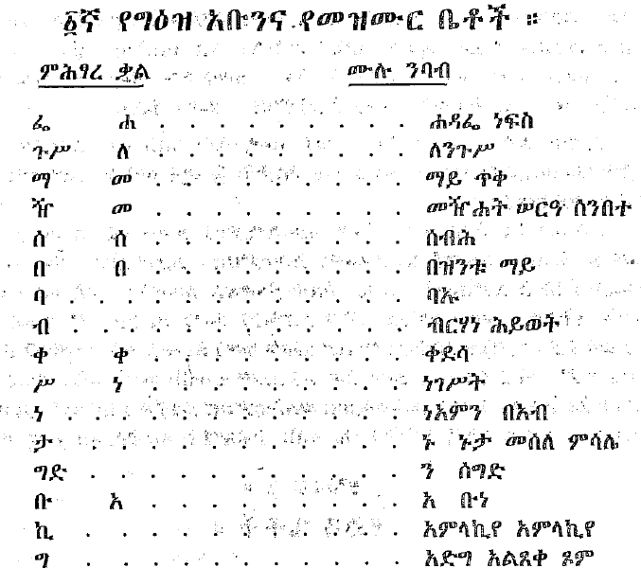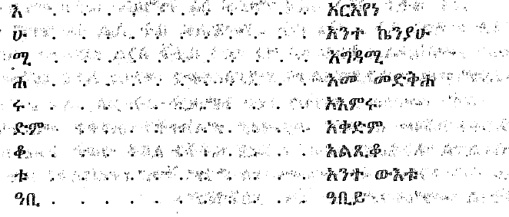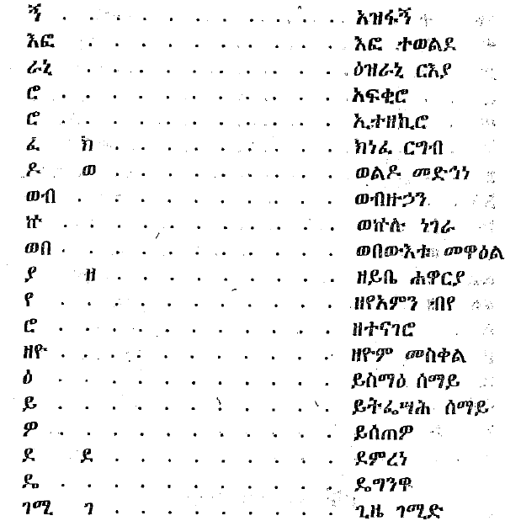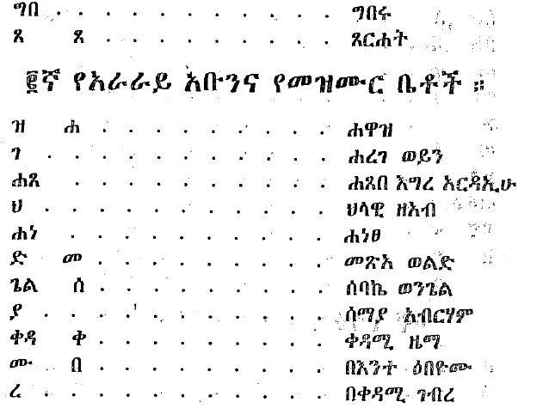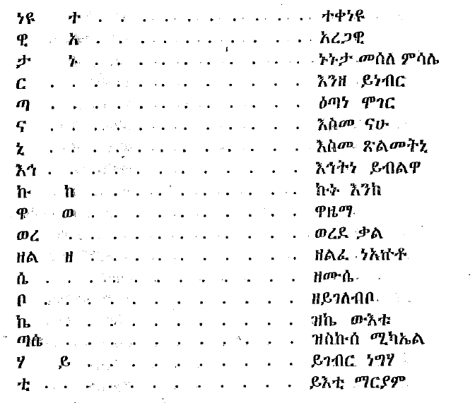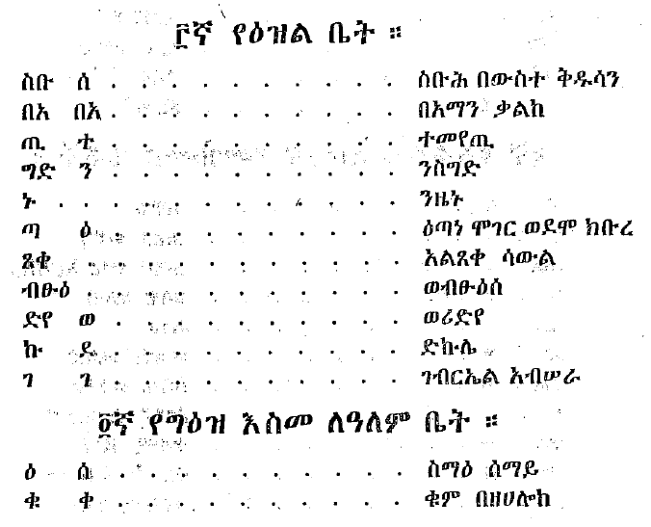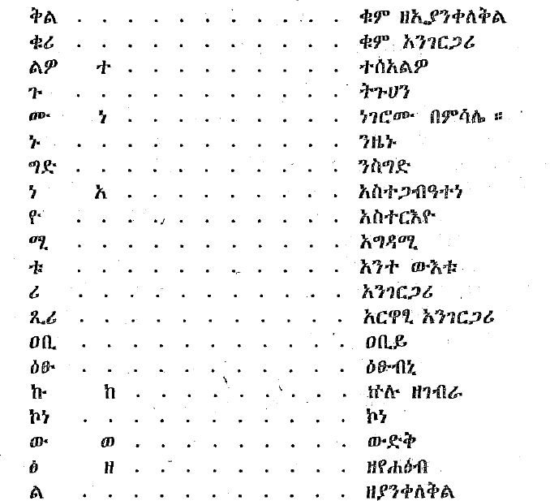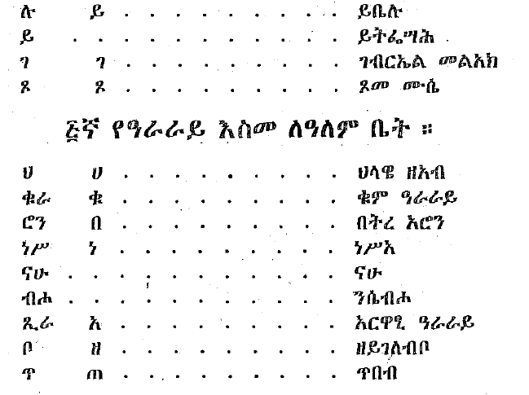

**Chapter Seven**

**(Ge’ez, Ezil and Zeyearg’s Zeyworid)**

Ethiopia’s Zaima is classified into Ge’ez, Ezil and Araraay melodies. That means it has three kinds of chanting styles. These melodies have separate times for singing. May be they are sung in specified seasons. Sometimes they are picked by other criteria. But Araraay songs are sung at any time. Ge’ez and Ezil melodies are sung only during liturgical services. This can be demonstrated as follows:

1. **Different occasions**

If Easter holiday coincides on Miazia 30 (April), the litorgy up to Sene (June) seven is conducted in Ezil melodies. From the beginning of the Lent season up to Hosanna day, liturgy is conducted in Ge’ez followed by ItaneMoger.

From Hosana upto Easter, and from Easter upto Aba Gerima, it is conducted in Ezil. From Meskerem 26 up to Hedar6 the liturgy will be in Ezil melody. From Hedar 6 which is called Abba Yohani up to Sibket, it will be in Ge’ez.

1. **Kidanu (Covenant)**

Kidan which is conducted in the night, in the morning or on regular days is prepared in three kinds. Kidan is conducted on fixed dap and carried out in Ge’ez, Ezil an Araraay. But the third Kidan is conducted always in Araraay. In is also conducted in Ge’ez for 14 dap in one year. These are

1. 28th of Tahsas known as Emanuel Day.

2. Monday to Friday of Hebir Her week**.**

3. Eve of Hosanna.

4. Ascension Day

5. Eve of Debre Tabor Day

6. Yohannes

7. Meskel

8.12th of the Hedar and Sene

9. Sibket.

On these days, Kidan is conducted is Geez.

1. **WaZaima Ge’ez**

WaZaima is sung mostly is Araraay melody. But it is sung in Ge’ez for 14 dup of the week. These are Kidus Yohannes Day, Meskel, Hedar’s St Michael Day, Sebhat, Emanuel, Nicodimus Monday, Tuesday, Wednesday, Thursday, Friday, Paraclete Hosana, and Ascension of Sene’s st. Michael Day.

**Chapter Eight**

**(Deggua’s Adrash or Climax)**

After intensive training in Degua, students of Deggua finally travel to Bethlehem monastery for defending their education. This historic place is located in a place called Gayint Awraja of Begemidir. All students of Deggua that appeared on stage following the invasion of Gragn always come to Bethlehem monastery for graduation after which they are no image known as students but Deggua witnesses.

During the learning process, a Deggua student travels from place to place. The student, after finalizing his study, is allowed to go to Bethlehem. There, he is given a position as Deggua witness.

Sometimes, students fail to finish their students properly and go to Bethlehem without producing any script. The normal Deggua study period is 4 years. There are more brilliant ones who finish the studies before 4 years. Yet others take even 7 years to complete the study. In addition to the certificates, students also distinguish themselves by their own excellence. In any case, certificates are issues to those that complete the works. This certificate bears the stamp of the authorities.

After graduation, prayers are said for the graduates. Blessings are also showered on them. The title of Merigeta is also given them. This corresponds to what we call a degree nowadays. A graduate in Deggua then becomes a Merigeta, a certified teacher or authority in Deggua. Without any waste of time, he then becomes a teacher in Deggua.

Previously, there used to be up to one hundred Deggua teachers in Bethlehem. Together with their assistants, they even number more than this. Nowadays, Deggua teachers cannot be more than 30 in number. Their assistants are not as many as they used to be. This graduation ceremony is conducted for those that study Zaima, Kidase, Zimare and Meswait. For those specializing in kind and Akuakuam teachers, such ceremony is not conducted. Certificates are not issued for these either. But they will be recognized as witnesses for kine Gojjam, Wadla and Gondar or as witnesses of Akuakam and Metsaf. The students of these lessons are then deployed to their places of assignment. But the church does not have a record showing the number of students graduating every year like this.

**Special Remarks**

1. Deggua studies used to be hard and challenging in ancient times. Even a more challenging task is the writing of Deggua at the end of the studies. They have to first of all collect the parchments before producing the Deggua script. Graduating students spend a lot of time before defending their scripts and graduating. Others do not have the ability to produce their own scripts and hence the shortage of Deggua books.

But by the gracious order of His Imperial Majesty Haile Selassie the First, Deggua books have been produced and printed in sufficient numbers and we do not have shortage nowadays.

1. Church order is kept through knowledge of Deggua and by the teachers of Deggua. As a matter of fact, churches are opened and closed by teachers of Deggua. It is wrongly commented by many that the Ethiopian church remained primitive due to the unnecessary attention given to Zaima. It is said that Zaima has killed the Ethiopian church. As a matter of fact, however, Zaima has indeed opened the way for other studies.

**Ancient Ethiopia Curricula**

**LikeSiltanat Habte Mariam Workineh.**