Weekly Report 2026
Name: WU ZIJIAN
DATE: 2026/05/11
Note: Please write the details of your research. As much detail as possible
締め切り：毎週月曜 10:00 am
DDL: 10am Every Monday
提出期間：Friday 〜 月曜 10:00 am
提出先：zhoulab@ml.hosei.ac.jp
1. 進捗状況 Research progress
1. This week, I updated the RF h-Edit project from a task-specific local editing prototype into a more general framework based on generic support proposal and clean-estimate-space adaptive control.
2. I implemented a generic support module that combines changed-token attention with clean-estimate / velocity disagreement, then generates edit-core, transition, and preserve regions for localized RF editing.
3. I integrated the generic support provider into the SD3 RF editing pipeline and connected it to the adaptive controller, including directional edit progress, preserve-drift monitoring, adaptive edit boost, preserve lock, and clean-effect projection.
4. I ran the four main pretty tasks, organized manual-support upper-bound comparisons, generic-support results over three seeds, and seed-10 support ablations for attention-only, clean-disagreement-only, velocity-disagreement-only, attention x clean, and attention x velocity.
2. 研究成果 Research Results
1. The main implementation result is a working generic_support + adaptive_full_v1 pipeline with command-line options, debug maps, trajectory statistics, and reproducible experiment records.
2. The method now saves support diagnostics such as changed-token attention, clean disagreement, velocity disagreement, support score, core mask, edit mask, and preserve-region statistics.
3. Experiments show that structure preservation is strong, especially because the clean-estimate controller constrains non-edit regions; the dog_sunglasses task is currently the best generic-support case.
4. The current limitation is that generic support does not always create enough target evidence: cat_crown, mug_heart, and backpack_remove_toy_charm still require stronger support or reference/layout cues to approach the manual-support upper bound.
Experiment Figures
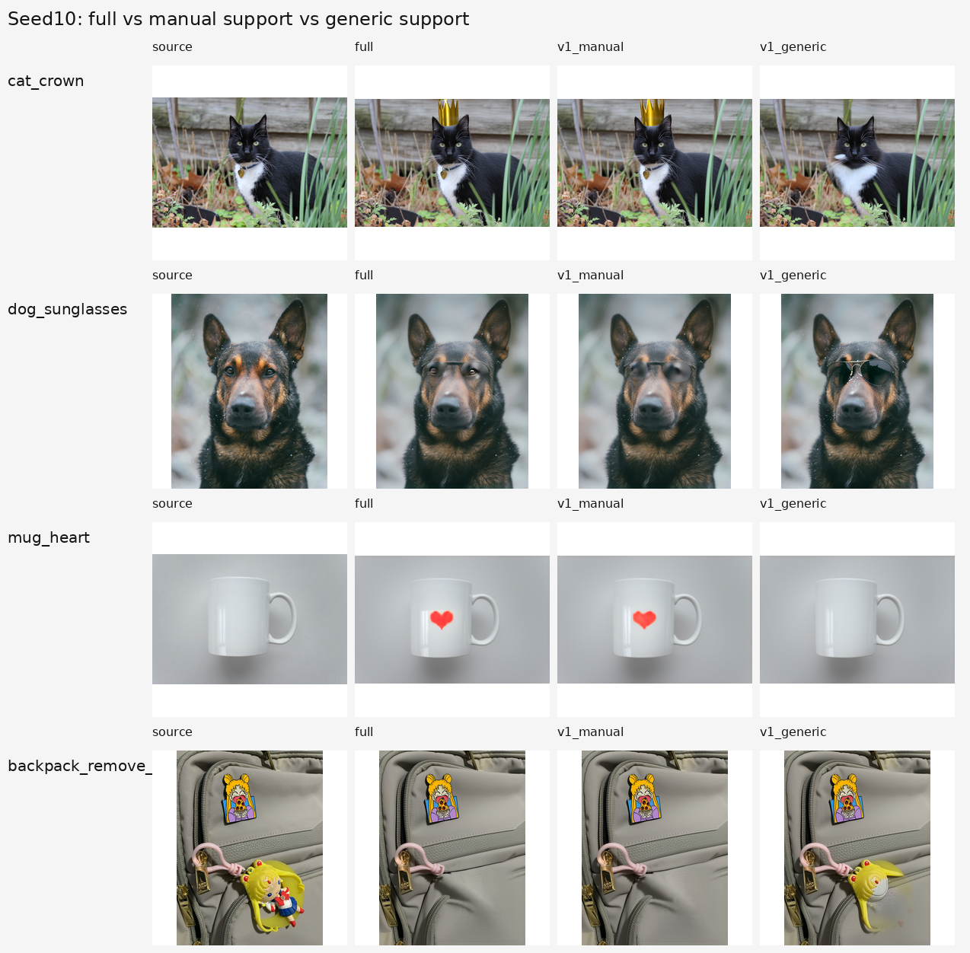
Figure 1. Seed-10 comparison: source, full method, manual-support adaptive v1, and generic-support adaptive v1 on four tasks.
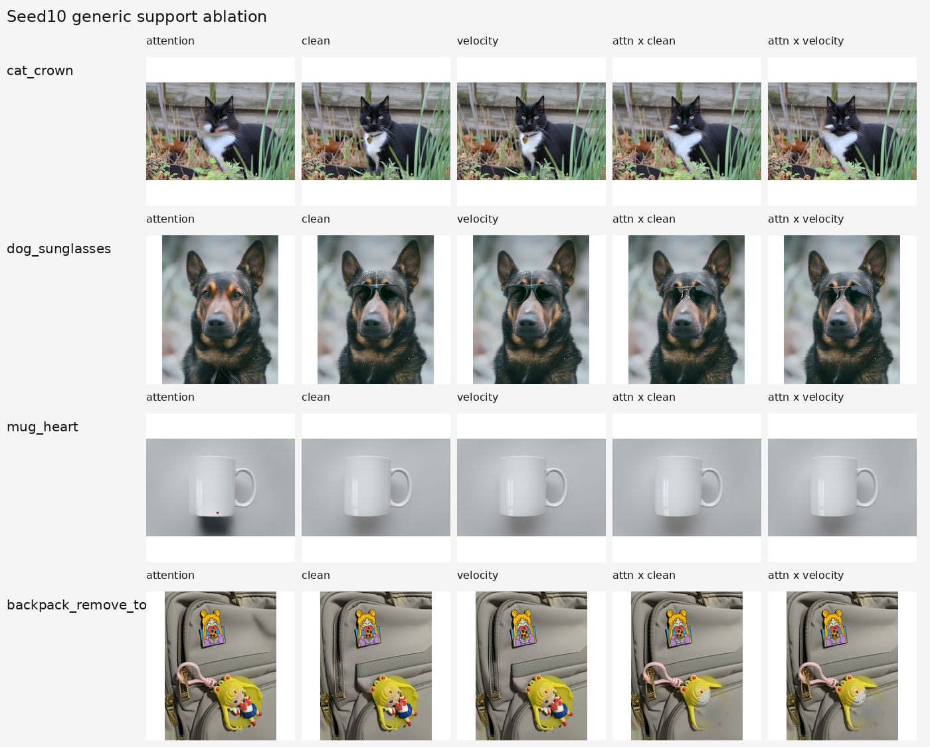
Figure 2. Seed-10 generic support ablation: attention-only, clean-only, velocity-only, attention x clean, and attention x velocity.
3. 研究計画 Research Plan
1. Next week, I will focus on improving support quality rather than adding more controller terms, because the controller already preserves structure well when the support region is reasonable.
2. I will test a stronger generic support proposer using multi-step target attention aggregation, proposal/reference-free layout evidence, and better handling of insertion versus removal tasks.
3. I will convert the current visual observations into a systematic evaluation table, including edit success, localization quality, non-edit preservation, and artifact level for each task and method.
4. I will refine the paper claim to distinguish the core contribution, clean-estimate closed-loop RF control, from the still-developing generic support proposal, and keep manual support as an upper-bound baseline.
4. 先週読んだ学術論文のまとめ
Summary of the Academic Paper Read Last Week
（学部生は2〜3週に1本、大学院生は1〜2週に1本のペースで論文を読む。以前読んだ論文をもう一度読むのも構わない。Undergraduate students are expected to read one paper every 2 to 3 weeks, while graduate students should read one every 1 to 2 weeks.）
(1) 論文の基本情報 Basic Information：FlowAlign: Trajectory-Regularized, Inversion-Free Flow-based Image Editing
Authors: Jeongsol Kim, Yeobin Hong, Jonghyun Park, Jong Chul Ye
Venue: arXiv 2025, arXiv:2505.23145
(2) 研究の背景と中心となる研究課題 Research Background & Key Research Problems：Recent inversion-free flow-based editing methods such as FlowEdit can edit images by solving an ODE with a pre-trained flow model, but they often suffer from unstable editing trajectories and weak source-image consistency.
(3) 提案手法 Proposed Method：FlowAlign introduces trajectory regularization for inversion-free flow-based image editing. It adds source-similarity regularization at the terminal point so that semantic alignment with the target prompt and structural consistency with the source image can be balanced during the ODE trajectory.
(4) 新規性と貢献 Novelty and Contributions：The key contribution is to view flow-based image editing as a trajectory-control problem. Instead of only changing guidance strength, the method regularizes the trajectory to improve consistency and controllability, and it also supports reverse editing by reversing the ODE path.
(5) 研究結果 Research Results：The paper reports better source preservation and editing controllability than previous inversion-free flow-editing methods. This supports the idea that trajectory-level constraints are important for RF / flow-based editing.
(6) 自身の研究への示唆 Inspiration：This paper is highly relevant to my project because my current method also treats image editing as controlled RF ODE dynamics. It suggests that my clean-estimate diagnostics, preserve-drift control, and support-region projection can be positioned as a local closed-loop trajectory-control approach.
5. その他 Others
I updated the project documentation, generated comparison panels for manual support versus generic support, and summarized the current conclusion: generic support is promising but still weaker than high-quality manual support on several tasks.

