**COMSATS University Islamabad,**

**Lahore Campus**

**Name: Syed Asad Jamil**

**Reg. No: SP22-BSE-123**

**Semester: 4th**

**Section: B**

**Subject: Web Technologies**

**Teacher: Muhammad Ali Hassan**

**Assignment: 05**

**Restful APIs with Express**

**GitHub Repository:**

<https://github.com/Asad-Zaidi/RESTFUL-API-Express.git>

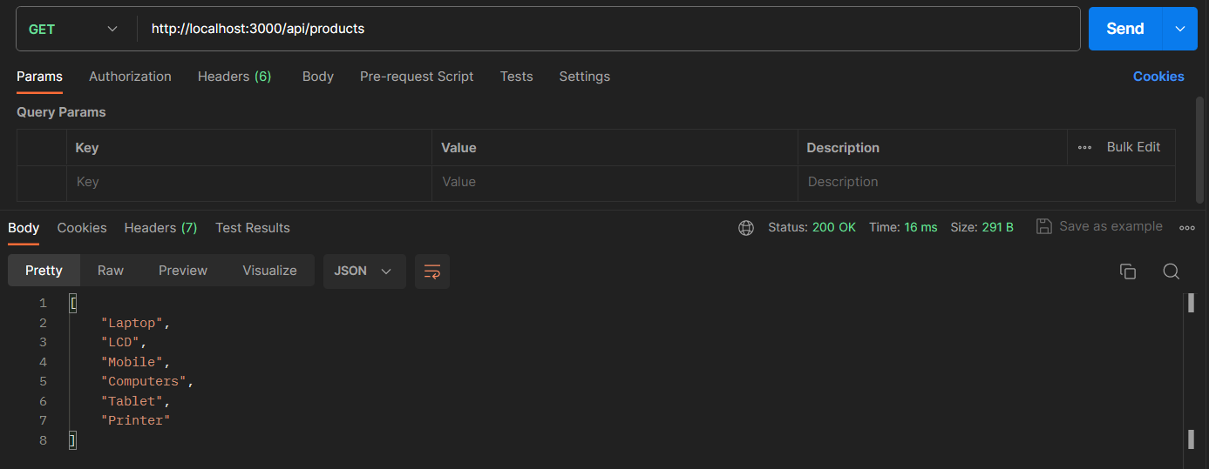**Get Method:**

**Delete Method:**

**Put Method:**

**Post Method:**

