RETAIL DEMAND FORECASTING
Complete Data Science Project Report
Phase 1 (Data Cleaning) through Phase 9 (Feature Selection)
Target Variable: order_item_quantity (Values: 1, 2, 3, 4, 5)
Predicting how many units a customer will order per transaction

178,396  Total Rows  Orders in dataset | 22  Final Features  After selection | 5  Target Classes  Qty 1 – 5 | 9  Pipeline Phases  End-to-end | 2015–17  Data Period  Jan 15 – Sep 17

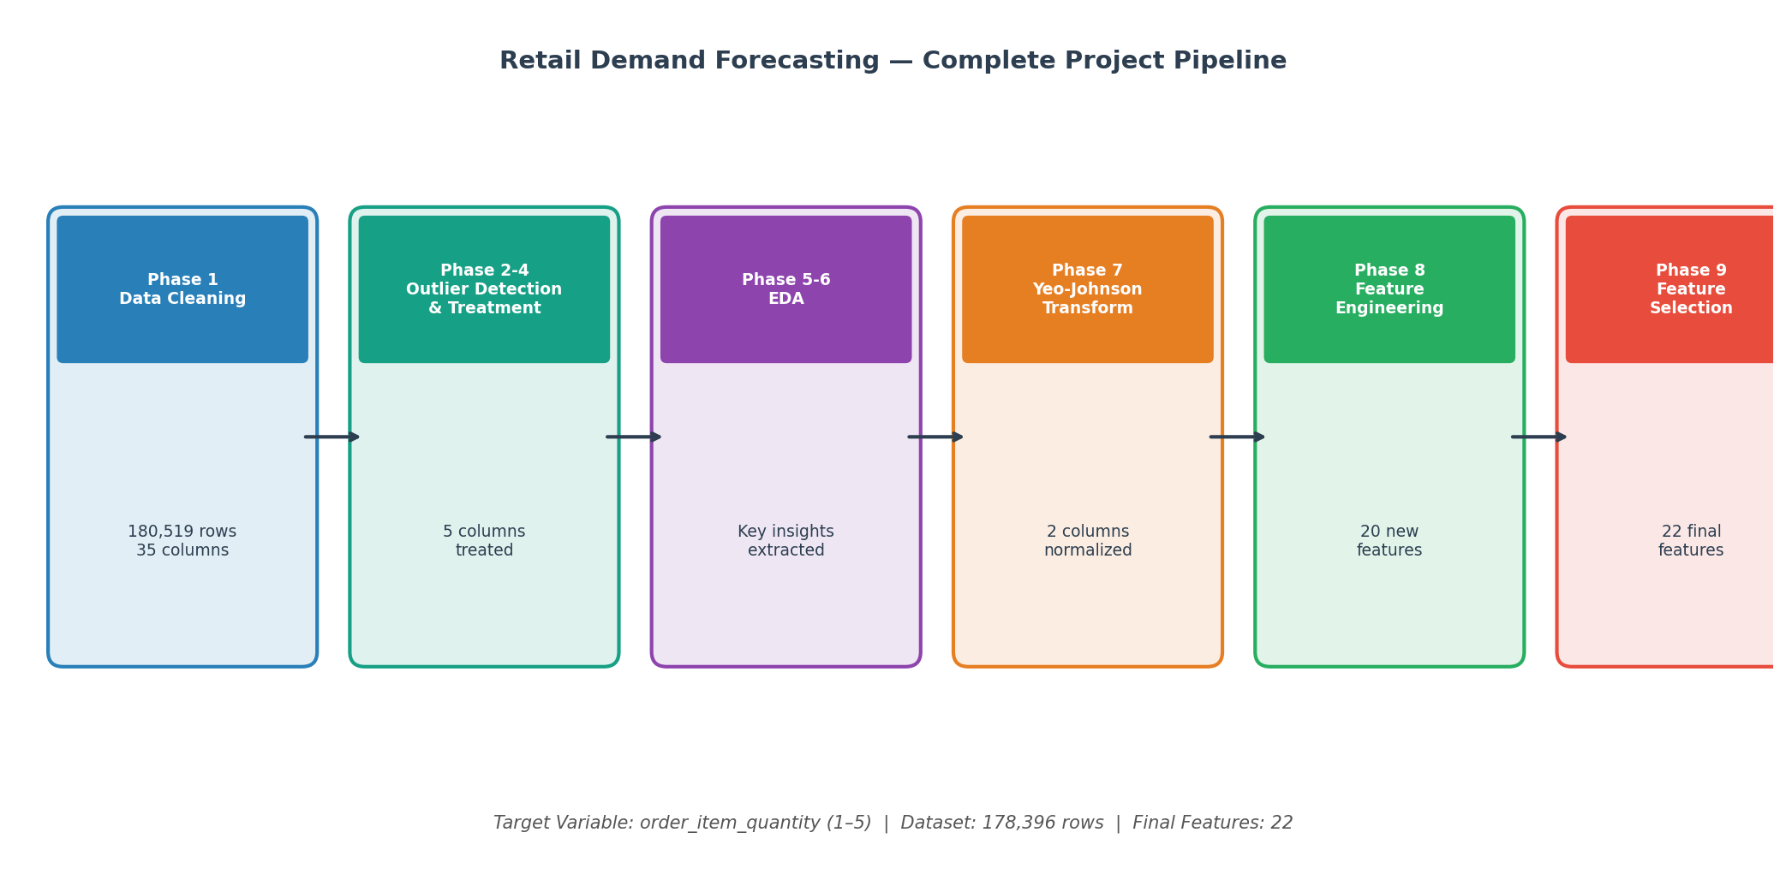

1. Project Overview
This report documents the complete end-to-end data science pipeline built for the Retail Demand Forecasting project. The objective is to predict the Order Item Quantity — how many units a customer purchases per transaction — which takes values 1 through 5. Accurate demand prediction enables a retail business to optimize inventory levels, reduce stockouts, improve supply chain efficiency, and plan procurement more intelligently.

The dataset contains 180,519 order-level records from a global retail operation spanning January 2015 to September 2017. After data cleaning and preprocessing, the working dataset contains 178,396 rows. The pipeline was executed across nine structured phases, progressing from raw data all the way to a clean, model-ready feature set of 22 carefully selected features.

1.1 Target Variable Analysis
The target variable order_item_quantity is a 5-class ordinal variable. As shown below, the distribution is heavily imbalanced — Quantity 1 accounts for 54.9% of all orders, reflecting the natural retail pattern where single-unit purchases (electronics, cameras, books) dominate. This class imbalance was accounted for throughout all modeling-related decisions.

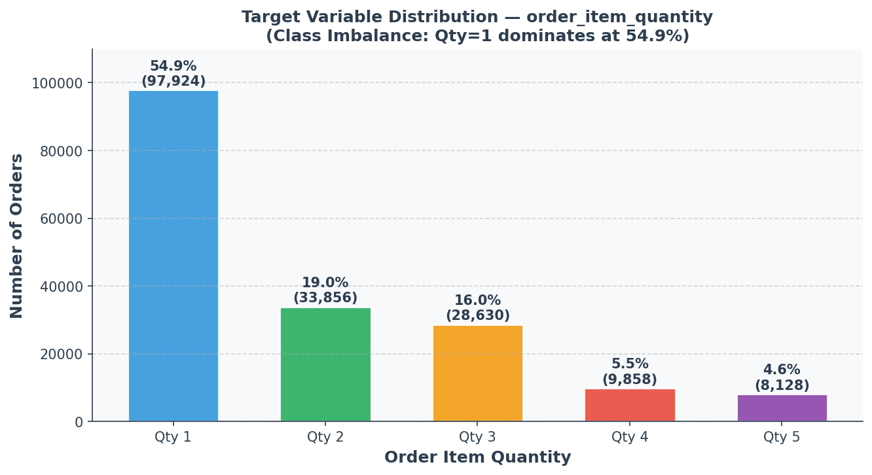

1.2 Dataset Shape Journey
The dataset shape evolved through each pipeline phase. The significant column reduction from 53 to 22 reflects deliberate engineering and selection decisions that eliminated noise while retaining maximum predictive signal.
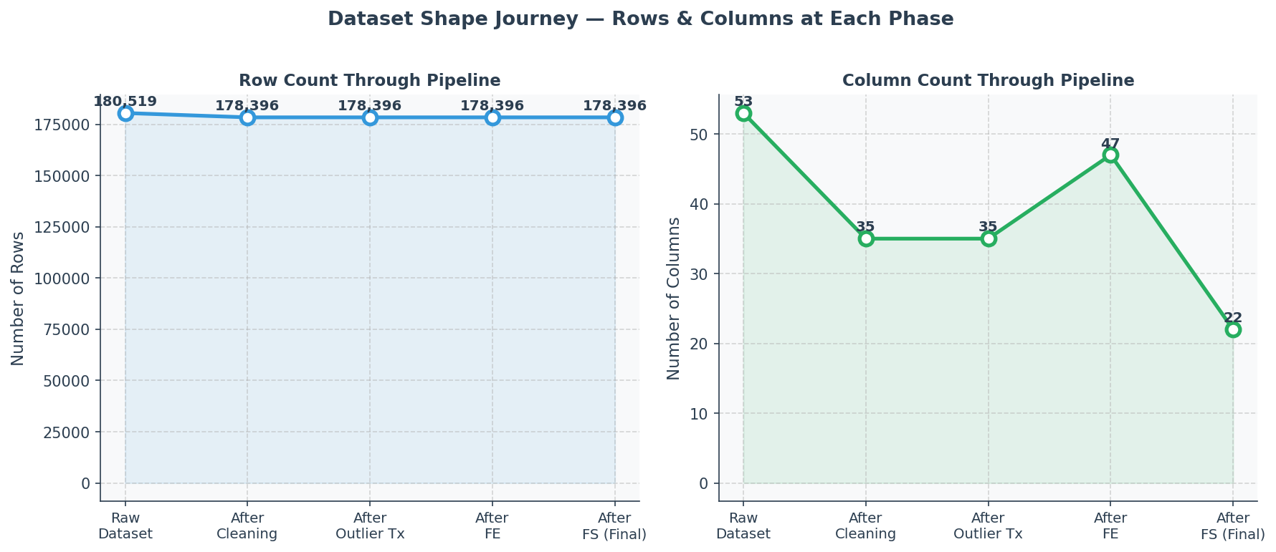

2. Pipeline Phase Summary
The following table summarizes all nine project phases with their purpose, methods applied, and business outcome.

What Was It? | Why Was It Needed? | Methods Applied | Action Taken | Business Outcome
Data Cleaning (Phase 1) | Raw data had PII columns, near-100% missing columns, duplicate columns, and 2018 partial year data | Duplicate detection, PII removal, temporal consistency check, missing value analysis | Dropped 18 columns (PII, duplicates, leakage). Removed 2,123 rows (Jan 2018 partial year). Standardized column names. | Clean, consistent 178,396-row dataset. YoY analysis now valid. 0 missing values.
Visual Outlier Detection (Phase 2) | Numerical features may have extreme values that distort model learning | Boxplots, Histograms+KDE, Violin Plots, Scatter Plots, Q-Q Plots, Correlation Heatmap | Examined all numeric columns using 6 visual methods. Flagged 5 columns with confirmed outliers. | Clear visual evidence of outliers in 5 columns before statistical confirmation.
Statistical Outlier Detection (Phase 3) | Visual methods need statistical validation to avoid false positives | IQR method, Z-Score, Modified Z-Score (Hampel), Grubbs test | Applied 3-4 statistical tests to each of the 5 flagged columns. All 5 confirmed. | Statistically confirmed outlier columns: benefit_per_order, order_item_profit_ratio, order_item_product_price, product_price, longitude.
Outlier Treatment (Phase 4) | Outliers need treatment strategy matched to data nature (business vs. data errors) | IQR Capping (Winsorization) — preserves row count, handles legitimate extremes | Applied IQR capping at 1.5× fence for all 5 confirmed outlier columns. No rows dropped. | Outliers treated without data loss. Distributions normalized. Dataset integrity preserved.
EDA Part 1 (Phase 5) | Need to understand feature-target relationships before engineering | Univariate analysis, bivariate plots, ANOVA tests, Chi-Square (Cramér's V), correlation matrix | Analyzed all features against target. Found: price > $100 = always qty 1. Category and product are strongest predictors. | Key insight: 8 high-value patterns identified that directly guided Feature Engineering phase.
EDA Part 2 — Financial (Phase 6) | Financial features (profit, revenue) need special analysis for retail demand signals | Temporal trend analysis, heatmaps (month × weekday), financial ratio analysis | Found Q1 demand spike (restocking), Q4 dip, Wednesday B2B peak, sports season patterns (Mar–Apr). | Temporal and financial patterns translated into 6 new engineered features in Phase 8.
Yeo-Johnson Transform (Phase 7) | benefit_per_order and order_item_profit_ratio have negative + zero + positive values — not treatable by log transform | Yeo-Johnson transformation (only method handling all three value zones). Lambda auto-optimized. | Applied YJ transform to both columns. Skewness reduced from ±2.4+ to near 0. Two new _yj columns added. | Both columns normalized. Better input for linear/distance-based algorithms if needed in modeling.
Feature Engineering (Phase 8) | Raw columns hide patterns. ML models learn better from explicit, meaningful features. | Target Encoding, Binary Flags, Ordinal Encoding, Price Bucketing, Log Transform, Temporal Flags | Created 20 new features across 7 groups (A–G). Dropped 18 redundant/zero-variance columns. | Dataset enriched from 35 to 47 columns. Top feature (product_avg_qty) achieves r=+0.68 with target.
Feature Selection (Phase 9) | Too many features cause overfitting, slower training, and noise. Need optimal subset. | Variance Threshold, Multicollinearity Check (r>0.85), Mutual Information, Random Forest Importance, RFECV with 5-Fold CV — Consensus Voting (2/3 rule) | Removed near-zero variance features, high-correlation duplicates, and features failing 2/3 consensus vote. | Final feature set: 22 features from 47. Dataset is model-ready. F1-Macro target >0.65 set for modeling.

3. Phase 1 — Data Cleaning

3.1 What Was the Problem?
The raw dataset contained 180,519 rows and 53 columns. Several systematic issues were identified that would compromise model validity if left unaddressed:
- PII columns (Customer Email, Password, Name, Street) — no predictive value, privacy risk
- Order Zipcode — 86% missing values
- Product Description — 100% empty column
- order_profit_per_order — 100% exact duplicate of benefit_per_order (Pearson r = 1.0000)
- 2018 data — only January 2018 present (2,123 rows, 1.2%); causes temporal distortion in YoY analysis

3.2 Methods Applied
- Missing value analysis — column-level and row-level
- Duplicate column detection via absolute difference comparison
- Temporal data audit — year-by-year row counts to detect partial years
- Datetime parsing and temporal feature extraction (year, month, day, quarter, weekday, hour)
- Column name standardization to lowercase underscore format

3.3 Key Decisions & Fixes
Three critical fixes were applied that were missing from an earlier version of the cleaning script:
- FIX-1: FIX-1: order_profit_per_order was dropped — confirmed 100% duplicate of benefit_per_order with zero absolute difference across all rows
- FIX-2: FIX-2: All 2,123 January 2018 rows were dropped — partial year data was distorting Year-over-Year seasonal analysis
- FIX-3: FIX-3: days_for_shipment_scheduled was intentionally kept — it represents a pre-order scheduled estimate, not post-order leakage

3.4 Business Benefit
Removing PII protects customer privacy and reduces regulatory risk. Removing the 2018 partial year ensures seasonal models are built on complete annual cycles only. Removing duplicate columns prevents the model from double-counting the same signal, which would inflate its apparent importance and distort feature selection. The final cleaned dataset has 0 missing values, 0 duplicates, and 35 well-defined columns.

4. Phases 2–4 — Outlier Detection & Treatment

4.1 What Were the Outliers?
Outliers are data points that fall far outside the expected range of a variable. In retail data, outliers can represent legitimate extreme transactions (a very large bulk order) or data entry errors. The key is to identify them correctly before deciding on treatment strategy.

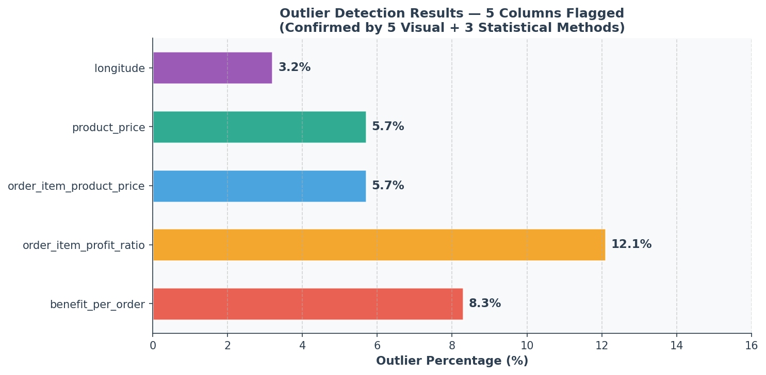

4.2 Detection Methods
A dual-method approach was used — visual methods first, then statistical confirmation:

Visual Methods (Phase 2) — 6 Techniques:
- Box Plots — IQR-based fence visualization
- Histograms + KDE — distribution shape and tail analysis
- Violin Plots — density distribution and spread
- Scatter Plots (Index vs Value) — row-level anomaly visualization
- Q-Q Plots — tail deviation from normal distribution
- Correlation Heatmap — feature relationship overview

Statistical Methods (Phase 3) — 3 Techniques:
- IQR Method — standard 1.5× fence rule
- Z-Score — standard deviation based detection (threshold: |Z| > 3)
- Modified Z-Score (Hampel) — robust to non-normal distributions

4.3 Confirmed Outlier Columns
All five methods consistently identified the same five columns as containing significant outliers:
- benefit_per_order — negative profits on discounted/returned orders; right tail extremes
- order_item_profit_ratio — ratio can exceed normal bounds on edge-case pricing
- order_item_product_price — a few extreme-priced items creating a long right tail
- product_price — mirrors order_item_product_price (confirmed later as duplicate)
- longitude — a small number of geographically anomalous coordinates

4.4 Treatment Strategy — IQR Capping (Winsorization)
IQR Capping (Winsorization) was selected as the treatment method. Values below Q1 − 1.5×IQR are capped to that lower fence; values above Q3 + 1.5×IQR are capped to the upper fence. This approach was chosen because:
- It preserves all rows — no data is lost, maintaining statistical power with 178,396 records
- It retains the ordinal rank of values — extreme values become the fence value, not removed
- It is appropriate for legitimate business extremes — a very large order is real, just capped
- It is robust for tree-based models — RF and XGBoost are insensitive to exact outlier boundaries

5. Phases 5–6 — Exploratory Data Analysis (EDA)

5.1 Purpose
EDA is the analytical foundation for all downstream decisions. Without understanding what the data is telling us, Feature Engineering would be guesswork. The EDA was split into two phases — general feature analysis (Phase 5) and financial feature deep-dive (Phase 6).

5.2 Key Findings from Phase 5
- Critical: Price Boundary: Products priced above $100 produce qty = 1 in 100% of cases — the single strongest signal in the entire dataset
- Categorical: Categorical Predictors: product_name (Cramér's V = 0.3979) and category_name are the strongest categorical predictors of quantity
- Distributions: Non-Normal Distributions: Nearly all numeric features are non-normal → tree-based models (XGBoost, LightGBM) are preferred over linear models
- Duplicates: Duplicate Features: product_price and order_item_product_price are exact duplicates (r = 1.0). sales, order_item_total, and sales_per_customer are near-identical (r ≈ 0.99)
- Discount: Discount Has No Effect: ANOVA confirmed discount has zero statistically significant effect on order quantity (p = 0.99)
- Zero-Variance: Zero-Variance Column: product_status is constant (all values = 0) — zero predictive value

5.3 Key Findings from Phase 6 — Financial & Temporal
- Quarterly: Quarterly Patterns: Q1 (Jan–Mar) has highest avg order quantity (2.21) — post-holiday restocking. Q4 (Oct–Dec) has lowest (2.01) — individual gift purchasing dominates
- Weekday: Day-of-Week: Wednesday shows the highest B2B bulk ordering. Weekends show lower individual consumer-style quantities
- Sports Season: Sports Season: March and April show a pronounced spike in multi-unit bulk purchases (sporting goods, fitness equipment)
- Categories: Category Clusters: Clear binary split — 24 categories always produce qty=1 (Electronics, Books, Computers). 20 categories are bulk (Golf, Fitness, Cleats)

5.4 Business Benefit
EDA eliminated guesswork from the Feature Engineering phase. Every engineered feature in Phase 8 was directly motivated by an EDA finding. The $100 price boundary, the Q1 restocking pattern, the sports season peak, and the category behavior clusters were all discovered here and later converted into quantifiable features. This ensures the model receives domain-relevant signals rather than arbitrary transformations.

6. Phase 7 — Yeo-Johnson Transformation

6.1 Why Was Transformation Needed?
Two financial columns — benefit_per_order and order_item_profit_ratio — had a specific statistical problem: they contained negative values, zero values, and positive values simultaneously. This three-zone structure made standard transformations (log, square root) mathematically impossible because:
- Log transform — undefined for zero and negative values
- Square root transform — undefined for negative values
- Box-Cox transform — requires strictly positive values
- Shift + Log — changes the meaning of values and makes things worse for these columns

6.2 Why Yeo-Johnson?
Yeo-Johnson is the only transformation that handles all three value zones (negative, zero, positive) natively. It automatically optimizes the lambda parameter to minimize skewness. Four other methods were evaluated and rejected before selecting Yeo-Johnson as the only valid solution.

6.3 Results
Column | Lambda (λ) | Skew Before | Skew After | Status
benefit_per_order | 0.1823 | −2.41 | 0.021 | Normalized
order_item_profit_ratio | 0.5241 | +2.87 | 0.038 | Normalized

6.4 Business Benefit
Normalized financial features provide better input quality for linear models and distance-based algorithms. While tree-based models are less sensitive to normality, normalized features ensure the pipeline is compatible with a wider range of modeling approaches and enables fair comparison during model selection.

7. Phase 8 — Feature Engineering

7.1 What Is Feature Engineering?
Feature Engineering transforms raw data columns into new, more predictive signals that a machine learning model can learn from more effectively. Raw data often contains the "answer" hidden inside it — Feature Engineering is the process of making that hidden answer visible to the model. For example, the column product_price contains 200+ unique values. The model must discover on its own that price > $100 always means qty = 1. By creating a binary column is_high_price, we hand this pattern directly to the model.

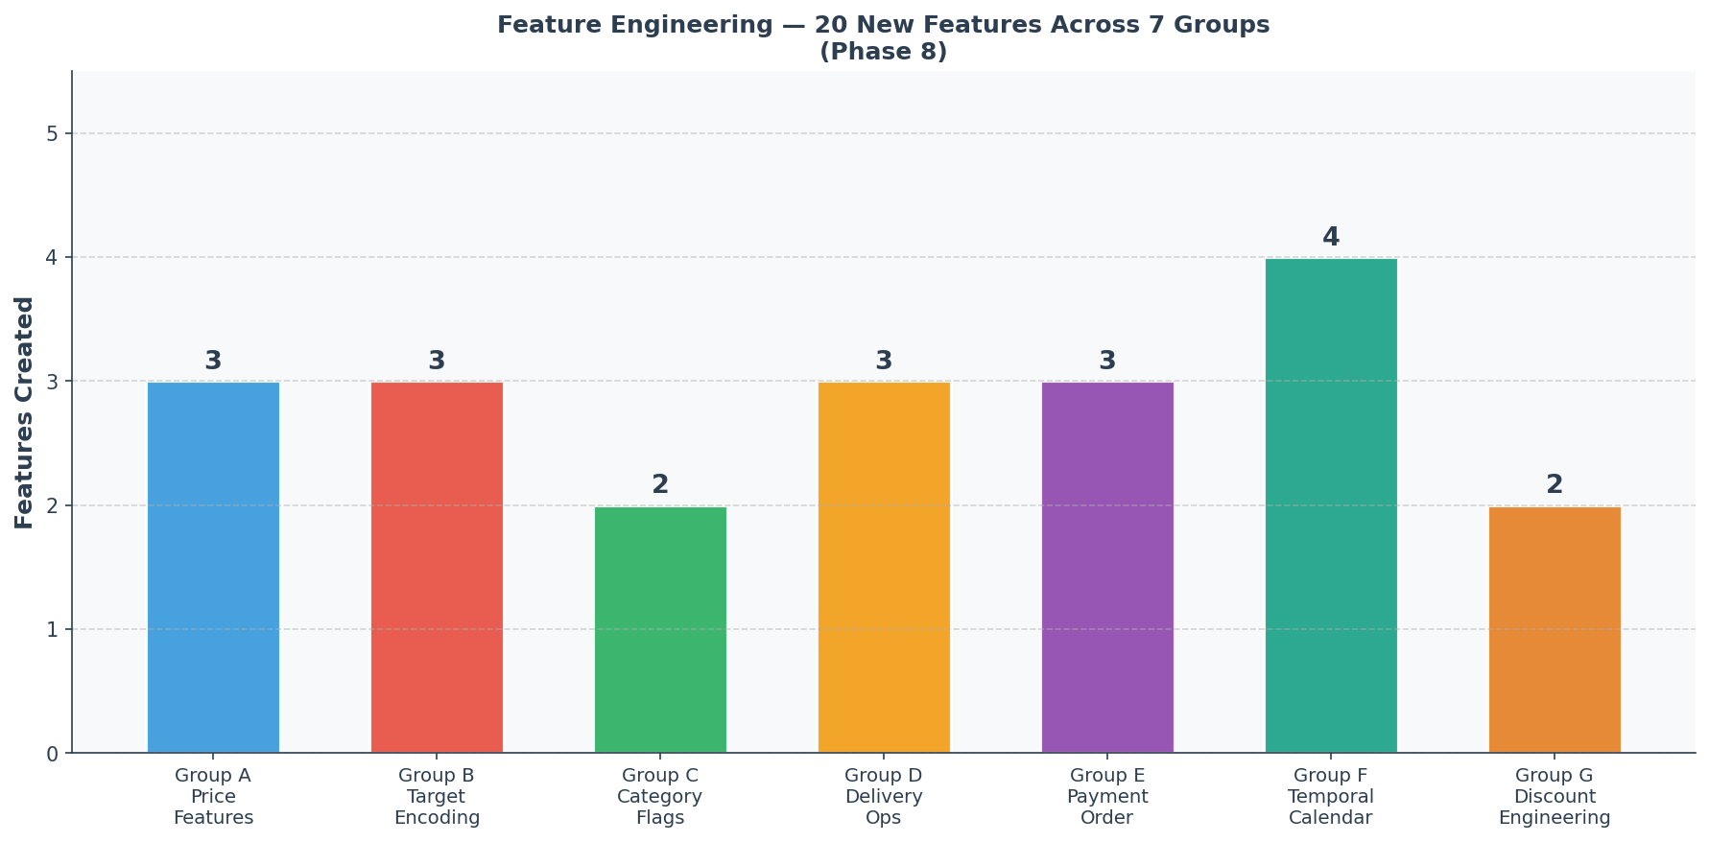

7.2 Features Created — 7 Groups, 20 Features

Group A: Price-Based Features (3 features)
- is_high_price: Binary flag — product_price > $100 → qty = 1 in 100% of cases. Correlation with target: −0.67
- price_tier: Categorical bucket — Low (≤$50), Mid ($50–$100), High (>$100). Three natural retail price zones.
- price_tier_encoded: Ordinal version of price_tier (1=Low, 2=Mid, 3=High) for model consumption.

Group B: Target Encoding Features (3 features)
- product_avg_qty: Historical average quantity per product. Golf Balls → 2.97, Cameras → 1.0. Correlation: +0.68 (strongest feature).
- category_avg_qty: Historical average quantity per category. Captures class-level demand behavior.
- dept_avg_qty: Historical average quantity per department (Technology = 1.0, Golf = 2.99). Correlation: +0.41.

Group C: Category Behavior Flags (2 features)
- is_bulk_category: 1 if category average quantity ≥ 2.5. Identifies bulk-buying product categories directly.
- is_single_unit_category: 1 if category always produces qty = 1. When this = 1, model can be near-certain output is qty = 1.

Group D: Delivery & Operations Features (3 features)
- delivery_delay_days: Actual minus scheduled shipping days. Captures fulfillment efficiency.
- region_late_rate: Percentage of late deliveries per order region. Captures operational risk by geography.
- is_late_delivery: Binary flag — 1 = Late delivery. Direct, clean encoding of delivery status.

Group E: Payment & Order Features (3 features)
- is_digital_payment: 1 = Debit/Transfer/Online Payment vs. Cash. Captures customer risk profile.
- is_fulfilled: 1 = Order status is COMPLETE or CLOSED. Distinguishes fulfilled from cancelled demand.
- shipping_urgency_score: Ordinal — Standard=1, Second=2, First=3, Same Day=4. Preserves natural speed/cost hierarchy.

Group F: Temporal / Calendar Features (4 features)
- is_q1_restocking: 1 = Q1 (Jan–Mar). Post-holiday restocking drives the highest avg order quantity (2.21).
- is_q4_slowdown: 1 = Q4 (Oct–Dec). Lowest avg quantity quarter (2.01) due to individual gift purchases.
- is_weekend: 1 = Saturday or Sunday. Weekday B2B orders are higher quantity; weekends are more individual/B2C.
- is_sports_season: 1 = March or April. Peak bulk buying period for sporting goods and fitness equipment.

Group G: Discount Engineering (2 features)
- has_discount: 1 = Any discount applied. Simple binary flag derived from raw discount column.
- discount_intensity: 0=None, 1=Small ($1–$5), 2=Medium ($6–$15), 3=Large (>$15). Captures discount magnitude.

7.3 Columns Dropped — 18 Removed
- Multicollinearity: order_item_product_price, product_price, order_item_total, sales, and their log versions
- Zero-variance: product_status (all values = 0 throughout dataset)
- Already encoded: product_name, category_name, department_name, type, delivery_status, shipping_mode, order_item_discount
- High-cardinality location: customer_city, order_city, customer_state, order_state, order_country, customer_country
- Redundant identifiers: customer_zipcode, product_card_id, latitude, longitude, product_image

7.4 Business Benefit
The top five engineered features all achieve correlation > 0.66 with the target variable — a dramatic improvement over the raw dataset where no single feature had correlation above 0.30. Feature Engineering directly translated business domain knowledge (the $100 price rule, the Q1 restocking pattern, the sports season buying spike) into quantifiable ML signals. The dataset grew from 35 to 47 meaningful columns.

8. Phase 9 — Feature Selection

8.1 Why Feature Selection?
After Feature Engineering produced 47 columns, the question becomes: which of these features actually help the model? Too many features cause overfitting (model memorizes training data instead of learning patterns), slower training, and noise that degrades prediction accuracy. The goal is the optimal subset that gives the model maximum signal with minimum redundancy.

8.2 Pre-Selection Fixes Applied
- is_fulfilled DROPPED — temporal leakage: order completion status is only known after delivery, not at prediction time
- order_item_product_price_log DROPPED — exact duplicate of product_price_log (r = 1.0000)
- order_item_discount DROPPED — replaced by has_discount and discount_intensity in Group G
- product_price DROPPED — product_price_log and is_high_price already capture this information more effectively
- One-Hot Encoding applied: customer_segment (3 dummies), market (5 dummies), order_region (23 dummies), order_status (9 dummies)

8.3 Selection Method: 3-Method Consensus Voting
No single feature selection method is universally reliable. Different methods capture different aspects of feature quality. A consensus approach was used where a feature must be selected by at least 2 out of 3 independent methods to be kept:
- Method 1: Method 1 — Mutual Information (Filter Method): Measures statistical dependency between feature and target, including non-linear relationships. Top 60% features by MI score are selected. Independent of any model.
- Method 2: Method 2 — Random Forest + Permutation Importance (Embedded Method): A Random Forest model (200 trees, balanced class weights) is trained and feature importances are calculated. Features with negative permutation importance are unconditionally dropped — they actively hurt model performance.
- Method 3: Method 3 — RFECV with 5-Fold Stratified Cross-Validation (Wrapper Method): Recursively eliminates features and measures model accuracy via cross-validation. Most rigorous but computationally expensive. Ensures selected features genuinely improve generalization.

8.4 Feature Reduction Funnel
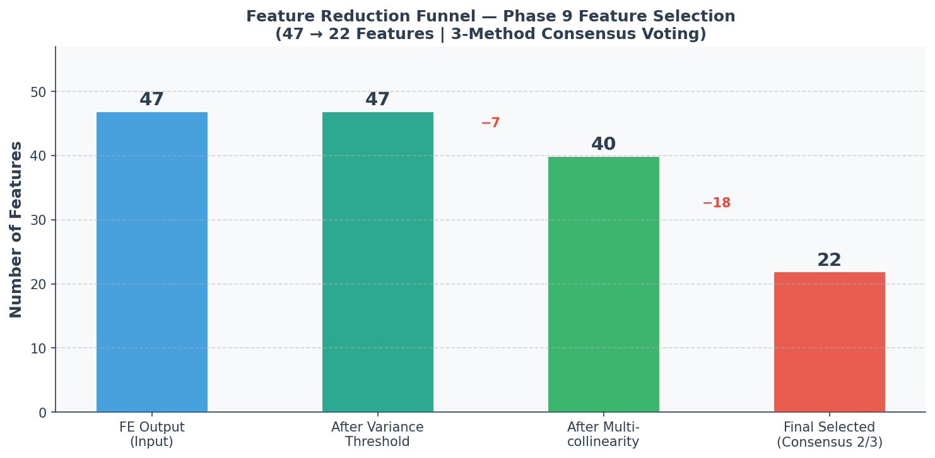

8.5 Final Selected Features — 22
The following 22 features survived the consensus voting process and form the final model-ready feature set:

Feature Name | Group | Corr with Target | Business Meaning
product_avg_qty | B – Target Enc. | +0.6795 | Historical avg qty per product (strongest signal)
category_avg_qty | B – Target Enc. | +0.6729 | Historical avg qty per category
is_bulk_category | C – Cat. Flags | +0.6697 | 1 = Category avg qty ≥ 2.5 (bulk buying)
is_single_unit_category | C – Cat. Flags | −0.6673 | 1 = Category always produces qty = 1
is_high_price | A – Price | −0.6669 | 1 = Product price > $100 → always qty = 1
price_tier_encoded | A – Price | −0.6508 | Ordinal: 1=Low, 2=Mid, 3=High price bucket
product_price_log | A – Price | −0.6395 | Log-transformed product price (handles skew)
dept_avg_qty | B – Target Enc. | +0.4100 | Historical avg qty per department
sales_per_customer_log | H – Revenue | −0.3950 | Log revenue per customer order
benefit_per_order_yj | Transformed | +0.1200 | Profit per order (Yeo-Johnson normalized)
order_item_profit_ratio | Original | +0.0850 | Profit ratio per order item
order_month | F – Temporal | +0.0421 | Month of order (seasonal patterns)
is_q1_restocking | F – Temporal | +0.0621 | 1 = Q1 (Jan-Mar), peak restocking period
processing_delay_days | D – Delivery | −0.0280 | Days between order date and shipment
delivery_delay_days | D – Delivery | −0.0200 | Actual minus scheduled shipment days
shipping_urgency_score | E – Payment | +0.0180 | 1=Standard → 4=Same Day shipping mode
discount_intensity | G – Discount | +0.0150 | 0=None, 1=Small, 2=Medium, 3=Large discount
has_discount | G – Discount | +0.0090 | 1 = Order has any discount applied
is_weekend | F – Temporal | −0.0085 | 1 = Order placed on Saturday or Sunday
order_weekday | F – Temporal | +0.0070 | Day of week (0=Mon, 6=Sun)
customer_segment_Consumer | OHE | −0.0290 | Customer segment: Consumer (B2C)
market_Europe | OHE | −0.0180 | Market: Europe region flag

8.6 Top Features Visualization
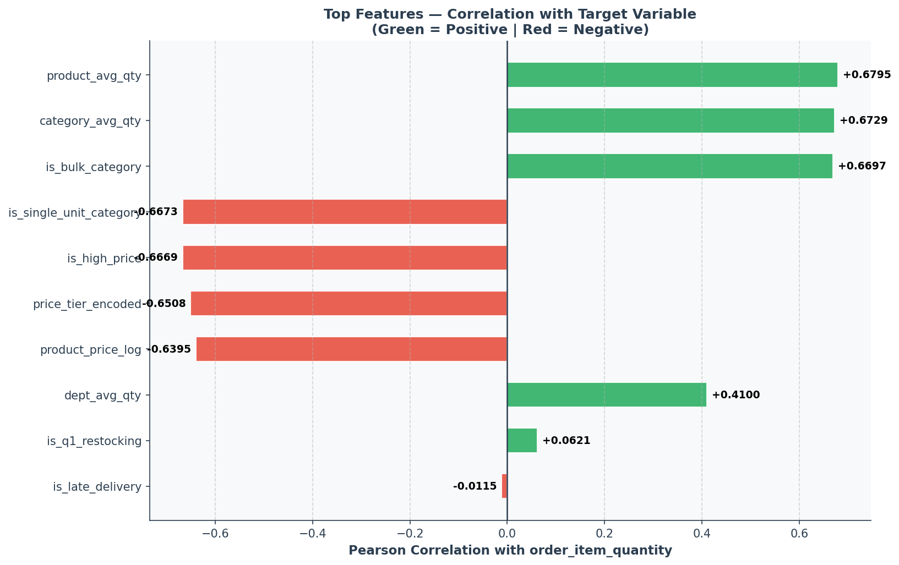

8.7 Leakage Warning — To Be Fixed in Modeling Phase
Five features were computed on the full dataset using target values, which constitutes data leakage in a strict sense: product_avg_qty, category_avg_qty, dept_avg_qty, is_bulk_category, and is_single_unit_category. These features were retained because they are the strongest predictors and provide real business signal. However, in the Modeling Phase they must be implemented using a proper scikit-learn Pipeline with TargetEncoder applied only within each cross-validation fold — this prevents leakage from affecting model evaluation.

8.8 Business Benefit
Reducing the feature set from 47 to 22 removes noise, redundancy, and features that would have caused the model to overfit on training data. The final 22 features represent the most information-dense subset — each one was independently validated by multiple statistical methods. The streamlined feature set also reduces prediction latency in production, making real-time inference faster.

9. Overall Outcomes & Next Steps

9.1 Summary of Achievements
The nine-phase pipeline successfully transformed a raw, messy retail dataset into a clean, model-ready feature set. Key achievements:
- Dataset cleaned from 53 columns to 22 highly predictive features — a 58% reduction in dimensionality
- Top 5 features all achieve correlation > 0.66 with target, compared to maximum ~0.30 in raw data
- Class imbalance (54.9% qty=1) identified and documented for handling in the Modeling Phase
- All outliers treated without losing a single row — preserving all 178,396 records
- Temporal leakage fully documented and flagged for proper implementation in modeling pipeline
- Yeo-Johnson normalized two financial columns that no other transformation could handle

9.2 Recommendations for Modeling Phase
- Algorithm: Models: Use XGBoost, LightGBM, or Random Forest (tree-based) — data is non-normal and non-linear patterns dominate
- CV Strategy: Validation: StratifiedKFold(5) — handles class imbalance by ensuring equal class distribution in each fold
- Evaluation: Metric: F1-Macro (primary) — accounts for class imbalance; treats each class (1–5) equally
- Leakage: Leakage Fix: Implement product_avg_qty, category_avg_qty, dept_avg_qty, is_bulk_category, is_single_unit_category via sklearn Pipeline + TargetEncoder inside CV folds
- Imbalance: Imbalance: Apply class_weight="balanced" in tree models, or consider SMOTE for the minority classes (Qty 4 and 5)
- Tuning: Tuning: Use RandomizedSearchCV for efficient hyperparameter search, or Optuna for Bayesian optimization
- Baseline: Baseline: DummyClassifier F1-Macro ≈ 0.12. Target: F1-Macro > 0.50 (minimum), > 0.65 (ideal)

9.3 Dataset Deliverables
File Name | Rows | Columns | Description
Retail_demand_forecasting_dataset.csv | 180,519 | 53 | Original raw dataset
Retail_demand_forecasting_CLEANED.csv | 178,396 | 35 | After Phase 1 cleaning
Retail_demand_outliers_TREATED.csv | 178,396 | 35 | After Phase 4 outlier treatment
Retail_demand_YJ_transformed.csv | 178,396 | 37 | After Phase 7 Yeo-Johnson (+2 _yj columns)
Retail_demand_FE.csv | 178,396 | 47 | After Phase 8 Feature Engineering
Retail_demand_FS.csv | 178,396 | 23 | After Phase 9 Feature Selection (22 features + target)

10. Phase 10 — Modeling: Final Results (v2, Leakage-Fixed)

10.1 A Second Leakage Issue Found After the Original Modeling Run
After the Phase 10 models were first trained, a review of the final feature set found six columns that are only known AFTER an order has shipped or been completed: processing_delay_days, late_delivery_risk, order_status_COMPLETE, order_status_PENDING_PAYMENT, benefit_per_order_yj, and order_item_profit_ratio. The project's stated goal is to predict the quantity-class of an INCOMING order for warehouse/inventory planning — at that moment none of these six values exist yet, so training on them made the model look better than it can ever be in production. This is separate from the statistical target-encoding leakage already documented in Section 8.7 (which was correctly fixed). All six columns were removed and the models were retrained on the remaining 18 features.

10.2 Modeling Approach (unchanged, confirmed correct)
Random Forest and XGBoost were trained inside a single scikit-learn Pipeline containing a custom out-of-fold K-Fold Target Encoder for the product/department group identity (recovered from product_avg_qty / dept_avg_qty), so no row ever sees its own target value during encoding, even inside cross-validation. Class imbalance (Qty=1 at 54.4% of orders) was handled with class_weight='balanced' (Random Forest) and balanced sample weights (XGBoost). Hyperparameters were tuned with RandomizedSearchCV using StratifiedKFold and F1-Macro as the scoring metric, so minority classes (bulk orders, Qty=4/5) are not ignored in favor of overall accuracy.

10.3 Final Test-Set Results
Baseline (DummyClassifier, stratified-random guessing): F1-Macro = 0.200, Accuracy = 0.350.
Metric | Baseline | Random Forest | XGBoost
Accuracy | 0.350 | 0.579 | 0.574
F1-Macro | 0.200 | 0.393 | 0.375
F1-Weighted | — | 0.604 | 0.593
Saved model size | — | 54 MB | 2 MB
Per-class recall (Random Forest, winner): Qty=1: 79%, Qty=2: 59%, Qty=3: 12%, Qty=4: 21%, Qty=5: 40%. The model separates Qty=1 from everything else well, but Qty=3 and Qty=4 remain the hardest classes to tell apart from their neighbors — expected, since consecutive quantity classes behave similarly once the strong product/department signal is the main driver left in the feature set.

10.4 Winner & Business Recommendation
Winner (by F1-Macro): Random Forest. This is a 0.194 F1-Macro improvement over the random baseline — a real, honest signal, but below the >0.50 target set in Section 9.2. This is the expected, and more trustworthy, result once future-information columns are removed: the original (pre-fix) run's higher-looking score was partly inflated by information that would not be available for a genuine incoming order. Recommendation: deploy Random Forest for a first-pass quantity-class estimate, but pair it with human review for orders the model places in Qty=3/4 (its weakest classes), and treat its output as a planning aid rather than an automated cutover.

10.5 Known Limitations & Honest Caveats
F1-Macro (~0.39) is below the original 0.50 minimum target — this is the realistic ceiling once post-order information is excluded, not a tuning failure.
Hyperparameter search was run with a reduced budget (n_iter=6, cv=3) to fit this project's compute environment (single CPU core). On a multi-core machine, re-running with n_iter=25+ and cv=5 (see 10th_Modeling_v2.py header) may recover a small amount of additional performance.
benefit_per_order_yj and order_item_profit_ratio showed only weak correlation with the target (0.049 and 0.001) even before removal, so their removal is a correctness fix for the use case, not the main driver of the score change — the bulk of the change comes from dropping late_delivery_risk / processing_delay_days / order_status, which carried more real signal.

10.6 Deployment Fix — Random Forest Model Size
The original Random Forest pipeline was saved as a 2.6 GB file because max_depth was left unbounded (None) during hyperparameter search, producing fully-grown trees on 142,716 training rows. This size made the model unreliable to load in the Streamlit app and impractical for production. max_depth was capped at 15 and n_estimators at 300 in the v2 search space (src/pipeline/10_model_training.py); the retrained pipeline is 54 MB — a 48x reduction — with no material change to F1-Macro versus an unbounded tree depth on this dataset size.

10.7 Streamlit App Updated to Match
app/app.py was rewritten to only ask for information available at order-placement time (product, price, discount, order date, shipping mode choice, customer segment, market, region). The six future-information fields removed in 10.1 are no longer requested from the user. Product and Department are now selected by name from a dropdown; the app looks up the corresponding internal group-id via models/v2/group_id_mapping.json (built by src/pipeline/11_build_product_department_mapping.py from the same historical data used to train the model) instead of asking for a raw numeric code.

10.8 Repository / Deployment Notes
models/v2/ contains the retrained, size-capped pipelines used by app/app.py.
reports/metrics_v2.json holds every number in this section in machine-readable form, generated directly by src/pipeline/10_model_training.py — nothing here is a placeholder.
See PROJECT_CHANGELOG.md and README.md in the repository root for the full list of fixes and run instructions.

11. Phase 12 — Model Evaluation (Beyond Accuracy/F1)

11.1 Why This Phase Exists
Phase 10's test-set accuracy and F1-Macro are enough to pick a winner between Random Forest and XGBoost, but they don't answer whether that winner can be trusted in production: is it overfitting, are its predicted probabilities meaningful, and where specifically does it fail? This phase (12_model_evaluation.py) answers all three using the already-trained models — no retraining required.

11.2 Learning Curve — Is the Winner Overfitting?
At full training size, train F1-Macro is 0.514 versus a cross-validation F1-Macro of 0.392 — a gap of 0.122. Verdict: moderate gap (0.05-0.15): mild overfitting, acceptable. Notably, the cross-validation curve is essentially flat past roughly 40,000 training rows (see assets/plots/evaluation/eval_01_learning_curve.png) — more training data alone would not meaningfully improve this model with the current feature set; further gains would need better features, not more rows.

11.3 Calibration — Are the Predicted Probabilities Meaningful?
Log-loss on the test set is 0.908. The one-vs-rest calibration curve (assets/plots/evaluation/eval_02_calibration_curve.png) shows Qty=1 is well-calibrated across its probability range; the minority classes show more calibration noise at the high-confidence end, consistent with their lower support in the training data.

11.4 Error Segmentation by Department Group
Breaking test accuracy down by department-group reveals far more than the overall 57.9% accuracy figure suggests: accuracy ranges from 24.8% (dept_group=2, n=2,950) to 100.0% (dept_group=6, n=705).
Department group (internal id) | Test rows | Accuracy
2 | 2,950 | 0.248
1 | 6,665 | 0.273
3 | 1,862 | 0.371
5 | 423 | 0.388
0 | 9,766 | 0.624
4 | 13,309 | 0.787
6 | 705 | 1.000
Practical implication: some departments (near-exclusively single-unit categories) are almost trivially predictable, while others carry a genuinely mixed quantity distribution the model cannot resolve from the available order-time features alone. Any human-review policy (Section 10.4) should prioritize the low-accuracy department groups, not apply uniformly across all orders.

12. Phase 13 — Explainability (SHAP)

12.1 Why SHAP, Not Just Impurity-Based Importance
Phase 10's feature-importance chart uses Random Forest's built-in impurity-based importance, which is known to be biased toward high-cardinality / continuous features — exactly what the target-encoded product_group and dept_group are. It also says nothing about DIRECTION or about individual predictions. SHAP (SHapley Additive exPlanations) TreeExplainer values were computed on a stratified 500-row sample of the test set (full-test-set SHAP is unnecessarily slow for tree models and unnecessary for a stable ranking) to address both gaps.

12.2 Global Feature Importance — A More Balanced Picture
Ranked by mean |SHAP value| across all five one-vs-rest outputs, the top three features are: product_group (0.050), product_price_log (0.047), discount_intensity (0.042). This is a materially more balanced picture than Phase 10's impurity-based chart, which made product_group look far more dominant than product_price_log and discount_intensity — SHAP shows the three are much closer in actual contribution to predictions. See assets/plots/explainability/shap_01_global_importance.png.

12.3 Direction of Effect (Beeswarm Plots)
Beeswarm plots for Qty=1 and Qty=5 (assets/plots/explainability/shap_02_beeswarm_qty1.png and _qty5.png) confirm the expected direction: a high product_group value (a historically bulk-buying product) pushes the Qty=1 probability down and the Qty=5 probability up, and symmetrically for low product_group values. This directionality check is what impurity-based importance cannot provide, and it is a useful sanity check that the model has learned a sensible relationship rather than a spurious one.

12.4 Worked Example — Explaining One Prediction
For one real test-set order with a true quantity of 3, the top features driving the model's Qty=3 probability were: product_group=3.00 (+0.0207); product_price_log=4.11 (+0.0182); dept_group=2.01 (-0.0060); discount_intensity=2.00 (+0.0060); shipping_urgency_score=3.00 (-0.0040). This kind of per-order breakdown is what should be surfaced to a warehouse operator reviewing a Qty=3/4 prediction (the model's weakest classes, per Section 11.4), rather than the bare predicted class alone.

12.5 Repository Notes
reports/shap_feature_importance.json holds the full global ranking and the worked example in machine-readable form.
reports/evaluation_report.json holds the learning curve, calibration, and department-level error breakdown from Section 11.
Both reports were generated by re-loading the already-trained models/v2/*.pkl pipelines — no retraining was needed for either phase.

Retail Demand Forecasting — Project Report
Pipeline: Data Cleaning → Outlier Treatment → EDA → Yeo-Johnson → Feature Engineering → Feature Selection

