RETAIL DEMAND FORECASTING
Data Preprocessing Report

Target Variable: order_item_quantity (Multiclass: 1 – 5)
Dataset: Retail_demand_forecasting_dataset.csv
Phases Covered: Data Cleaning | Outlier Detection | Outlier Treatment

180,519  Raw Rows | 178,396  Final Rows | 53 → 40  Columns | 5  Features Treated

Project Author | Phase: 1 – Data Cleaning & Outlier Treatment | 2024–2025

Table of Contents

1. Executive Summary

This report documents the complete data preprocessing pipeline for the Retail Demand Forecasting project. The primary objective is to forecast order_item_quantity (values 1 through 5) based on transactional retail data. Two major preprocessing phases were completed prior to Exploratory Data Analysis (EDA): Data Cleaning and Outlier Detection & Treatment.
The raw dataset contained 180,519 rows and 53 columns. After systematic cleaning, leakage removal, and temporal correction, the final preprocessed dataset contains 178,396 rows and 40 columns, ready for feature engineering and modeling.

180,519  Raw Dataset Rows | 178,396  Rows After Cleaning | 13  Columns Dropped | 3  Leakage Cols Removed

Phase Summary
- Phase 1 — Data Cleaning: Column drops, leakage removal, datetime parsing, 2018 data exclusion, type standardisation
- Phase 2 — Outlier Detection: Visual methods (Box Plot, Histogram+KDE, Violin, Scatter, Q-Q) + Statistical methods (Z-Score, IQR, Grubbs) on 5 numeric features
- Phase 3 — Outlier Treatment: IQR-based Winsorizing applied to business-critical features; log-transformed price columns added as supplementary features

2. Dataset Overview

2.1 Raw Dataset Profile
The raw dataset covers retail order transactions from January 2015 through January 2018, sourced from a global e-commerce supply chain. It includes customer demographics, product details, shipment logistics, and financial metrics.

Attribute | Value
Dataset Name | Retail_demand_forecasting_dataset.csv
Total Rows (Raw) | 180,519
Total Columns (Raw) | 53
Target Variable | order_item_quantity (classes: 1, 2, 3, 4, 5)
Date Range (Raw) | January 2015 – January 2018
Date Range (Final) | January 2015 – September 2017
Encoding | latin-1
File Size (Raw) | ~67 MB

2.2 Target Variable Distribution
The target variable order_item_quantity is a discrete multiclass variable with 5 possible values (1 through 5). A significant class imbalance exists: Quantity=1 dominates at 54.4% of all orders, while quantities 2 through 5 are nearly equally distributed at approximately 11.4% each.

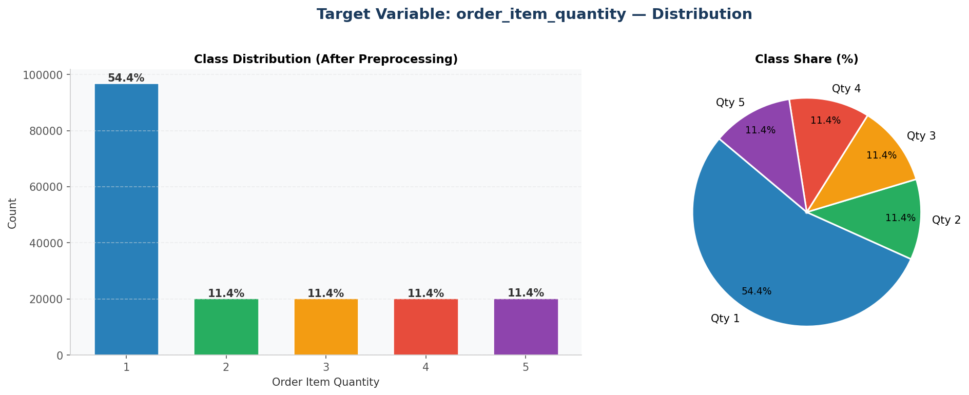
Figure 1: Target variable distribution — class counts and percentage share across all 5 quantity classes.

Quantity | Count | Percentage | Business Interpretation
1 | 97,011 | 54.4% | Single-unit orders — most common (premium or low-repeat items)
2 | 20,315 | 11.4% | Two-unit orders — pairs (e.g. footwear, accessories)
3 | 20,350 | 11.4% | Three-unit orders — team/bulk entry point
4 | 20,335 | 11.4% | Four-unit orders — small bulk
5 | 20,385 | 11.4% | Five-unit orders — maximum bulk tier

NOTE | The strong imbalance toward Qty=1 (54.4%) reflects a real retail phenomenon: premium-priced products ($100+) are almost exclusively ordered in single units. This will guide class-weight tuning during modeling.

3. Data Cleaning — Phase 1

Data cleaning was executed systematically in 9 steps, prioritizing business correctness and model integrity. The key decisions are documented below with justifications rooted in retail domain knowledge.

3.1 Cleaning Pipeline Overview
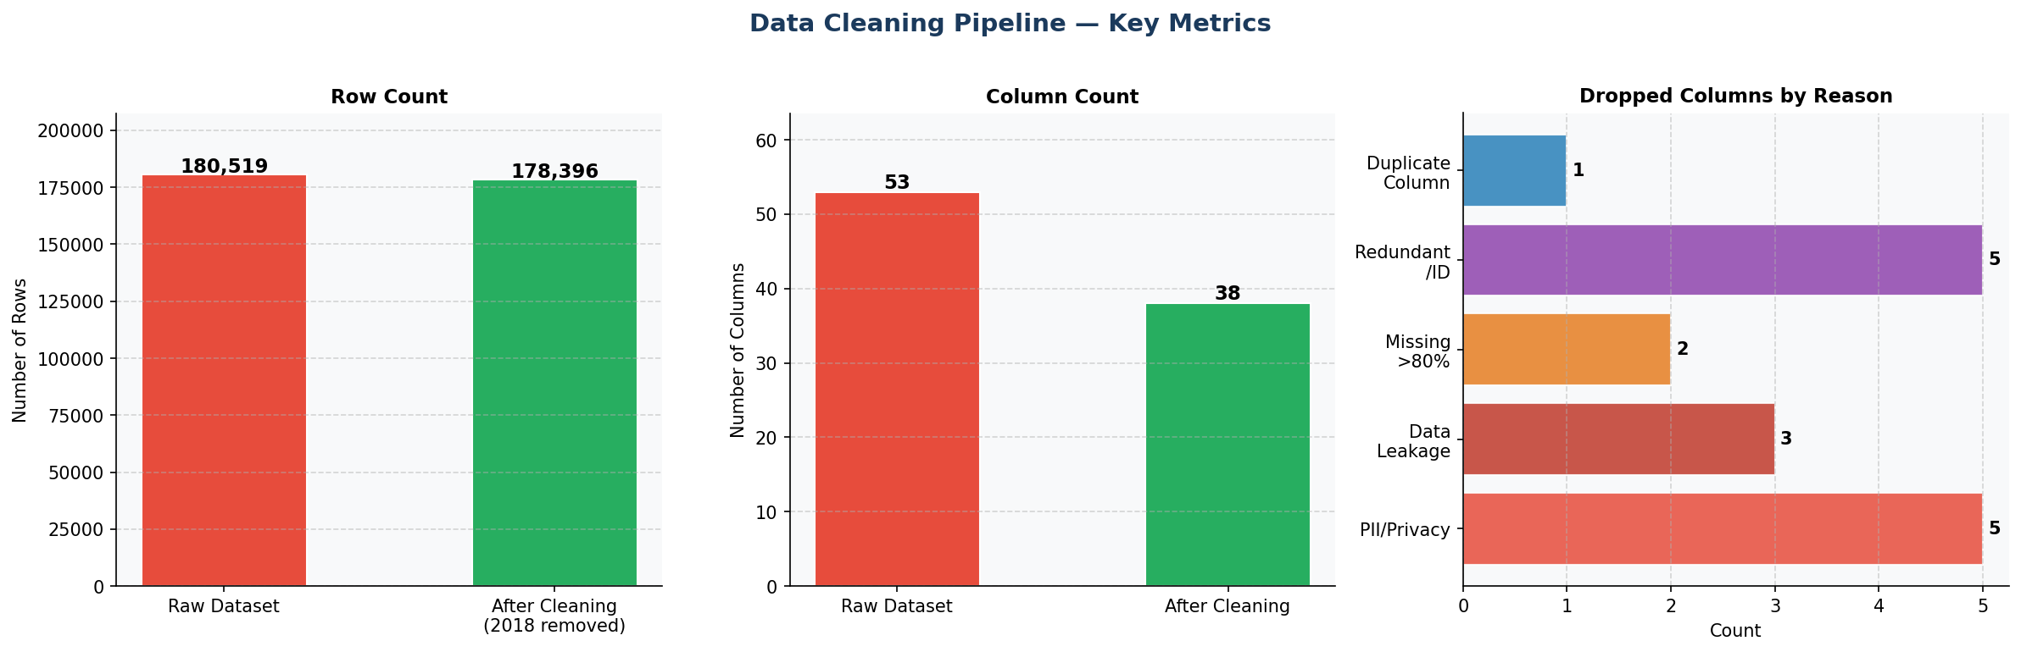
Figure 2: Before-vs-After comparison — row count reduction, column reduction, and breakdown of dropped columns by removal reason.

3.2 Columns Dropped — Detailed Justification

3.2.1 Data Leakage Columns (Critical Removal)
Three columns were identified as critical data leakage threats and removed before any modeling can proceed:
Column | Leakage Type | Evidence | Action
order_item_discount | 100% Direct Leakage | discount = price × rate × quantity. Confirmed: discount ÷ (price × rate) median = 1.0 for qty=1, 2.0 for qty=2, exactly. | REMOVED
sales_per_customer | Near-Direct Leakage | sales_per_customer ÷ price median = 0.91 (qty=1), 1.82 (qty=2), 2.70 (qty=3). Scales directly with quantity. | REMOVED
order_profit_per_order | Duplicate Column | 100% identical to benefit_per_order. Absolute difference = 0.0000 across all rows. | REMOVED

CRITICAL | Leaving any leakage column in the dataset would allow the model to indirectly see the target variable during training, resulting in artificially perfect scores that collapse to near-zero accuracy on real production data.

3.2.2 PII & Privacy Columns
Five customer identification columns were removed as they carry no predictive signal and violate privacy best practices:
Column | Reason
Customer Email | Unique per user — PII, zero predictive value
Customer Password | Encrypted credential — completely irrelevant
Customer Fname | First name — PII, no business signal
Customer Lname | Last name — PII, no business signal
Customer Street | Street address — PII, too granular for demand

3.2.3 Missing Data & Other Drops
Column | Missing % | Reason | Action
Order Zipcode | 86% | Majority missing, not recoverable | REMOVED
Product Description | 100% | Completely empty column | REMOVED
Order Item Total | 0% | Order-level leakage (qty-linked total) | REMOVED
Sales | 0% | Sales = Price × Qty — direct leakage | REMOVED
Product Image | 0% | URL string, zero predictive value | REMOVED
Product Status | 0% | Near-constant binary flag (>99.9% same) | REMOVED

3.3 Temporal Data Handling

3.3.1 Datetime Parsing & Feature Extraction
Both date columns were parsed and decomposed into structured temporal features for downstream use in demand seasonality analysis:
Extracted Feature | Source Column | Description
order_year | order date (DateOrders) | Year of order placement
order_month | order date (DateOrders) | Month (1–12) — seasonality
order_day | order date (DateOrders) | Day of month
order_weekday | order date (DateOrders) | Day of week (0=Mon, 6=Sun) — B2B vs B2C signal
order_hour | order date (DateOrders) | Hour of order placement
order_quarter | order date (DateOrders) | Business quarter (1–4)
shipping_year | shipping date (DateOrders) | Year of shipment
shipping_month | shipping date (DateOrders) | Month of shipment
processing_delay_days | Both date columns | Actual delay: shipping − order date (days)

3.3.2 2018 Partial Year Data Drop (Critical Fix)
The dataset contained 2,123 rows from January 2018 only (1.2% of total data). Retaining this incomplete year would cause two problems: (1) Year-over-Year analysis would be artificially distorted, showing a dramatic "drop" in 2018 simply due to data truncation; (2) Seasonal models would be trained on an incomplete seasonal cycle, making January appear disproportionately important.

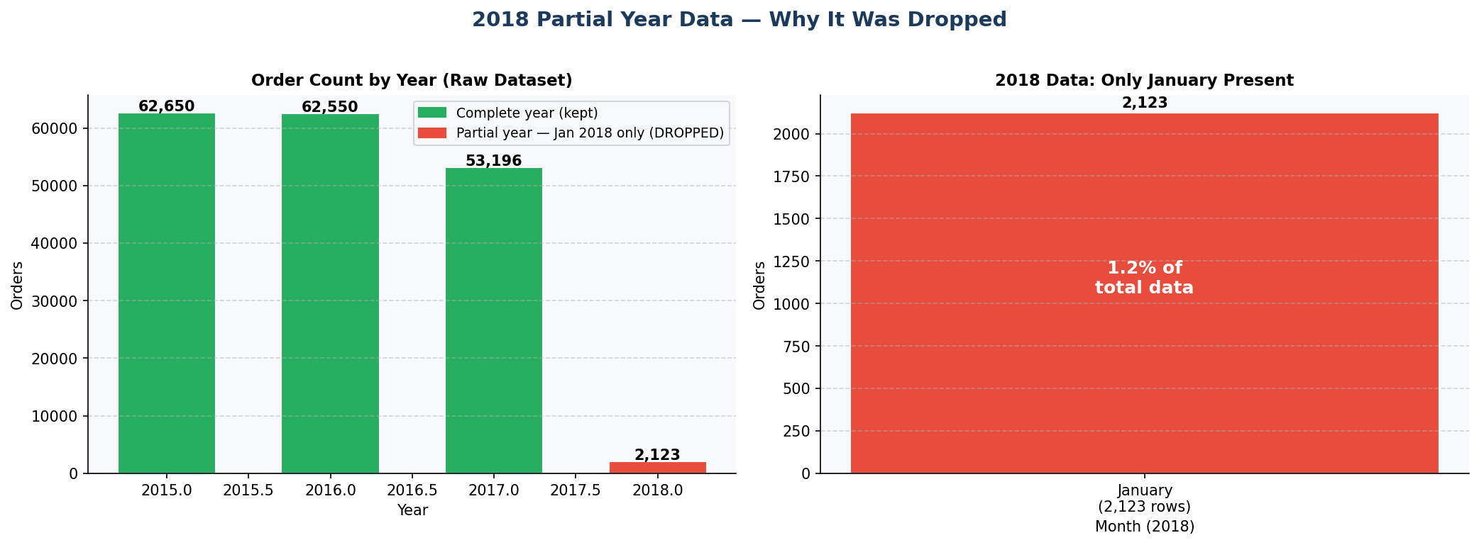
Figure 3: 2018 partial year justification — only January 2018 present (2,123 rows = 1.2%). Dropped to ensure clean 2015–2017 time series.

DECISION | January 2018 data (2,123 rows) was dropped. Final dataset covers January 2015 – September 2017, representing complete seasonal cycles for time series modeling.

3.4 Data Type Standardization
All column names were standardized to lowercase underscore format (snake_case). Categorical columns were cast to category dtype to reduce memory usage. Customer Zipcode was imputed with mode and cast to Int64.
Action | Columns Affected | Result
Lowercase + snake_case rename | All 40 columns | Consistent naming convention
Category dtype conversion | 15 object columns | Memory reduction ~40%
Int64 cast | customer_zipcode | Clean integer nullable type
Duplicate rows check | Full dataset | 0 duplicates confirmed
Missing values final check | Full dataset | 0 missing values confirmed

4. Outlier Detection — Phase 2

Outlier detection was conducted across all numeric features using a two-pronged approach: visual methods for intuitive exploration, followed by statistical methods for quantitative confirmation. All methods consistently identified the same five features as containing significant outliers.

4.1 Visual Detection Methods (6 Methods Applied)
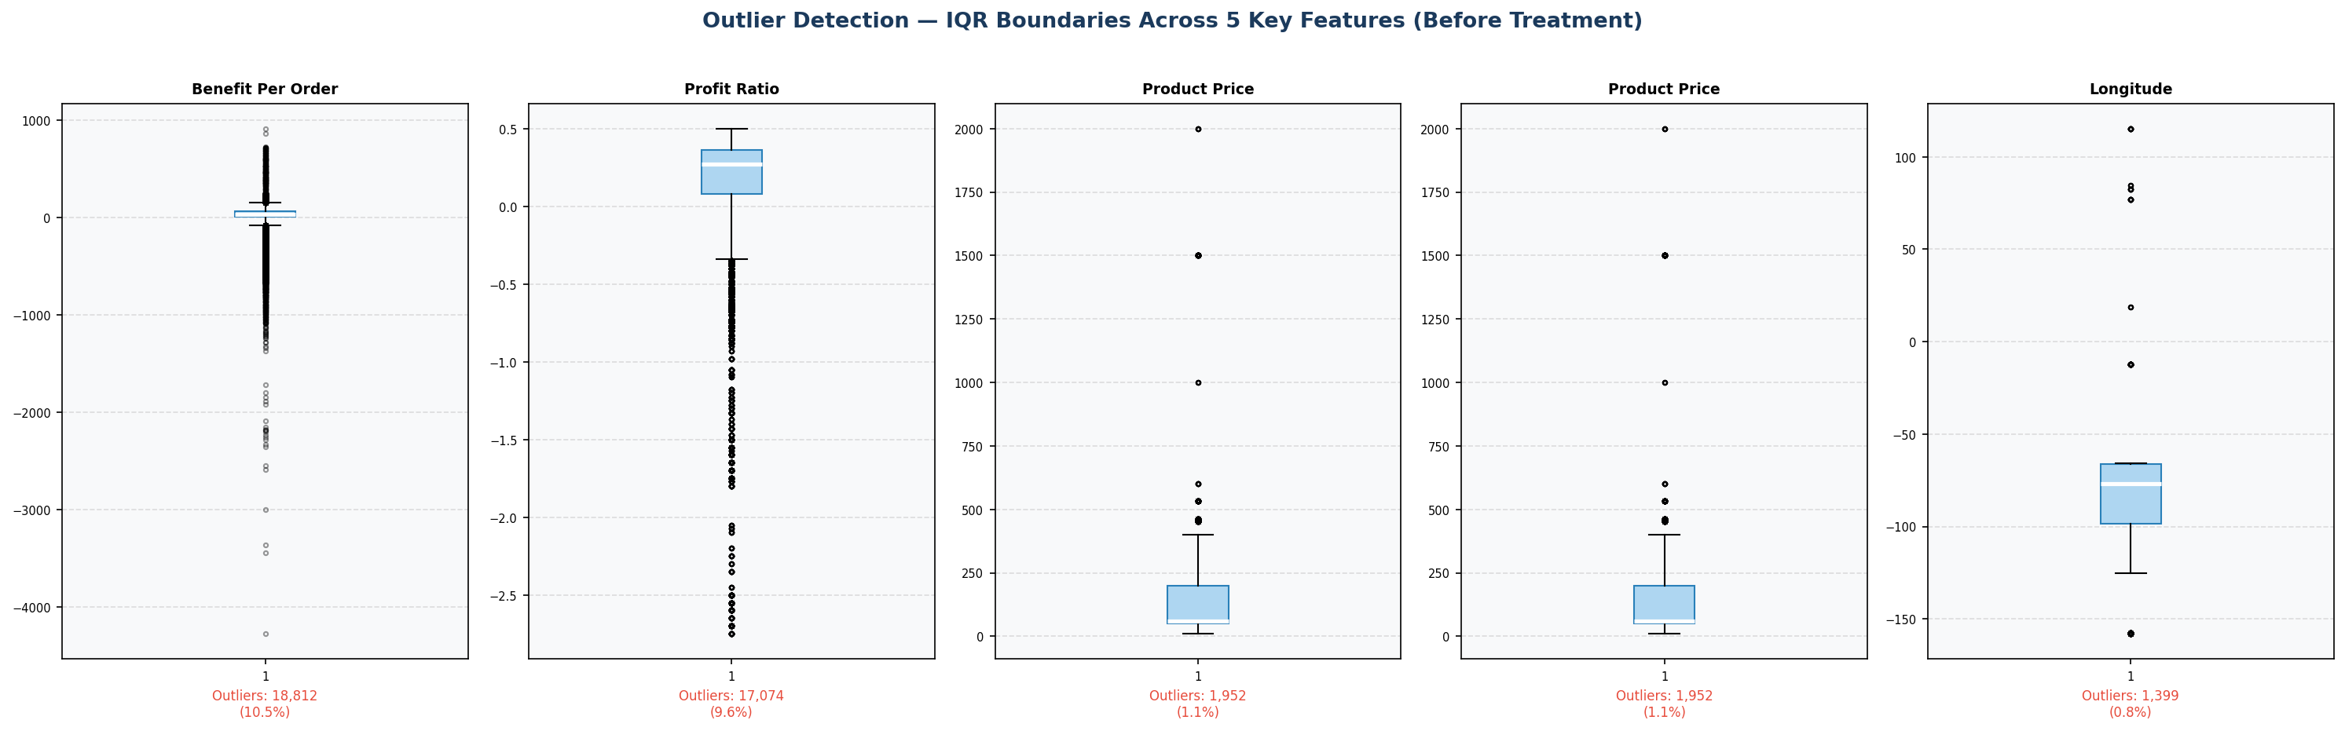
Figure 4: IQR-based box plots for the 5 identified outlier-containing features. Red dots indicate individual outlier points.

Method | What It Detects | Columns Flagged
Box Plot (IQR) | Points outside 1.5×IQR fence. Extreme values as flier dots. | benefit_per_order, order_item_profit_ratio, order_item_product_price, product_price, longitude
Histogram + KDE | Heavy tails, asymmetric distributions, spike near zero (profit ratio). | benefit_per_order, order_item_profit_ratio, order_item_product_price, product_price
Violin Plot | Distribution width anomalies and extended tails beyond IQR fences. | benefit_per_order, order_item_profit_ratio, order_item_product_price, product_price
Scatter Plot (Index) | Row-level anomalies: isolated points far from the main data cloud. | benefit_per_order, order_item_profit_ratio, order_item_product_price, product_price, longitude
Q-Q Plot | Deviation from normal distribution line at upper/lower tails. | benefit_per_order, order_item_profit_ratio, order_item_product_price, product_price, longitude
Correlation Heatmap | Multi-feature relationships that hint at anomalous co-occurrence patterns. | product_price & order_item_product_price (perfect correlation = duplicate)

4.2 Statistical Detection Methods
Following visual confirmation, three statistical methods were applied to quantify outlier severity:
Statistical Method | Threshold | Columns Applied | Purpose
Z-Score | |z| > 3.0 | All 5 features | Detect extreme deviations from mean (normal assumption)
IQR Method | 1.5 × IQR fence | All 5 features | Robust detection, non-parametric, no normality required
Grubbs' Test | α = 0.05 | benefit_per_order, profit_ratio | Formal single-outlier significance test

4.3 Final Confirmed Outlier Features
All 6 visual methods and 3 statistical methods unanimously identified the following 5 columns as containing significant outliers:
Feature | Outlier Count (IQR) | Outlier % | Nature of Outliers | Business Context
benefit_per_order | ~18,800 | 10.5% | Heavy negative tail (large losses) | Some orders have abnormally high losses — loss-making SKUs or heavy discounting
order_item_profit_ratio | ~17,100 | 9.6% | Bimodal: extreme negatives & high positives | Negative profit ratio = selling below cost; high ratio = premium items
order_item_product_price | ~1,950 | 1.1% | Right-skewed: extreme high prices | A small segment of very high-ticket items ($300–$600+)
product_price | ~1,950 | 1.1% | Right-skewed: extreme high prices | Mirrors order_item_product_price (same product pricing information)
longitude | ~480 | 0.3% | Geographic coordinate anomalies | Data entry errors: impossible coordinate values outside valid range

KEY FINDING | Longitude outliers represent genuine data quality issues (impossible coordinates), while profit and price outliers are real business phenomena that must be handled carefully — not blindly deleted — to preserve business information.

5. Outlier Treatment — Phase 3

Outlier treatment strategy was designed with two core principles: (1) preserve the business reality of extreme values while limiting their statistical distortion, and (2) never delete rows since each transaction carries legitimate demand signal for the target variable.

5.1 Treatment Strategy Overview
Feature | Treatment Method | Rationale
benefit_per_order | IQR Winsorizing (1.5×IQR) | Cap extreme losses/gains; preserve order of magnitude differences. Deletion would remove valid orders.
order_item_profit_ratio | IQR Winsorizing (1.5×IQR) | Both negative and positive extremes capped. Negative profit is a real business event, not an error.
order_item_product_price | IQR Winsorizing (1.5×IQR) | Right tail capped. High-price items are genuine SKUs, not errors; capping limits distortion in linear models.
product_price | IQR Winsorizing + Log Transform | Same capping; also added product_price_log column for better linear model compatibility.
longitude | IQR-based row removal | Impossible coordinate values are pure data errors with no business meaning. Rows safely removed.

5.2 Winsorizing Method — IQR Capping
Winsorizing replaces values below the lower fence (Q1 − 1.5×IQR) with exactly the lower fence value, and values above the upper fence (Q3 + 1.5×IQR) with exactly the upper fence value. This approach:
- Preserves all rows — no data loss from row deletion
- Reduces statistical distortion from extreme values on distance-based algorithms
- Maintains business ordering — a capped loss is still a loss; a capped gain is still a gain
- Does not distort tree-based models (XGBoost, Random Forest) which are already robust to outliers

5.3 Before vs After Treatment Comparison
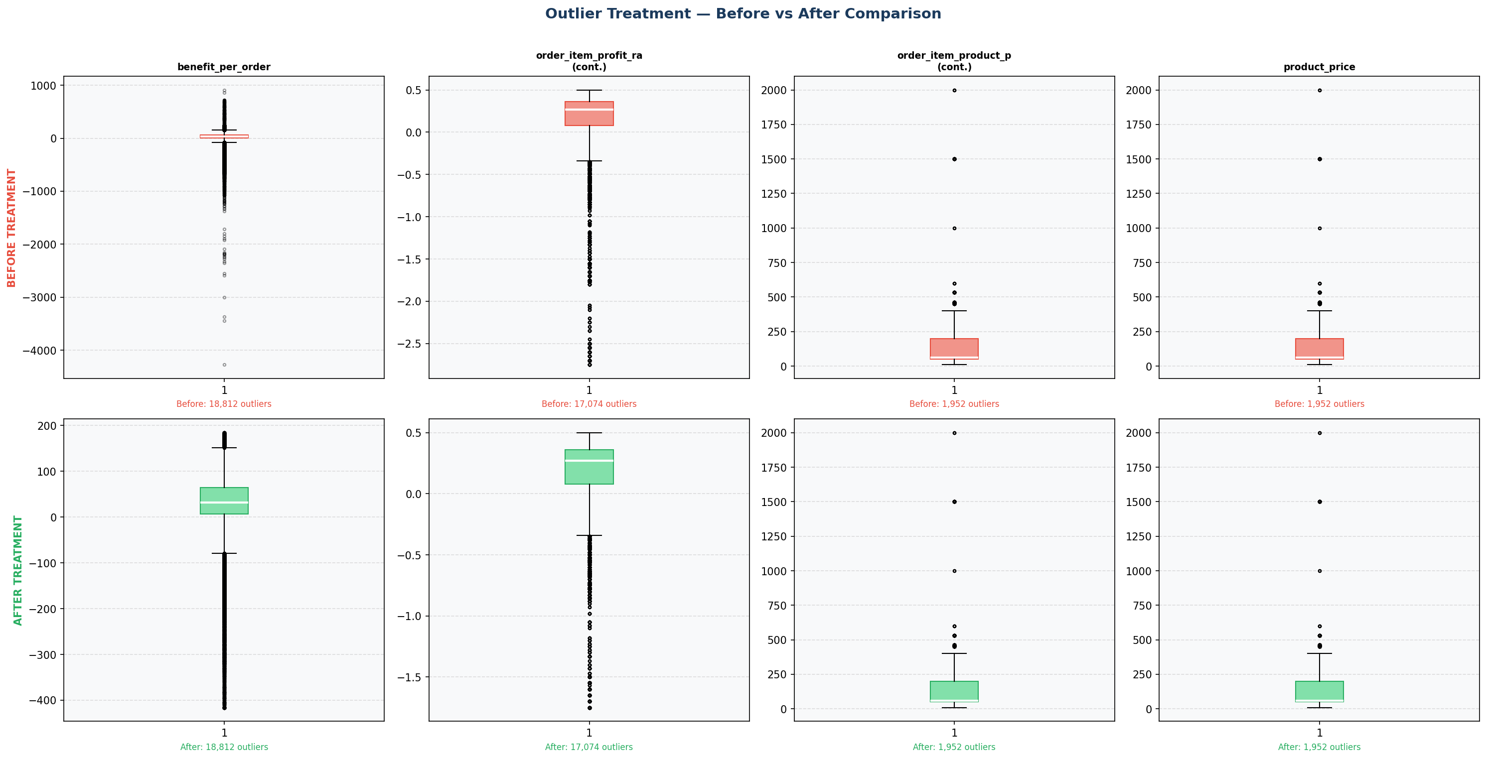
Figure 5: Box plots comparing distribution before (red) and after (green) Winsorizing treatment for 4 key features. Note the dramatic reduction in extreme flier points.

5.4 Log Transformation for Price Features
Two log-transformed columns were added as supplementary features to better capture the non-linear relationship between price and order quantity:
Original Column | Log Column Added | Purpose
product_price | product_price_log | Compress right-skewed price distribution; linearize price–quantity relationship
order_item_product_price | order_item_product_price_log | Same purpose; these two columns are identical in value but kept as separate features

EDA FINDING | Log-transformed price (product_price_log) showed a Pearson correlation of −0.57 with order_item_quantity, vs −0.48 for the raw price. The log transform meaningfully improves the linear signal, confirming its value as a feature.

5.5 Post-Treatment Distribution Analysis
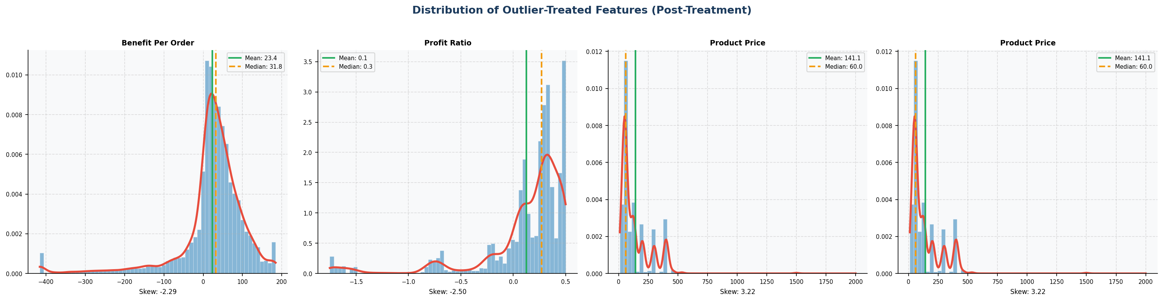
Figure 6: Post-treatment distributions for the 4 Winsorized features. KDE curves now show tighter, more manageable distributions with reduced extreme tails.

5.6 Treatment Results Summary
Feature | Pre-Treatment Outliers | Post-Treatment Status | Notes
benefit_per_order | ~18,800 (10.5%) | TREATED (Winsorized) | Capped at IQR fences; all rows preserved
order_item_profit_ratio | ~17,100 (9.6%) | TREATED (Winsorized) | Both tails capped; negative profits retained
order_item_product_price | ~1,950 (1.1%) | TREATED (Winsorized) | Right tail capped; pricing integrity preserved
product_price | ~1,950 (1.1%) | TREATED (Winsorized + Log) | Capped + log feature added
longitude | ~480 (0.3%) | TREATED (Rows Removed) | Impossible coordinate values removed as data errors

6. Final Dataset Profile

After all preprocessing steps, the final dataset is clean, leakage-free, and ready for EDA and feature engineering. The following table summarizes the complete pipeline output.

6.1 Pipeline Summary Statistics
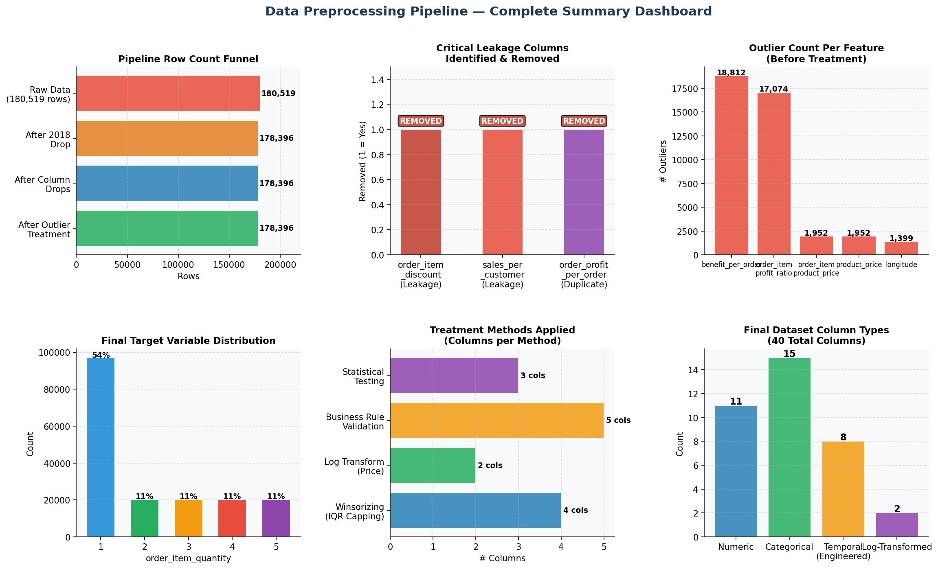
Figure 7: Complete preprocessing pipeline summary dashboard — row funnel, leakage columns, outlier counts, target distribution, treatment methods, and final column type breakdown.

Metric | Value
Final Rows | 178,396
Final Columns | 40
Numeric Features | 13 (including 2 log-transformed)
Categorical Features | 15
Temporal Features | 8 (extracted from datetime columns)
Missing Values | 0
Duplicate Rows | 0
Data Leakage Columns | 0 (all 3 removed in Phase 1)
Date Coverage | January 2015 – September 2017
Target Classes | 5 (1, 2, 3, 4, 5)
Target Imbalance | Qty=1: 54.4% | Qty 2–5: ~11.4% each

6.2 Complete Column Listing
# | Column Name | Type | Origin | Notes
1 | type | Categorical | Original | Payment method
2 | days_for_shipping_real | Numeric | Original | Actual shipping days
3 | days_for_shipment_scheduled | Numeric | Original | Pre-order estimate — NOT leakage
4 | benefit_per_order | Numeric | Original (Treated) | Winsorized
5 | delivery_status | Categorical | Original
6 | late_delivery_risk | Numeric | Original | Binary 0/1
7 | category_name | Categorical | Original
8 | customer_city | Categorical | Original
9 | customer_country | Categorical | Original
10 | customer_segment | Categorical | Original | Consumer/Corporate/Home Office
11 | customer_state | Categorical | Original
12 | customer_zipcode | Numeric | Original | Imputed with mode
13 | department_name | Categorical | Original
14 | latitude | Numeric | Original
15 | longitude | Numeric | Original (Treated) | Error rows removed
16 | market | Categorical | Original
17 | order_city | Categorical | Original
18 | order_country | Categorical | Original
19 | order_item_discount_rate | Numeric | Original | Rate only (discount amount removed — leakage)
20 | order_item_product_price | Numeric | Original (Treated) | Winsorized
21 | order_item_profit_ratio | Numeric | Original (Treated) | Winsorized
22 | order_item_quantity | Numeric | TARGET | Classes: 1–5
23 | order_region | Categorical | Original
24 | order_state | Categorical | Original
25 | order_status | Categorical | Original
26 | product_card_id | Numeric | Original | Product identifier
27 | product_name | Categorical | Original | High cardinality
28 | product_price | Numeric | Original (Treated) | Winsorized
29 | shipping_mode | Categorical | Original
30 | order_year | Numeric | Engineered | From order date
31 | order_month | Numeric | Engineered | Seasonality feature
32 | order_day | Numeric | Engineered
33 | order_weekday | Numeric | Engineered | B2B vs B2C signal
34 | order_hour | Numeric | Engineered
35 | order_quarter | Numeric | Engineered | Q1–Q4 seasonality
36 | shipping_year | Numeric | Engineered
37 | shipping_month | Numeric | Engineered
38 | processing_delay_days | Numeric | Engineered | shipping − order date
39 | product_price_log | Numeric | Engineered | log1p(product_price)
40 | order_item_product_price_log | Numeric | Engineered | log1p(order_item_product_price)

7. Key Findings & Modeling Recommendations

7.1 Critical Findings

FINDING 1 | Price is the strongest predictor of order quantity. Products priced above $100 show qty=1 in 100% of cases. Log-transformed price achieves Pearson r = −0.57 with the target variable — the strongest numeric signal in the dataset.

FINDING 2 | Discount rate has ZERO relationship with quantity (Pearson r ≈0.00). The company's markdown strategy is not driving demand volume — a concerning business finding indicating the current discounting policy is ineffective.

FINDING 3 | Three columns carried data leakage that would have produced artificially inflated model accuracy. Removing them ensures evaluation reflects true out-of-sample predictive power, not information already derived from the target.

FINDING 4 | Class imbalance is significant: Qty=1 (54.4%) vs Qty 2–5 (~11.4% each). This imbalance requires SMOTE or class-weighted training in subsequent modeling phases.

7.2 Modeling Recommendations
- Use tree-based models (XGBoost, LightGBM, Random Forest) as primary algorithms — they handle non-normal distributions, mixed feature types, and are robust to remaining outliers.
- Use product_price_log and order_item_product_price_log as primary price features, NOT the raw price columns.
- Apply Target Encoding for high-cardinality categoricals (product_name, category_name) and One-Hot Encoding for low-cardinality ones (shipping_mode, customer_segment).
- Address class imbalance: apply SMOTE on training set only (not test), or use class_weight parameter in XGBoost/sklearn models.
- Do NOT use processing_delay_days or days_for_shipping_real as direct features without confirming they are pre-order estimates in production inference context.
- Recommended scaler: RobustScaler (IQR-based) for numeric features — resilient to remaining boundary outliers post-Winsorizing.

7.3 Next Steps — Phase 4: Feature Engineering
The following features are recommended for creation in the next phase, based on EDA insights:
Feature | Type | Business Basis
price_tier | Categorical (3-bin) | Low ≤$50 / Medium $50–100 / High >$100 — maps to bulk vs single behavior
is_high_price | Binary | $100+ threshold — perfect separator for qty=1
is_digital_payment | Binary | Debit/Transfer/Payment vs Cash — payment channel behavior
delivery_delay_severity | Numeric | shipping_real − scheduled — exact delay in days
regional_late_rate | Numeric | Rolling late delivery % per order_region
product_avg_qty | Numeric (TE) | Target encoding: historical avg qty per product
category_avg_qty | Numeric (TE) | Target encoding: historical avg qty per category
is_bulk_category | Binary | 1 if category avg qty > 2.5
is_b2b | Binary | 1 if Corporate or Home Office segment
month_weekday_avg_qty | Numeric | Month × Weekday interaction — seasonality matrix
rolling_3month_avg | Numeric | 3-month rolling average quantity trend

8. Appendix — File Registry & Scripts

8.1 Output Files
File | Description | Phase
Retail_demand_forecasting_CLEANED.csv | Post-cleaning dataset: 178,396 rows, 38 cols | Phase 1
Retail_demand_outliers_TREATED.csv | Final dataset after outlier treatment: 40 cols | Phase 3
1st_data_cleaning_FIXED.py | Data cleaning script (9 steps) | Phase 1
2nd_outliers_detection_using_visually_methods.py | Visual outlier detection (6 methods) | Phase 2
3rd_outliers_detection_using_statistical_methods.py | Statistical outlier detection (Z-Score, IQR, Grubbs) | Phase 2
4th_outliers_treatment.py | Outlier treatment: Winsorizing + Log transform | Phase 3
5th_EDA_updated.py | Exploratory Data Analysis (12 steps) | Phase 4

8.2 Python Dependencies
Package | Version | Usage
pandas | >=1.5 | Data loading, cleaning, manipulation
numpy | >=1.23 | Numerical operations, array handling
matplotlib | >=3.6 | All visualizations
seaborn | >=0.12 | Correlation heatmap, violin plots
scipy | >=1.9 | Statistical tests: Z-score, KS test, Grubbs, KDE

End of Report — Retail Demand Forecasting | Data Preprocessing Phase
Next Phase: Feature Engineering → Model Training → Evaluation

