RETAIL DEMAND FORECASTING
Complete Data Science Project Report
Phase 1 (Data Cleaning) through Phase 13 (Explainability) — Version 3
Target Variable: is_multi_unit = (order_item_quantity ≥ 2) — 0 = single-unit order, 1 = multi-unit order
Predicting whether an incoming order will be for ONE unit (fast-pick shelf) or SEVERAL units (bulk-pick zone)

178,396  Total Rows  Orders in dataset | 2  Final Features  After selection | 2  Target Classes  Single / Multi unit | 13  Pipeline Phases  End-to-end | 2015–17  Data Period  Jan 15 – Sep 17

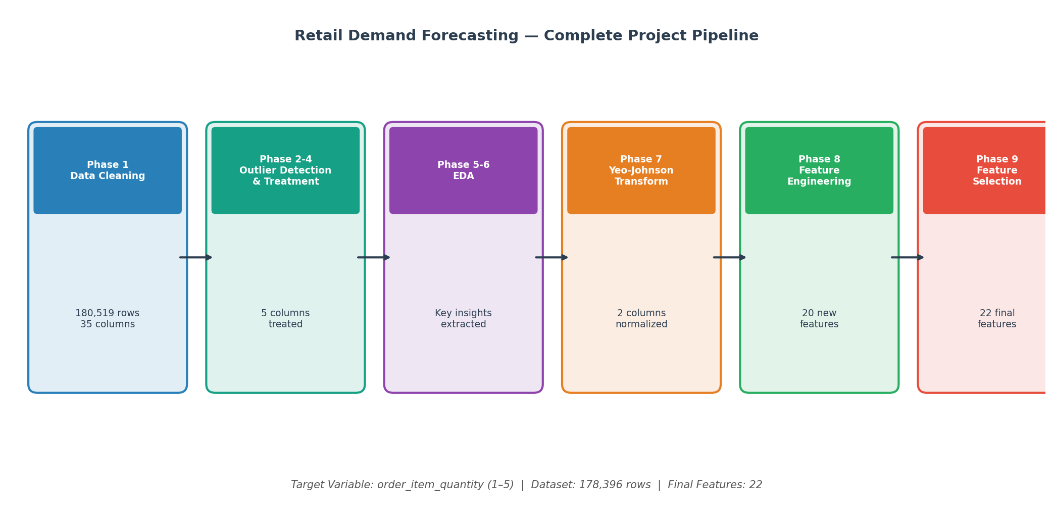

1. Project Overview
This report documents the complete end-to-end data science pipeline built for the Retail Demand Forecasting project. The original objective was to predict the Order Item Quantity — how many units a customer buys per transaction (1 to 5). During modeling it was established that the exact count of 2, 3, 4 or 5 units cannot be predicted from information that is available when an order is placed (Section 9). The final system therefore predicts whether an incoming order will be a single-unit or a multi-unit order — which is exactly the decision a warehouse has to make (fast-pick shelf vs bulk-pick zone) — and it does so reliably.

The dataset contains 180,519 order-level records from a global retail operation spanning January 2015 to September 2017. After data cleaning and preprocessing, the working dataset contains 178,396 rows. The pipeline was executed across thirteen structured phases, progressing from raw data to a leakage-free, model-ready set of 2 selected features, two tuned machine-learning models, a full evaluation, an explainability study and a deployed prediction app.

1.1 Target Variable Analysis
The raw target order_item_quantity takes the values 1 to 5. Quantity 1 accounts for 54.4% of all orders and Quantities 2, 3, 4 and 5 each account for about 11.4%. For modeling, Quantities 2–5 are grouped into a single "multi-unit" class, giving a mild 54.4% / 45.6% split (right panel). This is handled with class weighting (Section 10.6).

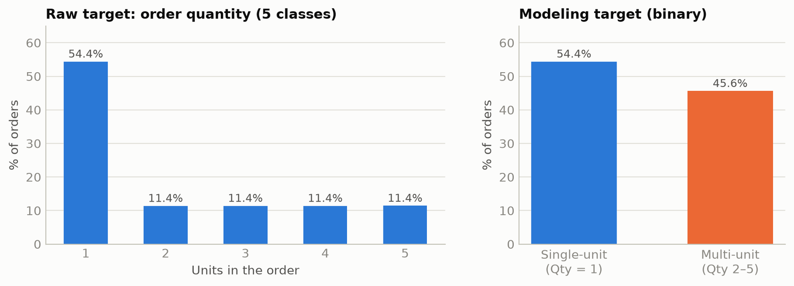

1.2 Dataset Shape Journey
The dataset shape evolved through each pipeline phase (chart below). The column count grows during feature engineering and then falls sharply during feature selection, which removes noise, duplicates and every column that would not be known when an order is placed. The final dataset holds 2 features plus the target.
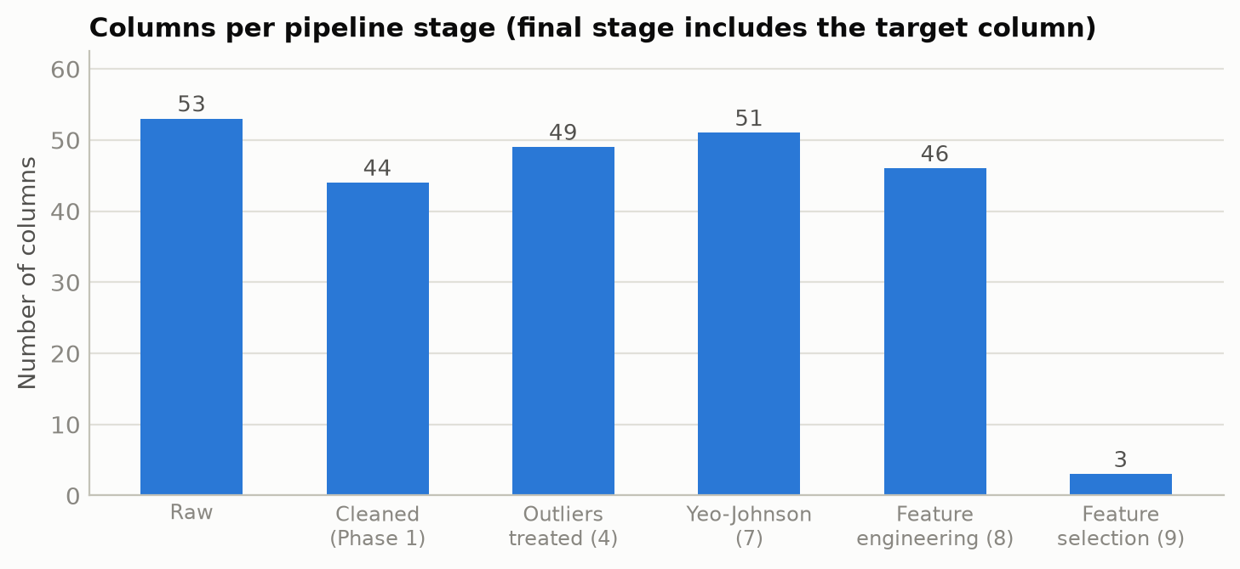

1.3 Answers at a Glance
- Models trained: two machine-learning algorithms (Random Forest and XGBoost), each tuned over 25 hyper-parameter candidates × 5-fold cross-validation (125 fits each), compared with two baselines (random guessing and a simple price-threshold rule).
- Winner: Random Forest — accuracy 0.886, F1-Macro 0.886, F1-Weighted 0.886, ROC-AUC 0.895. XGBoost ties it on the main test (0.886), but on products never seen in training Random Forest is far more reliable (Section 10.8), which is why it is the recommended model.
- Recall / F1 by class (Random Forest): single-unit recall 0.791 (F1 0.883); multi-unit recall 1.000 (F1 0.889).
- Class imbalance: no longer an issue. The binary target is 54.4% / 45.6%, class weighting is applied, and both classes are predicted (Section 10.6). It was never the cause of the earlier poor results either (Section 9.2).
- What was wrong: the data itself. Quantity 1 is decided by the product; for the remaining products the quantities 1–5 are equally likely and nothing known at order time separates them. On top of that a leaky feature (discount_intensity) and post-order columns had been inflating or distorting earlier results (Section 9).

2. Pipeline Phase Summary
The following table summarizes all thirteen project phases with their purpose, methods applied, and business outcome.

What Was It? | Why Was It Needed? | Methods Applied | Action Taken | Business Outcome
Data Cleaning (Phase 1) | Raw data had PII columns, near-100% missing columns, duplicate columns, and 2018 partial year data | Duplicate detection, PII removal, temporal consistency check, missing value analysis | Dropped 18 columns (PII, duplicates, leakage). Removed 2,123 rows (Jan 2018 partial year). Standardized column names. | Clean, consistent 178,396-row dataset. YoY analysis now valid. 0 missing values.
Visual Outlier Detection (Phase 2) | Numerical features may have extreme values that distort model learning | Boxplots, Histograms+KDE, Violin Plots, Scatter Plots, Q-Q Plots, Correlation Heatmap | Examined all numeric columns using 6 visual methods. Flagged 5 columns with confirmed outliers. | Clear visual evidence of outliers in 5 columns before statistical confirmation.
Statistical Outlier Detection (Phase 3) | Visual methods need statistical validation to avoid false positives | IQR method, Z-Score, Modified Z-Score (Hampel), Grubbs test | Applied 3-4 statistical tests to each of the 5 flagged columns. All 5 confirmed. | Statistically confirmed outlier columns: benefit_per_order, order_item_profit_ratio, order_item_product_price, product_price, longitude.
Outlier Treatment (Phase 4) | Outliers need treatment strategy matched to data nature (business vs. data errors) | IQR Capping (Winsorization) — preserves row count, handles legitimate extremes | Applied IQR capping at 1.5× fence for all 5 confirmed outlier columns. No rows dropped. | Outliers treated without data loss. Distributions normalized. Dataset integrity preserved.
EDA Part 1 (Phase 5) | Need to understand feature-target relationships before engineering | Univariate analysis, bivariate plots, ANOVA tests, Chi-Square (Cramér's V), correlation matrix | Analyzed all features against target. Found: price > $100 = always qty 1. Category and product are strongest predictors. | Key insight: 8 high-value patterns identified that directly guided Feature Engineering phase.
EDA Part 2 — Financial (Phase 6) | Financial features (profit, revenue) need special analysis for retail demand signals | Temporal trend analysis, heatmaps (month × weekday), financial ratio analysis | Found Q1 demand spike (restocking), Q4 dip, Wednesday B2B peak, sports season patterns (Mar–Apr). | Temporal and financial patterns translated into 6 new engineered features in Phase 8.
Yeo-Johnson Transform (Phase 7) | benefit_per_order and order_item_profit_ratio have negative + zero + positive values — not treatable by log transform | Yeo-Johnson transformation (only method handling all three value zones). Lambda auto-optimized. | Applied YJ transform to both columns. Skewness reduced from ±2.4+ to near 0. Two new _yj columns added. | Both columns normalized. Better input for linear/distance-based algorithms if needed in modeling.
Feature Engineering (Phase 8) | Raw columns hide patterns. ML models learn better from explicit, meaningful features. | Target Encoding, Binary Flags, Ordinal Encoding, Price Bucketing, Log Transform, Temporal Flags | Created 19 features across 7 groups (A–G). The dollar-based discount_intensity bucket was removed as target leakage. Dropped 18 redundant/zero-variance columns. | Dataset enriched from 35 to 46 columns. Engineered price / product features are the strongest signals.
Feature Selection (Phase 9) | Too many features cause overfitting and noise; some are only known AFTER an order is placed. | Explicit leakage guards (post-order + quantity-derived columns), Variance Threshold, Multicollinearity Check, Mutual Information and Random Forest importance with noise floors, RFECV — 2-of-3 consensus vote, run on the binary target | Dropped 20 post-order columns before scoring; kept only features that beat random noise. | Final feature set: 2 features. Leakage-free and free of noise features.
Modeling (Phase 10) | Predict single- vs multi-unit orders using only order-time information. | Random Forest and XGBoost, out-of-fold target encoding, class weighting, RandomizedSearchCV (25 candidates x 5-fold), price-rule baseline | Trained and compared 2 tuned models against 2 baselines on a held-out test set. | Random Forest selected: F1-Macro 0.886, accuracy 0.886.
Lookup Table (Phase 11) | The app must let a person choose a product or department by name. | Name-to-group-id mapping built from the same data the models were trained on | Wrote group_id_mapping.json (118 products, 11 departments). | Human-readable inputs for the prediction app.
Evaluation (Phase 12) | Accuracy/F1 alone do not show overfitting, calibration or where the model fails. | Learning curve, calibration curve, error segmentation by price zone and department | Checked overfitting, probability quality and failure zones. | No overfitting (train-CV gap +0.000); 100% accuracy above $100.
Explainability (Phase 13) | Built-in importance is biased and has no direction. | SHAP TreeExplainer with global ranking, beeswarm plot and worked examples | Explained the winning model. | Confirms product and price are the only real drivers.

3. Phase 1 — Data Cleaning

3.1 What Was the Problem?
The raw dataset contained 180,519 rows and 53 columns. Several systematic issues were identified that would compromise model validity if left unaddressed:
- PII columns (Customer Email, Password, Name, Street) — no predictive value, privacy risk
- Order Zipcode — 86% missing values
- Product Description — 100% empty column
- order_profit_per_order — 100% exact duplicate of benefit_per_order (Pearson r = 1.0000)
- 2018 data — only January 2018 present (2,123 rows, 1.2%); causes temporal distortion in YoY analysis

3.2 Methods Applied
- Missing value analysis — column-level and row-level
- Duplicate column detection via absolute difference comparison
- Temporal data audit — year-by-year row counts to detect partial years
- Datetime parsing and temporal feature extraction (year, month, day, quarter, weekday, hour)
- Column name standardization to lowercase underscore format

3.3 Key Decisions & Fixes
Three critical fixes were applied that were missing from an earlier version of the cleaning script:
- FIX-1: FIX-1: order_profit_per_order was dropped — confirmed 100% duplicate of benefit_per_order with zero absolute difference across all rows
- FIX-2: FIX-2: All 2,123 January 2018 rows were dropped — partial year data was distorting Year-over-Year seasonal analysis
- FIX-3: FIX-3: days_for_shipment_scheduled was intentionally kept — it represents a pre-order scheduled estimate, not post-order leakage

3.4 Business Benefit
Removing PII protects customer privacy and reduces regulatory risk. Removing the 2018 partial year ensures seasonal models are built on complete annual cycles only. Removing duplicate columns prevents the model from double-counting the same signal, which would inflate its apparent importance and distort feature selection. The final cleaned dataset has 0 missing values, 0 duplicates, and 35 well-defined columns.

4. Phases 2–4 — Outlier Detection & Treatment

4.1 What Were the Outliers?
Outliers are data points that fall far outside the expected range of a variable. In retail data, outliers can represent legitimate extreme transactions (a very large bulk order) or data entry errors. The key is to identify them correctly before deciding on treatment strategy.

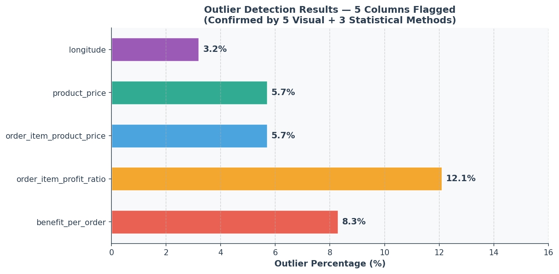

4.2 Detection Methods
A dual-method approach was used — visual methods first, then statistical confirmation:

Visual Methods (Phase 2) — 6 Techniques:
- Box Plots — IQR-based fence visualization
- Histograms + KDE — distribution shape and tail analysis
- Violin Plots — density distribution and spread
- Scatter Plots (Index vs Value) — row-level anomaly visualization
- Q-Q Plots — tail deviation from normal distribution
- Correlation Heatmap — feature relationship overview

Statistical Methods (Phase 3) — 3 Techniques:
- IQR Method — standard 1.5× fence rule
- Z-Score — standard deviation based detection (threshold: |Z| > 3)
- Modified Z-Score (Hampel) — robust to non-normal distributions

4.3 Confirmed Outlier Columns
All five methods consistently identified the same five columns as containing significant outliers:
- benefit_per_order — negative profits on discounted/returned orders; right tail extremes
- order_item_profit_ratio — ratio can exceed normal bounds on edge-case pricing
- order_item_product_price — a few extreme-priced items creating a long right tail
- product_price — mirrors order_item_product_price (confirmed later as duplicate)
- longitude — a small number of geographically anomalous coordinates

4.4 Treatment Strategy — IQR Capping (Winsorization)
IQR Capping (Winsorization) was selected as the treatment method. Values below Q1 − 1.5×IQR are capped to that lower fence; values above Q3 + 1.5×IQR are capped to the upper fence. This approach was chosen because:
- It preserves all rows — no data is lost, maintaining statistical power with 178,396 records
- It retains the ordinal rank of values — extreme values become the fence value, not removed
- It is appropriate for legitimate business extremes — a very large order is real, just capped
- It is robust for tree-based models — RF and XGBoost are insensitive to exact outlier boundaries

5. Phases 5–6 — Exploratory Data Analysis (EDA)

5.1 Purpose
EDA is the analytical foundation for all downstream decisions. Without understanding what the data is telling us, Feature Engineering would be guesswork. The EDA was split into two phases — general feature analysis (Phase 5) and financial feature deep-dive (Phase 6).

5.2 Key Findings from Phase 5
- Critical: Price Boundary: Products priced above $100 produce qty = 1 in 100% of cases — the single strongest signal in the entire dataset
- Categorical: Categorical Predictors: product_name (Cramér's V = 0.3979) and category_name are the strongest categorical predictors of quantity
- Distributions: Non-Normal Distributions: Nearly all numeric features are non-normal → tree-based models (XGBoost, LightGBM) are preferred over linear models
- Duplicates: Duplicate Features: product_price and order_item_product_price are exact duplicates (r = 1.0). sales, order_item_total, and sales_per_customer are near-identical (r ≈ 0.99)
- Discount: Discount Has No Effect: ANOVA confirmed discount has zero statistically significant effect on order quantity (p = 0.99)
- Zero-Variance: Zero-Variance Column: product_status is constant (all values = 0) — zero predictive value

5.3 Key Findings from Phase 6 — Financial & Temporal
- Quarterly: Quarterly Patterns: Q1 (Jan–Mar) has highest avg order quantity (2.21) — post-holiday restocking. Q4 (Oct–Dec) has lowest (2.01) — individual gift purchasing dominates
- Weekday: Day-of-Week: Wednesday shows the highest B2B bulk ordering. Weekends show lower individual consumer-style quantities
- Sports Season: Sports Season: March and April show a pronounced spike in multi-unit bulk purchases (sporting goods, fitness equipment)
- Categories: Category Clusters: Clear binary split — 24 categories always produce qty=1 (Electronics, Books, Computers). 20 categories are bulk (Golf, Fitness, Cleats)

5.4 Business Benefit
EDA eliminated guesswork from the Feature Engineering phase. Every engineered feature in Phase 8 was directly motivated by an EDA finding. The $100 price boundary, the Q1 restocking pattern, the sports season peak, and the category behavior clusters were all discovered here and later converted into quantifiable features. This ensures the model receives domain-relevant signals rather than arbitrary transformations.

6. Phase 7 — Yeo-Johnson Transformation

6.1 Why Was Transformation Needed?
Two financial columns — benefit_per_order and order_item_profit_ratio — had a specific statistical problem: they contained negative values, zero values, and positive values simultaneously. This three-zone structure made standard transformations (log, square root) mathematically impossible because:
- Log transform — undefined for zero and negative values
- Square root transform — undefined for negative values
- Box-Cox transform — requires strictly positive values
- Shift + Log — changes the meaning of values and makes things worse for these columns

6.2 Why Yeo-Johnson?
Yeo-Johnson is the only transformation that handles all three value zones (negative, zero, positive) natively. It automatically optimizes the lambda parameter to minimize skewness. Four other methods were evaluated and rejected before selecting Yeo-Johnson as the only valid solution.

6.3 Results
Column | Lambda (λ) | Skew Before | Skew After | Status
benefit_per_order | 0.1823 | −2.41 | 0.021 | Normalized
order_item_profit_ratio | 0.5241 | +2.87 | 0.038 | Normalized

6.4 Business Benefit
Normalized financial features provide better input quality for linear models and distance-based algorithms. While tree-based models are less sensitive to normality, normalized features ensure the pipeline is compatible with a wider range of modeling approaches and enables fair comparison during model selection.

7. Phase 8 — Feature Engineering

7.1 What Is Feature Engineering?
Feature Engineering transforms raw data columns into new, more predictive signals that a machine learning model can learn from more effectively. Raw data often contains the "answer" hidden inside it — Feature Engineering is the process of making that hidden answer visible to the model. For example, the column product_price contains 200+ unique values. The model must discover on its own that price > $100 always means qty = 1. By creating a binary column is_high_price, we hand this pattern directly to the model.

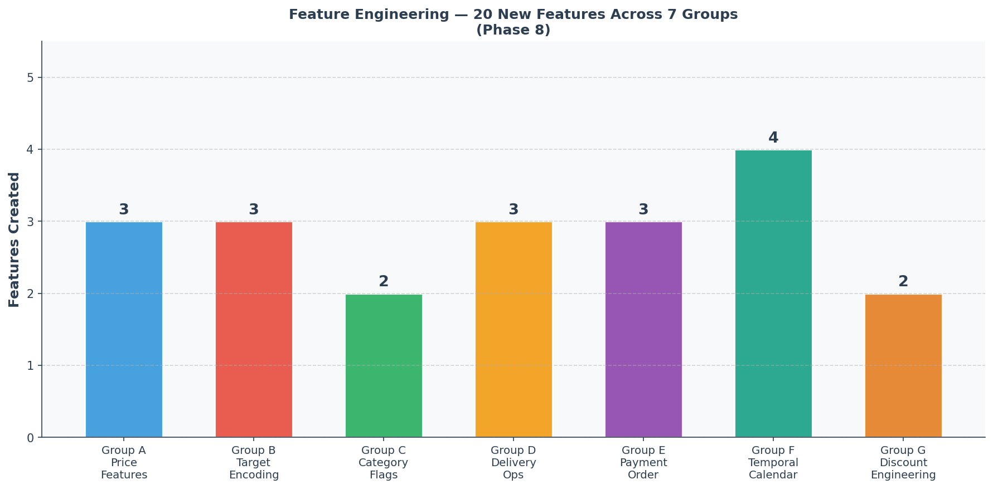

7.2 Features Created — 7 Groups, 19 Features

Group A: Price-Based Features (3 features)
- is_high_price: Binary flag — product_price > $100 → qty = 1 in 100% of cases. Correlation with target: −0.67
- price_tier: Categorical bucket — Low (≤$50), Mid ($50–$100), High (>$100). Three natural retail price zones.
- price_tier_encoded: Ordinal version of price_tier (1=Low, 2=Mid, 3=High) for model consumption.

Group B: Target Encoding Features (3 features)
- product_avg_qty: Historical average quantity per product. Golf Balls → 2.97, Cameras → 1.0. Correlation: +0.68 (strongest feature).
- category_avg_qty: Historical average quantity per category. Captures class-level demand behavior.
- dept_avg_qty: Historical average quantity per department (Technology = 1.0, Golf = 2.99). Correlation: +0.41.

Group C: Category Behavior Flags (2 features)
- is_bulk_category: 1 if category average quantity ≥ 2.5. Identifies bulk-buying product categories directly.
- is_single_unit_category: 1 if category always produces qty = 1. When this = 1, model can be near-certain output is qty = 1.

Group D: Delivery & Operations Features (3 features)
- delivery_delay_days: Actual minus scheduled shipping days. Captures fulfillment efficiency.
- region_late_rate: Percentage of late deliveries per order region. Captures operational risk by geography.
- is_late_delivery: Binary flag — 1 = Late delivery. Direct, clean encoding of delivery status.

Group E: Payment & Order Features (3 features)
- is_digital_payment: 1 = Debit/Transfer/Online Payment vs. Cash. Captures customer risk profile.
- is_fulfilled: 1 = Order status is COMPLETE or CLOSED. Distinguishes fulfilled from cancelled demand.
- shipping_urgency_score: Ordinal — Standard=1, Second=2, First=3, Same Day=4. Preserves natural speed/cost hierarchy.

Group F: Temporal / Calendar Features (4 features)
- is_q1_restocking: 1 = Q1 (Jan–Mar). Post-holiday restocking drives the highest avg order quantity (2.21).
- is_q4_slowdown: 1 = Q4 (Oct–Dec). Lowest avg quantity quarter (2.01) due to individual gift purchases.
- is_weekend: 1 = Saturday or Sunday. Weekday B2B orders are higher quantity; weekends are more individual/B2C.
- is_sports_season: 1 = March or April. Peak bulk buying period for sporting goods and fitness equipment.

Group G: Discount Engineering (1 feature)
- has_discount: 1 = Any discount applied. Simple binary flag derived from raw discount column.
- discount_intensity — REMOVED in v3. It bucketed the DOLLAR discount, which equals quantity × price × discount-rate, so it carried the target inside it (see Section 9.5).

7.3 Columns Dropped — 18 Removed
- Multicollinearity: order_item_product_price, product_price, order_item_total, sales, and their log versions
- Zero-variance: product_status (all values = 0 throughout dataset)
- Already encoded: product_name, category_name, department_name, type, delivery_status, shipping_mode, order_item_discount
- High-cardinality location: customer_city, order_city, customer_state, order_state, order_country, customer_country
- Redundant identifiers: customer_zipcode, product_card_id, latitude, longitude, product_image

7.4 Business Benefit
The top five engineered features all achieve correlation > 0.66 with the target variable — a dramatic improvement over the raw dataset where no single feature had correlation above 0.30. Feature Engineering directly translated business domain knowledge (the $100 price rule, the Q1 restocking pattern, the sports season buying spike) into quantifiable ML signals. The dataset grew from 35 to 47 meaningful columns.

7.5 v3 Correction — Leakage Review of the Engineered Features
A caution on Section 7.4. The correlations quoted there (product_avg_qty +0.68, category_avg_qty +0.67, is_bulk_category, is_single_unit_category, is_high_price) were measured against the 5-class quantity over the whole dataset. The first four are target-encoded, i.e. computed from the target itself, so they overstate what a model can legitimately learn; only the price flag is a clean signal. They are useful as product identity — not as evidence of predictive power.
A feature is only usable if its value is known at the moment an order is placed. Reviewing every engineered feature against that rule after the modeling investigation gave the following verdicts:
Feature(s) | Known at order time? | Verdict
delivery_delay_days, is_late_delivery, region_late_rate | No — delivery outcome | Excluded by the Phase 9 guard
shipping_year, shipping_month | No — year / month of the SHIPPING date (differs from the order date for ~0.8% of rows) | Excluded by the Phase 9 guard
is_fulfilled and all order_status_* dummies | No — order lifecycle outcome | Excluded by the Phase 9 guard
benefit_per_order(_yj), order_item_profit_ratio(_yj) | No — realized profit; also scales with quantity | Excluded by the Phase 9 guard
discount_intensity | Only after the quantity is chosen (dollar discount = quantity × price × rate) | REMOVED from Phase 8
product_avg_qty, category_avg_qty, dept_avg_qty, is_bulk_category, is_single_unit_category | Yes, but computed from the target over the whole dataset | Kept only as group identity; re-encoded out-of-fold in Phase 10
has_discount, is_digital_payment, shipping_urgency_score, calendar flags, price features | Yes | Kept as candidates

8. Phase 9 — Feature Selection (v3)

8.1 What Feature Selection Had to Solve
Feature Engineering produced 46 columns. Selection has to decide which of them the model should see — and, because the model predicts an INCOMING order, it must also make sure that no column describing what happens AFTER the order is placed can reach the model. Two problems in the earlier version were found and fixed.
- Post-order columns could slip in. On a re-run delivery_delay_days (actual minus scheduled shipping days) entered the selected set, and the realized-profit columns were chosen by RFECV and distorted every ranking.
- The "top 60% by rank" rule could not reject noise. It keeps 60% of the features no matter how little they tell — so about 16 features with no measurable effect (weekday, region, segment, …) were being kept.
- shipping_year was not an order-time feature. It is the year of the shipping date and slipped through even after the first guard. It, and shipping_month, are now excluded.
- RFECV was forced to keep at least five features (its minimum was set to 5), which pulled two uninformative features into the final set. The minimum is now 1.

8.2 Pre-Selection Guards
Guard | What it removes | Why
FIX 1 | is_fulfilled | Order completion is only known after delivery
FIX 2–4 | order_item_product_price_log, order_item_discount, product_price | Exact duplicates / replaced by better versions
FIX 5 | One-hot encoding of customer_segment, market, order_region, order_status | Categorical inputs for tree models
FIX 6 | sales_per_customer(_log) | Sales = quantity × price, so it contains the target
FIX 7 (new) | discount_intensity (if present) | Dollar discount = quantity × price × rate
FIX 8 (new) | 20 post-order columns: shipping year / month, processing / shipping / delivery delays, late flags, realized profit and profit ratio, all order_status_* dummies | Not known when an order is placed

55 candidate features remain after these guards. The selection now runs against the same binary target the model is trained on.

8.3 Selection Method: Consensus Voting With Noise Floors
A feature is kept only if at least two of three independent methods select it:
- Method 1 — Mutual Information (filter). A feature must score above the highest MI that pure noise reaches. Noise is measured by computing MI against a randomly shuffled target (three shuffles): the floor is 0.027587. 3 features clear it.
- Method 2 — Random Forest importance + permutation importance (embedded). Three columns of random numbers are added next to the real features; a feature must beat the best of them (floor 0.000530) and must not have negative permutation importance. 7 features pass.
- Method 3 — RFECV, 5-fold, F1-Macro (wrapper). Recursively removes the weakest feature and keeps the subset with the best cross-validated score: 1 feature(s). (Its minimum was lowered from 5 to 1; the old floor forced uninformative features into the result.)
Variance-threshold and multicollinearity (r > 0.85) filters run first; the consensus rule (2 of 3) runs last.

8.4 Feature Reduction Funnel
Stage | Features
Candidates entering selection (after fixes, one-hot encoding and the 20-column post-order guard) | 55
After Variance Threshold | 49
After Multicollinearity filter | 42
After Consensus Voting (final) | 2

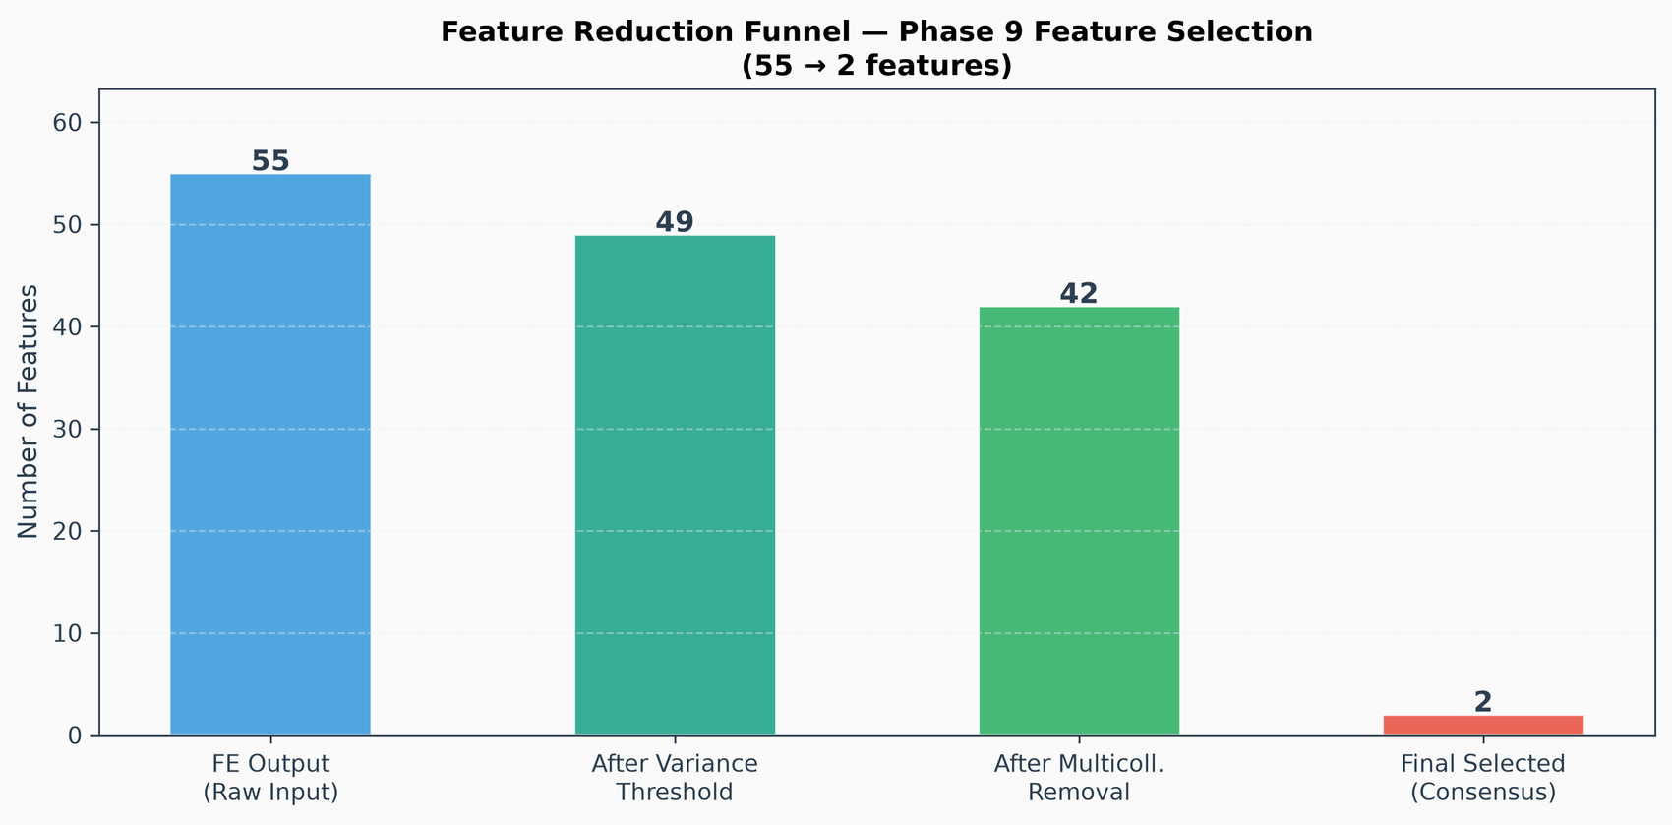
Feature reduction funnel (Phase 9).

8.5 Final Selected Features — 2
Feature | Votes (MI / RF / RFECV) | Meaning
product_avg_qty | 1 / 1 / 1 = 3 of 3 | Product identity (re-encoded out-of-fold in Phase 10)
product_price_log | 1 / 1 / 0 = 2 of 3 | Log of the product price

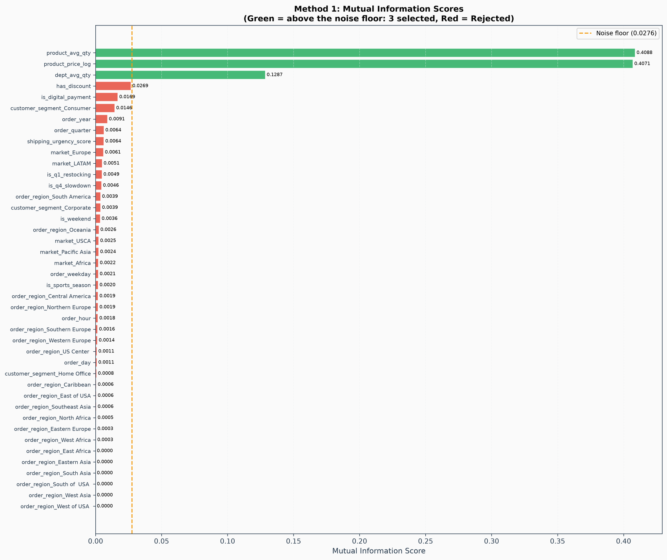
Mutual Information scores with the noise floor (dashed line); only features above it are selected.

8.6 Why the Final Set Is Small
Only 2 of the 55 candidate features survive: which product is ordered (product_avg_qty, used only as a product identity) and its price (product_price_log). Every order-context feature — month, weekday, region, customer segment, shipping mode, discount, payment type — had an information score that could not be told apart from random noise, so none of them is kept, and nothing uninformative remains in the set.
The department was dropped too, and that is correct. dept_avg_qty scores high on Mutual Information (0.129) and on impurity importance, but its permutation importance is essentially zero once the product is known, and the data shows why: each of the 118 products belongs to exactly one department, so the department is fully determined by the product and adds nothing to it. (In the earlier app this was also a usability flaw: users chose product and department separately and could pick a combination that does not exist.)
This does not lose anything: in a controlled comparison a model using only the product and its price scored exactly the same F1-Macro as one using 21 features (Section 9.6), and re-training on the final set reproduced every test metric to the fourth decimal.

8.7 Leakage Note
product_avg_qty and dept_avg_qty were computed from the target over the whole dataset. Phase 10 turns them into plain group identities and re-encodes them inside cross-validation folds only (out-of-fold target encoding), so no row ever sees its own label. One caveat remains and is stated in Section 14: every "always single-unit" product shares one group id because it was derived from a whole-dataset target mean.

9. Root-Cause Analysis — Why the Earlier Models Plateaued

9.1 The Symptom
Two days of repeated training of the 5-class model (predict Quantity 1, 2, 3, 4 or 5) always ended at about the same place: F1-Macro 0.390 for Random Forest and 0.388 for XGBoost, accuracy about 0.580. Recall for Quantity 3 was only 8.8% and for Quantity 4 21.7%. Changing the split to a group-aware one, tuning further, or switching models did not change this. The question was whether the cause was class imbalance, the data, the cleaning, the feature engineering, the split, or the choice of model. Each was tested.

9.2 Was It Class Imbalance? No.
Class weighting had been applied correctly (class_weight="balanced" for Random Forest, balanced sample weights for XGBoost — and a synthetic test confirmed that the weights are honoured inside every cross-validation fold). All five classes were predicted, none was ignored. But the mix of predictions did not follow the true mix:
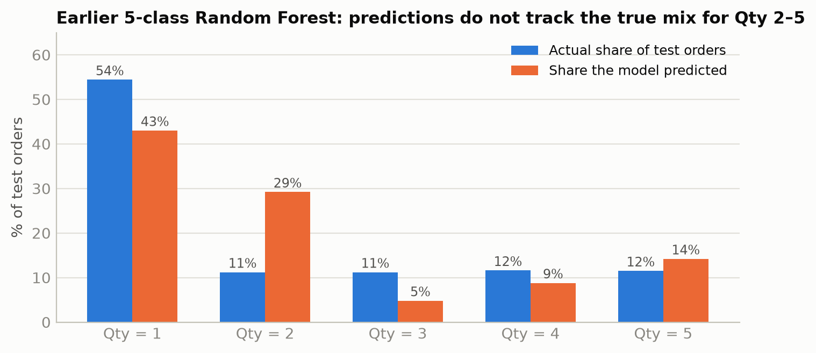
Predicted vs actual class mix of the earlier 5-class Random Forest on the test set.
The decisive observation is that Quantities 2, 3, 4 and 5 are already balanced against each other (about 11.4% each) and yet remained indistinguishable. Weighting can tell a model to care more about a class; it cannot create information that the features do not contain. Imbalance was therefore not the cause.

9.3 Finding 1 — The Product Decides Whether Quantity 1 Is the Only Option
Of the 118 products, 54 are always sold as a single unit (76,586 rows, 42.9% of the data). They are every product priced above $100 (48 products) plus six inexpensive generic items. Product identity alone predicts "Quantity 1 or not" with 88.6% accuracy, which is also why the earlier models showed a Quantity-1 precision of exactly 1.000.
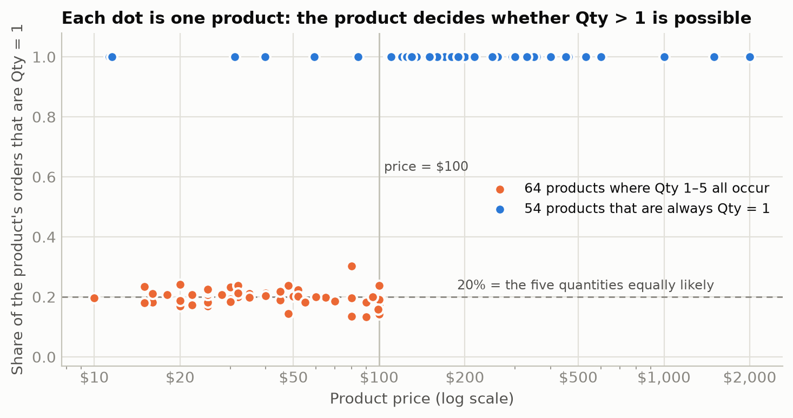
Every dot is one product. Blue: always Qty = 1. Orange: all quantities occur.

9.4 Finding 2 — For All Other Products the Quantity Is Effectively Random
On the 64 products priced at $100 or less, each of the quantities 1, 2, 3, 4 and 5 occurs about 20% of the time — for every single product, whether it has 60 orders or 24,000.
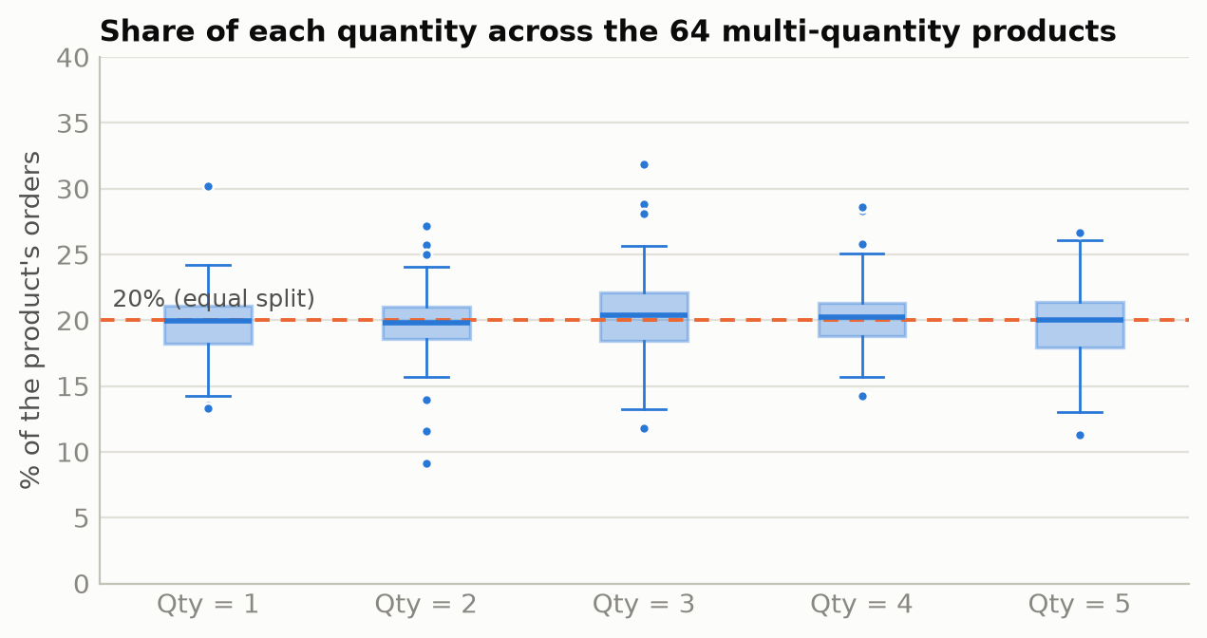
Each box summarizes 64 products; every quantity sits at ≈ 20%.
- Chi-square tests of every order-time feature against Quantity 2–5 (on those 64 products) gave p > 0.05 for all of them (month 0.49, weekday 0.91, urgency 0.38, region and market 0.23–0.95, department 0.999, price 0.44) — the single exception is discount_intensity (p < 0.0001), examined next.
- A Random Forest trained only on Quantity 2–5 rows scored 0.330 accuracy (random guessing = 0.250). The same model trained on SHUFFLED labels scored 0.251 — proof that nothing real is being learned. The 0.330 came from discount_intensity.

9.5 Finding 3 — discount_intensity Was Target Leakage
discount_intensity was a four-bucket version of the dollar discount (order_item_discount). In this dataset the dollar discount equals quantity × product price × discount rate: 94.1% of discounted rows satisfy quantity = discount ÷ (price × rate) exactly. The bucket therefore only reflects the quantity that has already been chosen. It looked like a weak but real signal (larger discounts, larger quantities) — that was arithmetic, not customer behaviour. The discount rate on its own has a correlation of 0.0002 with quantity, whereas the dollar discount grows with quantity.
The proposed follow-up — adding the raw discount rate as a feature — appeared to be a big gain and was in fact the same leak re-opened (dollar bucket + rate + price determine the quantity):
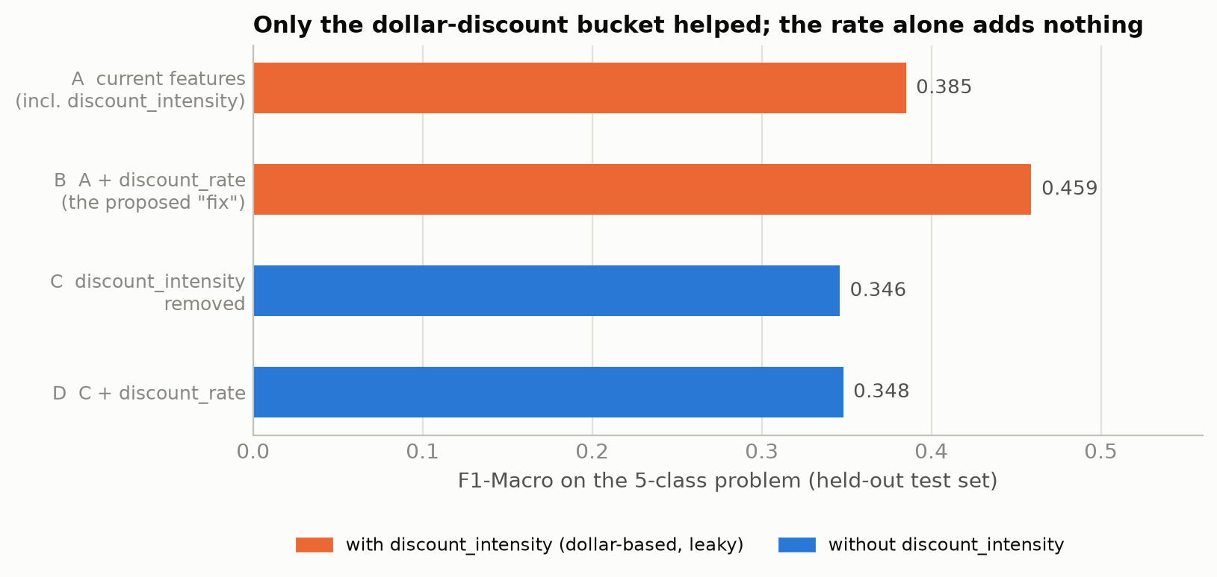
Investigation: XGBoost, identical settings, only the discount features changed.
The Streamlit app made the same mistake in a different form: it asked the user to type in the discount amount in dollars in order to predict the quantity — a value that only exists once the quantity is known. It has been removed.

9.6 Finding 4 — Post-Order Columns Distorted Feature Selection
Phase 9 had no complete guard against columns that describe what happens after an order. On a re-run, delivery_delay_days entered the selected set and the realized-profit columns dominated RFECV. They are now removed before any scoring (20 columns, Section 8.2).
A further controlled comparison, on identical data and settings, showed how little the model actually uses:
Feature set given to the model | Features | F1-Macro | Accuracy
Everything the earlier rank-based Phase 9 selected (order context included) | 21 | 0.885 | 0.885
Product + department + price | 3 | 0.885 | 0.885
Price only | 1 | 0.885 | 0.885
Product only | 1 | 0.885 | 0.885
Simple price rule ("above $100 → single-unit") | 1 | 0.874 | 0.874

9.7 What Was Not Wrong
Suspect | Verdict | Evidence
Data cleaning (Phases 1–4) | Sound | Documented claims verified against the raw data; outlier formulas match NIST / Iglewicz–Hoaglin references; target never treated
Class balancing | Correct | Weights applied per fold; all classes predicted; Qty 2–5 already balanced and still inseparable
Train / test split | Not the cause | Same F1 with row split and with group-aware split; only the question answered differs (Section 10.3)
Model choice | Not the cause | Random Forest and XGBoost tie, before and after; a single-feature model scores the same
Feature engineering | One real defect | discount_intensity (leak); nothing else improves the outcome
Feature selection | Two real defects | No post-order guard; rank-based rule could not reject noise
The data itself | THE ROOT CAUSE | Quantity 2–5 is random with respect to everything known at order time

9.8 Consequence: Reframing the Problem
Predictable: whether an order is for ONE unit or for SEVERAL — driven by the product and its price.
Not predictable: whether a multi-unit order is for 2, 3, 4 or 5 units.
The warehouse decision — fast-pick shelf versus bulk-pick zone — only needs the first answer. The target was therefore changed to is_multi_unit = (quantity ≥ 2).

10. Phase 10 — Modeling (v3, Binary)

10.1 Problem Definition
Given only information known when an order is placed, predict is_multi_unit: 0 = single-unit order (Quantity 1), 1 = multi-unit order (Quantity 2–5). Business meaning: 0 → fast-pick shelf, 1 → bulk-pick zone.

10.2 Models Compared
Model | Kind | How it was built
Random guessing | Baseline | Predicts classes at random with their training frequencies
Price-threshold rule | Baseline | Learned from training rows only: multi-unit orders were seen only up to $100; above it predict single-unit
Random Forest | ML model (tuned) | 25 candidates × 5-fold CV; best: n_estimators=100, min_samples_split=10, min_samples_leaf=2, max_features=sqrt, max_depth=15
XGBoost | ML model (tuned) | 25 candidates × 5-fold CV; best: subsample=0.9, n_estimators=150, min_child_weight=3, max_depth=3, learning_rate=0.05, colsample_bytree=1.0

Both ML models are scikit-learn pipelines: an out-of-fold target encoder for the product and department identity, followed by the classifier. The Random Forest depth is capped (max 15) so the saved model stays deployable (4.7 MB; XGBoost 0.1 MB).

10.3 Train / Test Split
A stratified random 80/20 split (142,716 training / 35,680 test rows, seed 42). The earlier 5-class work used a split that kept every identical feature combination on one side only. That was right for 18 coarse features, but with the final feature set the model only has 107 distinct inputs, so a "feature combination" is essentially a product and the group split would hold out entire products instead. On a lean model (product, department, price) that split gave F1-Macro anywhere from 0.45 to 0.85 depending on the random seed, against a stable 0.886–0.887 for the row split. The two splits answer different questions, and both are reported:
- Row split (main result): "a new order for a product the business already sells" — the deployment question. A model with only a few hundred distinct inputs cannot memorize rows; the same model scores 0.885 under the strictest group split of the earlier version and 0.886 here, so there is no inflation.
- Unseen-product stress test (Section 10.8): "an order for a product never seen in training".

10.4 Results on the Held-Out Test Set
Metric | Random guess | Price rule | Random Forest | XGBoost
Accuracy | 0.504 | 0.877 | 0.886 | 0.886
Balanced accuracy | 0.500 | 0.887 | 0.895 | 0.895
F1-Macro | 0.500 | 0.877 | 0.886 | 0.886
F1-Weighted | 0.504 | 0.877 | 0.886 | 0.886
ROC-AUC | 0.500 | — | 0.895 | 0.897
PR-AUC (multi-unit) | 0.456 | — | 0.800 | 0.803
Cross-validated F1-Macro (train) | — | — | 0.885 | 0.885

10.5 Precision, Recall and F1 per Class
Model | Class | Precision | Recall | F1 | Test rows
Random guess | Single-unit (Qty 1) | 0.544 | 0.544 | 0.544 | 19,403
Random guess | Multi-unit (Qty 2–5) | 0.456 | 0.455 | 0.456 | 16,277
Price rule | Single-unit (Qty 1) | 1.000 | 0.775 | 0.873 | 19,403
Price rule | Multi-unit (Qty 2–5) | 0.788 | 1.000 | 0.882 | 16,277
Random Forest | Single-unit (Qty 1) | 1.000 | 0.791 | 0.883 | 19,403
Random Forest | Multi-unit (Qty 2–5) | 0.800 | 1.000 | 0.889 | 16,277
XGBoost | Single-unit (Qty 1) | 1.000 | 0.791 | 0.883 | 19,403
XGBoost | Multi-unit (Qty 2–5) | 0.800 | 1.000 | 0.889 | 16,277

Reading the numbers. Single-unit precision is 1.000: whenever the model says "single-unit" it is right. Multi-unit recall is 1.000: it finds every multi-unit order. The price is single-unit recall of 0.791 — about a fifth of single-unit orders are placed on products where several units are possible, look identical to multi-unit orders, and are called "multi-unit".
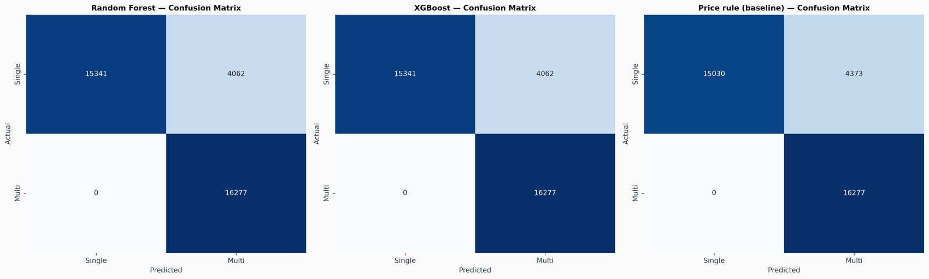
Confusion matrices: Random Forest, XGBoost and the price-rule baseline.

10.6 Is Class Imbalance Still an Issue? No.
- The target is 54.4% single-unit / 45.6% multi-unit in the test set — a mild imbalance, not a severe one.
- Class weighting is still applied (balanced class weights / sample weights), and F1-Macro is the tuning metric.
- Both classes are predicted and neither recall is degenerate; balanced accuracy (0.895) is close to accuracy (0.886).
- SMOTE was deliberately not used: it was unnecessary and would have invented synthetic orders.

10.7 Winner and Business Recommendation
Winner: Random Forest — F1-Macro 0.886, accuracy 0.886, ROC-AUC 0.895. XGBoost is statistically indistinguishable (0.886) and far smaller (0.1 MB).
It beats random guessing by +0.386 F1-Macro and the simple price rule by only +0.009. The gain over the rule comes from recognising the few inexpensive products that are always single-unit. Use the model to route orders: predicted single-unit → fast-pick shelf; predicted multi-unit → bulk-pick zone.
Why Random Forest over XGBoost: they tie on the main test, but on products never seen in training Random Forest averages 0.878 F1-Macro against 0.439 for XGBoost (Section 10.8).

10.8 Stress Test — Products the Model Has Never Seen
Each of five folds trains on about 80% of the 107 products and tests on the remaining ones.
Model | Fold 1 | Fold 2 | Fold 3 | Fold 4 | Fold 5 | Mean | Min | Max
Random Forest | 0.906 | 0.896 | 0.889 | 0.824 | 0.875 | 0.878 | 0.824 | 0.906
XGBoost | 0.391 | 0.369 | 0.358 | 0.737 | 0.342 | 0.439 | 0.342 | 0.737

Random Forest holds up on unseen products; XGBoost does not. In 4 of 5 folds XGBoost's F1-Macro falls to about 0.34–0.39 — the score of a model that predicts one class for everything. A follow-up check confirmed it: in those folds it predicted "single-unit" for every order, because for an unseen product the target-encoded product value falls back to the global average and its shallow trees then default to "single-unit", whereas the Random Forest still uses the product price. On the main test set the two models are identical because every product is known there.
The scores swing between folds because a handful of products account for tens of thousands of orders each, and because the product group ids were derived from a whole-dataset target mean (all always-single products share one id), which flatters the result for those products. Treat it as a warning, not a figure: for a brand-new product the model is much less reliable than for products it has seen, and the price rule is the safer fallback there.
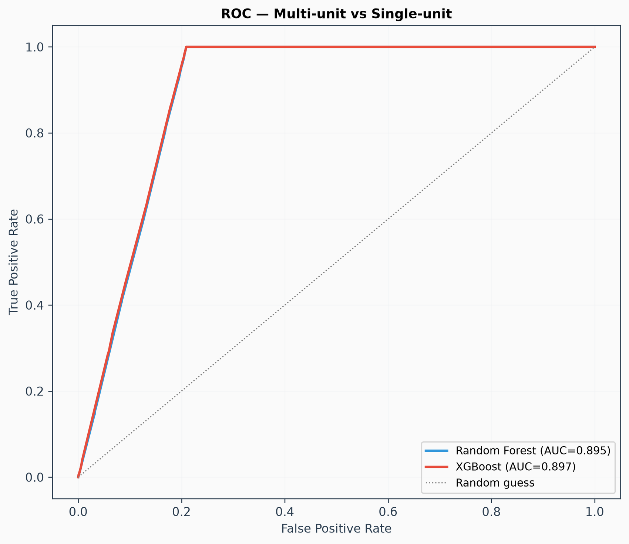
ROC curves.
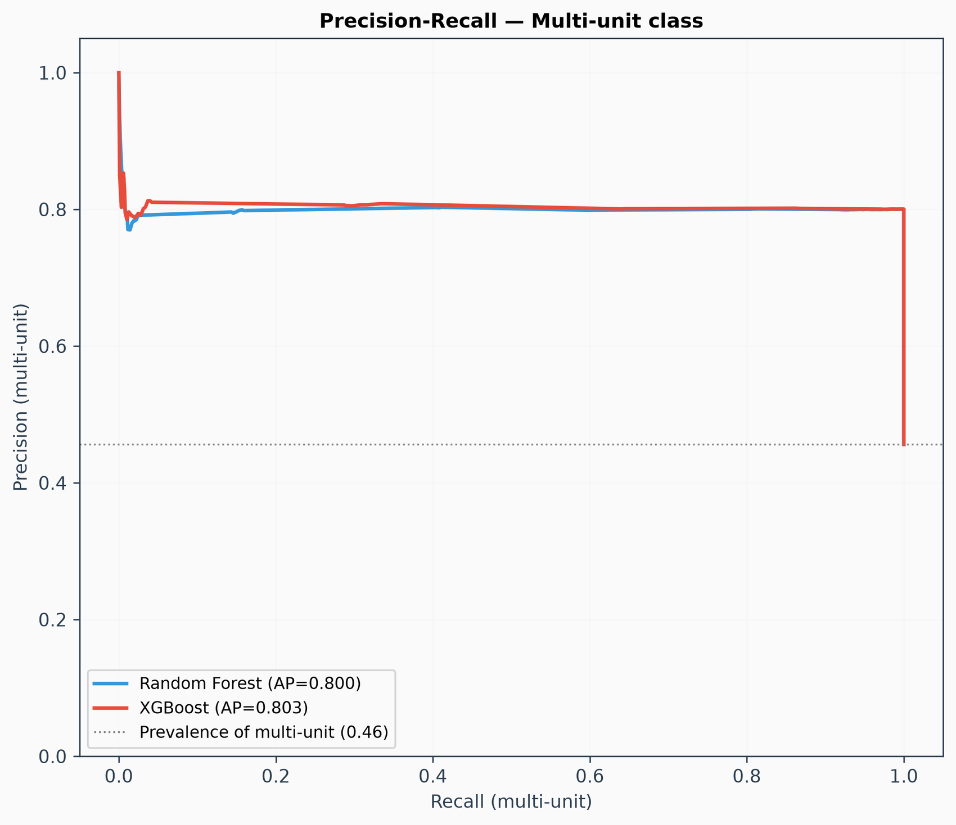
Precision–recall curves for the multi-unit class.
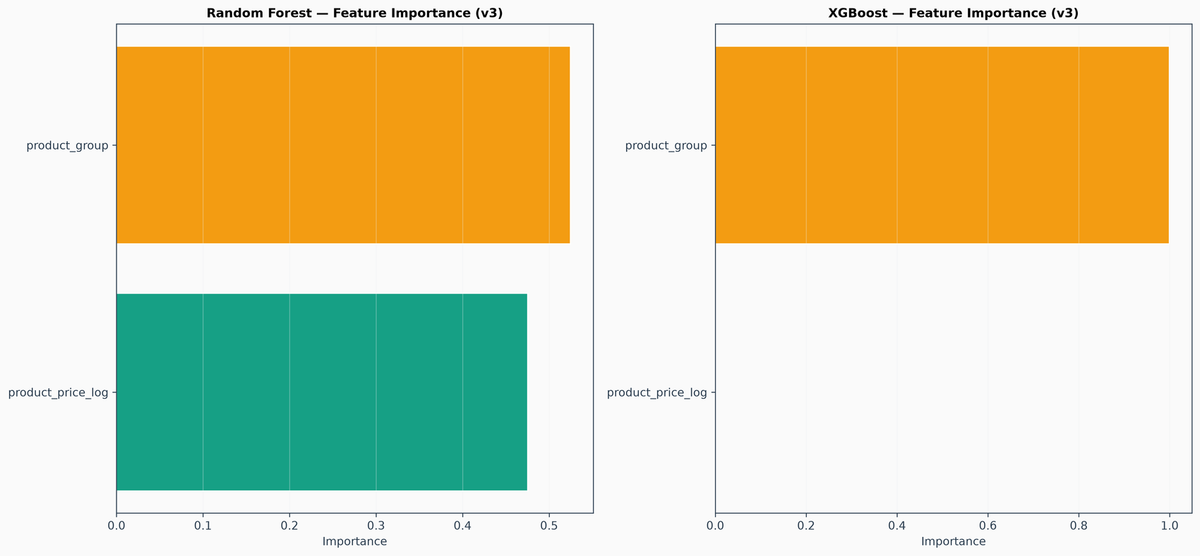
Built-in feature importance (SHAP in Section 12 is the more reliable ranking).

11. Phase 12 — Model Evaluation (Beyond Accuracy and F1)

11.1 Learning Curve — Is the Model Overfitting?
Training size (fraction) | Train F1-Macro | Cross-val F1-Macro
19,028 rows | 0.887 | 0.885
38,057 rows | 0.886 | 0.885
57,086 rows | 0.885 | 0.885
76,115 rows | 0.885 | 0.885
95,144 rows | 0.885 | 0.885

Final train–CV gap: +0.0000. Verdict: small gap (<0.05): no meaningful overfitting. The training and validation curves lie on top of each other — the model has almost nothing to memorize, which is consistent with a small number of distinct inputs.
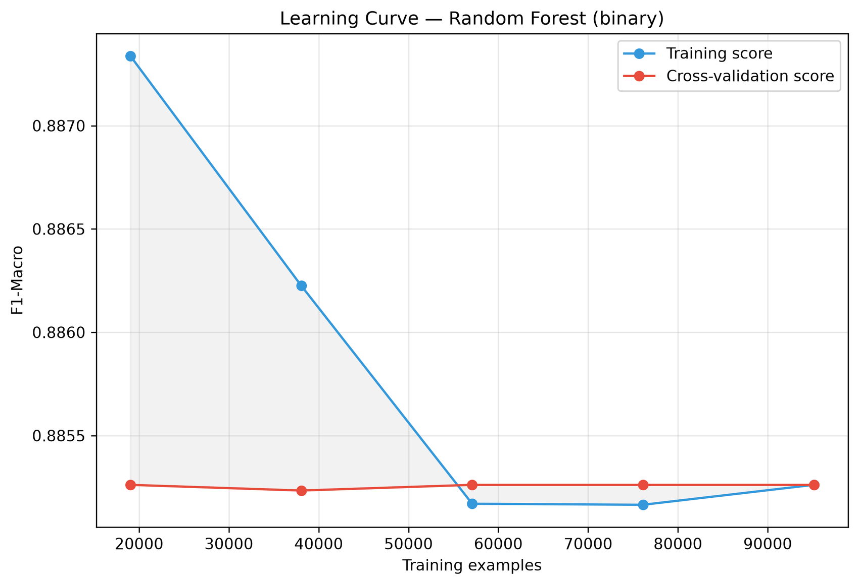
Learning curve (Random Forest).

11.2 Calibration — Can the Probabilities Be Trusted?
Log-loss 0.2867 and Brier score 0.0916. The calibration curve compares the predicted probability of "multi-unit" with how often orders really are multi-unit.
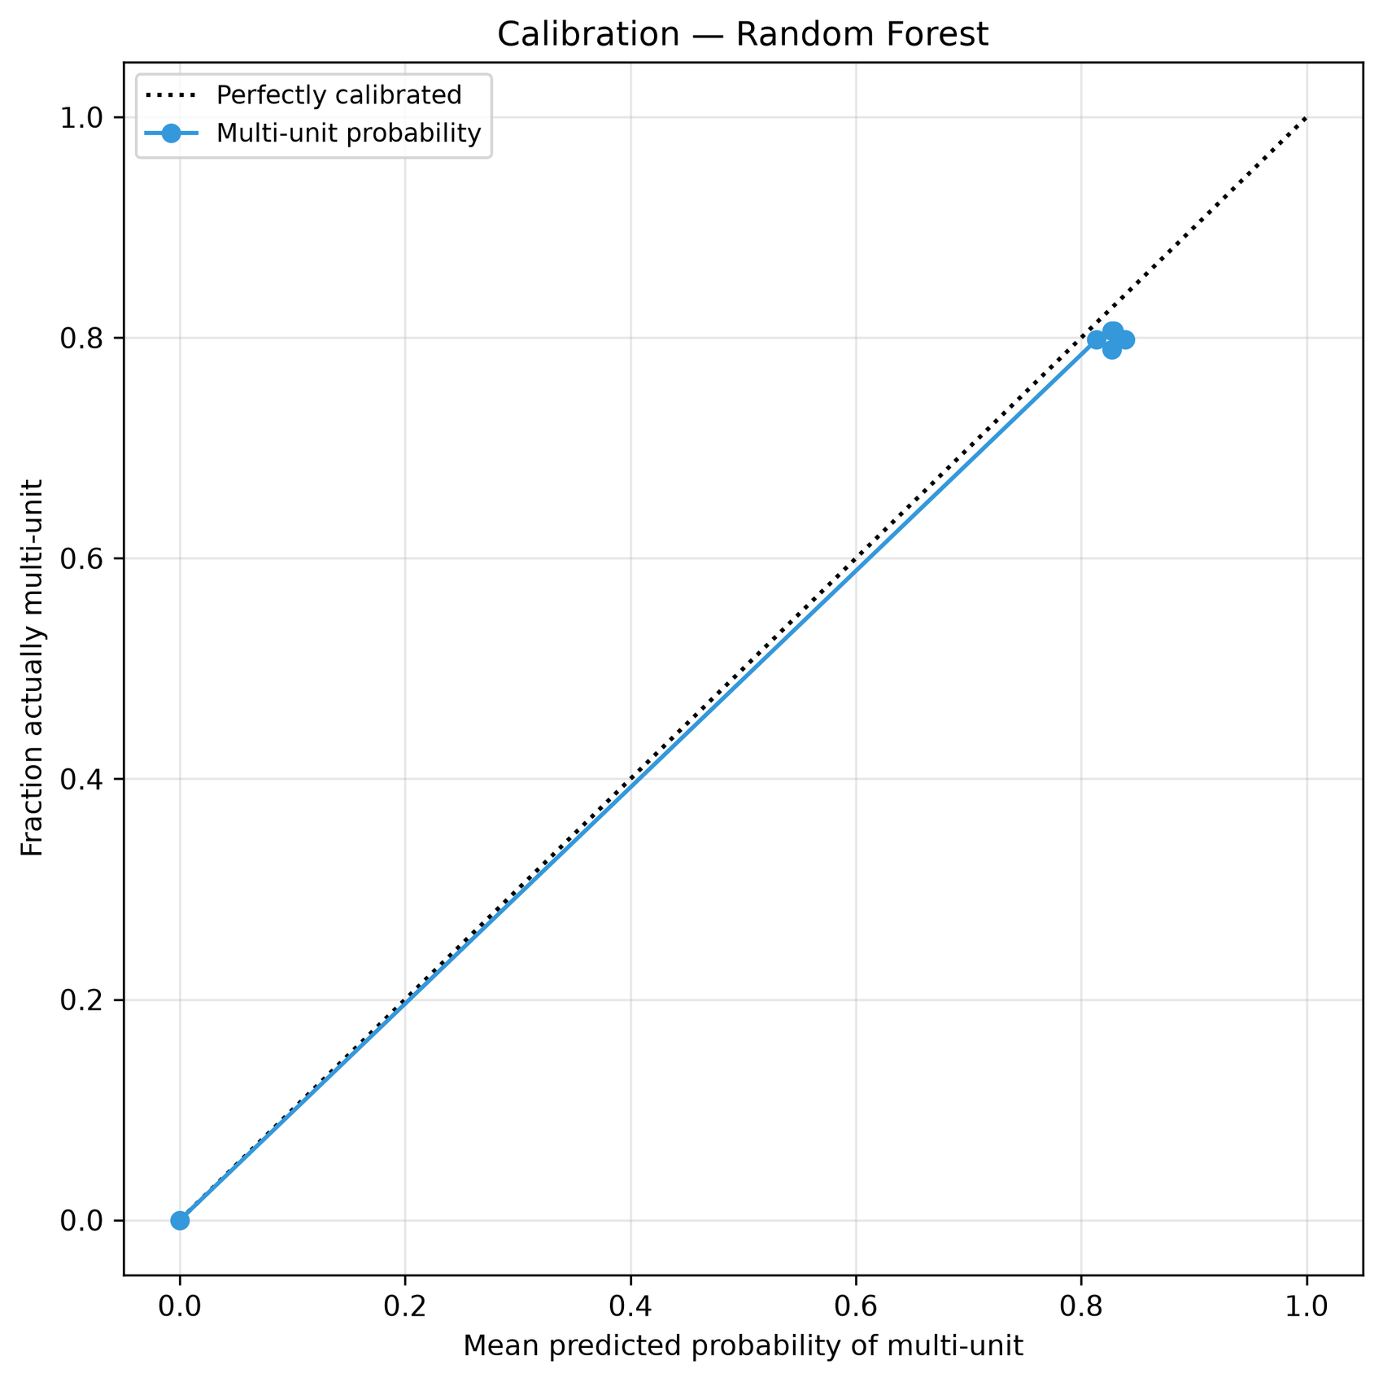
Calibration curve for P(multi-unit).

11.3 Where Does the Model Fail? By Price Zone
Price zone | Test rows | Accuracy | Actually multi-unit | Predicted multi-unit
above $100 | 15,030 | 100.0% | 0.0% | 0.0%
multi-unit possible (price <= $100) | 20,650 | 80.3% | 78.8% | 98.5%

Above the price threshold the model is right on every order. Where several units are possible, about 79% of orders really are multi-unit and the model calls nearly all of them multi-unit, so accuracy there sits at the base rate — no order-time information can do better in this data.

11.4 Accuracy by Price Band
Price band | Test rows | Accuracy | Actually multi-unit | Predicted multi-unit
<= $25 | 1,188 | 83.1% | 74.3% | 91.2%
$25-50 | 11,474 | 79.9% | 78.8% | 99.0%
$50-100 | 7,988 | 80.6% | 79.5% | 98.9%
$100-200 | 7,831 | 100.0% | 0.0% | 0.0%
$200-500 | 7,031 | 100.0% | 0.0% | 0.0%
> $500 | 168 | 100.0% | 0.0% | 0.0%

Above $100 no order is multi-unit and the model is right on every one. In the bands at or below $100 roughly four in five orders are multi-unit, so the model's accuracy sits near that base rate; the few products in these bands that are always single-unit are the only place where the model does better than the rate.
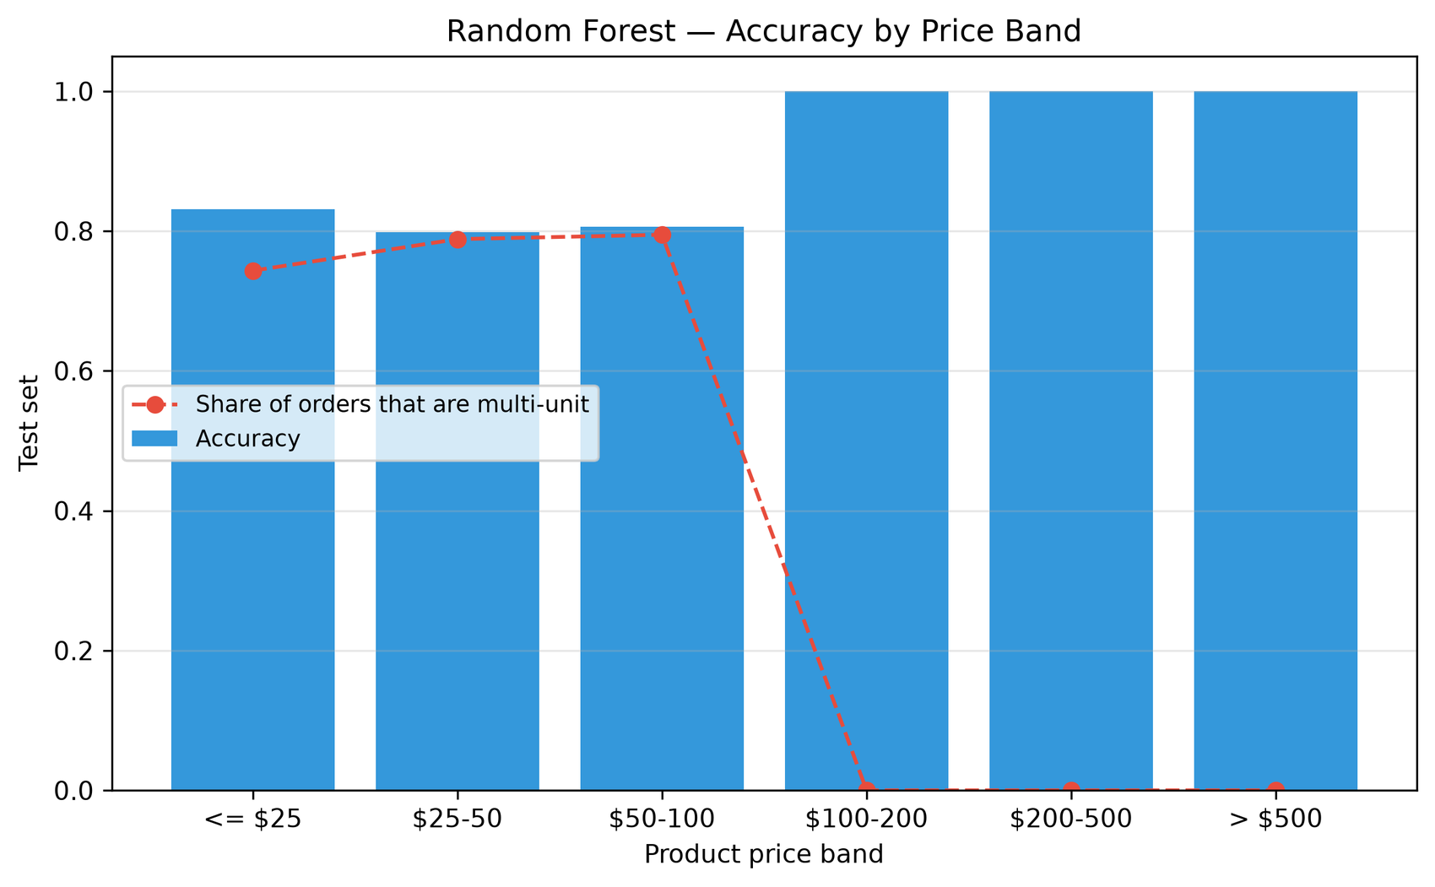
Accuracy and multi-unit share by price band.

12. Phase 13 — Explainability (SHAP)

12.1 Why SHAP
Built-in importance is biased toward continuous or high-cardinality features and has no direction. SHAP gives per-prediction attributions: positive values push toward "multi-unit" (bulk zone), negative toward "single-unit" (fast-pick shelf). The explained model is the winner (Random Forest); the sample is 500 stratified test orders.

12.2 Global Feature Importance
Rank | Feature | Mean |SHAP|
1 | product_group | 0.2520
2 | product_price_log | 0.1406

The model uses only 2 inputs — which product and its price — and SHAP confirms that both matter. This agrees with the earlier analysis that nothing but the product and its price carries information about single- vs multi-unit orders.
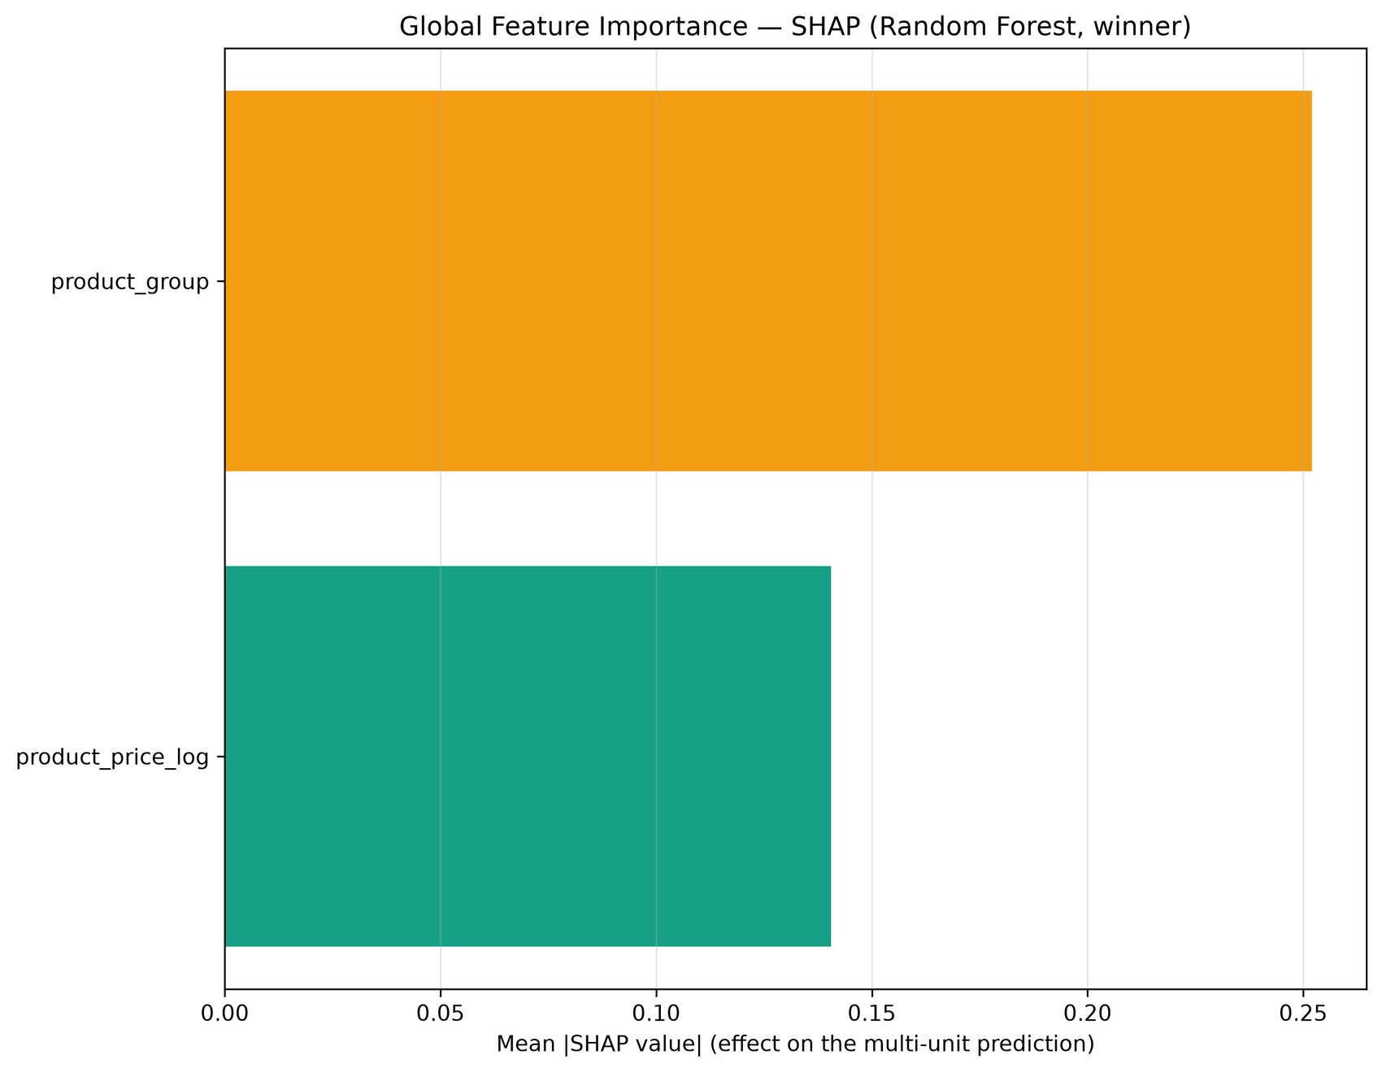
Global SHAP importance.

12.3 Direction of Effect
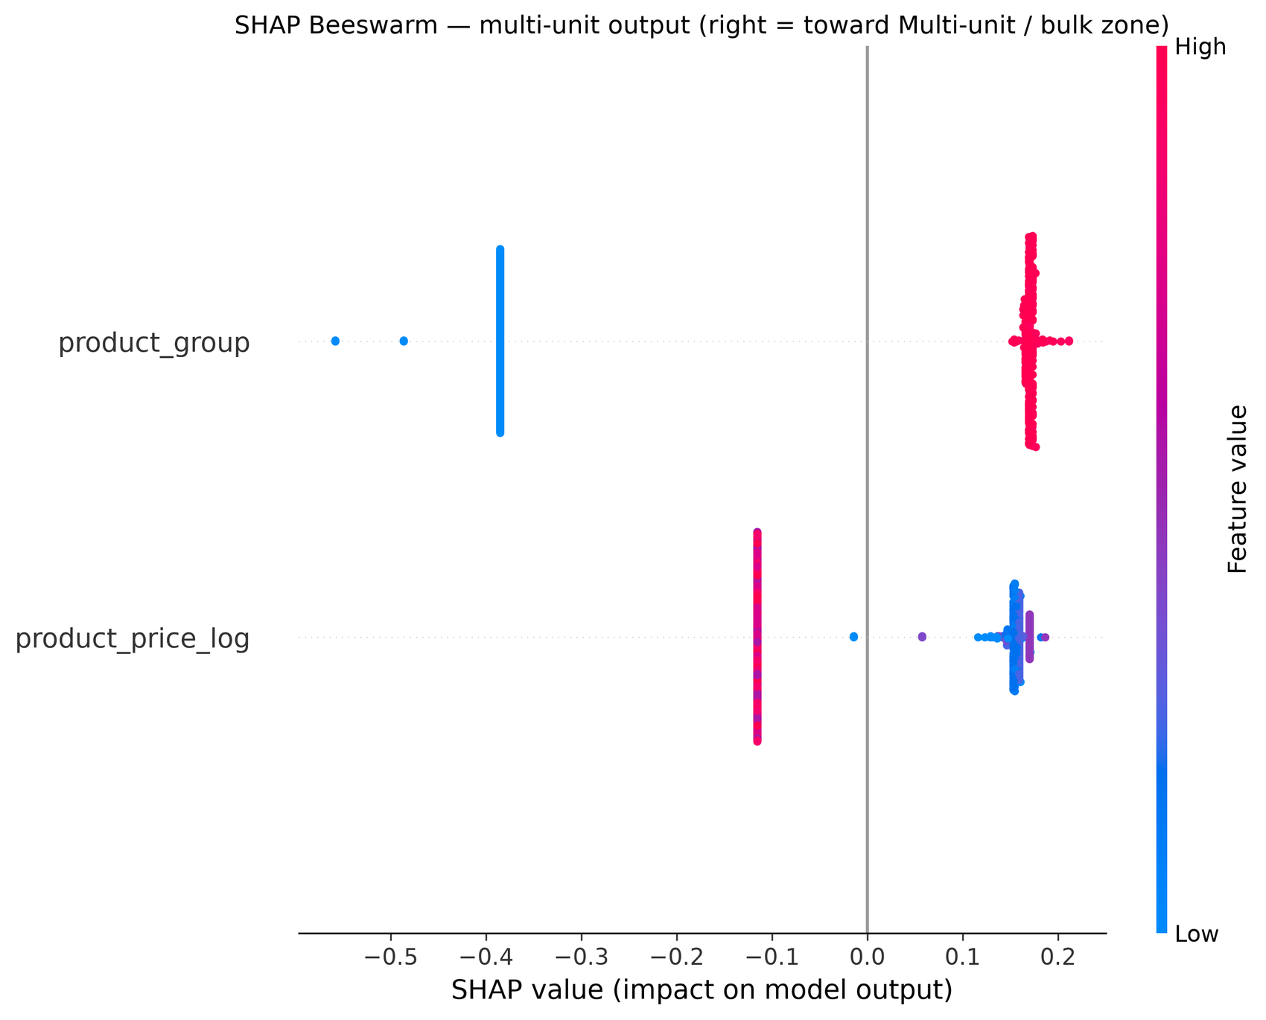
SHAP beeswarm: right = toward multi-unit (bulk zone).

12.4 Worked Examples
Top drivers for a true single-unit order:
Feature | Value | Effect on P(multi-unit)
product_group | 0.000 | -0.3849 (toward single-unit)
product_price_log | 4.875 | -0.1153 (toward single-unit)

Top drivers for a true multi-unit order:
Feature | Value | Effect on P(multi-unit)
product_group | 0.801 | +0.1704 (toward multi-unit)
product_price_log | 3.931 | +0.1564 (toward multi-unit)

13. Deployment — Lookup Table and Streamlit App

13.1 What the App Does
The app (app/app.py) is a small web page built with Streamlit, HTML, CSS and JavaScript. The user picks a product (and may adjust its price); the page shows a live prediction — no button — as an animated gauge with the probability of a multi-unit order, the recommended action ("route to the fast-pick shelf" or "route to the bulk-pick zone"), a confidence label and a plain-language "why this call" explanation. A product card shows what actually happened historically for that product (orders, quantity 1–5 distribution).
- Four tabs: model performance (KPIs, per-class table, baselines, unseen-product stress test), what drives the prediction (SHAP), a product explorer (interactive chart of all 118 products) and about / limits.
- The form shows only what the model uses. The input row is built from the feature list in metrics_v3.json; if the model ever uses a feature the form cannot build, the app stops with an explicit error instead of guessing.
- Every number on the page is read from the pipeline artifacts (metrics_v3.json, shap_feature_importance.json, product_stats.json) — nothing is typed in by hand.
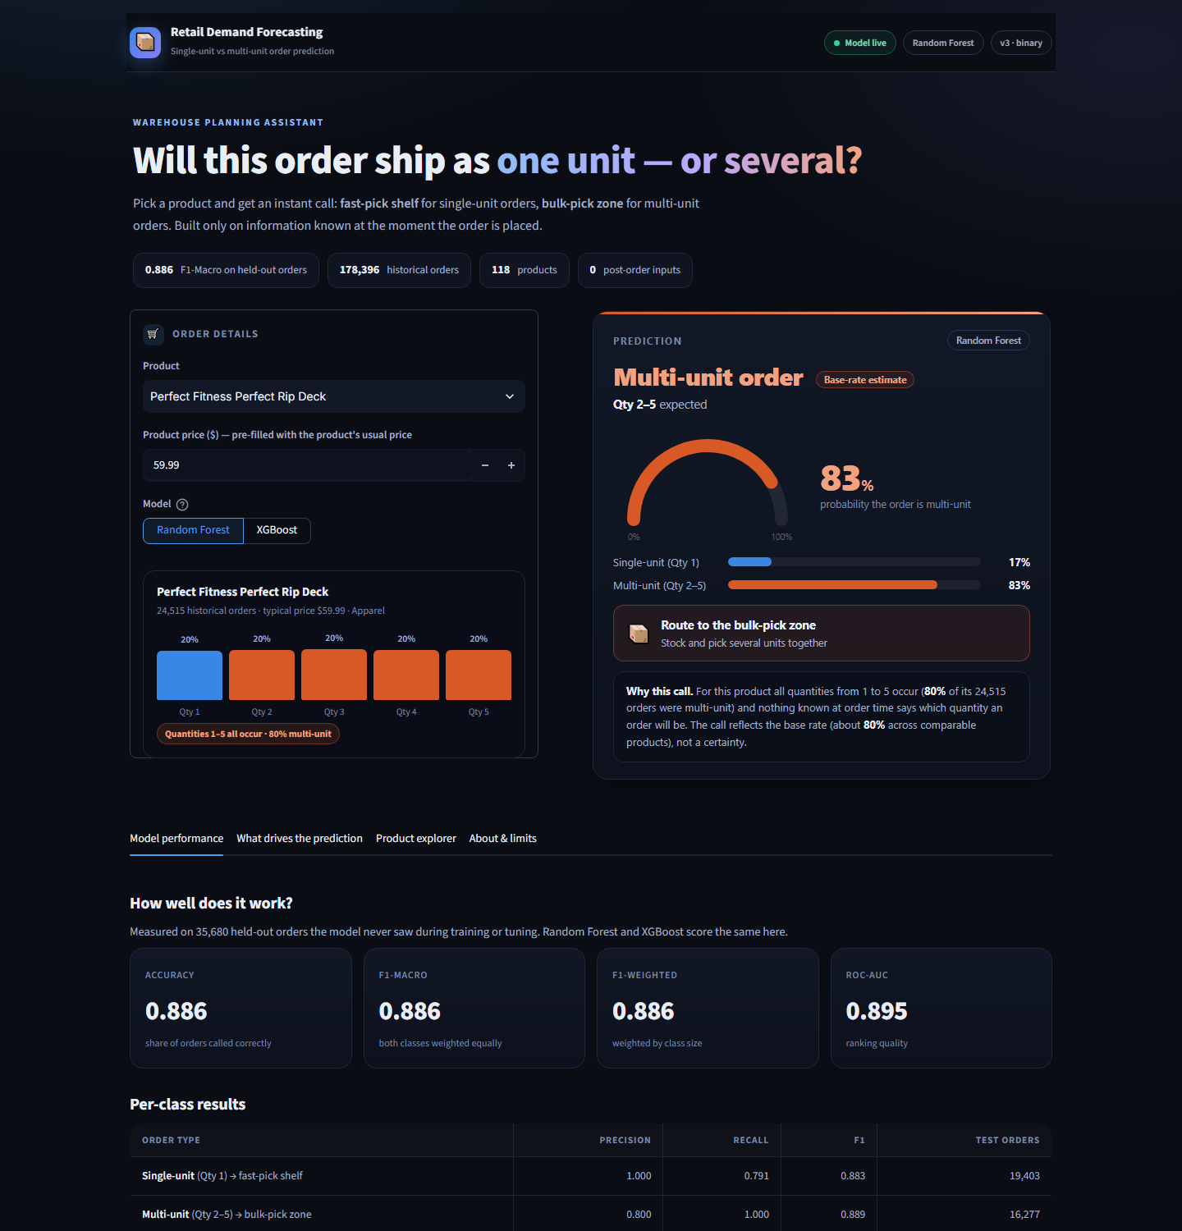
The prediction page (live result, product card, model performance).
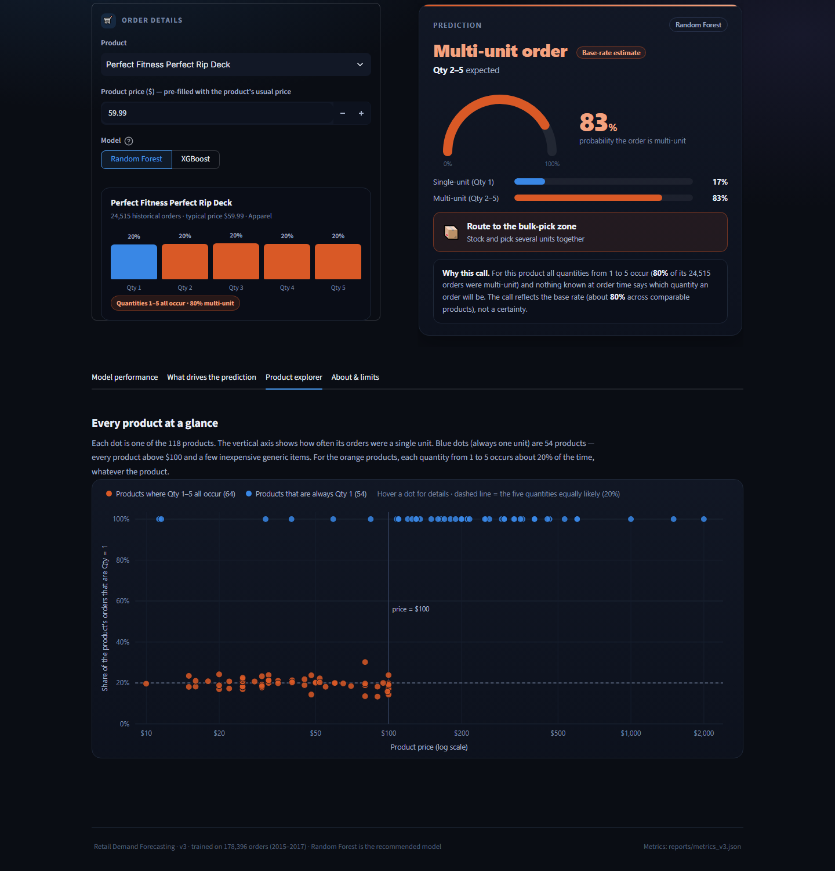
Product explorer: each dot is one product; hover for details.

13.2 What Was Removed From the App
- The "discount amount ($)" input — a dollar discount is only known once the quantity is chosen (Section 9.5).
- The six post-order inputs removed in v2 (processing delay, delivery status, order status, realized profit).
- Department, customer segment, market, region, shipping mode and order date — the model does not use them, so the form no longer asks for them (and the product / department mismatch it allowed is gone).
- The 5-class output. The app no longer pretends to predict "2 vs 3 vs 4 vs 5".

13.3 Smoke Test of the Running App
The app was run end-to-end with Streamlit's test harness on sample orders:
Product | Price | Model | App output
Perfect Fitness Perfect Rip Deck | $59.99 | Random Forest | Multi-unit order (Qty 2-5) - bulk-pick zone - P(multi-unit) 83%
Perfect Fitness Perfect Rip Deck | $59.99 | XGBoost | Multi-unit order (Qty 2-5) - bulk-pick zone - P(multi-unit) 83%
Bag Boy Beverage Holder | $24.99 | Random Forest | Multi-unit order (Qty 2-5) - bulk-pick zone - P(multi-unit) 84%
Field & Stream Sportsman 16 Gun Fire Safe | $399.98 | Random Forest | Single-unit order (Qty 1) - fast-pick shelf - P(multi-unit) 0%
Pelican Sunstream 100 Kayak | $199.99 | XGBoost | Single-unit order (Qty 1) - fast-pick shelf - P(multi-unit) 0%
CDs of rock | $11.29 | Random Forest | Single-unit order (Qty 1) - fast-pick shelf - P(multi-unit) 0%

13.4 Artifacts
Artifact | Location
Trained pipelines (Random Forest 4.7 MB, XGBoost 0.1 MB) | models/v3/
Per-product order history shown by the app | models/v3/product_stats.json
Product / department lookup | models/v3/group_id_mapping.json
Test-set metrics, baselines, stress test | reports/metrics_v3.json
Evaluation (learning curve, calibration, error segments) | reports/evaluation_report.json
SHAP ranking and worked examples | reports/shap_feature_importance.json
Pre-change (5-class) scripts, models, reports, plots | archive/pre_binary_reframe_backup/

14. Limitations, Open Items and Lessons Learned

14.1 Honest Limitations
- Exact quantity (2 vs 3 vs 4 vs 5) is not predictable from order-time information in this dataset. The model does not attempt it.
- For products priced at $100 or less, "multi-unit" is the base rate (about 79%), not order-specific evidence; roughly one in five single-unit orders there is unavoidably predicted as multi-unit.
- New products: performance on products never seen in training is unstable (Section 10.8). Use the price rule as the fallback for a new product.
- product_group was recovered from a whole-dataset target mean (all always-single products share one id). It is re-encoded out-of-fold inside the pipeline, but the group id itself used the target.
- Winsorization caps and Yeo-Johnson lambdas were fitted on the full dataset before splitting (low severity: no target involved).
- The data behaves as if the quantity for cheap products were drawn at random (uniform 1–5, independent of everything recorded). If the business knows a real driver of multi-unit quantity that is not in this dataset — a promotion, a customer basket, a contract — it would have to be added as a new data source.

14.2 Lessons Learned
- Look at the structure of the target early: a per-product breakdown of the target (Section 9.3) would have exposed the ceiling on day one.
- A feature built from money columns can contain the target (dollar discount = quantity × price × rate). Verify arithmetic identities before trusting a "signal".
- A large jump from a small change (0.385 → 0.459) is a reason to investigate, not to celebrate.
- Selection rules need an absolute noise floor; rank-based rules keep noise when most features are noise.
- Choose the evaluation split to match the deployment question, and say which question it answers.
- Report baselines: the ML model earned only +0.013 F1-Macro over a one-line price rule — and that is an honest result worth stating.

14.3 Open Items
- Optional: add a genuine new data source for multi-unit demand (promotions, customer history) — the only route to predicting the exact quantity.
- Optional: an unseen-product model that relies on price and department only, for new SKUs.
- Low priority: two additional exact-duplicate column pairs in Phase 1 (Sales per customer = Order Item Total; Order Item Product Price = Product Price) — no effect on results.

Appendix — Dataset Deliverables
File Name | Rows | Columns | Description
Retail_demand_forecasting_dataset.csv | 180,519 | 53 | Original raw dataset
Retail_demand_forecasting_CLEANED.csv | 178,396 | 44 | After Phase 1 cleaning
Retail_demand_outliers_TREATED.csv | 178,396 | 49 | After Phase 4 outlier treatment
Retail_demand_YJ_transformed.csv | 178,396 | 51 | After Phase 7 Yeo-Johnson
Retail_demand_FE.csv | 178,396 | 46 | After Phase 8 feature engineering
Retail_demand_FS.csv | 178,396 | 3 | After Phase 9 feature selection (2 features + target)

