**Index**

|  |  |  |
| --- | --- | --- |
| **Chapter No.** | **Particulars** | **Page Number** |
| **1** | **INTRODUCTION** |  |
| 1.1 | ABSTRACT |  |
| 1.2 | EXISTING SYSTEM AND LIMITATIONS OF THE EXISTING SYSTEM |  |
| 1.3 | NEED FOR THE PROPOSED SYSTEM |  |
| 1.4 | SCOPE OF SYSTEM |  |
| 1.5 | BRIEF DESCRIPTION OF TECHNOLOGY USED 1.6.1 OPERATING SYSTEMS USED (WINDOWS OR UNIX) 1.6.2 DATABASE (IF APPLICABLE) |  |
| **2** | **PROPOSED SYSTEM** |  |
| 2.1 | STUDY OF SIMILAR SYSTEMS |  |
| 2.2 | FEASIBILITY STUDY |  |
| 2.3 | OBJECTIVES OF PROPOSED SYSTEM |  |
| 2.4 | FUNCTIONAL AND NON-FUNCTIONAL REQUIREMENTS |  |
| 2.5 | USERS OF SYSTEM |  |
| 2.6 | MODULE SPECIFICATION |  |
| **3** | **SYSTEM ANALYSIS AND DESIGN** |  |
| 3.1 | ENTITY RELATIONSHIP DIAGRAM |  |
| 3.2 | USE CASE DIAGRAM |  |
| 3.3 | CLASS DIAGRAM |  |
| 3.4 | SEQUENCE DIAGRAM |  |
| 3.5 | ACTIVITY DIAGRAM |  |
| 3.6 | MODULE HIERARCHY DIAGRAM |  |
| 3.7 | COMPONENT DIAGRAM |  |
| 3.8 | DEPLOYMENT DIAGRAM |  |
| 3.9 | WEB SITE MAP DIAGRAM |  |
| 3.10 | TABLE SPECIFICATION [DATA DICTIONARY] |  |
| 3.11 | USER INTERFACE DESIGN AND REPORTS |  |
| **4** | **DRAWBACKS AND LIMITATION** |  |
| **5** | **PROPOSED ENHANCEMENT** |  |
| **6** | **CONCLUSION** |  |
| **7** | **BIBLIOGRAPHY** |  |
| **8** | **ANNEXURES** |  |
| **9** | **SAMPLE CODE** |  |

**1. INTRODUCTION**

**1.1 ABSTRACT**

This project is a real-time chat application developed using Java Swing and Java Networking APIs. It facilitates two-way communication between a server and a client over a network. The main objective of this application is to demonstrate the core concepts of socket programming in Java along with GUI programming using Swing. The server component listens for incoming client connections and maintains communication, while the client connects to the server, sends messages, and receives responses in real-time. The design includes a user-friendly graphical interface that mimics popular chat applications, enabling intuitive interaction between the users.

This application serves as a foundation for more advanced communication systems and showcases essential Java skills including socket handling, multithreading, event-driven programming, and GUI layout management. Additionally, it helps users understand the practical application of Java’s input/output streams and how real-time systems handle continuous data transfer without delays.

**1.2 EXISTING SYSTEM AND LIMITATIONS OF THE EXISTING SYSTEM**

Existing systems for chat and messaging—like WhatsApp, Slack, and Microsoft Teams—are robust and feature-rich, offering capabilities such as media sharing, group chats, message encryption, and cloud syncing. However, these platforms are complex and require extensive server-side architecture, database management, and third-party integrations.

In contrast, traditional command-line or basic chat systems built in Java or other languages lack GUI features, making them less interactive and less suitable for real-world applications. Additionally, they may not support real-time communication effectively, especially without proper threading or buffering mechanisms.

The limitations of such basic systems include:

* Lack of graphical interface, making it difficult for users unfamiliar with the command line.
* Poor error handling and user feedback.
* Minimal customization and user engagement.
* Inability to support concurrent client connections in some versions.
* Limited scalability for real-world application or deployment.

Our system aims to address these issues by incorporating an interactive UI and real-time message handling to simulate modern-day chat applications in a simplified manner.

**1.3 NEED FOR THE PROPOSED SYSTEM**

The proposed system addresses the need for a lightweight, easy-to-understand, and functional chat application that can be used for educational, testing, or prototype purposes. It serves multiple objectives:

* Provides a hands-on demonstration of core networking concepts in Java.
* Offers students and developers a simple yet interactive project to understand how communication over sockets works.
* Allows users to experience real-time interaction within a LAN setup, making it ideal for intranet environments, such as classrooms or small organizations.

Unlike more complex systems, the proposed chat application can be customized easily for academic or demo purposes. The modular nature of the code allows future enhancement, such as enabling file transfer, group chat, encryption, and even database integration. It fills the gap between theoretical learning and real-world application in a classroom or development setting.

**1.4 SCOPE OF SYSTEM**

The scope of the project is primarily educational and demonstrative. It serves as a foundational model for:

* Teaching the concepts of socket programming and GUI development using Java.
* Building a more robust system by integrating multithreading for multiple clients.
* Upgrading the UI to include message formatting, themes, or user profile icons.
* Extending the app to a peer-to-peer network instead of relying solely on a client-server architecture.
* Possibly integrating with databases for storing chat history or user credentials.
* Converting into a web-based model using Java Servlets or REST APIs for remote interaction.

While the application in its current state is suited for small-scale or local network usage, the architecture allows future scalability and adaptability for various platforms and deployment methods.

**1.5 BRIEF DESCRIPTION OF TECHNOLOGY USED**

The chat application is developed using core Java technologies. It leverages the Java Swing library for building the GUI components, allowing us to create an intuitive and visually organized interface. Java Networking APIs are used for socket communication between the server and the client.

Key technologies used:

* **Java Swing:** Provides all UI components including JFrame, JTextField, JLabel, JButton, and layout managers such as BoxLayout for positioning.
* **Java Networking:** Uses ServerSocket and Socket for establishing a communication channel. DataInputStream and DataOutputStream manage the message exchange.
* **Java I/O Streams:** Facilitates data transfer between client and server through buffered and unbuffered streams, ensuring smooth communication without data loss.
* **Threading (Optional):** In an enhanced version, threads can be used to allow the server to handle multiple clients simultaneously.

This technology stack ensures platform independence, as Java runs on any system with the JVM installed, and provides a robust framework for client-server communication.

**1.6.1 OPERATING SYSTEMS USED (WINDOWS OR UNIX)**

The application is platform-independent due to Java’s "write once, run anywhere" philosophy. However, during development and testing, Windows OS (Windows 10 and Windows 11) was used. The application runs seamlessly on UNIX-based systems as well, provided that the Java Runtime Environment (JRE) is installed.

**Windows Environment Advantages:**

* Wide compatibility with Java IDEs (Eclipse, IntelliJ, NetBeans).
* Built-in GUI support with Windows Look and Feel for Swing.
* Easier socket configuration and firewall access for local communication.

**UNIX-Based Systems (Linux/macOS):**

* Provide robust terminal access for server/client launching.
* Strong support for networking utilities and debugging tools.
* Ideal for deploying server components in a production environment.

The application requires no changes to run on different OS platforms except adjusting firewall or port access if necessary.

**1.6.2 DATABASE (IF APPLICABLE)**

In the current implementation of the chat application, no database integration is used. The communication is handled in-memory between the client and server through sockets. However, a database can be introduced in future versions for the following enhancements:

* **User authentication:** Storing usernames, passwords, and login sessions.
* **Chat history:** Saving past messages for future retrieval.
* **User profiles:** Allowing image uploads, usernames, and status updates.
* **Group chats:** Managing chat rooms, user lists, and permissions.

Recommended databases for future integration:

* **MySQL:** Open-source, reliable, and widely used in enterprise applications.
* **SQLite:** Lightweight and ideal for single-user or desktop-based applications.
* **MongoDB:** A NoSQL option for scalable and flexible document storage.

Integration with a database would typically involve using JDBC (Java Database Connectivity) for queries, inserts, and updates from within the Java application.

**PROPOSED SYSTEM**

**2.1 STUDY OF SIMILAR SYSTEMS**

Various chat systems and messaging platforms exist in the market, each designed with specific use cases in mind. Examples include:

* **WhatsApp Web/Desktop** – Built using Electron and WebSockets, it allows real-time messaging synced with a mobile device.
* **Slack** – A workspace-focused platform using React and backend technologies like Node.js for chat, file sharing, and integration.
* **IRC (Internet Relay Chat)** – One of the earliest systems for real-time messaging that relies on a distributed client-server model.
* **Basic Java Console-Based Chat Applications** – Used for educational purposes but often lack user-friendly interfaces and real-time responsiveness.

These systems have common elements: client-server architecture, message queues, GUI/console interfaces, and sometimes persistent message storage.

**Comparative Study:**

| **Feature** | **Existing Systems** | **Proposed System** |
| --- | --- | --- |
| GUI Interface | Advanced & Rich | Basic but functional |
| Message Encryption | Yes | No (but can be added) |
| Database Integration | Yes | Not currently |
| Multi-user Support | Yes | Single client-server |
| Customization | Limited (Proprietary) | High (Open source) |

The proposed system takes a minimalist yet efficient approach, ideal for learning and prototyping while ensuring real-time bidirectional communication.

**2.2 FEASIBILITY STUDY**

A feasibility study helps determine whether the proposed system is technically, operationally, and economically viable.

**1. Technical Feasibility:**

* The application uses core Java, which is platform-independent.
* Minimal hardware requirements make it runnable on most systems with JRE installed.
* Java provides built-in libraries for networking and GUI, eliminating the need for external dependencies.

**2. Operational Feasibility:**

* Easy to install, launch, and run.
* GUI simplifies user interactions.
* Suitable for small setups like classrooms, internal organizational messaging, or demos.

**3. Economic Feasibility:**

* No licensing costs—Java is open-source
* Can be developed and tested using free IDEs like IntelliJ IDEA Community Edition or Eclipse.
* No server hosting costs as it runs locally.

**4. Schedule Feasibility:**

* The system can be developed within a short timeframe (1–2 weeks).
* Requires only basic knowledge of Java and networking.

This feasibility study confirms that the system is both implementable and beneficial for the intended scope.

**2.3 OBJECTIVES OF PROPOSED SYSTEM**

The proposed system is designed with several key objectives in mind:

* **Enable Real-Time Communication:** Create a functional client-server application where messages are exchanged instantly.
* **Learn Networking Principles:** Offer a live example of how socket programming works in Java.
* **Provide GUI Interaction:** Replace command-line interface with Swing-based UI for a user-friendly experience.
* **Demonstrate Event-Driven Programming:** Handle user actions like typing and clicking to trigger messaging events.
* **Design for Extensibility:** Ensure the base system is modular so future enhancements like encryption, group chats, or multimedia messages can be added.

By focusing on these objectives, the application serves both as a learning tool and a working communication model that can grow into a more comprehensive system.

**2.4 FUNCTIONAL AND NON-FUNCTIONAL REQUIREMENTS**

**Functional Requirements:**

* **Client-Server Communication:** The client connects to the server, sends and receives messages.
* **Message Display:** Messages should appear in the correct order in the GUI chat area.
* **Send Button Functionality:** The message typed should be sent and cleared upon pressing the send button.
* **Exit Mechanism:** Gracefully close socket connections and terminate the app.

**Non-Functional Requirements:**

* **Usability:** Simple layout for all users, even with limited technical knowledge.
* **Reliability:** Connection should remain stable during chat sessions.
* **Performance:** Instant message exchange without noticeable delay.
* **Portability:** Must work across different operating systems (Windows, Linux, macOS).
* **Security (Future Scope):** Ability to integrate encryption or secure sockets for safe communication.

This breakdown ensures clarity between what the system must do (functional) and how well it does it (non-functional).

**2.5 USERS OF SYSTEM**

The system is targeted toward the following types of users:

**Students and Learners:**

Understand practical implementation of Java networking.

Observe how GUI events interact with background processes.

Use as a mini-project or assignment in computer science courses.

**Educators:**

Demonstrate core concepts in networking and UI programming.

Showcase a real-time example of sockets and threading.

**Developers:**

Use as a template or base for larger chat systems.

Extend into enterprise-grade chat tools or incorporate into other applications.

**IT Admins (Internal Networks):**

Simple internal communication within local networks without needing the Internet or third-party tools.

By tailoring the application to these user types, the system becomes a multi-purpose tool for communication, education, and prototyping.

**2.6 MODULE SPECIFICATION**

The proposed system can be broken down into the following key modules:

**1. Server Module:**

* Listens for incoming client connections on a specific port.
* Handles message receiving from the client.
* Sends acknowledgments or responses.
* Manages connection closing gracefully.

**2. Client Module:**

* Establishes connection with the server.
* Sends messages through output streams.
* Receives and displays messages from the server.
* GUI interaction with buttons, text fields, and message area.

**3. GUI Module:**

* Built using Java Swing.
* Provides input area, send button, and chat history area.
* Handles button clicks and text field actions.

**4. Networking Module:**

* Utilizes Socket, ServerSocket, DataInputStream, and DataOutputStream.
* Ensures bi-directional communication via TCP protocol.

**Optional Future Modules:**

**Encryption Module:** Add message-level encryption using RSA or AES.

**Multithreading Module:** Support for handling multiple clients on the server.

**Database Module:** Store chat history or user profiles.

This modular approach supports both current functionality and scalability for future enhancements.

ENTITY RELATIONSHIP DIAGRAM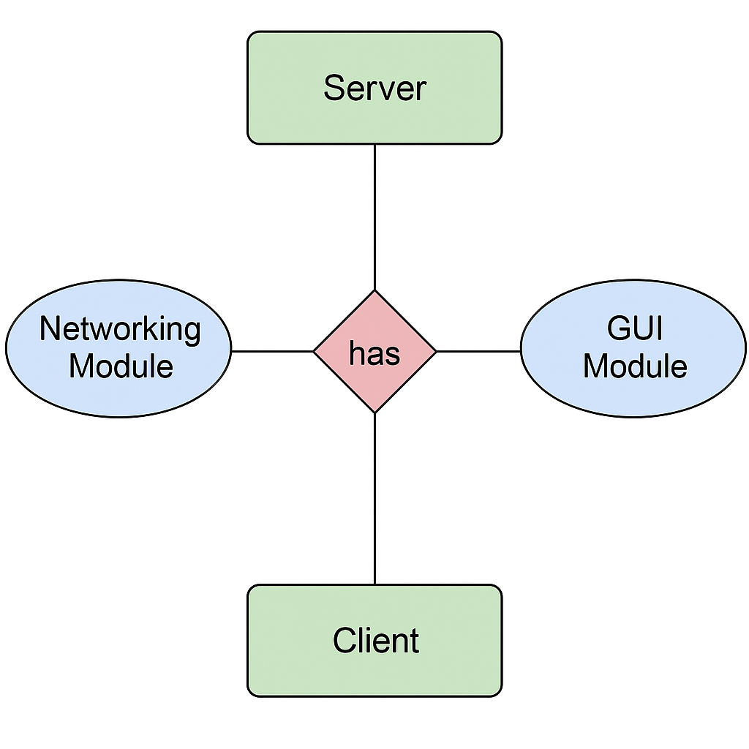

Use case

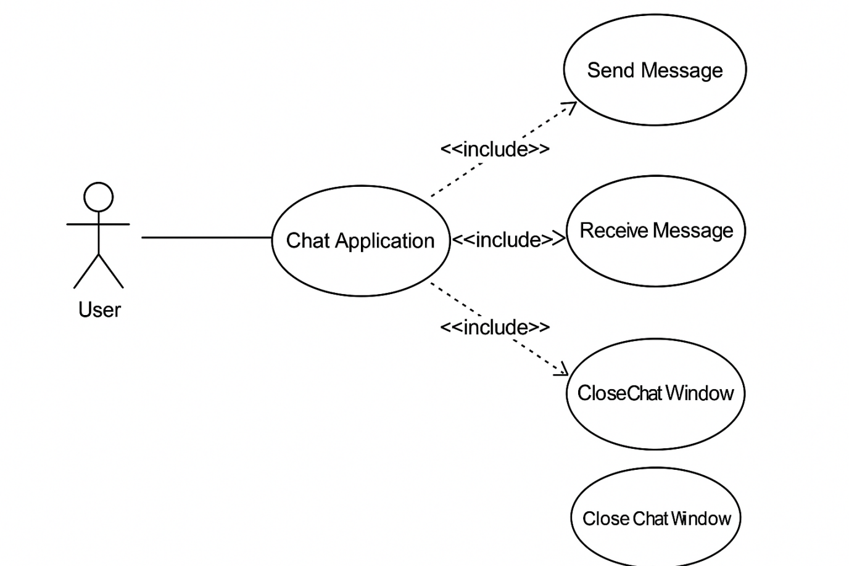

Class Diagram

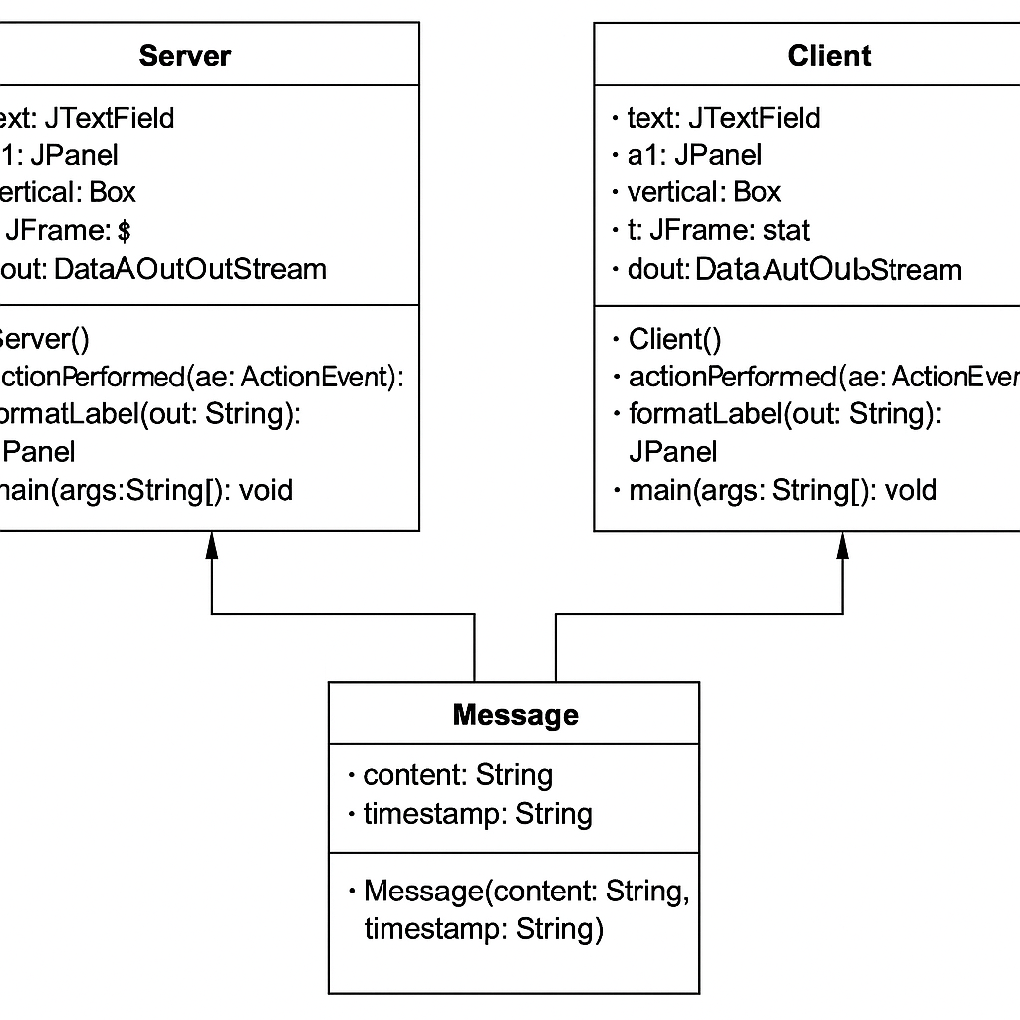

Sequence Diagram

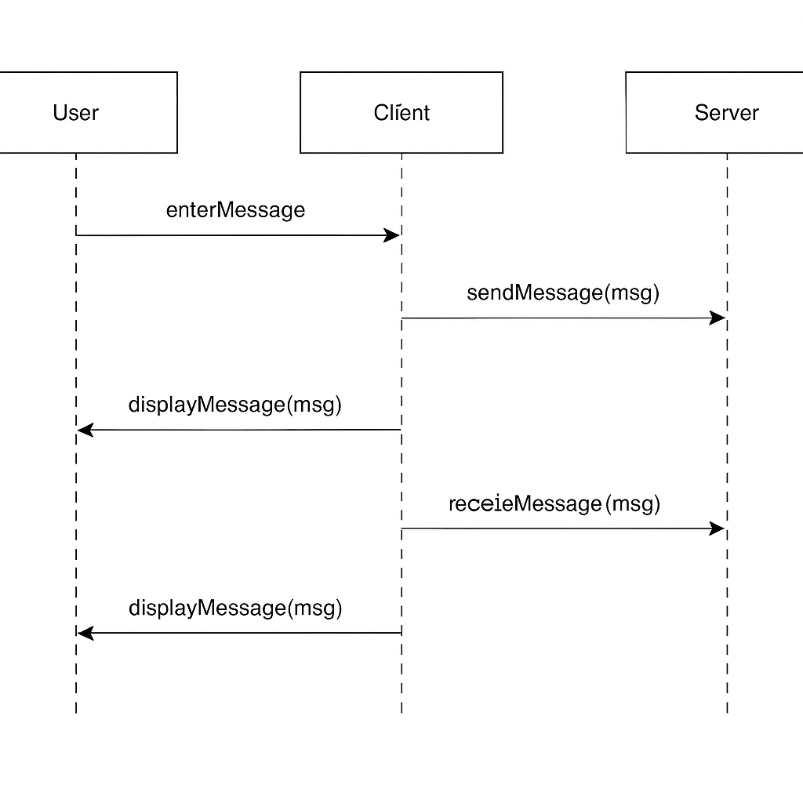

**4. DRAWBACKS AND LIMITATIONS**

Every system has some limitations in its initial stages of development, and this chat application is no exception. Despite its success in achieving basic real-time communication between a server and a client using Java Swing and Socket programming, several limitations remain that could affect scalability, usability, and performance.

**4.1 Limited to Single Client-Server Architecture**  
The current system supports communication between only one server and one client at a time. This limitation restricts the usability in real-world multi-user chat scenarios such as group chats or broadcast messaging, which are common in modern applications like WhatsApp or Slack.

**4.2 No User Authentication**  
There is no authentication mechanism such as login or registration features. Any user who accesses the client interface can join the chat, leading to security issues. There’s no identity verification, which limits the scope of secure communication.

**4.3 Absence of Persistent Storage**  
The system does not store chat history. Once the application is closed, all data is lost. This lack of data persistence affects traceability and accountability, making the system less reliable for professional or enterprise use.

**4.4 Basic GUI without Responsiveness**  
While the GUI is implemented using Java Swing, it lacks responsiveness and a modern design. The chat window cannot auto-scroll effectively, and message formatting is basic, reducing the user experience.

**4.5 Limited File Support**  
The application currently supports only plain-text messaging. It does not support multimedia messaging (images, documents, videos), which is a major drawback in today's messaging platforms.

**5. PROPOSED ENHANCEMENT**

To make the chat application more robust, user-friendly, and applicable in a larger scope, several enhancements can be proposed.

**5.1 Multi-Client Support Using Threads**  
Implement multithreading on the server-side to allow multiple clients to connect and chat simultaneously. Each client connection would be handled in its own thread, improving scalability and enabling group communication.

**5.2 Implementing User Authentication and Management**  
Incorporate login/signup functionality to ensure user authentication. This would involve storing user credentials in a database (e.g., MySQL) and verifying them during login.

**5.3 Chat History and Logging**  
Integrate a database to store messages. This would help in creating chat history logs, which could be retrieved and displayed when needed. This would add professional utility and enable features like search and export of chat logs.

**5.4 Modernizing the GUI**  
Enhance the GUI using JavaFX or external libraries to create a responsive and modern interface. Features like emoji support, dark mode, message timestamping, and auto-scroll can greatly improve user experience.

**5.5 Media Support and File Transfer**  
Introduce functionality for file transfers, image previews, and video messaging. This can be achieved using byte streams and appropriate serialization of multimedia content.

**5.6 End-to-End Encryption**  
Incorporate encryption techniques like AES or RSA to ensure that messages are encrypted during transmission, making the communication more secure.

**6. CONCLUSION**

This Java-based client-server chat application project demonstrates the basic principles of real-time communication using Java Swing and Socket programming. It successfully facilitates one-to-one messaging over a network and provides a functional GUI for message exchange.

Despite its simplicity, the project serves as a solid foundation for understanding core concepts in network communication, graphical user interface design, and Java I/O handling. Through this project, we explored how a message travels through sockets, how to create responsive UIs using Swing, and how user actions (like pressing "Send") can trigger backend logic to process and transmit data.

While the current version is limited to basic functionalities, it offers immense potential for future development. With enhancements like multi-client support, GUI improvement, and security features, it can evolve into a full-fledged chat platform. The learning outcomes from this project also pave the way for understanding more complex communication architectures such as distributed systems, peer-to-peer models, and cloud-based messaging services.

**7. BIBLIOGRAPHY**

**Java: The Complete Reference** by Herbert Schildt – For Java fundamentals and GUI development.

**Head First Java** by Kathy Sierra – For Object-Oriented Programming concepts.

Oracle Java Documentation – For understanding Java Swing, Socket, and I/O packages.

Java Tutorials by W3Schools – For practical examples and GUI concepts.

GeeksforGeeks – For implementation of Socket programming in Java.

Stack Overflow – For troubleshooting and refining the GUI and thread handling.

TutorialsPoint – For understanding layout managers and event handling in Swing.

**8. ANNEXURES**

**Annexure A – Screenshots**  
Include screenshots of:

Server interface.

Client interface.

**Annexure B – Source Code Snippets**  
Provide key code snippets with comments:

Server socket initialization.

Client connection logic.

GUI creation using Swing components.

Event handling methods (send button, message appending).