- Introduction:
SportSync is a web-based Sports Tournament Registration Portal developed using the MERN Stack technology, which includes MongoDB, Express.js, React.js, and Node.js. The project is designed to simplify and digitize the process of managing sports tournaments in colleges and organizations. Traditionally, tournament registrations and management activities are performed manually, which often leads to data redundancy, delayed communication, and inefficient record handling. SportSync provides a centralized and automated solution to overcome these challenges through a modern and responsive web application.
The system allows users to register and log in securely, browse available tournaments, and register their teams for different sports such as Cricket, Football, Volleyball, Badminton, and Chess. Participants can submit team details, upload payment proof, and track the status of their registrations directly through the platform. The application is designed with a user-friendly interface that improves accessibility and ensures a smooth registration experience for users across multiple devices.
The project also includes a powerful admin dashboard that enables administrators to manage tournaments, view registrations, approve or reject teams, publish announcements, and generate participation certificates in PDF format. Additional features such as venue maps, role-based authentication, and form validation help improve the reliability and usability of the system. The use of JWT authentication and secure backend APIs ensures that the application maintains proper security and access control mechanisms.
SportSync was developed with the objective of creating a scalable and efficient tournament management platform while applying modern software engineering principles and full-stack development concepts. The project demonstrates practical implementation of frontend and backend integration, database management, RESTful APIs, and responsive UI design. Overall, the system provides a complete digital solution for sports tournament registration and management, making it suitable as a final year MCA project.
.

  - Problem Statement
In many colleges and sports organizations, the process of managing sports tournaments and team registrations is still carried out manually using paper forms, spreadsheets, and offline communication methods. This traditional approach is time-consuming, inefficient, and prone to errors such as duplicate entries, loss of data, and difficulty in maintaining records. Coordinating tournament schedules, participant details, payment records, and announcements manually becomes challenging, especially when multiple sports and large numbers of participants are involved.
Another major issue in the existing system is the lack of a centralized platform where users can easily view tournament details, register their teams, and track their registration status. Participants often face communication delays regarding approvals, schedules, and updates. Similarly, administrators face difficulties in managing registrations, verifying payment proofs, organizing tournament information, and generating reports efficiently.
The absence of automation also affects transparency and user experience. Manual handling of certificates, announcements, and registration approvals increases administrative workload and reduces operational efficiency. In addition, there is limited accessibility for users because traditional systems are not optimized for online and mobile-friendly usage.
To overcome these problems, the SportSync system is proposed as a web-based Sports Tournament Registration Portal that automates the entire tournament management process. The system provides secure user authentication, online team registration, admin management features, announcement handling, certificate generation, and centralized data management. The platform aims to improve efficiency, reduce manual effort, enhance user experience, and provide a reliable and scalable solution for sports tournament management.

  - Objectives

The primary objective of the SportSync project is to develop a complete web-based Sports Tournament Registration Portal that automates the process of tournament management, team registration, participant handling, and administrative operations. The system is designed to minimize manual work, improve efficiency, and provide a centralized digital platform for managing sports-related activities within colleges and organizations. The project also aims to implement modern web development technologies and software engineering principles using the MERN stack.
The detailed objectives of the project are explained below:

1.2.1 To Develop a Centralized Tournament Management System
One of the major objectives of the project is to provide a centralized platform where all tournament-related activities can be managed efficiently. In traditional systems, tournament data is usually scattered across spreadsheets, forms, and physical records, making it difficult to maintain consistency and accessibility.
The proposed system aims to:
- Store all tournament information in a centralized database.
- Allow users to access tournament details from a single platform.
- Reduce duplication and inconsistency of records.
- Simplify tournament management for administrators.
- Improve accessibility of tournament information.
The centralized structure ensures that all data related to tournaments, teams, registrations, and announcements is organized systematically and can be accessed securely whenever required.

1.2.2 To Automate the Team Registration Process
The project aims to replace the manual registration process with a fully automated online registration system. Manual registration often consumes significant time and may lead to errors such as incomplete forms, duplicate entries, and misplaced records.
The objectives of automation include:
- Allowing users to register teams online.
- Providing digital forms for participant information.
- Enabling file uploads for payment proof and documents.
- Reducing paperwork and manual verification efforts.
- Improving the speed and accuracy of registration management.
The registration module is designed to support multiple sports and dynamic team member management, making the process more efficient and user-friendly.

1.2.3 To Provide Secure User Authentication and Authorization
Security is one of the most important objectives of the SportSync system. The project implements secure authentication and authorization mechanisms to ensure that only authorized users can access protected resources and functionalities.
The system aims to:
- Provide secure user registration and login functionality.
- Encrypt passwords using Bcrypt hashing.
- Use JWT (JSON Web Token) for authentication.
- Implement role-based access control for users and administrators.
- Prevent unauthorized access to sensitive data and admin operations.
The authentication system ensures that user data remains secure and protected from malicious activities.

1.2.4 To Simplify Tournament Management for Administrators
Managing tournaments manually can become difficult when handling large numbers of teams and participants. Therefore, one of the major objectives of the project is to provide administrators with an efficient dashboard for managing all tournament operations.
The admin panel is designed to:
- Create, update, and delete tournaments.
- Manage registrations and participant details.
- Approve or reject team registrations.
- Publish announcements and updates.
- Monitor tournament statistics and participation details.
This functionality reduces administrative workload and helps organizers manage events more effectively.

1.2.5 To Improve User Experience Through a Responsive Interface
Another important objective of the project is to create a modern and responsive user interface that provides a smooth experience across different devices such as desktops, tablets, and smartphones.
The system focuses on:
- Responsive web design using Tailwind CSS.
- Easy navigation and accessibility.
- Attractive and modern user interface.
- User-friendly forms and dashboard layouts.
- Proper validation and error handling.
A responsive interface ensures better usability and accessibility for all users.

1.2.6 To Provide Real-Time Registration Status Tracking
In traditional systems, participants often face difficulties in tracking the status of their registrations. The SportSync system aims to solve this issue by providing status tracking functionality.
The objectives include:
- Allowing users to view registration status.
- Displaying statuses such as Pending, Approved, or Rejected.
- Providing transparency in the approval process.
- Reducing communication delays between users and administrators.
This feature improves communication and keeps participants informed about their registration progress.

1.2.7 To Generate Digital Participation Certificates
The project aims to automate the generation of participation certificates for approved teams and participants. Manual certificate creation is time-consuming and repetitive, especially when dealing with large events.
The certificate module objectives are:
- Automatically generate certificates in PDF format.
- Include participant and tournament details dynamically.
- Allow users to download certificates online.
- Reduce manual effort in certificate preparation.
This feature adds professionalism and automation to the overall system.

1.2.8 To Provide Tournament Venue Information Using Maps
The SportSync system also aims to improve accessibility to tournament venues by integrating map functionality into the application.
The objectives include:
- Displaying tournament venues on interactive maps.
- Providing location details for participants.
- Improving navigation and accessibility.
- Enhancing overall user convenience.
The project uses Leaflet Maps/OpenStreetMap integration to provide map functionality without requiring expensive external APIs.

1.2.9 To Maintain Accurate and Organized Data Records
Maintaining proper records is essential for effective tournament management. The project aims to store and manage all data systematically using MongoDB database management.
The objectives are:
- Store user, tournament, and registration data efficiently.
- Reduce data redundancy and inconsistency.
- Enable fast retrieval of records.
- Maintain data integrity and reliability.
The database-driven architecture ensures scalability and efficient data handling.

1.2.10 To Apply Modern Full-Stack Development Concepts
The project also serves as a practical implementation of modern full-stack web development technologies and software engineering principles.
The objectives include:
- Using the MERN stack for application development.
- Implementing RESTful APIs.
- Following MVC architecture principles.
- Applying frontend-backend integration techniques.
- Understanding real-world project workflows.
This objective helps in gaining practical knowledge and industry-relevant development experience.

1.2.11 To Reduce Manual Work and Improve Efficiency
One of the overall objectives of the project is to improve operational efficiency by reducing dependency on manual work and traditional record management methods.
The system aims to:
- Minimize paperwork and repetitive tasks.
- Reduce human errors during registration and management.
- Improve speed and productivity.
- Automate repetitive administrative operations.
Automation helps organizers focus more on event management rather than manual documentation tasks.

1.2.12 To Build a Scalable and Maintainable System
The final objective of the project is to develop a scalable and maintainable application that can be extended with additional features in the future.
The project is designed with:
- Modular architecture.
- Reusable components.
- Proper folder structure.
- Clean and maintainable code practices.
Future enhancements such as live score tracking, online payments, and mobile applications can be integrated easily into the system due to its scalable architecture.

- Design
The design phase is one of the most important stages in software development because it defines the overall structure, workflow, architecture, and interaction between different modules of the system. The design of the SportSync system focuses on creating a scalable, secure, maintainable, and user-friendly web application capable of handling tournament registrations, participant management, and administrative operations efficiently.
The SportSync application follows a modular and layered architecture using the MERN Stack technology, which consists of MongoDB, Express.js, React.js, and Node.js. The frontend and backend are developed separately and communicate through RESTful APIs. The frontend is responsible for handling user interactions and displaying data, while the backend manages business logic, authentication, and database operations.
The design of the system was prepared by considering the following factors:
- Scalability of the application
- Secure data handling
- Separation of frontend and backend
- Modular component structure
- Efficient database management
- Responsive user interface
- Ease of maintenance and future enhancement
The design phase also includes the preparation of various diagrams such as System Architecture Diagram, Use Case Diagram, ER Diagram, Sequence Diagram, Activity Diagram, DFD, and Deployment Diagram. These diagrams help in understanding the structure and workflow of the application more clearly.

  - System Architecture
The SportSync application follows a three-tier architecture consisting of the Presentation Layer, Application Layer, and Database Layer. This architecture ensures proper separation of concerns, improves maintainability, and enhances scalability of the system.
The architecture of the system is designed to provide smooth communication between users, frontend components, backend services, and the database server. Each layer of the architecture performs a specific set of responsibilities that contribute to the overall functionality of the application.
The system architecture diagram illustrates the interaction between users, the React frontend, the Express/Node.js backend server, and the MongoDB database.

    - Overview of System Architecture
The SportSync system architecture consists of the following major components:
- Client/User Interface Layer
- Frontend Application Layer
- Backend/API Layer
- Database Layer
- File Storage Layer
The communication between these layers takes place through secure HTTP requests and RESTful APIs.

    - Presentation Layer (Frontend)
The Presentation Layer is developed using React.js and Tailwind CSS. This layer is responsible for interacting with users and displaying information in a visually appealing and responsive manner.
The frontend handles:
- User registration and login forms
- Tournament listing pages
- Team registration forms
- User dashboard
- Admin dashboard
- Announcements page
- Certificate download interface
The frontend communicates with the backend APIs using Axios HTTP requests.

Features of Frontend Layer

Responsive User Interface
The interface is designed using Tailwind CSS to ensure compatibility across:
- Desktop devices
- Tablets
- Mobile devices

Component-Based Architecture
React.js uses reusable components, which helps in:
- Code reusability
- Better maintainability
- Easier debugging
- Faster development

State Management
The frontend uses Context API for:
- Authentication state management
- User session handling
- Global application state management

Route Protection
Protected routes are implemented to restrict unauthorized access to:
- User dashboard
- Admin dashboard
- Tournament management pages

2.1.3 Application Layer (Backend)
The Application Layer is developed using Node.js and Express.js. This layer contains the business logic of the application and acts as a bridge between the frontend and the database.
The backend handles:
- Authentication
- Tournament management
- Registration processing
- Certificate generation
- File uploads
- Announcement management
The backend exposes RESTful APIs which are consumed by the frontend.

2.1.4 Backend Architecture
The backend follows the MVC (Model-View-Controller) architecture pattern.

Components of MVC Architecture

Models
Models represent database schemas and collections.
Examples:
- User Model
- Tournament Model
- Registration Model
- Announcement Model

Controllers
Controllers contain business logic and process incoming requests.
Examples:
- Authentication Controller
- Tournament Controller
- Registration Controller

Routes
Routes define API endpoints and connect requests to controllers.
Examples:
- /api/auth
- /api/tournaments
- /api/registrations

Middleware
Middleware is used for:
- JWT authentication
- Role verification
- Error handling
- File upload validation

2.1.5 Authentication Architecture
The authentication system uses JWT (JSON Web Token) based authentication.

Authentication Flow
- User submits login credentials.
- Backend validates user details.
- Password is verified using Bcrypt.
- JWT token is generated.
- Token is sent to frontend.
- Frontend stores token securely.
- Protected APIs verify token before granting access.

Benefits of JWT Authentication
- Stateless authentication
- Improved security
- Faster API communication
- Easy scalability
- Role-based access control

2.1.6 Database Layer
The Database Layer uses MongoDB as the primary NoSQL database.
MongoDB is used because:
- It provides flexible schema design.
- It supports scalable applications.
- It handles JSON-like documents efficiently.
- It integrates well with Node.js.
The database stores:
- User details
- Tournament information
- Team registrations
- Announcements
- Certificate records

2.1.7 File Upload System
The project includes a file upload system for:
- Payment screenshots
- Registration documents
Multer middleware is used for handling multipart form-data uploads.

File Upload Workflow
- User uploads payment screenshot.
- File is validated.
- File is stored in uploads folder/server.
- File path is saved in database.
- Admin can review uploaded file.

2.1.8 API Communication
The frontend and backend communicate using REST APIs.

Common API Methods
Method | Purpose
GET | Retrieve data
POST | Create new records
PUT | Update records
DELETE | Remove records

Advantages of REST APIs
- Platform independent
- Lightweight communication
- Scalable architecture
- Easy frontend-backend separation

2.1.9 Admin Architecture
The Admin Panel is a dedicated module for tournament administrators.
The admin system provides:
- Tournament management
- Registration approval/rejection
- Announcement publishing
- Dashboard analytics
- User monitoring
Role-based middleware ensures that only admin users can access these functionalities.

2.1.10 Advantages of the Proposed Architecture
The proposed architecture offers several advantages:

Scalability
The layered architecture allows future expansion of modules without affecting existing functionalities.

Security
JWT authentication and middleware improve application security.

Maintainability
Modular code structure simplifies debugging and maintenance.

Performance
Frontend and backend separation improves application performance.

Reusability
Reusable React components reduce development effort.

Flexibility
MongoDB provides flexible schema management for future enhancements.

2.1.11 Future Architectural Enhancements
The current architecture can be extended further with:
- Real-time notifications using Socket.io
- Online payment gateways
- Cloud storage integration
- Docker containerization
- Mobile application integration
- Microservices architecture

2.2 Database Design
Database design is one of the most important aspects of the SportSync project because the application handles a large amount of user, tournament, and registration data. The database is designed to ensure proper data organization, efficient storage, scalability, and fast retrieval of records.
The project uses MongoDB, which is a NoSQL document-oriented database. MongoDB stores data in collections and documents rather than traditional relational tables. The database design is prepared carefully to maintain relationships between different entities while ensuring flexibility and performance.
The database is responsible for:
- Storing user information
- Managing tournaments
- Handling registrations
- Maintaining announcements
- Tracking certificates
- Managing uploaded files

2.2.1 Database Requirements
The database design was created based on the following requirements:
- Efficient storage of tournament records
- Secure management of user credentials
- Support for multiple registrations
- Fast retrieval of data
- Scalable architecture
- Proper relationships between entities

2.2.2 MongoDB Database Structure
The SportSync database consists of multiple collections.
Main collections include:
- Users
- Tournaments
- Registrations
- Announcements
- Certificates
Each collection stores related documents in JSON-like format.

2.2.3 User Collection
The User collection stores information about all registered users.

Fields in User Collection
Field Name | Description
_id | Unique user identifier
name | User full name
email | User email address
password | Encrypted password
role | User/Admin role
createdAt | Account creation date

Purpose
- Authentication
- User management
- Role handling

2.2.4 Tournament Collection
The Tournament collection stores tournament-related information.

Fields in Tournament Collection
Field Name | Description
_id | Tournament ID
title | Tournament title
sport | Sport category
venue | Tournament venue
registrationDeadline | Last registration date
maxParticipants | Maximum allowed teams
status | Upcoming/Ongoing/Completed

Purpose
- Managing tournaments
- Displaying tournament information
- Registration tracking

2.2.5 Registration Collection
The Registration collection stores team registration details.

Fields in Registration Collection
Field Name | Description
_id | Registration ID
userId | Registered user
tournamentId | Tournament reference
teamName | Team name
members | Team members
paymentProof | Uploaded screenshot
status | Pending/Approved/Rejected

Purpose
- Registration tracking
- Approval management
- Participant handling

2.2.6 Announcement Collection
The Announcement collection stores notices and updates.

Fields
Field Name | Description
title | Announcement title
content | Announcement description
priority | Importance level
createdAt | Date of creation

Purpose
- Display tournament updates
- Notify users
- Share important information

2.2.7 Certificate Collection
The Certificate collection stores certificate-related information.

Fields
Field Name | Description
registrationId | Registration reference
certificateUrl | PDF path
generatedAt | Generation timestamp

Purpose
- Manage certificates
- Allow downloads
- Maintain participation records

2.2.8 Relationships Between Collections
The collections are connected through references.

Relationships
- One User can register for multiple Tournaments.
- One Tournament can have multiple Registrations.
- One Registration belongs to one Tournament.
- One Registration can generate one Certificate.
These relationships are represented in the ER Diagram.

2.2.9 Advantages of MongoDB Database Design

Flexible Schema
MongoDB allows easy modification of fields.

Scalability
The database can handle increasing records efficiently.

Faster Development
JSON-like documents integrate naturally with JavaScript.

Better Performance
MongoDB provides fast read/write operations.

Easy Integration
MongoDB works seamlessly with Node.js and Mongoose.

2.2.10 Data Validation
Mongoose schema validation is used for:
- Required fields
- Email format validation
- Password constraints
- Enum values
- Reference validation
This helps maintain data integrity and consistency.

2.2.11 Future Database Enhancements
The database can be enhanced in future with:
- Match scheduling collections
- Online payment transaction records
- Real-time score tracking
- Team ranking systems
- Attendance management

Diagrams

System Architecture Diagram

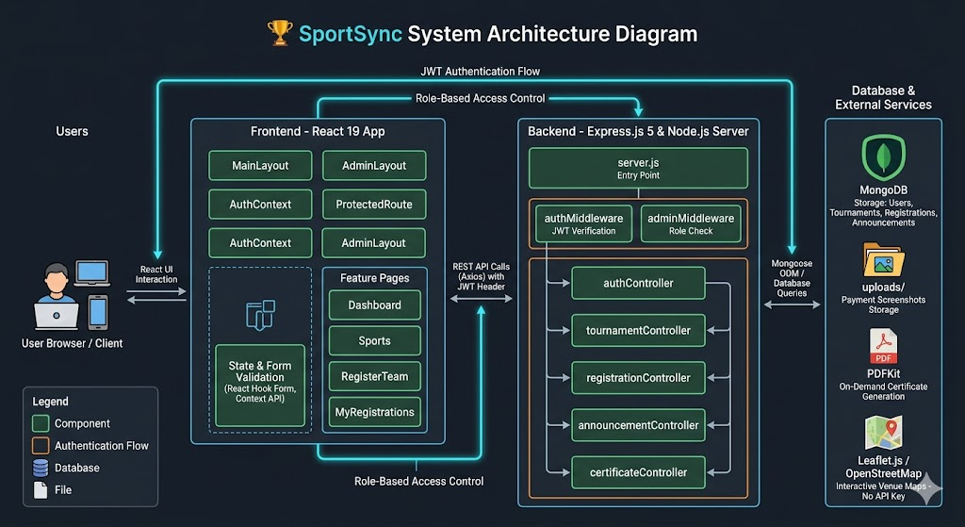

Use Case Diagram
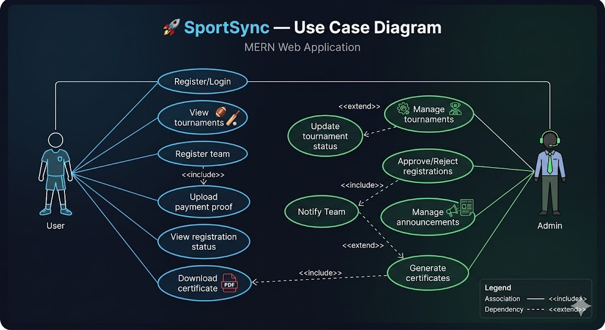

Entity Relation Diagram
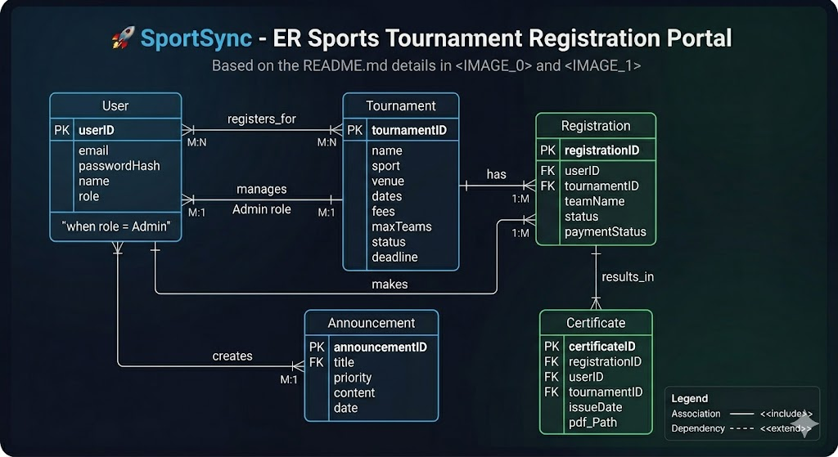

Activity Diagram
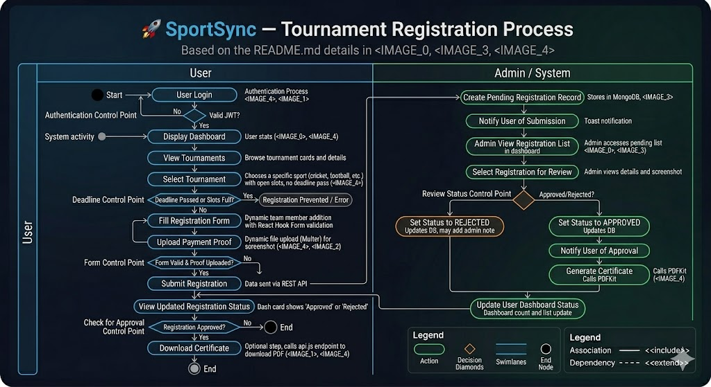

DFD Level 0

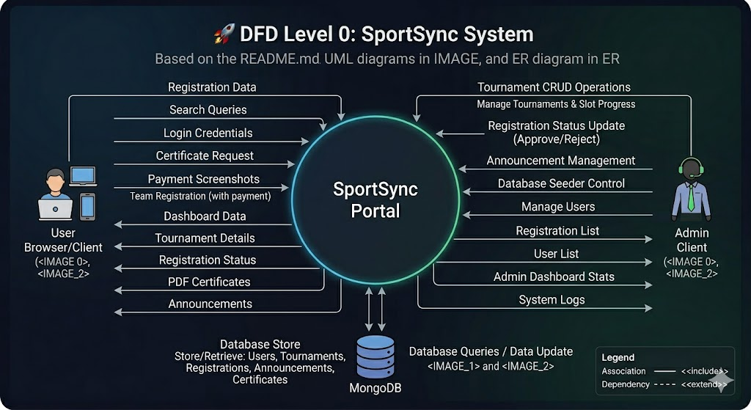

DFD Level 1

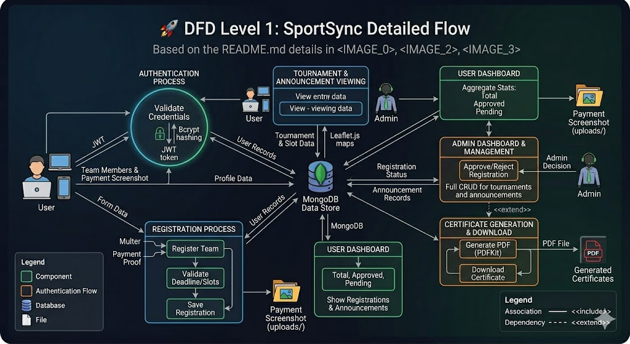

Sequence Diagram
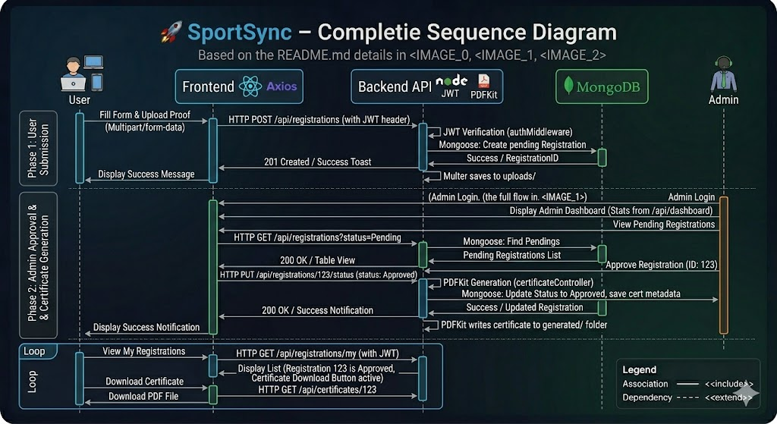

Component Diagram
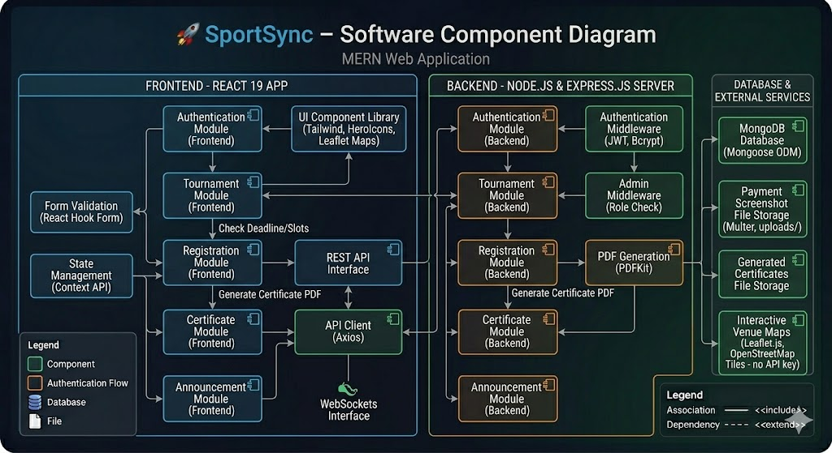

Deployment Diagram
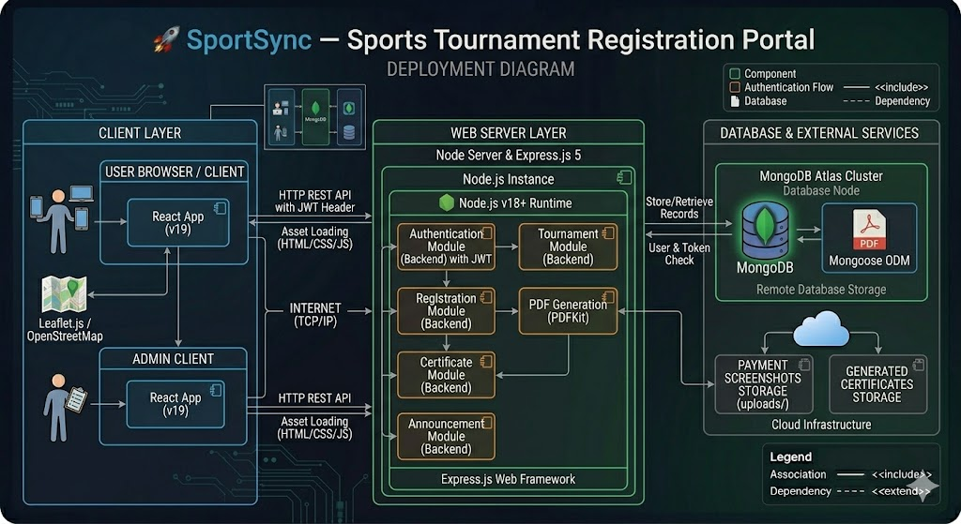

Class Diagram

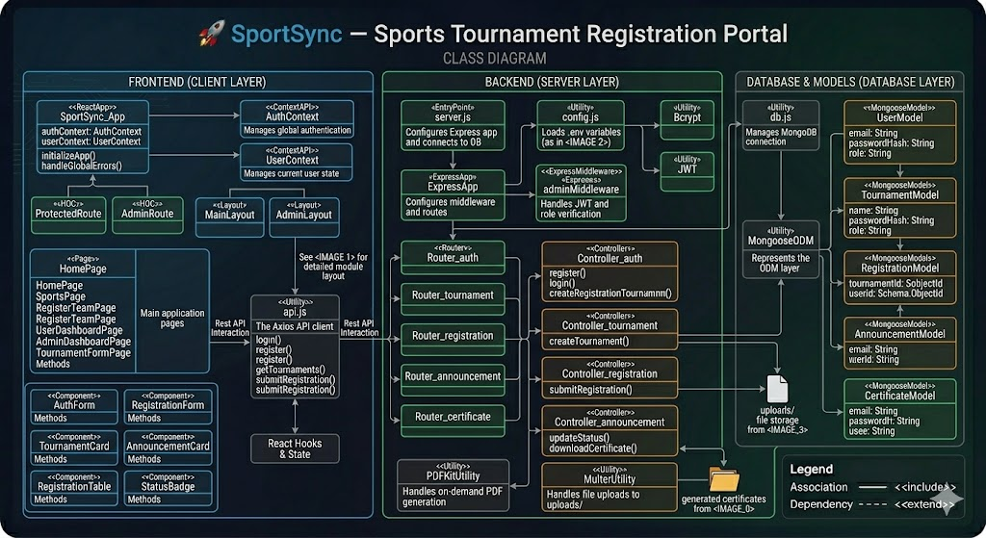

Flowchart Diagram
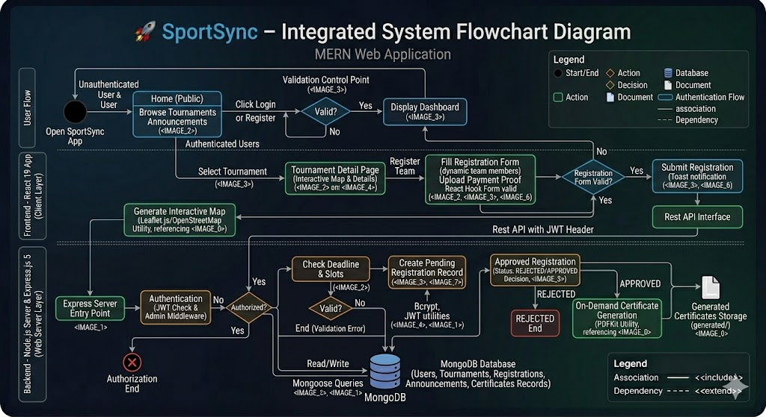
- Implementation
The implementation phase is one of the most important stages of the software development lifecycle because it converts the system design into a functional and working application. In this phase, all modules of the SportSync project were developed using the MERN Stack technologies, including React.js for frontend development, Node.js and Express.js for backend development, and MongoDB for database management.
The implementation of the project was carried out using a modular and scalable development approach. The frontend and backend were developed separately and later integrated using RESTful APIs. The system was implemented by following modern web development practices such as component-based architecture, MVC architecture, reusable modules, secure authentication, responsive design, and proper error handling.
The implementation phase included:
- Frontend user interface development
- Backend API development
- Database integration
- Authentication system implementation
- Tournament registration workflow
- Admin dashboard implementation
- File upload functionality
- Certificate generation
- Frontend-backend integration
The project was developed in a way that ensures maintainability, scalability, and future enhancements.

  - Frontend Development
The frontend of the SportSync application was developed using React.js and Tailwind CSS. The frontend acts as the presentation layer of the system and is responsible for handling user interactions, displaying data, and communicating with the backend APIs.
The frontend was designed with a focus on:
- Responsive user interface
- Modern design
- Easy navigation
- Better user experience
- Reusable components
- Efficient state management
The frontend implementation follows a component-based architecture, which allows better code organization and maintainability.

3.1.1 React.js Frontend Framework
React.js was used as the frontend framework because it provides:
- Faster rendering
- Reusable components
- Efficient state management
- Virtual DOM optimization
- Scalability for large applications
React.js enables the development of interactive and dynamic user interfaces efficiently.

Advantages of Using React.js
- Improved performance using Virtual DOM
- Better component reusability
- Easier debugging and maintenance
- Efficient frontend routing
- Faster development process

3.1.2 Frontend Folder Structure
The frontend follows a structured folder organization to improve maintainability.

Main Frontend Folders

Folder Name | Purpose
components | Reusable UI components
pages | Application pages
layouts | Layout structures
context | State management
services | API calls
routes | Route handling
This structure helps in maintaining modular and scalable code.

3.1.3 User Interface Design
The user interface was designed using Tailwind CSS to provide a responsive and modern design.

Features of UI Design
- Mobile-first responsive layout
- Dark theme interface
- Modern card-based design
- Smooth hover effects
- User-friendly navigation
- Interactive forms and dashboards
The application interface adapts properly to different screen sizes including desktops, tablets, and mobile devices.

3.1.4 Frontend Pages
Several pages were developed for different functionalities of the application.

Public Pages
- Home Page
- Sports Listing Page
- Tournament Details Page
- Login Page
- Register Page

User Pages
- User Dashboard
- Team Registration Page
- My Registrations Page
- Profile Page

Admin Pages
- Admin Dashboard
- Tournament Management
- Registration Management
- Announcement Management
Each page was implemented using reusable React components.

3.1.5 React Router Implementation
React Router DOM was used for client-side routing.

Purpose of Routing
- Navigate between pages without reloading
- Create protected routes
- Manage user navigation efficiently

Protected Routes
Protected routes were implemented for:
- User dashboard
- Admin dashboard
- Registration management pages
Unauthorized users are redirected to the login page automatically.

3.1.6 State Management
The application uses Context API for global state management.

Managed States
- User authentication state
- JWT token storage
- User profile information
- Dashboard data

Benefits
- Reduces prop drilling
- Improves code organization
- Simplifies authentication handling

3.1.7 Form Handling and Validation
React Hook Form was used for handling forms and validations.

Forms Implemented
- Login Form
- Registration Form
- Tournament Form
- Team Registration Form
- Announcement Form

Validation Features
- Required field validation
- Email format validation
- Password strength validation
- Duplicate entry prevention
Real-time validation messages improve user experience.

3.1.8 Frontend API Communication
Axios was used for sending HTTP requests to backend APIs.

Common API Operations
- User authentication
- Fetch tournaments
- Submit registrations
- Update profiles
- Download certificates

Advantages of Axios
- Simplified API calls
- Better error handling
- Easy request configuration
- Promise-based operations

3.1.9 Responsive Design Implementation
Responsive design was implemented using Tailwind CSS utility classes.

Responsive Features
- Flexible layouts
- Mobile sidebar menu
- Responsive cards and tables
- Adaptive typography
This ensures smooth user experience across all devices.

3.1.10 Frontend Security Measures
Several frontend security practices were implemented.

Security Features
- Protected routes
- Token validation
- Form validation
- Secure API request handling
Sensitive operations are only accessible to authenticated users.

3.2 Backend Development
The backend of the SportSync project was developed using Node.js and Express.js. The backend is responsible for processing requests, handling business logic, managing authentication, interacting with the database, and providing APIs for the frontend.
The backend was designed following the MVC architecture pattern to improve maintainability and scalability.

3.2.1 Node.js Runtime Environment
Node.js was used because it provides:
- Asynchronous processing
- High performance
- Event-driven architecture
- Efficient API handling
Node.js is suitable for scalable web applications and real-time systems.

3.2.2 Express.js Framework
Express.js was used to simplify backend development.

Features of Express.js
- REST API development
- Middleware support
- Route management
- Request handling
- Better scalability
Express.js helps organize backend operations efficiently.

3.2.3 Backend Folder Structure
The backend uses a modular folder structure.

Main Backend Folders
Folder Name | Purpose
controllers | Business logic
routes | API routes
models | Database schemas
middleware | Authentication and validation
config | Database configuration
This structure follows MVC architecture principles.

3.2.4 REST API Development
RESTful APIs were developed for communication between frontend and backend.

Main APIs
- Authentication APIs
- Tournament APIs
- Registration APIs
- Announcement APIs
- Certificate APIs

HTTP Methods Used
Method | Purpose
GET | Retrieve data
POST | Create records
PUT | Update records
DELETE | Delete records

3.2.5 Authentication Implementation
JWT authentication was implemented for secure access.

Authentication Workflow
- User logs in.
- Backend verifies credentials.
- JWT token is generated.
- Token is returned to frontend.
- Protected APIs verify token.

Password Security
Passwords are encrypted using Bcrypt hashing.

Advantages
- Improved security
- Stateless authentication
- Secure route protection

3.2.6 Middleware Implementation
Middleware functions were implemented for:
- JWT verification
- Admin role validation
- Error handling
- File uploads

Types of Middleware

Authentication Middleware
Verifies JWT tokens.

Admin Middleware
Restricts admin-only operations.

Error Middleware
Handles application errors properly.

3.2.7 Database Connectivity
MongoDB Atlas was connected using Mongoose ODM.

Advantages of Mongoose
- Schema validation
- Easy database operations
- Relationship management
- Query simplification
Database operations include:
- Insert
- Update
- Delete
- Fetch

3.2.8 File Upload Functionality
Multer middleware was implemented for handling file uploads.

Uploaded Files
- Payment screenshots
- Tournament-related images

Upload Features
- File type validation
- File size validation
- Secure storage handling

3.2.9 PDF Certificate Generation
PDFKit was used for certificate generation.

Certificate Features
- Dynamic participant details
- Tournament information
- Downloadable PDF format
Certificates are generated only for approved registrations.

3.2.10 Backend Error Handling
Proper error handling mechanisms were implemented.

Common Error Responses
- Invalid credentials
- Unauthorized access
- Duplicate registrations
- Invalid form submissions
Meaningful error messages improve usability and debugging.

3.3 Integration
Integration is the process of connecting the frontend, backend, and database components into a fully functional application. In the SportSync project, integration plays an important role in ensuring smooth communication between different modules and system layers.
The integration process was implemented using RESTful APIs and Axios HTTP requests.

3.3.1 Frontend and Backend Integration
The React frontend communicates with Express backend APIs through HTTP requests.

Integration Workflow
- User performs an action on frontend.
- Frontend sends request using Axios.
- Backend processes request.
- Database operation is performed.
- Response is returned to frontend.
- Frontend updates UI dynamically.
This workflow ensures smooth interaction between the client and server.

3.3.2 API Integration
All frontend modules were integrated with backend APIs.

Integrated Modules
- Authentication
- Tournament management
- Team registration
- Dashboard statistics
- Announcements
- Certificate downloads

Benefits
- Real-time data updates
- Dynamic content loading
- Faster operations

3.3.3 Database Integration
MongoDB was integrated with backend services using Mongoose.

Database Operations
- User registration
- Tournament creation
- Registration storage
- Announcement management
The backend handles all CRUD operations efficiently.

3.3.4 Authentication Integration
JWT authentication was integrated between frontend and backend.

Process
- Token generated during login
- Token stored on frontend
- Token attached with API requests
- Backend validates token
This ensures secure communication.

3.3.5 File Upload Integration
The registration form integrates with Multer middleware for uploading payment screenshots.

Workflow
- User selects file.
- Frontend sends multipart form-data.
- Backend processes upload.
- File path stored in database.

3.3.6 Certificate Integration
The certificate module integrates registration data with PDF generation.

Workflow
- Admin approves registration.
- Backend generates PDF certificate.
- Certificate link becomes available.
- User downloads certificate.

3.3.7 Error Handling During Integration
Several validation and error handling mechanisms were implemented.

Examples
- Invalid API requests
- Missing authentication token
- Database connection failures
- Invalid form data
Proper responses are returned to frontend for better user experience.

3.3.8 Advantages of System Integration
The integration process provides several benefits:
- Smooth communication between modules
- Faster data processing
- Improved application performance
- Better user experience
- Efficient workflow automation
- Centralized data handling

4. Testing

Testing is one of the most important phases in software development because it ensures that the developed application works correctly, efficiently, and securely according to the specified requirements. The testing phase of the SportSync project was performed to identify errors, validate functionalities, improve system reliability, and ensure smooth user experience across different modules of the application.
The SportSync application was tested thoroughly after the implementation phase to verify that all modules such as authentication, tournament registration, admin management, announcements, certificate generation, and database operations were functioning properly. Both frontend and backend functionalities were tested to ensure proper integration between the client-side interface and server-side APIs.
The testing process focused on:
- Functional correctness
- User interface validation
- Authentication security
- API response handling
- Database operations
- Error handling
- System integration
- Performance verification
The project testing was carried out manually and through practical execution of all workflows. Different test scenarios were executed to validate expected outputs and identify possible issues in the system.

4.1 Test Cases
Test cases are predefined conditions or scenarios used to verify whether the system behaves as expected. Each module of the SportSync application was tested with multiple test cases to ensure that all functionalities were working correctly.
The test cases were designed to validate:
- User input handling
- Authentication functionality
- Database operations
- API communication
- Registration workflow
- Admin operations
- Error handling

The following test cases were executed during the testing phase of the project.

4.1.1 Authentication Module Test Cases
The authentication module was tested to verify secure login, registration, password validation, and role-based access control.

Test Case Table – Authentication Module
Test Case ID | Test Scenario | Input | Expected Result | Actual Result | Status
TC-01 | User Registration | Valid user details | User account created successfully | Successful | Pass
TC-02 | Duplicate Registration | Existing email address | Error message displayed | Successful | Pass
TC-03 | User Login | Valid credentials | JWT token generated and login successful | Successful | Pass
TC-04 | Invalid Login | Incorrect password | Invalid credentials error | Successful | Pass
TC-05 | Protected Route Access | Access dashboard without login | Redirect to login page | Successful | Pass
TC-06 | Admin Route Validation | Normal user accessing admin page | Unauthorized access message | Successful | Pass

Observations
- Password hashing using Bcrypt worked correctly.
- JWT authentication validated tokens successfully.
- Protected routes prevented unauthorized access.
- Invalid credentials generated proper error responses.

4.1.2 Tournament Module Test Cases
The tournament management module was tested to verify tournament creation, updating, deletion, and retrieval functionalities.

Test Case Table – Tournament Module
Test Case ID | Test Scenario | Input | Expected Result | Actual Result | Status
TC-07 | Create Tournament | Valid tournament details | Tournament created successfully | Successful | Pass
TC-08 | Update Tournament | Updated tournament data | Tournament updated successfully | Successful | Pass
TC-09 | Delete Tournament | Tournament ID | Tournament removed successfully | Successful | Pass
TC-10 | Fetch Tournament List | API request | List of tournaments displayed | Successful | Pass
TC-11 | Invalid Tournament Data | Empty required fields | Validation error displayed | Successful | Pass

Observations
- CRUD operations worked properly.
- Tournament data was stored correctly in MongoDB.
- Validation errors were handled efficiently.
- Tournament filtering and listing functioned properly.

4.1.3 Team Registration Module Test Cases
The registration module was tested to ensure proper team registration workflow and file upload functionality.

Test Case Table – Registration Module
Test Case ID | Test Scenario | Input | Expected Result | Actual Result | Status
TC-12 | Team Registration | Valid registration details | Registration submitted successfully | Successful | Pass
TC-13 | Upload Payment Screenshot | Valid image file | File uploaded successfully | Successful | Pass
TC-14 | Duplicate Team Registration | Existing team name | Duplicate registration error | Successful | Pass
TC-15 | Missing Required Fields | Incomplete form | Validation error displayed | Successful | Pass
TC-16 | Registration Status Tracking | Approved registration | Correct status displayed | Successful | Pass

Observations
- File upload functionality worked correctly.
- Validation prevented incomplete registrations.
- Registration data was stored properly.
- Status updates reflected accurately on dashboard.

4.1.4 Admin Dashboard Test Cases
The admin dashboard was tested to validate management functionalities.

Test Case Table – Admin Dashboard
Test Case ID | Test Scenario | Input | Expected Result | Actual Result | Status
TC-17 | View Registrations | Valid admin login | Registrations displayed | Successful | Pass
TC-18 | Approve Registration | Registration ID | Status changed to Approved | Successful | Pass
TC-19 | Reject Registration | Registration ID | Status changed to Rejected | Successful | Pass
TC-20 | Delete Registration | Registration ID | Registration deleted | Successful | Pass
TC-21 | Dashboard Statistics | Dashboard API call | Statistics displayed correctly | Successful | Pass

Observations
- Admin operations worked efficiently.
- Role-based authorization restricted unauthorized users.
- Dashboard statistics displayed dynamically.

4.1.5 Announcement Module Test Cases
The announcement module was tested to verify notice creation and display functionality.

Test Case Table – Announcement Module
Test Case ID | Test Scenario | Input | Expected Result | Actual Result | Status
TC-22 | Create Announcement | Valid announcement | Announcement published | Successful | Pass
TC-23 | Update Announcement | Modified content | Announcement updated | Successful | Pass
TC-24 | Delete Announcement | Announcement ID | Announcement deleted | Successful | Pass
TC-25 | Display Announcements | Fetch API request | Announcements displayed | Successful | Pass

Observations
- Announcement CRUD operations worked successfully.
- Priority levels displayed correctly.
- Announcements appeared dynamically on frontend.

4.1.6 Certificate Module Test Cases
The certificate generation module was tested to ensure correct PDF generation functionality.

Test Case Table – Certificate Module
Test Case ID | Test Scenario | Input | Expected Result | Actual Result | Status
TC-26 | Generate Certificate | Approved registration | PDF generated successfully | Successful | Pass
TC-27 | Download Certificate | Valid registration ID | Certificate downloaded | Successful | Pass
TC-28 | Unauthorized Access | Invalid user access | Access denied | Successful | Pass

Observations
- PDF certificates were generated successfully.
- Certificate details were displayed correctly.
- Unauthorized downloads were restricted.

4.1.7 API Testing
Backend APIs were tested using Postman.

API Testing Objectives
- Validate API responses
- Verify status codes
- Check authentication
- Test CRUD operations

Common Status Codes Tested
Status Code | Meaning
200 | Success
201 | Record Created
400 | Bad Request
401 | Unauthorized
404 | Not Found
500 | Internal Server Error

Observations
- APIs returned correct responses.
- Error handling worked properly.
- Authentication middleware validated tokens successfully.

4.1.8 User Interface Testing
The frontend interface was tested across multiple devices and screen sizes.

Devices Tested
- Desktop
- Laptop
- Tablet
- Mobile phone

UI Testing Focus
- Responsive design
- Navigation
- Form validations
- Button interactions
- Sidebar behavior

Observations
- Responsive layout worked correctly.
- Forms displayed proper validations.
- User interface remained consistent across devices.

4.2 Results
The testing phase of the SportSync project produced successful results across all major modules of the application. All functionalities were executed and verified according to the expected outcomes defined during the system design and implementation phases.
The application successfully handled:
- User authentication
- Tournament management
- Team registrations
- File uploads
- Dashboard operations
- Announcements
- Certificate generation
- Database interactions
The integration between frontend, backend, and database worked efficiently without major issues. API communication was successful, and all modules responded correctly to user actions.

4.2.1 Functional Results
The functional testing results confirmed that:
- All forms validated inputs correctly.
- Protected routes prevented unauthorized access.
- Registrations were stored properly in MongoDB.
- Admin operations performed successfully.
- Certificates generated dynamically.
The system behaved according to the expected requirements.

4.2.2 Performance Results
The application demonstrated good performance during testing.

Performance Observations
- Fast API response times
- Smooth frontend rendering
- Efficient database queries
- Quick dashboard loading
- Stable file upload operations
The system maintained stable performance even with multiple records and repeated operations.

4.2.3 Security Results
Security testing verified:
- Password encryption using Bcrypt
- JWT token validation
- Protected API routes
- Role-based access control
Unauthorized users were unable to access protected resources, ensuring proper security implementation.

4.2.4 User Experience Results
The user interface provided a smooth and responsive experience.

UX Observations
- Easy navigation
- Mobile responsiveness
- Clean dashboard layout
- User-friendly forms
- Clear validation messages
The application was easy to use for both normal users and administrators.

4.2.5 Integration Results
The integration testing confirmed successful communication between:
- React frontend
- Express backend
- MongoDB database
All modules exchanged data properly through REST APIs without data inconsistency issues.

4.2.6 Overall Testing Summary
The overall testing results indicate that the SportSync application is stable, functional, secure, and capable of handling sports tournament registration and management operations effectively.

Final Outcomes
- All major modules passed testing successfully.
- The application achieved expected functionality.
- System integration worked efficiently.
- Security mechanisms functioned correctly.
- Responsive UI improved user accessibility.
- Database operations remained consistent and reliable.
The testing phase validated that the SportSync project successfully fulfills its objectives and provides a reliable digital solution for sports tournament management.

5. Conclusion
The conclusion phase summarizes the overall development, implementation, and achievements of the SportSync project. The project was developed with the objective of creating a modern, secure, and efficient web-based Sports Tournament Registration Portal capable of automating tournament registration and management processes. The system successfully integrates frontend development, backend APIs, database management, authentication mechanisms, and responsive user interface design into a single scalable application.
The project demonstrates the practical implementation of MERN Stack technologies including MongoDB, Express.js, React.js, and Node.js. Through the development of multiple modules such as authentication, tournament management, team registration, announcements, certificate generation, and admin dashboard management, the project successfully addresses the limitations of traditional manual tournament management systems.
The SportSync application provides a centralized platform that simplifies tournament operations for both participants and administrators. The project not only improves operational efficiency but also enhances user experience through automation, responsive design, and secure workflows. The implementation of JWT authentication, role-based access control, file upload management, and PDF certificate generation further strengthens the functionality and professionalism of the system.
Overall, the project successfully fulfills its objectives and demonstrates practical knowledge of full-stack web application development, database integration, RESTful APIs, responsive UI design, and software engineering principles.

5.1 Summary
The SportSync project was developed to solve the challenges associated with traditional sports tournament registration and management systems. Manual systems often lead to inefficient record management, delayed communication, data redundancy, and increased administrative workload. To overcome these issues, the SportSync application was designed as a complete web-based solution that automates tournament-related activities and centralizes data management.
The system allows users to:
- Register securely using JWT authentication.
- Browse available tournaments.
- Register teams for different sports.
- Upload payment screenshots and required documents.
- Track registration status.
- Download participation certificates.
At the same time, administrators are provided with a dedicated dashboard where they can:
- Create and manage tournaments.
- Approve or reject registrations.
- Publish announcements.
- Manage participant information.
- Monitor system activities.
The frontend of the application was developed using React.js and Tailwind CSS, providing a responsive and modern user interface. The backend was developed using Node.js and Express.js, while MongoDB was used for efficient database management. RESTful APIs were implemented for smooth communication between frontend and backend components.
The project also included:
- File upload functionality using Multer.
- Password encryption using Bcrypt.
- JWT-based authentication and authorization.
- PDF certificate generation using PDFKit.
- Interactive venue maps using Leaflet.js.
The system was tested thoroughly to verify:
- Functional correctness
- User authentication
- API communication
- Database operations
- User interface responsiveness
- Security mechanisms
All modules performed successfully during testing, and the application achieved the expected outcomes according to the project objectives.
The SportSync project demonstrates practical implementation of:
- Full-stack development
- Database management
- REST API integration
- Authentication systems
- Responsive web design
- Software architecture principles
The project serves as a complete and reliable digital solution for sports tournament registration and management while also showcasing the practical application of modern web technologies.

5.2 Future Enhancements
Although the SportSync application successfully fulfills the major requirements of tournament management and registration, several additional features and improvements can be implemented in the future to further enhance the functionality, scalability, and usability of the system.
Future enhancements can transform the application into a more advanced and enterprise-level sports management platform capable of handling larger events and more complex operations.

5.2.1 Online Payment Gateway Integration
Currently, the system supports payment proof uploads manually. In future versions, online payment gateways such as:
- Razorpay
- Stripe
- PayPal
can be integrated directly into the application.

Benefits
- Secure online transactions
- Instant payment verification
- Faster registration process
- Reduced manual payment handling

5.2.2 Real-Time Notifications
The current system displays registration statuses and announcements through dashboards. Future versions can implement real-time notifications using technologies such as Socket.io.

Possible Features
- Instant registration updates
- Live announcements
- Real-time admin notifications
- Tournament schedule alerts
This would improve communication between users and administrators.

5.2.3 Live Match Score System
The current project focuses mainly on tournament registration and management. Future enhancements may include a live score tracking system.

Features
- Real-time score updates
- Match statistics
- Live scoreboards
- Tournament leaderboards
This would increase user engagement and improve the overall functionality of the application.

5.2.4 Mobile Application Development
Currently, SportSync is a responsive web application. In future, a dedicated mobile application can be developed using:
- React Native
- Flutter

Benefits
- Better mobile experience
- Push notifications
- Faster accessibility
- Offline support
A mobile application would increase the usability and accessibility of the platform.

5.2.5 Cloud Storage Integration
At present, uploaded files are stored locally. Future improvements can include cloud storage services such as:
- AWS S3
- Cloudinary
- Firebase Storage

Benefits
- Improved scalability
- Better file security
- Faster file delivery
- Reduced server storage dependency

5.2.6 Advanced Analytics Dashboard
Future versions of the admin dashboard can include advanced analytics and reporting features.

Features
- Tournament participation graphs
- Revenue analytics
- User activity reports
- Registration trends
This would help administrators make better decisions and monitor tournament performance effectively.

5.2.7 AI-Based Recommendations
Artificial Intelligence features can be added in future versions for:
- Tournament recommendations
- Automated scheduling
- Smart notifications
- User behavior analysis
This would improve personalization and automation within the platform.

5.2.8 Team Chat and Communication System
A communication module can be integrated to allow direct interaction between:
- Team members
- Organizers
- Administrators

Features
- Real-time messaging
- Team discussions
- Tournament updates
This would improve collaboration and communication efficiency.

5.2.9 Multi-Language Support
Future versions can support multiple languages to improve accessibility for users from different regions.

Benefits
- Better user experience
- Increased accessibility
- Wider user adoption

5.2.10 Advanced Security Enhancements
Additional security features can be implemented such as:
- Two-factor authentication (2FA)
- OTP verification
- Account recovery systems
- CAPTCHA integration
These features would further strengthen application security.

5.2.11 Cloud Deployment and DevOps Integration
The application can be deployed using cloud platforms and DevOps pipelines.

Possible Technologies
- Docker
- Kubernetes
- AWS
- CI/CD pipelines

Benefits
- Improved scalability
- Faster deployments
- Better server management
- Automated testing and deployment

5.2.12 Match Scheduling Automation
Future versions can include automatic tournament scheduling systems.

Features
- Fixture generation
- Round robin scheduling
- Knockout bracket generation
This would reduce manual scheduling efforts for administrators.

5.2.13 Attendance and QR Verification System
QR code-based participant verification can be integrated.

Benefits
- Faster event check-in
- Attendance tracking
- Secure participant verification

5.2.14 Social Media and Email Integration
The application can integrate with:
- Email services
- Social media platforms

Features
- Email notifications
- Social media sharing
- Tournament promotions

5.2.15 Overall Future Scope
The SportSync project has significant future scope and can evolve into a complete sports event management platform. The modular architecture and scalable design of the application make it suitable for implementing advanced features and handling larger-scale tournament operations in the future.
The project successfully establishes a strong foundation for future enhancements while demonstrating the practical implementation of modern web technologies and software engineering concepts.

6. References
The following references were used during the analysis, design, development, and implementation of the SportSync project. These references include official documentation, online resources, research materials, tutorials, and technology guides related to MERN Stack development, database management, authentication, frontend development, backend APIs, and software engineering concepts.

6.1 Books and Study Materials
- Raj, P., & Raman, A. Full Stack Web Development Using MERN Stack. BPB Publications.
- Freeman, E. Head First HTML and CSS. O’Reilly Media.
- Nixon, R. Learning PHP, MySQL & JavaScript. O’Reilly Media.
- Pressman, R. S. Software Engineering: A Practitioner’s Approach. McGraw-Hill Education.
- Sommerville, I. Software Engineering. Pearson Education.
- Elmasri, R., & Navathe, S. B. Fundamentals of Database Systems. Pearson.
- Duckett, J. JavaScript and JQuery: Interactive Front-End Web Development. Wiley Publications.
- Gamma, E., Helm, R., Johnson, R., & Vlissides, J. Design Patterns: Elements of Reusable Object-Oriented Software. Addison-Wesley.

6.2 Official Documentation References

React.js Documentation
- https://react.dev/

Node.js Documentation
- https://nodejs.org/en/docs/

Express.js Documentation
- https://expressjs.com/

MongoDB Documentation
- https://www.mongodb.com/docs/

Mongoose Documentation
- https://mongoosejs.com/docs/

Tailwind CSS Documentation
- https://tailwindcss.com/docs/

React Router Documentation
- https://reactrouter.com/

Axios Documentation
- https://axios-http.com/docs/intro

JWT Documentation
- https://jwt.io/introduction

Bcrypt.js Documentation
- https://www.npmjs.com/package/bcryptjs

Multer Documentation
- https://www.npmjs.com/package/multer

PDFKit Documentation
- https://pdfkit.org/

React Hook Form Documentation
- https://react-hook-form.com/

Leaflet.js Documentation
- https://leafletjs.com/

6.3 Online Learning Platforms and Tutorials
- GeeksforGeeks
https://www.geeksforgeeks.org/
- W3Schools
https://www.w3schools.com/
- MDN Web Docs
https://developer.mozilla.org/
- FreeCodeCamp
https://www.freecodecamp.org/
- Stack Overflow
https://stackoverflow.com/
- JavaTPoint
https://www.javatpoint.com/
- Tutorialspoint
https://www.tutorialspoint.com/
- Medium Articles on MERN Stack Development
https://medium.com/

6.4 Tools and Software Used
Tool/Software | Purpose
Visual Studio Code | Code Editor
MongoDB Atlas | Cloud Database
Postman | API Testing
Git & GitHub | Version Control
Node.js | Backend Runtime
React.js | Frontend Framework
Express.js | Backend Framework
MongoDB | Database
Tailwind CSS | Frontend Styling
PDFKit | Certificate Generation
Multer | File Upload Handling

6.5 Research and Technical References
- MERN Stack Architecture and Best Practices
- REST API Design Principles
- JWT Authentication and Authorization Mechanisms
- MongoDB Database Design Techniques
- Responsive Web Design Principles
- MVC Architecture Concepts
- Full Stack Web Application Development Practices
- Software Testing Methodologies
- UML Diagram Design Standards
- Database Relationship Modeling Concepts

6.6 Conclusion of References
The references listed above played an important role in understanding modern web development concepts, software architecture, authentication systems, responsive design techniques, and database management practices. These resources helped in the successful development and implementation of the SportSync project using industry-standard technologies and development methodologies.

7. Appendices
The appendices section contains additional supporting information related to the SportSync project. These details provide supplementary technical references, implementation samples, API information, environment configurations, screenshots, and supporting materials used during the development of the application.
The appendices help in providing a deeper understanding of the project implementation and act as supporting documentation for the overall system development process. This section includes important technical details that are useful for future maintenance, deployment, testing, and enhancement of the application.

7.1 Source Code Structure
The SportSync project follows a modular folder structure for both frontend and backend development. The structure helps maintain scalability, readability, and proper organization of project files.

7.1.1 Frontend Folder Structure
The frontend was developed using React.js and Tailwind CSS.

Frontend Structure
frontend/
│
├── public/
│ └── index.html
│
├── src/
│ ├── components/
│ ├── context/
│ ├── layouts/
│ ├── pages/
│ ├── services/
│ ├── routes/
│ ├── App.js
│ └── index.js
│
├── package.json
└── tailwind.config.js

Description of Frontend Folders
Folder | Purpose
components | Reusable UI components
pages | Application pages
context | Authentication state management
services | API service handling
routes | Frontend route protection
layouts | Common page layouts

7.1.2 Backend Folder Structure
The backend was developed using Node.js and Express.js.

Backend Structure
backend/
│
├── config/
├── controllers/
├── middleware/
├── models/
├── routes/
├── uploads/
├── server.js
└── package.json

Description of Backend Folders
Folder | Purpose
config | Database configuration
controllers | Business logic
middleware | Authentication and validation
models | MongoDB schemas
routes | API endpoints
uploads | Payment screenshots

Reference Images of the Project

