
PUCIT
Punjab University College of Information Technology

First Deliverable
Version 1.0

Table of Contents

First Deliverable Guide 3
1 Introduction 3
1.1 Project/Product Feasibility Report 3
1.1.1 Technical Feasibility 4
1.1.2 Operational Feasibility 4
1.1.3 Economic Feasibility 4
1.1.4 Schedule Feasibility 4
1.1.5 Specification Feasibility 5
1.1.6 Information Feasibility 5
1.1.7 Motivational Feasibility 5
1.1.8 Legal & Ethical Feasibility 5
1.2 Project/Product Scope 5
1.3 Project/Product Costing 5
1.3.1 Project Cost Estimation By Function Point Analysis 6
1.3.2 Project Cost Estimation by using COCOMO’81 (Constructive Cost Model) 8
1.4 CPM - Critical Path Method 9
1.5 Gantt chart 12
1.6 Introduction to Team member and their skill set 13
1.7 Tools and Technology with reasoning 13
1.8 Vision Document 13
1.9 Risk List 14
1 Introduction 15
1.1 Systems Specifications 16
1.2 Identifying External Entities 17
1.3 Context Level Data Flow Diagram 17
1.4 Capture "shall" Statements 17
1.5 Allocate Requirements 18
1.6 Prioritize Requirements 18
1.7 Requirements Trace-ability Matrix 18
1.8 Example 18
1.8.1 Introduction 18
1.8.2 Existing System Business Organization 18
1.8.4Scope of the System 19
1.8.5 Summary of Requirements:(Initial Requirements) 20
1.8.6 Identifying External Entities 22
1.8.9 Capture "shall" Statements and External Entities 23
1.8.10 Allocate Requirements 23
1.8.11 Priorities Requirements 25
1.8.12 Requirements Traceability Matrix 28
1.9 High Level Usecase Diagram 30

First Deliverable Guide

1 Introduction
First part of this deliverable is all about planning and scheduling of project. This deliverable must contain following artifacts:

- Project Feasibility
- Project Scope
- Project Costing
- Critical Path Method Analysis (CPM Analysis)
- Gantt Chart
- Introduction to team members
- Tools and Technologies
- Vision Document
- Risk List

1.1 Project/Product Feasibility Report
The basic purpose of our mobile app Student Counselling is to provide information about Lahore based universities i.e. User can search about last year merits, HEC ranked universities list, searched nearby hostels, entry test preparation material and aggregate calculations. They can get all of these things on a single platform and get benefit of it. Not only students but parents and teachers can also use this app to take an overview of universities.

There are many types of feasibilities:

- Technical
- Operational
- Economic
- Schedule
- Specification
- Information
- Motivational
- Legal and Ethical

1.1.1 Technical Feasibility
The technology we are using (Flutter) will make it possible to implement the application. The group members of Student Counselling are enough skilled in using android studio and flutter. Android studio is a good option for building mobile application. Flutter is a hybrid application development platform which will work for both Android and iOS provided by Google. On admin side we will use React and node.js for website where admin can handle Database.

1.1.2 Operational Feasibility
Most of students don’t have how-know of educational institutes. As Lahore is hub of universities, they got confused. The selection of field after intermediate is never an easy task so we believe most of users especially students will get it right platform to search.

1.1.3 Economic Feasibility
The organizations for which we are working have labs with a vast number of systems having tools which would be enough to be feasible economically. Furthermore, our team members owned individual machines to work on.
The application is absolutely free for users so that they can access it easily and get benefit of it. It will improve user’s search skills and communication between them.

1.1.4 Schedule Feasibility
There are almost eight months to complete the project so it is divided into chunks and there is deadline for every chunk. This way will allow us to work in an efficient way. Meetings will be conducted on regular basis to review the individual works.
.

1.1.5 Specification Feasibility
We’ve a well-planned application project. The application will require following
- Android or iOS phone.
- Minimum 512 MB Ram and 100 MB free space.
- Any of internet browser (for website).
- Internet

.The requirements of our system are well defined and well understood. There is no ambiguity in it. The functional and nonfunctional requirements will be fulfilled. Apart from basic features, we are thinking to provide some extra facility like search of scholarship. Due to time constraint and lack of resources we have to drop few functionalities of our system. Existing functions of the application will be developed efficiently.

1.1.6 Information Feasibility
We have enough information to give through this application so that user can feel ease to access it. There will be a friendly GUI which will help and derive user to go through that information.
We will get the required information from universities and students. Official websites of universities can help in gathering the data. Getting the reviews of students regarding their problem they faced or facing while getting admission in universities will also be very helpful. Using the functionalities of google maps we can provide the location of nearby hostels of the selected universities.

1.1.7 Motivational Feasibility
Being a student and having experience of facing issues after we passed intermediate to choose field for graduation, we are going to provide ease to those students who have either no idea what to do or those who are facing issues for institute selection.
This application is easy to use and understand. Moreover this application will provide all the necessary information need to get admission in university, to all the student on a single platform. All the clients, actors and stakeholders are completely aware of underlying concept. Students will be satisfied because this application will save their time.

1.1.8 Legal & Ethical Feasibility
There will be no ethical and legal issue while developing this application on Flutter and information which we’ll provide is publically available.
Security measures will be taken to protect the information provided by student during Sign in the application. Anyone will not allow to use any kind of abusive language in community group. Authentic information will be provided to student.

1.2 Project/Product Scope
This application is client-server based app which will work to facilitate users especially students to get knowledge of universities in Lahore to be notified for admission dates, last year merits and HEC ranked list of institutes. This app will provide a community group to ask questions from users and to make them easy to communicate with each other. Android as well as iOS users will be able to use this application. Users can select field and can get information of nearby hostel as well. Deadlines to apply in different institutes will be posted accordingly.

1.3 Project/Product Costing
A metric is some measurement we can make of a product or process in the overall development process. Metrics are split into two broad categories:
- Knowledge oriented metrics: these are oriented to tracking the process to evaluate, predict or monitor some part of the process.
- Achievement oriented metrics: these are often oriented to measuring some product aspect, often related to some overall measure of quality of the product.
Most of the work in the cost estimation field has focused on algorithmic cost modeling. In this process costs are analyzed using mathematical formulas linking costs or inputs with metrics to produce an estimated output. The formulae used in a formal model arise from the analysis of historical data. The accuracy of the model can be improved by calibrating the model to your specific development environment, which basically involves adjusting the weightings of the metrics.
Cost estimation can be done by just one methodology.

1.3.1 Project Cost Estimation by Function Point Analysis

Information domain values are defined in the following manner:

User inputs:
- User login
- User signup
- Announcements
- Community group
- University’s information
- Hostel’s location
- Entrance test content
- Last year merit of university
- Marks entry

Number of user outputs:
- User account
- User account setting
- University’s information
- Messages of community group
- Notifications
- Announcements
- Hostel’s location
- Entrance test content
- Calculated aggregate

User inquiries:
- Searching for university
- Searching for hostel located around targeted university
- Search for entrance test content

Files:
- User
- University data
- Group chat
- Entrance test content
- Last year merit
- Announcements

External interfaces:
- Login
- Signup
- Home screen
- Announcements
- User Account
- Setting
- Community group

No. of inputs:-……………….= 9
No. of outputs:-……………...= 9
No. of inquiries:-…………….= 3
No. of files:-…………………= 6
No. of External interfaces:-….= 7

Type of component | Count | Complexity of components
 |  | Low | Average | High | Total
External inputs | 9 | 3 | 4 | 6 | 36
External outputs | 9 | 4 | 5 | 7 | 45
External inquires | 3 | 3 | 4 | 6 | 12
Files | 6 | 7 | 10 | 15 | 60
External interfaces | 7 | 5 | 7 | 10 | 35
Count total |  |  |  |  | 188

Calculating Factors:

Scaling
0 | Not applicable
1 | Incidental
2 | Moderate
3 | Average
4 | Significant
5 | Essential

 | Value of adjustment factors | Values
1 | Data communications | 3
2 | Distributed data processing | 0
3 | Performance | 4
4 | Heavily used configuration | 3
5 | Transaction rate | 0
6 | On-Line data entry | 2
7 | End-user efficiency | 4
8 | On-Line update | 3
9 | Complex processing | 2
10 | Reusability | 4
11 | Installation ease | 4
12 | Operational ease | 4
13 | Multiple sites | 3
14 | Facilitate change | 3
Total | ∑(Fi) | 39

Finally, Total Project Cost and Total Project Effort are calculated given the average productivity parameter for the system.

FP est. = Count Total * [0.65 + 0.01 * (Fi)]
=188*[0.65+0.01*39]
=195.52

Effort estimation
T.F.P=FP
Total productivity of the organization = 25 FP/PM
Effort=T.F.P/productivity
Effort=195.52/25
Effort=7.82 person/month

Total Cost
Labor rate=6000 Rs/RM

Cost / FP = labor rate / productivity parameter
=6000/25
=240
Total Project Cost = FP est. * (cost / FP)
=195.52*240
=46,924

1.4 CPM - Critical Path Method

Activity # | Activity Name | Dependency | Duration(days)
A | Proposal | None | 7
B | Project Scope | A | 5
C | Project Planning and Analysis | A,B | 13
D | High level use case description and Diagram | C | 13
E | Designing and Modeling | D | 28
F | Application and Database development | E | 50
G | Website development | E | 30
H | Firebase Integration | E,F,G | 15
I | Testing and Modification | F,G,H | 27
J | Deployment and marketing | I | 20

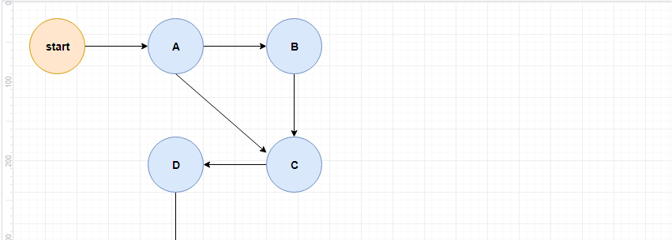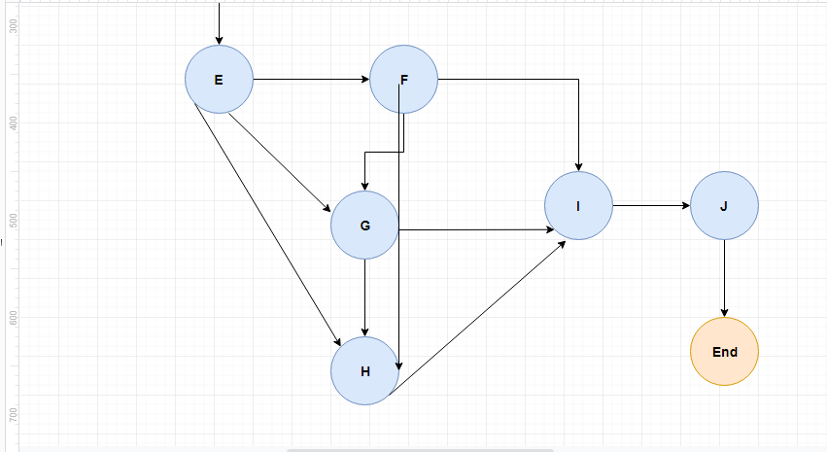

Activity | Duration | ES | EF | LS | LF | TS | FS
Start | 0 | 0 | 0 | 0 | 0 | 0 | 0
A | 7 | 0 | 7 | 0 | 7 | 0 | 0
B | 5 | 7 | 12 | 7 | 12 | 0 | 0
C | 13 | 12 | 25 | 12 | 25 | 0 | 0
D | 13 | 25 | 38 | 25 | 38 | 0 | 0
E | 28 | 38 | 66 | 38 | 66 | 0 | 0
F | 50 | 66 | 116 | 66 | 116 | 0 | 0
G | 30 | 66 | 96 | 86 | 116 | 20 | 20
H | 15 | 116 | 131 | 116 | 131 | 0 | 0
I | 27 | 131 | 158 | 131 | 158 | 0 | 0
J | 20 | 158 | 178 | 158 | 178 | 0 | 0
End | 0 | 178 | 178 | 178 | 178 | 0 | 0

The critical path is:
Start->A->C->D->E->F->H->I->J->End

1.5 Gantt chart

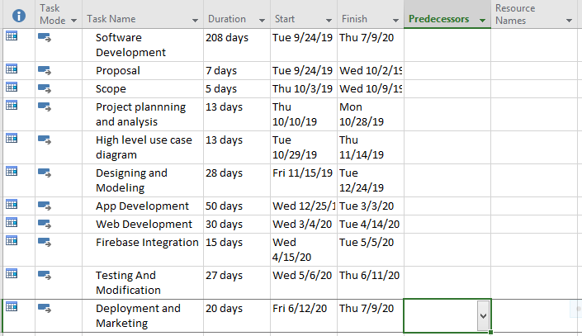
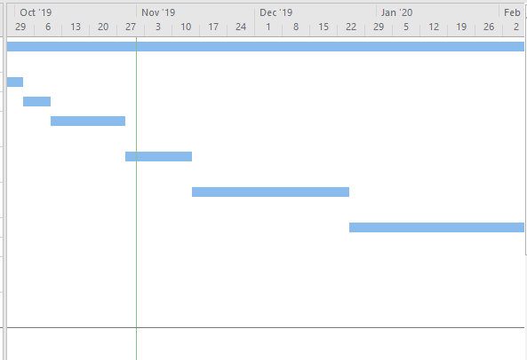
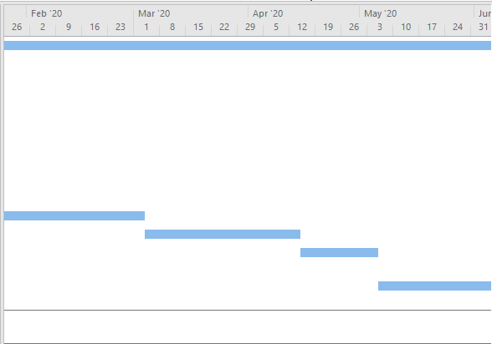
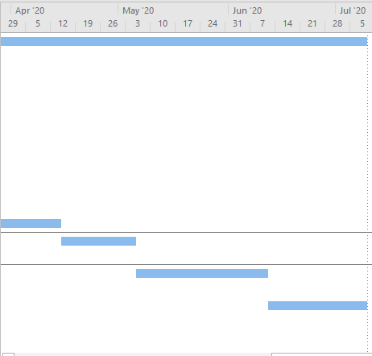

1.6 Introduction to Team member and their skill set
Roll No. | Names | Skills
BSEF16A509 | Arsalan Yasir (Leader) | Flutter, Java, .NET, JavaScript, HTML,  Android, Management Skills
BSEF16511 | Umer Jamil | Java, C#, .NET, JavaScript, HTML,  Flutter
BSEF16A529 | Ameer Hamza | C#, .NET, OOAD, JavaScript, HTML, Creative Writing, Android
BSEF16A514 | Amna Masoom | C#, ASP.NET, OOAD, JavaScript, HTML, Creative Writing, Android
BSEF16A532 | Syed Ahmad Farooq Gillani | Java, C#, ASP.NET, JavaScript, HTML,  Flutter

1.7 Tools and Technology with reasoning

Android Studio:
It’s a professional tool develop by Google to develop
Mobile applications.
- Flutter:
Flutter is Google’s UI toolkit for building beautiful, hybrid mobile
Application for both Android and iOS under single codebase.

- Visual Studio:
Visual studio is used for website customization and event handling.
(Website only for admin panel)

- Firebase:
Database used for retrieving and storing data for both mobile
Application and website is firebase

- Microsoft Visio:
Microsoft Visio is used for use case and sequence diagrams.

- Microsoft Office:
For documentation purposes.

- Xcode:
Used for creating integrated application compatible for MacOS and iOS devices.

Languages:

Dart:
Dart is the programming language used to code Flutter applications.

React:
React is a JavaScript library created by Facebook. React is a User Interface (UI) library. React is a tool for building UI components. We use it as frontend language of our website.
Node.js:
As for backend server side of our website, we use Node.js.

Vision Document
We are motivated to provide a single platform to have enough knowledge of admission process. The basic problems are going to be solved through this app such like filed selection, HEC ranked list of universities, and admission deadlines.

Student Counselling will only be for the universities in Lahore, having major stakeholders as students, parents and developers team.

This application is going to provide information of last year merits, universities list and fields selection and admission deadlines to students especially for those who don’t have enough knowledge.

- Have you fully explored what the "problem behind the problem" is?
- Being students we had faced such problems in admission process so we fully explored the problem.

- Is the list of stakeholders complete and correct?
- Yes there will be three main stakeholders i.e.: Students, parents and developers team.

- Have you sufficiently explored constraints to be put on the system?
- Yes.

- Have you covered all kinds of constraints - for example political, economic, and environmental?
- Yes.

- Have all key features of the system been identified and defined?
- Yes.

- Will the features solve the problems that are identified?
- It will be a very rare chance for not being guided by this app (considering system specification and boundaries).

- Are the features consistent with constraints that are identified?
- Yes the mentioned features are consistent with constraints.

1.9 Risk List

- Internet connection lost from user side.

- Application Crash issues.

*********************REQUIREMENTS ENGINEERING*********************

1 Introduction

Here, requirements specification is to be discussed. Requirements specification would lead to the following four steps:

- Identify external interfaces
- Development of context diagram
- Capture “shall statements
- Allocate requirements
- Prioritize requirements
- Development of requirements traceability matrix

Systems Specifications

Introduction

Now a day, we all know that education have become so important. Every student who wants to study further, wants to get admission in the best university according to his marks and interest.
While in the process of getting admission in the universities, there are many confusions and problem that are faced by students. Most of the students forgets the date of submission of the form or application. Most of them don’t know how to apply, how entry test should be prepared, how to calculate aggregate, what is the last year merit of their selected university, ranking of universities according to HEC. The issue faced by students of afternoon, after getting admission in universities, is they are not provided with hostels. Although this information is available on internet but this information is so scattered that it is hard to know for a student who does not have enough command on searching the appropriate things using internet moreover it is also time consuming in a way that a student have to go to every single website to get information.
These above mention things encouraged us to build an application that will save students time and provide ease to the students who do not have command on searching the appropriate things using internet.
This will guide students in the process of getting admission into the university.

Existing System
There is no such application that can provide all the admission related information to the student on a single platform, allow the students to communicate with each other in a community group and find hostel near his selected universities.
The procedure of getting information is, a student will go to the search engine search his query. Search engine will provide lots of websites along with an official website of the university, if it exist. Student has to search all the query separately which is time consuming as well. Most of the students who are not allotted the hostels ask their friends or people they know about hostels. Most of them do not even know that they can search hostels on online using maps.

Organizational Chart
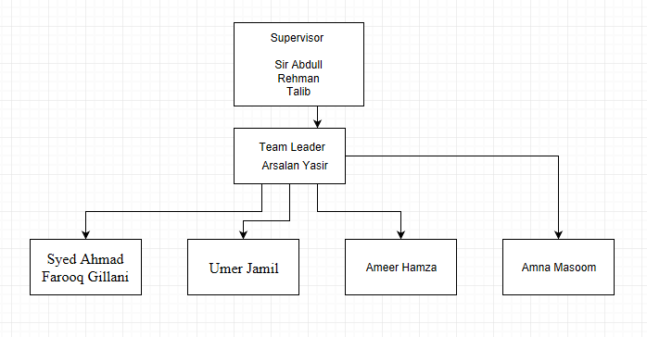
Scope of the System
According to the requirements of our system or application, this application should be developed on a very large scale but due to time and money constrains we are only registering the universities of Lahore. There are certain features that will nor be added due to above mentioned reason, like we are not providing the merit lists of universities, scholarship details of different universities will not be provided. Similarly we are not planning to make a dominant admin side of our application.

Summary of Requirements (Initial Requirements)
- List of universities according to the ranking of HEC
Our application will provide the list of universities according to the ranking done by HEC. This will provide ease to the students to who are concerned to select the best one among all the universities provided in the list, according to their marks and interest.
- Last year merit.
Our application will provide last year merit of various departments of the universities. This will make student able to judge whether his or her aggregate is enough to get admission in that department of university.
- Aggregate calculator
An aggregate calculator will be provided to students to help those who do not know how to calculate the aggregate.
- Entry test preparation content
All the content related to the preparation of entrance test will be provided in our application such as past papers etc.
- Form submission dates
Most of the students do not know the admission date of universities or they forgot the date so we decided to develop a feature that will provide the admission date of all the universities.
- List of hostels
The major problem faced by students enrolled in the afternoon classes is that they are not provided with facility of the hostels. Most of the students do not know what to do.
Our application will provide the list of all the hostels located near the selected university.
- Student/Parent login
Students will make an account in order to use the application or to be a part of community group.
- Community group
In this group students will be able to communicate with each other. They will be able to ask questions talk to their fellows.

1.2 Identifying External Entities

- Over Specify Entities from Abstract

- Students
- Universities
- Admin Site
- Community group

- Perform Refinement

- Students
- Admin

1.3 Context Level Data Flow Diagram
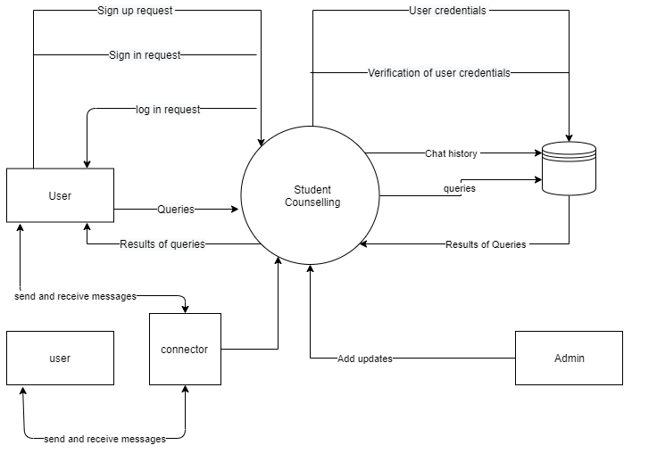

1.4 Capture "shall" Statements
No. | External Entity | Initial Requirements
1 | Admin | Admin Shall register universities
2 | Student | Student shall sign up
3 | System | System Shall authenticate the provided information by student
4 | System | System Shall provide a community group to students for communication purposes
5 | Admin | Admin Shall provide all the required information for admission to the student
6 | Admin | Admin Shall provide content for preparation of entry test
7 | System | System Shall show the list of all the hostel located near selected university.
8 | Student | Student Shall be able to manage the account
9 | Student | Student Shall be able to see the last year merits of universities.
10 | Student | Student Shall receive notification
11 | Student | Student Shall be able to rate the application
12 | System | System Shall provide a way to calculate aggregate

1.5 Allocate Requirements
Para# | Use Case Name | Initial requirement
1 | UC_UniRegistration | Admin Shall register universities
2 | UC_StudentSignup | Student shall sign up
3 | UC_AuthenticateStudent | System shall authenticate the provided information by student
4 | UC_CommunityGroup | System shall provide a community group to students for communication purposes
5 | UC_AdmissionInfo | Admin Shall provide all the required information for admission to the student
6 | UC_HostelList | System Shall show the list of all the hostel located near selected university.
7 | UC_StudentAccountManagment | Student Shall be able to manage the account
8 | UC_LastYearMerit | Student Shall be able to see the last year merits of universities.
9 | UC_Notifications | Student Shall receive notification
10 | UC_RateApp | Student Shall be able to rate the application
11 | UC_AggregateCalculator | System Shall provide a way to calculate aggregate
12 | UC_EntryTestContent | Admin Shall provide content for preparation of entry test

1.6 Prioritize Requirements
Para# | Rank | Initial Requirements | Use case ID | Use Case Name
1 | Highest | Student shall sign up | UC_2 | UC_StudentSignup
2 | Highest | Admin Shall register universities | UC_1 | UC_UniRegistration
3 | Highest | System Shall authenticate the provided information by student | UC_3 | UC_AuthenticateStudent
4 | Medium | System Shall provide a community group to students for communication purposes | UC_4 | UC_CommunityGroup
5 | Highest | Admin Shall provide all the required information for admission to the student | UC_5 | UC_AdmissionInfo
6 | Highest | System Shall show the list of all the hostel located near selected university. | UC_6 | UC_HostelList
7 | Highest | Student Shall be able to manage the account | UC_7 | UC_StudentAccountManagment
8 | Medium | Student Shall be able to see the last year merits of universities. | UC_8 | UC_LastYearMerit
9 | Medium | Student Shall receive notification | UC_9 | UC_Notifications
10 | Medium | System Shall provide a way to calculate aggregate | UC_11 | UC_AggregateCalculator
11 | Highest | Admin Shall provide content for preparation of entry test | UC_12 | UC_EntryTestContent
12 | Lowest | Student Shall be able to rate the application | UC_10 | UC_RateApp

1.7 Requirements Trace-ability Matrix

Para# | Sr# | Initial Requirements | Use Case Name | Catagory | Build
1 | 1 | Admin Shall register universities | UC_UniRegistration | UC_1
2 | 2 | Student shall sign up | UC_StudentSignup | UC_2
3 | 3 | System Shall authenticate the provided information by student | UC_AuthenticateStudent | UC_3
4 | 4 | Student Shall be able to manage the account | UC_StudentAccountManagment | UC_7
5 | 5 | Admin Shall provide all the required information for admission to the student | UC_AdmissionInfo | UC_5
6 | 6 | System Shall show the list of all the hostel located near selected university. | UC_HostelList | UC_6
7 | 7 | Admin Shall provide content for preparation of entry test | UC_EntryTestContent | UC_12
8 | 8 | Student Shall be able to see the last year merits of universities. | UC_LastYearMerit | UC_8
9 | 9 | Student Shall receive notification | UC_Notifications | UC_9
10 | 10 | System Shall provide a community group to students for communication purposes | UC_CommunityGroup | UC_4
11 | 11 | System Shall provide a way to calculate aggregate | UC_AggregateCalculator | UC_11
12 | 12 | System Shall be able to rate the application | UC_RateApp | UC_10

