**Function Hoisting:**

Ordering of lines matter in JavaScript.

Accessing the variable before declaration gives error.

But incase of function calling the function before declaration of function does not give error because JavaScript has something called function hoisting.

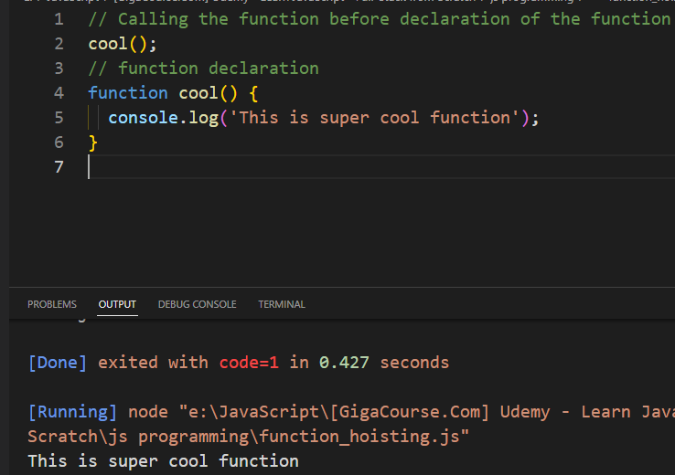

// Creating an anonymous function and setting it to variable

// Anonymous function are not hoisted, hence we should call the function after

// function declaration

let variable_y = function () {

  console.log('Anonymous Function');

};

// Calling the function after the declaration of the function

variable_y();

**Template Literals:**

Use two back ticks ``(left to 1) also known as template literal.

To create template literal where we can add dynamic text /value, wrap text within back ticks `` , instead of regular quotes.

We can add dynamic text/value inside the two back ticks using ${}.

Inside {} you can include an expression, dynamic value, dynamic text.

//****************************Template Literals******************************************//

let variable_a = 'Asad Rao';

console.log(`Hello my name is ${variable_a}`);

**Automatic Semicolon Insertion:**