The following line of JavaScript code tells the web browser to show a pop up “Thanks for clicking” anytime the visitor clicks anywhere on the page

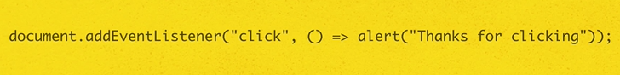

None of the words like document, addEventListener, click or alert in the above JavaScript code are part of JavaScript Language.

The words in the above code have only meaning in the context of the web browser environment and can only be used in web browser environment.

Periods like parenthesis ,quotes ,commas and other symbols make the code as JavaScript code.

Periods is the syntax, structure and skeleton of the JavaScript language.



Popular JavaScript Environments

**1)Web browser Environment**

Example:

Unique Ability of JS in web browser environment

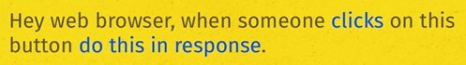

**2)Node JavaScript**

Example:

Unique Ability of JS in web browser environment



**3)Mongo DB**

Example:

Unique Ability of JS in web browser environment

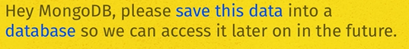

Each JavaScript environment has unique and new set of new vocabulary.

The below code is JavaScript code to make the computer solve following expressions.

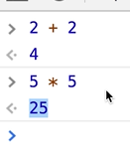

**Storing number in memory:**



23 is stored in the memory.

**Storing name/string of text in memory:**



Anything wrapped in quotes , JavaScript treat it as a string of text.

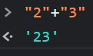

**Add string of text together:**

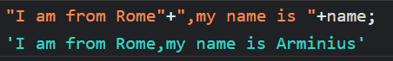

Web browser stores the title (like google) of the webpage in memory.

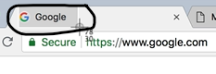

**Manipulating title (google):**

Web browser environment has created a label (Object) named document.

We can look inside the object with a period (dot)

Document object contains a property called title.



**Changing the value of the property:**

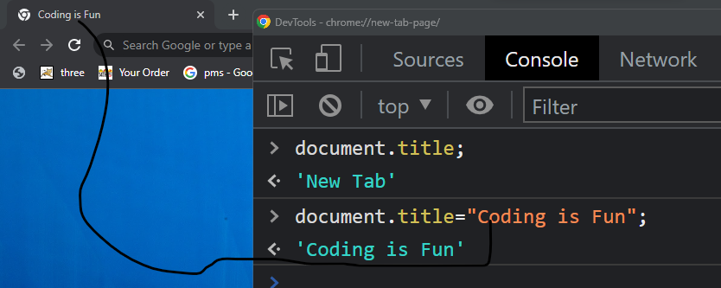

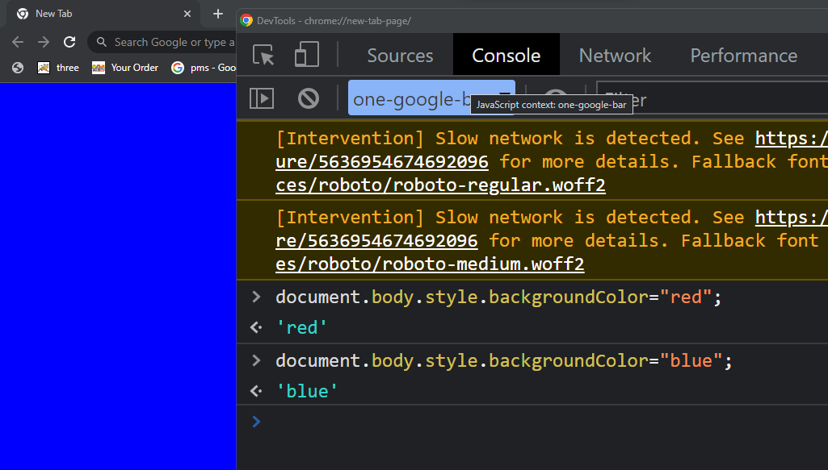

**Creating a function:**

**Object:**

**Properties and methods inside the Object**

**Function inside an Object is called a Method:**

name and age are the properties of the cat Object

function key word is not required , when declared inside the object.

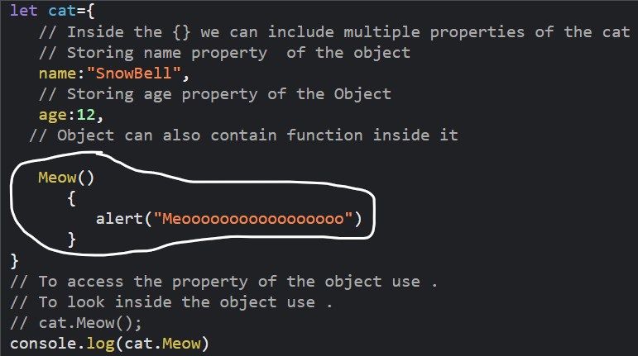

name is the property

age is the property

Meow is inside an Object or belongs to the object and is a method.

// Object is like a container and we can store property inside the object

// cat is an object

// Everything related to the cat is inside the object

let cat={

// Opening of the Object

// Inside the {} we can include multiple properties of the cat

// Storing name property of the object

name:"SnowBell",

// Storing age property of the Object

age:12,

// Object can also contain function inside it

Meow()

{

// body of the method

alert("Meooooooooooooooooo")

}

// Closing of the Object

}

// To access the property of the object use .

// To look inside the object use .

// cat.Meow();

console.log(cat.Meow)

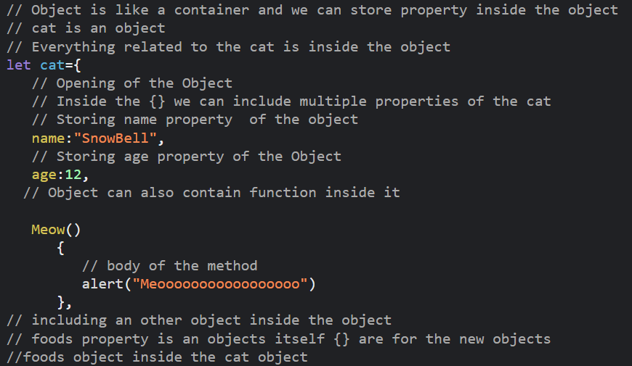

Foods is a nested Object inside cat Object.

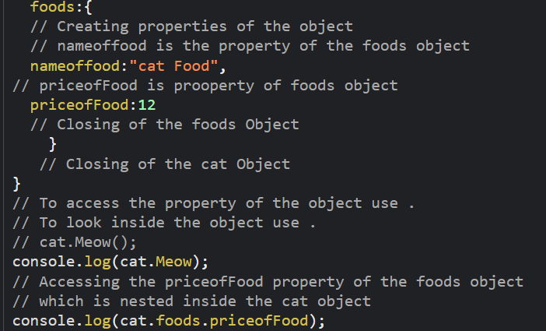

// Js Environment like Web browser

// has pre-build objects that store data

// and abilities of the web page

// document is an object of the browser

// addEventListener is a method of document object

// addEventListener method of document object

// calls the myfunction when

// click event happens

// calling addEventListener using dot

// onclick is the argument of the addEventListener method

// We are listening for onclick event

// onclick is the argument  of addEventListener method

// onlick is the event

// myfunction is the argument of addEventListener method

document.addEventListener(onclick,myfunction);

function myfunction(){

  alert("Hellooooo Browser");

}

**Arrays:**

Collection of items, array store collection in memory.

Functions inside the Object

If(strawberryCount) condition is interpreted as false for only 0 zero number, false, empty string and true for any non-zero number, true, string of text with content in it.

