10-fold result of the stacking model
The stacking model combines random forest, XGBoost, and gradient boosting by linear regression. These ten folds are a random split. The molecules are shuffled and divided into ten folds. Each fold is trained on the molecules inside that fold and scored on the molecules left out. Scaffolds are not kept together.
The test result is R² 0.58 ± 0.20, MAE 0.15 ± 0.03 eV, and RMSE 0.19 ± 0.04 eV. The training fit is higher, R² 0.87 ± 0.04. The test values are the result to report.
The test R² of the ten folds runs from 0.13 to 0.81. Fold 1 is the highest, at 0.81. Fold 6 is the lowest, at 0.13, with an MAE of 0.19 eV. One fold can look much stronger than the average. The mean of the ten folds is the summary.
Table 1. Random 10-fold cross-validation of the stacking model. Training R² is the fit on the molecules used to train that fold. Test R², MAE, and RMSE are the scores on the molecules left out of that fold.
Fold | Training R² | Test R² | Test MAE (eV) | Test RMSE (eV) | Test molecules
1 | 0.835 | 0.814 | 0.132 | 0.179 | 29
2 | 0.897 | 0.728 | 0.128 | 0.165 | 29
3 | 0.933 | 0.671 | 0.186 | 0.235 | 29
4 | 0.938 | 0.444 | 0.148 | 0.185 | 29
5 | 0.864 | 0.426 | 0.101 | 0.135 | 29
6 | 0.883 | 0.132 | 0.190 | 0.229 | 28
7 | 0.806 | 0.747 | 0.116 | 0.144 | 28
8 | 0.817 | 0.674 | 0.181 | 0.241 | 28
9 | 0.876 | 0.529 | 0.157 | 0.195 | 28
10 | 0.851 | 0.673 | 0.160 | 0.190 | 28
Mean ± SD | 0.87 ± 0.04 | 0.58 ± 0.20 | 0.15 ± 0.03 | 0.19 ± 0.04 | 28–29
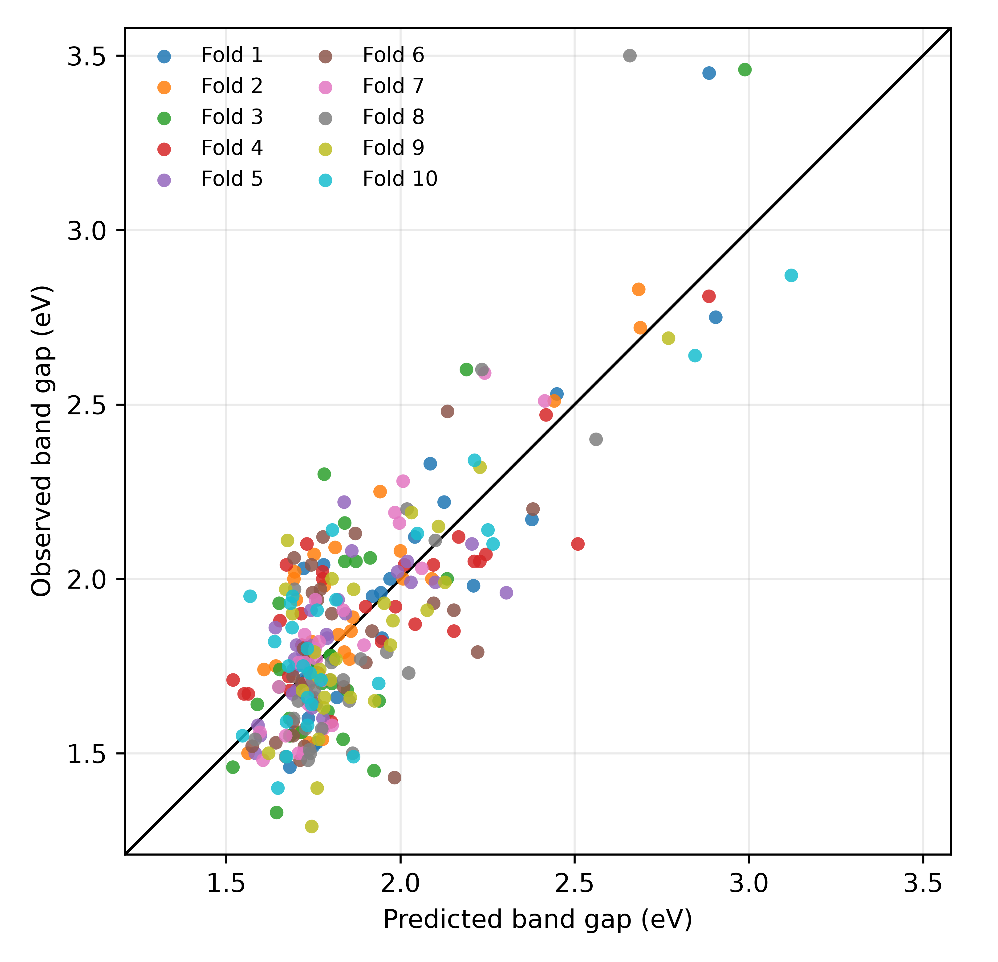
Figure 1. Held-out predictions from the random 10-fold test of the stacking model. Each color is one test fold. The line is ideal agreement.

