Scaffold split of the stacking model
The stacking model combines random forest, XGBoost, and gradient boosting by linear regression. Molecules that share a scaffold stay together. The largest scaffolds fill the training set until it reaches 80%. The remaining scaffolds are the test set, and none of those scaffolds appear in the training set.
The training set has 228 molecules in 187 scaffolds. The test set has 57 molecules in 57 scaffolds. The training fit is R² 0.83, MAE 0.10 eV, and RMSE 0.13 eV. The test result is R² 0.31, MAE 0.18 eV, and RMSE 0.28 eV. The test values are the result to report.
The training fit is higher because those molecules were used to fit the model. The largest test error is 1.39 eV, from an observed gap of 3.50 eV to a prediction of 2.11 eV. The nearest training molecule has a similarity of 0.50 and a gap of 2.12 eV. The reported result is the full test set. The five largest errors have a mean similarity of 0.68 to the nearest training molecule. The other test molecules have a mean similarity of 0.77.
Table 1. Training fit and scaffold test of the stacking model. The test molecules do not share a scaffold with the training molecules.
Split | Molecules | R² | MAE (eV) | RMSE (eV)
Training | 228 | 0.831 | 0.102 | 0.133
Test | 57 | 0.312 | 0.183 | 0.280
Table 2. The five test molecules with the largest absolute errors. Similarity is the RDKit Tanimoto similarity to the nearest training molecule.
Observed (eV) | Predicted (eV) | Error (eV) | Similarity | Nearest training gap (eV)
3.50 | 2.11 | -1.39 | 0.50 | 2.12
2.87 | 2.11 | -0.76 | 0.50 | 2.12
2.60 | 2.09 | -0.51 | 0.74 | 2.13
2.28 | 1.82 | -0.46 | 0.74 | 1.40
2.11 | 1.69 | -0.42 | 0.93 | 1.33
The reported result is the full test set: R² 0.31, MAE 0.18 eV, and RMSE 0.28 eV.
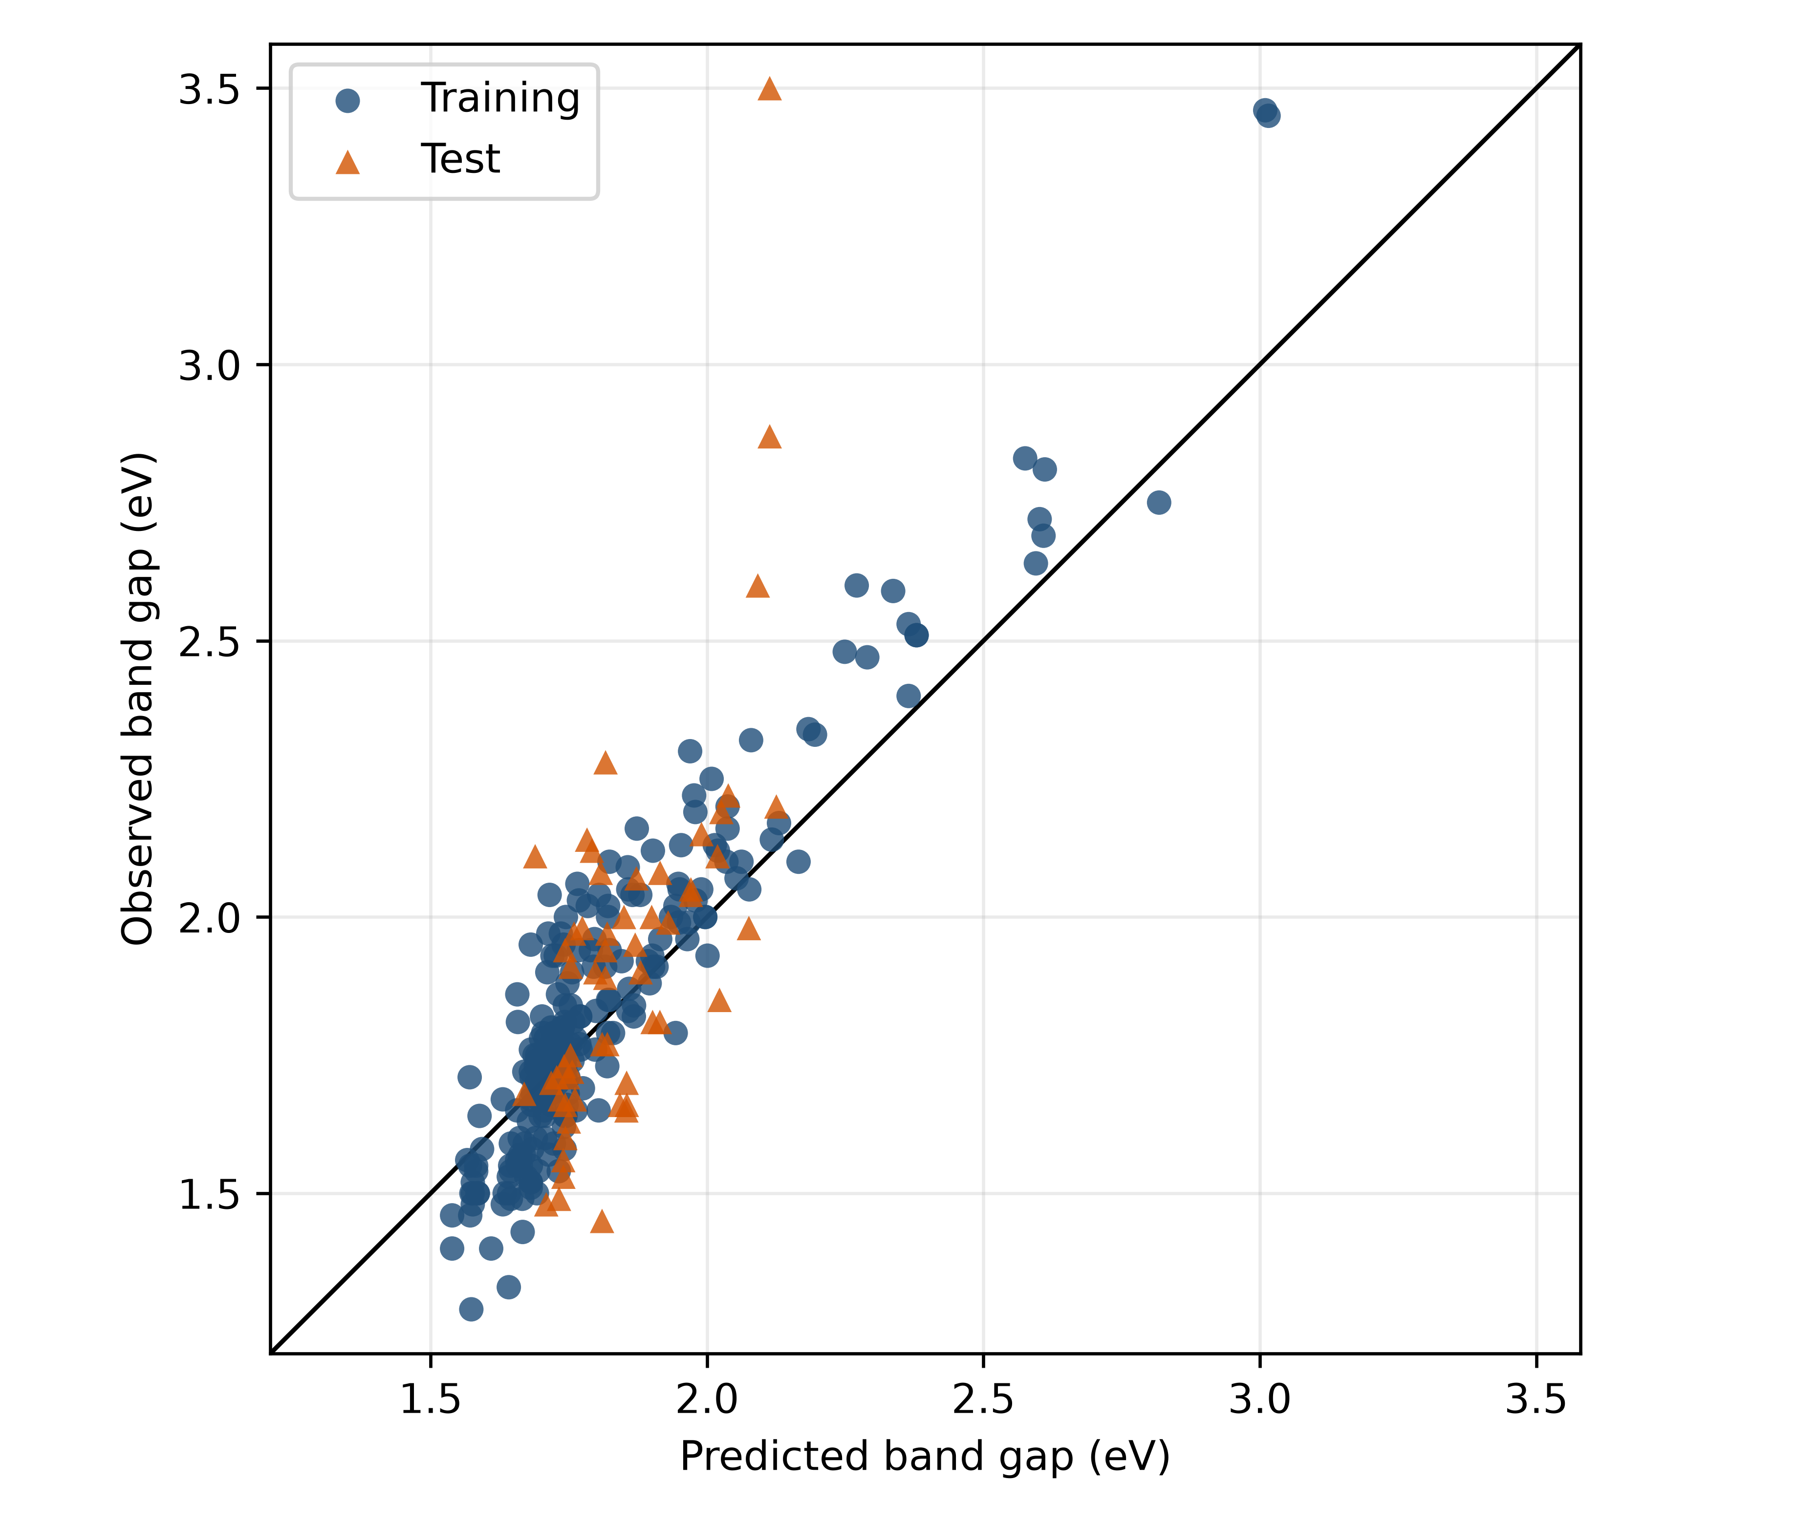
Figure 1. Training predictions and scaffold-test predictions of the stacking model. Blue circles are the training molecules. Orange triangles are the test molecules. The line is ideal agreement. The orange points farthest above the line are the outliers in Table 2.

