PERSONAL DATA

|  |  |
| --- | --- |
| **Full name:** | Madaminov Asadullokh |
| **Date of Birth:** | 01/11/2002 |
| **Location:** | Tashkent , Uzbekistan |
| **Mobile:** | +998 97 9920752 |
| **E-mail:** | Madaminovasadulloh2002@gmail.com |
| **Telegram:** | @madaminovasadullokh |
| **LinkedIn:** | [**www.linkedin.com/in/asadmadaminov**](http://www.linkedin.com/in/asadmadaminov) |

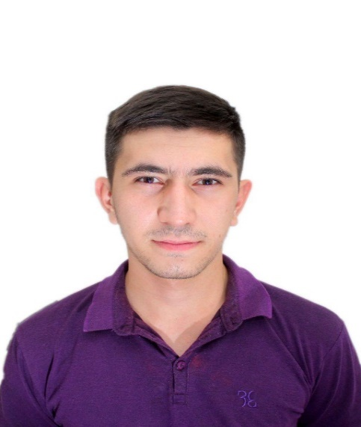

OBJECTIVE

|  |  |
| --- | --- |
| **Desired Position:** | Junior python engineer |

SUMMARY OF QUALIFICATION

|  |
| --- |
| I am working with Python starting from the **beginning of 2019**.  We did some projects in university (GUI calculator, Search Engine for movies, Basic web-site).  I have completed plenty of courses in COURSERA that are tightly bound with Python programming language. |

TECHNICAL SKILLS

* Python programming language, Kivy framework, Flask framework
* MySQL, HTML, CSS, PoPSQL,
* Javascript programming language, NodeJs platform
* Java programming language

RELEVANT EXPERIENCE

* Communication with the customer
* Clarification of business requirements
* Projects and features development

LANGUAGES

* English – Advanced
* Russian – Advanced
* Uzbek – Native Speaker

EDUCATION

* 2008 – 2019 /Andijan school №2
* 2019 – 2023 / Inha university in Tashkent / School of Logistics / Tashkent, Uzbekistan

SEVERAL FACTS ABOUT ME

|  |
| --- |
| I prefer a healthy lifestyle like traveling, biking, jogging and so on.  I am interested in management theory, the natural sciences and sci fiction literature.  I am free of the bad habits.  I can find the optimal way from difficult situation by myself in short time period.  I have an experience in teaching other people by programming skills.  I have an experience in public speaking (starting from 9 up to 150 audience). |

COURSES AND CERTIFICATES

|  |  |  |  |  |  |  |  |  |  |  |
| --- | --- | --- | --- | --- | --- | --- | --- | --- | --- | --- |
| |  |  | | --- | --- | | **Certificate:** | “Youth participation in community dicision making” | | **Issued:** | Unicef Uzbekistan | | **Years of study:** | 08/08/2017 – 15/08/2017 | | **Location of event** | Tashkent | | **Files:** |  | |