|  |
| --- |
| HDSSD |
| Requirements Specification (RS) |
| Online Bullying Education Web Application |

|  |
| --- |
| Muhammad Asad Malik  11/11/18 |

Requirements Specification (RS)

Document Control

Revision History

|  |  |  |  |  |  |
| --- | --- | --- | --- | --- | --- |
| **Date** | **Version** | **Scope of Activity** | **Prepared** | **Reviewed** | **Approved** |
| 14/10/2005 | 1 | Create | AB | X | X |
| 21/10/2005 | 2 | Update | CD |  |  |

Distribution List

|  |  |  |
| --- | --- | --- |
| **Name** | **Title** | **Version** |
| Eamon Nolan | Lecturer |  |
|  |  |  |
|  |  |  |
|  |  |  |
|  |  |  |

Related Documents

|  |  |
| --- | --- |
| **Title** | **Comments** |
| Title of Use Case Model |  |
| Title of Use Case Description |  |

**Table of Contents**

Requirements Specification (RS) 1

Document Control 1

Revision History 1

Distribution List 1

Related Documents 1

1 Introduction 4

1.1 Purpose 4

1.2 Project Scope 4

1.3 Definitions, Acronyms, and Abbreviations 5

2 User Requirements Definition 5

3 Requirements Specification 5

3.1 Functional requirements 5

3.1.1 Use Case Diagram 5

3.1.2 Requirement 1 <Registration and Login> 6

3.1.3 Requirement 2 <Quiz> 7

3.1.4 Requirement 3 <Communication Forum> 9

3.1.5 Requirement 4 <Education on Cyberbullying> 11

3.2 Non-Functional Requirements 13

3.2.1 Performance/Response time requirement 13

3.2.2 Availability requirement 13

3.2.3 Security requirement 13

3.2.4 Reliability requirement 13

3.2.5 Maintainability requirement 13

3.2.6 Extendibility requirement 13

4 Interface requirements 13

4.1 GUI 13

4.2 Application Programming Interfaces (API) 18

5 System Architecture 18

6 System Evolution 19

# Introduction

## Purpose

The purpose of doing this project stop cyberbullying as much as possible and help teens, adult and parents. know days everyone has some sort of device like mobile phone, laptop, tablet and others. Due to this people are harass and embarrass other people on internet non-stop like sending bad emails, texts, posting hurtful things about the person on social media, by creating fake profile and pretending to be that person, by putting embarrassing photo or video without the permission of that person then making fun of them with multiple people and spreading rumours about someone online they might not even meet in real life. (Anon., 2014- 2018)

My application will help different age group on how to recognize and prevent cyberbullying, with different topic for teens, adult and parents for their kids. The step by step guide line on different situation to protect themselves and alert them in future. The application will also provide Forum functionality where person who is getting bullied can talk to other people and find out the best solution to the problem. The web application will also have different Quiz’s to teach about cyberbullying. It will solve the problem of people who stay silence and suffer with anxiety, depression and low self-esteem and they don’t want to tell anyone what happened.

## Project Scope

The aim of this Project to develop web application on cyberbullying the application will have four main functionalities. Login, Educating on cyberbullying, commination forum and Quiz. The users will be able access the website but will not be able to access the forum and Quiz on till they signup and login. The Education on cyberbullying section users will be able to learn what is it online bullying, how to prevent it, what are the sign or how to recognize it and tips for teens, adult and parents. The Forum the users will be able to communicate with each other on different topic and system will automatically check for bad word remove bad comments in the forum. The Quiz section will have different types of Quiz’s, example: how well do you know cyberbullying and how to prevent cyberbullying Quiz and many others quiz’s

## Definitions, Acronyms, and Abbreviations

AD Another Definition

……..

**To be completed….**

# User Requirements Definition

This section describes the set of objectives and requirements for the system from the customer’s perspective. What are the clients saying they want?

**To be completed….**

# Requirements Specification

This section will have all the functional requirement of the application. It will provide detailed description of all the different feature of the system.

## Functional requirements

### Use Case Diagram full system

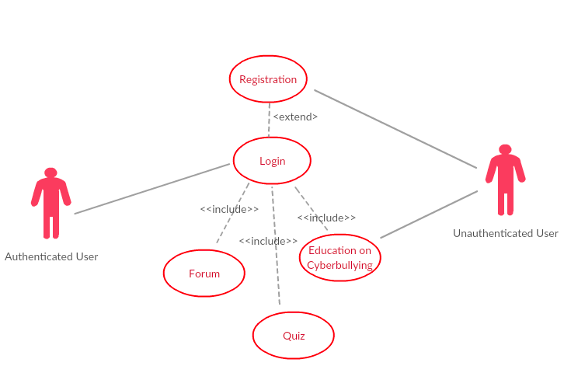

### Requirement 1 <Registration and Login>

#### Description & Priority

Figure 1 – the system will allow new users to register and create account with username and password, That will be store in MySQL database. Then user will be able to login into the system

#### Use Case

**Scope**

The scope of this use case is to registration and login

**Description**

This use case describes the registration and login process

**Use Case Diagram**

**Figure 1**: Registration and Login

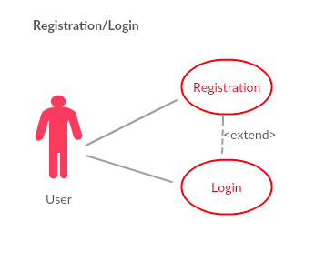

**Flow Description**

**Precondition**

Internet access is required for register and login in order to connect to MySQL database.

**Activation**

This use case starts when a user presses the signup button

**Main flow**

1. The system present register and login to user so they can login with their credentials
2. The user enters the details username and password
3. The system validates username and password
4. if it’s matches in the database, they will be login to website
5. if not matches database they will told to register
6. ones the user register they will have full access to the website.

**Alternate flow**

A1: <username don’t match>

1. The system checks for username and confirm it
2. The system checked that the username did not match
3. The use case continues at position 2 of the main flow

A2: <Password don’t match>

1. The system checks for password and confirm it
2. The system checked that the password did not match
3. The use case continues at position 2 of the main flow

**Exceptional flow**

E1: <not successful>

1. The user is not getting full access if they don’t choose to register

**Termination**

The user gets the registered successfully massage and then presented with login page

**Post condition**

The system now allows the user to access all the features

### Requirement 2 <Quiz>

#### Description & Priority

Figure 2: this use case start when the user start the Quiz. They will answer the question on the different topic. The system will provide the score at the end of the Quiz as how many question they get right.

#### Use Case

**Scope**

The scope of this use case is to do the Quiz

**Description**

This use case describes the Quiz process

**Use Case Diagram**

**Figure 2**: Quiz

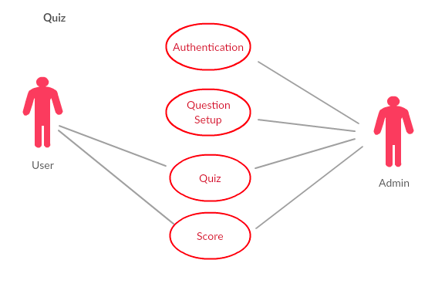

**Flow Description**

**Precondition**

For user to do the Quiz they must be register and login to the system

**Activation**

This use case starts when an click the start Quiz button

**Main flow**

1. The system present with different types of Quiz’s

2. The use case begin when user start the quiz

3. The system provide the question with options to pick from

4. The user answer all the question and submit

5. the system provides with the total score of the user

**Alternate flow**

A1: <must answer all the question>

1. The system check if all the question where answered

1. The if all the question are not answer
2. The use case continues at position 3 of the main flow

**Exceptional flow**

N/A

**Termination**

If the webpage has been closed by user

**Post condition**

The system goes into a wait state on till user interaction is detected

### Requirement 3 <Communication Forum>

#### Description & Priority

Figure 3: this use case start when user clicks on the forum. The Authenticated user will be able to view, add a post, add an answer, ask a question, edit post, search for post and unauthenticated user can only view forum. All the forum will be approved by the system.

#### Use Case

**Scope**

The scope of this use case is to communication with other using Forum.

**Description**

This use case describes the process of the Forum

**Use Case Diagram**

**Figure 3**: Communication Forum

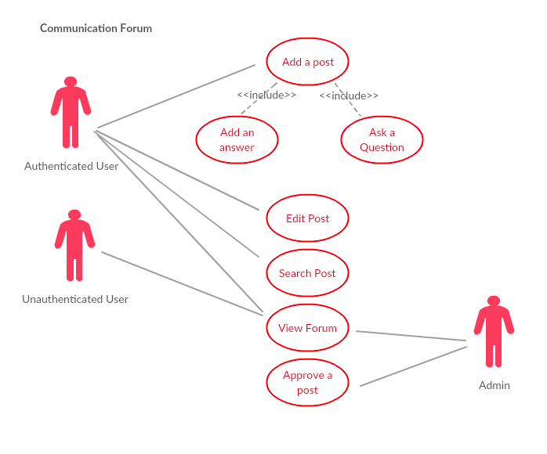

**Flow Description**

**Precondition**

For user to access the Forum full they must be register and login to the system

**Activation**

This use case starts when an select the Communication Forum

**Main flow**

1. The system presents with different forum
2. The user selects the forum they like to view
3. The system presents the forum to the user, with other user’s comments
4. The user must login to make changes, or add new forum, ask a question.
5. All the comment and post will be checks by a system

**Alternate flow**

A1: <user must login>

1. The system check if the user logged in, they have the access to all the feature
2. The if the user is not logged in
3. The use case continues at position 4 of the main flow

**Exceptional flow**

N/A

**Termination**

The user closed the webpages.

**Post condition**

The system goes into a wait state on till user interaction in detected

### Requirement 4 <Education on Cyberbullying>

#### Description & Priority

Figure 4: this use case start when user clicks on Education on cyberbullying section. This section will teach about what is cyberbullying, how to prevent it and what are the signs to recognize bullying.

#### Use Case

**Scope**

The scope of this use case is to educate user on cyberbullying

**Description**

This use case describes the process Education on cyberbullying section

**Use Case Diagram**

**Figure 4:** Education on cyberbullying

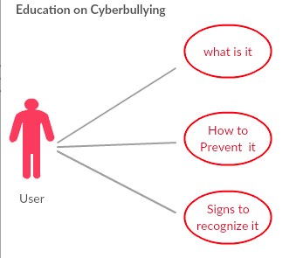

**Flow Description**

**Precondition**

For user to access this section they must have internet connection

**Activation**

This use case starts when an select the Education on cyberbullying section

**Main flow**

1. The system presents with different topic to educate on cyberbullying
2. The user selects whatever topic thy like to read on

**Alternate flow**

**N/A**

**Exceptional flow**

**N/A**

**Termination**

The user closed the webpages.

**Post condition**

N/A

## Non-Functional Requirements

### Performance/Response time requirement

The performance is the main aspect of the web application. The web application will be connected to MySQL database to store login details, Quiz and Forum data which will requires an interwork connection to work without network the application will not work. The internet speed can also affect overall performance of the web application. The application function may get slower.

### Availability requirement

The application must be available constantly as the user will use the application to learn about cyberbullying. Ones the user have network they can access the application and login to use all the feature. The application may have little downtime if any bugs or errors appear, but they will be repaired or remove immediately.

### Security requirement

This application will be designed to only accepts password with at least 8 characters. the password will be encrypted using password hashing method and store in MySQL database. The user will not be able to do the Quiz, access forum fully if they are not logged in to the system. this application will also be security tested to find out any threats.

### Reliability requirement

The reusing the code will be big factor to save development time. Created methods or functions can be reused repeatedly once there is no bugs or errors. So, this will speed up development time and provide time to work on other part of the application like security.

### Maintainability requirement

The maintainability will be measured by writing code in a way where its easily readable with or without comments. So, this will be easier to re-edit code and also what functionality each piece of code has

### Extendibility requirement

This project can be extended in future its very big topic. Can add more different feature so help people out with bullying.

# Interface requirements

## GUI

GUI 1.

This is screen is for home page

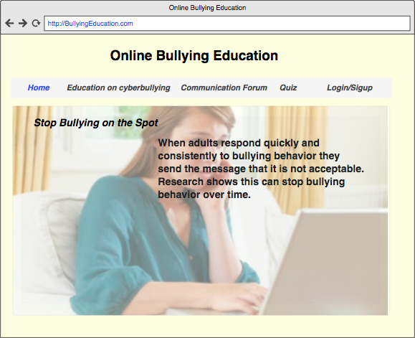

GUI 2.

This is a screen shows the login and signup

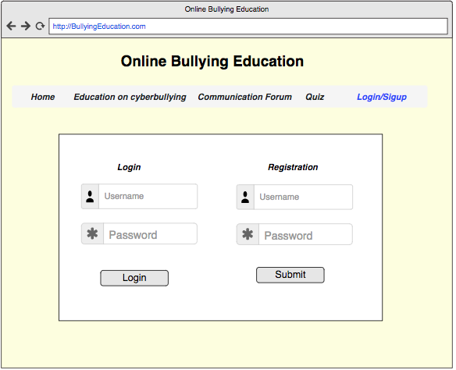

GUI 3.

This screen shows the Quiz

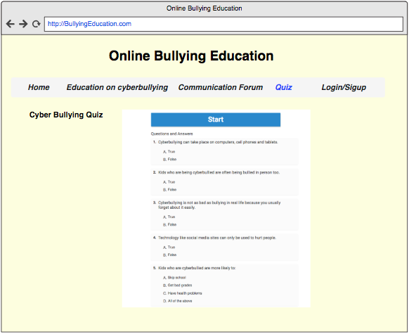

GUI 4.

This screen show the Communcation Fourm

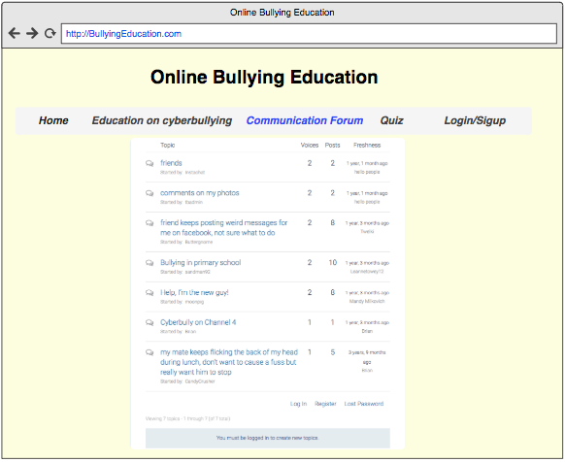

GUI 5.

This screen shows the Education on cyberbullying pages

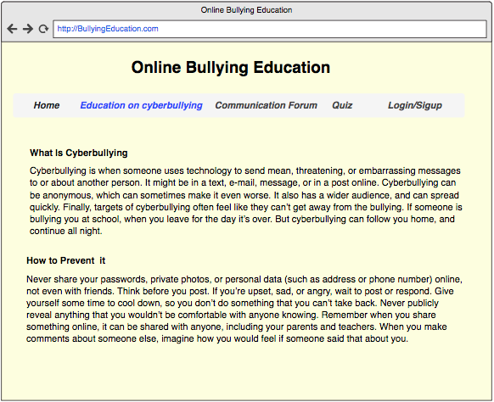

## Application Programming Interfaces (API)

Explain which interfaces your system offers or which are used by your system. Examples include Google maps and Weka.

**To be completed…**

# System Architecture

This is a class diagram of the system. which shows how everything is linked with relationship one to many.

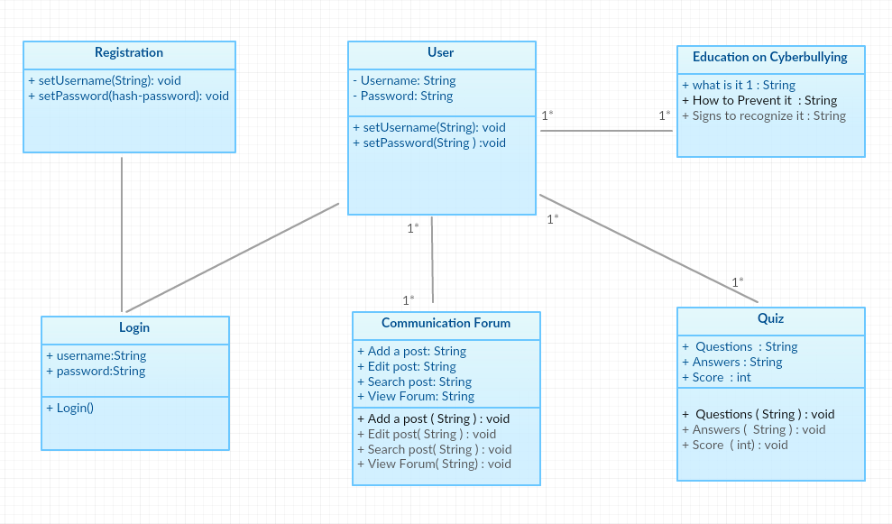

# System Evolution

This section describes how the system could evolve over time.

**To be completed….**