**Mobile Computing**

**Student Name: Asad Ullah Shahid**

**Teacher Name: Sir Haq Nawaz**

**Lecture 01:**

In lecture one we studied GIT commands. How to upload a file on GitHub.

1. First make a folder and a file you want to upload.

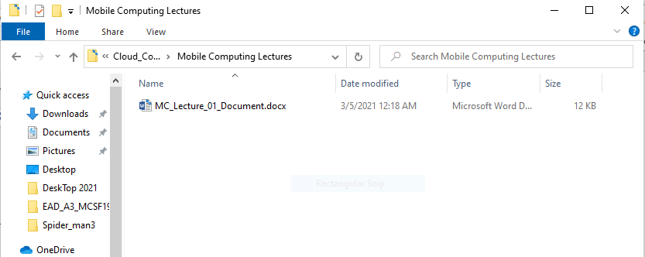

1. Open GIT CMD and go to folder where you made the file.

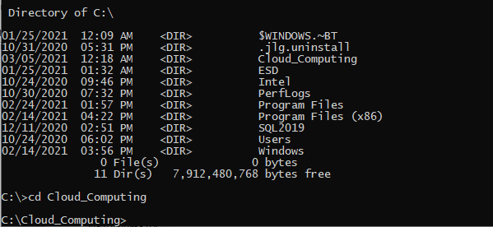

1. Now use command git init and git remote add origin (GitHub link)

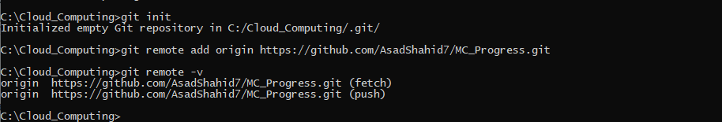

1. Now use add command and git commit command with message